# Non-Disclosure Agreement

This Non-Disclosure Agreement ("Agreement") is entered into as of [DATE] by and between:

1. Karl Patrick B. Amper, located at Purok 5- A, Apokon, Tagum City, Davao del Norte, 8100, and Kenny Walter Diolola, located at Purok Kalubi, Villanueva Subdivision, Brgy. Poblacion, Kidapawan City, North Cotabato, 9400.

*Collectively, the Disclosing Party and the Receiving Party are referred to as "the Parties."*

## 1. Definition of Confidential Information

=

For the purposes of this Agreement, "Confidential Information" refers to any information, whether written, oral, electronic, or otherwise, disclosed by the Disclosing Party to the Receiving Party, including but not limited to excerpts from dissertations, datasets, methods, ideas, research, notes, drafts, analyses, and other materials related to the training of machine learning models.

## 2. Obligations of the Receiving Party

*The Receiving Party agrees to:*

a. Maintain the confidentiality of the Confidential Information and not disclose it to any third party without the prior written consent of the Disclosing Party;

b. Use the Confidential Information solely for the purposes of machine learning training as specified by the Disclosing Party; and

c. Take all reasonable measures to protect the confidentiality of the Confidential Information, at least to the same extent it protects its own confidential information.

## 3. Exclusions from Confidential Information

*Confidential Information does not include information that:*

a. Is or becomes publicly available without breach of this Agreement by the Receiving Party;

b. Is already known to the Receiving Party at the time of disclosure;

c. Is independently developed by the Receiving Party without use of or reference to the Confidential Information; or

d. Is required to be disclosed by law or governmental order, provided the Receiving Party promptly notifies the Disclosing Party to enable the Disclosing Party to seek a protective order or other remedy.

## 4. Term

This Agreement shall remain in effect for a period of 4 weeks from December 9, 2024 to January 5, 2025.

## 5. Miscellaneous

This Agreement constitutes the entire understanding between the Parties regarding the subject matter hereof and supersedes all prior agreements, whether written or oral. Any amendments to this Agreement must be made in writing and signed by both Parties.

## 6. Signatures

Disclosing Party: ___________________________ Date: ___12/9/24__

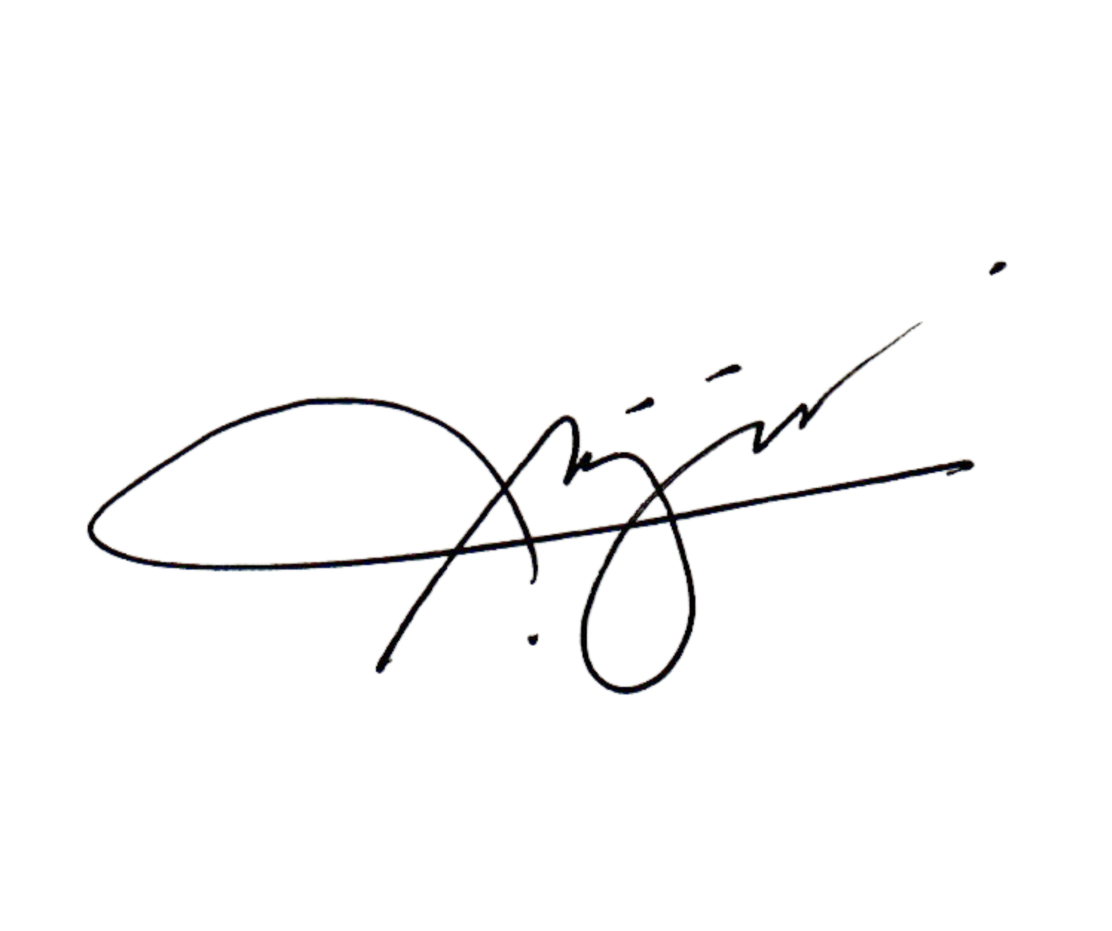

Receiving Party: ___________________________ Date: 12/09/2024