**CHAPTER I**

**THE PROBLEM AND ITS SETTING**

**Background of the Study**

Mosquitoes are small flies that belongs to the family *Culicidae*. Females of the majority of species are *ectoparasites*, whose tube-like mouth parts pierce through the skin of the host to consume blood. The word "mosquito" came from Spanish for "little fly". Many species of the family feed on the blood of various hosts, mainly vertebrates; including reptiles, amphibians, mammals, birds, and even some kinds of fish. Some mosquitoes also attack invertebrates. The saliva of the mosquito causes a rash that is a serious nuisance. More seriously, the roles of most species of mosquitoes as carrier of deadly of diseases. In passing from one host to another, they may transmit harmful infections such as *Malaria; Yellow Fever; Chikungunya; West Nile virus, Dengue Fever; Filariasis; Zika virus and other arboviruses;* rendering it the deadliest animal family in the world (https://en.wikipedia.org/wiki/Mosquito). The most dangerous animals on Earth are mosquitoes when it comes to killing humans being the carrier of devastating diseases (Gates, 2013).

A sound is a vibration that propagates as an audible wave of pressure in a medium such as air. Through a transmission medium which should be a matter (which means a medium must occupy a space). In general, the sound that human beings can hear is the vibration of air molecules around them. An audible frequency is defined as a periodic vibration of which the frequency is audible to the most human. The standard range of audible frequencies is from 20 to 20,000 Hz, although the range of frequencies individuals hear is greatly influenced by age, genes, and environmental factors. Frequencies below 20 Hz are usually felt rather than heard, assuming that the amplitude of the vibration is great enough. Frequencies above 20,000 Hz may be sensed by young people. High frequencies are the first ones to be affected by hearing loss due to age and/or prolonged exposure to very loud noises (<https://en.wikipedia.org/wiki/Audio_frequency>).

The attempt to study the effects of sounds on animals must consider species differences in hearing capabilities. Although the hearing ranges of many species may overlap to a large degree, considerable variation occurs in high- and low-frequency hearing. As a result, a sound that is easily audible to one species can be less audible or sometimes may even be inaudible to another species. The purpose of this review is to describe the variation in the hearing ranges of common laboratory animals and other wild animals(<http://www.ingentaconnect.com/content/aalas>).

In this experimental study, the researcher would create an electronic bracelet device that serves as a mosquito repellent that emits a humming sound having a high frequency and that frequency changes over time. Such sound is at a frequency range which is inaudible to the most human being. Although there are products that exist in the market like the Pest Repel Pro which repels rodents and insects like mosquitoes by the use of ultrasonic sound, these products have a constant frequency with respect to what species it is repelling.

**Statement of the Problem**

This study attempted to produce an electronic mosquito repellent that can repel biting mosquitoes without using mosquito coils, lotions or sprays, and as at the same time prevent diseases of which mosquitoes are responsible for transmitting. It sought to answer the following:

1. What is the maximum distance the device can repel the mosquito?
2. Is there a significant difference between the frequency of mosquito bite between a person wearing the device and a person not wearing the device?

**Objectives of the Study**

This study aimed to produce a bracelet that can repel female breeding mosquitoes by emitting a humming sound which produces high frequency vibrates the air molecules around the area covered by the device and is sensed by the mosquito’s sensilla. Specifically, this study aimed to:

1. Determine the maximum distance the bracelet can repel mosquitoes.
2. Determine if there is a significant difference in the frequency of mosquito bite between a person wearing the device and a person not wearing the device.

**Conceptual Framework**

This study aimed to solve the problems caused by mosquito bites. The transmission of different some deadly diseases is caused by mosquitoes, by using this device, it can prevent mosquitoes from biting us humans, thus preventing the spread of diseases transmitted by mosquitoes.

This study involved the interplay of the independent and dependent variables to repel the female breeding mosquito by humming sound at a frequency inaudible to human beings and mosquitoes are sensitive to those frequency ranges. The independent variables of this study were the hearing frequency range of the mosquito and the frequency response of the buzzer in the device. The dependent variable of this study is the range of repulsion. This framework is illustrated in the figure:

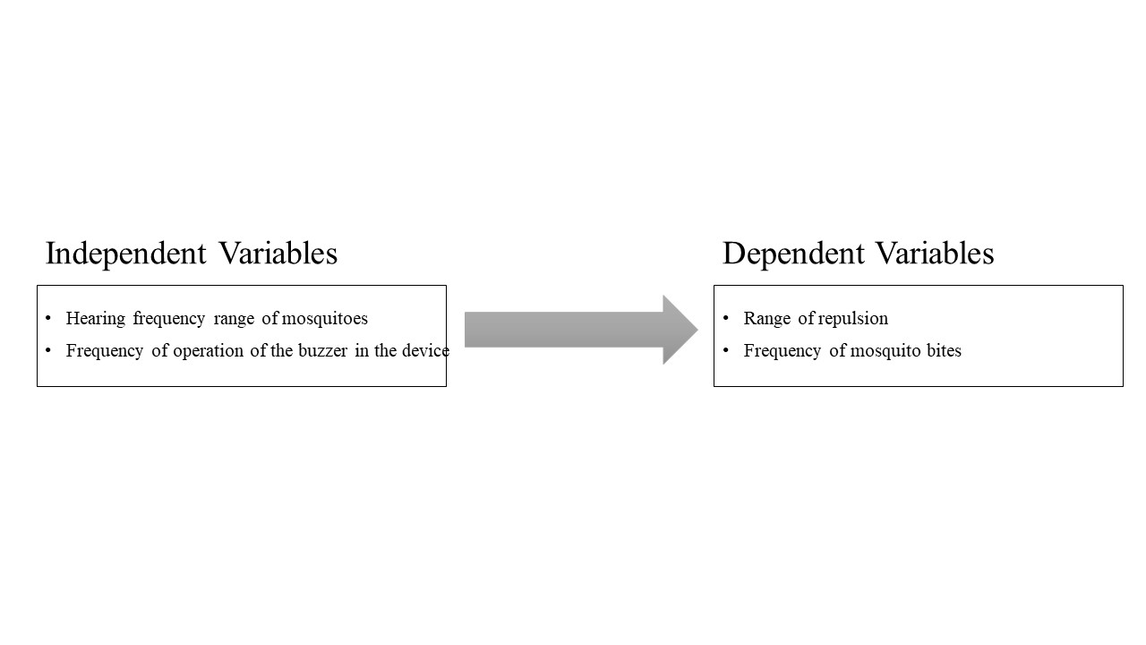

*Figure 1. Schematic diagram of the conceptual framework of the study.*

**Null Hypothesis of the Study**

There is no significant difference between the frequency of mosquito bite between a person wearing the product and a person not wearing the product.

**Significance of the Study**

Mosquitoes has always been a big problem to mankind as it transmits deadly diseases such as Dengue Fever, Malaria and other diseases. There are existing solutions to this problem such as insect repellent lotions, sprays, mosquito coils, electric mosquito traps and fogging; but still these solutions were not enough as the lotion’s smell wears off and you need to reapply. In the same manner, the sprays and mosquito coils need to be replaced from time to time and the smoke they emit is also hazardous to the health of people especially those who are asthmatic. This study innovated a new way to repel mosquito without smell and smoke.

As a whole, everyone can benefit from this study specially the children who are most likely the victims of a mosquito bite. They would only need to power on and wear the device and they are mosquito free. The local economy can also benefit from this study since the transmission of some diseases through mosquito bites is a global problem, as we know it mosquitoes are found in every part of the planet except Antarctic.

**Scope and Limitations of the Study**

The development of the study spans from simple concept testing in April of 2016, the researcher had enough knowledge and skills on a microcontroller to improve study in the following year. After tests were done, the size of the circuit was reduced. Other works to improve the over-all physical make-up of the device was done from June to October 2017. After qualifying for the National Invention Contest and Exhibits 2018, the product’s circuit was later improved by adding safety features and were done from April 2018 to August 2018. The device undergoes testing and this study was completed in March of 2019.

The study was limited to frequencies from 22kHz to 45Khz in order to achieve the frequency that annoys the mosquitoes. Also due to the power limitations in the product of the study, the sound can only propagate for 2 meters.

**Definition of Terms**

To facilitate the understanding of the study, the following terms are operationally defined:

**Bracelet -** a band or chain worn around the wrist with a strap used to secure it.

**Dengue Fever -** a disease caused by a family of viruses that is transmitted by mosquitoes.

**Electronic-** a system which consists of an electronic component connected in a PCB which works together to perform a specific task.

**Frequency -** the rate of occurrence of anything, the incidence relative to a time period. In electronics, it refers to the number of cycles per second measured in hertz.

**Frequency Response -** describes how a device responds to sound across a range of frequencies.

**Malaria Fever-** a disease caused by a protozoan parasite in the genus Plasmodium in the red blood cells and is transmitted by the bite of female anopheline mosquitoes.

**Micro-Controller Unit (MCU) -** a small computer embedded in an integrated circuit. It can be programmed to do a specific job.

**Mosquito –** is a flying insect that belongs to the family of *Culicidae,* known for biting and sucking blood. However, only the female of the animal family bites other animals and humans.

**PCB** (Printed Circuit Board) **-** mechanically supports and electrically connects electronic components using conductive tracks and pads.

**Repellent-** the product that can repel a specified matter which can be a life form or other objective matter.

**Sensilla-** a simple sensory receptor typically hair or rod-shaped present in arthropods or other invertebrates.

**CHAPTER II**

**REVIEW OF RELATED LITERATURE**

Mosquitoes are small flies that belongs to the family *Culicidae*. Females of the majority of species are *ectoparasites*, whose tube-like mouth parts pierce through the skin of the host to consume blood. The word "mosquito" came from Spanish for "little fly". Many species of the family feed on the blood of various hosts, mainly vertebrates; including reptiles, amphibians, mammals, birds, and even some kinds of fish. Some mosquitoes also attack invertebrates. The saliva of the mosquito causes a rash that is a serious nuisance. More seriously, the roles of most species of mosquitoes as carrier of deadly of diseases. In passing from one host to another, they may transmit harmful infections such as *Malaria; Yellow Fever; Chikungunya; West Nile virus, Dengue Fever; Filariasis; Zika virus and other arboviruses;* rendering it the deadliest animal family in the world (<https://en.wikipedia.org/wiki/Mosquito>).

More than 3,500 species of the *Culicidae* have already been described by biologists. They are divided into two subfamilies which results in 43 genera. These figures are subject to continuous change, as more species are discovered, and as DNA studies the taxonomy of the family. There are two main subfamilies; the *Anophelinae* and *Culicinae*. *Arboviral* diseases like yellow fever and dengue fever usually transmitted by *Culicine* species. Some transmit various species of avian malaria, but it is not clear that they ever transmit any form of human malaria. However, all the most important carriers of human malaria are *Anopheline (Harbach, 2008).*

Review of literature revealed that the most dangerous animal on Earth when it comes to killing humans are mosquitoes. The is no other animal even comes close to being the carrier of devastating diseases. Malaria is one of the worsts disease carried by mosquitoes killing more than 600,000 people worldwide every year. It even threatens half of the world’s population and costs billions of dollars in lost productivity annually. Most mosquito-carried diseases include dengue fever, yellow fever, and encephalitis. Mosquitoes are found in every region of the world except Antarctica. During the peak breeding seasons, except termites and ants they out number every other animal species on Earth. They were responsible for the of thousands of deaths during the construction of the Panama Canal. And they affect population patterns on a massive scale: In many malarial zones. Considering their impact, you might expect mosquitoes to get more attention than they do. Sharks kill fewer than a dozen people every year and in the U.S. alone, and they get a week dedicated to them on TV every year. Mosquitoes kill 50,000 times as many people (Gates, 2013).

Animals respond to ultrasound and avoid its presence. Animals like dogs, cats and other small mammals respond to 22-25 kHz of ultrasound, rats and other rodents at 60-70kHz, lizards and other small reptiles at 52-63kHz. Insects like flies, mosquitoes and cockroaches respond to ultrasound with higher bandwidth at 28-44 kHz (Oween & Hopp, 1994).

In addition, mosquitoes detect sound with their hair sensilia. Their hair on the antennae is one kind of which is called Johnson’s organ, in the second antennal segment. Tympanic organs may be located in different places in different groups. Airborne sound can be localized by sound receptors and are very sensitive to sound modulation (Hickman, 1973).

The human species and mosquitoes have different perceptions of sound. In a human auditory system, there are three main parts: the outer, middle, and inner ear. The outer ear composed of the pinna which is the auditory canal or often referred to as the auditory meatus. The human auditory canal ends on a tympanic membrane otherwise known as the eardrum. The middle ear is a cavity filled with air spanned by three tiny bines called the malleus, incus, and stapes; or sometimes called the hammer, anvil, and stirrup, respectively referring to their shapes. Together these bones firm a mechanical-lever action between the air on the eardrum and the fluid-filled cochlea of the inner ear which leads to an auditory nerve which then sends electrical impulses to the brain (Everest and Pohlman, 2009).

An audible frequency is defined as a periodic vibration of which the frequency is audible to the most human. The standard range of audible frequencies is from 20 to 20,000 Hz, although the range of frequencies individuals hear is greatly influenced by age, genes, and environmental factors. Frequencies below 20 Hz are usually felt rather than heard, assuming that the amplitude of the vibration is great enough. Frequencies above 20,000 Hz may be sensed by young people. High frequencies are the first ones to be affected by hearing loss due to age and/or prolonged exposure to very loud noises some are usually caused by genetic lines (<https://en.wikipedia.org/wiki/Audio_frequency>).

The attempt to study the effects of sounds on animals must consider species differences in hearing capabilities. Although the hearing ranges of many species may overlap to a large degree, considerable variation occurs in high- and low-frequency hearing. As a result, a sound that is easily audible to one species can be less audible or sometimes may even be inaudible to another species. The purpose of this review is to describe the variation in the hearing ranges of common laboratory animals and other wild animals(<http://www.ingentaconnect.com>).

A micro-controller (or MCU for micro-controller unit) is a small computer embedded in single integrated circuit. In modern terminology, it is a system on a chip or SoC. A micro-controller contains one or more CPUs (processor cores) along with memory and programmable input/output peripherals. Program memory in the form of Ferroelectric RAM, NOR flash or OTP ROM is also often included on chip, as well as a small amount of RAM. Micro-controllers are designed for embedded applications, in contrast to the microprocessors used in personal computers or other general-purpose applications consisting of various discrete chips. In this case the micro-controller was used to output a pulse width modulation signal on whose sound will be emitted by a buzzer whose operating frequency is capable of operating on frequencies in the ultrasonic range (<https://en.wikipedia.org/wiki/Microcontroller>).

**CHAPTER** **III**

**RESEARCH DESIGN AND METHODOLOGY**

This chapter presents the method utilized by the researcher in data gathering. Descriptions on the research design, locale, procedures and statistical treatment used are also included.

**Research Locale**

During the summer break of 2017, the proponent conducted the experiment at the Villanueva Subdivision, Kidapawan City. Improvements of the product were done in the Electronics Engineering Laboratory of Notre Dame of Kidapawan College, Datu Ingkal Street, Kidapawan City.

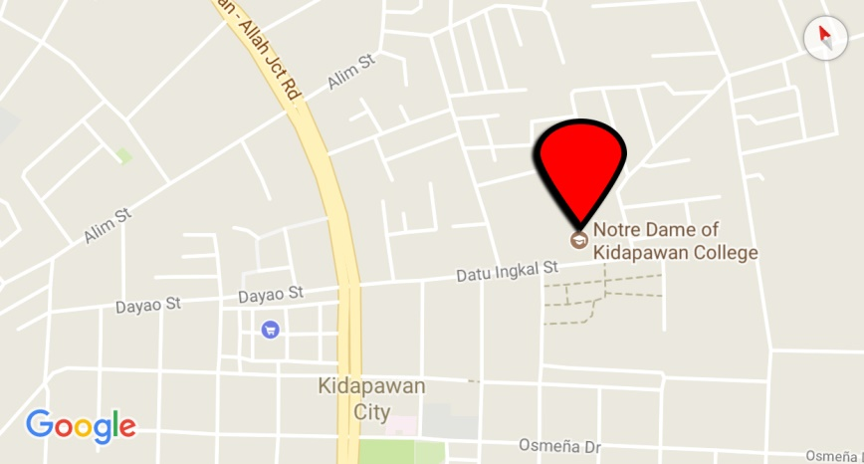

*Figure 2. Map of the Location of the Study.*

**Research Design**

The study to test the effectiveness of the Electronic Bracelet as a mosquito (*Culicidae)* repellent was laid out using an experimental design to evaluate its effectiveness to repel female breeding mosquitoes, which bite humans. The device utilized the capability of modern microcontrollers to produce an ultrasonic PWM signal which later is emitted by a buzzer to take advantage of the high sensitivity of mosquitoes and the inability of a human to hear sound in such frequencies.

Electronic System:

Schematic Diagram

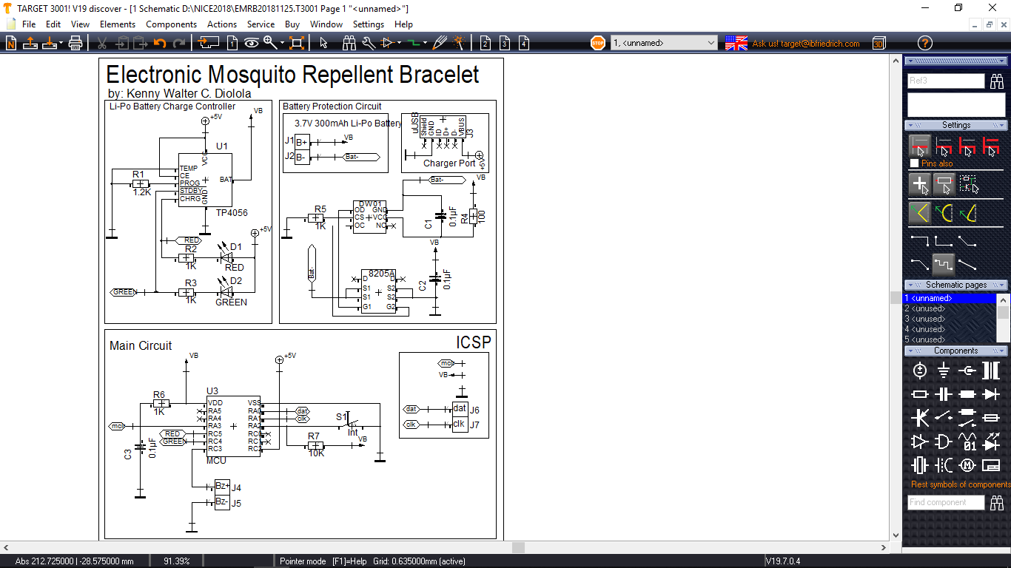

*Figure 3. The Schematic Design of the Device*

Figure 3 shows the schematic diagram of the device. The whole system of the device is powered by a rechargeable 3.7V Li-Po Battery with a capacity of 300mAh.

PCB Design

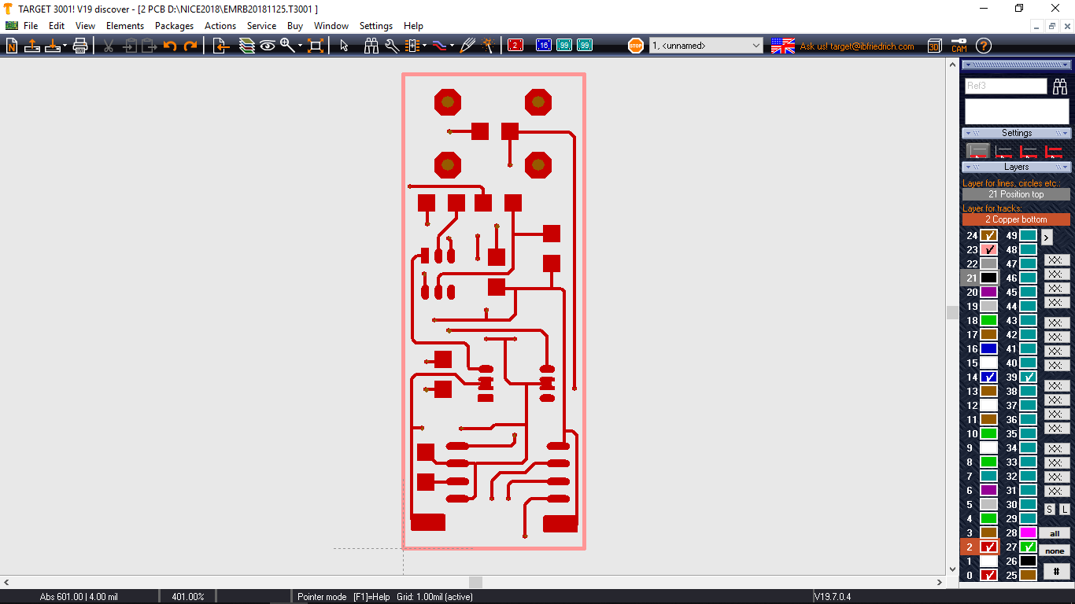

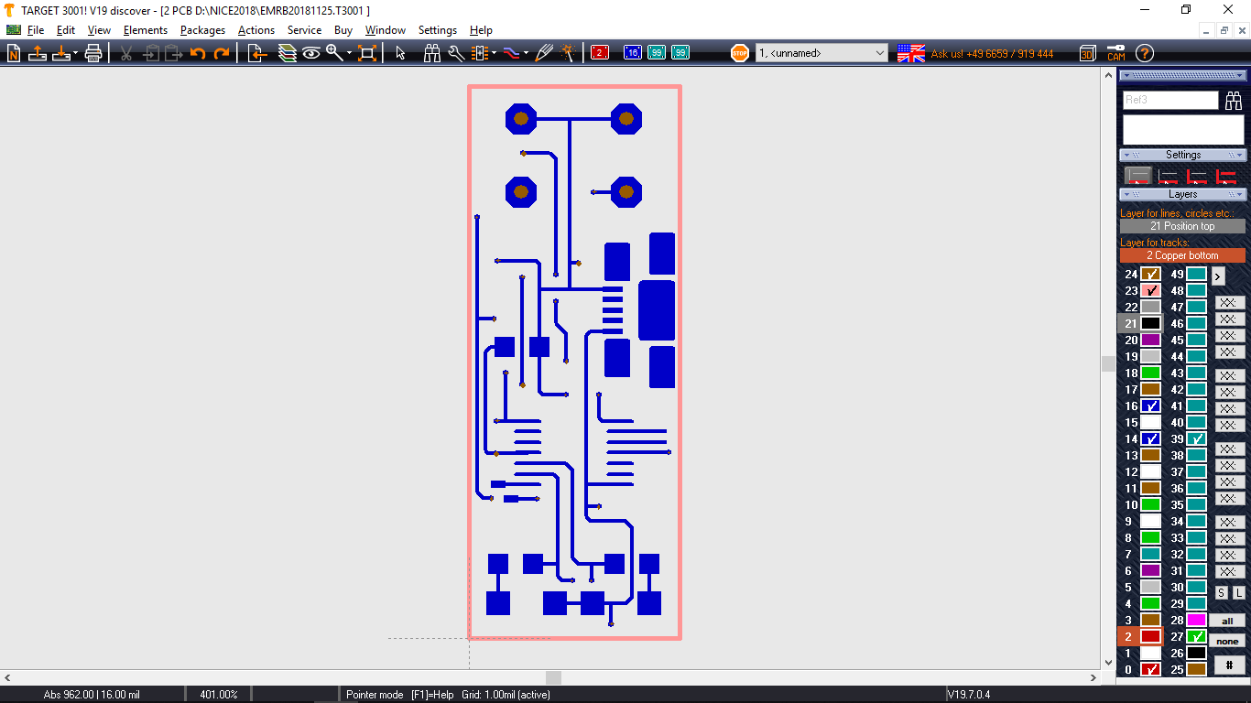

*Figure 4. The PCB Design of the Product*

Figure 4 shows the pcb design laid out by the researcher in accordance with the previously discussed schematic diagram. This was done using the TargetV19 pcb design software.

**Requirements in the Assembly of the Device**

The materials, components, and tools needed in this study are as follows:

1. 3.7V 300mAh Li Po Battery
2. PIC16F series microcontroller
3. Ultrasonic buzzer
4. PB switch
5. SMD LEDs
6. 220 Ohm Resistor
7. 1K Ohm Resistor
8. 10K Ohm Resistor
9. M7 Diode
10. Casing
11. Rubberized wrist band

**Computer Software**

The program which was written on the microcontroller was written using Flowcode V5 for PICmicros. The PICkit2 Programmer was then used to burn the program in the microcontroller. For the 3D printing of the casing of the device, it was laid out using Google SketchUp. The PCB design was done using TargetV19 which is a PCB design software.

**Hand Tools**

1. Soldering Iron- Bakon 950D Portable Soldering Station
2. Multi-tester
3. PICkit2 Programmer
4. Cutter
5. Wire Stripper

**Assembly Procedure**

Then cut the pre-sensitized printed circuit board, remove its protective layer and place the PCB design on the tracing paper on it, secure it with scotch tape and expose it to UV light for one minute. While waiting for PCB, prepare the first etching solution: sodium hydroxide and water at a ratio of 1:10, place the mixture in a container that the PCB can fit in. After one minute the PCB should be ready for etching, carefully remove the tape and the tracing paper, then submerge the PCB in the solution and move the container lightly in a circular motion to speed up the etching process. After 5-10 minutes the exact copy of the PCB design should now be visible.

For the second etching process, ferric chloride is used. The same process would be repeated just like the first etching but the chemical is not mixed with water. After the second etching, the PCB should be thoroughly cleaned. Now that the PCB is clean and dry, it’s time to solder all the necessary components. The micro-controller should be the last one to be soldered as it is the most sensitive and expensive one. After every component has been soldered, it’s time to load the firmware using the Microchip PickIt2 to load the firmware. The firmware contains all the necessary commands to the micro-controller to mimic the sound of male mosquitoes at their frequency range. After loading the firmware, it is time to attach the power source which is a small lithium polymer battery. Finally place everything in the 3D printed casing of the project which can be easily attached to the rubberized wrist band.

**Bill of Materials**

|  |  |
| --- | --- |
| **ITEM** | **COST** |
| 3D Print | P 32.00 |
| Ferric Chloride | P 38.00 |
| HF Speaker | P250.00 |
| Li-Po Battery | P 250.00 |
| Micro-controller (PIC16f690) | P 150.00 |
| PCB (pre-sensitized) | P 150.00 |
| Rubber Wrist Band | P 50.00 |
| SMD Components | P 20.00 |
| Solder | P 10.00 |
| **TOTAL** | **P 950.00** |
|  | |

Table 1. Bill of Materials for a Single Device

**CHAPTER IV**

**RESULTS AND DISCUSSIONS**

In this chapter, the result of the experimentation is presented. This is visualized by the subsequent tables.

The first problem was to determine the maximum distance away from the bracelet that can repel mosquitoes. To prove this, the researcher trapped mosquitoes using olive oil and a plastic plate that does not kill them. The mosquitoes were also carefully transferred to a mini cage that they can’t get out and let oil dry overnight so the mosquitoes can move freely again. Then the bracelet was tested at a different distance away from them. After each trial, the mosquitoes were left to calm down. The next test was not started until everyone of them calm down and stay in one place.

Table 1. Testing of reactions mosquitoes to the bracelet at different distances

|  |  |  |  |  |  |  |  |
| --- | --- | --- | --- | --- | --- | --- | --- |
| Distance | Total Number of Mosquitoes | Trial 1 | Trial 2 | Trial 3 | Trial 4 | Trial 5 | Average Number of Mosquitoes Reacted |
| 20 cm | 12 | 9 | 8 | 9 | 9 | 8 | 8.6 |
| 50 cm | 12 | 8 | 9 | 9 | 9 | 8 | 8.6 |
| 80 cm | 12 | 8 | 8 | 8 | 9 | 9 | 8.4 |
| 110Cm | 12 | 9 | 7 | 8 | 8 | 7 | 7.8 |
| 140 cm | 12 | 7 | 8 | 8 | 8 | 7 | 7.8 |
| 170 cm | 12 | 6 | 7 | 7 | 7 | 8 | 7.0 |
| 200 cm | 12 | 5 | 5 | 6 | 5 | 6 | 5.4 |
| 230 cm | 12 | 4 | 3 | 3 | 1 | 2 | 2.6 |
| 250 cm | 12 | 5 | 2 | 2 | 0 | 1 | 2.0 |
| 280 cm | 12 | 0 | 1 | 0 | 0 | 0 | 0.2 |

Table 1 shows the reactions of mosquitoes to the bracelet at different distances in five trials. Based on the average number of mosquitoes that reacted, majority of them reacted to the device in 20 cm, 50 cm, 80 cm, 110 cm, 140 cm and 170 cm. The female mosquitoes as experimental subjects moved away from the person with the electronic mosquito repellent upon hearing the mimicking sound emitted from the device. In relation to this, mosquitoes detect sound with their hair sensilla on their antennae in the second antennal segment called Johnson’s organ. Such airborne sound can be localized by sound receptors and are very sensitive to sound modulation (Hickman, 1973). Moreover, Oween & Hopp (1994) cited that animals respond to ultrasound and avoid its presence. Insects like mosquitoes, flies, and cockroaches respond to ultrasound with higher bandwidth at 28-44kHz.

Table 2. Testing the product in terms of mosquito bite

|  |  |  |  |  |  |
| --- | --- | --- | --- | --- | --- |
| Test No. | Respondent 1 | Respondent 2 | Respondent 3 | Experimental Average | Control  (No Bracelet) |
| 1 | 1 | 0 | 0 | 0.33 | 7.00 |
| 2 | 0 | 1 | 1 | 0.67 | 9.00 |
| 3 | 0 | 0 | 0 | 0.00 | 6.00 |
| 4 | 2 | 0 | 0 | 0.67 | 10.00 |
| 5 | 0 | 0 | 0 | 0.00 | 5.00 |
|  |  |  |  |  |  |

Table 2 shows the result on the test of the frequency of the mosquito bite by four (4) respondents including the control treatment. The test was done for one (1) hour from 6 pm to 7 pm when mosquitoes are most active. The said test is repeated for each respondent on the same area, however, each respondent should be alone in that certain area for better accuracy. The average frequency score of the three (3) respondents was calculated to be able to compare it to the control. Based on the table above, more mosquitoes bite the respondent (control) compared to those wearing the electronic mosquito repellent .

*Figure 4. Comparison of the frequency of mosquito bite between the experimental and control.*

In fact, mosquitoes bite with the aid of their odor receptors. Female mosquitoes hunt their blood host by detecting organic substances such as carbon dioxide (CO2) and 1-octen-3-ol produced from the host, and through visual recognition with regard to the host location. The preferred victim's sweat simply smells better than others' because of the proportions of the carbon dioxide, octenol and other compounds that make up body odor. Another compound identified in human blood that attracts mosquitoes is sulcatone or 6-methyl-5-hepten-2-one, especially for *Aedes aegypti* mosquitoes with the odor receptor gene. Of 72 types of odor receptors on its antennae, at least 27 are tuned to detect chemicals found in perspiration (Mosquito-borne diseases, 2008). In addition, most female mosquitoes must feed on blood to lay eggs. Insects like mosquitoes are sensitive to waves of light and sound, chemical stimuli of taste and smell either directly or indirectly, temperature and humidity, color stimuli, ultraviolet light, ultrasonic sound waves, gravity, etc. They have also produced sense organs of the greatest variety and sensitivity.

Table 3. Summary of data on the mean of mosquito bites between experimental and control

|  |  |  |  |
| --- | --- | --- | --- |
| Data | Experimental | Control | Total |
| N | 5 | 5 | 10 |
|  | 1.67 | 37 | 38.67 |
| Mean | 0.33 | 7.40 | 7.734 |
|  | 1.0067 | 291 | 292.0067 |
| Std. Dev. | 0.335 | 2.0736 | 2.4086 |

Table 3 presents the statistical summary of data on the mean of mosquito bites between the experimental and control treatments in five (5) replications. It indicates that there are more mosquito bites in the control treatment compared to the experimental treatment .

Table 4. One-way completely randomized ANOVA.

|  |  |  |  |  |  |
| --- | --- | --- | --- | --- | --- |
| **Source** | **SS** | **df** | **MS** | **F** | **P-value** |
| Between Treatments | 124.8209 | 1 | 124.8209 | 56.5795 | 0.000068 |
| Within Treatments | 17.6489 | 8 | 2.2061 |  |  |
| Total | 142.4698 | 9 |  |  |  |

As shown above in table 4, the results of the one-way ANOVA test determine that there is a significant difference between the experimental and control treatment (p-value=0.00 < 0.05). This revealed that the electronic mosquito repellent is effective in repelling mosquitoes that bite humans due to the emitted ultrasound produced by the device that mimicked the sound of male mosquitoes which female mosquitoes tend to avoid after breeding because of the ultrasound frequency response of mosquitoes, which is 28-44 kilohertz according to Oween and Hopp (1994). Hickman (1977) also supported that the insects like mosquitoes are sensitive to waves of light and sound, chemical stimuli of taste and smell either directly or indirectly, temperature and humidity, color stimuli, ultraviolet light, ultrasonic sound waves, gravity, etc. They have produced sense organs of the greatest variety and sensitivity. Airborne sound can be localized by sound receptors and are very sensitive to sound modulation.

**CHAPTER V**

**SUMMARY, CONCLUSION AND RECOMMENDATION**

**Summary of Findings**

After conducting the experiment, the results were recorded and the study came out with the following findings:

1. The Electronic Mosquito Repellent Bracelet can repel mosquito at a maximum range of 200 cm to 230 cm or about two meters away.
2. The result of the One-Way Analysis of Variance at 0.05 level of significance revealed that there is a significant difference between the frequency of mosquito bite between a person wearing the product and a person not wearing the product (p-value = 0.00 < 0.05).

**Conclusions**

Based on the results of the study, the produced device, Electronic Mosquito Repellent Bracelet, is effective in repelling mosquitoes that bite humans. The one-way Analysis of Variance revealed that there is a significant difference between the experiment and control (p-value = 0.00 < 0.05). Thus, the null hypothesis is rejected. Moreover, the said product has its necessity and promising marketability.

**Recommendations**

For the future researchers who want to conduct study the same or related to this study, the researcher recommends the following:

1. Upgrade the project for a better experience by making it into a watch with the same capability of the Electronic Bracelet as a mosquito repellent.
2. Improve the up-time of the product by increasing the capacity of the battery.
3. Use the other vacant pins of the micro-controller for other purposes.
4. Install a speaker with higher frequency response bandwidth to repel other insects.

**REFERENCES**

# Books

Association, A. M. (2008). *Mosquito Borne Diseases.* San Diego, California: Current Events Inc.

Calvo, E., Pham, V., Marinotti, O., Andersen, J., & Ribeiro, J. (2009). *The Salivary Gland Transcriptome of the Neotropical Malaria Vector.* UStype Inc.

Farrel, S. (2013). *Mosquitoes of Michigan: Their Biology and Control.* Michigan: Michigan Mosquito Control Organization.

Gates, B. (2013). *The Deadliest Animal in the World.* Cambridge, USA: Harvard University Press.

Harbach, E. (2008). *Family Culicidae Meigen.* Boston, USA: Hachette Book Group.

Harris, D., Harris, S., & Kaufmann, M. (2012). *Digital Design and Computer Architecture.* New York: Random House Books Inc.

Hickman, C. (1973). *Biology of Invertibrates.* Greencastle, Indiana: The C.V. Mosby Company.

Larson, R. (2010). *Electricity and Electromagnetism.* Golden Books Services.

Reidenbach, K., Cook, S., Bertone, M., Harbach, R., Wiegmann, B., & Besansky, N. (2009). *Phylogenetic Analysis and Temporal Diversification of Mosquitoes.* New York: Simon and Schuster Press Inc.

**E-Sources**

<https://en.wikipedia.org/wiki/Audio_frequency>

<https://en.wikipedia.org/wiki/Microcontroller>

<https://en.wikipedia.org/wiki/Mosquito>

<https://www.gatesnotes.com/Health/Most-Lethal-Animal-Mosquito-Week>

http://www.ingentaconnect.com/content/aalas/jaalas/2007/00000046/00000001/art00003

<http://smithsonianchips.si.edu/augarten/p38.htm>

**APPENDICES**

**Appendix A**

**Cost of Each Product**

|  |  |
| --- | --- |
| **ITEM** | **COST** |
| 3D Print | P 32.00 |
| Ferric Chloride | P 38.00 |
| HF Speaker | P250.00 |
| Li-Po Battery | P 250.00 |
| Micro-controller (PIC16f690) | P 150.00 |
| PCB (pre-sensitized) | P 150.00 |
| Rubber Wrist Band | P 50.00 |
| SMD Components | P 20.00 |
| Solder | P 10.00 |
| **TOTAL** | **P 950.00** |
|  | |

**Appendix B**

**Schematic Diagram and PCB Layout**



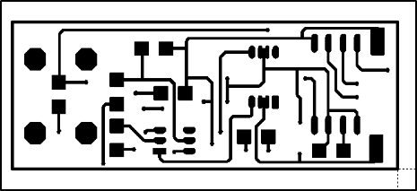

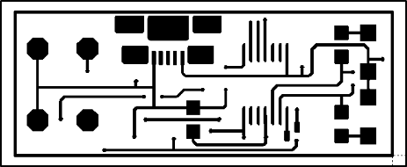

**Appendix C**

**PIC16F690 DATASHEET**

