Relationships between lake transparency, thermocline depth and sediment oxygen demand in Arctic lakes.

Kenneth Fortino¹* **, Stephen C. Whalen¹, Cody R. Johnson²

¹ Department of Environmental Sciences and Engineering, University of North Carolina Chapel Hill, Chapel Hill, NC 27599

² Department of Watershed Sciences, Utah State University, Logan, UT 84322

* Current Address: Department of Biological and Environmental Sciences, Longwood University,
Farmville, VA 23909

** Corresponding Author: Email: fortinok@longwood.edu

Abstract
The burial of organic matter within lake sediments can be a significant component of landscape carbon cycling. Whether organic matter deposited in lake sediments is sequestered or mineralized depends on factors limiting the decomposition rate of organic matter, such as temperature and the availability of oxygen. In stratified lakes, the distribution of temperature and oxygen is determined by the depth of the thermocline and therefore sediment organic matter burial should be sensitive to changes in thermocline depth. Using a survey of more than 30 lakes over 3 years in the Alaskan Arctic, we found that thermocline depth during the summer was positively correlated with water transparency. Furthermore using sediment incubations from 3 lakes, we show that variation in sediment oxygen demand is primarily affected by variation in temperature and the availability of oxygen with limited effect of the source of the sediments. Since variation in temperature and oxygen concentration in stratified lakes is mainly determined by the depth of thermocline, these results indicate that changes in transparency can have indirect effects on the rate of organic matter mineralization in lakes. A reduction in thermocline depth that results from decreased lake transparency may decrease the breakdown of sediment organic matter and increase the storage of organic carbon in lake sediments.

Key words:-
light attenuation; burial efficiency; temperature; warming; Alaska

Introduction
Lakes are an integral part of the global carbon cycle (Cole et al. 2007, Tranvik et al 2009). Nearly all of the world's lakes export CO₂ to the atmosphere and these emissions account for approximately 15% of the annual CO₂ production from freshwater systems (lakes, reservoirs, wetlands, and groundwater; Cole et al. 2007). However, lakes are simultaneously a sink for organic carbon via burial in their sediments (Cole et al. 2007, Sobek et al 2009). Organic matter sequestration in lake sediments is estimated to represent 22% of burial in all freshwater systems, which itself represents 30 to 60% of the organic carbon stored in marine sediments per year (Cole et al. 2007).
Sediment organic matter burial efficiency is the imbalance between organic matter inputs and losses (Capone and Kiene 1988, Canfield 1994, Burdige 2007). Inputs of organic matter to the sediments derive from primary production in the water column, surface sediment, and watershed but the loss of sediment organic matter is largely a sediment process and depends on the factors limiting organic matter mineralization within the sediments (Capone and Kiene 1988, Canfield 1994, Burdige 2007, Sobek et al. 2009).
Temperature, the availability of oxygen (Hargrave 1969, Graneli 1978, Archer and Devol 1992, Sobek et al. 2009), and the availability of labile organic matter (Sweerts et al 1986, Sugai and Kipphut 1992, Kristensen 2000, Dedieu et al. 2007) have all been shown to alter the rate of sediment respiration (and by inference organic matter mineralization). Therefore variation in lake environmental conditions or organic matter inputs may alter the burial efficiency of organic matter in lake sediments and change their relationship with carbon cycling at the landscape scale.
In lakes that thermally stratify, the depth of the thermocline is the principal factor controlling the distribution of temperature and oxygen in the water overlying the sediments (Wetzel 2001). Sediments above the thermocline are exposed to relatively warm and oxygenated conditions and should have proportionally greater organic matter mineralization rates. Below the thermocline the sediments are exposed to relatively cold temperatures and are isolated from inputs of atmospheric oxygen, which should result in proportionally lower organic matter mineralization rates. As a result, whole-lake sediment organic matter mineralization (and burial efficiency) should be sensitive to changes in the stratification depth.
A principal factor affecting the stratification depth of a lake is the attenuation of radiant energy by dissolved organic matter (DOM, often estimated from dissolved organic carbon, DOC) in the lake water (Fee et al. 1996, Houser 2006, Caplanne and Laurion 2008). Many of the world's surface waters are becoming less transparent as a result of increased inputs of DOC from the watershed and recovery from acidification (Forsberg 1992, Gunn et al. 2001, Arvola et al. 2010).
Evans et al. (2006) show that the DOC concentration of lakes in the United Kingdom has increased by 63% between the periods of 1988–1993 and 1998–2003. Similarly, Skjelkvale et al. (2005) found that the DOC concentrations of a large number of surface waters in North America and Europe have increased 0.05 to 0.13 mg L⁻¹ y⁻¹ for the past 11 years. In both cases it appears that part of this change in DOC concentration was due to reduced SO₄ deposition and the subsequent reduction in DOC flocculation as the lakes recovered from acidification. As a result, the magnitude of the increases may level off in the future. However some of the increase also appears to be due to the effects of warming and elevated DOC release from soils (Keller et al. 2008), which means that the concentrations could continue to increase in the future (Skjelkvale et al. 2005). Dissolved organic carbon release from high latitude soils may increase up to 600% in response to warming especially in regions with extensive permafrost (Frey and Smith 2005). Neff and Hooper (2002) found a 2 to 3 fold increase in DOC export from Alaskan Arctic soils experimentally warmed to 30º C. The predominant trend in response to climate changes in the northern hemisphere seems to be an increase in DOC export from the watershed and thus a decrease in lake transparency (Skjelkvale et al. 2005). However some regions may see a reduction in DOC input into lakes and increases in lake transparency as a result of reduced precipitation (Schindler et al. 1996, Schindler 1997).
In this paper we propose that there is a relationship between transparency and sediment metabolic processes. We support this assertion by demonstrating a relationship between lake transparency and stratification depth during the summer, open-water period in arctic Alaskan lakes, and provide evidence that temperature and oxygen availability are principal factors affecting the rate of sediment organic matter mineralization in these Arctic lakes. Furthermore we hypothesize that an implication of these relationships is that climate-mediated changes in DOM inputs to lakes may indirectly affect sediment organic matter processing by altering the distribution of temperature and oxygen via changes in lake transparency and stratification depth.

Materials and Methods

Study Site
This study was conducted in the Arctic Foothills region of Alaska. This region of the Arctic is underlain by continuous permafrost with predominantly tundra vegetation (Ping et al. 1998). The annual mean temperature is between -10º and -8º C with low annual precipitation (140 to 270 mm), of which 40% is snow (Ping et al. 1998). During the summer, the region experiences 24-h daylight and average temperatures of 11º C (Oechel et al. 2000). The numerous lakes in the region are typically oligotrophic, relatively small and shallow (Levine and Whalen 2001), and are ice-covered for approximately 9 months. The mean (± 1 standard deviation) percent organic matter of the surface sediments (0 – 1 cm) of lakes in the region is 47.5% (± 16.6%) for the sediments above the thermocline, which are partially derived from benthic algal production and 40.6% (± 9.7%) for sediments below the thermocline (Fortino 2010). The dry bulk density of the sediments ranges between 0.008 g cm⁻³ to 0.416 g cm⁻³ (Fortino 2010).

Lake Surveys
On 7 August, 2006, we sampled a total of 18 lakes in the region to the east of Toolik Lake (Fig. 1). In each lake, temperature and light (photosynthetic photon flux density; PPFD) profiles were collected using a YSI Model 85 multiparameter water quality meter and a LiCor LI-192SA underwater 2π quantum sensor with a Li-Cor LI-250 Quantum Meter respectively. In some lakes the profiles for both temperature and PPFD were collected with a Hydrolab, Data Sonde 5. Light and temperature measurements were done at 0.5 m intervals from the water surface to the lake bottom or to a point where the lake reached a constant hypolimnetic temperature with increasing depth. The thermocline depth was defined as the depth with the greatest change in temperature from the preceding depth. The light attenuation coefficient (K_{d}) in the lake was determined as the slope of the natural logarithm of the PPFD with depth.
A second survey was conducted on 7 August, 2007. Twelve lakes were sampled to the north of the Toolik Lake field station (Fig. 1). Temperature and light profiles were collected and analyzed using the same methods as in 2006. Surface water samples for DOC concentration were collected in 20 ml borosilicate glass scintillation vials. Each sample was filtered through a 0.45 μm polypropylene (PP) filter, acidified with 500 μl of 1N HCl and stored at 4º C until analyzed for DOC on a Shimadzu TOC-V Total Carbon Analyzer.
The final survey was conducted on 12 July, 2008. We resampled 15 of the same lakes that were sampled in 2006. Temperature and light profiles were collected using the same methods as in 2006 and 2007. A 1 L sample of surface water was collected from each lake in an amber high density polyethylene sample bottle from which, 2 duplicate 20 ml sub-samples were filtered through a 0.45 μm PP filter and analyzed for chromophoric dissolved organic matter (cDOM) using a Turner Designs 10-AU fluorometer (Clark et al. 2004). Following the cDOM measurement, the samples were acidified with 100 μl of 1 N HCl and analyzed on a Shimadzu TOC-V Total Carbon Analyzer for DOC. The remaining 960 ml of sample were used to determine chlorophyll a (Chl a) concentration. Chl a concentration was measured fluorometrically (Turner Designs Model TD-700 Fluorometer) from duplicate samples of filter-trapped (Whatman GF/F) particulate matter extracted for 24 h in a buffered 90% acetone solution (Welchmeyer 1994).
Lake areas and maximum depths were determined as part of a group sampling effort. Lake watershed areas were calculated using a digital elevation model and the hydrology toolset in ArcMap GIS software (ESRI 2006).

Sediment Incubations
The effect of temperature and oxygen availability on sediment organic matter mineralization was determined by measuring sediment oxygen demand (SOD) of intact sediment cores taken from 3 lakes. Lakes E–4, S–3, and GTH 91 are oligotrophic lakes in the vicinity of Toolik Lake with surface areas of 4.0, 4.2, and 2.5 ha, and depths of 4, 5, and 10 m, respectively (Fig. 2). The percent organic matter of the surface sediments (0 – 1cm) above the thermocline was measured as 31%, 66%, and 23% for lakes E-4, S-3, and GTH 91, respectively (Fortino 2010). The percent organic matter of the hypolimnetic surface sediments (0 – 1 cm) was measured as 45%, 46%, and 24% lakes E-4, S-3, and GTH 91, respectively (Fortino 2010).
Sediment cores were collected from 3 m depth using a K-B style gravity corer. Cores were standardized for incubation by extruding the upper 15 cm of sediment (and overlying water) from each core into a 25 cm long and 4.8 cm internal diameter plastic incubation core. The incubation cores were sealed with acrylic or polycarbonate tops and bottoms. The core tops were beveled toward a center opening to exclude all air from the core when sealed. A magnetic stir bar was suspended approximately 1 cm above the sediment–water interface in each core. During incubation, the cores were arranged around a central array of magnets turning at 1 rpm, which slowly turned the stir bars within the cores and prevented stratification of the overlying water. The cores were incubated in a 750 L temperature controlled (± 1º C) water bath. Sampling was performed via two septum–sealed ports fitted to the core top. One port was oriented vertically and allowed for the insertion of a cannula into the overlying water of the core. The other port was arranged perpendicular to the first and permitted the simultaneous replacement of water removed during sampling. The replacement water was collected from the lake at the same time and depth as the cores with a Van Dorn sampler. Between sampling events, the replacement water was stored in a 4–L plastic bottle in the same incubator as the cores.
The cores were allowed to acclimate approximately 1 h prior to the initial oxygen sampling. During sampling, 4 ml of overlying water was slowly removed from the core through the vertical port using a stainless steel cannula attached to a plastic syringe. The syringe was purged with 1 ml of the sample and the remaining volume was used to determine the oxygen concentration by Winkler titration (Carpenter 1965) modified for the small volume. Plastic stops were designed to fit onto the syringe plunger to ensure that a repeatable volume was retained in the syringe following each purge. The exact volume of sample retained in each syringe following purging was determined gravimetrically. Titrations were conducted immediately following sampling to minimize storage artifacts.
We assessed the impact of temperature on SOD by incubating replicate cores from each lake at 4 different temperatures representing a realistic range of temperatures experienced by the sediments during the arctic summer (2-17º C). Lake GTH 91 had 10 replicate cores at each temperature, lake S-3 had 9 replicate cores at each temperature, and lake E-4 had 9 replicate cores for the 2º and 12º C treatments and 8 replicate cores for the 7º and 17º C treatments. All cores were incubated in the dark and the oxygen concentration of the overlying water in the cores was sampled three times over approximately 24 h.
We measured the effect of oxygen availability on SOD by using the reduction in the oxygen concentration of the overlying water during an approximately 48 h of dark incubation as a manipulation of oxygen availability. We then quantified the effect of this reduction in oxygen on SOD. For the sediments from Lakes E–4 and S–3, this was accomplished by extending the incubation time of the cores used in the 12º C treatment of the temperature dependence experiment (n = 9 cores for both lakes). The response of the sediments from Lake GTH 91 was assessed in a separate experiment at 9º C (n = 10 cores). Oxygen measurements were taken at 5 time points over the 48 h period to determine SOD.

Statistics and Calculations
The relationship between the thermocline depth and K_{d} was investigated with least square regressions for each year. Differences in K_{d} and DOC concentration among years were tested with analysis of variance (ANOVA). Dissolved organic carbon, cDOM, and Chl a concentrations were standardized as Z–scores to facilitate direct comparison of the regression slopes (Gotelli and Ellison 2004). Dissolved organic carbon, cDOM, and Chl a concentrations were compared using Pearson's correlations. The collinearity between K_{d} and Julians day and K_{d} and lake area was assessed with least square regressions with and without the largest lake in the dataset. The thermocline depth in GTH 91 was predicted using a multiple regression of thermocline depth by K_{d}, surface area, and Julian day without interaction terms from the survey data. Variables were natural log transformed when appropriate to improve linearity.
In the temperature dependence experiment, SOD was calculated as the sum of the change in oxygen concentration of the overlying water between the successive time intervals. In the oxygen availability experiment, SOD was calculated for each time interval as the change in oxygen concentration of the overlying water from the preceding time point. All oxygen concentration measurements were corrected for oxygen added via the replacement water. Fluxes were normalized to the surface area of the core and expressed as an hourly rate.
Two outlying points were removed from the analysis of the oxygen availability experiment due to obviously unrealistic values. The effect of temperature and the source of the sediments (i.e., lake) on SOD was examined with analysis of covariance (ANCOVA). The effect of the initial oxygen concentration of the overlying water and sediment source on SOD was evaluated using a repeated measures ANCOVA. Analyses were performed in JMP (JMP, Ver. 4.0.4. SAS Institute Inc., Cary, NC, 1989-2007) or R (R Development Team).

Results

Lake Surveys
Light attenuation coefficients (K_{d}) ranged from 0.21 to 0.97 m⁻¹ across all years and had a mean (± 1 standard deviation) of 0.51 (± 0.2) m⁻¹ (Tables 1 and 2). The mean (± standard deviation) K_{d} in the lakes sampled in 2008 on Julian day 194 was 0.64 (± 0.18) and was significantly greater than the mean K_{d} in 2007 (0.43 ± 0.06) or 2006 (0.45 ± 0.23) sampled on Julian day 219 (F_{2, 44} = 6.4, p = 0.003). Across all years, K_{d} was significantly but weakly related to surface area (p = 0.02, r² = 0.12) but the relationship is skewed by the presence of Lake GTH 68 that has a surface area much greater than any other lake in the survey (Tables 1 and 2). Removal of Lake GTH 68 from the analysis shows a weaker relationship between K_{d} and lake surface area (p = 0.06, r² = 0.08). Thermocline depth ranged 3.5 to 11.5 m across all years (Tables 1 and 2) and was inversely related to K_{d} in each of the years (Fig. 3).
The DOC concentration ranged from 4.2 to 6.0 mg L⁻¹ in the lakes sampled in 2007, which was significantly greater (F_{1, 27} = 38.6, p < 0.001) and less variable than the range of DOC concentrations (1.3 to 4.2 mg L⁻¹) in the 2008 survey (Tables 1 and 2). Dissolved organic carbon concentration was positively related to K_{d} in the 2008 survey (r² = 0.62, p = 0.0002) but not in the 2007 survey (r² = 0.17, p = 0.185) (Fig. 4).
During the 2008 survey, DOC and cDOM concentrations were highly correlated (r = 0.94, p < 0.0001). Chl a concentrations were also significantly correlated with DOC concentration (r = 0.52, p = 0.031) and cDOM concentration (r = 0.51, p = 0.034). The significant correlations prevent the partitioning of the individual impact of each factor on K_{d} in a single model. Separate regressions show similar effects of the standardized (Z-score) variables on K_{d} (Fig. 5). Chromophoric dissolved organic matter concentration explained the most variation in K_{d} (r² = 0.78), while Chl a concentration explained the least variation in K_{d} (r² = 0.34) and DOC concentration, with an r² = 0.62, was intermediate (Fig. 5).

Sediment Incubations
Sediment oxygen demand ranged between -3.3 and 39.0 mmol O₂ m⁻² d⁻¹ with a median of 15.1 mmol O₂ m⁻² d⁻¹ across all sediments and temperatures. The oxygen concentration of the overlying water in the cores during the experiment ranged from 0.20 to 0.33 mmol O₂ L⁻¹. Temperature and sediment source (i.e., lake) explained 42% of the variation in SOD and there was significant and positive relationship between SOD and temperature across all three lake sediments (slope ± CI_{95%} = 0.61 ± 0.24 mmol O₂ m⁻² d⁻¹ per degree C) and no significant interaction between temperature and sediment source (Fig. 6; Table 3). After accounting for the variation due to temperature there remained a significant effect of sediment source on SOD (Table 3). Median SOD across all temperatures was 12.6, 16.88, and 15.7 mmol O₂ m⁻² d⁻¹ in the sediments from lakes E-4, S-3 and GTH 91, respectively.
In the oxygen availability experiment, we tested the effect of the oxygen concentration of the overlying water on SOD. The oxygen concentration of the overlying water ranged between 0.1 and 0.3 mmol O₂ L⁻¹ and SOD ranged between -7.7 and 39.8 with a median of 11.4 mmol O₂ m⁻² d⁻¹ (Fig. 7). The highest SOD values were similar to those from the temperature experiment but the reduction in oxygen in the overlying water reduced SOD at a rate (± CI_{95%}) of 49 ± 21 mmol O₂ m⁻² d⁻¹ per mmol O₂ L⁻¹ to levels below those seen in the temperature dependence experiment (Figs. 6 and 7).
As with the temperature dependence experiment, there were significant differences in SOD among the sediments collected from the different lakes after accounting for the variation due to oxygen concentration and no interaction between oxygen concentration and sediment source (Table 4). The median SOD across all oxygen concentrations was 10.1, 14.8, and 9.8 mmol O₂ m⁻² d⁻¹ in the sediments from lakes E-4, S–3 and GTH 91, respectively.

Discussion

Lake Surveys
The results of the surveys clearly show that lakes with greater light attenuation develop shallower thermoclines (Fig. 3), which is consistent with the hypothesis that water clarity is a principal factor controlling thermocline depth in small (< 500 ha) lakes (Fee et al 1996, Mazumder and Taylor 1994, Houser 2006). Light attenuation results from the absorption of photons by pure water and dissolved and suspended particulate matter (including phytoplankton) in the lake water (Wetzel 2001). The lakes in the region of this study contain very low levels of suspended particulates (K. Fortino, pers. obs.) and therefore, as in other systems, light attenuation in excess of the attenuation due to the water is likely due to dissolved organic matter (DOC and cDOM; Fee et al. 1996, Houser 2006, Caplanne and Laurion 2008). This conclusion is supported by the strong correlations of both DOC and cDOM with K_{d} in the 2008 survey (Fig. 5). Unfortunately, cDOM was not measured in 2007 when DOC was a poor predictor of K_{d} and there was less light attenuation per unit of DOC than in the 2008 survey. Assuming that light attenuation is primarily due to cDOM, these results suggest that there was a decoupling of the bulk DOC concentration from the chromophoric (i.e., light attenuating) component of the DOC in 2007 but not 2008. We did not collect sufficient data to characterize the dissolved organic matter in the lakes so we cannot test any hypothesizes as to why there was no relationship between the bulk DOC and light attenuation in 2007. Given the high correlation between DOC, cDOM, and K_{d} in 2008 and the well established relationship between DOC and light attenuation in oligotrophic lakes (Wetzel 2001), we suspect that the lack of a relationship between DOC and K_{d} in the 2007 survey was a somewhat isolated phenomenon and not a general pattern for the region.
In the 2008 survey DOC, cDOM, and Chl a all have a nearly identical relationship with K_{d} (Fig.5), however the correlations among the factors prevents the statistical partitioning of their individual effects. Unlike in 2007, bulk DOC is highly correlated with K_{d} and cDOM, and both variables likely reflect allochthonous organic matter (OM) inputs. The relationship between Chl a and K_{d} is significant but estimating light attenuation due to Chl a concentration alone using a Chl a specific attenuation coefficient of 0.016 m⁻¹ (mg Chl a)⁻¹ (Bannister 1974) produced values varying from 0.006 and 0.034 m⁻¹, which accounted for 1.25 to 4% of observed variation in K_{d}. Overall, these results strongly suggest that K_{d} in these lakes is controlled by variation in allochthonous DOM.

Sediment Incubations
SOD ranged between -7.7 and 39.8 mmol O₂ m⁻² d⁻¹ with a median of 13.8 mmol O₂ m⁻² d⁻¹ across all the lakes (Fig. 6). This range of measurements is similar to the SOD range of 1.6 to 33 mmol O₂ m⁻² d⁻¹ reported by Pace and Prairie (2005) in a review of studies using similar methods. As far as we are aware there are no other published measurements of gross SOD from the Alaskan low arctic, yet the range of SOD observed in our study is similar to the range of DIC flux measurements (-0.4 to 42 mmol DIC m⁻² d⁻¹, Hobbie et al. 1980), and SOD (32 to 47 mmol O₂ m⁻² d⁻¹, Ramlal et al. 1994) collected in other shallow arctic systems at higher latitudes.
Cornwell and Kipphut (1992) measured a net SOD range of 7.1 to 8.1 mmol O₂ m⁻² d⁻¹ in Toolik Lake (Fig. 1). These measurements are lower and much less variable than ours, but represent in situ net SOD over 2 to 7 day periods and do not likely reflect the range of environmental conditions found in our study or in the environment. Our measurements of dark SOD across a greater range of environmental conditions and lakes are likely more representative of the actual variation in sediment mineralization in this region of the Arctic.
Across all of the lakes, variation in SOD was significantly related to variation in temperature and oxygen concentration (Figs. 6 and 7; Tables 3 and 4). SOD increased with temperature regardless of the sediment source and there were no significant differences in the relationship among the different lakes (Fig. 6). Pace and Prairie (2005) calculate a mean slope of 0.65 ± 1 for the log–log SOD to temperature relationship in a review of lake SOD experiments. Similar treatment of the present data gives a mean log–log SOD to temperature slope of 0.26 ± 0.08 across all three lakes, which although lower than what was observed by Pace and Prairie (2005), is within the large standard deviation of their collected measurements. This observation indicates that the sediments from the lakes in this study are at the lower end of temperature sensitivity relative to the lakes they report.
In addition to reduced sensitivity to temperature, we found that SOD increased linearly with temperature across the temperature range tested, whereas previous studies have observed that the response of SOD to temperature is greatest at lower temperatures (< 10º C; Hargrave 1969, Graneli 1978, Pace and Prairie 2005). This difference in response appears to be the result of greater SOD at low temperatures and lower SOD at high temperatures in our study. We measured a median SOD of 12.1 mmol O₂ m⁻² d⁻¹ at 2º C across lakes, whereas the lakes surveyed in Hargrave (1969) do not achieve SOD rates this high until temperatures of approximately 9º C. A similar comparison at higher temperatures shows that the median SOD at 17º C in the sediments from the lakes in our study is 19.7 mmol O₂ m⁻² d⁻¹ while Hargrave (1969) predicts a SOD of 39 mmol O₂ m⁻² d⁻¹ at 17º C. This reduced sensitivity of the SOD response to temperature may be due to selection for sediment microbial communities that perform more efficiently at lower temperatures (Madigan et al. 2000) in the persistently cooler temperatures found in arctic lakes.
We measured a significant negative relationship between the concentration of oxygen in the overlying water and SOD (Fig. 7). Given that we used the reduction in dissolved oxygen concentration that resulted from incubation duration to manipulate the oxygen concentration, we cannot isolate the effects of incubation time and oxygen concentration on SOD. It is possible that some of the observed reduction in SOD is an artifact of the longer incubation duration (e.g., the consumption of reduced iron) and not a response to the reduce oxygen availability. However previous studies have shown that SOD is affected by the concentration of oxygen in the water overlying the sediments. Hargrave (1969) found an approximate reduction of 42 mmol O₂ m⁻² d⁻¹ per mmol O₂ L⁻¹ in Marion Lake, B.C. and Park and Jaffe (1999) calculate an approximate reduction of 63 mmol O₂ m⁻² d⁻¹ per mmol O₂ L⁻¹ using a numerical model of sediment oxygen dynamics. Both of these estimates agree well with the estimated decline of 50 mmol O₂ m⁻² d⁻¹ per mmol O₂ L⁻¹ across the three lakes observed in our study, which supports our interpretation of the results as a measurement of the effect of oxygen availability on SOD.
After accounting for the variation in SOD due to temperature and oxygen concentration, we found significant differences in SOD associated with the source of the sediments (Tables 3 and 4). The differences among the sediments from the different lakes were small relative to the effects of temperature and oxygen concentration but suggest that other factors may be affecting SOD on a landscape scale. Due to the confounding effects of oxygen concentration and temperature not accounted for in the analysis of the temperature dependence and oxygen availability experiments, respectively, differences in SOD among sediments from the different lakes need to be interpreted cautiously. Nonetheless, among the shallow lakes, the sediments from lake S–3 consistently had higher SOD than those from lake E–4. This may be due to variation in the abundance of benthic algae or sediment metabolism due to variation in sediment substrate quality along a gradient of lake productivity (Sugai and Kipphut 1992, Pace and Prairie 2005).
Nutrient and chlorophyll data suggest that all of the lakes in this study have similar and low water column productivity (Fortino 2010). Despite this, the organic content of the surface (0-3 cm) sediments of S–3 is greater than E–4 and the sediments from S–3 were more labile than those of E–4 when tested under controlled conditions (Fortino 2010). These results indicate greater quantities and a higher quality of sediment organic matter in lake S–3, relative to lake E–4, which is likely the result of benthic algal biomass and may result in greater SOD in lake S–3. Nonetheless, the differences in SOD due to sediment source were small relative to the effects of temperature and oxygen availability and are not likely to have significant impacts on the variation in SOD over short temporal scales in intact sediments.
The variation in SOD among sediments from within a lake in the core incubation experiments greatly exceeded differences in SOD among the three lakes. This difference in the magnitude of variation suggests that patch–scale variation in temperature and oxygen availability has a greater influence on SOD than landscape–scale differences among lakes (Hobbie et al. 1980, den Heyer and Kalff 1998).

Conclusion and Implications
Our results show that during the summer open water season in Alaskan arctic lakes, transparency is correlated with stratification depth and variation in the rate of sediment organic matter mineralization is controlled mainly by variation in temperature and the availability of oxygen. The combination of these results indicates a link between water column conditions (i.e., transparency) and sediment processes because lake stratification is the major factor controlling the distribution of temperature and oxygen, and thus sediment organic matter mineralization in these lakes. This link has implications for how these lakes may respond to climate changes.
Climate change is predicted to increase the temperature of lake epilimnia which has been hypothesized to increase the rate of sediment organic matter breakdown, reducing the role of lakes as sinks for organic carbon (Gudasz et al. 2010). However if climate changes simultaneously increase the production of dissolved organic carbon from soils (Neff and Hooper 2002, Frey and Smith 2005), lake transparency should decrease, which our results show would reduce the thermocline depth and reduce the area of the sediments exposed to the relatively warm and oxygenated epilimnetic water, reducing the whole lake organic matter mineralization rate. If the effect of exposing more of the sediments to colder and more hypoxic conditions in the hypolimnion is greater than the direct warming effect in the epilimnion, the net effect of climate change would be an overall reduction in the mineralization of sediment organic matter in the lake and a greater burial efficiency of sediment organic matter. Assuming this is the general response of lakes in the northern hemisphere, there may be a negative feedback between climate change and organic matter storage in lakes.

Acknowledgments
Invaluable field assistance was provided by Dendy Lofton, Matthew Harrell, Tim Yarborough, Daniel Garr, and Melissa Sanders and all the members of the Geomorphic Trophic Hypothesis project. Dendy Lofton performed the chromophoric dissolved organic matter measurements. Lake maximum depths were collected by the Geomorphic Trophic Hypothesis project. We would like to thank the Toolik Field Station staff for all of their support during this project. Comments by Dina Leech and two anonymous reviewers greatly improved a previous draft of this manuscript.
All of the GIS work was performed by the Toolik Field Station GIS support staff, including Andrew Balser, Jason Stucky, Randy Fulweber, and Lael Rogan. Funding was provided by National Science Foundation Grants NSF 0323557 and NSF 0516043.

Literature Cited
Archer D and Devol A. 1992. Benthic oxygen fluxes on the Washington shelf and slope - A comparison of in situ microelectrode and chamber flux measurements. Limnology and Oceanography, 37:614-629.

Arvola L, Rask M, Ruuhijärvi J, Tulonen T, Vuorenmaa J, Ruoho-Airola T, Tulonen J. 2010. Long-term patterns in ph and colour in small acidic boreal lakes of varying hydrological and landscape settings. Biogeochemistry, 101:269-297.

Bannister TT. 1974. A general theory of steady state phytoplankton growth in a nutrient saturated mixed layer. Limnology and Oceanography, 19:1-12.

Burdige DJ. 2007. Preservation of organic matter in marine sediments: Controls, mechanisms, and an imbalance in sediment organic carbon budgets? Chemical Reviews, 107:467-485.

Canfield DE. 1994. Factors influencing organic matter preservation in marine sediments. Chemical Geology, 114:315-329.

Caplanne S, Laurion, I. 2008. Effect of chromophortic dissolved organic matter on epilimnetic stratification in lakes. Aquatic Sciences, 70:123-133.

Capone DG, Kiene RP. 1988. Comparison of microbial dynamics in marine and freshwater sediments: Contrasts in anaerobic carbon catabolism. Limnology and Oceanography, 33:725-749.

Carpenter JH. 1965. The Chesapeake Bay Institute technique for the Winkler dissolved oxygen method. Limnology and Oceanography, 10:141-143.

Clark CD, Hiscock WT, Millero FJ, Hitchcock G, Brand L, Miller WL, Ziolkowski L, Chen RF, Zitka RG. 2004. CDOM distribution and co2 production on the Southwest Florida Shelf. Marine Chemistry, 89:145-167.

Cole JJ, Prairie YT, Caraco NT, McDowell WH, Tranvik LJ, Striegl RG, Duartie CM, Kortelainen P, Downing JA, Middelburg JJ, Melack J. 2007. Plumbing the global carbon cycle: Integrating inland waters into the terrestrial carbon budget. Ecosystems, 10:171-184.

Cornwell JC, Kipphut GW. 1992. Biogeochemistry of manganese- and iron-rich sediments in Toolik Lake, Alaska. Hydrobiologia, 240:45-59.

Dedieu K, Rabouille C, Gilbert F, Soetaert K, Metzger E, Simonucci C, Jezequel D, Prevot F, Anschutz P, Hulth S, Ogier S, Mesnage V. 2007. Coupling of carbon, nitrogen and oxygen cycles in sediments from a Mediterranean lagoon: a seasonal perspective. Marine Ecology Progress Series, 346:45-59.

den Heyer C, Kalff J. 1998. Organic matter mineralization rates in sediments: A within and among lake study. Limnology and Oceanography, 43:695-705.

ESRI. 2006. ArcINFO. Environmental Systems Research Institute, Inc. Redlands, CA.

Evans CD, Pippa JC, Clark JM, Monteith DT, Cresser MS. 2006. Alternative explanations for rising dissolved organic carbon export from organic soils. Global Change Biology, 12:2044-2053.

Fee EJ, Hecky RE, Kasian SEM, Cruikshank DR. 1996. Effects of lake size, water clarity, and climatic variability on mixing depths in Canadian Shield lakes. Limnology and Oceanography, 41:912-920.

Fortino K. 2010. Organic Matter Processing in Arctic Lake Sediments. PhD thesis, University of North Carolina at Chapel Hill.

Forsberg C. 1992. Will an increased greenhouse impact in Fennoscandia give rise to more humic and colored lakes. Hydrobiologia, 229:51-58.

Frey KE, Smith LC. 2005. Amplified carbon release from vast West Siberian peatlands by 2010. Geophysical Research Letters, 32:L09401, doi:10.1029/2004GL022025.

Gotelli NJ, Ellison AM. 2004. A Primer of Ecological Statistics. Sinauer Associates Inc.

Granéli W. 1978. Sediment oxygen uptake in south Swedish lakes. Oikos, 30:7-16.

Gudasz C, Bastviken D, Sterger K, Premke K, Sobek S, Tranvik LJ. 2010. Temperature-controlled organic carbon mineralization in lake sediments. Nature, 466:478-480.

Gunn JM, Snucius E, Yan ND, Arts MT. 2001. Use of water clarity to monitor the effects of climate change and other stressors on oligotrophic lakes. Environmental Monitoring and Assessment, 67:69-88.

Hargrave BT. 1969. Similarity of O2 uptake by benthic communities. Limnology and Oceaography, 14:801-805.

Hobbie JE. 1980. Major Findings. In Hobbie JE, editor. Limnology of Tundra Ponds. Stroudsburg, PA, Dowden, Hutchensen, and Ross.

Houser JN. 2006. Water color affects the stratification, surface temperature, heat content, and mean epilimnetic irradiance of small lakes. Canadian Journal Of Fisheries And Aquatic Sciences, 63(11):2447-2455.

Keller W, Paterson AM, Somers KM, Dillon PS, Heneberry J, Ford A. 2008. Relationships between dissolved organic carbon concentrations, weather, and acidification in small Boreal Shield lakes. Canadian Journal of Fisheries and Aquatic Science, 65:786-795.

Kristensen E. 2000. Organic matter diagenesis at the oxic/anoxic interface in coastal marine sediments, with emphasis on the role of burrowing animals. Hydrobiologia, 426:1-24.

Levine MA, Whalen SC. 2001. Nutrient limitation of phytoplankton production in Alaskan arctic foothill lakes. Hydrobiologia, 455:189-201.

Madigan MT, Martinko JM, Parker J. 2000. Brock Biology of Microorganisms. Upper Saddle River, NJ. Prentice-Hall.

Madzumer A, Taylor, W. 1994. Thermal structure of lakes varying in size and water clarity. Limnology and Oceanography, 39:968-976.

Neff JC, Hooper DU. 2002. Vegetation and climate controls on potential CO2, DOC and DON production in northern latitude soils. Global Change Biology, 8:872-884.

Oechel WC, Vourlitis GL, Hastings SJ, Zulueta RC, Hinzman L, Kane D. 2000. Acclimation of ecosystem CO2 exchange in the Alaskan Arctic in response to decadal climate warming. Nature, 406:978-981.

Pace M, Prairie YT. 2005. Respiration in Lakes. In: del Giorgio PA, Williams PJlB, editors. Respiration in Aquatic Ecosystems. USA: Oxford University Press.

Park SS, Jaffe PR. 1999. A numerical model to evaluate sediment oxygen demand. Journal of Environmental Quality, 28:1219-1226.

Ping CL, Bockheim JG, Kimble JM, Michaelson GJ, Walker DA. 1998. Characteristics of cryogenic soils along a latitudinal transect in arctic Alaska. Journal of Geophysical Research, 103:28917-28928.

R Development Core Team. 2009. R: A Language and Environment for Statistical Computing. R Foundation for Statistical Computing, Vienna, Austria.

Ramlal PS, Hesslein RH, Hecky RE, Fee EJ, Rudd JWM, Guilford SJ. 1994. The organic carbon budget of a shallow Arctic tundra lake on the Tuktoyaktuk Peninsula, N. W. T., Canada. Biogeochemistry, 24:145-172.

Schindler DW, Bayley SE, Parker BR, Beaty KG, Cruikshank DR, Fee EJ, Schindler EU, Stainton MP. 1996. The effects of climatic warming on the properties of boreal lakes and streams at the Experimental Lakes Area in northwestern Ontario. Limnology and Oceanography, 41:1004-1017.

Schindler D. 1996. Widespread effects of climate warming on freshwater ecosystems in North America. Hydrological Processes, 11:1043-1067.

Skjelkvale BL, Stoddard JL, Jeffries DS, KT, Hasen T, Bowman J, Mannio J, Monteith DT, Mosello R, Rogora M, Rzychon D, Vesely J, Wieting J, Wilander A, Worsztynowicz A. 2005. Regional scale evidence for improvements in surface water chemistry 1990-2001. Environmental Pollution, 137:165-176.

Sobek S, Druisch Kaiser E, Zurbrügg R, Wongfun N, Wessels M, Pasche N, Wehrli B. 2009. Organic carbon burial efficiency in lake sediments controlled by oxygen exposure time and sediment source. Limnology and Oceanography, 54:2243-2254.

Sugai SF, Kipphut GW. 1992. The influence of light and nutrient addition upon the sediment chemistry of iron in an arctic lake. Hydrobiologia, 240:91-101.

Sweerts JP, Rudd JWM, Kelly CA. 1986. Metabolic activities in flocculent surface sediments and underlying sandy littoral sediments. Limnology and Oceanography, 31:330-338.

Tranvik LJ, Downing JA, Cotner JB, Loiselle SA, Striegle RG, Ballatore TJ, Dillon P, Finlay K, Fortino K, Knoll LB, Kortelainen PL, Kutser T, Larsen S, Laurion I, Leech DM, McCallister SL, McKnight DM, Melack JM, Overholt E, Porter JA, Prairie Y, Renwick WH, Roland F, Sherman BS, Schindler DW, Sobek S, Tremblay A, Vanni M, Verschoor AM, von Wachenfeldt E, Weyhenmeyer GS. 2009. Lakes and reservoirs as regulators of carbon cycling and climate. Limnology and Oceanography, 54(6):2298-2314.

Welschmeyer NA. 1994. Flurometric analysis of chlorophyll a in the presence of cholorophyll b and pheopigments. Limnology and Oceanography, 39:1985-1992.

Wetzel RG. 2001. Limnology: Lake and River Ecosystems. San Diego, CA, Academic Press.

Tables
Table 1. Description of lakes surveyed during 2006 and 2008. Z_{max} is the maximum depth, Area is the surface area, WS Area is the area of the lake's watershed, K_{d} is the light attenuation coefficient, Thermocline Z is the depth of the thermocline, DOC is the concentration of dissolved organic carbon, cDOM is the concentration of chromophoric dissolved organic matter in quinone sulfate units (QSU), and Chl a is the concentration of chlorphyll a. A dash indicates that the lake was not stratified at the time of the sampling. A “ns” indicates that the parameter was not measured.
Lake | Z_{max} | Area | WS Area | Year | K_{d} | Thermocline Z | DOC | cDOM | Chl a
 | (m) | (ha) | (ha) |  | (m⁻¹) | (m) | (mg L⁻¹) | (QSU) | (μg L⁻¹)
GTH 30 | 21.4 | 6.8 | 526.9 | 2006 | 0.87 | 5.0 | ns | ns | ns
 |  |  |  | 2008 | 0.86 | 4.0 | 4.2 | 67.6 | 0.84
GTH 31 | 12.0 | 2.2 | 114.0 | 2006 | 0.58 | 6.0 | ns | ns | ns
 |  |  |  | 2008 | 0.97 | 3.5 | 3.9 | 59.6 | 0.76
GTH 32 | 15.7 | 12.9 | 568.0 | 2006 | 0.80 | 6.0 | ns | ns | ns
 |  |  |  | 2008 | 0.70 | 4.5 | 3.6 | 48.7 | 1.1
GTH 33 | 13.3 | 4.2 | 635.9 | 2006 | 0.76 | 5.0 | ns | ns | ns
 |  |  |  | 2008 | 0.77 | 4.0 | 3.7 | 46.55 | 1.07
GTH 34 | 17.4 | 3.6 | 782.6 | 2006 | 0.80 | 5.5 | ns | ns | ns
 |  |  |  | 2008 | 0.83 | 4.5 | 3.5 | 47.9 | 0.92
GTH 57 | 21.6 | 30.0 | 228.5 | 2006 | 0.25 | 9.5 | ns | ns | ns
 |  |  |  | 2008 | 3.9 | 5.5 | 2.3 | 15.5 | 0.46
GTH 58 | 16.2 | 4.1 | 103.2 | 2006 | 0.39 | 7.5 | ns | ns | ns
 |  |  |  | 2008 | 0.61 | 3.5 | 4.1 | 45.1 | 1.3
GTH 65 | 16.5 | 4.3 | 141.2 | 2006 | 0.38 | 6.0 | ns | ns | ns
 |  |  |  | 2008 | 0.62 | 4.0 | 3.1 | 46 | 0.91
GTH 66 | 25.9 | 16.6 | 202.9 | 2006 | 0.30 | 7.0 | ns | ns | ns
 |  |  |  | 2008 | 0.54 | 4.0 | 2.1 | 20.9 | 0.46
GTH 68 | 27.4 | 77.1 | 478.7 | 2006 | 0.26 | 11.5 | ns | ns | ns
 |  |  |  | 2008 | 0.30 | 5.5 | 1.3 | 5.9 | 0.42
GTH 69 | 14.3 | 6.1 | 17.1 | 2006 | 0.37 | 6.0 | ns | ns | ns
GTH 71 | 18.3 | 17.1 | 66.0 | 2006 | 0.23 | 9.0 | ns | ns | ns
 |  |  |  | 2008 | 0.47 | 5.5 | 1.4 | 3.9 | 0.55
GTH 73 | 13.7 | 9.9 | 213.9 | 2006 | 0.46 | - | ns | ns | ns
 |  |  |  | 2008 | 0.68 | 4.5 | 2.3 | 17.5 | 0.97
GTH 74 | 11.3 | 5.9 | 1295.1 | 2006 | 0.27 | - | ns | ns | ns
 |  |  |  | 2008 | 0.65 | 4.5 | 2.8 | 33.9 | 0.64
GTH 92 | 10.4 | 5.6 | 842.0 | 2006 | 0.23 | 7.5 | ns | ns | ns
 |  |  |  | 2008 | 0.62 | 4.0 | 1.7 | 25 | 0.80
GTH 96 | 9.2 | 8.2 | 504.8 | 2006 | 0.21 | 9.5 | ns | ns | ns
 |  |  |  | 2008 | 0.85 | 4.5 | 3.3 | 46.7 | 2.1
Table 2. Description of lakes surveyed during 2007. Z_{max} is the maximum depth, Area is the surface area, WS Area is the area of the lake's watershed, K_{d} is the light attenuation coefficient, Thermocline Z is the depth of the thermocline, and DOC is the concentration of dissolved organic carbon.
Lake | Z_{max} | Area | WS Area | K_{d} | Thermocline Z | DOC
 | (m) | (ha) | (ha) | (m⁻¹) | (m) | (mg L⁻¹)
GTH 10 | 11.3 | 0.1 | 11.7 | 0.37 | 5.5 | 4.5
GTH 13 | 11.3 | 19.8 | 112.8 | 0.49 | 4.5 | 5.5
GTH 16 | 9.8 | 6.7 | 82.4 | 0.39 | 6.0 | 4.7
GTH 18 | 15.2 | 13.6 | 495.7 | 0.41 | 6.5 | 4.2
GTH 19 | 10.7 | 4.3 | 16.1 | 0.37 | 6.5 | 4.2
GTH 20 | 18.3 | 1.2 | 39.1 | 0.46 | 5.5 | 6.0
GTH 21 | 13.7 | 5.1 | 373.3 | 0.39 | 6.0 | 4.6
GTH 23 | 9.5 | 1.3 | 518.5 | 0.42 | 5.5 | 5.0
GTH 24 | 9.1 | 3.3 | 937.1 | 0.57 | 5.0 | 4.6
GTH 76 | 12.2 | 6.2 | 53.3 | 0.41 | 7.5 | 4.4
GTH 80 | 10.1 | 2.1 | 73.2 | 0.44 | 6.0 | 4.5
GTH 81 | 10.1 | 12.7 | 62.6 | 0.41 | 6.5 | 4.3
Table 3. Results of the analysis of covariance (ANCOVA) assessing the effects of temperature (Temp.) and sediment source (Lake) on sediment oxygen demand from the temperature dependence experiment. Source is the source of variation in the ANCOVA model. df is the degrees of freedom in the model. SS is the sum of squares value. F is F-value of the ANCOVA. P is the p-value of the ANCOVA.
Source | df | SS | F | P
Temp. | 1 | 1056.2 | 62.4 | < 0.0001
Lake | 2 | 202.8 | 6.0 | 0.003
Temp. * Lake | 2 | 17.6 | 0.5 | 0.596
Error | 106 | 1792.7
Table 4. Results of a repeated measures ANCOVA assessing the effect of the oxygen concentration in the overlying water (Oxygen) and the source of the sediments (Lake) on sediment oxygen demand from the oxygen availability experiment.
Source | df | df_{denom} | F | P
Intercept | 1 | 123 | 243.1 | < 0.0001
Oxygen | 1 | 123 | 8.1 | 0.006
Lake | 2 | 123 | 0.8 | < 0.0001
Lake * Oxygen | 2 | 123 | 0.8 | 0.44
Table 5. Summary of environmental variables from GTH 91 during 2006 and 2008. Thermocline Z is the thermocline depth. K_{d} is the light attenuation coefficient. O₂ Deficit is the area-weighted mean oxygen concentration of the hypolimnion divided by the area-weighted mean oxygen concentration of the epilimnion multiplied by 100. Epi. and Hypo. Temp. are the area-weighted mean temperatures of the epilimnion and hypolimnion respectively. Missing data are indicated with a dash (-).
Year | Date | Thermocline Z | K_{d} | O₂ Deficit | Epi. Temp. | Hypo. Temp.
 |  | (m) | (m⁻¹) | (%) | (ºC) | (ºC)
2006 | 19 Jun | 2.0 | 1.04 | 95 | 7.2 | 4.6
 | 23 Jun | 2.0 | - | 78 | 11.6 | 4.6
 | 29 Jun | 3.0 | 0.95 | 76 | 12.9 | 4.6
 | 3 Jul | 4.0 | - | - | 11.9 | 4.5
 | 7 Jul | 3.5 | 0.87 | 59 | 11.5 | 4.4
 | 19 Jul | 5.0 | 0.87 | 60 | 11.9 | 4.5
 | 26 Jul | 5.5 | 0.94 | 49 | 13.2 | 4.4
 | 1 Aug | 4.0 | 0.56 | 32 | 13.4 | 4.4
2008 | 30 Jun | 2.5 | 0.79 | 57 | 15.6 | 4.7
 | 9 Jul | 3.5 | 0.83 | 59 | 15.6 | 4.7
 | 14 Jul | 3.5 | 0.68 | 53 | 15.1 | 4.4
 | 21 Jul | 4.5 | 0.84 | - | 13.1 | 5.0
 | 30 Jul | 5.5 | 0.72 | - | 10.3 | 4.4

Figure Legends
Figure 1. Map of the lakes used in the survey.
Figure 2. Map of the lakes used in the incubation experiments.
Figure 3. The relationship between thermocline depth and light attenuation coefficient (K_{d}) in surveys conducted between 2006 and 2008. The line represents the best-fit least squares regression for 2006 (p = 0.001, r² = 0.55), 2007 (p = 0.04, r² = 0.36), and 2008 (p = 0.001, r² = 0.51).
Figure 4. The relationship between the dissolved organic carbon (DOC) concentration and light attenuation coefficient (K_{d}) in the lakes sampled in 2007 and 2008.
Figure 5. The relationship between the light attenuation coefficient (K_{d}) and Z-score standardized dissolved organic carbon (DOC), chromophoric dissolved organic matter (cDOM), or natural log transformed chlorophyll a (Chl a) concentrations in the lakes sampled in 2008.
Figure 6. The relationship between temperature and sediment oxygen demand (SOD). Each point represents the SOD from one core. The dashed line is the least squares regression based on the ANCOVA of temperature and sediment source.
Figure 7. The effect of bottom water oxygen concentration on sediment oxygen demand (SOD) in sediments from lakes GTH 91, S-3, and E-4. Each point represents SOD from a single core and the dashed lines represent the least squares regression based on the repeated measures ANCOVA of all three lakes.
Figure 1
Figure 2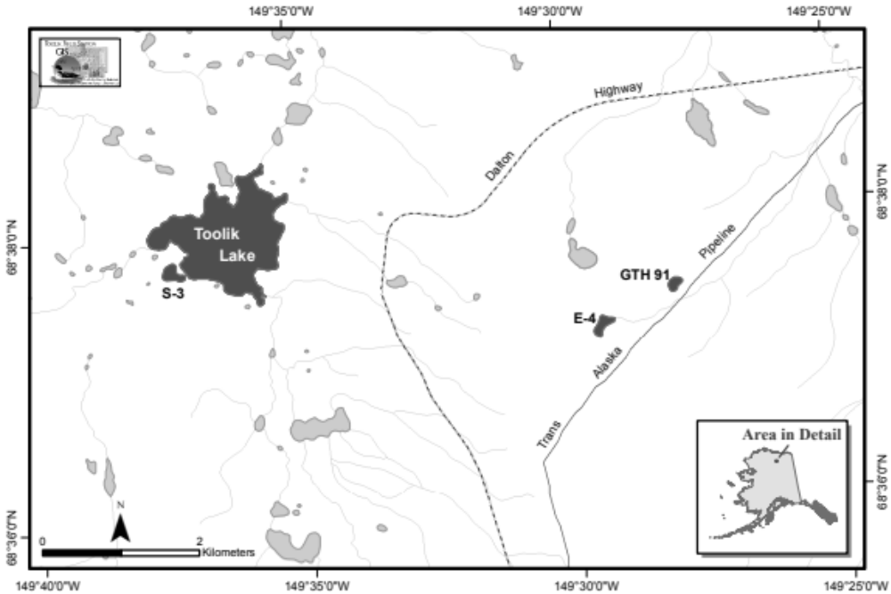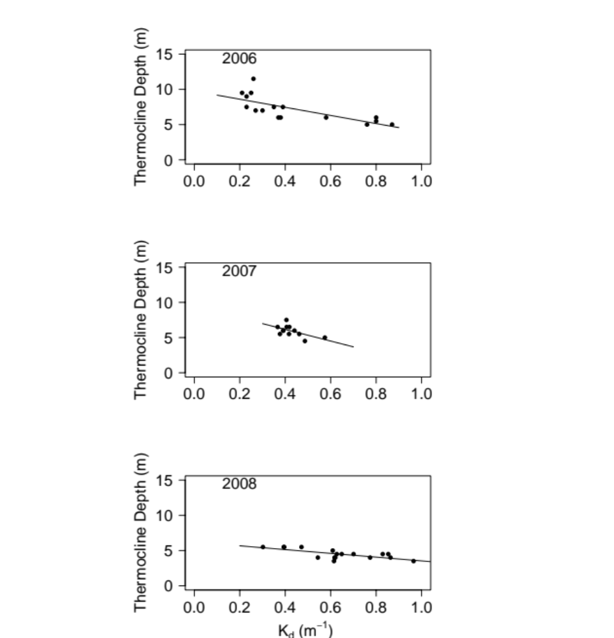
Figure 3

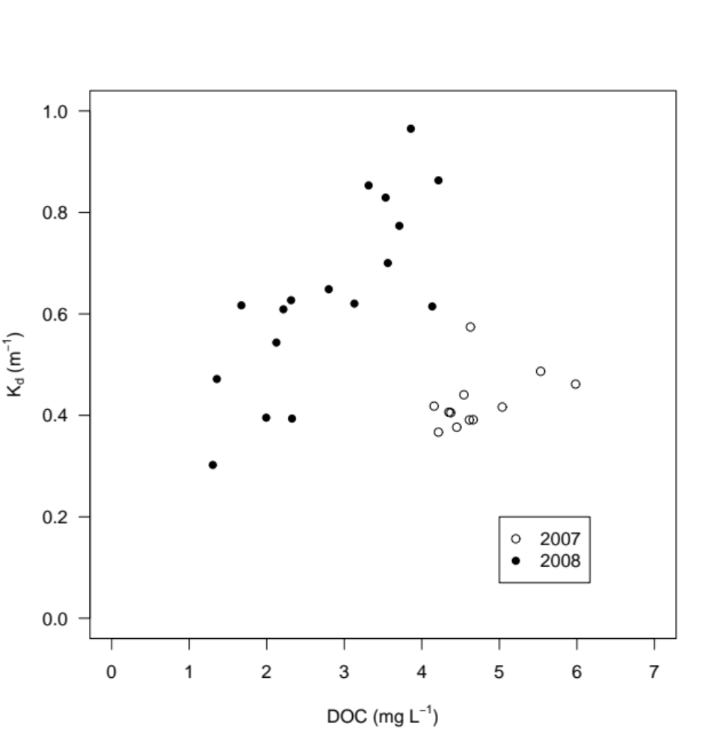
Figure 4
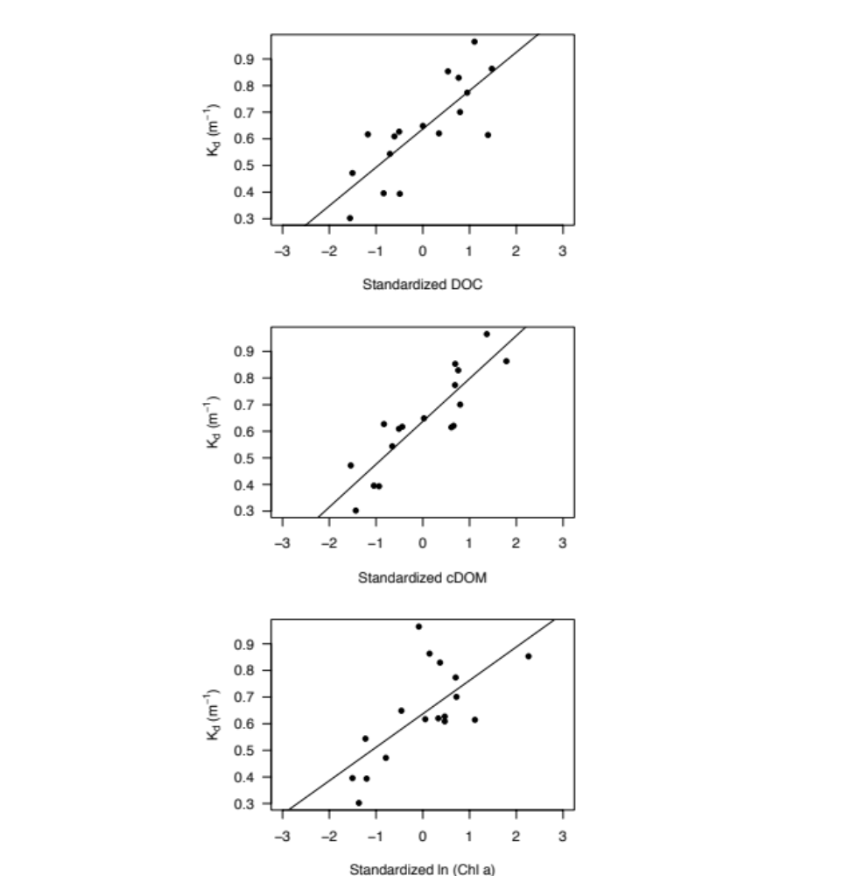
Figure 5
Figure 6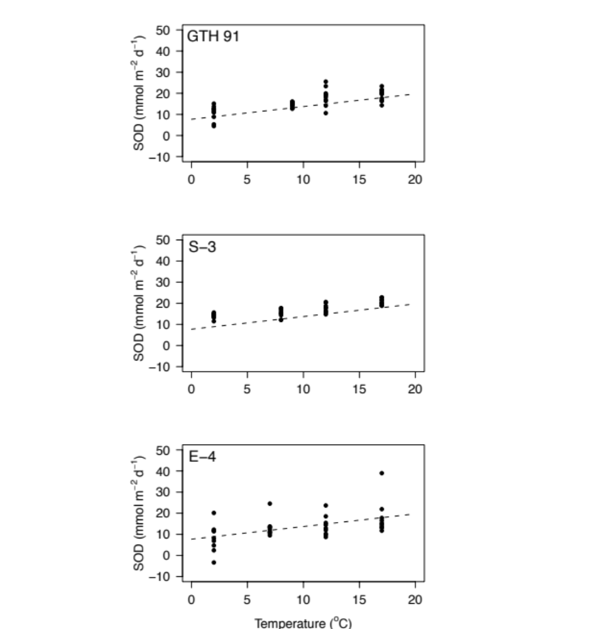
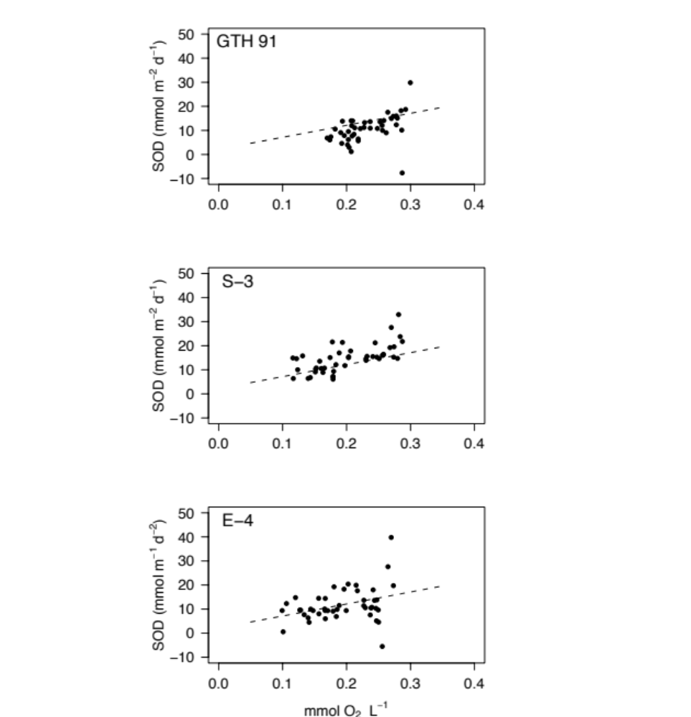
Figure 7

