# I. Cover Page

Kenneth Fortino, Assistant Professor of Biology

Address:

Home: 1202 Seventh Ave., Farmville, VA 23901

Office: 301 Chichester

Phone:

Home: 336-601-4335

Office 434-395-2223

Grant Sought: Faculty Research Grant

Grant Period: 2 years

Amount Requested: $8100

Date of Submission: January 2015

Applicant (Kenneth Fortino)

Department Chair (Mark Fink)

Dean (Jennifer Apperson)

# II. Abstract

# Small man-made ponds represent a substantial proportion of aquatic habitat globally, and dominate the in regions that lack natural lakes, like the southeastern United States. Despite their ubiquity, small man-made ponds are understudied relative to other aquatic ecosystems. In particular, the factors that control nutrient limitation on the production of algae in these ponds are incompletely described. The nutrient limitation of algal production is important because when it is relaxed ponds can become eutrophic and have reduced ecological, recreational, and aesthetic value. Prior research by my lab has shown that terrestrial leaf litter can alter the oxygen and nutrient dynamics of small pond sediments and thus leaf litter may play a role in limiting algal production. The goal of the proposed research is to describe the nutrient limitation patterns in small ponds in central Virginia and to quantify the impact of terrestrial leaf litter on these patterns of nutrient limitation. We propose to address these goals through a series of lab and field experiments. The proposed project is designed to continue to develop the local research program that I have established in the area around Farmville, to increase our knowledge of the basic ecology of small man-made ponds, and to provide valuable information for the restoration and management of pond ecosystems. Finally, the proposed project will allow my lab to continue to train promising research students and develop collaborations between Longwood and other universities.

# III. Narrative Description of the Project

**The effect of terrestrial leaf litter on primary production and nutrient cycling in man-made ponds.**

## A. Rationale

Small ponds dominate the global distribution of lakes and man-made ponds approach the total surface area covered by natural ponds globally (Downing 2010). In regions that lack natural lakes, such as the southeastern United States, man-made ponds are the principle "lake" habitat and therfore are an important part of the regional ecology. Despite their abundance, small ponds, and especially small man-made ponds have received much less research than larger natural lakes (Downing 2010). One of the most important issues affecting the ecology and management of small ponds is the process of eutrophication. Eutrophication occurs when excess nutrient input into the pond removes limitations on the growth of algae and results in an excess production of organic matter in the system (Nixon 1995). This excess organic matter can reduce fish habitat and the recreational and aesthetic value of the pond (Wetzel 2001). Understanding the factors that control nutrient limitation in small ponds will allow for more effective pond management and increase our knowledge of nutrient cycling in urban and suburban ecosystems.

Small ponds can receive nutrients and resources from within the pond (i.e., internal loading) or from the surrounding watershed. Terrestrial leaf litter (i.e., fallen dead leaves) can be an important source of nutrition for freshwater ecosystems. The input of terrestrial leaf litter has been shown to be the principle source of energy and nutrients to small streams (Allen 1995) but much less is known about the role of leaf litter in ponds. My lab's past research has found that small ponds near Farmville contain a substantial density of leaf litter in the sediments (Fig. 1) and this material is a persistent resource to the system (Fig. 2). Our research also supports the model developed in streams (Tant et al. 2013) that shows that leaf litter can alter oxygen and nutrient availability (Fig. 3).

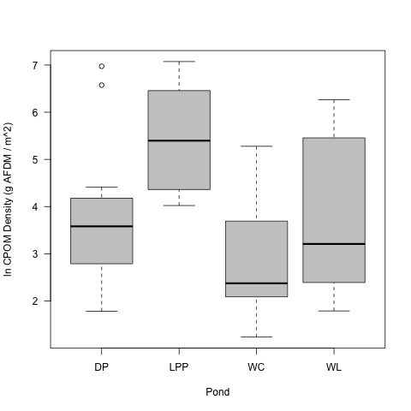

Figure 1. The density of leaf litter (CPOM) from 4 small ponds in Farmville VA. Leaf litter density is reported as the natural log of the ash-free-dry-mass of the leaves.

The proposed project will evaluate the effect of terrestrial leaf litter on the eutrophication of small ponds. Our previous work has shown that leaf litter alters the timing of nutrient release from the sediments (Fig. 3) which we hypothesize can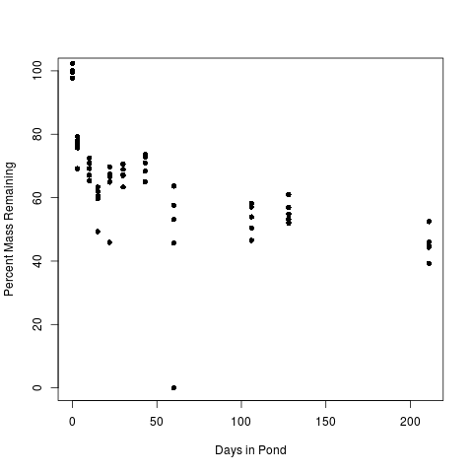

Figure 2. The percent mass of 5 g leaf packs incubated in a small pond in Farmville VA.

alter extent of nutrient limitation in the pond. This research will benefit the field of aquatic ecology by expanding our knowledge of small ponds, which are understudied in the field (Downing 2010). Additionlly the results of this research will help environmental managers make informed decisions about reducing eutrophication and restoring water quality in ponds and their watersheds. This latter result will particularly benefit the Environmental Science Program that is being developed in the Department of Biological and Environmental Sciences (BES) by supporting BES's emerging strength in aquatic ecology and environmental science. This project will allow for the continuation of the research program my lab has established in the local ecosystems. These local projects provide a foundation for the ongoing environmental science research at Longwood and connect Longwood to the broader regional scientific community through continued collaborations with researchers at other universities.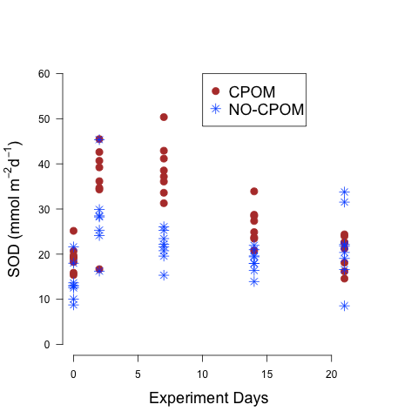

Figure 3. The presence of leaf litter (CPOM) increases the sediment oxygen consumption of pond sediments during a lab incbation.

The proposed project is patterned after my previously successful collaborations with Longwood undergraduate students. This project is a continuation of a research program that has already trained 8 undergraduate research students and resulted in student poster presentations at the annual meetings of 2 different professional societies. Additionally the knowledge of local ecosystems provided by this research program has allowed me to develop laboratory exercises that expose students to real research experiences by allowing them work in actual study systems.

## B. Goals

The principle goal of this project is to *evaluate the role of terrestrial leaf litter in the nutrient limitation of phytoplankton in small man-made ponds.* The algal (i.e., phytoplankton) productivity of small ponds in a critical question in aquatic ecology on both a theoretical and applied level. Understanding the factors that control the production of biomass by producers (i.e., algal growth) furthers our knowledge of the movement and storage of energy and resources in ecosystems (Schlesinger and Bernhardt 2013). Additionally the excess growth of algae in ponds (i.e, eutrophication) can limit their use for recreation and aesthetics, as well as degrade downstream water quality (Wetzel 2001). Knowlege of the factors that limit algal growth will allow for more effective restoration of eutrophied systems. In order to accomplish the stated goal, the project is divided into 2 objectives.

### Objectives

*Objective 1: Quantify phytoplankton nutrient limitation in small man-made ponds in central Virginia.*

The nutrient or nutrients limiting the growth of algae in the water column of a pond has a profound effect on the ecosystem function of the system. Ponds that have excessive algal growth are considered eutrophic and are reduced in their value for fishing, recreation, and aesthetics. Furthermore, the excessive organic matter produced by the algal production can result in increased oxygen consumption and fish kills. Nutrient limitation in natural lakes in the north temperate regions of North America is well described and these systems have been shown be primarily limited by the availability of phosphorus (Wetzel 2001). Much less is known about nutrient limitation in man-made ponds, especially those in urban and suburban settings. This objective is designed to assess the nutrient limitation of ponds near Farmville, VA. All of the ponds in this region are man-made but they vary with respect to surrounding land use, age, and physical characteristics. The data collected through this objective will be used to develop a context for southeastern man-made ponds within what is already known about nutrient limitation in ponds genrally. Furthermore, these data will be used to perform field-based tests of the hypotheses generated by the lab experiments described in objective 2.

*Objective 2: Quantify the effect of terrestrial leaf litter on the nutrient limitation of phytoplankton in small ponds.*

My lab's previous work has shown that terrestrial leaf litter is a substantial component of the sediments of small, man-made ponds in the region around Farmville, VA (Fig #). Furthermore we have shown that the presence of this leaf litter can increase sediment oxygen demand and organic matter breakdown (Fig #), and alter sediment nutrient cycling (Fig. #). One consequence of this alteration of organic matter and nutrient processing is that terrestrial leaf litter may affect the availability of nutrients to the algae in the water column. This objective is designed to test how leaf litter can alter the growth of algae in controlled lab setting. The lab experiment will allow us to isolate the effect of the leaf litter and develop hypotheses as to how leaf litter may be affecting algal growth in real ponds.

The combined data from the completion of these objectives will increase our understanding of the factors limiting algal growth in man-made ponds in the Southeast and inform pond management decisions.

## C. Subjects

The only subjects of this research are the microbial communities associated with the pond water and sedments.

## D. Procedures

*Objective 1* I propose to evaluate the nutrient limitation of the algae (i.e., phytoplankton) in 6 - 10 ponds in the vicinity of Farmville, VA. The exact number of ponds will depend on our ability to get permission from land owners and the algal production rate, which will affect the incubation length. Emphasis will be on selecting ponds that represent a gradient in environmental parameters with special attention to the amount of terrestrial leaf litter input.

To determine nutrient limitation, we will collect water from the surface of the pond. The pond water will be filtered through 153 μm mesh to remove all animals that can graze on the algae and then distributed into replicate 300 ml glass bottles. These bottles will then be amended with inorganic nitrogen, inorganic phosphorus, both nutrients, or left unamended as controls. We will then incubate the bottles under constant illumination for 3 - 5 days, depending on the growth rate of the algae. At the end of the incubation the density of the algae in the bottles will be compared to the initial density to calculate the algal growth. Algal density will be measured initially and at the end of the incubation by determining the concentration of chlorophyll in the water. Chlorophyll is a pigment specific to algae (and plants) and therefore will be proportional to the algal cell abundance. Nutrient limitation will be determined by comparing the growth of the algae in the nutrient amended bottles to the control. If additional nutrients stimulate algal growth, we will conclude that that nutrient is limiting in the system.

My lab is already equipped to collect the water but the incubation chamber, bottle-top pipette, and reagents and standards are required for the incubations and quantification of chlorophyll.

*Objective 2* To evaluate the effect of terrestrial leaf litter on algal nutrient limitation, my lab will conduct a series of experiments were we incubate pond water and sediment with and without leaf litter and measure algal growth. These incubations will be very similar to those described above, except in this case the glass bottles will contain pond sediments as well. The sediments can be a significant source of nutrients to the algae in the water, so by adding the sediments in this series of experiments we will be assessing the ability of the sediment nutrient supply to supplement the water nutrient content. Additionally, half of the bottles will have 10 mm leaf discs added to the sediment surface and half will contain litter-free sediments. This will allow us to assess the impact of the presence of leaf litter on the sediment nutrient dynamics. As with the experiments described for objective

### Timeline for Completion of the Project

Data collection for objectives 1 and 2 will begin in the Fall of 2015 and continue through the Winter and Spring of 2016 with 2 undergraduate students that I will recruit to the project in the Spring of 2015. If I am accepted into the PRISM program for the Summer of 2016, I will continue data collection during the Summer of 2016. Data analysis will be ongoing but will be completed by the Fall of 2016, which will coincide with the beginning of manuscript preparation. I plan to submit the completed manuscript for publication by the Spring of 2017. Additionally, I plan to have the participating students present the results of the study at the annual meetings of the Association of Southeastern Biologists and the Society for Freshwater Science during the Spring of 2016.

## E. Expected Outcomes

The principle expected outcome of this project is the continuation of the program of research in man-made pond organic matter cycling and biogeochemistry that I established with the materials purchased with my last Faculty Development Grant. This program has, and will continue to provide scholarly opportunities for myself and research opportunities for Longwood students. The materials requested in this proposal will allow me to expand the capabilities of my lab to address the research questions that have arisen as a result of the past 2 years of research. This project will continue to allow me to train research students and continue the collaborations with researchers that I have established at Valdosta State University and Coastal Carolina University.

## F. Current Status of the Project

The proposed project is a continuation of the work that my lab initiated with the resources acquired from my last Faculty Development Grant (2013). Since then, my lab has established that leaf litter is an abundant component of the sediments of the small, man-made ponds that we have sampled. We have also quantified the rate of leaf litter decomposition once it is deposited into a pond and have shown that the litter persists for more than a year and would be a stable resource for the pond ecosystem. Finally, our lab has shown that the presence of leaf litter in the pond sediments alters the oxygen and nutrient dynamics of the pond. These findings have led to the development of new hypotheses about the role of terrestrial leaf litter in ponds. In total the project has trained 8 Longwood students. I am currently working with 3 of those students, 2 of which will graduate this Spring and 1 who is planning to continue in the lab in the Fall.

## G. Personnel

I have gained experience in the methods required for the completion of this project during my 15 years of experience performing research in aquatic systems. Some of the analyses will also draw upon the experienc of my collaborator Matt Waters from Valdosta State University

# IV. Budget

The acquire the materials needed for the completion of this project I will need $. The majority of the budget is for the incubation chamber needed to grow the algae and leaf litter associated microboal communities. The remaining items will be used to measure the chlorophyll concentration of the water to estimate the growth of the algae.

Incubation Chamber $6500

Bottle-top Pipette $ 600

Reagents & Standards $ 500

Lab Consumables $ 500

**Total** **$8100**

# V. Previous Grants

2010 Summer Research Fellows Grant at DePauw University - $1000

2013 Longwood Faculty Development Grant - $8300

# Literature Cited

Allen, J. D. 1995. Stream Ecology: Structure and function of running waters. Chapman and Hall.

Downing, J. A. 2010. Emerging role of small lakes and ponds: little things mean a lot. Limnetica 29:9-24.

Nixon, S.W., 1995, Coastal marine eutrophication--A definition, social causes, and future concerns: Ophelia 41:199-219.

Schlesinger, W. H. and E. S. Bernhardt. 2013. Biogeochemistry: An analysis of global change. Academic Press.

Tant, C. J., A. D. Rosemond, and M. R. First. 2013. Stream nutrient enrichment has a greater effect on coarse than on fine benthic organic matter. Freshwater Science 32:1111-1121.

Wetzel, R. G. 2001. Limnology. Academic Press.