## http://www.clatterbuckinspections.com/system/files/userfiles/Longwood_University_Logo.pngWho are we?

* Leanna Tacik, a senior Biology major at Longwood University
* Dr. Kenneth Fortino, an Assistant Professor of Biology at Longwood University

## What do we want to do?

We are interested in sampling your pond as part of a research project on the relationship between sediment characteristics and biodiversity in small ponds.

Two or three times during the summer:

* We will use a small inflatable raft to:
* Collect mud samples from various locations around the pond to determine the diversity of mud-dwelling animals and the amount of food resources in the mud.
* Collect water samples that will be used to determine the amount of algae living in the water.
* Map the bathymetry (depth-profile) of the pond.
* Measure basic physical variables (pH, temperature, dissolved oxygen, etc…)
* 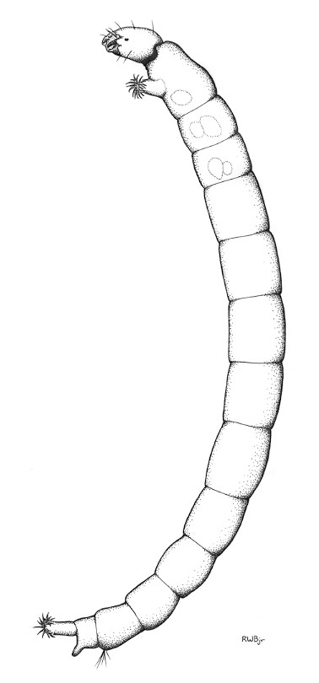We will also sample the animals living in the shallow water near the pond margin with a dip net.

All of the samples will be taken back to the lab in the Longwood Biology Dept. for processing and we will be happy to share any of the information we learn about your pond.

## Why do we want to do this?

This research will give us a better understanding of the way that energy and nutrients are used by pond organisms. Small ponds are a very abundant freshwater habitat but they have not received much study and there is still a lot that we do not know about the basic biology of pond organisms and their food resources.

Furthermore, this research is part of a program at Longwood University called LU-PRISM that provides undergraduate science majors with an opportunity to perform scientific research. Leanna’s participation in this program will help prepare her for a career in science by developing her research experience.

## Please feel free to contact us with any questions or if you are interested in participating in this study by allowing us to sample your pond.

## Thank you,

Leanna Tacik – [leanna.tacik@live.longwood.edu](mailto:leanna.tacik@live.longwood.edu)

Kenneth Fortino- fortinok@longwood.edu Office- (434) 395-2223

**Department of Biological & Environmental Sciences**  
Longwood University  
201 High Street  
Farmville, VA 23909

(434) 395-2652