Kaitlyn Peters and Kenneth Fortino

THE EFFECTS OF LEAF LITTER AND NUTRIENTS ON SEDIMENT OXGEN DEMAND IN A MAN-MADE POND IN CENTRAL VIRGINIA

Abstract:

On a global scale, the abundance and surface area of man-made ponds is nearly equal to that of natural ponds (Downing 2007). Despite this, little is known about the biogeochemical nutrient cycling of man-made ponds. Recent research suggests that leaf litter is an important resource in ponds because it is abundant, variable, and decomposes slowly (Fortino unpublished data). In order to better understand its significance, we simultaneously tested the effects of leaf litter (20, 1 cm senecent tulip poplar leaf disks) and nutrient enrichment (300 μg L-1 DIN + 30μg L-1 DIP) on sediment oxygen demand (SOD). The experiment utilized a complete factorial design, with four replicates for each treatment combination. The sediment mesocosms were created in 300 ml BOD bottles using fine (< 250 μm) sediments and water collected from a small man-made pond in Farmville, Va. The mesocsoms were incubated in the dark for 22 days and sediment oxygen demand and absorbance was measured at 1, 3, 8, 15, and 22 days. We found that, when normalized to sediment organic matter content, both leaf litter and nutrient enrichment increased sediment oxygen demand, but there was no interaction between leaf litter and nutrient levels. Spectroscopy scans revealed that the labile organic matter initially increased in the leaf litter treatments, but then declined and stabilized on the last two samples’ dates. The effect of leaf litter on SOD was greatest at 2 and 7 days of incubation and not significant after 22 days. These results indicate that sediment metabolism in this system is limited by organic matter quality and nutrients and that leaf litter can temporarily increase the availability of labile organic substrates.

Introduction:

On a global scale, the abundance and surface area covered by man-made ponds is nearly equal to that of natural ponds (Downing 2006). In addition, in regions such as Virginia where natural lakes are rare, man-made ponds represent the dominant lake habitat. Despite their abundance, little is known about the role of man-made ponds in nutrient cycling. In particular, there has been relatively little research done to understand how man-made ponds cycle watershed organic and inorganic nutrients (Tranvik et al. 2009).

When allochthonous organic matter enters an aquatic system, there are a number of different fates for the mass of organic matter (Gessner et al 1999). Initially, organic matter will lose some of its mass due to leaching. A portion of the remaining mass can then either be consumed by microbes (bacteria and fungi) and invertebrates (Webster and Benfield 1986), or be converted into fine particulate organic matter (FPOM; Gessner et al. 1999). If the organic matter had been consumed, the microbes and animals will then release the mineralized food as either inorganic nutrients or CO2 (Gessner et al. 1999).

An important organic matter resource is course particulate organic matter (CPOM). Recent evidence (Fortino, unpublished data) suggests that CPOM is an important resource in man-made ponds because it is abundant, variable, and decomposes slowly. Our experimental design used 300ml BOD bottles to create controlled systems that allowed us to isolate and quantify the effects of CPOM and nutrient enrichment on sediment oxygen demand. We hypothesized that:

1. Sediments with CPOM will have a net influx of inorganic N and P into the sediments from the water column due to the immobilization of inorganic N and P in the fungal and bacterial biomass on the CPOM, while sediments without CPOM will have a net flux of inorganic N and P out of the water column.

2. Sediments with CPOM will have a net flux of DOM out of the sediments due to the leaching of DOM from the leaves.

3. Sediments with CPOM will have greater SOD due to the respiration of the fungal and bacterial communities on the leaves.

4. Sediments with CPOM will not increase the percent organic matter of the FPOM because leaf mass is mainly being lost as CO_2 and DOM.

5. Sediments with CPOM will increase water column bacterial abundance due to the production of DOM from leaf leaching.

6. The water exposed to CPOM will have greater water column respiration due to the increase in leachate from the leaves.

7. CPOM particles will have greater fungal biomass than fine sediments.

8. Sediments with CPOM will have an increase in inorganic N and P flux into the sediments when exposed to elevated inorganic N and P due to nutrient limitation in the fungi growing on the leaves.

9. CPOM mass loss will be greater with elevated inorganic N and P due to nutrient limitations on the leaf associated fungi.

10. Sediments with CPOM will have greater SOD when exposed to elevated inorganic N and P due to greater respiration by leaf associated fungi.

11. The water oxygen consumption will be greater in the treatments with elevated N and P.

12. Water column bacteria biomass will increase more following fertilization with inorganic N and P in sediments with CPOM due to the ability of the bacteria to balance the stoichiometry of leaf produced DOM.

Methods:

We used a complete factorial design to evaluate the combined effects of CPOM and nutrient enrichment on bacterial abundance, fungal biomass, inorganic N and P, and microbial respiration in man-made ponds. Each treatment combination was replicated 4 times in 300 ml BOD bottles. Each BOD bottle contained either no CPOM and ambient nutrients (control), CPOM and ambient nutrients, no CPOM and added nutrients, or CPOM and added nutrients. The nutrient enriched treatments were created by adding 300 micrograms/liter of DIN and 30 micrograms/liter of DIP to the replacement water. CPOM treatments were created by adding 20 leaf disks to the specified BOD bottles. We gathered sediments from Lancer Park Pond on 29 May 2014, using an Ekman-dredge. Once obtained, we ran the sediments through a 243 micrometer mesh net to remove all CPOM and macroinvertebrates. The collected sediments were allowed to settle overnight and the overlying water was siphoned off. The BOD bottles (300 ml) were filled with 100 ml of sediment slurry, and 185 ml of Lancer Park Pond water collected from 0.5 m on 9 June 2014. The bottles and remaining lake water were incubated in the dark at ambient lab temperature (min - max). The BOD bottles were gently agitated on rocker-shakers (tilt = 8o  rate = 8 rpm).

The incubation began on 9 June and we sampled the bottles on 10 June, 12 June, 17 June, 24 June, and 1 July 2014. On each sampling date, the samples of the overlying water were collected approximately 2 cm from the sediment water interface with a 30 ml glass syringe fitted with a cannula. These samples consisted of 15 ml for dissolved oxygen, 15 ml for water respiration, 30 ml for nutrients, and 5 ml for absorbance. An additional 3 ml of overlying water was removed with a pipette for bacterial abundance. Once the samples were removed, 83 ml of lake water would be added to the bottle and capped. In approximately 5 hours, the bottle would be removed again, uncapped, and 15 ml pulled for the second dissolved oxygen sample.

At the end of the experiment, 3 0.5 cc samples were taken from the surface sediment in each BOD bottle. One of each sample was used for sediment organic matter content, sediment ergosterol, sediment C:N. An additional 0.8 cm diameter core was taken from the entire sediment column for bulk sediment organic matter determination. In BOD bottles containing CPOM, 12 of the 20 leaf disks were for leaf organic matter calculations, 4 disks were used for for leaf ergosterol, and 4 disks were used for leaf C:N analysis. Sediment and CPOM organic matter was calculated by loss on ignition at 550o C, ergosteral density was determined using HPLC, and sediment and CPOM C:N was determined using mass spectroscopy.

Oxygen concentration was determined using Winkler titration adjusted for 10 ml (Carpenter 1965). Sediment oxygen demand was calculated as the change in oxygen concentration over time.

Results

Leaf litter significantly increased sediment oxygen demand in the pond sediments during the incubation (Fig. 1). Note that, since these results were normalized by their organic matter content, the effect is not due to the increase in organic matter with the leaf additions. The SOD and the effect of leaf litter on SOD was greatest after 2 and 7 days of incubation and declined during the experiment. There was no significant effect of leaf litter on SOD after 22 days (Fig. 2).

Added nutrients significantly increased sediment oxygen demand in the pond sediments. There was no significant interaction between leaf litter and nutrients, so the effect of nutrients was independent of the presence of leaf litter (Fig. 3). The SOD was greatest after 2 and 7 days of incubation and declined during the experiment but the effect of nutrients remains consistent for the 22 days of incubation (Fig. 4). The leaf litter resulted in an initial increase in the amount of labile dissolved organic matter but this effect did not persist past the first week of incubation (Fig. 5).

Discussion:

As of now, we lack the data and or data analyses to address many of our hypotheses; however, based on the SOD and spectroscopy data, we can still reflect on a few of them.

For some of the hypotheses that we have data for, we found that there was not support for our original hypotheses.

We hypothesized that sediments with CPOM will have a net flux of DOM out of the sediments due to the leaching of DOM from the leaves. We did see evidence that the leaf litter was changing the dissolved organic matter in the overlying water because there was more labile organic matter in the water of the treatments with leaves (Fig. 5).

Despite our limited data, we can make three summary observations. First, sediment microbial metabolism is more limited by organic matter source (i.e., quality) than by the quantity of organic matter in the sediments (Fig. 3). Second, leaf litter contributes a temporary source of higher quality organic matter that stimulates sediment microbial metabolism (Figs. 1-2). Lastly, sediment microbial communities are nutrient limited but the nutrient limitation is not increased by the presence of leaf litter (figs. 3-4).

Literature Cited:

Carpenter, J. H., 1965. The Chesapeake Bay Institute technique for the Winkler dissolved

oxygen method. Limnology and Oceanography 10:144-143.

Downing, J. A., Prairie, Y. T., Cole, J. J., Duarte, C. M., Tranvik, L. J., Striegl, R. G.,

McDowell, W. H., Kortelainen, P., Caraco, N. F., Melack, J. M., and Middleburg, J. J.

2006. The global abundance and size distribution of lakes, ponds, and impoundments.

Limnology and Oceanography 51:2388-2397.

Gessner, M. O., Chauvet, E., and Dobson, M. 1999. A perspective on leaf litter breakdown in

streams. Oikos 85:377-384.

Tranvik, L. J., Downing, J. A., Cotner, J. B., Loiselle, S. A., Striegle, R. G. , Ballatore, T. J.,

Dillon, P., Finlay, K., Fortino K., Knoll, L. B., Kortelainen, P. L., Kutser, T., Larsen, S.,

Laurion, I., Leech, D. M., McCallister, S.L., McKnight, D.M., Melack, J. M., Overholt,

E., Porter, J. A., Prairie, Y., Renwick, W. H., Roland, F., Sherman, B. S., Schindler, D.

W., Sobek, S., Tremblay, A., Vanni, M., Verschoor, A. M., von Wachenfeldt, E.,

Weyhenmeyer, G. S. 2009. Lakes and reservoirs as regulators of carbon cycling and

climate. Limnology and Oceanography, 54:2298-2314.

Webster, J.R. and E.F. Benfield. 1985. Vasular plant breakdown in freshwater ecosystems. Annual Review of Ecology and Systematics, 17:567-594.

Figure Legends

Figure 1. The average sediment oxygen demand in 16 BOD bottles containing pond sediments with or without 20, 10 cm senescent tulip poplar leaf disks over 22 days of dark incubation. The boxes represent the 1st and 4th quartiles, the horizontal bar is the median, and the whiskers are the range of the data.

Figure 2. The sediment oxygen demand in 16 BOD bottles containing pond sediments with or without 20, 10 cm senescent tulip poplar leaf disks per sampling event over 22 days of dark incubation. The boxes represent the 1st and 4th quartiles, the horizontal bar is the median, and the whiskers are the range of the data.

Figure 3. The average sediment oxygen demand in 16 BOD bottles containing pond sediments with or without 300 ug L-1 DIN and 30 ug L-1 DIP nutrient additions over 22 days of dark incubation. The boxes represent the 1st and 4th quartiles, the horizontal bar is the median, and the whiskers are the range of the data.

Figure 4. The sediment oxygen demand in 16 BOD bottles containing pond sediments with or without 20, 10 cm senescent tulip poplar leaf disks per sampling event over 22 days of dark incubation. The boxes represent the 1st and 4th quartiles, the horizontal bar is the median, and the whiskers are the range of the data.

Figure 5 The change in the ratio of absorbance at 254 and 365 nm in a sample of overlying water over time from a sample of overlying water filtered through a GFF filter.

Figure 1.

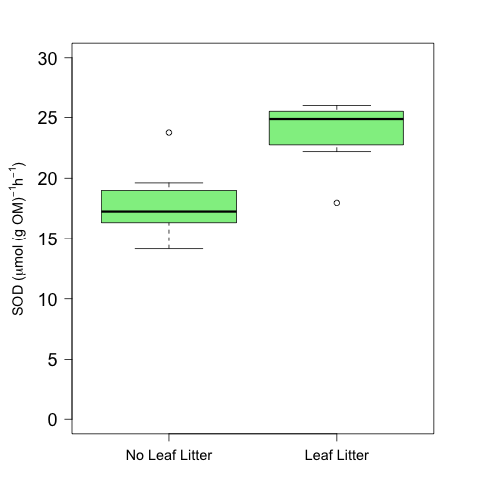

Figure 2

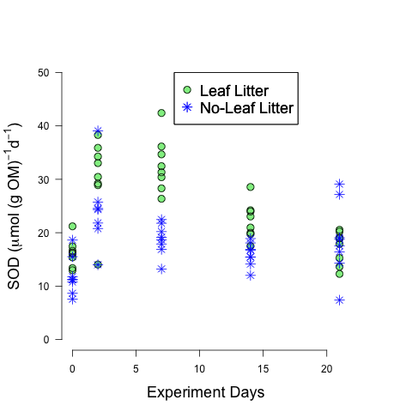

Figure 3

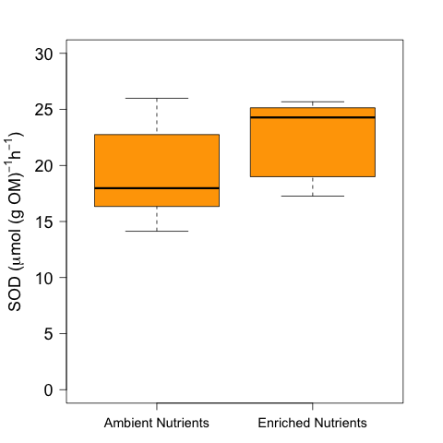

Figure 4

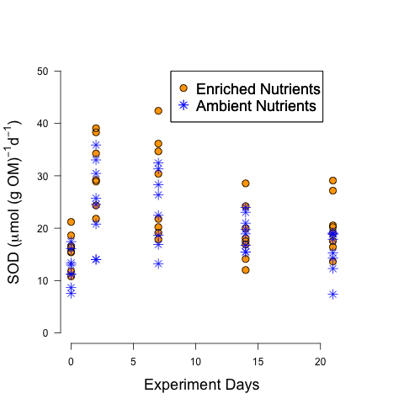

Figure 5

