**Introduction**

Detrital organic matter is important for aquatic ecosystems because it is a primary energy source and a habitat for macroinvertebrates (Webster & Benfield, 1986). Cummins (1974), identifies three classes of organic matter: coarse particulate (CPOM, > 1 mm), fine particulate (FPOM, <1 mm and > 0.5 mm), and dissolved (DOM, < 0.5 mm). In many systems a large proportion of the organic matter pool derives from leaf litter (Cummins, 1974). The processing of OM is affected by many factors including macroinvertebrates, thus making it important to simultaneously measure macroinvertebrates and sediment organic matter (Cummins, 1974).

The decomposition of leaf litter in aquatic systems goes through a multiphase process. Compounds that are easily dissolved are extracted from the litter within the first few days, and then the acceleration of microbial activity takes place. Bacterial degradation improves the detritus nutritional value, and is beneficial for zoobenthos to feed on.

The benthic macroinvertebrates include annelids, oligochates, insect larvae, gastropods, mollusks, and crustaceans. The most abundant macroinvertebrate in freshwater ecosystems tends to be insect larvae. While collecting these organisms in field is needed to preserve them, due to their size.

Macroinvertebrates size ranging from 200 to 500 μm, some may not be seen easily with the naked eye. If organisms are preserved they can be place under a microscope for further identifying and classification.

For most studies there has been no preservation of the samples and the bugs were picked live. These bugs tended to be larger species that were easily seen to the naked eye. Formalin has been the common preservation method, yet only a few studies have used ethanol; however, ethanol was used after initial formalin preservation. Past studies investigating macroinvertebrates and organic matter processing have used preservation inconsistently. Most studies used no preservation of the samples and the macroinvertebrates were picked live. These macroinvertebrates tended to be larger species that were easily seen to the naked eye, however, this method risks underestimating the density of small or cryptic individuals. Where preservation was used, formalin was the most common preservation method, with fewer studies using ethanol or a combination of formalin and ethanol. To our knowledge there has been no systematic evaluation of the effect of preservation on sediment organic matter mass determination.

There have been three observed methods for sampling of small macroinvertebrates in leaf litter: Litter and macroinvertebrate samples are taken separately, but this method fails to specifically associate community structures with the leaf litter sample. Macroinvertebrates are picked live from the leaf litter and preserved separately. This method collects the macroinvertebrates actually living in the a specific leaf litter sample but runs a risk of missing and under sampling small or cryptic individuals. Furthermore, this method limits the number of samples that can be collected because each sample must be processed at the time of collection. Finally, whole leaf litter samples can be preserved and the macroinvertebrates can be separated in the lab. This method allows for the careful separation of very small individuals and does not require that samples be processed at the time of collection but adding preservative to the leaf litter could introduce preservation artifacts to the leaf litter mass assessment. To our knowledge, preservation artifacts for leaf litter mass determination have not been assessed

We are investigating if preserving the samples in ethanol in field and separating the OM and bugs in lab with result in the introducing of preservation artifacts within our assessments.

**Methods**

*Study Site*

Wilck’s Lake is a 194760 m2 surface area, man-made lake located in Farmville, Virginia (37⁰18’13” N, 78⁰24’51” W). Wilck’s Lake is used mainly for recreational fishing and boating and most of the lake is approximately 2.0 m deep. On 14, June 2013 the lake had a secchi depth of 0.6 m, was not stratified with an average water temperature of 26.3o C, and an average dissolved oxygen concentration 6.04 mg L-1.

*Sample Collection and Processing*

Two replicate Ekman samples were collected at 9 approximately equidistant locations along a transect line beginning approximately 10 m from the North shore of the lake and ending approximately 10 m from the South shore of the lake. Once collected, each sample was washed through a 250 μm mesh. For each location, one of the replicate samples was used as a control and stored in water and the other was preserved with 70% ethanol in the field.

The control samples, that were stored in water, were washed with tap water through a 1 mm sieve the same day of the sampling. The material retained by the sieve (hereafter coarse particulate organic matter; CPOM) was placed in a pre-weighed plastic petri dish and dried at 50⁰ C for approximately 24 hours. After drying the CPOM was massed and then ground in a mortar and pestle. A subsample of the ground CPOM was placed into pre-weighed crucibles and ashed in a muffle furnace at 550⁰ C for approximately 5 hours. The ash free dry mass of the samples was determined as the proportional change in mass of the ashed sample multiplied by the dry mass of the CPOM (Benfield 2006). The treatment samples, which were preserved in ethanol, were processed in exactly the same manner as the control samples 7 days later.

*Data Analysis*

ANOVA

R (Citation strings (or BibTeX entries) for R and R packages can also be obtained by citation().)

**Results**

In comparison of the control and treatment samples, both were significantly similar; this is shown by the mean and standard deviation the sample’s CPOM density. The control CPOM had mean of 228.4237 g with a standard deviation of 410.7339 g, and the treatment sample had a mean of 258.8367 g and standard deviation of 423.7274 g. The un-preserved sample AFDM standard deviation is 165.961, and 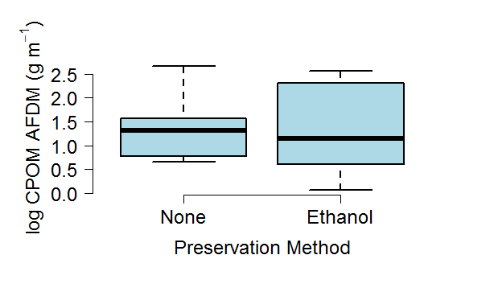the treated AFDM is 149.8506. These to samples types having a closely similar mean and standard deviations shows there was no significant difference between AFDM of coarse particulate organic matter in the ethanol preserved and un-preserved samples. There was no negative relationship between the AFDM and the type of sample (F1, 16 = 0.0004, p = 0.99; Fig. 1).

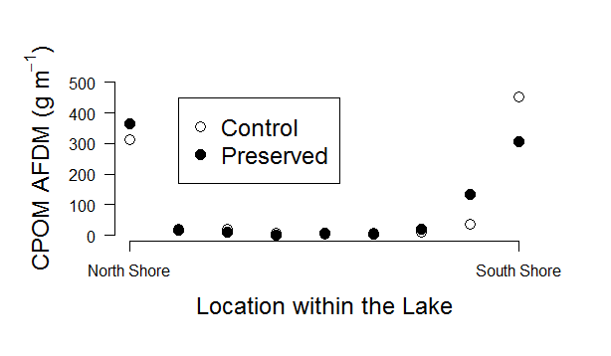 Samples that were taken near shore have significantly greater coarse particulate organic matter density than those taken near the middle of the transect (Fig. 2). The near shore samples also had a greater inorganic fraction of coarse sediment; however one sample from the open portion of the lake had the highest inorganic fraction (Fig. 3).

**Figure 1.** This graph shows there was no significant difference between the AFDM of the CPOM in the ethanol preserved and un-preserved.

**Discussion**

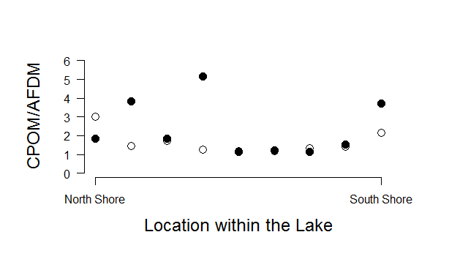Significantly no difference being shown in the AFDM or the inorganic fraction between the unpreserved and preserved samples leads to the conclusion that there is no effect of ethanol. The samples were taken in mid-June which results in older leaf litter being sampled; it is planned to sample freshly fallen litter at the end fall.

**Figure 2.** The figure shows the effect location has on CPOM density. Samples taken near shore have a greater CPOM density.

Sampling new leaf litter will demonstrate the effect of preservation on detritus that has not been drastically affected by natural breakdown within the water; doing such sampling, will allow a representation of EtOH preservation effect on two different periods within the detritus cycle.

Location within lake was shown to affect the AFDM and inorganic fraction, and this is due to where leaves travel in the lake (Fig. 2). In the open water, CPOM was not as abundant as near shore locations. This difference resulted in a higher inorganic fraction among the near shore locations than the open locations (Fig. 3).

**Figure 3.** This figure shows the comparison of location and inorganic fraction of coarse sediment. The inorganic fraction was greater in samples taken closer to shore. However, one sample from the open portion of the lake had the highest inorganic fraction.

**Literature Cited**

Batzer, D., & Palik, B. (2007). Running head: Influence of litter on pond invertebrates. *Fundamental and Applied Limnology*, *168*, 155-162.

Bohman, I., & Herrmann, J. (2006). The timing of winter-growing shredder species and leaf litter turnover rate in an oligotrophic lake, SE Sweden. *Hydrobiologia, 556*(1), 99-108.

Bottollier-Curter, M., Charcosset, J., & Poly, F. (2012). Light interception principally drives the understry response to boxelder invasion in the riparian forests. *Biological Invasions, 14*(7), 1445-1458.

Brainard, A., & Fairchild, G. (2012). Sediment characteristics and accumulation rates in constructed ponds. *Journal of Soil and Water Conservation, 67*(5), 425-432.

Cummins, K. W. (1974). Structure and function of stream ecosystems. *BioScience*, *24*(11), 631-641

Francis, T. (2007). Effects of urbanization on the dynamics of organic sediments in temprate lakes. *Ecosystems, 10*(7), 1057-1068.

Freschet, G. (2012). Multiple mechanisms for trait effect on litter decomposition: moving beyond home-field advantage with a new hypothesis. *Journal of Ecology, 100*, 619-630.

Hansen, K. (1998). The impact of *Chironomus plumosus* larvae on organic matter decay andnutrient (N, P) exchange in a shallow eutrophic lake sediment following a phytoplankton sedimentation. *Hydrobiologia, 364*, 65-74.

Li, A., & Dudgeon, D. (2008). Food resources of shredders and other benthic macroinvertebrates in relation to shading conditions in tropical Hong Kong streams. *Freshwater Biology, 53*(10), 2011-2025.

Mancinelli, G., & Costantini, M. (2002). Cascading effects of predatory fish exclusion on the detritus-based food web of a lake litoral zone. *Oecologia, 133*(3), 402-411.

Martins, R. T. (2011). Colonization by oligocaetes in decomposing leaves of *Eichhornia azurea kunth* in a neotropical system. *Annual Limnology*, *47*, 339- 346.

Moore, J. (2004). Detritus, trophic dynamics and biodiversity. *Ecology Letters*, *7*, 584-600.

Oertli, B. (1993). Leaf litter processing and energy flow through macroinvertebrates in a woodland pond . *Oecologia*, *96*(4), 466-477.

Pabst, S. & Scheifhacken, N. (2008). Leaf litter degradation in the wave impact of a pre-alpine lake. *Hydrobiologia, 613*, 117-131.

Pye, M., & Vaughan, I. (2012). Episodic acidification affects the breakdown and invertebrate colonisation of oak litter. *Freshwater Ecology*, *57*, 2318-2329.

Stenert, C. (2012), Negative effects of exotic pine invasion on macroinvertebrate communities in southern Brazil coastal ponds. *Marine and Freshwater Research, 63*, 283-292.

Stewart, J., & Downing, J. (2008). Macroinvertebrate communities and environmental conditions in recently constructed wetlands. *Wetlands, 28*(1), 141-150.

Szkokan-Emilson, E., Wesolek, B., & Gunn, J. (2011). Terrestrial matter as subsides that aids in recovery of macroinvertebrates in industrial damanged lakes. *Ecological Applications*, *21*(6), 2082-2093.