Hi:

- I’m currently having a different problem. After I tried to publish, first thing this morning, my password does not seem to validate. As far as I know, my current password is UConnBleedBlue62$. The password works for me signing into your site but does not validate for publishing. Can you verify that UConnBleedBlue62$ is my password?

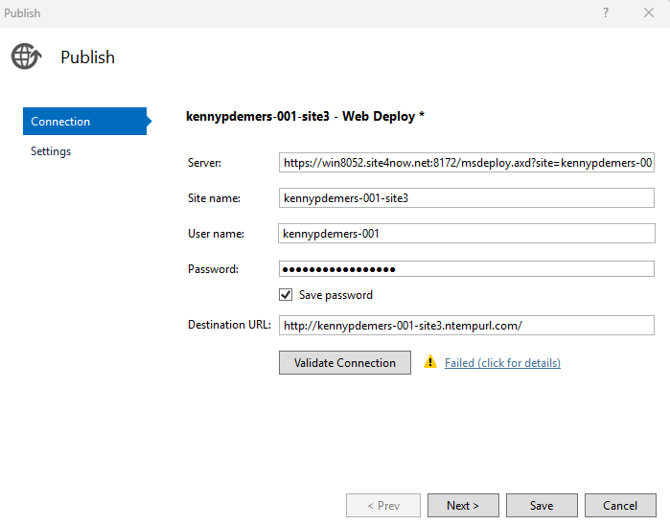
- What determines what gets displayed when I click on “Show WebDeploy Info”?
  - For site 1, this pops up
  - 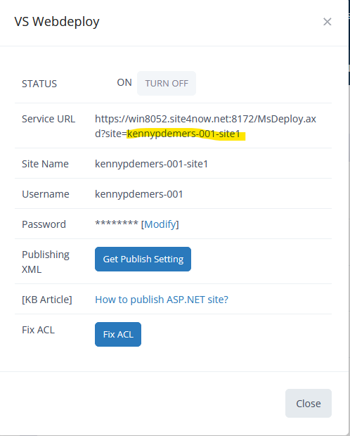
  - For sit 3, only this pops up
  - 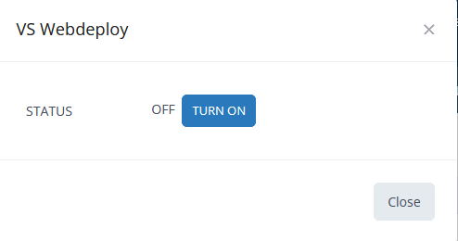
  - Why doesn’t all the WebDeploy information get displayed?
- When I go to publish via Visual Studio, should the Site be On or Off

Thanks for your help.

Regards,

Kenny

