Hi:

- I’m currently having a different problem. After I tried to publish, first thing this morning, my password does not seem to validate. As far as I know, my current password is UConnBleedBlue62$. The password works for me signing into your site but does not validate for publishing. Can you verify that UConnBleedBlue62$ is my password?

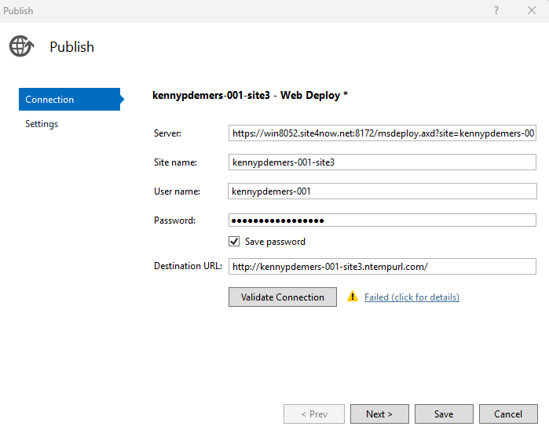

- When I go to publish via Visual Studio, should the Site be On or Off

Thanks for your help.

Regards,

Kenny

