Examen-2.R

Usuario

2022-05-11

#Examen 11/05/2022  
#Kenny Rincon Lopez  
  
erupciones <- read.csv("erupciones.csv", header = T)  
  
#DIAGRAMA DE DISPERSION   
#EJERCICIO 1  
plot(erupciones$eruptions, erupciones$waiting, pch=19,  
 col= "gray",  
 xlab= "tiempo de espera entre erupciones(min)",  
 ylab= "Duracion de la erupcion(min)",  
 main="geyser old faithfull")

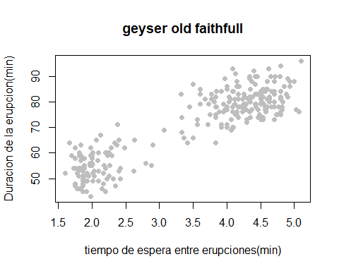

mean(erupciones$eruptions)

## [1] 3.487783

#[1] 3.487783  
  
sd(erupciones$eruptions)

## [1] 1.141371

#[1] 1.141371  
  
var(erupciones$eruptions)

## [1] 1.302728

#[1] 1.302728  
  
mean(erupciones$waiting)

## [1] 70.89706

#[1] 70.89706  
  
sd(erupciones$waiting)

## [1] 13.59497

#[1] 13.59497  
  
var(erupciones$waiting)

## [1] 184.8233

#[1] 184.8233  
  
cor.test(erupciones$eruptions, erupciones$waiting)

##   
## Pearson's product-moment correlation  
##   
## data: erupciones$eruptions and erupciones$waiting  
## t = 34.089, df = 270, p-value < 2.2e-16  
## alternative hypothesis: true correlation is not equal to 0  
## 95 percent confidence interval:  
## 0.8756964 0.9210652  
## sample estimates:  
## cor   
## 0.9008112

#Pearson's product-moment correlation  
  
#data: erupciones$eruptions and erupciones$waiting  
#t = 34.089, df = 270, p-value < 2.2e-16  
#alternative hypothesis: true correlation is not equal to 0  
#95 percent confidence interval:  
# 0.8756964 0.9210652  
#sample estimates:  
# cor   
#0.9008112   
  
geyser.lm <- lm(erupciones$eruptions ~ erupciones$waiting)  
summary(geyser.lm)

##   
## Call:  
## lm(formula = erupciones$eruptions ~ erupciones$waiting)  
##   
## Residuals:  
## Min 1Q Median 3Q Max   
## -1.29917 -0.37689 0.03508 0.34909 1.19329   
##   
## Coefficients:  
## Estimate Std. Error t value Pr(>|t|)   
## (Intercept) -1.874016 0.160143 -11.70 <2e-16 ***  
## erupciones$waiting 0.075628 0.002219 34.09 <2e-16 ***  
## ---  
## Signif. codes: 0 '***' 0.001 '**' 0.01 '*' 0.05 '.' 0.1 ' ' 1  
##   
## Residual standard error: 0.4965 on 270 degrees of freedom  
## Multiple R-squared: 0.8115, Adjusted R-squared: 0.8108   
## F-statistic: 1162 on 1 and 270 DF, p-value: < 2.2e-16

#Call:  
# lm(formula = erupciones$eruptions ~ erupciones$waiting)  
  
#Residuals:  
# Min 1Q Median 3Q Max

#Coefficients:  
#Estimate Std. Error t value Pr(>|t|)   
#(Intercept) -1.874016 0.160143 -11.70 <2e-16 ***  
# erupciones$waiting 0.075628 0.002219 34.09 <2e-16 ***

#Signif. codes: 0 ‘***’ 0.001 ‘**’ 0.01 ‘*’ 0.05 ‘.’ 0.1 ‘ ’ 1  
   
 #Residual standard error: 0.4965 on 270 degrees of freedom  
 #Multiple R-squared: 0.8115, Adjusted R-squared: 0.8108   
 #F-statistic: 1162 on 1 and 270 DF, p-value: < 2.2e-16  
   
 valores <- c(80,40, 45, 53, 61)  
-1.874016 + 0.075628*80

## [1] 4.176224

#[1] 4.176224  
  
-1.874016 + 0.075628*40

## [1] 1.151104

#[1] 1.151104  
  
-1.874016 + 0.075628*45

## [1] 1.529244

#[1] 1.529244  
  
-1.874016 + 0.075628*53

## [1] 2.134268

#[1] 2.134268  
  
-1.874016 + 0.075628*61

## [1] 2.739292

#[1] 2.739292