AN6002 Final Project: Group 2

Exploring Trust in Artificial Intelligence: A Multilevel Analysis of Influencing Factors, Trust Erosion, and Trust Calibration Strategies

Team Members
Wang Gaoyang – Section 1, 5, 6
Kavin Lertsattha – Section 2
Triston Cheong – Section 3
Timothy Tan – Section 4

1. Introduction: The AI Trust Problem

1.1 Background
A 2025 global study of 48,340 people in 47 countries found that 66 % of people now use AI regularly, yet only 46 % are willing to trust AI systems [1]. The problem is not only how much people trust AI, but whether that trust is deserved: two in three of respondents said they rely on AI output without evaluating its accuracy, and 56 % said they had made mistakes in their work because of AI. In a pre-registered study of 308 participants, adding explanations to large language model (LLM) answers increased people's reliance on both correct and incorrect answers (Figure 1.1) [2]. An explanation in AI response can therefore make an answer more persuasive without making it more accurate.
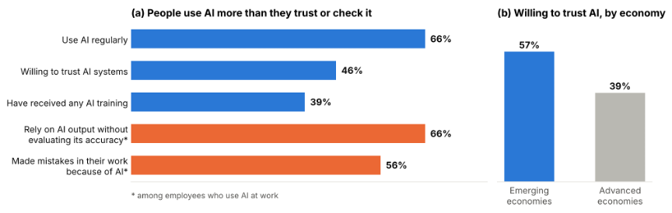
Fig 1.1 - Global rates of AI adoption, training, and unchecked workplace reliance (Left), and willingness to trust AI systems by economy type (Right). From Trust, Attitudes and Use of Artificial Intelligence: A Global Study 2025 (KPMG International, et al.)

1.2 Why calibrated trust, not more trust
Trust issues in AI can fail in two directions: Over-trust leads people to accept wrong outputs. Under-trust leads people to reject useful tools and lose their benefits. The goal is therefore not to maximise trust but to calibrate it, so that people rely on AI where it is reliable and question it where it is not.

1.3 Research questions
This report addresses two fundamental questions about AI trust and outlines practical solutions::
- What leads someone to trust an AI system in the first place? Section 2 examines this at the country level, testing whether geographical, demographic and socioeconomic indicators predict national AI sentiment and trust. Section 3 examines it at the individual level, identifying the personal and situational factors that place users into different skepticism categories.
- How does that trust change after the system fails them? Section 4 analyses how trust decays after an AI error, who loses the most trust, and whether that loss is recovered.
- What can be done? Section 5 combines these findings into practical strategies for governments, educators and AI developers to calibrate trust.

2. AI Trust by Country

2.1 Purpose & Goal
This section investigates the potential influence of geographical, demographic, and socioeconomic factors on public trust towards artificial intelligence (AI) across different countries. By examining variations in country-level characteristics, the analysis aims to identify factors that may be associated with differences in AI trust levels across different countries and consequently influence an individual’s level of trust regarding AI.
To investigate these relationships, multiple machine learning models will be developed and evaluated to determine their ability to accurately predict the percentage of a country’s population that trusts AI. The predictive performance of the models will be compared to identify the most suitable approaches for classification and regression, respectively. Furthermore, predictor variable importance will be analysed to identify which geographical, demographic, and socioeconomic indicators contribute most significantly to the models' predictions.

2.2 Methodology

Dataset
The analysis utilises data from three publicly accessible secondary data sources: the Global AI Trust and Attitudes by Country 2025 dataset [3], the United Nations Development Programme's Human Development Index (HDI) [4], and the World Bank's World Development Indicators [5]. These datasets provide a combination of national development, demographic, socioeconomic, and AI-related indicators, enabling an examination of potential relationships between country characteristics and public attitudes towards AI. Additionally, the World by ISO GeoJSON dataset [6] provides geographical boundaries for 248 countries and is used for geographical visualization purposes.

Data Preparation
The data preparation and machine learning analysis were conducted using Python, primarily utilising the Pandas, NumPy, GeoPandas, and Scikit-learn libraries. The datasets were initially cleaned by standardising column names, removing unnecessary attributes, and converting relevant variables into appropriate data types. Country identifiers were standardised using ISO3 country codes to facilitate accurate merging across datasets. From the datasets, the following seven predictor variables were selected to examine:
- Age dependency ratio
- Government effectiveness
- Individuals using the Internet (% of population)
- Population density
- Life expectancy at birth
- Mean years of schooling
- Gross national income (GNI) per capita

Following data cleaning and integration, the consolidated data were separated into two distinct datasets based on the availability of AI trust information. The labelled dataset comprised 47 country records, containing AI trust percentage values for each country, which were used to develop and evaluate the machine learning models. The unlabelled dataset comprised 146 country records, for which AI trust percentages were unavailable. These countries were identified using the UNDP and World Bank datasets, with countries already included in the training dataset excluded to prevent data overlap.
Missing predictor values were handled using median imputation, while standardisation was applied to machine learning models sensitive to differences in variable scales. Both preprocessing procedures were incorporated into the machine learning pipelines to ensure consistent application during model training and evaluation.

Machine Learning Model Development and Evaluation
A total of nine different regression machine learning models were implemented to predict the AI trust percentage for the countries in the labelled dataset. However, due to the small sample size of the labelled dataset, repeated five-fold cross validation with 20 repetitions was employed, resulting in 100 validation evaluations per model. Regression performance was assessed using Mean Absolute Error (MAE), Root Mean Squared Error (RMSE), and the coefficient of determination (R²), measuring prediction errors and the models' ability to explain variations in national AI trust percentages. The cross-validation results are summarized in table 2.1 as shown below. Upon comparison, the K Nearest Neighbours (KNN) Regression model performed the best with the lowest RMSE and highest R² and is thus the model employed moving forward.

Regression Model | MAE | RMSE | R²
Random Forest | 7.61 | 9.39 | 0.21
KNN Regressor | 7.28 | 9.23 | 0.26
Linear SVR | 8.57 | 12.00 | -0.81
Linear Regression | 9.21 | 13.89 | -2.56
RBF SVR | 8.15 | 10.54 | 0.15
Gradient Boosting | 7.97 | 9.58 | 0.15
MLP | 12.80 | 25.46 | -18.28
Decision Tree | 9.56 | 11.50 | -0.27
AdaBoost | 7.61 | 9.36 | 0.20
Table 2.1 - Performance results of cross-validated machine learning models.

Model Optimization and Prediction
Following the initial model comparison, the KNN regression model was selected for further optimization. Whereby, the number of nearest neighbors (k) was evaluated from 2 to 15, alongside uniform and distance-based neighbor weighting methods. The combination achieving the lowest cross-validated RMSE was selected. The optimal k value was found to be 3 resulting in a RSME value of 8.8924.
The optimized model was subsequently fitted using the labelled dataset and applied to the unlabeled dataset to generate country-level predictions of AI trust percentages. The predicted result values would then be appended to the original dataset and exported as CSV and GeoJSON files for data visualization using Tableau.

Predictor Variable Importance Analysis
To identify the national characteristics contributing most significantly to the predictions, feature importance analyses were conducted on the optimized models. Permutation importance was applied to the KNN regression model by randomly shuffling individual predictor variables and measuring the resulting deterioration in model performance. Each variable was shuffled 30 times to calculate its mean importance and standard deviation.

2.3 Results and Analysis

AI Trust Mapping
The resulting AI trust map in figure 2.1 reveals notable differences in AI trust percentages between countries and continents. Notably that many developed countries, particularly those in North America, Western Europe, and Oceania, exhibit predominantly low trust percentages towards AI. Conversely, countries across Africa, Asia, and parts of South America predominantly show high trust percentages.
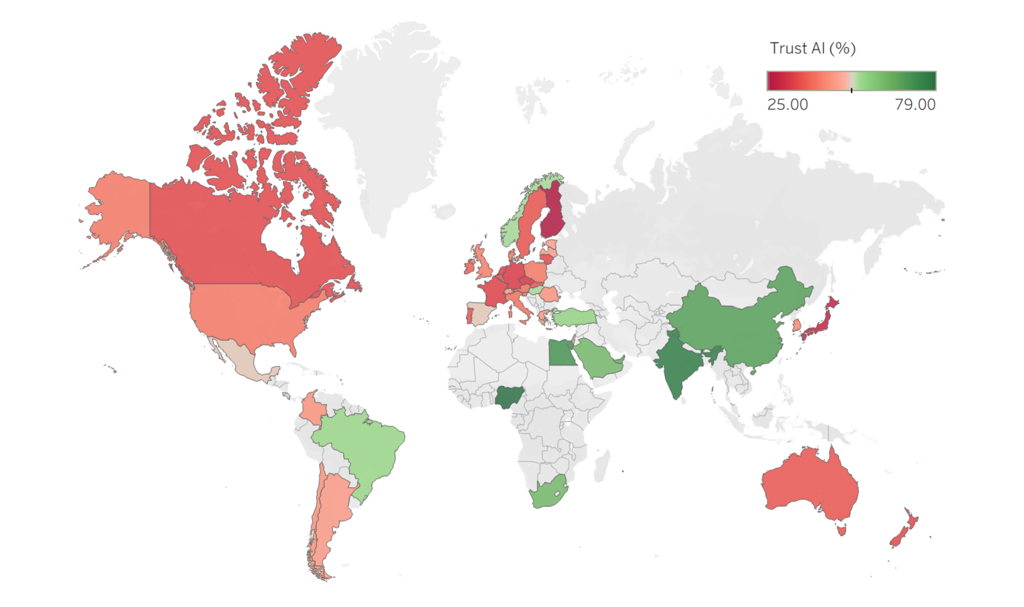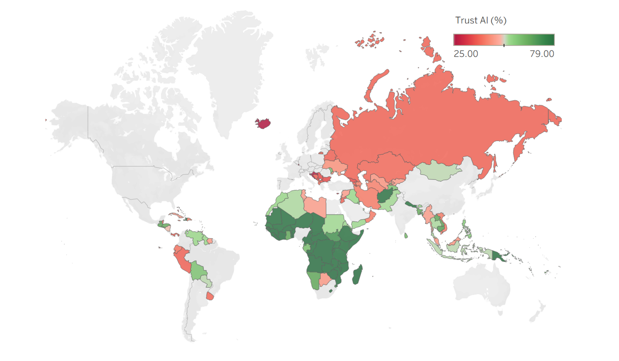
Figure 2.1 - Predicted AI Trust map for Labelled Dataset (Left) and Unlabeled Dataset (Right)
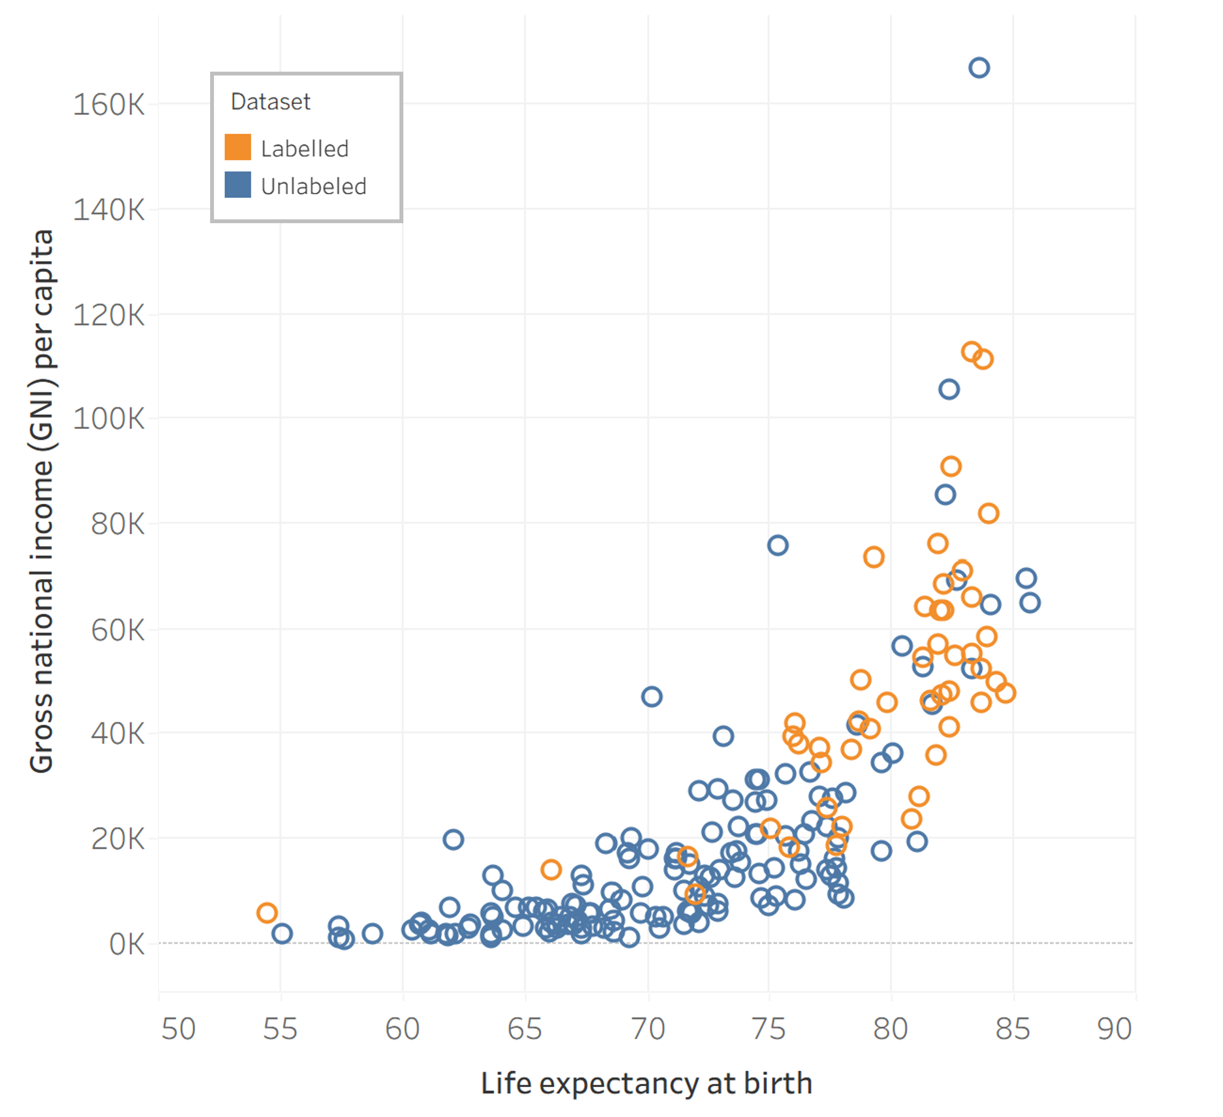
However, these patterns must be interpreted cautiously due to substantial differences in the socioeconomic composition of the labelled and unlabeled datasets. The labelled dataset contains only 47 countries, predominantly representing developed economies, with relatively few developing countries included. In contrast, the unlabeled dataset contained 146 countries, many of which have substantially lower income levels and different demographic characteristics.
This imbalance is evident in the scatter plot comparing life expectancy against gross national income (GNI) per capita shown in figure 2.2. The labelled dataset countries are concentrated towards the upper-right region of the graph, characterized by higher incomes and longer life expectancies, while testing dataset countries are more widely distributed across lower income and life expectancy ranges. These differences demonstrate that the unlabeled dataset contains many countries whose socioeconomic characteristics are underrepresented in the labelled dataset.
Figure 2.2 - Scatter Plot of GNI against Life Expectancy for different countries in dataset.

Predictor Variable Importance
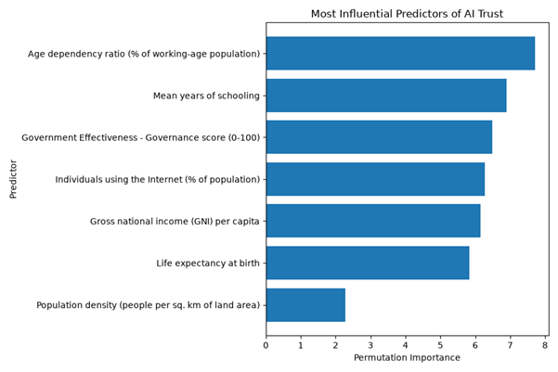
The predictor variable importance analyses provide further insights into the socioeconomic characteristics most strongly associated with the models' predictions. The results are as shown in figure 2.3 below.
For the KNN regression model results shown in figure 2.3, the age dependency ratio was identified as the most influential predictor of AI trust percentages, followed by mean years of schooling, government effectiveness, internet usage, and GNI per capita. The prominence of age dependency ratio may indicate that differences in national age structures are associated with varying attitudes towards AI, potentially reflecting generational differences in technological familiarity, adoption, and perceived risks. Similarly, the importance of education and internet usage may reflect differences in digital literacy and exposure to AI technologies. Another possible explanation is that countries with higher income levels and life expectancy tend to have greater technological exposure and more established regulatory environments, potentially contributing to different attitudes towards the opportunities and risks associated with AI.
Figure 2.3 - Predictor Variable Importance Plot for AI Trust KNN Model

2.4 Overall Findings and Limitations
Overall, the analysis demonstrates that geographical, demographic, and socioeconomic indicators provide some predictive information regarding national AI trust percentages. However, the relatively low regression R² value indicates that these factors cannot fully explain cross-country differences in public attitudes towards AI.
The most significant limitation is the small sample size and unequal geographical representation of the labelled dataset. With only 47 labelled countries available, the model may not adequately capture the diversity of socioeconomic conditions and public attitudes present globally. Expanding the labelled dataset to include a more geographically and economically representative selection of countries would likely improve reliability and generalizability.
Therefore, while the findings suggest that country level indicators are relevant to predicting AI trust levels, the results should not be interpreted as evidence of causal relationships or conclusive geographical differences in trust.

3. What Factors Determine a Person’s Trust in AI?
As artificial intelligence systems become embedded in everyday decision-making, from financial planning and medical queries to legal research and general knowledge, understanding the conditions under which people trust these systems have become more pressing.

3.1 Purpose & Goal
This study looks deeper into individual factors that influence one’s trust in AI which would help relevant institutions to better design AI systems and enhance the user experience.

3.2 Methodology

Dataset
This section explores a dataset [7] of 1,000 AI interaction records to understand the factors that influence whether a person trusts an AI system. The dataset categorises respondents into 4 trust categories under the variable, ‘user_skepticism_category’ – Blind Trust, Moderate Trust, Skeptical, or Highly Skeptical (see Table 3.1) which we have used as the target variable.

Trust Category | n | Share | Behavioural Profile
Blind Trust | 367 | 36.7% | Accepts AI outputs without verification or critical evaluation.
Moderate Trust | 311 | 31.1% | Extends measured trust; may verify selectively; does not default to skepticism.
Skeptical | 265 | 26.5% | Actively questions outputs; verifies AI claims before acting on them.
Highly Skeptical | 57 | 5.7% | Systematically distrusts AI; treats outputs as unreliable by default.
Table 3.1 – Types of Trust Profiles

Data Preparation
Firstly, data preparation involved handling missing values. Missing values were handled by imputing with the mode (e.g. the urgency_level variable had 221 missing values and were imputed with mode, 'Medium' (the other categories being ‘Low’ and ‘High’). A separate missing flag column was also created to signal which values were initially missing.

Secondly, the appropriate encoding techniques were applied to nominal (e.g. ai_model_name, query_category) and ordinal variables (answer_detail_level, respondent_age_bracket). One-hot encoding was applied to nominal variables while ordinal encoding was applied to ordinal variables.

Lastly, variables that represent post AI interaction output were removed from the feature set (e.g. whether the respondent performed a fact check, how long was verification performed) as we are interested in the question, “Based only on what we knew before and during the interaction, can we predict how much someone will trust the AI?”.

3.3 Results and Analysis
The analysis identifies primary factors that systematically determine trust levels using a Multinomial Logistic Regression (MNLogit) drawing on variables with statistically significant coefficients (p < 0.05). Blind Trust serves as the reference group in all comparisons. Results are expressed as odds ratios (ORs), where OR > 1 indicates greater odds of belonging to that trust group relative to Blind Trust, and OR < 1 indicates lower odds.

These factors fall into three broad layers – response quality (i.e. what the AI outputs), query context (i.e. why the AI is consulted) and user characteristics (i.e. who is asking):

Layer | Key Factors | Direction of Effect
Response Quality | Source citation, hedging language | Presence of citation → less skepticism;  Presence of hedging → more skepticism
Query Context | Decision importance, urgency level | Higher stakes → more skepticism;  Higher urgency → less skepticism
User Characteristics | AI familiarity, digital literacy, education, belief alignment | Higher expertise → more skepticism  Higher belief alignment → less skepticism

Table 3.2 - Summary of a three-layer framework and its relationship with trust in AI

(i) Response Quality
Response quality signals whether the AI cited its sources and whether it used hedging language which are strong and consistent predictors of trust across all skeptic groups. These are signals users read directly from the AI's output, making them among the most actionable levers for AI system design.

Source Citation
Cited sources strongly reduce the odds of extreme skepticism. A sourced response is nearly 36 times less likely to leave a user in the Highly Skeptical category compared to an unsourced one (see Table 3.3). Citations function as an external validity anchor — they give skeptical users something to independently verify, transforming passive trust into active, informed acceptance.
Trust Group (vs Blind Trust) | Odds Ratio
Moderate Trust | 0.689
Skeptical | 0.244
Highly Skeptical | 0.028

Table 3.3 - Influence of source citation on trust

Hedging Language
The presence of hedging words (e.g. "may", "could", "approximately", "it is possible that") is associated with increased skepticism. Users in the Skeptical and Highly Skeptical groups are roughly 2 to 4 times more likely to appear in those categories when the AI hedges (see Table 3.4). Skeptical users interpret hedging as a signal of unreliability or evasiveness. This creates a design tension: AI systems that are appropriately uncertain may paradoxically be trusted less than AI systems that are overconfident.
Trust Group (vs Blind Trust) | Odds Ratio
Skeptical | 1.821
Highly Skeptical | 3.842

Table 3.4 - Influence of hedging language on trust

(ii) Query Context
Context surrounding the query incorporates how important the decision is and how urgently it must be answered which shapes trust independently of the AI's response content. These factors reflect the stakes and time-pressure the user brings to the interaction.

Decision Importance

Decision importance is the single most powerful predictor of trust category. As decision stakes rise, respondents shift dramatically away from Blind Trust. A one-unit increase (e.g. Medium → High) makes it over 107 times more likely that a respondent is Highly Skeptical rather than a Blind Truster and still over 10 times more likely for the Skeptical group (see Table 3.5). High-stakes queries trigger heightened scrutiny; users are unwilling to accept AI outputs uncritically when the consequences of error are significant
Trust Group (vs Blind Trust) | Odds Ratio
Moderate Trust | 1.92
Skeptical | 10.33
Highly Skeptical | 107.48

Table 3.5 - Influence of decision importance on trust

Urgency
Higher urgency is consistently associated with lower skepticism — across both the Skeptical and Highly Skeptical groups, a higher urgency level reduces the odds of distrust. A unit increase in urgency (e.g. low to medium) results in about 2 times more likely a respondent falls in the Skeptical category and 5 times in the Highly Skeptical category rather than a Blind Truster (see Table 3.6).

When users are time-pressured, they tend to accept AI outputs more readily. This is consistent with cognitive load theory: under pressure, users cannot afford sustained critical evaluation. While urgency may temporarily dampen skepticism, this does not represent genuine trust — it represents expedient acceptance.

Trust Group (vs Blind Trust) | Odds Ratio
Moderate Trust | 0.760
Skeptical | 0.578
Highly Skeptical | 0.222

Table 3.6 - Influence of urgency on trust

(iii) User Characteristics
User characteristic signals specifically the user’s level of expertise and whether the AI’s response aligns with their pre-existing beliefs are strong and consistent predictors of trust across all skeptic groups. These are signals that originate from the user themselves rather than the AI’s output.

Education, AI familiarity and Digital Literacy
A one-unit increase in any of these three measures makes it substantially more likely that a respondent is Skeptical or Highly Skeptical rather than a Blind Truster (see Table 3.7). The effect is strongest for AI familiarity, with highly familiar users being over 13 times more likely to be Highly Skeptical. This likely reflects recalibrated trust — experienced users have encountered AI errors, hallucinations, or confidently wrong outputs, and have adjusted their trust accordingly.
Feature | Skeptical OR | Highly Skeptical OR
AI Familiarity Level | 2.73 | 13.69
Digital Literacy Score | 2.12 | 4.51
Education Level | 2.18 | 3.23

Table 3.7 - Influence of Education, AI familiarity and digital literacy on trust

Belief Alignment
When an AI response aligns with the user's pre-existing beliefs, the odds of skepticism are substantially reduced. Conversely, when alignment is unknown or absent, skepticism rises. This is one of the strongest trust predictors for the Skeptical group. The presence of belief alignment results in about 16 times less likely that a respondent is Skeptical, whereas the absence of belief alignment results in about 5 times more likely that a respondent is Skeptical.

When the AI's output confirms what a user already believes, they are far less likely to question it. This is a classic confirmation bias effect: trust is conditional not just on response quality, but on whether the response agrees with the user.

Condition | Skeptical OR | Interpretation
Belief alignment = True | 0.063 | 94% reduction in odds of Skeptical vs Blind Trust
Belief alignment = Missing | 5.349 | 435% increase in odds of Skeptical vs Blind Trust

Table 3.8 - Influence of belief alignment on trust

3.4 Overall Findings and Limitations
Drawing together the findings, trust in an AI system can be understood as a function of three interacting layers (Response Quality, Query Context, and User Characteristics). Across all three layers, a coherent picture emerges: trust in AI is depressed by high-stakes decisions and expertise and inflated by time pressure and confident-sounding responses. AI systems that wish to build calibrated trust rather than blind acceptance or reflexive skepticism must simultaneously signal transparency (citation, appropriate uncertainty), reduce unnecessary ambiguity (hedging only where warranted), and account for the user's context and background. The interaction between these layers explains why the same AI response can elicit Blind Trust from one respondent and Highly Skeptical behaviour from another. A first-time user asking a low-stakes query will read a confident, sourced response very differently from an expert user asking a critical-decision question.

The following are limitations that readers should consider when interpreting the findings:
- Small Highly Skeptical sample size: n = 57 (5.7%) is a small minority class. MNLogit estimates for this panel carry wider confidence intervals. Findings for this group should be treated as directionally indicative.
- Cross-sectional data: This dataset captures a single interaction per respondent. Trust is dynamic and may shift within a session or across interactions with the same AI system.
- Self-reported variables: Features such as belief_alignment_status and subject_matter_expertise rely on reported or inferred classifications. Measurement error in these variables may attenuate or distort coefficient estimates.
- Observational design: MNLogit establishes association, not causation. The observed relationships may be confounded by unmeasured user or contextual factors.
- Pseudo R² interpretability: The model presented a Pseudo R² of 0.48 which is high by conventional benchmarks (between 0.2 and 0.4 already represent excellent model fit) but is not directly comparable to Ordinary Least Squares (OLS) R² (meant for linear regression) and should not be interpreted as "48% of variance in Y explained by model" in the same sense. It is better read as: “The model’s predictions are 48% better than a model that knows nothing.”

4. What Happens to Trust When AI Makes Mistakes?

4.1 Purpose & Goal
Despite the continued improvement of AI technology, LLM-based tools still have inherent limitations and can be prone to errors in judgement, hallucinations and providing false information due to factual inaccuracies present in their training data [8,9]. What happens to a user’s trust in AI when errors are encountered? And what characteristics influence the extent and permanence of trust lost? This section aims to answer these questions.

4.2 Dataset & Data Preparation
The dataset used for this analysis can be understood as the recorded results of an experiment involving 301 individual instances of AI use [10]. In these experiments, individuals from different educational, cultural and professional backgrounds use an LLM tool of their choice for help with problems of varying importance and nature, including general advice & factual queries, creative tasks, predictions and medical diagnosis. Whether an AI error is detected is then recorded, along with the nature/severity of that error and the user’s subsequent actions, trust levels and AI usage patterns. The information in the dataset can be broadly described below:

User Profile:
- Individual background such as age, gender, nationality, education, etc.
- AI use characteristics such as tech literacy, prior ai experience, and critical thinking scores
AI Use Session Info:
- The AI tool used and nature of the problem that it is being used for.
- Whether an error is detected, the nature of that error and its severity.
Post-Session Metrics:
- AI trust score and total trust drop magnitude after the session
- AI use habits after the session (frequency, verification habits, AI abandonment)
- Amount of trust recovered, and what triggered the recovery.

Data preparation was done in Python, mainly with the pandas and NumPy libraries. Categorical columns with information pertaining to errors such as ‘error_detected_by’, ‘error_type’ and ‘error_domain’ were found to have null values for records where no AI error was observed - ‘na’ values were imputed into these columns to avoid downstream errors results from null values. A subset of the original dataset (n = 201) was created to only contain instances where an error was observed, to allow for more accurate correlation analysis and machine learning model training to understand factors affecting trust drop other than the incidence of errors.

4.3 Analysis & Results

4.3.1 The Impact of AI Errors on Trust Levels and Recovery
Initial exploratory analysis reveals, as expected, that the single strongest determiner of whether an individual loses trust in AI after using it is whether the AI was found to have made an error or not. Users who did not detect an error after using the AI tool experienced little to no trust loss (<0.5)., while the amount of trust loss experienced by those who do observe an error ranges very widely, from 0.5 to 4.0.

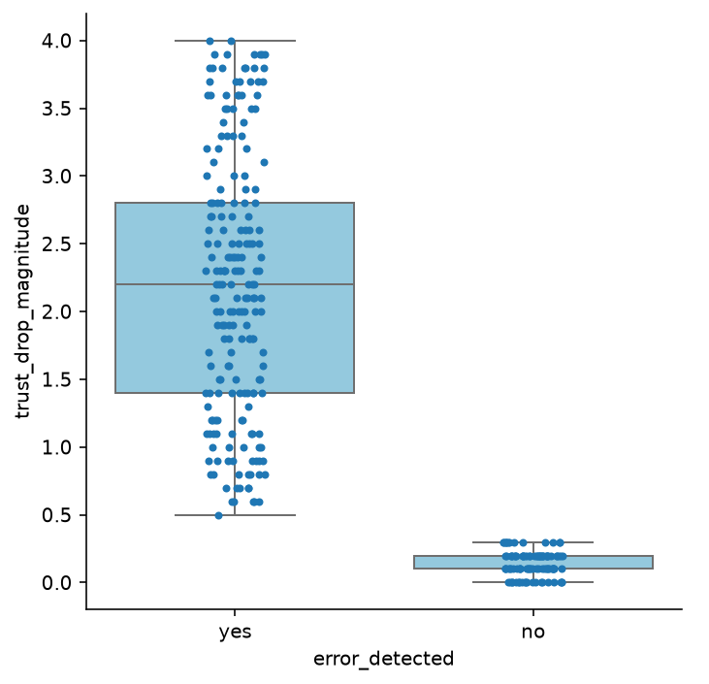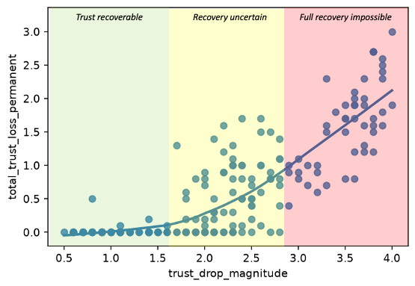
Fig 4.1 a) Impact of AI error incidence on user trust loss (left); b) Impact of trust loss magnitude on trust loss permanence (right)

Whether that lost trust is eventually recovered, was observed to be dependent on the magnitude of initial trust loss: as seen in the right-side plot of the figure above, minor breaches of trust (trust drop < 1.5) tend to result in full trust recovery; on the other hand, trust is less likely to be regained if the initial trust drop was severe. As a result, understanding what factors affect the magnitude of trust loss after an error is thus key to understanding the dynamics of AI trust loss and recovery.

4.3.2 Other Factors Impacting Post-Error Trust Drop Magnitude
Further analysis identified three potential factors that can impact the magnitude of trust loss experienced, when an error is made: their prior experience with AI, their critical thinking ability, and their general openness to technology.

Prior Experience with AI
To identify statistically significant variables in the dataset, ANOVA testing was done for categorical variables, and correlation coefficients were summarized for numeric variables. These revealed that relationships between variables in the dataset and trust loss are unexpectedly scarce. Correlation analysis revealed no significant correlations between any of the non-trust related variables in the dataset and trust drop magnitude, while ANOVA revealed only one significant variable: a user’s AI experience level (p = 0.0161).

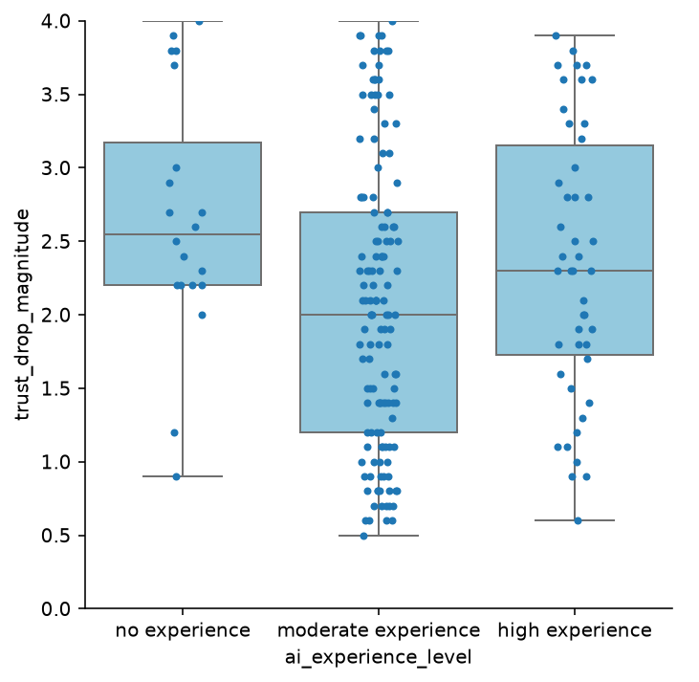
Fig 4.2 - Impact of AI experience levels of the trust loss after encountering an error.
Visualizing AI experience levels reveals some additional insights. Two groups tend to experience higher trust loss following an AI error: Users with no experience with AI might be even more reluctant to trust AI if their initial experience results in an error; meanwhile, users with high amounts of experience with AI might feel betrayed or more disappointed if AI produces an error after prolonged use.

Critical Thinking & Openness to Technology
Empirical research backs the notion that critical thinking score and openness to technology are key factors influencing a user’s propensity to trust AI tools [11-13]. Despite the poor correlations within the dataset, K-Means clustering based on these two factors together as well as trust drop magnitude reveals user personas that form a potentially useful framework for understanding how an individual’s critical thinking skills and openness to technology interact with the resilience of their trust in AI:

Cluster | Trust Drop | Critical Thinking Score* | Openness To Technology*
1 | 1.81 | 3.67 | 4.91
2 | 3.32 | 5.94 | 6.91
3 | 1.64 | 8.29 | 6.28
Table 4.1 – K-Means Clustering grouping with k = 3. Note: critical thinking/openness to technology scored out of 10
Three distinct user types can be identified from the clusters:
1: Disengaged Users – Low in both critical thinking and openness, these users are generally uninterested and do not trust AI much to begin with, hence do not experience much trust loss.
2: Uncritical Enthusiasts – Highly open to technology but lacking in critical thinking, these users may be uncritically reliant on AI and are more likely to be disappointed when it fails them.
3: AI-Literate – Open to technology while thinking critically about its use, these are ideal users who have well calibrated expectations of how AI should perform and are less affected by errors.
As the correlations within the dataset are not strong, the silhouette scores are not high. The elbow method (inertia) and silhouette scores for K ranging from 2-10 are shown below; despite a low silhouette score of 0.27, K = 3 was chosen for the highest explainability and ease of application.
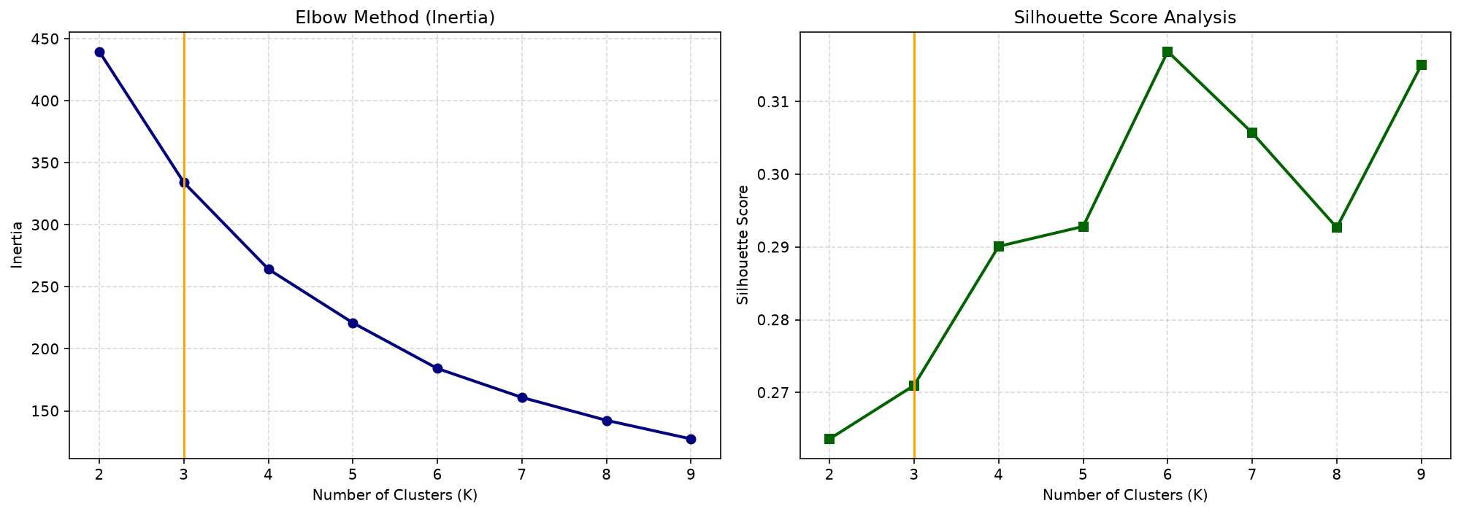
Fig 4.3 - Inertia and Silhouette scores vs K

4.4 Overall Findings and Limitations
In summary, while AI errors are almost certain to cause some loss in trust, the severity of that trust loss and whether that trust is regained are determined by other factors: 1. A user’s past experience with AI; 2. Their critical thinking levels; and 3. Their openness to technology.

It must be noted, however, that there are limitations with the dataset that are likely to have affected the aforementioned analysis. The dataset is notably small (errors detected n = 201). There are also no sources cited for its origin, and thus a possibility that the data was generated rather than obtained from actual experiments, which would explain the poor correlations between factors that should be strongly related based on actual research.
An attempt was made to develop machine learning models for trust drop magnitude prediction. These include: Linear/Random Forest/Ridge/Lasso regression models for predicting the value of trust drop magnitude, and Logistic Regression/Random Forest/Gradient Boosting for classification into high and low trust drop based on the median trust drop value. However, all models performed extremely poorly: The regression models had test set R² values of ~0.1 for Random Forest and ~0.01 for Ridge/Lasso. Meanwhile, all classification models had accuracies below 0.5. It is likely that none of the models were able to achieve a good fit because of poor or non-existent correlations within the dataset. With more real data, it should be expected that the analysis and predictive modelling will have stronger statistical support in line with the empirical evidence and findings from other sections.

5. Proposed Solutions: Calibrating Trust in AI
Sections 2 to 4 show that trust in AI depends on what users know about AI (prior experience, how the answer is presented, the stakes of the decision, and what happens when the AI fails. Section 4's user types offer us target. Uncritical Enthusiasts (open to technology but low in critical thinking) suffered the largest trust drops (3.32) after errors, Disengaged Users trusted AI little from the start, and AI-Literate users, who are open to AI but think critically about it, kept the most stable trust (1.64). The strategies below aim to move users toward the AI-Literate profile, reducing over-trust where AI is unreliable without creating under-trust where it is reliable. Section 5.1 focuses on people and institutions; Section 5.2 on how AI systems present their answers.

5.1 Building People's Ability to Judge AI and AI Accountability
We propose three solutions (A1 to A3), shaped by two findings. First, blind trust often reflects inexperience rather than a more reliable AI: higher education, AI familiarity and digital literacy all increased the odds of being skeptical rather than a blind truster (Section 3), and users with no prior AI experience were among those who lost the most trust after errors (Section 4). A1 and A2 therefore build people's ability to judge AI, reaching students through schools and older or less-connected people through communities. A3 focus on moving part of the checking to the organisations that build and deploy AI, as well as liability system.
A1. Enhancing AI literacy – Ways to verify AI (schools and educators)
AI literacy should go beyond basic tool usage to include critical verification: recognizing that LLMs can deliver confident falsehoods, tracing claims to independent sources, and knowing which decisions should never be delegated. Learning platforms like Common Sense Media put this into practice by teaching students and Uncritical Enthusiasts to critically audit AI-written articles and verify their claim independently.
- Common Sense Education's free lesson How to SIFT with AI (grades 9–12) has students investigate an AI-written article with real-looking citations, trace each claim back to its original source, and actively look for evidence against claims they want to be true. It teaches students to use AI as a verification aid rather than accepting its outputs at face value [14].

A2. Reaching older and less-connected groups (governments and community organisations).
The importance of the age dependency ratio (Section 2.3) suggests that older populations, often less familiar with AI, need dedicated support. This idea is exemplified by Infocomm Media Development Authority (IMDA) in Singapore:
- Since August 2024, IMDA has run generative AI workshops for older adults at community centers and libraries, reaching more than 6,000 seniors across over 500 workshops in various languages. The content covers risks such as hallucinations and deepfakes, and some classes teach seniors to verify AI answers by comparing responses across different GenAI models such as Gemini and Microsoft Copilot. Volunteers from the Singapore Computer Society have also run workshops for low-income residents with little family support [15]. This could be adapted by countries with older populations or lower internet use and also help Disengaged Users see where AI is genuinely useful.

A3. Assurance and accountability (governments and regulators).
Government effectiveness was also among the strongest predictors of national AI trust (Section 2), and four in five people say they would trust AI more if assurance mechanisms such as standards, monitoring and independent checks were in place [1]. We therefore propose that regulators push AI companies on two fronts: assurance, so that systems are tested by authorities and the results can be checked by the public, and accountability, so that companies face liability or penalties when their AI causes harm. Two examples are demonstrated below:
- Testing and transparency. Singapore’s AI Verify, launched by IMDA and PDPC in 2022, is a testing framework and toolkit that companies can adopt voluntarily. A company runs technical tests on its own AI system, such as fairness and robustness, and completes process checks on how the system is governed, such as who is accountable for it. It can then choose to share the results with customers and regulators. This provides the public with objective metrics instead of relying on self-reported claims, enabling companies that govern their AI effectively to demonstrate it, which supports calibrated trust[16].

- Clear liability. In the Moffatt v. Air Canada (2024) lawsuit, the airline argued its chatbot was responsible for its own misleading advice. But the tribunal rejected this and held the airline liable for negligent misrepresentation [17]. Hence, when organisations are accountable for what their AI says, they have a direct incentive to make it accurate, and users can rely on it knowing they have recourse if it is wrong.

5.2 Designing AI that signals when to trust it
Section 3.3 found that how AI response shape trust directly: cited sources sharply reduce skepticism, while hedging language increases it instead. The query context matters as well: higher decision stakes increase skepticism, but time pressure reduces it, so users check least when they are in a hurry. Hence, the development of AI should focus not only on accuracy, but also on indicating when the model is unreliable.
B1. Make sources real and checkable (AI developers)
We found that Citations were one of the strongest trust levers in Section 3: a sourced response was about 36 times less likely to leave a user highly skeptical. That makes fake or irrelevant citations especially dangerous. In the case Mata v. Avianca (2023), lawyers filed a brief citing court cases that ChatGPT had invented, and the chatbot even assured them the cases were real [18]. Sources should therefore link to retrievable documents that support the specific claim, helping users catch errors rather than simply raising trust. Checking should also be convenient, as in Google Gemini's "double-check response" feature, which compares the answer with Google Search results and highlights supported or contradicted statements [19].
B2. Reduce sycophancy and surface counterevidence (AI developers)
Language models trained on human feedback tend to tell users what they want to hear, partly because people rate agreeable answers more highly [20]. In April 2025, OpenAI rolled back a GPT-4o update after it became noticeably sycophantic; a reward signal based on users' thumbs-up feedback had contributed, because "user feedback in particular can sometimes favor more agreeable responses" [23]. An AI that flatters is most dangerous for Uncritical Enthusiasts, who rely on AI without questioning it (Section 4). We propose that developers test for sycophancy before every release, as OpenAI has since committed to do [21], and that on contested or high stakes questions the system presents the strongest evidence against the user's apparent view rather than only confirming it.
B3. Indicate limits clearly, especially where errors are expected (AI developers)
Section 4.3.1 showed that detection of errors in AI response is what triggers trust loss. Small drops tend to recover fully while large ones do not, and that Uncritical Enthusiasts suffer the largest drops (3.32). When Google first demonstrated its Bard chatbot in February 2023, the promotional demo stated that the James Webb Space Telescope took the first picture of a planet outside our solar system, which was false. Alphabet's shares fell 7.7 % that day afterwards, removing about US$100 billion in market value [22]. AI systems should therefore:
- Make clear what the system can do: according to Guidelines for Human-AI Interaction proposed by Amershi et al., AI systems should explicitly state their capabilities (G1 “Make clear what the system can do”) [23]. By setting expectations for potential errors, this practice helps mitigate the loss of trust when mistakes occur. Especially in high-stakes domains such as health, law and finance. AI should show sources and warnings by default or even decline to answer when reliability is low. This also helps prevent disastrous consequences caused by over-trust, particularly for users under time pressure who rarely verify information. Google's AI Overviews shows this in practice. Shortly after launch in May 2024, the feature told users to put glue on pizza and eat rocks. Google responded by restricting the timing of when overviews appear, as well as limiting the use of forum and social-media content and pausing summaries on higher-stakes topics such as health [24].

6. Conclusion
This report started from a simple problem: many people now use AI regularly without being trained to judge it. Using three datasets at different levels (countries, individual AI interactions, and users after an AI error), we asked what shapes trust in AI and how that trust changes when AI fails. The results point the same way: trust depends on who the user is, how high the stakes are and how the answer is presented, and it falls once users detect an error. Many of these factors have little to do with whether the AI is actually right, so trust can drift away from how reliable the AI really is.
At the country level (Section 2), AI trust percentages were associated with age structure, mean years of schooling, government effectiveness and internet use, with many lower-income countries predicted to trust AI more than developed ones. At the individual level (Section 3), decision stakes were the dominant driver of skepticism; education, AI familiarity and digital literacy made users more critical; and response quality such as citations and the absence of hedging, together with time pressure, pushed users toward blind trust. After failure (Section 4), detecting an error caused trust to fall; small drops recovered while large ones did not, and users with no or extensive AI experience, as well as users who lack critical thinking capabilities, lost the most.
Calibrated trust therefore cannot be left to users alone. Section 5 proposed shared responsibility: governments and educators building AI literacy, reaching older and less-connected groups, and providing assurance and accountability; and AI developers making sources checkable, resisting sycophancy, and signaling the limits of their systems before errors occur.
These proposals are general directions rather than tested interventions. They rest on observational datasets, some of which may be synthetic, that show associations rather than causes, and their effect on trust calibration would need to be evaluated, for example through controlled experiments, before large-scale adoption. The aim is not to make people trust AI more or less, but to make their trust follow how reliable the AI really is.

References
[1] N. Gillespie, S. Lockey, T. Ward, A. Macdade, and G. Hassed, Trust, Attitudes and Use of Artificial Intelligence: A Global Study 2025. The University of Melbourne and KPMG, 2025. https://doi.org/10.26188/28822919
[2] S. S. Y. Kim, J. Wortman Vaughan, Q. V. Liao, T. Lombrozo, and O. Russakovsky, "Fostering appropriate reliance on large language models: The role of explanations, sources, and inconsistencies," in Proc. CHI Conf. Human Factors in Computing Systems, 2025, Art. no. 420. https://doi.org/10.1145/3706598.3714020
[3] Mind Lab, "Global AI trust and attitudes by country 2025," Kaggle, 2025 [Dataset]. https://www.kaggle.com/datasets/kylefengkfeng209/global-ai-trust-and-attitudes-by-country-2025
[4] United Nations Development Programme, "Human Development Index (HDI)," Human Development Reports, 2023 [Dataset]. https://hdr.undp.org/data-center/human-development-index#/indicies/HDI
[5] World Bank, "World Development Indicators," DataBank, 2026 [Dataset]. https://databank.worldbank.org/source/world-development-indicators
[6] WunderBart, "World by ISO GeoJSON," GitHub Gist, n.d. [GeoJSON dataset]. https://gist.github.com/WunderBart/e18b8c620480a46eb7d11a1dbdbb4aef
[7] E. Fatima, "AI trust insights," Kaggle, 2025 [Dataset]. https://www.kaggle.com/datasets/emanfatima2/ai-trust-insights
[8] P. Song, P. Han, and N. Goodman, "Large language model reasoning failures," arXiv preprint arXiv:2602.06176, 2026. https://arxiv.org/html/2602.06176v1
[9] D. A. Alber, Z. Yang, A. Alyakin, E. Yang, et al., "Medical large language models are vulnerable to data-poisoning attacks," Nature Medicine, vol. 31, pp. 618–626, 2025. https://www.nature.com/articles/s41591-024-03445-1
[10] S. Landge, "Human trust decay in AI," Kaggle, n.d. [Dataset]. https://www.kaggle.com/datasets/landgesakshi/human-trust-decay-in-ai
[11] "The role of undergraduates' critical thinking in generative AI reliance behaviors in problem-solving," British Journal of Educational Technology, vol. 56, no. 5, pp. 1919–1941, 2025. https://doi.org/10.1111/bjet.13613
[12] S. Afroogh, A. Akbari, E. Malone, M. Kargar, and H. Alambeigi, "Trust in AI: Progress, challenges, and future directions," Humanities and Social Sciences Communications, vol. 11, Art. no. 1568, 2024. https://doi.org/10.1057/s41599-024-04044-8
[13] M. van Bekkum, M. de Boer, F. van Harmelen, A. Meyer-Vitali, and A. ten Teije, "Modular design patterns for hybrid intelligence systems," in Proc. 30th ACM Int. Conf. Inf. Knowl. Manage., 2021, pp. 288–296. https://doi.org/10.1145/3462244.3479926
[14] Common Sense Education, "How to SIFT with AI," Digital Literacy Lesson (Grades 9–12), n.d. https://www.commonsense.org/education/digital-literacy/how-to-sift-with-ai
[15] S. Koh, "This is how seniors are keeping up to date amidst national push for Gen AI," The Straits Times, Nov. 2, 2025 (republished by HardwareZone, Nov. 7, 2025). https://www.hardwarezone.com.sg/lifestyle/ai/singapore-seniors-learning-ai-skills-literacy
[16] Personal Data Protection Commission Singapore, "Launch of AI Verify – An AI governance testing framework and toolkit," May 2022. https://www.pdpc.gov.sg/news-and-events/announcements/2022/05/launch-of-ai-verify---an-ai-governance-testing-framework-and-toolkit
[17] Moffatt v. Air Canada, 2024 BCCRT 149. Summary by Dentons, "Airline ordered to compensate a B.C. man because its chatbot provided inaccurate information," 2024. https://www.dentonsdata.com/airline-ordered-to-compensate-a-b-c-man-because-its-chatbot-provided-inaccurate-information/
[18] Mata v. Avianca, Inc., No. 22-cv-1461 (S.D.N.Y. June 22, 2023). Summary available at: https://en.wikipedia.org/wiki/Mata_v._Avianca,_Inc.
[19] Microsoft HAX Toolkit, "Google Gemini: G2 – Make clear how well the system can do what it can do," n.d. https://www.microsoft.com/en-us/haxtoolkit/example/google-gemini-g2-make-clear-how-well-the-system-can-do-what-it-can-do-2/
[20] M. Sharma et al., "Towards understanding sycophancy in language models," in Proc. Int. Conf. Learn. Represent. (ICLR), 2024. https://arxiv.org/abs/2310.13548
[21] OpenAI, "Expanding on what we missed with sycophancy," May 2025. https://openai.com/index/expanding-on-sycophancy/
[22] CNN, "Google shares lose $100 billion after company's AI chatbot makes an error during demo," Feb. 8, 2023. https://www.cnn.com/2023/02/08/tech/google-ai-bard-demo-error
[23] S. Amershi et al., "Guidelines for human-AI interaction," in Proc. CHI Conf. Human Factors in Computing Systems, 2019, pp. 1–13. https://doi.org/10.1145/3290605.3300233
[24] R. Hart, "Google restricts AI search tool after 'nonsensical' answers told people to eat rocks and put glue on pizza," Forbes, May 31, 2024. https://www.forbes.com/sites/roberthart/2024/05/31/google-restricts-ai-search-tool-after-nonsensical-answers-told-people-to-eat-rocks-and-put-glue-on-pizza/

