AQI論文重點

Table 1. Identified key indicators for monthly AQI of Taiwan

|  |  |  |  |  |
| --- | --- | --- | --- | --- |
|  | MARS | RF | XGB | Importance |
| Seasonal factor (SF) | 27.80% | 26.87% | 54.38% | 36.35% |
| Carbon power generation (CPG) | 15.61% | 23.27% | 21.10% | 20.00% |
| Steel and metals production (SMP) | 13.32% | 5.62% | 2.71% | 7.22% |
| Manufacturing employment population (MEP) | 12.54% | 4.18% | 2.52% | 6.41% |
| Retail employment population (REP) | 10.05% | 3.78% | 4.31% | 6.04% |
| [Highway cargo load (HCL) in thousand ton-kilometer](javascript:openUrl(210,21,%221%22,%22e3120001%22,%22%22)) | 8.48% | 4.78% | 1.60% | 4.95% |
| Number of registered cars (NRC) | 9.04% | 2.97% | 1.10% | 4.37% |
| Manufacturing purchasing manager index (PMI) | 3.16% | 3.14% | 1.69% | 2.66% |
| Industrial production index (IPI) |  | 5.05% | 2.74% | 2.60% |
| [Highway passenger load (HPL) in thousand person-kilometer](javascript:openUrl(210,21,%221%22,%22e3110001%22,%22%22)) |  | 4.47% | 2.39% | 2.29% |
| Chemicals and plastics production (CPP) |  | 3.38% | 2.30% | 1.89% |
| Number of registered motorcycles (NRM) |  | 3.83% | 0.56% | 1.46% |
| Non-manufacturing purchasing manager index (NMI) |  | 2.87% | 1.07% | 1.31% |
| Waste incineration volume (WIV) |  | 2.89% | 0.96% | 1.28% |
| Construction employment population (CEP) |  | 2.90% | 0.57% | 1.16% |

Table 5. The relationships between the indicators and principal components

|  |  |  |  |  |  |  |  |  |  |  |  |  |  |  |  |
| --- | --- | --- | --- | --- | --- | --- | --- | --- | --- | --- | --- | --- | --- | --- | --- |
|  | PC1 | PC2 | PC3 | PC4 | PC5 | PC6 | PC7 | PC8 | PC9 | PC10 | PC11 | PC12 | PC13 | PC14 | PC15 |
| MEP | 0.19 | 0.30 | -0.39 | -0.13 | 0.05 | -0.14 | 0.49 | -0.29 | 0.14 | -0.04 | 0.07 | -0.03 | 0.36 | 0.45 | -0.01 |
| CEP | 0.36 | -0.20 | 0.09 | 0.10 | 0.13 | -0.16 | -0.12 | -0.01 | -0.37 | 0.19 | -0.18 | 0.52 | 0.52 | -0.06 | 0.02 |
| REP | 0.35 | 0.13 | -0.27 | -0.09 | 0.06 | -0.09 | 0.12 | -0.34 | -0.11 | -0.04 | 0.09 | -0.11 | -0.16 | -0.74 | 0.17 |
| IPI | 0.25 | 0.14 | 0.33 | 0.48 | -0.07 | 0.13 | 0.26 | 0.14 | -0.12 | 0.00 | -0.27 | -0.56 | 0.23 | -0.07 | -0.05 |
| PMI | -0.28 | 0.01 | 0.26 | 0.19 | 0.29 | -0.75 | 0.30 | 0.02 | -0.05 | -0.18 | -0.01 | 0.09 | -0.19 | -0.05 | -0.01 |
| NMI | -0.01 | 0.29 | 0.34 | -0.18 | 0.62 | 0.05 | -0.41 | -0.24 | 0.14 | -0.01 | 0.15 | -0.22 | 0.24 | 0.02 | 0.05 |
| HPL | -0.16 | 0.44 | -0.04 | 0.09 | 0.33 | 0.37 | 0.22 | -0.04 | -0.19 | 0.25 | -0.39 | 0.33 | -0.34 | 0.02 | -0.07 |
| HCL | 0.31 | 0.25 | 0.14 | 0.28 | 0.04 | 0.10 | 0.12 | 0.35 | 0.13 | 0.11 | 0.69 | 0.27 | -0.12 | 0.00 | 0.04 |
| NRC | 0.39 | -0.12 | -0.03 | 0.05 | 0.10 | -0.08 | -0.15 | -0.19 | -0.08 | -0.08 | 0.02 | -0.06 | -0.32 | 0.17 | -0.78 |
| NRM | 0.38 | -0.19 | 0.03 | 0.11 | 0.11 | -0.02 | -0.11 | -0.16 | -0.14 | -0.07 | -0.09 | -0.08 | -0.42 | 0.43 | 0.60 |
| WIV | 0.33 | 0.14 | -0.19 | -0.16 | 0.13 | -0.24 | -0.16 | 0.53 | 0.49 | 0.01 | -0.42 | 0.00 | -0.05 | -0.07 | 0.03 |
| CPG | 0.17 | 0.19 | 0.47 | -0.13 | -0.32 | 0.13 | 0.07 | -0.23 | 0.25 | -0.54 | -0.18 | 0.36 | -0.01 | -0.04 | 0.00 |
| CPP | -0.01 | 0.48 | -0.15 | -0.17 | -0.16 | -0.13 | -0.26 | 0.30 | -0.60 | -0.37 | 0.06 | -0.08 | 0.01 | 0.10 | 0.01 |
| SMP | -0.09 | 0.37 | -0.10 | 0.45 | -0.38 | -0.28 | -0.43 | -0.33 | 0.18 | 0.29 | -0.06 | 0.06 | -0.01 | 0.04 | 0.03 |
| SF | -0.13 | -0.13 | -0.41 | 0.53 | 0.28 | 0.21 | -0.13 | 0.01 | 0.12 | -0.57 | -0.01 | 0.12 | 0.14 | -0.06 | 0.01 |

Table 6. The explained proportion of variance for principal components

|  |  |  |  |
| --- | --- | --- | --- |
|  | Variance | Proportion of  variance | Cumulative proportion |
| PC1 | 5.82 | 38.81% | 38.81% |
| PC2 | 3.27 | 21.82% | 60.62% |
| PC3 | 2.36 | 15.75% | 76.37% |
| PC4 | 1.05 | 6.99% | 83.37% |
| PC5 | 0.87 | 5.77% | 89.14% |
| PC6 | 0.45 | 3.00% | 92.14% |
| PC7 | 0.30 | 2.01% | 94.15% |
| PC8 | 0.27 | 1.79% | 95.94% |
| PC9 | 0.19 | 1.26% | 97.20% |
| PC10 | 0.17 | 1.13% | 98.33% |
| PC11 | 0.12 | 0.83% | 99.16% |
| PC12 | 0.07 | 0.46% | 99.62% |
| PC13 | 0.05 | 0.32% | 99.94% |
| PC14 | 0.01 | 0.04% | 99.98% |
| PC15 | 0.00 | 0.02% | 100.00% |

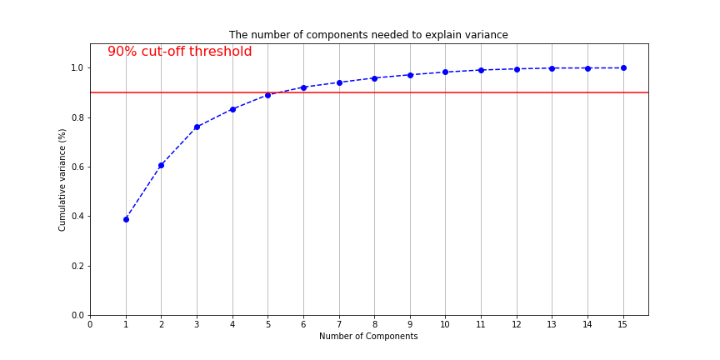

Table 2. Forecasting Taiwan aggregate AQI based on key indicators

(KPI TOP7: SF, CPG, SMP, MEP, REP, HCL, NRC)

|  |  |  |  |  |  |
| --- | --- | --- | --- | --- | --- |
| Training | MARS | RF | XGB | SVR | DNN |
| RMSE | 7.90 | 6.06 | 6.08 | 8.70 | 8.77 |
| MAE | 6.42 | 4.76 | 4.67 | 7.06 | 6.52 |
| MAPE | 10.32% | 7.37% | 7.12% | 11.21% | 10.20% |
| Testing | MARS | RF | XGB | SVR | DNN |
| RMSE | 10.48 | 8.18 | 6.97 | 7.43 | 7.85 |
| MAE | 7.86 | 6.79 | 5.49 | 6.06 | 6.45 |
| MAPE | 12.09% | 11.63% | 9.79% | 10.54% | 11.13% |

Table 7. Forecasting Taiwan aggregate AQI based on key indicators (PCA)

|  |  |  |  |  |  |
| --- | --- | --- | --- | --- | --- |
| Training | MARS | RF | XGB | SVR | DNN |
| RMSE | 9.76 | 5.75 | 4.97 | 8.94 | 8.41 |
| MAE | 8.12 | 4.83 | 3.67 | 7.59 | 6.34 |
| MAPE | 13.06% | 8.13% | 5.52% | 12.33% | 9.92% |
| Testing | MARS | RF | XGB | SVR | DNN |
| RMSE | 10.00 | 12.52 | 11.98 | 10.74 | 7.86 |
| MAE | 7.24 | 10.36 | 9.35 | 7.84 | 5.84 |
| MAPE | 12.90% | 18.53% | 15.43% | 13.82% | 10.07% |

Table 8. Identified key predictors of daily AQI of Hsinchu

|  |  |  |  |  |
| --- | --- | --- | --- | --- |
| Environmental factors and pollutants | MARS | RF | XGB | Average |
| PM2.5 | 33.69% | 17.96% | 64.30% | 38.65% |
| O3 | 20.26% | 9.91% | 19.92% | 16.70% |
| Wind speed per hour average (WSH) | 20.26% | 4.26% | 5.73% | 10.09% |
| Ambient temperature | 9.55% | 9.45% | 4.14% | 7.71% |
| PM10 | 0.00% | 14.81% | 0.72% | 5.18% |
| CO | 0.00% | 11.62% | 0.29% | 3.97% |
| NO | 6.85% | 2.69% | 1.13% | 3.56% |
| NOx | 5.88% | 3.94% | 0.72% | 3.51% |
| NO2 | 0.00% | 9.67% | 0.33% | 3.33% |
| SO2 | 3.50% | 1.50% | 0.33% | 1.78% |
| THCM (total hydrogen-carbon mix) | 0.00% | 4.20% | 0.65% | 1.62% |
| NHCM (non-hydrogen-carbon mix) | 0.00% | 3.71% | 0.21% | 1.31% |
| Humidity | 0.00% | 2.94% | 0.96% | 1.30% |
| CH4 | 0.00% | 2.18% | 0.41% | 0.87% |
| Rainfall | 0.00% | 0.73% | 0.12% | 0.28% |
| Weekday | 0.00% | 0.42% | 0.04% | 0.15% |
| Wind direction per hour average (WDH)  * 逐日沒有這資料 |  |  |  |  |

Table 11. The relationships between the indicators and principal components

|  |  |  |  |  |  |  |  |  |  |  |  |  |  |  |  |  |
| --- | --- | --- | --- | --- | --- | --- | --- | --- | --- | --- | --- | --- | --- | --- | --- | --- |
|  | PC1 | PC2 | PC3 | PC4 | PC5 | PC6 | PC7 | PC8 | PC9 | PC10 | PC11 | PC12 | PC13 | PC14 | PC15 | PC16 |
| Ambient… | 0.17 | -0.29 | -0.42 | 0.04 | 0.26 | 0.20 | 0.37 | 0.14 | -0.37 | -0.41 | -0.35 | -0.03 | 0.11 | 0.08 | 0.00 | 0.00 |
| CH4 | -0.27 | 0.20 | 0.14 | -0.35 | 0.26 | -0.19 | 0.40 | 0.02 | -0.21 | 0.21 | 0.02 | -0.14 | 0.05 | -0.01 | 0.61 | 0.00 |
| CO | -0.35 | 0.03 | 0.03 | 0.12 | -0.05 | 0.03 | -0.15 | -0.05 | 0.18 | -0.20 | -0.26 | -0.78 | -0.02 | 0.28 | 0.00 | 0.00 |
| NMHC | -0.35 | -0.14 | 0.01 | 0.01 | -0.11 | 0.06 | -0.03 | -0.08 | 0.16 | -0.20 | -0.38 | 0.34 | -0.64 | -0.19 | 0.24 | 0.00 |
| NO | -0.26 | -0.33 | -0.18 | -0.17 | 0.03 | -0.25 | -0.10 | -0.28 | -0.12 | -0.43 | 0.60 | -0.04 | -0.05 | -0.06 | 0.00 | -0.23 |
| NO2 | -0.36 | -0.13 | 0.00 | 0.06 | -0.07 | 0.03 | 0.00 | -0.04 | 0.16 | 0.11 | -0.25 | 0.30 | 0.53 | 0.12 | 0.01 | -0.60 |
| NOx | -0.36 | -0.19 | -0.05 | -0.01 | -0.04 | -0.05 | -0.03 | -0.11 | 0.09 | -0.04 | -0.02 | 0.22 | 0.40 | 0.08 | 0.00 | 0.77 |
| O3 | 0.00 | 0.58 | 0.11 | 0.00 | -0.06 | 0.25 | 0.32 | -0.04 | 0.31 | -0.57 | 0.17 | 0.14 | 0.14 | -0.01 | 0.00 | 0.00 |
| PM10 | -0.26 | 0.34 | -0.20 | 0.28 | -0.07 | 0.11 | -0.12 | 0.01 | -0.46 | 0.09 | 0.16 | 0.22 | -0.19 | 0.58 | 0.01 | 0.00 |
| PM2.5 | -0.29 | 0.25 | -0.16 | 0.33 | -0.03 | 0.13 | -0.17 | 0.09 | -0.33 | 0.03 | 0.02 | -0.13 | 0.16 | -0.72 | -0.01 | 0.00 |
| Rainfall | 0.02 | -0.19 | 0.50 | 0.02 | 0.10 | 0.58 | 0.02 | -0.54 | -0.27 | 0.05 | 0.03 | -0.04 | 0.02 | -0.01 | 0.00 | 0.00 |
| RH | -0.09 | -0.16 | 0.59 | -0.02 | 0.04 | -0.03 | -0.21 | 0.64 | -0.22 | -0.31 | 0.05 | 0.08 | 0.05 | 0.06 | 0.00 | 0.00 |
| SO2 | -0.09 | 0.10 | -0.26 | -0.45 | 0.49 | 0.44 | -0.45 | 0.16 | 0.19 | 0.06 | 0.06 | 0.04 | -0.01 | 0.02 | 0.00 | 0.00 |
| THC | -0.33 | 0.12 | 0.11 | -0.28 | 0.17 | -0.13 | 0.31 | -0.01 | -0.12 | 0.11 | -0.11 | 0.01 | -0.16 | -0.06 | -0.76 | 0.00 |
| Weekday | -0.06 | -0.10 | -0.15 | -0.46 | -0.73 | 0.35 | 0.13 | 0.21 | -0.12 | 0.09 | 0.08 | -0.11 | 0.01 | -0.02 | 0.00 | 0.00 |
| WSH | 0.20 | 0.29 | 0.05 | -0.38 | -0.16 | -0.29 | -0.40 | -0.31 | -0.33 | -0.25 | -0.40 | 0.07 | 0.15 | -0.01 | 0.00 | 0.00 |

Table 12. The explained proportion of variance for principal components

|  |  |  |  |
| --- | --- | --- | --- |
|  | Variance | Proportion of  variance | Cumulative proportion |
| PC1 | 6.77 | 42.28% | 42.28% |
| PC2 | 2.14 | 13.38% | 55.66% |
| PC3 | 1.65 | 10.30% | 65.96% |
| PC4 | 1.12 | 7.01% | 72.97% |
| PC5 | 0.99 | 6.21% | 79.19% |
| PC6 | 0.87 | 5.46% | 84.64% |
| PC7 | 0.70 | 4.39% | 89.03% |
| PC8 | 0.59 | 3.68% | 92.71% |
| PC9 | 0.45 | 2.79% | 95.50% |
| PC10 | 0.26 | 1.64% | 97.14% |
| PC11 | 0.19 | 1.21% | 98.35% |
| PC12 | 0.13 | 0.81% | 99.16% |
| PC13 | 0.07 | 0.45% | 99.62% |
| PC14 | 0.06 | 0.38% | 100.00% |
| PC15 | 0.00 | 0.00% | 100.00% |
| PC16 | 0.00 | 0.00% | 100.00% |

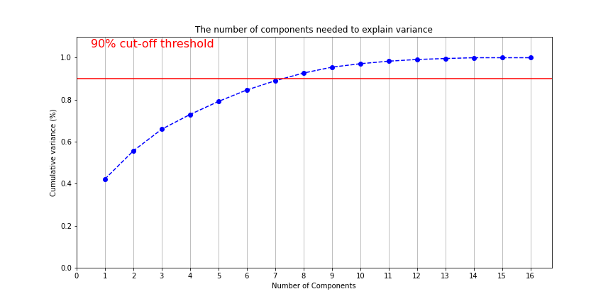

Table 9. Forecasting daily AQI of Hsinchu (KPI)

|  |  |  |  |  |  |  |  |  |
| --- | --- | --- | --- | --- | --- | --- | --- | --- |
| Training | MARS | RF | XGB | SVR | DNN | RNN | LSTM | GRU |
| RMSE | 7.23 | 5.03 | 4.35 | 12.65 | 10.11 | 9.77 | 8.72 | 8.11 |
| MAE | 4.80 | 2.45 | 2.68 | 6.83 | 6.23 | 6.29 | 5.04 | 4.72 |
| MAPE | 8.69% | 4.11% | 4.75% | 10.90% | 10.21% | 10.83% | 8.81% | 8.30% |
| Testing | MARS | RF | XGB | SVR | DNN | RNN | LSTM | GRU |
| RMSE | 7.09 | 8.96 | 7.66 | 9.76 | 9.26 | 8.17 | 7.68 | 7.64 |
| MAE | 5.09 | 5.59 | 5.34 | 5.79 | 5.94 | 5.23 | 4.78 | 4.86 |
| MAPE | 10.69% | 11.08% | 10.80% | 10.57% | 10.86% | 9.79% | 9.25% | 9.46% |

Table 13. Forecasting daily AQI of Hsinchu (PCA)

|  |  |  |  |  |  |  |  |  |
| --- | --- | --- | --- | --- | --- | --- | --- | --- |
| Training | MARS | RF | XGB | SVR | DNN | RNN | LSTM | GRU |
| RMSE | 14.76 | 11.93 | 14.95 | 13.54 | 12.46 | 12.39 | 11.43 | 11.78 |
| MAE | 9.65 | 7.43 | 8.87 | 8.36 | 7.32 | 7.14 | 6.93 | 7.61 |
| MAPE | 17.43% | 13.12% | 14.57% | 14.53% | 11.64% | 11.57% | 11.45% | 13.30% |
| Testing | MARS | RF | XGB | SVR | DNN | RNN | LSTM | GRU |
| RMSE | 11.65 | 11.63 | 11.71 | 10.24 | 8.80 | 8.66 | 8.83 | 8.09 |
| MAE | 7.92 | 8.33 | 8.08 | 7.29 | 6.17 | 6.65 | 6.25 | 6.09 |
| MAPE | 15.65% | 17.43% | 15.97% | 14.95% | 12.38% | 13.94% | 12.60% | 12.52% |

Table 14. Identified key predictors of hourly AQI of Kaohsiung

|  |  |  |  |  |
| --- | --- | --- | --- | --- |
| Environmental factors and pollutants | MARS | RF | XGB | Average |
| PM2.5 | 44.71% | 43.64% | 65.01% | 51.12% |
| PM10 | 7.17% | 23.34% | 21.87% | 17.46% |
| O3 | 13.28% | 3.57% | 2.84% | 6.56% |
| Ambient temperature | 10.98% | 4.30% | 2.56% | 5.95% |
| Humidity | 10.26% | 1.52% | 1.31% | 4.37% |
| NO | 6.26% | 1.09% | 0.77% | 2.71% |
| Wind direction per hour average (WDH) | 4.93% | 1.32% | 0.75% | 2.34% |
| CO | 0.00% | 6.24% | 0.63% | 2.29% |
| NOx | 2.40% | 1.55% | 0.36% | 1.44% |
| NO2 | 0.00% | 2.93% | 1.16% | 1.36% |
| CH4 | 0.00% | 3.19% | 0.52% | 1.24% |
| THCM (total hydrogen-carbon mix) | 0.00% | 2.03% | 0.24% | 0.76% |
| Wind speed per hour average (WSH) | 0.00% | 1.11% | 0.44% | 0.52% |
| Wind direction in the last ten minutes | 0.00% | 0.88% | 0.46% | 0.45% |
| SO2 | 0.00% | 0.86% | 0.46% | 0.44% |
| Wind speed in the last ten minutes | 0.00% | 0.97% | 0.28% | 0.42% |
| NHCM (non hydrogen-carbon mix) | 0.00% | 0.83% | 0.27% | 0.37% |
| Rainfall | 0.00% | 0.61% | 0.05% | 0.22% |

Table 16. The relationships between the indicators and principal components

|  |  |  |  |  |  |  |  |  |  |  |  |  |  |  |  |  |  |  |
| --- | --- | --- | --- | --- | --- | --- | --- | --- | --- | --- | --- | --- | --- | --- | --- | --- | --- | --- |
|  | PC1 | PC2 | PC3 | PC4 | PC5 | PC6 | PC7 | PC8 | PC9 | PC10 | PC11 | PC12 | PC13 | PC14 | PC15 | PC16 | PC17 | PC18 |
| Ambient… | 0.26 | -0.01 | 0.38 | -0.21 | -0.23 | -0.06 | 0.12 | 0.13 | 0.28 | 0.63 | -0.01 | 0.35 | -0.21 | 0.12 | 0.06 | 0.04 | 0.00 | 0.00 |
| CH4 | -0.33 | 0.04 | -0.28 | -0.11 | -0.06 | -0.05 | -0.04 | -0.03 | -0.34 | 0.56 | -0.07 | -0.21 | 0.04 | -0.11 | -0.05 | 0.03 | -0.54 | 0.00 |
| CO | -0.35 | -0.16 | 0.03 | -0.05 | 0.03 | 0.17 | -0.01 | 0.02 | 0.02 | -0.01 | 0.02 | -0.18 | -0.24 | 0.80 | 0.15 | -0.26 | 0.00 | 0.00 |
| NMHC | -0.22 | -0.06 | 0.28 | 0.21 | -0.42 | -0.54 | -0.03 | 0.26 | 0.15 | -0.30 | 0.04 | -0.01 | 0.11 | 0.04 | 0.01 | -0.02 | -0.39 | 0.00 |
| NO | -0.22 | 0.02 | 0.46 | 0.27 | 0.34 | 0.24 | 0.17 | 0.20 | 0.22 | 0.17 | -0.10 | -0.36 | 0.19 | -0.17 | -0.02 | 0.03 | 0.00 | 0.38 |
| NO2 | -0.36 | -0.03 | 0.11 | -0.02 | 0.02 | 0.08 | -0.04 | 0.00 | -0.33 | -0.15 | 0.08 | 0.54 | -0.36 | -0.14 | 0.01 | 0.09 | 0.00 | 0.51 |
| NOx | -0.35 | -0.01 | 0.30 | 0.12 | 0.18 | 0.17 | 0.06 | 0.10 | -0.11 | -0.01 | 0.01 | 0.18 | -0.15 | -0.18 | 0.00 | 0.08 | 0.00 | -0.77 |
| O3 | 0.13 | -0.35 | 0.00 | -0.29 | -0.27 | 0.21 | 0.05 | 0.34 | -0.05 | -0.16 | 0.03 | -0.44 | -0.47 | -0.30 | 0.01 | 0.03 | 0.00 | 0.00 |
| PM10 | -0.26 | -0.28 | -0.20 | -0.18 | -0.03 | 0.13 | -0.09 | 0.03 | 0.40 | 0.04 | 0.00 | 0.24 | 0.22 | -0.31 | 0.11 | -0.61 | 0.00 | 0.00 |
| PM2.5 | -0.28 | -0.25 | -0.26 | -0.13 | -0.03 | 0.12 | -0.10 | -0.01 | 0.47 | -0.02 | 0.02 | 0.09 | 0.10 | 0.10 | -0.17 | 0.69 | 0.00 | 0.00 |
| Rainfall | 0.05 | 0.08 | -0.05 | 0.49 | -0.61 | 0.58 | -0.06 | -0.04 | -0.07 | 0.06 | -0.01 | 0.06 | 0.15 | 0.03 | 0.03 | 0.01 | 0.00 | 0.00 |
| RH | -0.11 | 0.35 | -0.20 | 0.35 | 0.01 | -0.14 | -0.08 | -0.26 | 0.43 | 0.08 | 0.09 | -0.14 | -0.60 | -0.17 | -0.01 | -0.08 | 0.00 | 0.00 |
| SO2 | -0.08 | -0.19 | 0.45 | -0.21 | -0.18 | 0.00 | -0.17 | -0.77 | -0.01 | -0.03 | 0.00 | -0.19 | 0.04 | -0.11 | -0.02 | 0.02 | 0.00 | 0.00 |
| THC | -0.35 | 0.00 | -0.06 | 0.03 | -0.27 | -0.32 | -0.04 | 0.12 | -0.17 | 0.25 | -0.03 | -0.16 | 0.09 | -0.06 | -0.03 | 0.01 | 0.74 | 0.00 |
| WDH | 0.03 | -0.38 | -0.13 | 0.25 | -0.01 | -0.13 | 0.46 | -0.18 | -0.02 | -0.02 | -0.70 | 0.09 | -0.14 | 0.01 | -0.03 | -0.01 | 0.00 | 0.00 |
| Wind direction… | 0.04 | -0.38 | -0.10 | 0.23 | 0.04 | -0.10 | 0.51 | -0.16 | -0.06 | 0.11 | 0.68 | 0.00 | 0.05 | -0.02 | 0.07 | 0.02 | 0.00 | 0.00 |
| Wind speed… | 0.16 | -0.37 | 0.05 | 0.27 | 0.14 | -0.05 | -0.41 | 0.07 | -0.07 | 0.14 | 0.07 | 0.05 | -0.09 | 0.08 | -0.70 | -0.16 | 0.00 | 0.00 |
| WSH | 0.15 | -0.35 | -0.01 | 0.29 | 0.18 | -0.11 | -0.49 | 0.04 | -0.07 | 0.13 | -0.04 | -0.01 | -0.03 | -0.06 | 0.65 | 0.16 | 0.00 | 0.00 |

Table 17. The explained proportion of variance for principal components

|  |  |  |  |
| --- | --- | --- | --- |
|  | Variance | Proportion of  variance | Cumulative proportion |
| PC1 | 6.26 | 34.78% | 34.78% |
| PC2 | 3.92 | 21.80% | 56.58% |
| PC3 | 1.49 | 8.28% | 64.86% |
| PC4 | 1.23 | 6.82% | 71.69% |
| PC5 | 0.95 | 5.28% | 76.96% |
| PC6 | 0.89 | 4.92% | 81.88% |
| PC7 | 0.75 | 4.16% | 86.05% |
| PC8 | 0.66 | 3.68% | 89.72% |
| PC9 | 0.45 | 2.49% | 92.21% |
| PC10 | 0.37 | 2.06% | 94.27% |
| PC11 | 0.26 | 1.46% | 95.73% |
| PC12 | 0.25 | 1.39% | 97.12% |
| PC13 | 0.22 | 1.22% | 98.34% |
| PC14 | 0.14 | 0.77% | 99.11% |
| PC15 | 0.09 | 0.49% | 99.60% |
| PC16 | 0.07 | 0.40% | 100.00% |
| PC17 | 0.00 | 0.00% | 100.00% |
| PC18 | 0.00 | 0.00% | 100.00% |

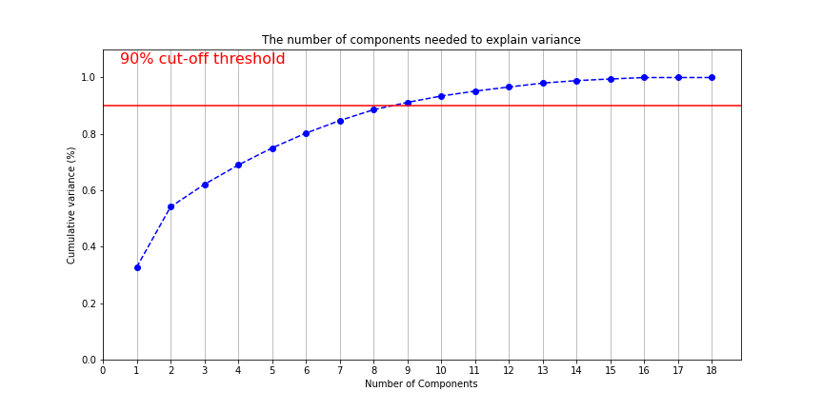

Table 15. Forecasting hourly AQI of Kaohsiung (KPI)

|  |  |  |  |  |  |  |  |  |
| --- | --- | --- | --- | --- | --- | --- | --- | --- |
| Training | MARS | RF | XGB | SVR | DNN | RNN | LSTM | GRU |
| RMSE | 13.32 | 10.71 | 11.50 | 14.05 | 12.75 | 10.83 | 6.57 | 9.53 |
| MAE | 9.24 | 7.56 | 8.01 | 9.22 | 8.57 | 6.42 | 3.66 | 5.88 |
| MAPE | 18.05% | 14.34% | 14.29% | 17.15% | 15.87% | 12.14% | 7.87% | 12.30% |
| Testing | MARS | RF | XGB | SVR | DNN | RNN | LSTM | GRU |
| RMSE | 14.59 | 14.01 | 13.58 | 15.04 | 14.09 | 12.80 | 11.53 | 12.44 |
| MAE | 9.96 | 9.65 | 9.32 | 10.14 | 9.51 | 7.82 | 7.05 | 7.98 |
| MAPE | 18.16% | 17.25% | 16.43% | 17.91% | 16.84% | 13.97% | 13.19% | 14.38% |

Table 18. Forecasting hourly AQI of Kaohsiung (PCA)

|  |  |  |  |  |  |  |  |  |
| --- | --- | --- | --- | --- | --- | --- | --- | --- |
| Training | MARS | RF | XGB | SVR | DNN | RNN | LSTM | GRU |
| RMSE | 13.72 | 11.81 | 10.75 | 14.27 | 13.07 | 10.26 | 9.80 | 9.61 |
| MAE | 9.84 | 8.62 | 7.85 | 10.09 | 8.96 | 7.07 | 6.01 | 5.97 |
| MAPE | 19.18% | 17.03% | 15.50% | 19.69% | 16.36% | 13.35% | 11.26% | 11.36% |
| Testing | MARS | RF | XGB | SVR | DNN | RNN | LSTM | GRU |
| RMSE | 15.13 | 14.64 | 14.89 | 15.38 | 15.06 | 12.88 | 13.43 | 13.49 |
| MAE | 10.62 | 10.58 | 10.51 | 10.76 | 10.26 | 8.82 | 8.84 | 8.93 |
| MAPE | 19.54% | 19.99% | 18.95% | 19.45% | 17.95% | 15.52% | 15.42% | 15.74% |