6/20/2026
Onyinyechi Anita Ikea
POLARIS POD

Business Requirements Document, Gap Analysis, And Process Mapping for Barrel & Brew
Focus: Brewery Industry
Proposed Solution: Brewery Operations Management System
Tools Used: Brd Template, Draw.Io, Fishbone Diagram, Process Mapping

BARREL & BREW CAPSTONE PROJECT
BRD, GAP ANALYSIS, AND PROCESS MAPPING
The purpose of this Business Requirements Document is to define the business need, current challenges, proposed solution, scope, stakeholders, requirements, assumptions, risks, and success measures for improving Barrel & Brew’s brewing and bottling operations.
This BRD is based on the case study requirement to document a proposed technical solution that addresses the gaps in Barrel & Brew’s current process.

2. BUSINESS BACKGROUND
Barrel & Brew is a family-owned craft brewery/winery that has operated for about ten years. The business is known for its unique small-batch products and has built a strong local customer base.
Over the past year, demand has increased significantly, and the company’s products are now stocked in over 500 local restaurants. However, this growth has exposed weaknesses in production planning, inventory tracking, quality control, staff workload, equipment reliability, and communication between departments.

3. BUSINESS PROBLEM STATEMENT
Barrel & Brew is struggling to meet increased demand because its operations still depend heavily on manual processes, informal communication, handwritten records, outdated spreadsheets, and aging equipment.
The current process creates production delays, inconsistent product quality, inaccurate inventory records, poor forecasting, staff pressure, and customer dissatisfaction. The Sales Manager currently estimates demand based on intuition, production requests are made by phone, recipes are checked from handwritten notebooks, fermentation is recorded manually, bottling is disrupted by equipment jams, and inventory is updated on an outdated spreadsheet.

4. BUSINESS OBJECTIVES
The project aims to help Barrel & Brew achieve the following objectives:
Objective | Description
Improve production reliability | Help the brewery meet weekly production targets more consistently
Improve product quality | Reduce batch variation and prevent avoidable batch rejection
Improve inventory accuracy | Provide real-time visibility of ingredients, batches, and finished goods
Improve demand planning | Replace intuition-based forecasting with data-supported planning
Reduce manual work | Minimize duplicate entry, handwritten records, and outdated spreadsheet dependency
Improve communication | Align sales, brewing, bottling, and management with shared information
Support staff productivity | Reduce unnecessary overtime and pressure on key employees
Improve management visibility | Provide dashboards and reports for better decision-making

5. PROPOSED SOLUTION
The proposed solution is a Brewery Operations Management System that connects sales demand, production planning, recipe management, fermentation tracking, quality control, bottling, inventory, and reporting.
The system will act as a single source of truth for the business and support the company’s desired future state of reliable production, high quality, empowered staff, improved operations, data-driven decisions, and modern infrastructure.

6. PROJECT SCOPE
In Scope

Area | Included Activities
Demand forecasting | Capture sales data, customer orders, and demand trends
Production planning | Create, review, approve, and track production requests
Recipe management | Store approved digital recipes and ingredient requirements
Inventory management | Track ingredients, work-in-progress batches, and finished goods
Fermentation tracking | Record fermentation progress in a digital log
Quality control | Capture QC checklist results and batch approval status
Bottling tracking | Record bottling activity, bottled quantity, and downtime
Sales availability check | Allow Sales to confirm available stock before customer commitment
Reporting dashboard | Provide KPIs for management review

Out of Scope
Area | Reason
Full replacement of all brewery equipment | Equipment upgrade may be handled as a separate capital project
Distributor system integration at launch | Can be considered in a later project phase
Customer-facing ordering portal | The first focus is internal operational control
Payroll or HR management | Staff morale is affected, but payroll is not part of this system
Accounting system replacement | Financial reporting may be integrated later

7. Stakeholders
Stakeholder | Role / Interest
Business Owner / Leadership Team | Sponsors the project and approves investment
Sales Manager | Uses sales data, forecasts demand, and checks stock before customer commitment
Brewer / Production Team | Uses digital recipes, records production and fermentation progress
Bottling Team | Records bottling output and reports bottling downtime
Quality Control Staff | Reviews and approves batch quality
Inventory Officer / Operations Staff | Monitors ingredients, finished goods, and stock movement
Management Team | Reviews dashboards and operational performance
IT / System Vendor | Configures and supports the system

8.STAKEHOLDER MAPPING|
Barrel & Brew’s current challenges affect several teams, including Sales, Brewing, Bottling, Quality Control, Inventory, Management, and IT/System Support. The company needs better production planning, inventory visibility, quality control, and communication between sales and production teams.
Stakeholder | Role / Interest | Influence | Interest | Engagement
Business Owner / Leadership Team | Sponsors project and approves investment | High | High | Manage closely
Sales Manager | Uses sales data, forecasts demand, and confirms stock | High | High | Involve closely
Brewer / Production Team | Uses recipes and records production progress | High | High | Involve closely
Quality Control Staff | Reviews and approves batch quality | High | High | Involve closely
Bottling Team | Records bottled output and downtime | Medium | High | Consult regularly
Inventory / Operations Officer | Tracks ingredients and finished goods | Medium | High | Consult regularly
Management Team | Reviews dashboards and performance | High | Medium | Keep satisfied
IT / System Vendor | Configures and supports the system | Medium | Medium | Collaborate
Restaurant Customers / Distributors | Depend on product availability and delivery | Low | High | Keep informed through Sales

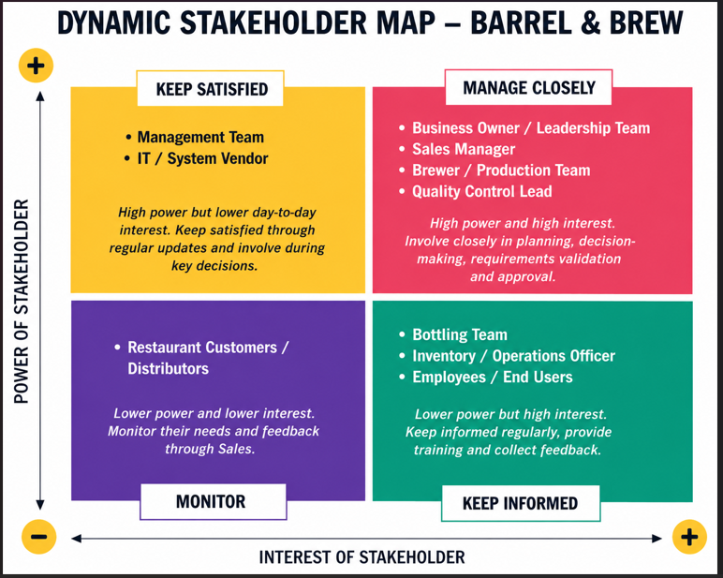
9. BUSINESS NEED

Barrel & Brew needs a structured, technology-enabled process that supports reliable production, consistent quality, empowered staff, improved operations, data-driven decisions, and modern infrastructure.

10. CURRENT-STATE ANALYSIS
- Sales Manager estimates demand based on intuition
- Sales Manager calls Brewer with production request
- Brewer checks handwritten notebook for recipe and ingredients
- Brewer confirms ingredients and brewing capacity
- Brewer begins brewing using handwritten recipe
- Brewer records fermentation manually in notebook and spreadsheet
- Brewer performs manual quality check by tasting
- Brewer notifies Bottling Team
- Bottling Team moves beer to bottling line
- Bottling line jams and production is halted
- Bottling Team completes bottling
- Bottles are manually counted
- Inventory is manually updated on outdated spreadsheet
- Sales Manager places customer order without confirming updated stock

8. CURRENT-STATE PAIN POINTS
Area | Current Problem | Business Impact
Forecasting | Demand is based on intuition | Overstock, shortages, missed targets
Production Planning | Requests are made by phone | Poor tracking and miscommunication
Recipe Management | Recipes are handwritten | Quality inconsistency
Inventory | Spreadsheet is out of date | Wrong stock information
Quality Control | Manual tasting | Inconsistent standards
Equipment | Bottling line jams | Production delays
Communication | Sales does not confirm availability | Disappointed customers
Staff Workload | Manual work and overtime | Low morale and burnout

9. GAP ANALYSIS
Gap Analysis with Proposed Solution Actions
Business Area | Current State | Desired Future State | Gap | Proposed Solution Action
Demand Forecasting | Intuition-based demand estimate | Data-driven forecasting | No formal forecasting system | • Implement demand forecasting  • Use distributor, restaurant, customer order, and sales trend data
Production Planning | Phone call request | Documented production request workflow | No structured planning process | • Use the integrated brewery management system to create and track production requests  • Include approval status, priority, quantity, and required date
Recipe Management | Handwritten recipes | Centralized digital recipe database | No digital recipe system | • Implement digital recipe management  • Store versioned recipes with ingredient validation
Inventory Management | Outdated spreadsheet | Real-time inventory tracking | Poor stock visibility | • Implement real-time inventory tracking  • Auto-update stock levels for ingredients, batches, and finished goods
Fermentation Tracking | Notebook and spreadsheet | Digital fermentation log | Duplicate manual recording | • Use the integrated system to capture fermentation progress digitally  • Track batch stage, temperature, observations, and status
Quality Control | Manual tasting | Standardized QC checklist | Weak quality control process | • Implement a digital QC workflow  • Use QC checkpoints, digital capture, and hold/release approval before bottling
Bottling Process | Frequent bottling line jams | Reliable equipment and maintenance tracking | Outdated equipment | • Introduce automated bottling support  • Track jam detection, auto-stop events, bottle count, and bottling downtime
Communication | Sales promises without confirming availability | Shared stock and batch visibility | Sales-production disconnect | • Use shared system visibility across sales, production, bottling, and inventory  • Allow Sales to confirm available stock and batch status before customer commitment
Staff Workload | Overworked staff and overtime | Reduced manual burden | Staff morale gap | • Reduce manual tasks through automation  • Use digital workflows for forecasting, recipes, QC, bottling, and inventory updates
Reporting | Informal knowledge and spreadsheets | Management dashboard | Poor decision visibility | • Implement dashboards and analytics  • Track production, sales, QC, inventory, bottling, and operational KPIs

11. CURRENT-STATE PROCESS MAP

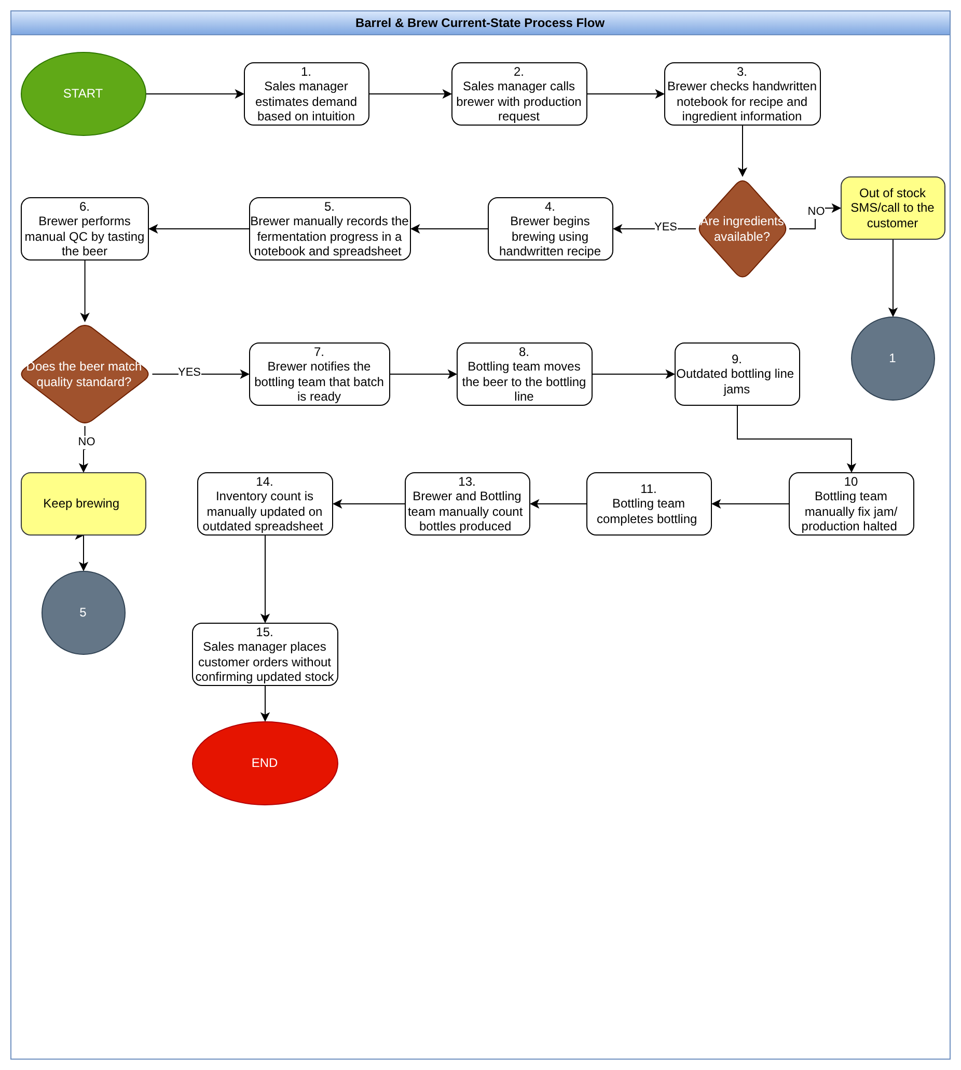

12. PROPOSED FUTURE-STATE SOLUTION

Barrel & Brew should implement a Brewery Operations Management System that connects:
- Sales demand
- Production planning
- Recipe management
- Fermentation tracking
- Quality control
- Bottling updates
- Inventory management
- Reporting dashboards

This system will help staff work with accurate information and reduce dependence on notebooks, outdated spreadsheets, and informal communication.

13. FUTURE-STATE PROCESS OVERVIEW
- Sales data and customer orders are captured in the system
- System generates demand forecast
- Sales Manager reviews and submits production request
- System checks recipe, inventory, and brewing capacity
- Brewer reviews and approves batch
- Brewer follows standardized digital recipe
- Fermentation progress is recorded digitally
- Quality control checklist is completed
- Batch status updates to ready for bottling
- Bottling Team receives notification
- Bottling is completed and quantity recorded
- Inventory updates automatically
- Sales confirms stock before customer commitment
- Management reviews dashboard

Future-State Swimlane Diagram
Swimlane | Role
Sales Manager | Captures demand and raises production request
Brewery Operations System | Checks data, updates status, and sends notifications
Brewer / Production Team | Reviews request, brews batch, tracks fermentation
Quality Control | Checks and approves batch quality
Bottling Team | Bottles approved batch and records output
Management | Monitors dashboard and performance

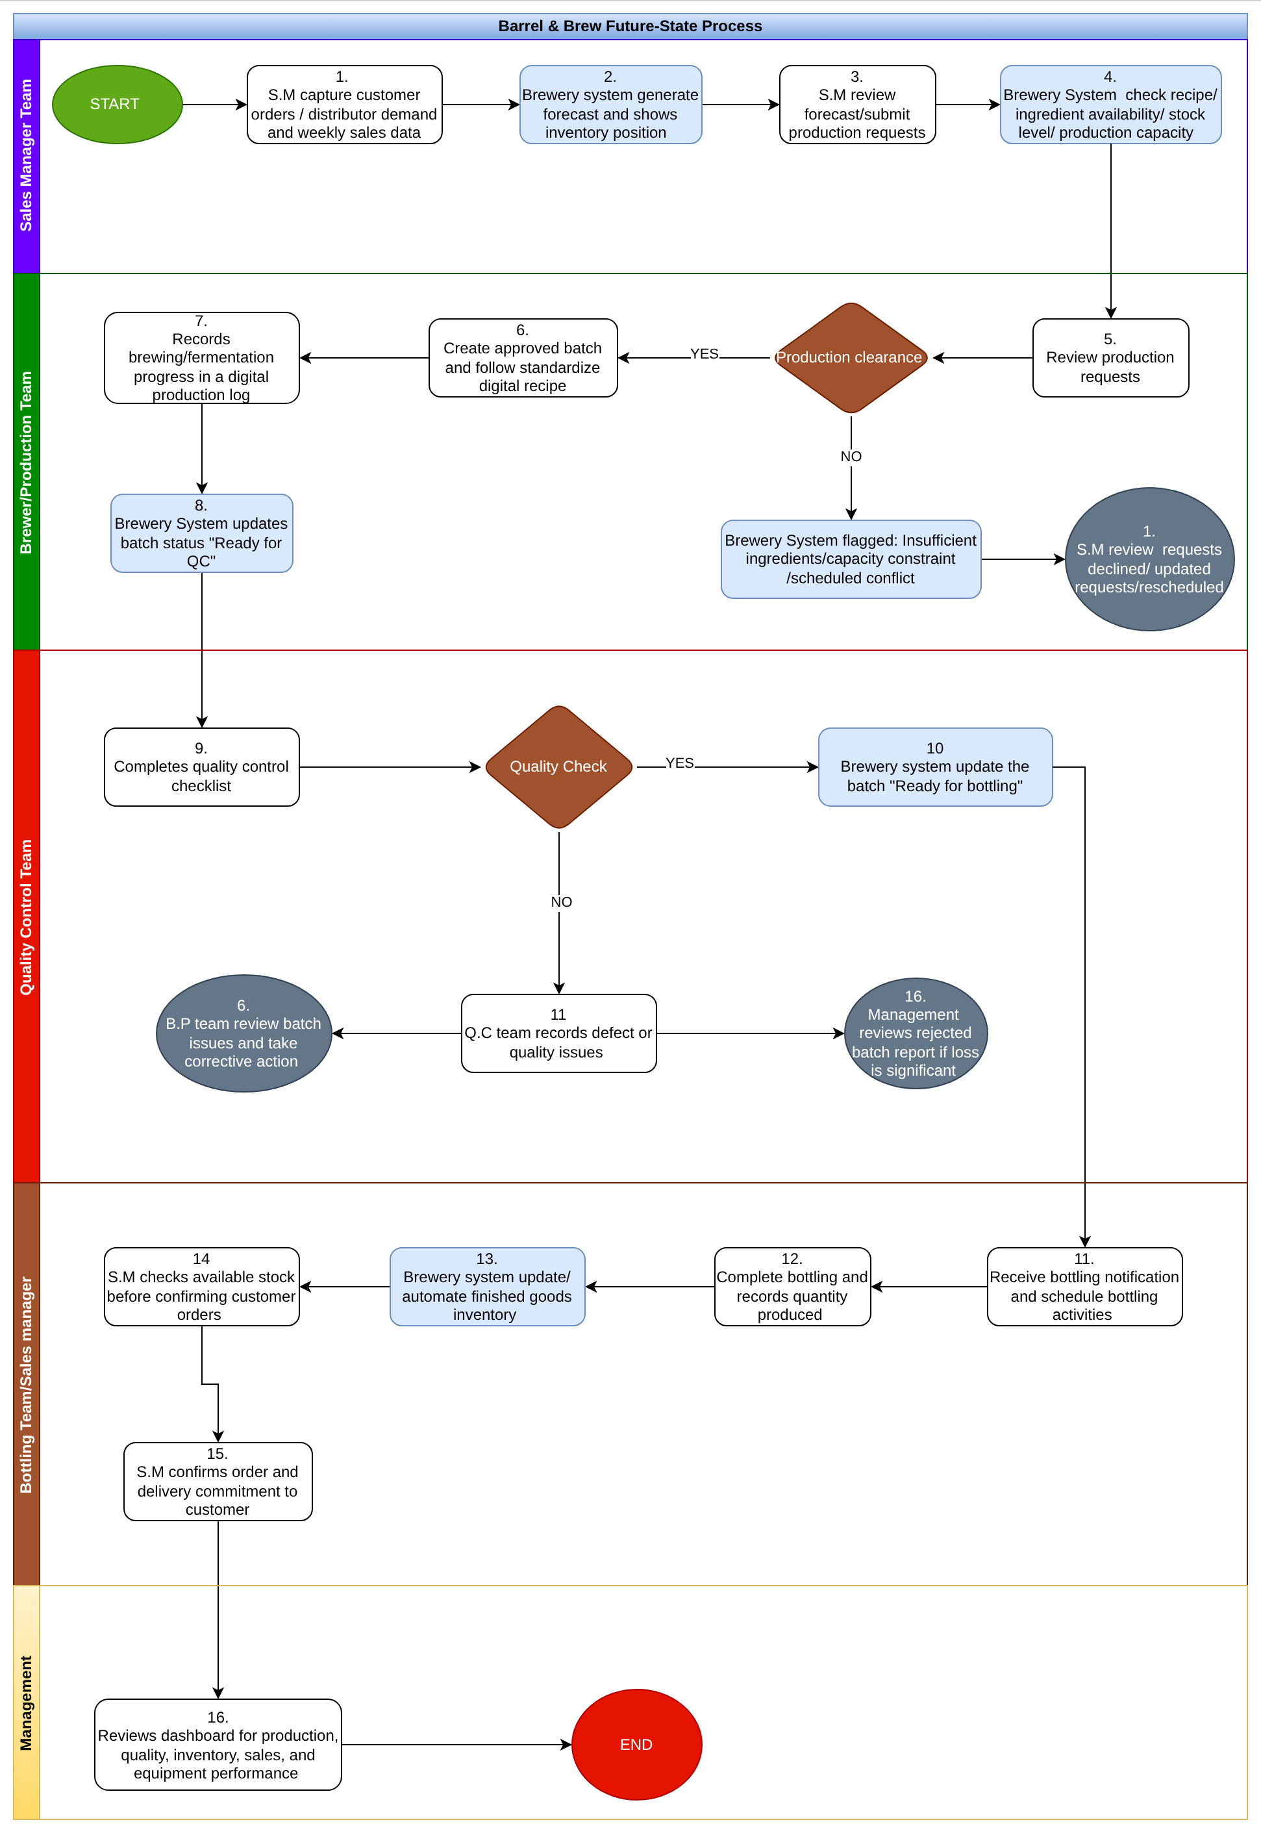

14. FUNCTIONAL REQUIREMENTS
14.1 Demand Forecasting Requirements
Requirement ID | Requirement
FR01 | The system shall capture weekly sales data and customer demand records.
FR02 | The system shall generate demand forecasts based on sales trends and confirmed orders.
FR03 | The Sales Manager shall be able to review forecasted demand before submitting a production request.
FR04 | The system shall allow management to compare forecasted demand against actual sales.

14.2 Production Planning Requirements
Requirement ID | Requirement
FR05 | The system shall allow the Sales Manager to submit a production request.
FR06 | The production request shall include product name, quantity, required date, priority, and reason for request.
FR07 | The system shall check ingredient availability and brewing capacity before production approval.
FR08 | The Brewer or Production Manager shall be able to approve, reject, or reschedule a production request.
FR09 | The system shall assign a unique batch ID to each approved production batch.

14.3 Recipe Management Requirements
Requirement ID | Requirement
FR10 | The system shall store approved digital recipes for each product.
FR11 | Each recipe shall include ingredients, quantities, brewing steps, fermentation requirements, and quality parameters.
FR12 | The system shall maintain recipe version history.
FR13 | Only authorized users shall be able to edit approved recipes.

14.4 Fermentation Tracking Requirements
Requirement ID | Requirement
FR14 | The Brewer shall record fermentation progress in the system.
FR15 | The fermentation log shall include batch ID, date, temperature, stage, observation notes, and responsible staff.
FR16 | The system shall update batch status as brewing, fermenting, ready for QC, approved, rejected, or ready for bottling.

15.5 Quality Control Requirements
Requirement ID | Requirement
FR17 | The system shall provide a quality control checklist for each batch.
FR18 | QC checks shall include taste, aroma, appearance, temperature review, batch notes review, and approval decision.
FR19 | A batch shall not move to bottling until QC approval is completed.
FR20 | The system shall record rejected batches and reasons for rejection.

14.6 Bottling Requirements
Requirement ID | Requirement
FR21 | The Bottling Team shall receive notification when a batch is ready for bottling.
FR22 | The system shall allow the Bottling Team to record bottled quantity.
FR23 | The system shall allow bottling downtime to be recorded, including cause and duration.
FR24 | The system shall update finished goods inventory after bottling is completed.

14.7 Inventory Requirements
Requirement ID | Requirement
FR25 | The system shall track ingredient inventory levels.
FR26 | The system shall deduct ingredients when a production batch is approved or started.
FR27 | The system shall update finished goods after bottling.
FR28 | The system shall show available, reserved, and out-of-stock quantities.
FR29 | The system shall alert users when ingredient or finished goods stock falls below reorder level.

14.8 Sales Availability Requirements
Requirement ID | Requirement
FR30 | The Sales Manager shall be able to view available finished goods before confirming customer orders.
FR31 | The system shall allow stock to be reserved for confirmed customer orders.
FR32 | The system shall prevent users from confirming orders that exceed available stock unless management override is approved.

14.9 Reporting Requirements
Requirement ID | Requirement
FR33 | The system shall provide a production performance dashboard.
FR34 | The system shall show weekly production target versus actual output.
FR35 | The system shall show inventory levels by product and ingredient.
FR36 | The system shall show batch rejection rate and quality issues.
FR37 | The system shall show bottling downtime and causes.
FR38 | The system shall show forecast accuracy and order fulfillment rate.

15. Non-Functional Requirements
Requirement ID | Requirement
NFR01 | The system should be easy for sales, brewing, bottling, and management staff to use.
NFR02 | The system should support role-based access control.
NFR03 | The system should be available during core production and sales hours.
NFR04 | The system should keep audit records of key changes, including recipe edits, QC approvals, and inventory adjustments.
NFR05 | The system should be scalable enough to support future growth and additional restaurant customers.
NFR06 | The system should protect business data through secure login and user permissions.
NFR07 | Reports and dashboards should load quickly enough for daily operational use.
NFR08 | The system should allow data export for management reporting.

16. Business Rules
Rule ID | Business Rule
BR01 | Production requests must be reviewed before brewing starts.
BR02 | Brewing must follow an approved recipe version.
BR03 | A batch must pass QC before bottling begins.
BR04 | Finished goods inventory must be updated after bottling is completed.
BR05 | Sales must confirm stock availability before committing to customers.
BR06 | Only authorized users can edit recipes or approve rejected batch decisions.
BR07 | Inventory alerts should be triggered when stock falls below reorder level.

17. Success Metrics
Success Metric | Target Outcome
Production target achievement | Increase weekly production target completion, reducing delay rate by 50%
Inventory accuracy | Reduce difference between system stock and physical stock by giving 100% real time inventory update
Batch rejection rate | Reduce rejected or discarded batches
Bottling downtime | Reduce downtime caused by bottling line jams
Forecast accuracy | Improve alignment between forecasted and actual demand
Order fulfillment rate | Increase percentage of customer orders fulfilled on time
Overtime hours | Reduce avoidable overtime by 30%
Customer complaints | Reduce complaints caused by unavailable products

18. RECOMMENDATION
Recommend that Barrel & Brew should:
- Implement the Brewery Operations Management System in phases
- Start with demand forecasting, production planning, inventory, and QC modules
- Train all users before go-live
- Clean existing recipe, inventory, and sales data before migration
- Track KPIs after implementation
- Create a preventive maintenance plan for bottling equipment

19. BRD Conclusion
Barrel & Brew’s growth has created a need for stronger operational control. The business can no longer rely on intuition, handwritten records, outdated spreadsheets, manual inventory updates, and informal communication.
The proposed Brewery Operations Management System will help the company improve production planning, recipe control, quality consistency, inventory accuracy, bottling tracking, staff productivity, and management reporting.
This BRD provides the foundation for moving from the current manual process to a more reliable, data-supported, and scalable operating model.

20.BRD Approval Section
The approval section confirms that the key stakeholders have reviewed and accepted the Business Requirements Document for the proposed Brewery Operations Management System. Approval from these stakeholders shows that the documented requirements, business needs, and proposed solutions align with Barrel & Brew’s operational goals.

Stakeholder Sign-Off Table
Stakeholder Name | Role / Title | Signature | Date
CEO/director | Owner / Executive Sponsor
HOS | Sales Manager
HOP | Lead Brewer / Production Head
Ikea Onyinychi A | Lead Business Analyst
HOD | IT / Technical Delivery Lead

Document Revision History
Version | Date | Author | Description of Changes
v1.0 | June 20, 2026 | Ikea Onyinyechi Anita | Initial Draft for Review

