INSTACART
Sales & Customer Insights
Dashboard Analysis
Portfolio Case Study | SQL & Power BI

Role | Data Analyst / Business Intelligence Analyst
Tools | PostgreSQL, SQL, Power BI, Power Query, DAX
Analysis | Descriptive, Diagnostic and Prescriptive
Deliverables | SQL analysis, data model, interactive dashboards, business report

Prepared by Ikea Onyinyechi Anita

Table of Contents
1. Executive Summary 3
2. Business Background and Problem 3
3. Project Objectives 3
4. Scope 4
5. Dataset and Data Model 4
6. Data Preparation and Modelling 4
7. SQL Business Questions 5
8. Dashboard Overview 5
9. KPI Analysis 8
10. Product Performance Analysis 8
11. Aisle Demand and Profitability Analysis 9
12. Sales Trend Analysis 10
13. Orders by Time of Day 10
14. Quantity Sold by Department 11
15. Descriptive Analysis Summary 11
16. Diagnostic Analysis 12
17. Prescriptive Analysis and Recommendations 12
18. Business Value Delivered 12
19. Challenges Encountered and Resolutions 13
20. Key Learnings 13
21. Skills Demonstrated 13
22. Limitations and Future Improvements 14
23. Conclusion 14
24. Portfolio Summary 14

1. Executive Summary
This project analyses Instacart transactional data using SQL and Power BI to provide management with a consolidated view of sales, customers, product performance, profitability, time-based demand and departmental activity. The solution combines SQL business-question analysis with interactive Power BI dashboards and a star-schema data model.
Key KPI | Reported Figure
Total Revenue | $158.37M
Total Orders | 1.05M
Total Customers | 63K
Average Order Value | $151.03

The dashboard shows that demand is concentrated in a small number of departments and aisles, customer activity peaks in the afternoon, and profitability differs materially across categories. These findings support inventory prioritisation, workforce planning, pricing review and product-mix decisions.

2. Business Background and Problem
Instacart operates an online grocery delivery and pickup model in which customers place orders across a broad catalogue of products, aisles and departments. A high-volume transaction environment creates a need for reliable reporting that helps management understand where demand is coming from and which areas require attention.

Business Problem
- Limited visibility into the departments and products driving sales.
- Difficulty distinguishing high-demand/high-profit areas from high-demand/low-profit areas.
- Limited understanding of the busiest periods for workforce planning.
- Need for a consistent view of sales trends for inventory and campaign planning.
- Need to answer management questions using reproducible SQL analysis rather than assumptions.

3. Project Objectives
- Build an interactive Power BI reporting solution for sales and product performance.
- Identify best- and worst-selling products.
- Identify aisles with high customer demand but low profitability.
- Identify aisles with both high demand and high profitability.
- Analyse monthly sales trends and time-of-day demand.
- Compare department-level quantity sold.
- Use SQL to answer defined business questions and validate key metrics.
- Translate findings into practical business recommendations.

4. Scope
In Scope | Out of Scope
Orders, products, aisles and departments | Customer demographic profiling
Revenue, quantity, order and customer KPIs | Delivery-route optimisation
Product and aisle performance | Supplier contract analysis
Sales trend and time-of-day analysis | Marketing attribution modelling
SQL and Power BI reporting | Predictive forecasting model development

5. Dataset and Data Model
The analytical model is based on transactional order data supported by product, aisle and department attributes.
Table | Role in Model | Key Analytical Use
Orders | Fact table | Order quantity, order date/time, customer/order activity
Products | Dimension | Product name, price/cost and category keys
Aisles | Dimension | Aisle-level grouping and demand/profit analysis
Departments | Dimension | Department-level sales and quantity analysis

Star Schema Design
The fact table contains transactional order activity, while descriptive attributes are held in dimension tables. This design supports one-to-many relationships, simpler DAX measures and clearer filtering across report pages.

6. Data Preparation and Modelling
- Reviewed data types for IDs, dates, quantities, prices and time fields.
- Handled missing values where required during Power Query transformation.
- Maintained product_id as the key linking order transactions to product attributes.
- Used department_id and aisle_id to connect product records to category dimensions.
- Created measures for revenue, orders, customers, average order value and profitability.
- Created time-of-day groupings to support workforce-demand analysis.

7. SQL Business Questions
The SQL analysis was designed around management questions that could be answered directly from the relational data.
Business Question | Analytical Purpose
What are the top 5 departments by revenue? | Identify the strongest revenue-driving categories.
What are the top 3 products sold during weekends? | Understand weekend product demand.
Does bread generate more profit than alcoholic products? | Compare category profitability.
Which products have not been sold at all? | Identify inactive catalogue items.
What are total orders, customers, revenue and AOV? | Provide executive-level KPIs.

Unsold Product Interpretation
A LEFT JOIN between Products and Orders is used to identify products without matching order records. When the order-side product ID is NULL, the product exists in the catalogue but has no recorded sale. If no rows are returned, the correct conclusion is that every product has at least one matching sale in the analysed data.

8. Dashboard Overview
The Power BI solution contains two main analytical pages. The Product page focuses on product and aisle performance, while the Sales page focuses on trends, time-of-day demand and department-level quantity sold.

Product Performance Dashboard
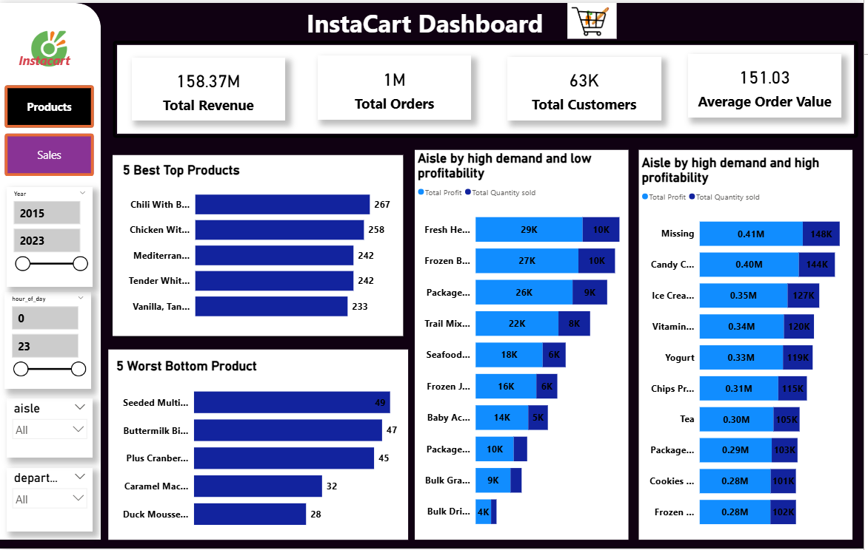
Figure 1. Product and aisle performance dashboard
Updated final Sales Dashboard (Year/Quarter filtering and Annual Quantity Sold Trend)
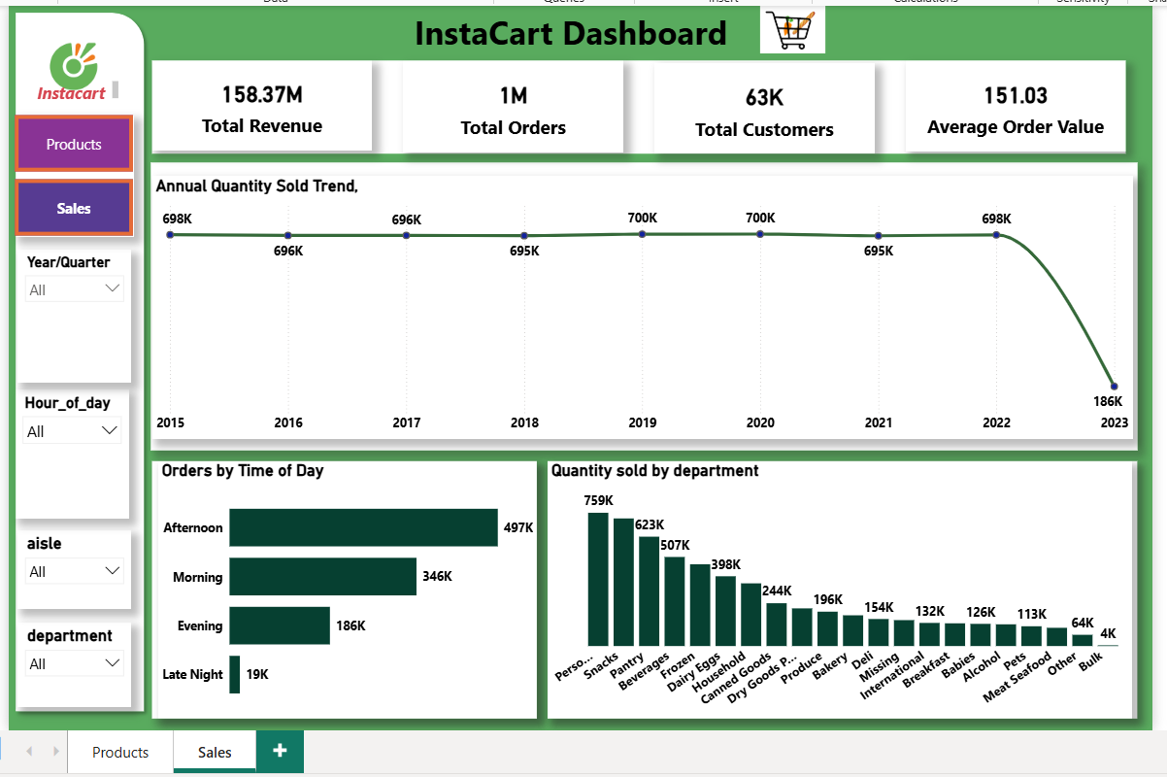

Sales Performance Dashboard
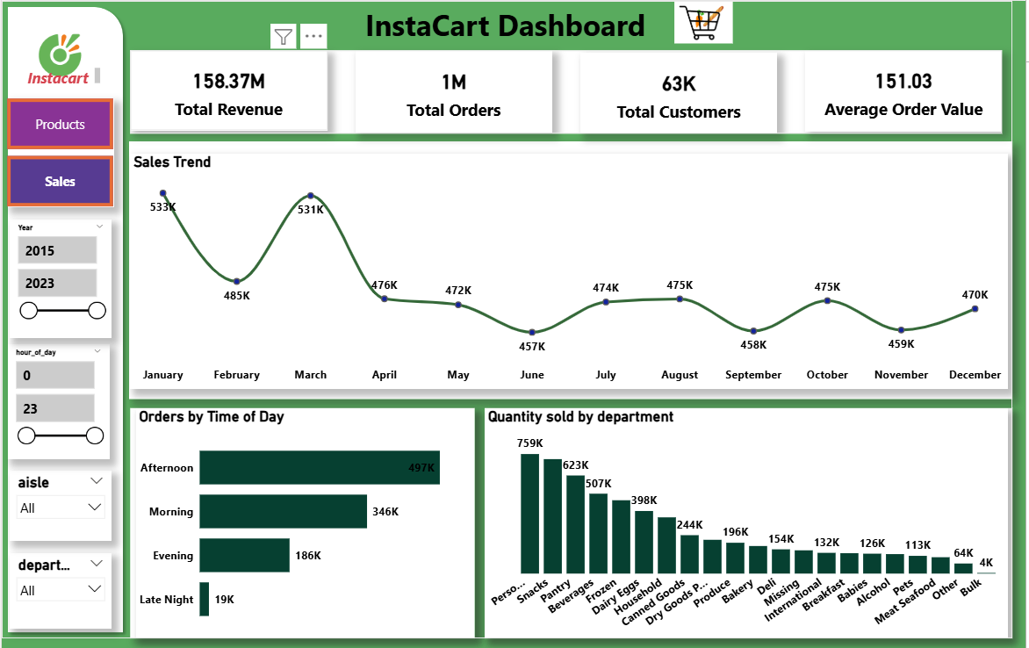
Figure 2. Sales trend, time-of-day and department dashboard

9. KPI Analysis
KPI | Figure | Interpretation
Total Revenue | $158.37M | Shows the total sales value generated in the analysed dataset.
Total Orders | 1M | Indicates substantial transaction activity across the platform.
Total Customers | 63K | Shows the customer base represented in the dashboard.
Average Order Value | $151.03 | Represents the average revenue generated per order.

Together, the KPI cards provide the executive view of scale: approximately $158.37 million in revenue generated from about one million orders across 63 thousand customers.

10. Product Performance Analysis

10.1 Five Best-Selling Products
Rank | Product Name | Quantity Sold
1 | Chili With Beans | 267
2 | Chicken With Rice Soup | 258
3 | Mediterranean Sea Salt | 242
4 | Tender White Meat Chicken, Vegetable | 242
5 | Vanilla, Tangerine & Shortbread Ice Cream | 233

Descriptive insight: the five leading products fall within a relatively narrow range of 233 to 267 units. The leading product exceeds the fifth-ranked product by 34 units, indicating that demand among the top five is comparatively balanced.

10.2 Five Worst-Selling Products
Rank | Product Name | Quantity Sold
1 | Seeded Multigrain Chickpea Chips | 49
2 | Buttermilk Biscuits | 47
3 | Plus Cranberry Almond + Antioxidants | 45
4 | Caramel Macchiato Creamer | 32
5 | Duck Mousse With Port Wine | 28

Descriptive insight: the lowest product recorded 28 units compared with 267 units for the best-selling product. This is a gap of 239 units, showing a substantial difference in demand across the catalogue.

11. Aisle Demand and Profitability Analysis

11.1 High Demand and Low Profitability
Aisle Name | Profit | Quantity Sold
Fresh Herbs | 29K | 10K
Frozen Breads Doughs | 27K | 10K
Packaged Seafood | 26K | 9K
Trail Mix Snack Mix | 22K | 8K
Seafood Counter | 18K | 6K
Frozen Juice | 16K | 6K
Baby Accessories | 14K | 5K
Packaged produce | 10K | 4k
Bulk Grains Rice Dried Goods | 9K | 3k
Bulk Dried Fruits Vegetables | 4K | 1447

Insight: these aisles attract meaningful unit demand but produce comparatively low profit. For example, Fresh Herbs records about 10K units sold with roughly 29K profit. This is the type of category where supplier pricing, product mix and margin should be reviewed before assuming that high demand is automatically beneficial.

11.2 High Demand and High Profitability
Aisle Name | Profit | Quantity Sold
Missing | 0.41M | 148K
Candy Chocolate | 0.40M | 144K
Ice Cream Ice | 0.35M | 127K
Vitamins Supplements | 0.34M | 120K
Yogurt | 0.33M | 119K
Chips Pretzels | 0.31M | 115K
Tea | 0.30M | 105K
Packaged Vegetables Fruits | 0.29M | 103K
Cookies Cakes | 0.28M | 101K
Frozen Produce | 0.28M | 102K

Insight: these aisles combine large unit volumes with stronger profit. Candy, for example, records approximately 144K units and 0.40M profit. These categories are stronger candidates for inventory protection and promotional visibility.

12. Sales Trend Analysis
Month | Sales
January | 533K
February | 485K
March | 531K
April | 476K
May | 472K
June | 457K
July | 474K
August | 475K
September | 458K
October | 475K
November | 459K
December | 470K

Descriptive insight: Annual quantity sold remained highly stable from 2015 to 2022, ranging from approximately 695K to 700K units. The highest annual quantities were recorded in 2019 and 2020 at approximately 700K each. The 2023 figure is 186K, but the dataset ends on 7 April 2023, so 2023 is a partial reporting year and should not be compared directly with complete prior years.
Diagnostic interpretation: The narrow range from 2015 to 2022 indicates consistent annual product demand across the complete years. The lower 2023 figure reflects incomplete period coverage rather than evidence of a confirmed demand collapse. Year-to-date versus prior-year-to-date analysis would provide a more appropriate comparison.

13. Orders by Time of Day
Time of Day | Orders | Approx. Share
Afternoon | 497K | 47.4%
Morning | 346K | 33.0%
Evening | 186K | 17.7%
Late Night | 19K | 1.8%

Descriptive insight: Afternoon is the busiest period with 497K orders, accounting for nearly half of the approximately 1.05M orders. Late Night contributes only about 19K orders, less than 2% of total activity.
Prescriptive implication: staffing and fulfilment capacity should be weighted toward afternoon activity, while late-night coverage can be reviewed for cost efficiency.

14. Quantity Sold by Department
Department | Quantity Sold
Personal Care | 759K
Snacks | 623K
Pantry | 507K
Beverages | ~450K
Frozen | ~430K
Dairy & Eggs | 398K
Household | ~330K
Canned Goods | 244K
Produce | 196K
Bakery | ~180K
Deli | 154K
Missing | 132K
International | 126K
Breakfast | ~120K
Babies | ~116K
Alcohol | 113K
Pets | ~100K
Meat & Seafood | ~90K
Other | 64K
Bulk | 4K

Descriptive insight: Personal Care leads department-level quantity at 759K, followed by Snacks at 623K and Pantry at 507K. Together, these three departments account for approximately 1.89M units. Bulk is the lowest at only 4K units.
The difference between Personal Care and Bulk is approximately 755K units, demonstrating a highly uneven distribution of demand across departments.

15. Descriptive Analysis Summary
- The business generated $158.37M in total revenue from approximately 1M orders and 63K customers.
- Average order value is $151.03.
- The strongest product sold 267 units while the weakest of the bottom-five products sold 28 units.
- Personal Care, Snacks and Pantry are the leading departments by quantity sold.
- Afternoon is the busiest period at 497K orders; Late Night is the quietest at 19K.
- January is the strongest month at 533K while June is the lowest at 457K.
- High-demand aisles do not always translate into high profitability.

16. Diagnostic Analysis
The dashboard supports several diagnostic hypotheses, but the available visuals show associations rather than confirmed causes.
Observed Pattern | Supported Interpretation / Hypothesis
High demand in Personal Care, Snacks and Pantry | Frequently purchased categories appear to dominate product movement.
High demand but low profitability in some aisles | Margin pressure may come from product cost, pricing or mix.
Afternoon peak | Customer order activity is concentrated during daytime shopping hours.
Monthly peaks and dips | Demand varies over time and may be affected by seasonality or promotions.
Large best-to-worst product gap | Customer preference is uneven across the product catalogue.
'Missing' category appears in aisle analysis | Category completeness should be checked before final business decisions.

17. Prescriptive Analysis and Recommendations
Priority | Recommendation | Evidence from Dashboard
High | Protect availability in Personal Care, Snacks and Pantry | 759K, 623K and 507K units respectively.
High | Review high-demand/low-profit aisles for pricing and supplier cost | Examples include Fresh Herbs at 10K units / 29K profit.
High | Align staffing with afternoon demand | 497K afternoon orders versus 19K late-night orders.
Medium | Promote high-demand/high-profit aisles | Candy ~0.40M profit / 144K units; Yogurt ~0.33M / 119K.
Medium | Review low-selling products for placement, pricing or rationalisation | Bottom-five range from 28 to 49 units.
Medium | Plan stock around monthly demand variation | 533K peak in January versus 457K in June.
High | Resolve 'Missing' category records | 'Missing' appears as a major high-demand/high-profit group.

18. Business Value Delivered
- Creates a single view of core commercial KPIs.
- Makes product and department performance easier to compare.
- Separates demand from profitability to avoid volume-only decisions.
- Supports workforce planning using time-of-day activity.
- Supports inventory planning using monthly and departmental demand patterns.
- Provides management with repeatable SQL answers to defined business questions.

19. Challenges Encountered and Resolutions
Challenge | Resolution
Measures required fields from different tables | Used model relationships and joined Orders to Products through product_id.
Need to identify unsold products | Used LEFT JOIN logic and NULL checks on the Orders side.
Time-of-day analysis required grouped hours | Created a Time_of_Day classification for reporting.
Nested relational columns appeared in Power Query | Expanded only required fields and maintained keys for the fact model.
Need to separate demand from profit | Created paired visuals for high-demand/low-profit and high-demand/high-profit aisles.
Category completeness issue | Flagged the 'Missing' aisle/category result for data-quality review.

20. Key Learnings
- How to translate business questions into SQL queries and dashboard visuals.
- How to structure a fact-and-dimension model for Power BI.
- How to create and interpret KPI measures.
- How to distinguish descriptive findings from diagnostic hypotheses and prescriptive actions.
- How to use data storytelling to connect a visual to a business decision.
- Why data-quality categories such as 'Missing' should be investigated before recommendations are finalised.

21. Skills Demonstrated
Area | Skills
SQL | JOINs, LEFT JOIN, GROUP BY, aggregation, CASE logic, NULL analysis, business queries
Power BI | Data modelling, relationships, slicers, navigation, KPI cards, interactive visuals
Power Query | Column selection, nested-table expansion, type handling, transformation
DAX | Measures, time-of-day classification, KPI calculations
Analytics | Descriptive, diagnostic and prescriptive analysis
Business Analysis | Problem framing, objectives, business questions, recommendations, reporting

22. Limitations and Future Improvements
- The dashboards identify patterns and associations in customer demand, sales activity and profitability, but these relationships should not automatically be interpreted as causal.
- Profitability analysis could be strengthened by incorporating supplier costs, promotional campaigns, discounts and other pricing variables.
- Customer segmentation could be introduced to distinguish high-value, frequent and lower-engagement customers and better understand the drivers of revenue.
- The dashboard now supports Year/Quarter filtering and annual quantity trend analysis. However, 2023 contains only partial-year data through 7 April 2023, so direct full-year comparisons with 2015-2022 should be avoided. Future analysis could add YTD versus prior-YTD measures for more appropriate period comparison.
- Business-defined targets and benchmarks for Average Order Value, profitability, demand and customer activity could be incorporated to support actual-versus-target performance monitoring.
- Predictive demand forecasting could be considered after validating the completeness, consistency and seasonality of the historical data.

23. Conclusion
The Instacart Sales & Customer Insights project demonstrates an end-to-end analytics workflow from relational data and SQL business questions through Power BI modelling, KPI development, dashboard design and business interpretation. The analysis identifies clear differences in product demand, aisle profitability, departmental activity and time-based ordering behaviour. Most importantly, the dashboards convert those patterns into practical decisions around inventory, pricing, product mix, data quality and workforce planning.

24. Portfolio Summary
Item | Details
Project | Instacart Sales & Customer Insights Dashboard
Role | Data Analyst / Business Intelligence Analyst
Industry | Retail / Online Grocery
Tools | PostgreSQL, SQL, Power BI, Power Query, DAX
Model | Star Schema
Deliverables | SQL analysis, Product Dashboard, Sales Dashboard, Portfolio Report
Core Outcome | Converted transactional data into decision-ready business insights

