LARGENCE
Legal Operating System

Deliverable 9: Final Consulting Report
Business Analysis Findings • Future-State Recommendations • KPI Framework • Governance • Roadmap
Stakeholder Presentation Summary and Project Closure
2-Week / 10-Working-Day LegalTech Business Analysis Engagement

Table of Contents
1. Executive Summary.................................................................. 2
2. Engagement Overview................................................................ 3
3. Business Challenge and Objectives.................................................. 3
3.1 Primary Business Objectives............................................................. 3
4. Scope and Analysis Approach........................................................ 4
4.1 In Scope................................................................................ 4
4.2 Out of Scope............................................................................ 4
4.3 Analysis Techniques..................................................................... 4
5. Stakeholder and Evidence Base...................................................... 4
6. Consolidated Current-State Findings................................................ 5
7. Root-Cause Summary................................................................. 6
8. Stakeholder Requirements Summary................................................... 7
9. Future-State Operating Model....................................................... 8
10. Prioritised Improvement Recommendations........................................... 9
11. KPI and Performance Measurement Framework........................................ 10
12. Compliance and Governance Summary................................................ 11
13. Improvement Roadmap.............................................................. 11
14. Risks, Dependencies and Constraints.............................................. 12
15. Outstanding Validation and Data Gaps............................................. 12
16. Expected Business Outcomes....................................................... 12
17. Final Recommendations............................................................ 13
18. Stakeholder Presentation Summary................................................. 13
19. Project Closure and Handover..................................................... 14
19.1 Closure Actions....................................................................... 14
19.2 Recommended Handover Package.......................................................... 14
20. Deliverable 9 Completion Check................................................... 14
21. Conclusion....................................................................... 15

1. Executive Summary
The Largence LegalTech Business Analysis engagement assessed the legal document lifecycle from initiation and drafting through review, revision, compliance, approval, execution, storage and retrieval. The analysis found that Largence already supports important parts of this lifecycle, but the end-to-end operating model is not yet consistently executed as one connected, visible and governed workflow.
The most material current-state challenges are fragmented off-platform work, review and approval delays, version uncertainty, manual follow-up, incomplete auditability and measurement, uneven adoption of advanced platform capabilities, and concerns around trust and governance for AI-assisted legal work. These issues are interrelated: when users move between Largence, Word, email, external repositories and signing tools, workflow visibility reduces and the organisation must rely more heavily on manual coordination and reconciliation.
The recommended future state is therefore not simply “more automation.” It is a controlled operating model in which the authoritative document, workflow status, review history, approvals, compliance evidence and final record remain traceable throughout the lifecycle. Administrative routing, reminders and repeatable controls may be automated where appropriate, while legal judgement, risk acceptance, final compliance approval and execution authorisation remain under qualified human control.
Implementation should be phased. Immediate priorities are to clarify workflow ownership, establish authoritative-version and approval-evidence rules, reduce avoidable off-platform handoffs, define measurable KPIs, strengthen responsible-AI controls and validate which recommendations can be delivered using existing Largence capability before proposing new development.
Important limitation: several quantitative baselines remain unavailable. This report therefore separates validated qualitative findings from target measures that still require data confirmation.

2. Engagement Overview
Item | Summary
Project | Largence LegalTech Business Analysis Project
Duration | 2 weeks / 10 working days
Delivery Team | 2 Project Managers and 4 Business Analysts
Primary Focus | Legal document lifecycle, collaboration, version control, adoption, governance, performance measurement and process improvement
Approach | Hybrid and iterative; elicitation, analysis, validation and documentation overlap where appropriate
Key Outputs | Current-state analysis, root-cause findings, requirements, future-state workflow, KPI framework, governance recommendations, roadmap, project-management records and final report/presentation
Implementation Boundary | The engagement recommends improvements but does not implement software, integrations or operational changes.

3. Business Challenge and Objectives
The core business challenge is the transition from fragmented legal work performed across multiple tools and communication channels toward a more integrated Largence-centred workflow that delivers measurable operational value without weakening legal, compliance or governance controls.

3.1 Primary Business Objectives
· Understand and document how the legal document lifecycle currently operates.
· Identify bottlenecks, delays, duplication, manual effort and process inefficiencies.
· Improve collaboration and version-control certainty across multi-stakeholder legal work.
· Reduce unnecessary off-platform activity and improve end-to-end workflow visibility.
· Define business, process, governance, collaboration, reporting and adoption requirements.
· Design a practical future-state workflow with clear ownership and control points.
· Define KPIs that show whether the workflow is becoming faster, more reliable, more governed and better adopted.
· Prioritise recommendations into a realistic improvement roadmap.

4. Scope and Analysis Approach

4.1 In Scope
· Current legal document lifecycle assessment and process mapping.
· Workflow bottlenecks, handoffs, review, approval and collaboration analysis.
· Document collaboration and version-control practices.
· Platform adoption, user workarounds and off-platform activity.
· Compliance, approval, auditability and responsible-AI governance.
· Stakeholder requirement analysis and prioritisation.
· Future-state workflow design and process optimisation.
· Performance measurement and KPI framework development.
· Improvement recommendations and implementation roadmap.

4.2 Out of Scope
· Software development and platform engineering.
· AI model development or training.
· Legal advice or substantive legal document review.
· Customer implementation and deployment.
· Product pricing and financial analysis.
· Cybersecurity testing and penetration testing.
· Detailed user-interface redesign or feature prototyping.
· Training delivery and systems integration implementation.

4.3 Analysis Techniques
Technique | How It Was Used
Questionnaire / Survey | Gathered wider feedback on workflow, collaboration, platform adoption and challenges.
Semi-Structured Interviews | Explored stakeholder workflows, bottlenecks, needs, expectations, governance and technical considerations.
Document Analysis | Reviewed available plans, process materials, requirements content and project documentation.
Current-State Analysis | Documented lifecycle stages, handoffs, workarounds, version-control and approval issues.
Root-Cause Analysis | Grouped causes across People, Process, Technology, Governance, Data/Measurement and External/Client factors.
Gap Analysis | Compared current-state limitations with desired business and stakeholder outcomes.
Benchmark Research | Used comparable LegalTech practices as supporting references only after relevant Largence gaps were identified.
Prioritisation | Assessed recommendations by business value, risk, urgency, dependency and feasibility.
Validation | Kept unresolved items visible for stakeholder confirmation rather than filling gaps by assumption.

5. Stakeholder and Evidence Base
Stakeholder Group | Primary Contribution to the Analysis
Executive Leadership / Project Sponsor | Strategic objectives, major risks, business outcomes and decision support.
Legal Professionals / Lawyers | End-to-end lifecycle, drafting/review experience, approvals, collaboration, version control and AI use.
Paralegals / Legal Support | Administrative workload, status tracking, follow-up, document handling and version reconciliation.
Legal Operations | Workflow bottlenecks, scalability, process ownership, automation opportunities and human-control boundaries.
Product Management | Platform capability, adoption, user behaviour, off-platform activity and feasibility context.
Compliance / Governance | Compliance checkpoints, approval controls, responsible AI, auditability and exception management.
Customer Success / Support | Adoption barriers, recurring user issues and improvement requests.
IT / Technology | Integration dependencies, external-tool constraints and technical feasibility.
Data & Analytics | Baseline availability, KPI definitions, data quality and reporting feasibility.
Users / Future-State Participants | Desired workflow characteristics and usability expectations.

6. Consolidated Current-State Findings
Finding | Current-State Effect | Business Impact | Priority
Fragmented end-to-end workflow | Users move between Largence, Word, email, repositories and e-signature tools. | Reduced visibility, duplicated coordination and incomplete workflow history. | High
Review and approval delays | Handoffs and follow-up depend partly on manual coordination. | Longer turnaround time and avoidable waiting. | High
Version uncertainty | Multiple edited copies can exist across channels. | Wrong-version risk, rework and reconciliation effort. | High
Approval evidence gaps | Decision evidence may not always be consistently linked to the exact approved version. | Weak accountability and auditability. | High
Off-platform collaboration | Material review and communication may occur outside the platform. | Incomplete decision history and event measurement. | High
Uneven advanced-feature adoption | AI, workflow automation, compliance intelligence and advanced reporting are not uniformly used. | Potential value remains unrealised and users retain old work habits. | Medium-High
AI trust and governance concerns | Users require confidence in accuracy, sources, review and accountability. | Limits adoption in higher-risk legal work. | High
Incomplete operational baselines | Key cycle-time, rework, adoption and compliance metrics are incomplete or unavailable. | Difficult to prove improvement or diagnose performance objectively. | High
Template / precedent control risk | Ownership, currency and approved status may not always be explicit. | Inconsistent drafting and possible compliance exposure. | Medium-High
External-tool dependencies | Client or business requirements may require tools outside Largence. | End-to-end traceability can be interrupted. | Medium
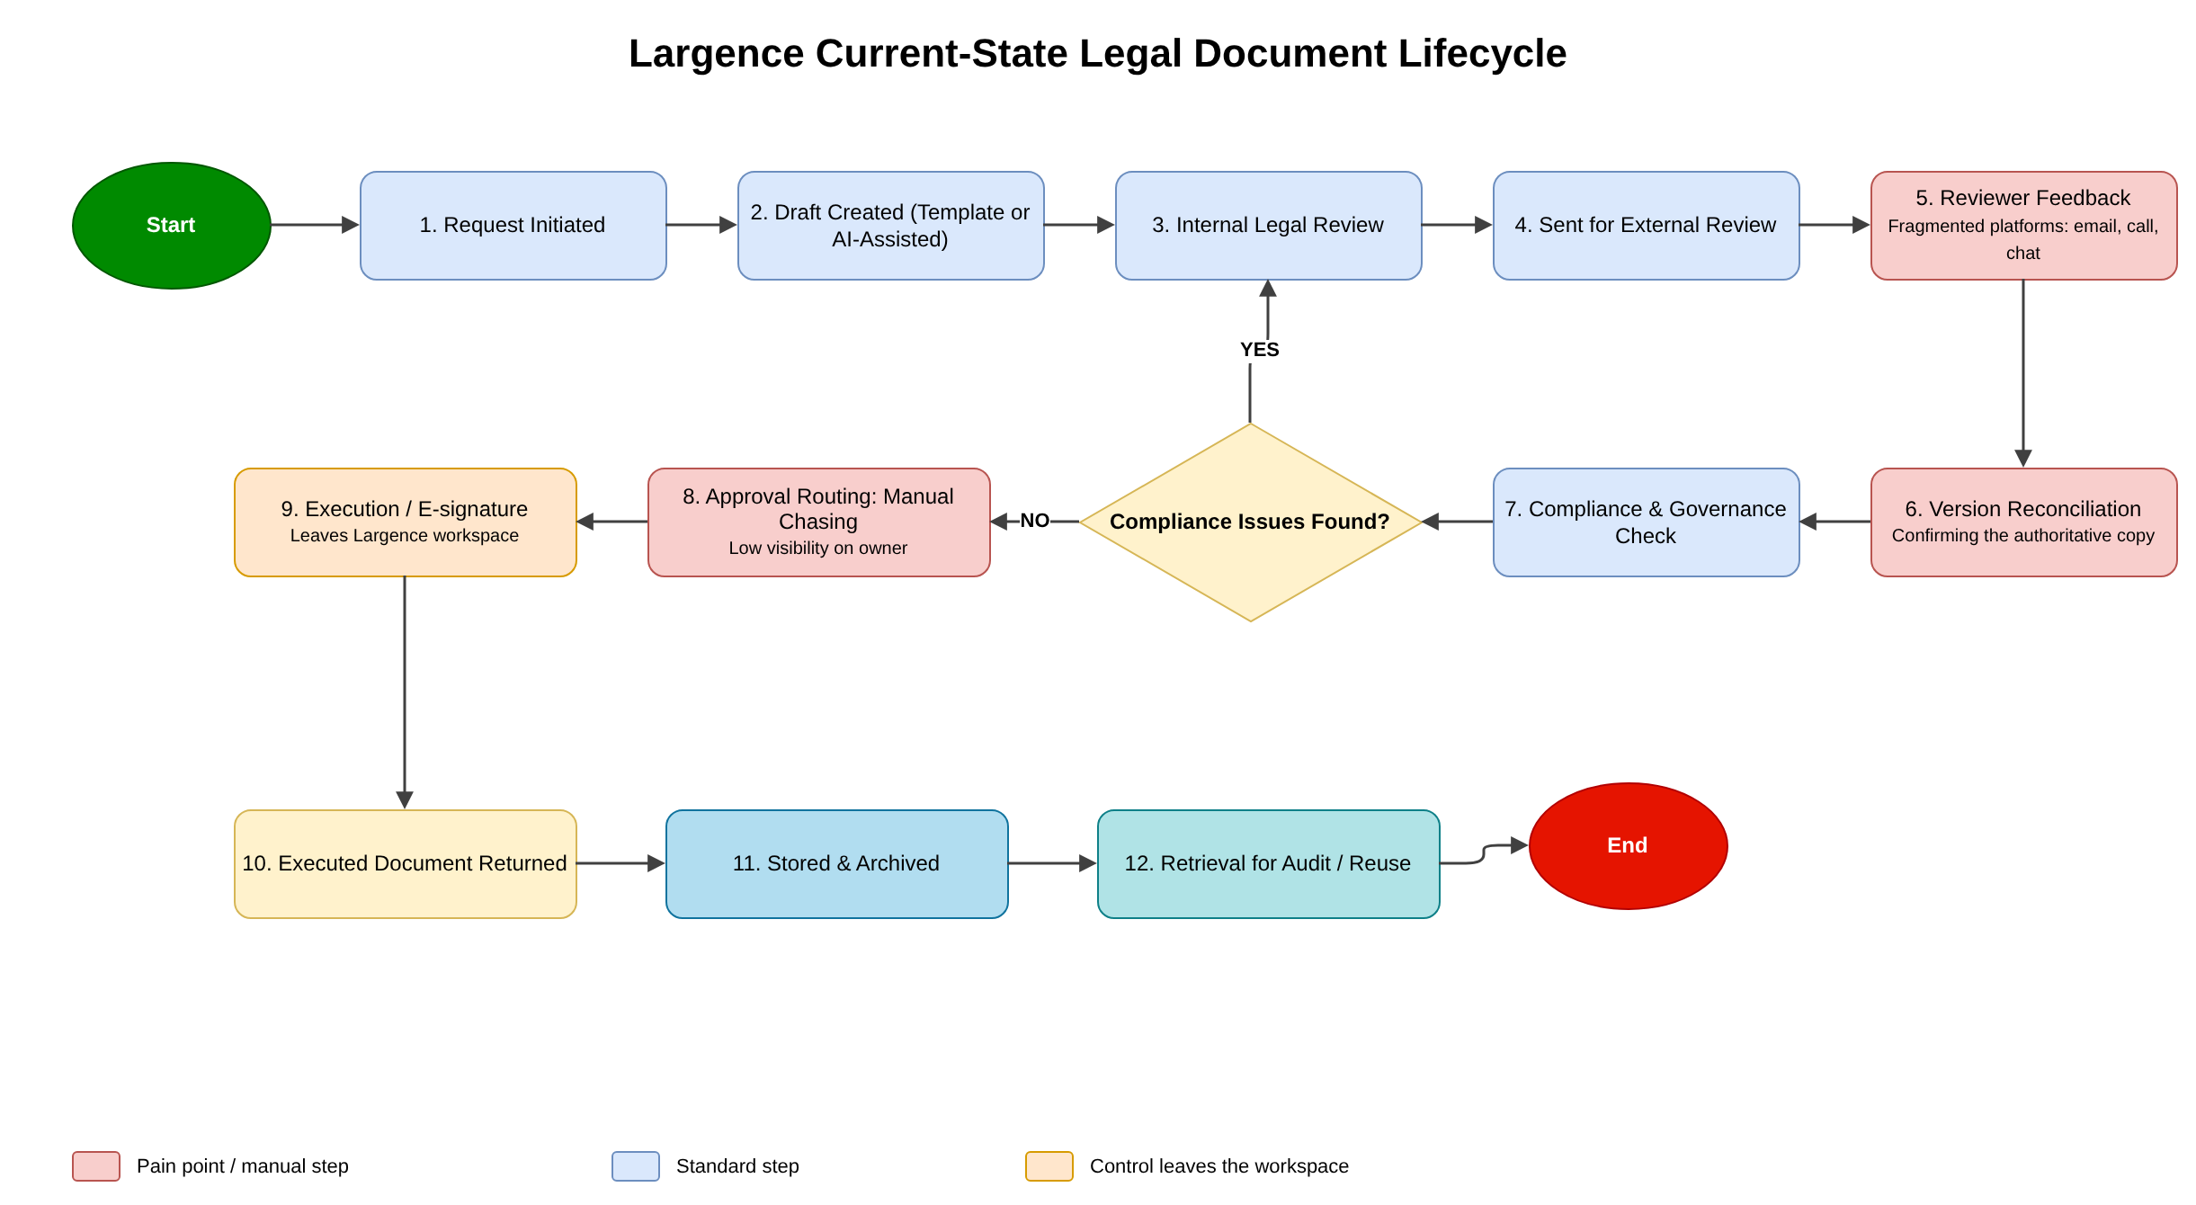

7. Root-Cause Summary
Cause Category | Likely Root Causes | Resulting Problems
People | Established work habits; uneven feature confidence; variable trust in AI; unclear role ownership in some stages. | Off-platform work, manual follow-up, uneven adoption.
Process | No consistently enforced end-to-end control path; repeated handoffs; unclear escalation; process variants not always governed. | Delays, inconsistent approvals, duplicated activity.
Technology / Integration | Need to use Word, email, signing tools or client systems; integration coverage may be incomplete. | Fragmented workflow and incomplete event history.
Governance | Authoritative-version, approval, template, evidence and AI rules require stronger definition/validation. | Version risk, auditability concerns and inconsistent controls.
Data / Measurement | Some external activity is not captured; baseline metrics are incomplete. | Limited ability to measure true turnaround, rework, adoption and compliance performance.
External / Client | Client-required channels, counterparties and outside counsel may work outside Largence. | Controlled process interruption and reconciliation needs.

8. Stakeholder Requirements Summary
ID | Category | Requirement | Priority
BR-01 | Business | Create a more connected and visible end-to-end legal document lifecycle. | Must
BR-02 | Business | Reduce avoidable review, approval and coordination delays. | Must
BR-03 | Business | Improve measurable adoption and operational value from Largence. | Must
PR-01 | Process | Define clear workflow ownership, stage ownership and escalation responsibilities. | Must
PR-02 | Process | Provide controlled routing for review, compliance and approval based on relevant document/risk rules. | Must
PR-03 | Process | Support governed process variants rather than forcing one universal workflow. | Should
DC-01 | Document Control | Clearly identify the authoritative working version and final approved/executed version. | Must
DC-02 | Document Control | Maintain traceable version history and reconcile externally edited copies. | Must
DC-03 | Document Control | Link approval evidence to the exact version approved. | Must
CO-01 | Collaboration | Reduce unnecessary movement across email, shared folders and separate tools. | Must
CO-02 | Collaboration | Support controlled internal/external collaboration with appropriate access. | Should
GV-01 | Governance | Record reviewer/approver, decision, timestamp, conditions and applicable version. | Must
GV-02 | Governance | Retain compliance, approval and execution evidence with the final record. | Must
GV-03 | Governance | Apply role-appropriate access and segregation of duties where required. | Must
AI-01 | Responsible AI | Require qualified human review before final reliance on AI-assisted legal content. | Must
AI-02 | Responsible AI | Define permitted, restricted and prohibited AI-assisted activities by risk. | Must
AI-03 | Responsible AI | Retain sufficient traceability for applicable high-risk AI-assisted work. | Must
KM-01 | Knowledge | Assign ownership and review status to controlled templates, precedents and playbooks. | Should
KM-02 | Knowledge | Guide users toward current approved content rather than uncontrolled historical copies. | Should
KP-01 | Reporting | Measure end-to-end cycle time, stage waiting time, review/approval performance and rework. | Must
KP-02 | Reporting | Measure platform adoption, feature usage and off-platform workflow leakage. | Must
KP-03 | Reporting | Measure compliance delays, exceptions, audit evidence completeness and version-related incidents. | Must
AD-01 | Adoption | Provide role-appropriate guidance and workflow cues that reduce reliance on informal workarounds. | Should
IN-01 | Integration | Identify and prioritise integrations that materially reduce fragmented workflow and preserve event traceability. | Should

9. Future-State Operating Model
The future-state operating model should follow the principle of a connected lifecycle with clear status, ownership and evidence at every material stage.
Future-State Stage | Recommended Control / Activity | Expected Benefit
1. Request / Initiation | Capture request, matter/document context, owner, document type, risk/context and target dates. | Clear accountability from start.
2. Drafting | Use approved templates/precedents and AI assistance where permitted; identify controlled working version. | Consistency and reduced repetitive effort.
3. Internal Review | Route to required reviewers; retain review status and material comments/decisions. | Visible review progress and less manual follow-up.
4. Revision | Update the controlled version; preserve material version history; reconcile external edits. | Reduced version ambiguity.
5. Compliance / Risk Check | Apply required checkpoints based on document/risk type; record exceptions and rationale. | Stronger governance and defensibility.
6. Approval | Submit the controlled version; record approver, decision, timestamp and conditions. | Approval traceability.
7. Execution / Signature | Confirm execution authority; use approved signing path; preserve executed copy and evidence. | Reliable finalisation.
8. Final Record / Storage | Mark final status; link supporting evidence and metadata; apply retention/access rules. | Single reliable final record.
9. Reporting / Learning | Capture cycle time, waiting, rework, adoption, compliance and exception data. | Continuous improvement and measurable value.
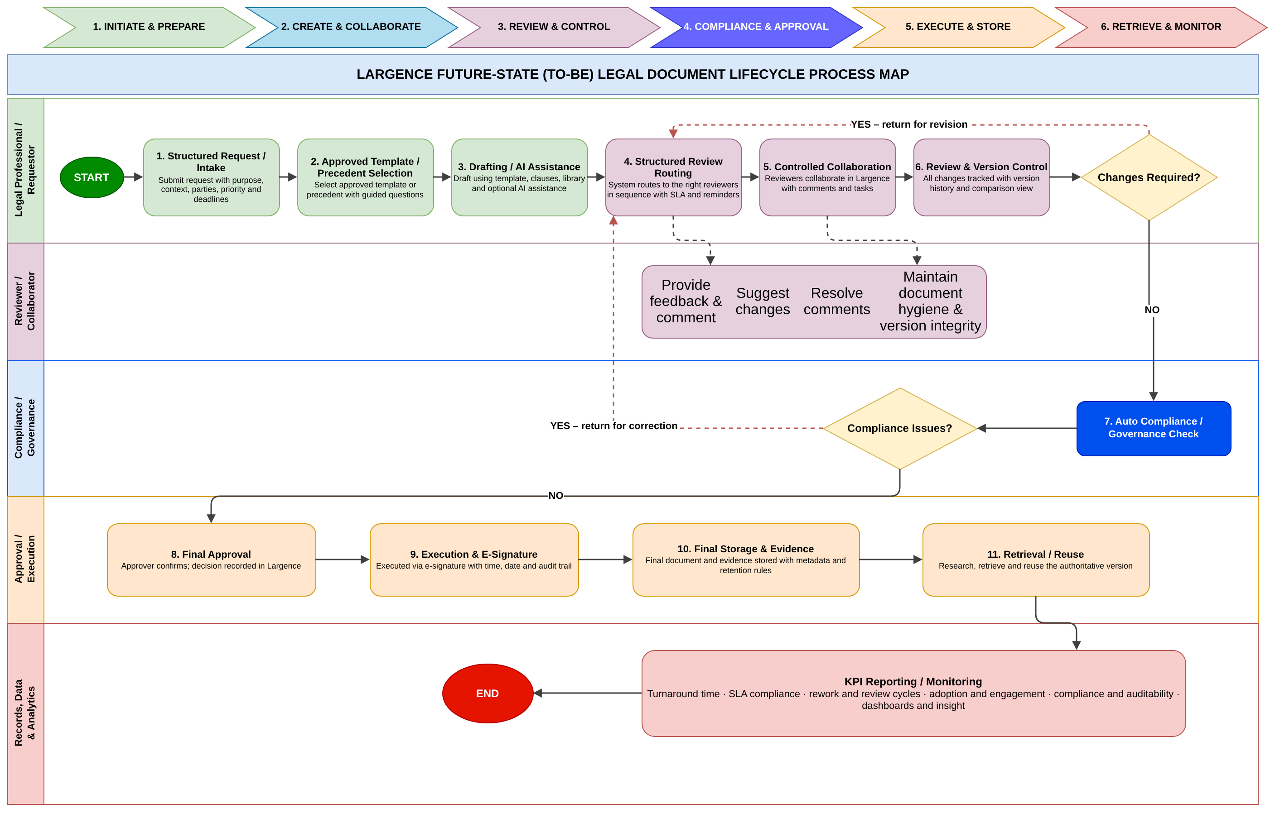

10. Prioritised Improvement Recommendations
ID | Recommendation | Problem Addressed | Priority / Timing
R1 | Establish an authoritative-version and document-status model. | Version confusion and rework. | Must / Immediate
R2 | Link approval and compliance evidence to the exact document version. | Auditability and approval certainty. | Must / Immediate
R3 | Define workflow ownership, approval authority, escalation and exception rules. | Manual follow-up and unclear accountability. | Must / Immediate
R4 | Reduce avoidable off-platform handoffs using existing Largence capability first. | Fragmented collaboration and incomplete visibility. | Must / Immediate
R5 | Introduce role-based dashboards and KPI definitions for cycle time, waiting, rework, adoption and governance. | Incomplete operational measurement. | Must / Near Term
R6 | Formalise responsible-AI controls, including human review, verification, traceability and escalation. | AI trust and governance risk. | Must / Immediate
R7 | Strengthen template, precedent and playbook governance. | Inconsistent drafting and outdated content risk. | Should / Near Term
R8 | Define controlled external collaboration and re-entry rules. | Client/outside-counsel workflow breaks. | Should / Near Term
R9 | Prioritise high-value integrations that reduce tool switching while preserving event history. | External-tool dependency. | Should / Medium Term
R10 | Create an adoption programme based on role-specific workflow use, guidance and support evidence. | Uneven use of advanced capabilities. | Should / Near Term
R11 | Create a structured final-record/evidence model for executed documents. | Retrieval and evidence continuity. | Must / Near Term
R12 | Use benchmark practices only where they address a validated Largence gap. | Risk of copying competitors without business justification. | Governance Principle

11. KPI and Performance Measurement Framework
No unsupported baseline values are inserted. The first implementation step for each KPI is to confirm the data source, owner and current baseline.
KPI | Definition | Measurement | Owner | Current Status
End-to-End Turnaround Time | Time from document request/initiation to final execution/closure. | Median and percentile duration by document type. | Legal Operations / Data | Baseline required
Stage Waiting Time | Time spent waiting at review, compliance and approval stages. | Duration between stage assignment and completion. | Process Owner | Baseline required
Review / Approval Cycle Count | Number of review or approval cycles before completion. | Count cycles per document/matter. | Legal Operations | Baseline required
On-Time Completion Rate | Percentage completed within agreed target time. | Completed within target ÷ completed total. | Process Owner | Target after baseline
Rework / Version Incident Rate | Documents requiring avoidable rework due to version or process issue. | Version-related incidents ÷ completed documents. | Legal Operations | Baseline required
Platform-Contained Workflow Rate | Share of workflows completed fully inside governed Largence process. | Fully contained workflows ÷ total workflows. | Product / Data | Instrumentation may be required
Advanced Feature Adoption | Use of AI, automation, compliance and reporting capabilities by eligible users. | Active eligible users/features used over period. | Product / Customer Success | Segment by role
Compliance Delay Rate | Workflows delayed by compliance review or unresolved exception. | Compliance-delayed workflows ÷ applicable workflows. | Compliance | Baseline required
Approval Evidence Completeness | Final records with complete approval/version/timestamp evidence. | Complete records ÷ applicable final records. | Compliance / Legal Ops | Target should be high
Audit Trail Completeness | Material events traceable across the governed lifecycle. | Required events captured ÷ required events. | Product / Compliance | Define required event set
Final Document Retrieval Time | Time required to locate the correct final approved/executed record. | Median retrieval duration. | Legal Operations | Baseline required
User Adoption / Active Usage | Relevant user groups actively using the governed workflow. | Active users ÷ eligible users. | Product / Customer Success | Segment by user type

12. Compliance and Governance Summary
Governance Area | Key Control Direction
Document Control | Authoritative version, status model, version history, external-edit reconciliation and final record.
Approval Governance | Defined authority, decision record, exact-version linkage, re-approval after material change and segregation where required.
Workflow Governance | End-to-end owner, review owners, routing rules, escalation, mandatory checkpoints and controlled variants.
Audit Trail | Creation, change, review, compliance, approval, AI-assisted activity, external collaboration, execution and final storage evidence.
Evidence / Retention | Final documents linked to required supporting evidence; retention and disposal aligned to applicable obligations.
External Access | Least-necessary access, approved collaboration methods, access removal and controlled handoff/re-entry.
Responsible AI | Permitted-use rules, qualified human review, accuracy verification, confidentiality, traceability, accountability and escalation.
Template / Precedent Governance | Named owners, approved/retired status, review cycles, regulatory-change triggers and controlled reuse.

13. Improvement Roadmap
Horizon | Priority Actions | Expected Output
0-30 Days: Validate & Control | Confirm owners, approval authorities, authoritative-version rule, required compliance checkpoints, AI-control rules, KPI definitions and data sources. Identify quick wins using existing capability. | Governance baseline; validated requirements; KPI dictionary; quick-win action list.
1-3 Months: Embed Workflow | Configure/standardise governed workflow, statuses, routing, reminders, final-record controls, role guidance and adoption support. Begin KPI reporting. | Reduced manual follow-up; stronger version/approval traceability; early adoption metrics.
3-6 Months: Integrate & Improve | Address priority integrations/external handoffs, improve event capture, template governance, controlled collaboration and role dashboards. | Better end-to-end visibility and reduced tool switching.
6-12 Months: Optimise & Scale | Use performance data to refine process variants, automation, compliance evidence and AI governance; expand successful practices across document types. | Continuous improvement, scalable governance and measurable operational value.

14. Risks, Dependencies and Constraints
Risk / Dependency | Potential Effect | Response
Stakeholder validation delay | Requirements or controls remain provisional. | Schedule focused validation with decision owners; maintain explicit validation log.
Limited baseline data | Benefits cannot be quantified reliably at project close. | Confirm KPI definitions/data owners first; establish baselines before target commitments.
Integration constraints | External tools continue to fragment the lifecycle. | Prioritise by business impact; define controlled handoff/re-entry where integration is not feasible.
User resistance / habit | Users may revert to Word/email/shared folders. | Role-specific guidance, visible value, adoption measurement and workflow support.
Over-automation of legal decisions | Automation could weaken accountability. | Keep legal judgement, exception approval and execution authority under qualified human control.
One-size-fits-all workflow | Different document/risk types may need different controls. | Use governed variants with common minimum control principles.
Scope expansion | Short engagement can be overloaded by implementation questions. | Separate BA recommendations from implementation/design work outside the agreed scope.
Benchmark overreach | Competitor features may be treated as requirements. | Use benchmarks only to support already-validated Largence needs.

15. Outstanding Validation and Data Gaps
· Average number of review and approval cycles by document type.
· Baseline end-to-end turnaround time and stage-level durations.
· Frequency and impact of version-related incidents or avoidable rework.
· Percentage of workflows completed fully within Largence versus off-platform.
· Average final-document retrieval time.
· Current adoption rates by feature and user type.
· Volume of compliance exceptions and compliance-related delays.
· Current completeness of approval and audit evidence.
· Official approval authorities by document type and risk level.
· Authoritative-version rule when external Word editing is necessary.
· Required AI traceability level by use case.
· Formal template/precedent ownership and review cycles.
· Retention requirements for documents, evidence and audit records.
· Approved external collaboration channels and permission rules.
· Near-term versus longer-term integration feasibility.
These items should be treated as closure/implementation validation actions, not silently converted into assumptions.

16. Expected Business Outcomes
Outcome Area | Expected Improvement | How Success Should Be Demonstrated
Operational Efficiency | Less waiting, manual chasing and duplicate coordination. | Turnaround time, stage waiting time, on-time completion.
Version Reliability | Greater certainty over the current and final approved version. | Lower version incidents/rework; complete version history.
Governance & Auditability | Clearer decisions, approvals and compliance evidence. | Approval evidence completeness; audit trail completeness.
Platform Adoption | More work completed in governed Largence workflows. | Active usage, feature adoption, platform-contained workflow rate.
Legal / AI Risk Control | Faster AI-assisted work without transferring legal accountability to automation. | Human-review compliance, traceability and exception records.
Knowledge Reuse | More consistent use of current templates, precedents and playbooks. | Approved content usage, review status and reduced uncontrolled reuse.
Management Visibility | More reliable operational data for prioritisation and improvement. | Regular KPI dashboard with agreed definitions and owners.

17. Final Recommendations
1. Approve a connected-workflow principle: every material document should have a visible owner, controlled version, status and decision history.
2. Make version certainty and approval evidence the first governance priorities because they affect execution risk, rework and auditability.
3. Reduce off-platform activity where it is avoidable, but govern unavoidable external collaboration rather than pretending it does not exist.
4. Automate administrative coordination, not legal accountability. Human legal review and accountable approval must remain mandatory for relevant work.
5. Establish KPI definitions and baselines before committing to numeric improvement targets.
6. Use existing Largence capability first where it can address the validated gap; treat new development as a later product/technical decision.
7. Phase implementation by value, risk and feasibility, starting with controls and quick wins before broader integrations or advanced automation.
8. Review adoption by stakeholder group because low usage may have different causes for lawyers, paralegals, operations, compliance and clients.
9. Use competitor benchmarks as evidence of possible practices, not as a substitute for Largence stakeholder requirements.
10. Maintain a formal validation log for outstanding authorities, baselines, retention rules, AI traceability and integration feasibility.

18. Stakeholder Presentation Summary
The following slide sequence can be used for the final stakeholder presentation. It is intentionally concise and decision-focused.
Slide | Title | Core Message
1 | Project Overview | Why the analysis was conducted; scope; two-week approach; stakeholders engaged.
2 | Current-State Problem | Fragmented lifecycle across Largence and external tools; main consequences.
3 | Where the Process Breaks | Review/approval delays, version uncertainty, manual follow-up, adoption and measurement gaps.
4 | Root Causes | People, Process, Technology, Governance, Data and External/Client causes.
5 | Stakeholder Requirements | Connected workflow, version certainty, controlled approvals, auditability, responsible AI, reporting and adoption.
6 | Future-State Workflow | Request → Draft → Review → Revision → Compliance → Approval → Execution → Final Record → Reporting.
7 | Priority Recommendations | Top immediate and near-term recommendations.
8 | KPI Framework | How turnaround, waiting, rework, adoption, compliance, auditability and retrieval will be measured.
9 | Governance & Responsible AI | Human accountability, approval evidence, access, retention, traceability and AI controls.
10 | Roadmap | 0-30 days, 1-3 months, 3-6 months and 6-12 months.
11 | Risks and Validation Gaps | Baseline data, integration feasibility, authorities, retention and adoption risks.
12 | Decisions Required | Confirm priorities, owners, validation actions and next implementation step.

19. Project Closure and Handover

19.1 Closure Actions
· Present the final findings and proposed roadmap to the project sponsor and key stakeholders.
· Capture stakeholder feedback, decisions, disagreements and deferred items.
· Update the final validation log and requirement status.
· Confirm ownership for post-project KPI baseline collection and governance-rule validation.
· Store final deliverables in the agreed shared repository using controlled filenames.
· Close or hand over remaining project risks/issues to the appropriate operational owner.
· Capture lessons learned from the two-week engagement.

19.2 Recommended Handover Package
Handover Item | Purpose
Current-State Analysis | Evidence-based description of how work operates today.
Requirements / Gap Analysis | Traceability from stakeholder need to desired future-state control.
Future-State Workflow | Target operating process and control points.
KPI Framework | Definitions, ownership and baseline data requirements.
Governance Recommendations | Document, workflow, audit, evidence and responsible-AI controls.
Improvement Roadmap | Prioritised sequence of implementation activities.
Project Management Records | Plan, risks, issues, communications and document-control records.
Final Consulting Report | Consolidated decision document for management and stakeholders.
Stakeholder Presentation | Concise summary of findings, decisions and next steps.

20. Deliverable 9 Completion Check
Required Component | Status
Executive summary | Complete
Project overview and objectives | Complete
Current-state findings | Complete
Root-cause summary | Complete
Stakeholder requirements summary | Complete
Future-state operating model | Complete
Prioritised recommendations | Complete
KPI framework | Complete
Compliance/governance summary | Complete
Improvement roadmap | Complete
Risks and dependencies | Complete
Outstanding validation/data gaps | Complete
Expected business outcomes | Complete
Stakeholder presentation summary | Complete
Closure and handover | Complete

21. Conclusion
The Largence engagement shows that the main opportunity is to convert a capable set of LegalTech functions into a more connected operating model. The future state should reduce fragmentation, improve review and approval coordination, strengthen version and evidence control, make operational performance measurable and support responsible use of AI without weakening human legal accountability.
The recommended next step is stakeholder approval of the priority controls, owners, KPI definitions and validation items, followed by a phased implementation plan that uses existing Largence capability where possible and introduces additional technical changes only where a validated business need remains.

