CANTEEN ORDERING SYSTEM
PROJECT DOCUMENTATION

Field | Details
Company | Unilever UK Office
Prepared By | Ikea Onyinyechi Anita
Course | Business Analysis Capstone Project
Document Type | Project Documentation
Date | 18/07/2026

Table of Contents
1. Background of the Project
2. Business Case
2.1 Executive Summary
2.2 Impacted Stakeholders
2.3 Business Problem
2.4 Business Objectives
2.5 Proposed Solution
2.6 Project Scope
2.7 Options Considered
2.8 Recommended Option
2.9 Financial Analysis / Cost-Benefit Analysis
2.10 Expected Benefits
2.11 Risks and Mitigation
2.12 Success Metrics
2.13 Business Case Conclusion
3. Stakeholder Analysis Matrix
4. RACI Matrix
5. System Features / Functional Requirements
6. Current Flow Process / As-Is Process Map
7. To-Be Process Map
8. User Stories and Acceptance Criteria
9. Product Backlog
10. Sprint Plan
11. Jira Screenshots
12. Final Project Conclusion

1. Background of the Project
Unilever is a British-Dutch FMCG company headquartered in London, England. It is one of the oldest FMCG companies in the world, with products available in about 190 countries.
In its UK office, Unilever has about 1,500 employees working across 12 floors. The company currently has 2 canteens serving these employees, and each canteen can seat about 150 employees at a time. This means both canteens can only accommodate about 300 employees at once.
Most employees prefer to take lunch between 12 noon and 1pm. This creates heavy congestion in the canteens during lunch hours. Employees spend time queuing for food, looking for available tables, eating quickly, and returning to their workstations.
The current process also creates challenges for the canteen team. Some popular dishes run out quickly because demand is not known in advance, while other food items remain unsold and are later thrown away. This creates both food shortage and food wastage.
To address these issues, Unilever needs a Canteen Ordering System that allows employees to order meals online before 11am and receive lunch at their workstations at a selected time.

2. Business Case

2.1 Executive Summary
Unilever UK has about 1,500 employees working across 12 floors, with only 2 canteens available to serve them. Each canteen can seat about 150 employees, meaning both canteens can only accommodate around 300 employees at a time.
Most employees prefer to take lunch between 12 noon and 1pm, which causes overcrowding, long queues, limited seating, and delays. Management observed that employees spend about 60 minutes going for lunch and returning, but only 10 to 15 minutes is spent actually eating.
The proposed solution is a Canteen Ordering System that allows employees to order meals online before 11am and receive lunch at their workstation at a selected time. This will reduce congestion, improve employee productivity, support better food planning, and reduce food wastage.

2.2 Impacted Stakeholders
The impacted stakeholders are the people or groups who will use, support, approve, or be affected by the Canteen Ordering System.
Stakeholder | Impact / Role in the Project
Senior Management | Approves the project, funding, and expected business value.
Employees / Canteen Users | Use the system to order meals, receive delivery, and provide feedback.
Menu Manager | Creates and updates the daily menu, available dishes, and prices.
Canteen Manager / Order Processor | Views confirmed orders and coordinates meal preparation and delivery.
Chef / Kitchen Staff | Prepares meals based on confirmed order summaries.
Meal Deliverer / Delivery Boy | Delivers meals to employees and closes delivered orders.
Payroll Department | Reviews meal deduction reports and processes salary deductions.
HR Department | Supports communication, adoption, and salary deduction enrollment.
IT / System Development Team | Designs, develops, tests, deploys, and maintains the system.
Business Analyst | Documents requirements, process maps, user stories, and supports stakeholder alignment.

2.3 Business Problem
The current canteen process causes long queues, overcrowding, and delays during the 12 noon to 1pm lunch period. Although the office has about 1,500 employees, both canteens can only seat about 300 employees at a time.
Employees spend around 60 minutes going for lunch and returning, while only 10 to 15 minutes is spent eating. The remaining time is mostly lost to queuing, searching for seats, collecting food, and moving between floors.
The canteen also lacks accurate demand planning. Some popular meals run out quickly, while other meals remain unsold and are thrown away. This creates poor employee experience, loss of productive time, food shortage, and food wastage.

2.4 Business Objectives
- Reduce long queues in the canteen during lunch hours.
- Reduce overcrowding between 12 noon and 1pm.
- Reduce the time employees spend away from their workstations during lunch.
- Improve employee lunch experience by allowing advance meal ordering.
- Help the canteen team prepare meals based on confirmed orders.
- Reduce food shortage and food wastage.
- Improve order tracking from meal selection to delivery.
- Support monthly salary deductions for meals ordered by employees.
- Provide feedback records that can help improve food quality and delivery service.

2.5 Proposed Solution
The proposed solution is to implement a web-based Canteen Ordering System for Unilever UK employees.
The system will allow employees to order meals online before 11am and have lunch delivered to their workstation at a selected time. Employees will be able to view the daily menu, check prices, select meals, edit orders before checkout, and confirm orders.
The canteen team will use the system to update menus, view confirmed orders, review total dishes ordered, prepare meals, assign delivery, close delivered orders, collect feedback, and generate monthly payroll deduction reports.

2.6 Project Scope
Scope Area | Description
In Scope | Employee login and role-based access
In Scope | Daily menu creation, update, and display
In Scope | Online lunch ordering before 11am
In Scope | Order editing before checkout and order locking after confirmation
In Scope | Canteen order dashboard and dish quantity summary
In Scope | Meal preparation, delivery assignment, and delivery closure
In Scope | Employee feedback submission
In Scope | Monthly payroll deduction report
Out of Scope | Online card payment or payment gateway integration
Out of Scope | Cash collection or external vendor payment processing
Out of Scope | Home delivery or delivery outside the office
Out of Scope | Restaurant table reservation or canteen space expansion
Out of Scope | Real-time GPS tracking for delivery staff

2.7 Options Considered
Option | Description | Advantage | Disadvantage
Option 1: Do Nothing | Continue with the current canteen process. | No immediate cost. | Does not solve queues, congestion, wasted time, food shortage, or food wastage.
Option 2: Expand Canteen Capacity | Increase seating space or create additional canteen areas. | Can reduce seating pressure. | Expensive, time-consuming, and may not fully solve the lunch-hour rush.
Option 3: Implement Canteen Ordering System | Allow employees to order meals online and receive delivery at workstations. | Reduces congestion, saves time, improves planning, and reduces food waste. | Requires system development, training, and change management.

2.8 Recommended Option
The recommended option is Option 3: Implement a Canteen Ordering System.
This option is the most suitable because it directly addresses the root causes of the problem. It reduces the need for employees to physically visit the canteen during the busiest lunch period and helps the canteen team plan meals based on confirmed orders.

2.9 Financial Analysis / Cost-Benefit Analysis
Category | Details | Estimated Amount
System Development Cost | Design and development of the web-based canteen ordering system | £60,000
Testing and Deployment Cost | User testing, bug fixing, deployment, and go-live support | £15,000
Payroll Integration Cost | Setup of payroll deduction report and integration with payroll process | £20,000
Training and Communication Cost | Training for employees, canteen staff, delivery staff, and payroll team | £10,000
Support and Maintenance Cost | First-year support, issue resolution, and minor system improvements | £20,000
Contingency Cost | Extra allowance for unexpected project needs | £15,000
Total Estimated Project Cost | Total investment required to implement the system | £140,000
Productivity Saving | 900 employees saving about 20 minutes daily for 220 working days at £25 per hour | £1,650,000
Food Waste Reduction | Estimated reduction in unsold or wasted meals due to better demand planning | £30,000
Total Estimated Annual Benefit | Productivity saving plus food waste reduction | £1,680,000
Net Annual Benefit | Total annual benefit minus total project cost | £1,540,000
Payback Period | £140,000 ÷ £1,680,000 | 0.08 years, about 1 month
Return on Investment, ROI | (£1,680,000 - £140,000) ÷ £140,000 × 100 | 1,100%

2.10 Expected Benefits
- Reduced lunch-hour waiting time.
- Reduced canteen congestion during peak lunch period.
- Improved employee productivity and lunch experience.
- Better canteen planning based on confirmed orders.
- Reduced food shortage and food wastage.
- Improved order tracking and delivery accountability.
- Simpler meal payment process through salary deduction.
- Better service improvement through employee feedback.

2.11 Risks and Mitigation
Risk | Possible Impact | Mitigation
Employees may forget to order before 11am | Some employees may miss lunch ordering | Send reminder notifications before the deadline
Menu may not be updated on time | Employees may order unavailable meals | Assign clear responsibility to the Menu Manager
Employees may resist the new system | Low adoption rate | Provide communication, user guides, and training
Delivery may be delayed | Employees may be dissatisfied | Create a clear delivery schedule and assign delivery staff properly
Payroll deduction errors may occur | Employees may be wrongly charged | Generate monthly reports and allow payroll review before deduction
System downtime may affect orders | Employees may be unable to place orders | Provide IT support and a backup process

2.12 Success Metrics
Success Metric | Target
Reduction in average lunch waiting time | At least 50% reduction
Employee adoption rate | At least 60% of employees using the system within the first 3 months
Order delivery accuracy | At least 95% of orders delivered correctly
On-time delivery rate | At least 90% of meals delivered within the selected time
Food wastage reduction | At least 30% reduction in wasted meals
Employee satisfaction | At least 80% positive feedback
Payroll deduction accuracy | At least 98% accuracy

2.13 Business Case Conclusion
The Canteen Ordering System is a practical and financially valuable solution for Unilever UK. It addresses the current problems of long queues, overcrowding, wasted employee time, food shortage, and food wastage.
The estimated project cost is £140,000, while the estimated annual benefit is £1,680,000. This gives a payback period of about 1 month and an estimated ROI of 1,100%. Based on the business need, expected benefits, and financial return, the project is recommended for approval and implementation.
Business Case Approval
Name | Role / Department | Responsibility | Signature | Date
 | Project Sponsor / Senior Management | Approves the business case, funding, and project continuation
 | IT Manager / Technical Lead | Confirms technical feasibility and system development readiness
 | HR/Admin Manager | Confirms employee communication, profile management, and adoption support
 | Canteen Operations Manager | Confirms operational need and canteen process requirements
 | Payroll Manager | Confirms payroll deduction process and reporting requirements

3. Stakeholder Analysis Matrix
Stakeholder | Role / Interest | Influence | Impact | Justification
Senior Management | Approves the project and expects improved productivity | High | High | Controls project approval, funding, and final decision-making.
Employees / Canteen Users | Use the system to order meals online | Medium | High | Main users directly affected by the new process.
Menu Manager | Creates and updates the daily menu | Medium | High | The system depends on accurate menu updates.
Canteen Manager / Order Processor | Views orders and coordinates preparation and delivery | High | High | Manages the main operational flow after orders are placed.
Chef / Kitchen Staff | Prepares meals based on confirmed orders | Medium | Medium | Work depends on the order summary generated by the system.
Meal Deliverer / Delivery Boy | Delivers meals and closes completed orders | Low | Medium | Completes the final delivery step but has limited decision-making power.
Payroll Department | Handles salary deductions for ordered meals | High | High | Ensures accurate monthly deduction from employee salaries.
HR Department | Supports communication and employee enrollment | Medium | Medium | Helps employees understand and adopt the new process.
IT / System Development Team | Builds, tests, deploys, and maintains the system | High | High | The project cannot be delivered without the technical team.
Business Analyst | Gathers requirements and documents the solution | High | High | Connects business needs with system requirements.

4. RACI Matrix
RACI Key
R = Responsible  Does the work | A = Accountable  Owns approval or final decision | C = Consulted  Provides input before action | I = Informed  Kept updated on progress

Stakeholder Abbreviations
SM: Senior Management | BA: Business Analyst | IT: IT Team | HR: HR/Admin | MM: Menu Manager
CM: Canteen Manager | KS: Kitchen Staff | DB: Delivery Boy | PR: Payroll | EMP: Employees

High-Level Activity | SM | BA | IT | HR | MM | CM | KS | DB | PR | EMP
Project approval and funding | A | C | I | I | I | I | I | I | I | I
Requirements gathering and documentation | I | A/R | C | C | C | C | C | I | C | C
Stakeholder analysis and communication | I | A/R | I | R | C | C | I | I | C | C
Current process analysis | I | A/R | C | C | C | C | C | I | C | C
Future process design | C | A/R | C | C | C | C | C | I | C | I
System design and development | I | C | A/R | C | I | C | I | I | C | I
Employee profile and user access setup | I | C | R | A/R | I | I | I | I | C | I
Menu setup and management | I | I | C | I | A/R | C | C | I | I | I
Employee meal ordering | I | I | I | I | I | I | I | I | I | A/R
Order processing and canteen coordination | I | I | C | I | C | A/R | C | C | I | I
Meal preparation | I | I | I | I | C | C | A/R | I | I | I
Meal delivery and order closure | I | I | C | I | I | A | I | R | I | I
Feedback management | I | C | C | C | I | A/R | C | I | I | R
Payroll deduction reporting | I | C | C | C | I | C | I | I | A/R | I
User acceptance testing | I | A/R | R | C | C | C | C | C+ | C | C
Training and change communication | I | R | C | A/R | C | C | I | I | C | I
Go-live approval | A | R | R | C | I | C | I | I | C | I
Post-implementation support | I | C | A/R | C | C | C | I | I | C | I

5. System Features / Functional Requirements
Requirement ID | Functional Requirement | Priority
FR001 | The system shall allow employees to log in securely using company credentials | High
FR002 | The system shall identify employees by name, employee ID, department, floor, and workstation | High
FR003 | The system shall restrict access to authorised users only | High
FR004 | The system shall display the daily menu to employees | High
FR005 | The system shall show the price of each dish | High
FR006 | The system shall show only available dishes for the day | High
FR007 | The system shall allow the Menu Manager to add food items to the daily menu | High
FR008 | The system shall allow the Menu Manager to update dish prices | High
FR009 | The system shall allow the Menu Manager to remove unavailable dishes | High
FR010 | The system shall allow the Menu Manager to mark dishes as available or unavailable | Medium
FR011 | The system shall allow employees to select one or more dishes from the menu | High
FR012 | The system shall allow employees to view the total cost of their order before checkout | High
FR013 | The system shall allow employees to edit their order before checkout | High
FR014 | The system shall allow employees to remove items before checkout | High
FR015 | The system shall allow lunch orders only before 11am | High
FR016 | The system shall reject new lunch orders after 11am | High
FR017 | The system shall display a message when the order deadline has passed | High
FR018 | The system shall allow employees to confirm their lunch order | High
FR019 | The system shall lock the order after checkout | High
FR020 | The system shall prevent employees from editing or cancelling confirmed orders | High
FR021 | The system shall generate an order confirmation message | Medium
FR022 | The system shall allow the Canteen Manager to view all confirmed orders | High
FR023 | The system shall show employee name, department, floor, workstation, selected dishes, and order time | High
FR024 | The system shall generate a summary of total dishes ordered | High
FR025 | The system shall allow the Canteen Manager to filter orders by department, floor, or delivery time | Medium
FR026 | The system shall provide the kitchen team with a summary of meals to be prepared | High
FR027 | The system shall show the quantity required for each dish | High
FR028 | The system shall allow the Canteen Manager to mark meals as ready for delivery | Medium
FR029 | The system shall allow the Canteen Manager to request delivery for prepared meals | High
FR030 | The system shall allow the Delivery Boy to view assigned deliveries | High
FR031 | The system shall show delivery details, including employee name, floor, workstation, and order items | High
FR032 | The system shall allow the Delivery Boy to close an order after delivery | High
FR033 | The system shall update the order status to Delivered once closed | High
FR034 | The system shall allow employees to submit feedback on food quality | Medium
FR035 | The system shall allow employees to submit feedback on delivery service | Medium
FR036 | The system shall allow the Canteen Manager to view employee feedback | Medium
FR037 | The system shall calculate the total cost of meals ordered by each employee monthly | High
FR038 | The system shall generate a monthly payroll deduction report | High
FR039 | The system shall allow Payroll to review meal deduction records before salary processing | High
FR040 | The system shall export the payroll deduction report in Excel or CSV format | Medium
FR041 | The system shall provide role-based access for employees, Menu Manager, Canteen Manager, Delivery Boy, Payroll, and Admin | High
FR042 | The system shall prevent users from accessing functions outside their assigned role | High
FR043 | The system shall allow Admin to manage user roles | Medium

6. Current Flow Process / As-Is Process Map
The current process requires employees to physically visit the canteen, queue for meals, search for seats, eat, and return to work. The process also ends with the canteen reviewing unsold food items and throwing away food that was not purchased.
Step | Process Activity
1 | Employee leaves workstation
2 | Employee goes to the canteen
3 | Employee joins the queue to buy food
4 | Employee waits to be served
5 | Decision: Is preferred meal available? If Yes, employee selects preferred meal. If No, employee selects another available meal and may feel dissatisfied.
6 | Employee pays or records meal purchase
7 | Employee looks for available table
8 | Decision: Is seating space available? If No, employee waits for table and loses more lunch time. If Yes, employee sits and eats.
9 | Employee finishes eating and leaves the canteen
10 | Employee returns to workstation
11 | Employee resumes work
12 | Canteen reviews unsold food items
13 | Unsold food is thrown away
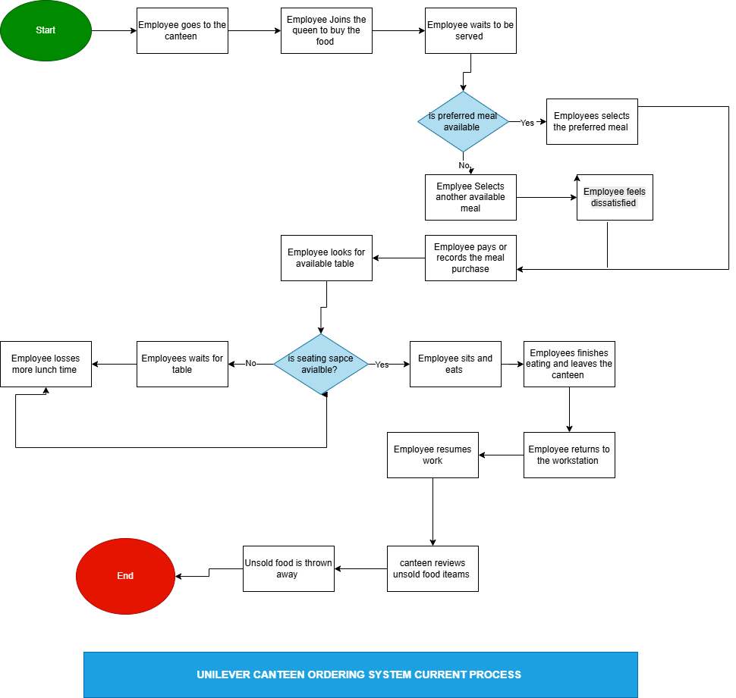
Current Process Pain Point | Description
Long queues | Employees spend too much time waiting to buy food.
Limited seating | Employees waste time looking for available tables.
Lost productivity | Employees spend about 60 minutes on lunch movement and waiting.
Poor meal availability | Some preferred meals run out before employees are served.
Food wastage | Unsold meals are thrown away at the end of the lunch period.
Poor demand planning | The canteen does not know what employees want before preparing meals.

7. To-Be Process Map
The future process allows employees to order lunch online before 11am, receive meals at their workstations, provide feedback, and have meal costs deducted from salary at month end.
Step | Process Activity
1 | Menu Manager creates or updates the daily menu
2 | System displays available dishes and prices
3 | Employee logs into the Canteen Ordering System
4 | Employee views daily menu
5 | Employee selects preferred lunch items
6 | Employee reviews order total
7 | Employee edits order before checkout, if needed
8 | System checks the order time
9 | Decision: Is the order placed before 11am? If No, system rejects the order and employee receives deadline message. If Yes, employee confirms order.
10 | System locks the order from further editing or cancellation
11 | System records confirmed order
12 | Canteen Manager views all confirmed orders
13 | Canteen Manager reviews total dishes ordered
14 | Kitchen Staff prepares meals based on confirmed order summary
15 | Canteen Manager marks meals ready for delivery
16 | Canteen Manager assigns delivery
17 | Delivery Boy delivers meal to employee workstation
18 | Delivery Boy closes the order in the system
19 | System updates order status to Delivered
20 | Employee submits feedback, if necessary
21 | System records feedback
22 | At month end, system generates meal deduction report
23 | Payroll reviews monthly meal deduction report
24 | Payroll deducts total meal cost from employee salary

Swimlane | Responsibilities in the Future Process
Employee | Logs in, views menu, selects meals, reviews order, edits before checkout, confirms order, receives meal, submits feedback if needed.
System | Displays menu, checks order time, rejects late orders, locks confirmed orders, records orders, updates order status, records feedback, generates payroll report.
Menu Manager | Creates or updates the daily menu.
Canteen Manager | Views confirmed orders, reviews total dishes ordered, marks meals ready for delivery, assigns delivery.
Kitchen Staff | Prepares meals based on confirmed order summary.
Delivery Boy | Delivers meals to employee workstations and closes delivered orders.
Payroll | Reviews monthly meal deduction report and deducts total meal cost from salary.
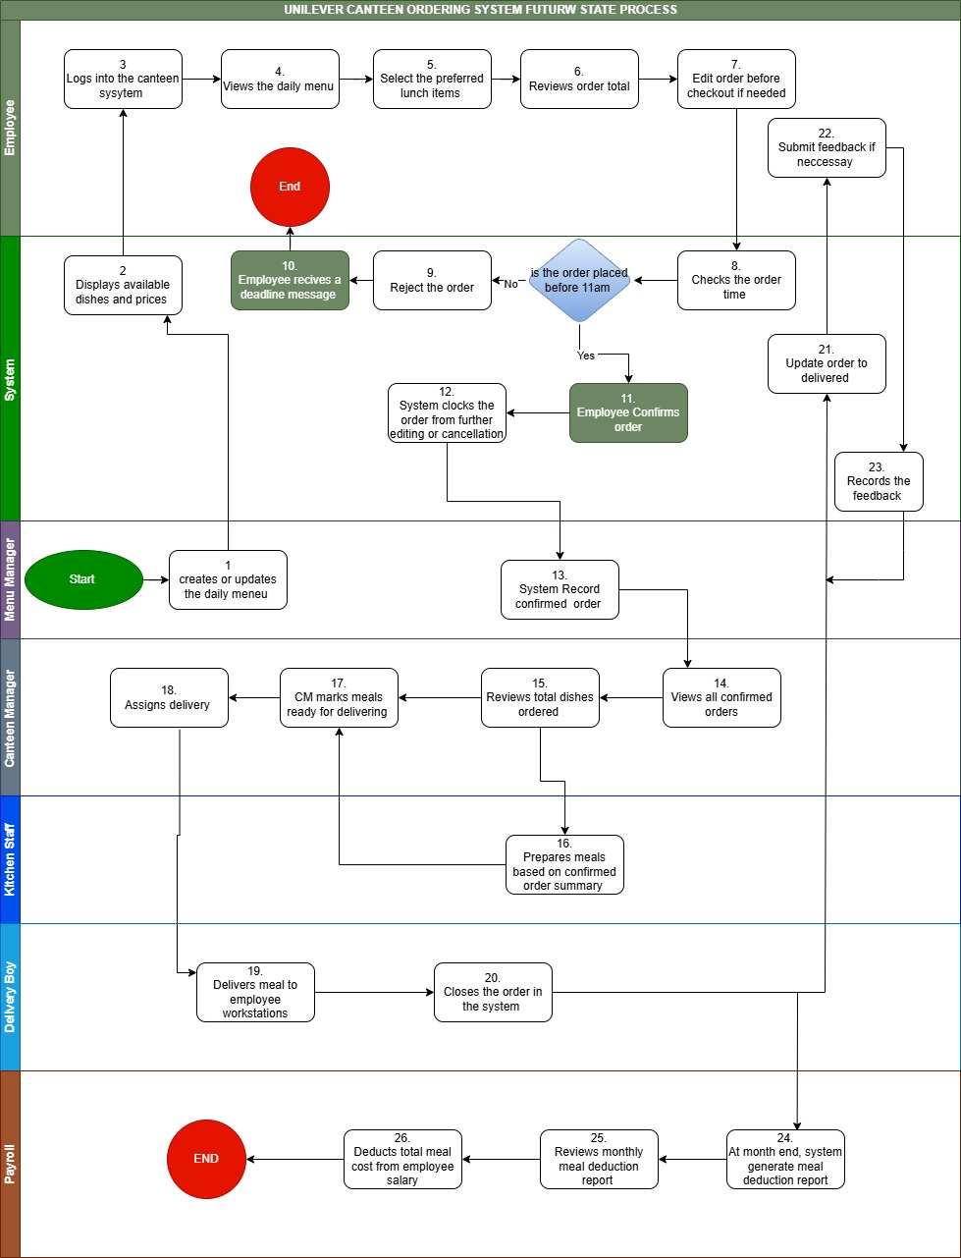

8. User Stories and Acceptance Criteria
User Story ID | User Story | Priority | Acceptance Criteria
UMOS6 | As an employee, I want to view the daily menu so that I can see available dishes before placing an order. | High | Menu shows available dishes and prices; unavailable dishes are not shown.
UMOS7 | As an employee, I want to see the price of each dish so that I can know the total cost before confirming my order. | High | Prices are displayed and order total is calculated before checkout.
UMOS8 | As an employee, I want to select lunch items from the menu so that I can place my meal order online. | High | Employee can select dishes and view selected items before checkout.
UMOS9 | As an employee, I want to edit my order before checkout so that I can correct mistakes before confirming. | High | Employee can add, remove, or change items before checkout.
UMOS10 | As an employee, I want to confirm my lunch order so that the canteen can prepare my meal. | High | System saves confirmed order and displays confirmation message.
UMOS11 | As an employee, I want the system to lock my order after checkout so that confirmed orders remain accurate. | High | Confirmed order cannot be edited or cancelled.
UMOS12 | As a Canteen Manager, I want the system to stop lunch orders after 11am so that the kitchen has enough time to prepare meals. | High | System accepts orders before 11am and rejects orders after 11am.
UMOS13 | As a Menu Manager, I want to create and update the daily menu so that employees can only order available meals. | High | Menu Manager can add, update, remove, or mark dishes as unavailable.
UMOS14 | As a Canteen Manager, I want to view all confirmed orders so that I can plan meal preparation. | High | Confirmed orders show employee details, selected dishes, and order time.
UMOS115 | As a Canteen Manager, I want to see the total quantity of each dish ordered so that I can guide the kitchen team. | High | System shows total quantity of each dish ordered.
UMOS16 | As a Chef, I want to receive a summary of confirmed meals so that I can prepare the correct quantity of food. | High | Meal summary shows dish names and quantities required.
UMOS17 | As a Canteen Manager, I want to request delivery for prepared meals so that employees can receive lunch at their workstations. | High | Canteen Manager can mark meals ready and assign delivery.
UMOS18 | As a Delivery Boy, I want to view assigned deliveries so that I know where to deliver meals. | High | Delivery list shows employee name, floor, workstation, and order items.
UMOS19 | As a Delivery Boy, I want to close an order after delivery so that the system shows the meal has been delivered. | High | Order status changes to Delivered after closure.
UMOS120 | As an employee, I want to submit feedback on food or delivery service so that the canteen team can improve service quality. | Medium | Employee can submit feedback after delivery and manager can view it.
UMOS21 | As a Payroll Officer, I want to receive a monthly meal deduction report so that meal costs can be deducted from salaries. | High | Report includes employee details, number of orders, and total amount due.
UMOS22 | As an Admin, I want to manage user roles so that users only access features related to their responsibilities. | Medium | Admin can assign roles and restrict unauthorized access.

9. Product Backlog
Backlog ID | User Story ID | Backlog Item | Priority
PB001 | UMOS6 | View daily menu | High
PB002 | UMOS7 | View dish prices | High
PB003 | UMOS8 | Place lunch order | High
PB004 | UMOS9 | Edit order before checkout | High
PB005 | UMOS10 | Confirm lunch order | High
PB006 | UMOS11 | Lock order after checkout | High
PB007 | UMOS12 | Enforce 11am order deadline | High
PB008 | UMOS13 | Create and update daily menu | High
PB009 | UMOS14 | View confirmed orders | High
PB010 | UMOS115 | View dish quantity summary | High
PB011 | UMOS16 | Prepare meals using order summary | High
PB012 | UMOS17 | Request delivery | High
PB013 | UMOS18 | View assigned deliveries | High
PB014 | UMOS19 | Close delivered order | High
PB015 | UMOS120 | Submit food or delivery feedback | Medium
PB016 | UMOS21 | Generate payroll deduction report | High
PB017 | UMOS22 | Manage user roles | Medium

10. Sprint Plan

10.1 Sprint 1: Menu and Employee Ordering
Sprint Goal: To allow employees to view the daily menu, select food items, edit orders, and prepare for checkout.
User Story ID | User Story Summary | Priority
UMOS6 | View daily menu | High
UMOS7 | View dish prices | High
UMOS8 | Place lunch order | High
UMOS9 | Edit order before checkout | High
UMOS13 | Create and update daily menu | High

10.2 Sprint 2: Checkout, Order Control, and Meal Preparation
Sprint Goal: To allow employees to confirm orders before 11am and allow the canteen team to view and prepare meals based on confirmed orders.
User Story ID | User Story Summary | Priority
UMOS10 | Confirm lunch order | High
UMOS11 | Lock order after checkout | High
UMOS12 | Enforce 11am order deadline | High
UMOS14 | View confirmed orders | High
UMOS15 | View dish quantity summary | High
UMOS16 | Prepare meals using order summary | High

10.3 Sprint 3: Delivery, Feedback, Payroll, and Access Control
Sprint Goal: To complete delivery, feedback, payroll deduction, and user access control.
User Story ID | User Story Summary | Priority
UMOS17 | Request delivery | High
UMOS18 | View assigned deliveries | High
UMOS19 | Close delivered order | High
UMOS20 | Submit food or delivery feedback | Medium
UMOS21 | Generate payroll deduction report | High
UMOS22 | Manage user roles | Medium

11. Jira Screenshots
Add your Jira screenshots under this section after creating the project in Jira.
- Jira project board
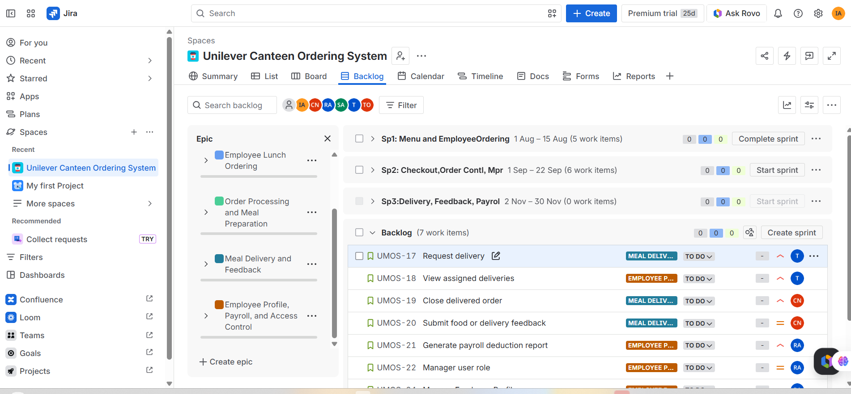
- Product backlog with all user stories
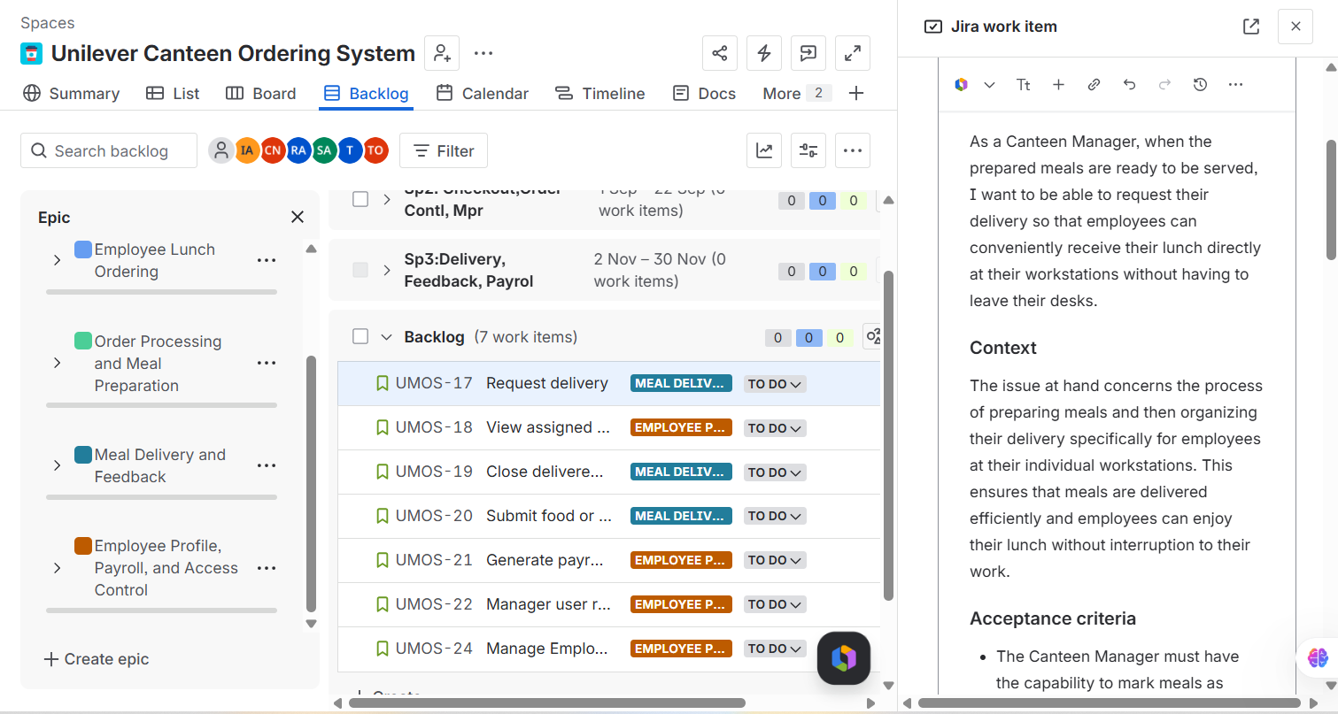
- Sprint 1
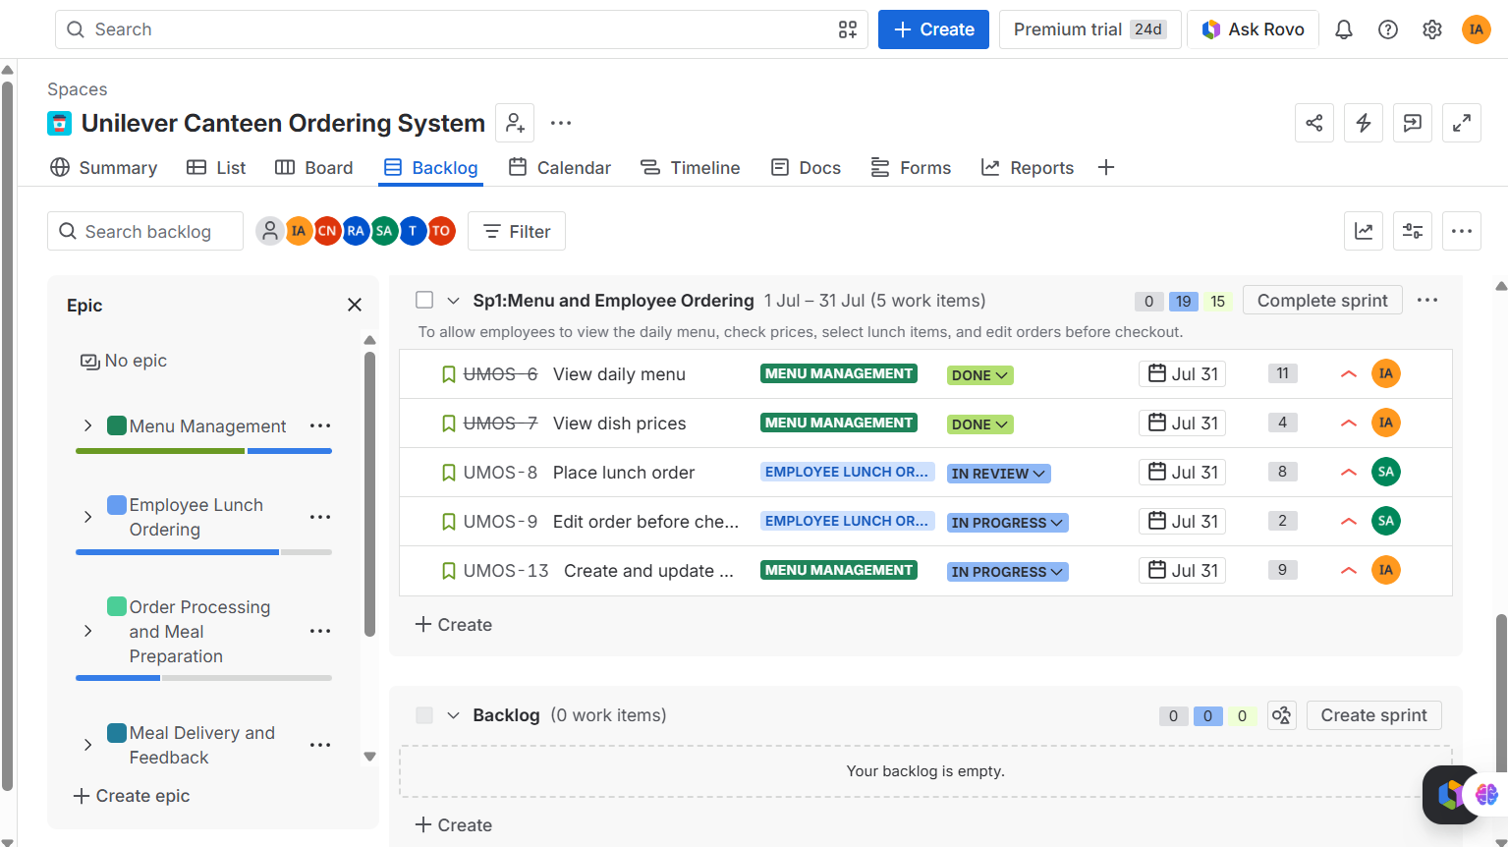
- Sprint 2
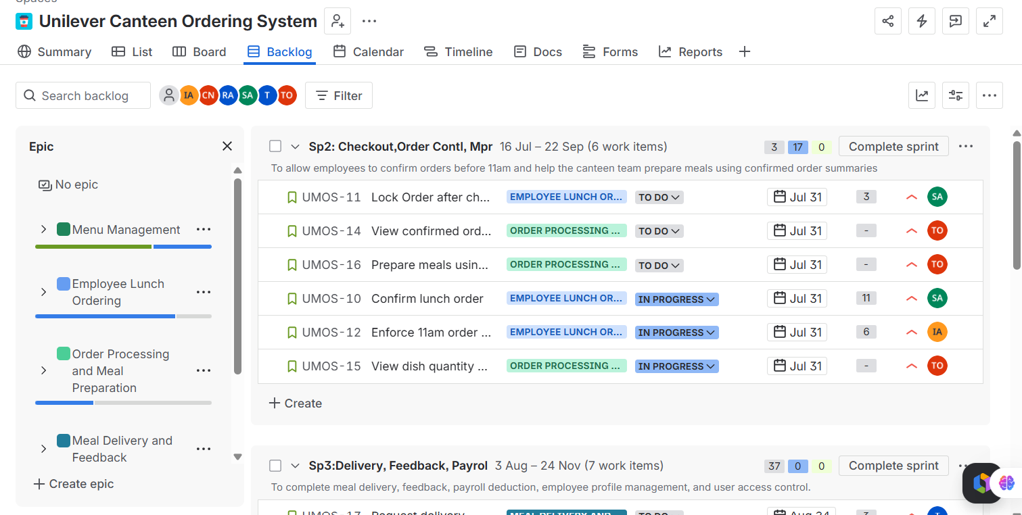
- Sprint 3
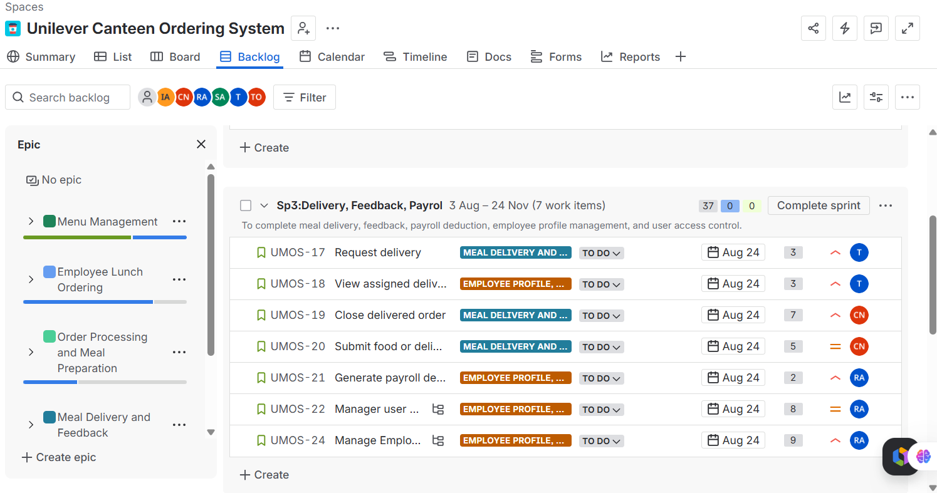
- Active sprint board showing To Do, In Progress, In Review, and Done columns
Jira Field | Suggested Entry
Project Name | Canteen Ordering System
Project Type | Scrum
Project Key | UMOS
Board Type | Scrum Board
Sprint Duration | 2 weeks
Number of Sprints | 3

12. Final Project Conclusion
The Canteen Ordering System project is designed to solve Unilever UK’s lunch-hour challenges by reducing canteen congestion, improving employee experience, supporting better meal planning, and reducing food wastage.
The current process causes employees to spend too much time away from their workstations during lunch and creates pressure on the canteen team because demand is not known in advance. The proposed system will allow employees to order meals online before 11am and receive lunch at their workstations.
The business case shows that the project is financially beneficial. With an estimated project cost of £140,000 and an estimated annual benefit of £1,680,000, the system has a payback period of about 1 month and an estimated ROI of 1,100%. Based on the business problem, stakeholder impact, functional requirements, process improvement, expected benefits, and financial analysis, the Canteen Ordering System is recommended for implementation.

