PURE LIFE HOSPITAL
ANALYTICS PROJECT
Power BI Portfolio Case Study

Operational • Clinical • Financial Performance Analysis
Prepared by Onyinyechi Ikea

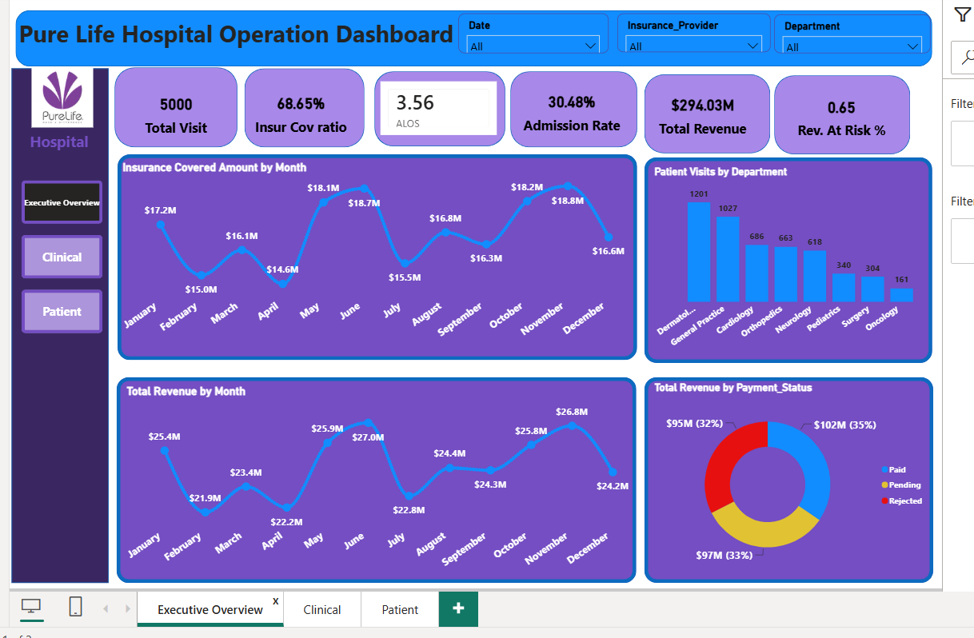

Table of Contents
1. Executive Summary
2. Business Problem
3. Project Objectives
4. Business Questions
5. Dataset and Analytical Approach
6. KPI Framework
7. Dashboard Design
8. Dashboard Findings and Insights
9. Recommendations
10. Business Impact

Implemented Dashboard Improvements
- Added a Date slicer to the Executive / Operations page for period-based filtering.
- Added Revenue at Risk % to quantify the share of revenue currently Pending or Rejected.
- Renamed department, visit-type and diagnosis visuals so titles match the metrics displayed.
- Enhanced the severity analysis by comparing outcome composition across severity scores.
- Configured the Patient page for drill-through investigation and added a Back button for navigation.
11. Limitations and Future Improvements
12. Conclusion

1. Executive Summary
Pure Life Hospital needed a clearer way to connect patient activity, clinical outcomes and financial performance. This project transformed the hospital dataset into an interactive Power BI reporting solution with an Executive/Operations view, a Clinical view and a Patient-level view.
The dashboard records 5,000 patient visits and $294.03M in total revenue. Insurance covers $201.84M, equivalent to a 68.65% insurance coverage ratio. The overall admission rate is 30.48%, average length of stay is 3.56 days, average severity score is 5.84, and mortality rate is 2.22%.
The strongest management concern is the revenue cycle. Only 35% ($102M) of billed revenue is shown as Paid, while 33% ($97M) is Pending and 32% ($95M) is Rejected. This means about 65% of billed revenue is not shown as paid in the payment-status view and deserves immediate claims and collections review.

2. Business Problem
Despite processing a high volume of patients and generating substantial billed revenue, Pure Life Hospital lacks a centralized, data-driven mechanism to monitor the intersection of clinical outcomes and financial performance. The project focuses on four connected challenges:
- Revenue cycle visibility: tracking Paid, Pending and Rejected payments and understanding insurance-covered versus patient-funded amounts.
- Resource allocation: understanding visit type and department volume to support staffing and capacity decisions.
- Clinical quality tracking: monitoring severity scores alongside patient outcomes to identify areas requiring closer attention.
- Patient history management: providing a consolidated patient-level view of repeat visits and related clinical and payment information.

3. Project Objectives
- Measure hospital utilization and operational workload.
- Assess clinical patterns using diagnosis, severity and outcome data.
- Evaluate revenue, insurance coverage and payment status.
- Provide patient-level visibility for detailed investigation.
- Translate dashboard findings into practical management recommendations.

4. Business Questions
- Which departments handle the highest patient load?
- Where might operational bottlenecks exist?
- What diagnoses appear most frequently?
- How efficiently are insurance claims and payments processed?
- Could there be areas of revenue leakage?

5. Dataset and Analytical Approach
The analysis uses patient, visit, clinical and financial fields including Patient ID, patient name, gender, city, age, visit type, admission date, insurance-covered amount, insurance provider, outcome status, payment status, department, primary diagnosis and severity score.

Analytical workflow
- Prepared and structured the dataset for Power BI analysis.
- Created a dedicated date table to support chronological month analysis.
- Built the data model and relationships required for reporting.
- Created DAX measures for total visits, revenue, insurance coverage ratio, admission rate, average length of stay, average severity score and mortality rate.
- Designed interactive report pages with slicers for insurance provider, department and patient ID.
- Reviewed dashboard results and translated them into operational, clinical and financial recommendations.

6. KPI Framework
KPI | Dashboard Value | Interpretation
Total Patient Visits | 5,000 | Overall hospital activity captured in the dashboard.
Insurance Coverage Ratio | 68.65% | Share of billed revenue covered by insurance.
Average Length of Stay (ALOS) | 3.56 days | Average duration of patient stay.
Admission Rate | 30.48% | Share of visits resulting in admission.
Total Revenue | $294.03M | Total billed revenue shown on the executive dashboard.
Average Severity Score | 5.84 | Average clinical severity across recorded visits.
Total Diagnoses | 9 | Number of diagnosis categories represented.
Insurance Covered Amount | $201.84M | Total amount covered by insurance.
Mortality Rate | 2.22% | Share of visits with a deceased outcome.

7. Dashboard Design

7.1 Executive / Operations Dashboard
The executive page combines headline KPIs with monthly financial trends, department workload and payment-status analysis. Date, Insurance Provider and Department slicers allow management to narrow the view.

Figure 1. Executive / Operations dashboard

7.2 Clinical Dashboard
The clinical page focuses on severity, visit type, diagnosis and outcome status. The severity visual has been upgraded to compare outcome composition across severity scores, making the page more analytical rather than showing counts alone. It combines clinical KPIs with distributions that help identify workload and risk patterns.
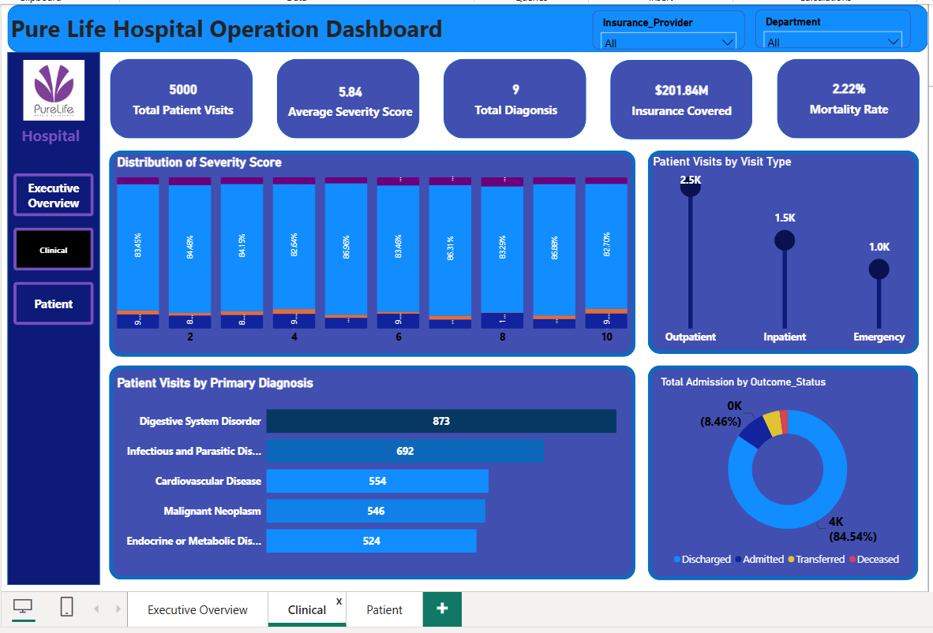
Figure 2. Clinical dashboard

7.3 Patient Dashboard
The patient page provides record-level visibility and supports detailed investigation by Patient ID. It now also functions as a drill-through destination from higher-level analysis, with a Back button for returning to the source page. It brings together demographic, visit, insurance, outcome and payment fields in one view.
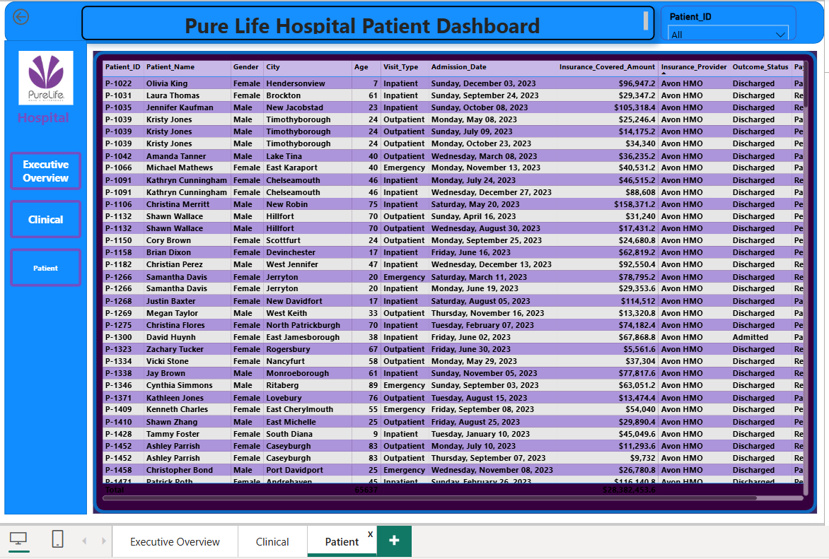
Figure 3. Patient-level dashboard

8. Dashboard Findings and Insights

8.1 Operational Findings
Department workload is uneven. Dermatology records 1,201 visits, followed by General Practice with 1,027. Together they account for 2,228 visits, or about 44.6% of all 5,000 visits. Cardiology (686), Orthopedics (663) and Neurology (618) form the next tier, while Oncology has the lowest displayed volume at 161 visits.
Visit type also shows a clear workload pattern: approximately 2.5K outpatient visits, 1.5K inpatient visits and 1.0K emergency visits. Outpatient activity therefore represents roughly half of recorded visits, making outpatient flow a major operational planning area.
The 30.48% admission rate and 3.56-day ALOS provide baseline measures for capacity and throughput. These should be monitored by department and over time before concluding that a specific department is inefficient.

8.2 Clinical Findings
The average severity score is 5.84. Severity score 9 has the highest displayed frequency at 846 visits, followed by score 3 at 656 and score 10 at 601. The presence of substantial volumes at scores 9 and 10 supports closer monitoring of high-severity cases.
Digestive System Disorder is the leading displayed primary diagnosis with 873 admissions/records, followed by Infectious and Parasitic Diseases (692), Cardiovascular Disease (554), Malignant Neoplasm (546), and Endocrine or Metabolic Disorders (524).
Outcome status is dominated by Discharged cases at about 4K (84.54%). The overall mortality rate is 2.22%. The dashboard supports monitoring, but the screenshot alone does not establish that higher severity causes mortality. A severity-by-outcome analysis would be needed to test that relationship directly.

8.3 Financial Findings
Total revenue is $294.03M, of which $201.84M is insurance-covered. This aligns with the 68.65% insurance coverage ratio and indicates that insurance reimbursement is a major part of the hospital revenue model.
Payment status is the clearest financial risk signal: Paid revenue is $102M (35%), Pending is $97M (33%), and Rejected is $95M (32%). Pending and Rejected combined represent about 65% of total revenue, which is now surfaced directly on the executive page as a Revenue at Risk % KPI (0.65, equivalent to 65%). This should be interpreted as revenue requiring follow-up, not automatically as permanently lost revenue.
Monthly revenue ranges from approximately $21.9M in February to $27.0M in June, with November also strong at $26.8M. Insurance-covered amounts range from about $14.6M in April to $18.8M in November. These variations provide a basis for monthly cash-flow and claims-performance monitoring.

9. Recommendations
Revenue cycle: Prioritize review of Pending and Rejected claims. Track rejection reasons, resubmission turnaround time, aging of pending claims and recovery rate by insurance provider.
Department capacity: Review staffing and appointment capacity in Dermatology and General Practice because they carry the largest displayed patient volumes.
Outpatient flow: Because outpatient visits represent the largest visit type, examine registration, consultation and discharge processes for avoidable waiting time.
Clinical monitoring: Create a severity-versus-outcome visual and monitor mortality by department and diagnosis. This would distinguish high case complexity from potential quality concerns.
High-severity cases: Introduce a focused view for severity scores 9-10 to monitor outcomes, ALOS and department concentration.
Patient history: Use the Patient ID drill-through/detail page to consolidate repeat visits and make patient history easier to review.
Financial accountability: Add KPIs such as rejection rate, pending claim value, collection rate and revenue at risk to make revenue-cycle performance more actionable.

10. Business Impact
- Faster visibility into department workload and patient demand.
- Improved monitoring of severity, diagnosis and patient outcomes.
- Clearer identification of revenue delayed or at risk through Pending and Rejected payment statuses.
- A consolidated patient-level view for detailed investigation.
- A common reporting layer that can support management discussions across operations, clinical care and finance.

11. Limitations and Future Improvements
- The clinical page now compares severity score with outcome status, improving visibility into associations between case severity and outcomes. The analysis still shows association rather than causation, so clinical-quality conclusions require additional patient-risk and treatment context.
- The executive page now includes Revenue at Risk %, based on Pending and Rejected revenue. Rejected does not automatically mean permanently lost revenue; claim aging, rejection reason, resubmission and recovery data would be needed for a complete revenue-cycle analysis.
- A Date slicer has been added to the executive page to support period filtering. A dedicated Year slicer or Year-Month trend axis can be added where explicit year-over-year comparison is required.
- The Patient page has been configured as a detailed investigation page with drill-through navigation and a Back button. This can be extended to additional source visuals and drill-through fields as the report evolves.
- Targets or external/internal benchmarks for ALOS, admission rate, mortality and claim rejection are still required so users can distinguish acceptable performance from exceptions. These should come from approved hospital targets or credible healthcare benchmarks rather than arbitrary values.
- Naming has been improved across the report, including Patient Visits by Department, Patient Visits by Visit Type and Patient Visits by Primary Diagnosis. The remaining abbreviated KPI label “Insurance Cov ratio” should be changed to “Insurance Coverage Ratio” for full consistency.

12. Conclusion
The Pure Life Hospital Analytics Project demonstrates an end-to-end approach to healthcare reporting in Power BI. It connects 5,000 patient visits with operational workload, clinical indicators and $294.03M in revenue. The dashboard’s most important management signal is the high share of revenue in Pending and Rejected payment statuses, alongside concentrated workload in a small number of departments and meaningful volumes of high-severity cases.
The project provides a strong foundation for decision-making, while the next phase should deepen the analysis through claims aging, severity-versus-outcome comparisons, department-level efficiency measures and more detailed patient drill-through.

