The purpose of this questionnaire is to evaluate the SMMSi Blockchain Management System using ISO/IEC 25010 standards. Your feedback is crucial in helping us enhance the system's performance and usability.
All responses will be kept anonymous and confidential. The data collected will be used exclusively for the improvement of the system.

By answering the evaluation, you signify your consent to participate in this survey.

SOFTWARE QUALITY EVALUATION

Direction: Please evaluate the software quality of the “SMMSi Blockchain Management System” based on the four characteristics of ISO/IEC 25010 Software Product Quality Standards for end user. Choose on the appropriate box using the four-point scale with its corresponding verbal description (4 as the highest and 1 as the lowest).
Rating:
Strongly Agree (Lubos na Sumasang-ayon) – 4
Agree (Sumasang-ayon) – 3
Disagree (Hindi Sumasang-ayon) – 2
Strongly Disagree (Lubos na Hindi Sumasang-ayon) – 1

1 Functional Sustainability |  | 4 | 3 | 2 | 1
1.1 | The system includes all necessary functions for school operations, such as student enrollment, grading, and record-keeping. (Ang sistema ay naglalaman ng lahat ng kinakailangang function para sa operasyon ng paaralan, tulad ng pagpapatala ng estudyante, pagmamarka, at pagtatago ng mga rekord.)
1.2 | The system accurately records and reflects real-time updates to student information and academic records on the blockchain. (Tumpak na naitala at naipakikita ng sistema ang mga real-time na update sa impormasyon ng estudyante at mga akademikong rekord sa blockchain.)
1.3 | The blockchain features are suitable for generating verifiable digital credentials (e.g., diplomas or transcripts) that prevent forgery. (Ang mga tampok ng blockchain ay angkop para sa pagbuo ng mga nabe-verify na digital credentials tulad ng diploma o transcript na nakakapigil sa pamemeke.)

2 Performance Efficiency |  | 4 | 3 | 2 | 1
2.1 | The time taken to record a grade or update a student record on the blockchain is fast and within institutional limits. (Ang oras na ginugugol sa pagtala ng marka o pag-update ng rekord ng estudyante sa blockchain ay mabilis at nasa loob ng mga limitasyon ng institusyon.)
2.2 | The system loads quickly and runs smoothly on standard devices without consuming excessive hardware or network resources. (Ang sistema ay mabilis mag-load at gumagana nang maayos sa mga karaniwang device nang hindi gumagamit ng labis na kagamitan o network resources.)
2.3 | The system can handle a large number of simultaneous users during enrollment or grading periods without slowing down or crashing. (Kayang hawakan ng sistema ang malaking bilang ng magkakasabay na gumagamit sa panahon ng enrollment o pagmamarka nang hindi bumabagal o nagko-crash.)

3 Compatibility |  | 4 | 3 | 2 | 1
3.1 | The system successfully and securely communicates with external educational databases or government portals. (Ang sistema ay matagumpay at ligtas na nakikipag-ugnayan sa mga panlabas na educational database o mga portal ng gobyerno.)
3.2 | The blockchain backend runs smoothly alongside the web server and school database without resource conflicts. (Ang backend ba ng blockchain ay gumagana nang maayos kasabay ng web server at database ng paaralan nang walang resource conflicts.)
3.3 | The system's architecture is designed to easily integrate with new third-party APIs or external institutional services. (Ang arkitektura ng sistema ay dinisenyo upang madaling maisama sa mga bagong third-party API o mga panlabas na serbisyo ng institusyon.)

4 Interaction Capability (Usability) |  | 4 | 3 | 2 | 1
4.1 | New users (students, teachers, or staff) can quickly and easily learn how to navigate and use the system’s core blockchain features. (Ang mga bagong gumagamit ay mabilis at madaling matutunan kung paano mag-navigate at gamitin ang mga pangunahing tampok ng blockchain sa sistema.)
4.2 | The system’s interface is clear, logically organized, and visually appealing for both administrative and student views. (Ang interface ng sistema ay malinaw, lohikal na nakaayos, at visually appealing para sa parehong admin at estudyante.)
4.3 | The system provides clear status notifications when a transaction is being validated or "mined" on the blockchain. (Nagbibigay ang sistema ng malinaw na abiso ng status kapag ang isang transaksyon ay bini-verify o "minina" sa blockchain.)

5 Reliability |  | 4 | 3 | 2 | 1
5.1 | The system rarely experiences critical errors, failures, or unexpected shutdowns during normal school operations. (Ang sistema ay bihira lang nakararanas ng mga kritikal na error, pagpalya, o hindi inaasahang pag-shutdown sa panahon ng normal na operasyon ng paaralan.)
5.2 | The decentralized management system is available and ready for use at all times when needed by the institution. (Ang decentralized management system ay available at handang gamitin sa lahat ng oras kapag kinakailangan ng institusyon.)
5.3 | In the event of a network failure, the system can quickly and accurately restore all student records and blockchain transaction data. (Sa kaganapan ng pagpalya ng network, mabilis at tumpak na naibabalik ng sistema ang lahat ng rekord ng estudyante at data ng transaksyon sa blockchain.)

6 Security |  | 4 | 3 | 2 | 1
6.1 | The system ensures that student records are immutable and protected against unauthorized tampering once saved to the ledger. (Sinisiguro ng sistema na ang mga rekord ng estudyante ay hindi na mababago at protektado laban sa hindi awtorisadong pakikialam kapag naisave na sa ledger.)
6.2 | The system securely manages sensitive student data and private blockchain keys using robust encryption protocols. (Ligtas na pinamamahalaan ng sistema ang sensitibong data ng estudyante at mga private blockchain keys gamit ang matitibay na encryption protocols.)
6.3 | Only authorized school personnel are able to log in to the administrative interface and modify critical academic settings. (Tanging ang mga awtorisadong tauhan lamang ng paaralan ang kayang mag-log in sa administrative interface at magbago ng mga kritikal na academic settings.)

7 Maintainability |  | 4 | 3 | 2 | 1
7.1 | An issue in a single service can be isolated, debugged, and fixed without requiring a restart of the entire management system. (Ang isang isyu sa iisang serbisyo ay maaaring ihiwalay, i-debug, at ayusin nang hindi nangangailangan ng pag-restart ng buong management system.)
7.2 | The system provides sufficient and easy-to-access logs for developers to diagnose the cause of any reported failures. (Nagbibigay ang sistema ng sapat at madaling i-access na mga log para sa mga developer upang ma-diagnose ang sanhi ng anumang naiulat na pagpalya.)
7.3 | Individual modules (e.g., Enrollment or Grading) can be updated and tested independently of other blockchain services. (Ang mga indibidwal na module tulad ng Enrollment o Grading ay maaaring i-update at i-test nang hiwalay sa ibang mga serbisyo ng blockchain.)

8 Flexibility (Portability) |  | 4 | 3 | 2 | 1
8.1 | The system applications can be easily updated to newer framework versions without requiring major architectural rework. (Ang mga aplikasyon ng sistema ay madaling ma-update sa mas bagong bersyon ng framework nang hindi nangangailangan ng malaking pagbabago sa arkitektura.)
8.2 | Specific services can be deployed across multiple server instances independently to handle a sudden surge in user demand. (Ang mga partikular na serbisyo ay maaaring i-deploy sa maraming server instance nang hiwalay upang harapin ang biglaang pagdagsa ng mga gumagamit.)
8.3 | Is the system modular enough to allow switching to a different blockchain protocol with minimal changes to other services. (Ang sistema ba ay sapat na modular upang payagan ang paglipat sa ibang blockchain protocol na may kaunting pagbabago lamang sa ibang mga serbisyo.)

9 Safety |  | 4 | 3 | 2 | 1
9.1 | The system is modular enough to allow switching to a different blockchain protocol with minimal changes to other services. (Ang sistema ay sapat na modular upang payagan ang paglipat sa ibang blockchain protocol na may kaunting pagbabago lamang sa ibang mga serbisyo.)
9.2 | The system provides alerts that quickly identify and flag potential security risks or unauthorized access attempts. (Nagbibigay ang sistema ng mga alerto na mabilis na makakatukoy at makakapag-flag ng mga potensyal na panganib sa seguridad o pagtatangkang pumasok nang walang pahintulot.)
9.3 | If the connection to the blockchain network is lost, the system gracefully reverts to a safe operational state without losing data. (Kung nawala ang koneksyon sa blockchain network, maayos itong bumabalik sa isang ligtas na operational state nang hindi nawawalan ng data.)

Unified Theory of Acceptance and Use of Technology (UTAUT) Model

Part 1: Profile of the Respondents
Instructions: Please check (✔) the box that corresponds to your personal information.
Your responses will be kept confidential. (Mangyaring lagyan ng tsek (✔) ang kahon na

tumutugma sa iyong personal na impormasyon. Ang iyong mga sagot ay mananatiling

kumpidensyal.)

Code | No. | Statement
PR | 1. | Please specify your age: | [ ] below  20 | [ ] 21-  25 | [ ]  26–40 | [ ]  41–55 | [ ] 56  and above
 | 2. | Years of experience in Chainsight: | [ ] no (0)  experience | [ ]  Below  1 year | [ ] 1–  5  years | [ ] 6–  10 years | [ ] 11 years and above
 | 3. | Role in Chainsight: | [ ]  Admin | [ ]  Teacher | [ ]  Parent | [ ]  Student

1. Performance Expectancy | 4 | 3 | 2 | 1
1.1 Using Chainsight helps me complete my academic or administrative tasks more quickly. (Ang paggamit ng ChainSight ay tumutulong sa akin upang mas mabilis kong matapos ang aking mga gawaing akademiko o administratibo.)
1.2 The system improves my efficiency in managing student records, grades, and announcements. (Pinapabuti ng sistema ang aking kahusayan sa pamamahala ng mga rekord ng mag-aaral, marka, at mga anunsyo.)
1.3 ChainSight helps me manage academic information

and school-related transactions more effectively.

(Tinutulungan ako ng ChainSight na mas maayos na

pamahalaan ang impormasyong akademiko at mga

transaksyong pang-eskwela.)

2. Effort Expectancy | 4 | 3 | 2 | 1
2.1 Learning to use Chainsight is easy for me.
(Madali para sa akin na matutunan kung paano gamitin ang ChainSight.)
2.2 The system is easy to understand and navigate.
(Madaling maunawaan at gamitin ang sistema.)
2.3 I can use the system without much effort.

(Nagagamit ko ang sistema nang hindi

nangangailangan ng malaking pagsisikap.)

3. Social Influence | 4 | 3 | 2 | 1
3.1 People important to me think that I should use
Chainsight. (Ang mga taong mahalaga sa akin ay
Naniniwalang dapat kong gamitin ang Chainsight.)
3.2 School administrators, teachers, or peers encourage
me to use the system. (Hinihikayat ako ng mga
administrador ng paaralan, guro, o kapwa gumagamit
na gamitin ang sistema.)
3.3 Using Chainsight is accepted and supported within

the school community. (Ang paggamit ng ChainSight

ay tinatanggap at sinusuportahan ng komunidad ng

paaralan.)

4. Facilitating Conditions | 4 | 3 | 2 | 1
4.1 I have the resources needed to use Chainsight.
(Mayroon akong mapagkukunan upang magamit ang
Chainsight.)
4.2 I have the knowledge necessary to use the system.
(Mayroon akong sapat na kaalaman upang magamit
ang Sistema.)
4.3 The system is compatible with my way of working.
(Ang Sistema ay angkop sa paraan ng pagtrabaho.)

5. Behavioral Intention | 4 | 3 | 2 | 1
5.1 I intend to use Chainsight regularly. (Nais kong
gamitin ang Chainsight nang regular.)
5.2 I plan to continue using the system in the future.

(Balak kong Ipagpatuloy ang paggamit ng Sistema

sa hinaharap.)
5.3 I would recommend chainsight to others.

(irerekomenda ko ang Chainsight sa iba.)

Statement of the Hypothesis
- Hypothesis and Research Model
  - H1: Performance Expectancy was hypothesized to influence Behavioral Intention positively.
  - H2: Effort Expectancy was hypothesized to influence Behavioral Intention positively.
  - H3: Facilitating Conditions were hypothesized to influence Behavioral Intention positively.
  - H4: Social Influence was hypothesized to influence Behavioral Intention positively.
- Moderating Variables
  - H1a: Age was hypothesized to affect the influence of Performance Expectancy on Behavioral Intention.
  - H2a: Age was hypothesized to affect the influence of Effort Expectancy on Behavioral Intention.
  - H3a: Age was hypothesized to affect the influence of Facilitating Conditions on Behavioral Intention.
  - H4a: Age was hypothesized to affect the influence of Social Influence on Behavioral Intention.
  - H1b: Years of experience in using school information systems is hypothesized to moderate the influence of Performance Expectancy on Behavioral Intention.
  - H2b: Years of experience in using school information systems is hypothesized to moderate the influence of Effort Expectancy on Behavioral Intention.
  - H3b: Years of experience in using school information systems is hypothesized to moderate the influence of Facilitating Conditions on Behavioral Intention.
  - H4b: Years of experience in using school information systems is hypothesized to moderate the influence of Social Influence on Behavioral Intention.
  - H1c: User role in the school (Administrator, Teacher, Student, or Parent) is hypothesized to moderate the influence of Performance Expectancy on Behavioral Intention.
  - H2c: Role in the school is hypothesized to moderate the influence of Effort Expectancy on Behavioral Intention.
  - H3c: Role in the school is hypothesized to moderate the influence of Facilitating Conditions on Behavioral Intention.
  - H4c: Role in the school is hypothesized to moderate the influence of Social Influence on Behavioral Intention.

DIAGRAM
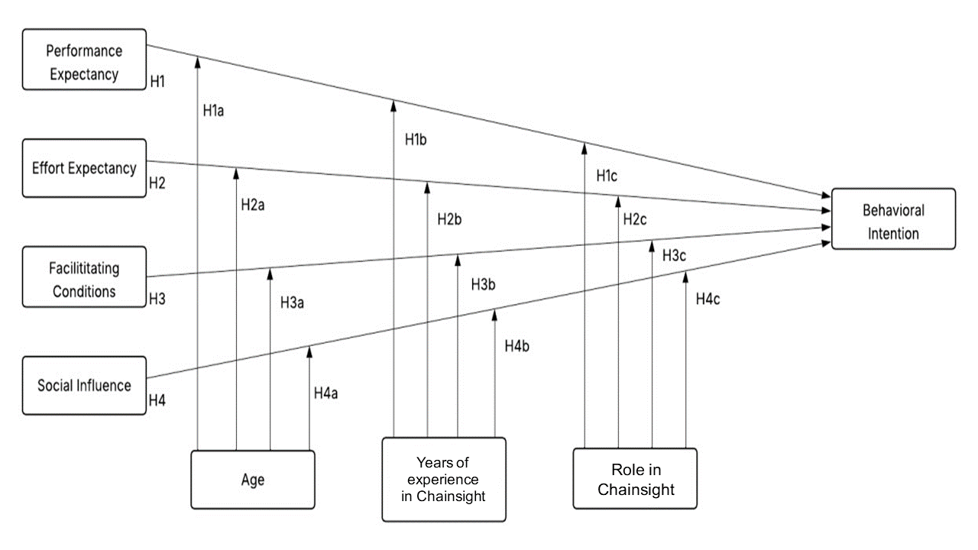

Comments or Suggestions:

Disclaimer: The information gathered in this survey will be used solely for the research and development purposes for ChainSight: A Cloud-Based Support System for Southern Mindoro Maritime School Inc. with Blockchain Technology. Your responses will be confidential, and no personal data will be shared with third parties. (Ang impormasyong makakalap mula sa pag-susuri na ito ay gagamitin lamang para sa pananaliksik at pag-unlad ng ChainSight: A Cloud-Based Support System for Southern Mindoro Maritime School Inc. with Blockchain Technology. Ang iyong mga sagot ay mananatiling kumpidensyal at walang anumang personal na datos ang ibabahagi sa ikatlong panig.)

Signature Over Printed Name _____________________________

