Name_Surname: 08.12.2020

Student Number:

EE231 Midterm Exam I

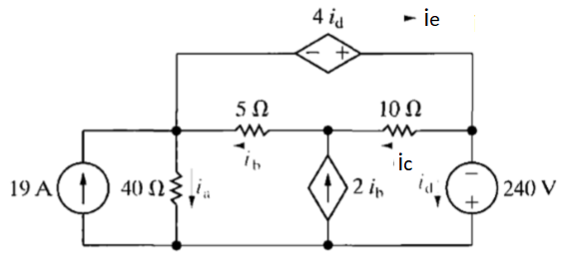

Figure 1

1. (10 pts) Use the node-voltage method to find the branch currents ia – ie for the circuit shown in Figure 1.
2. (10 pts) the mesh-current method to find the branch currents ia – ie for the same circuit.
3. (5 pts) Check your answers by showing that the total power generated equals the total power dissipitated.
4. (25 pts)

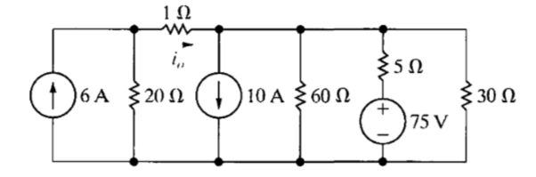

Figure 2

Use a series of source transformation to find the current i0 in the circuit shown in Figure 2.

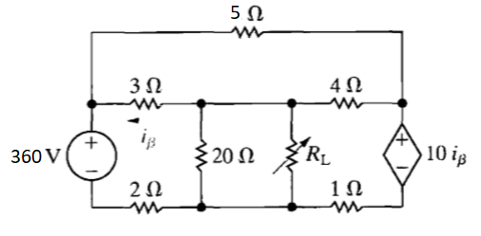

Figure 3

The variable resistor RL in the circuit in Figure 3 is adjusted for maximum power transfer to RL.

1. (10pts) Find the numerical value of RL.
2. (15 pts) Find the maximum power transferred to RL.
3. 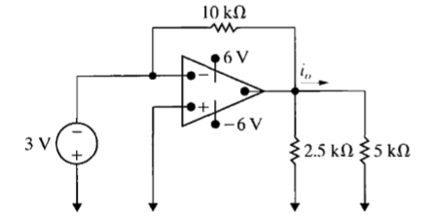(25 pts)

Figure 4

Find i0 in the circuit in Figure 4 if the op amp is ideal.