

Requirement & Design Specification

**Online learning**

**Version: 1.0**

– Hanoi, January 2024 –

# Status Report

|  |  |  |  |
| --- | --- | --- | --- |
| Date | A* M, D | In charge | Change Description |
| 06/01/2024 | A | CuongNDAHS170844 |  |
|  |  |  |  |
|  |  |  |  |
|  |  |  |  |
|  |  |  |  |
|  |  |  |  |
|  |  |  |  |
|  |  |  |  |
|  |  |  |  |
|  |  |  |  |
|  |  |  |  |
|  |  |  |  |

*A - Added M - Modified D - Deleted

Contents

Record of Changes 2

I. Overview 4

1. haha 4

1.1 Actors 4

1.2 Use Cases 4

2. Overall Functionalities 5

2.1 Screens Flow 5

2.2 Screen Descriptions 5

2.3 Screen Authorization 5

2.4 Non-UI Functions 6

3. System High Level Design 6

3.1 Database Design 6

3.2 Code Packages 7

II. Requirement Specifications 8

1. <<Feature Name>> 8

1.1 <<UseCaseCode_UC Name>> 8

2. Common Functions 11

2.1 UC-2_Login System 11

3. Patron Feature 12

3.1 UC-5_Order a Meal 12

3.2 UC-6_Register for Payroll Deduction 13

III. Design Specifications 14

1. <<Feature Name>> 14

1.1 <<SubFeature Name>> 14

1.2 System Access 15

IV. Appendix 19

1. Assumptions & Dependencies 19

2. Limitations & Exclusions 19

3. Business Rules 19

4. .. 19

# I. Overview

## 1. Introduction

## 2. System Funtions

### 2.1 Screens Flow

Slide Details

Slide List

Click “Manage slide”

Show detailed post information (thumbnail, category,

title, brief information, content, attached file, flag to

turn the featurning on/off, status), from that allow the

user to input new post information, view or edit existing

post information

Home

### 2.2 Screen Descriptions

|  |  |  |  |
| --- | --- | --- | --- |
| **#** | **Feature** | **Screen** | **Description** |
| 1 | Marketing | Posts Details | Show detailed post information (thumbnail, category,  title, brief information, content, attached file, flag to  turn the featurning on/off, status), from that allow the  user to input new post information, view or edit existing  post information  Show detailed post information (thumbnail, category,  title, brief information, content, attached file, flag to  turn the featurning on/off, status), from that allow the  user to input new post information, view or edit existing  post information  Show detailed post information (thumbnail, category,  title, brief information, content, attached file, flag to  turn the featurning on/off, status), from that allow the  user to input new post information, view or edit existing  post information  Show detailed post information (thumbnail, category,  title, brief information, content, attached file, flag to  turn the featurning on/off, status), from that allow the  user to input new post information, view or edit existing  post information  Show detailed post information (thumbnail, category,  title, brief information, content, attached file, flag to  turn the featurning on/off, status), from that allow the  user to input new post information, view or edit existing  post information  Show detailed post information (thumbnail, category,  title, brief information, content, attached file, flag to  turn the featurning on/off, status), from that allow the  user to input new post information, view or edit existing  post information |
| 2 | Marketing | Sliders List | Show the paginated list of sliders (including sliders' id,  title, image, backlink, status)  - The user can filter the sliders by the status + search by  title or backlink  - For each slider, the user can choose to hide, show, edit  it  Show the paginated list of sliders (including sliders' id,  title, image, backlink, status)  - The user can filter the sliders by the status + search by  title or backlink  - For each slider, the user can choose to hide, show, edit  it |
| 3 | Marketing | Sliders Details | Show detailed slider information (image, title, backlink,  status, notes) |

### 2.3 Screen Authorization

|  |  |  |  |  |  |
| --- | --- | --- | --- | --- | --- |
| **Screen** | **Admin** | **Manager** | **Expert** | **Marketing** | **Customer** |
| Posts Details | X | X |  |  |  |
| Sliders List | X | X |  |  |  |
| Sliders Details | X | X |  |  |  |
|  |  |  |  |  |  |

In which:

●Admin: Person who manages web

●Manager: Person who manages course, class, account

●Expert: Person who manage quizzes, test

●Teacher: Person who create class, quizzes, test

●Student: Person who join to learn and practice quizzes

### 2.4 Non-Screen Functions

|  |  |  |  |
| --- | --- | --- | --- |
| **#** | **Feature** | **System Function** | **Description** |
| 1 | <<Feature Name>> | <<Function Name1>> | <<Function Name1 Description>> |
| 2 | … |  |  |

## 3. System High Level Design

### 3.1 Database Design

*[Provide the tables relationship like example below]*

#### a. Database Schema

#### b. Table Descriptions

|  |  |  |
| --- | --- | --- |
| **No** | **Table** | **Description** |
| *01* | *<Table name>* | *<Description of the table>*  *- Primary keys: <<list of primary key fields>>*  *- Foreign keys: <<list of foreign key fields>>* |
| *02* | *<Table name2>* | *…* |

### 3.2 Code Packages

*[Provide the package diagram for each sub-system. The content of this section including the overall package diagram, the explanation, package and class naming conventions in each package. Please see the sample & description table format below]*

***Package descriptions***

|  |  |  |
| --- | --- | --- |
| **No** | **Package** | **Description** |
| *01* | *Member_authority* | *<Description of the package>* |
| *02* | *registration* | *<Description of the package>* |
| *03* | *…* |  |

# II. Requirement Specifications

## 1. Marketing

### 1.1 Post Details

Show the paginated list of post.

- Function Trigger: when Admin clicks on “Posts” buttons in the Manager page

- Function Description:

- Show the list of posts

- Each post include the id, thumbnail, title, category, author, featured and status

information

- Screen Layout

Show the paginated list of post.

- Function Trigger: when Admin clicks on “Posts” buttons in the Manager page

- Function Description:

- Show the list of posts

- Each post include the id, thumbnail, title, category, author, featured and status

Information

- Function Trigger: When admin clicks on “Edit” buttons or "New Post" buttons in the Post list

Page

Show detailed post information

- Function Description: The screen is shown with below information for the admin to input

new post information: Thumbnail, category, title, brief information, content, attached file,

flag to turn the featurning on/off, status

- Screen Layout:

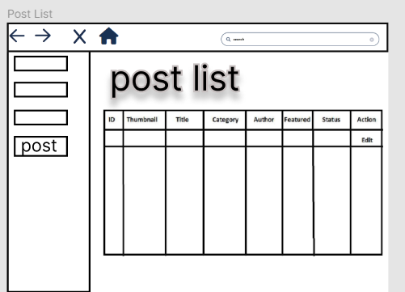

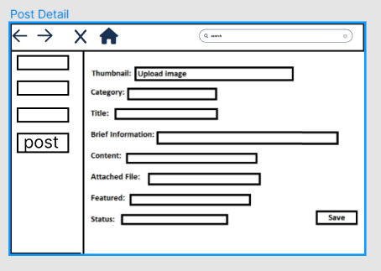

Show detailed post information

- Function Trigger: When admin clicks on “Edit” buttons or "New Post" buttons in the Post list

page

- Function Description: The screen is shown with below information for the admin to input

new post information: Thumbnail, category, title, brief information, content, attached file,

flag to turn the featurning on/off, status

- Screen Layou

- Function Details:

- Flow:

- The Admin clicks on a Post button on the Manager page

- The screen shows a list of post

- The Admin choose the sort method

- Exceptions:

- Only Admin can go to this page

- Function Details:

- Flow:

- The Admin clicks on a Post button on the Manager page

- The screen shows a list of post

- The Admin choose the sort method

- Exceptions:

- Only Admin can go to this page

- Function Details:

- Flow:

- The Admin clicks on a Post button on the Manager page

- The screen shows a list of post

- The Admin choose the sort method

From Post List page

- The Admin clicks edit to edit spost details

- The Admin clicks the “new post” button to create a new Post

- From Post List page

- The Admin clicks edit to edit spost details

- The Admin clicks the “new post” button to create a new Post

- Exceptions:

- Only Admin can go to this page

## 2. Common Functions

### 2.1 UC-2_Login System

## 3. Patron Feature

### 3.1 UC-5_Order a Meal

### 3.2 UC-6_Register for Payroll Deduction