**DATA-MINING PROJECT – CIA-2**

JAIYANTH JITENDRA P – 23011101051 [AIDS A, 2nd Year]

KENSON FRANCIS W – 23011101064 [AIDS A, 2nd Year]

**DATATYPE : IMAGE**

**Pothole Detection Using Image-Based Data Mining**

**Challenges Faced**

During the pothole detection project, some challenges were encountered:

1. **Image Quality Issues**:
   * Some images had **unclear potholes**, making it difficult for annotation and model learning.
   * Several images included **unnecessary elements** such as traffic, pedestrians, and background objects, reducing the clarity of the road surface.
2. **Lighting Conditions**:
   * Images had inconsistent **brightness**, **contrast**, and **shadows**, making preprocessing important for standardization.
3. **Manual Annotation**:
   * All images were **manually annotated** using RoboFlow, which was time-consuming .
4. **Time Taking:**

It was time taking to preprocess and detect the pothole on the given image

Few images were attached for reference:

Images that were similar to a plain road

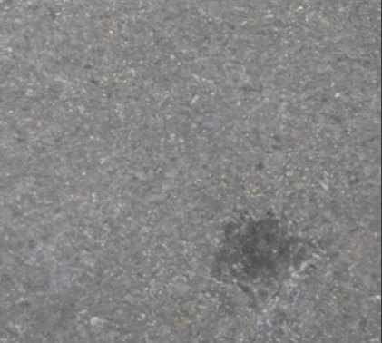 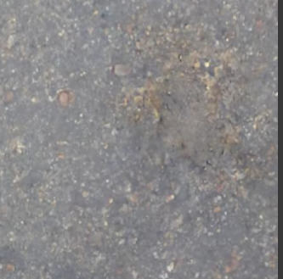

Images with unnecessary elements:

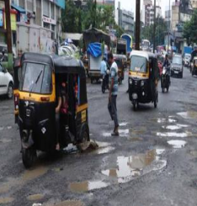 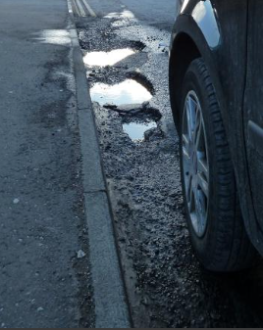

**Application of Pothole Detection Model**

**Use case of our model**: Model can process incoming images and flag roads with potholes.

**Where can a pothole detection model be used?**  
 In **smart city development**, to automatically detect potholes from road surveillance footage for quicker repairs.

**What happens if the model is trained at a larger scale?**  
With more data, the model can become **highly accurate**, adapting to different road textures, lighting conditions, and traffic environments across countries.

**Can this be used by municipal bodies?**  
Yes, the model can assist **municipal corporations** to automate road inspection and maintenance alerts.

**Is this model scalable to real-time systems?**  
With the use of real-time object detection algorithms (like YOLO), the model can be scaled to **live video analysis** from road-side cameras or dashcams.

**Can it help with accident prevention?**  
Definitely! Early pothole detection can help **reduce accidents**, especially for two-wheelers and night driving.

**Architecture Diagram Workflow**

**Pothole Detection Architecture Explanation**

**1. Convert the Image to Grayscale**

* **Why**: Reduces the complexity of the image by eliminating color information while preserving structural details. This simplifies processing and reduces computational overhead.
* **Implementation**: Uses the standard grayscale conversion formula (0.299×R + 0.587×G + 0.114×B) to weight each color channel according to human perception.
* **Benefit**: Focuses the analysis on intensity variations rather than color differences, which is more relevant for detecting structural irregularities like potholes.

**2. Apply Gaussian Blur**

* **Why**: Reduces noise and smooths out small irrelevant details that might interfere with the detection process.
* **Implementation**: Convolves the image with a Gaussian kernel, which gives more weight to pixels near the center.
* **Benefit**: Improves the robustness of subsequent steps by removing high-frequency noise while preserving the overall structure of the image.

**3. Apply Adaptive Thresholding**

* **Why**: Separates the foreground (potential potholes) from the background (road surface) by converting the grayscale image to binary.
* **Implementation**: Calculates a threshold for each pixel based on the mean of its local neighborhood, accounting for lighting variations across the image.
* **Benefit**: Works better than global thresholding for outdoor scenes where lighting conditions vary within the image.

**4. Perform Morphological Operations**

* **Why**: Refines the binary image by removing noise and filling small gaps.
* **Implementation**:
  + **Closing** (dilation followed by erosion): Fills small holes in the foreground objects.
  + **Opening** (erosion followed by dilation): Removes small objects and noise without affecting larger structures.
* **Benefit**: Creates cleaner regions of interest for contour detection, reducing false positives.

**5. Find Contours**

* **Why**: Identifies boundaries of potentially connected regions in the binary image.
* **Implementation**: Labels connected components and extracts boundary points.
* **Benefit**: Provides shape information needed to identify potential pothole regions.

**6. Filter Contours Based on Shape Factors**

* **Why**: Not all detected contours are potholes; this step eliminates contours that don't have pothole-like characteristics.
* **Implementation**: Calculates and evaluates multiple shape metrics:
  + **Area**: Must be large enough to be a pothole
  + **Perimeter**: Used to calculate circularity
  + **Circularity**: Potholes are somewhat circular but not perfectly so (0.2 < circularity < 0.9)
  + **Aspect Ratio**: Most potholes aren't extremely elongated (0.4 < aspect_ratio < 2.5)
  + **Extent**: Ratio of contour area to bounding rectangle area (must be > 0.3)
* **Benefit**: Greatly reduces false positives by applying domain knowledge about typical pothole shapes.

**7. Analyze Texture Inside Contours**

* **Why**: Potholes typically have different texture patterns than regular road surfaces.
* **Implementation**:
  + Applies the Laplacian operator to measure local variations in intensity
  + Calculates the mean texture value inside each contour
  + Keeps only contours with higher texture variation (texture_mean > 5)
* **Benefit**: Further refines detection by considering surface characteristics, not just shape.

**8. Use Edge Detection to Analyze Pothole Boundaries**

* **Why**: Pothole edges are typically distinct from the surrounding road surface.
* **Implementation**: Applies Canny edge detection algorithm to the blurred image to find strong edges.
* **Benefit**: Provides additional evidence for pothole presence by quantifying edge characteristics.

**9. Calculate a Composite Pothole Score**

* **Why**: Combines multiple features to create a robust confidence score.
* **Implementation**: Weighted sum of three key factors:
  + **Area Ratio**: Percentage of image covered by detected potholes (50% weight)
  + **Count Factor**: Number of detected potholes (30% weight)
  + **Edge Density**: Edge concentration in pothole regions (20% weight)
* **Benefit**: Produces a confidence score (0-1) that reflects the likelihood of pothole presence based on multiple complementary features.

**10. Highlight Detected Potholes**

* **Why**: Provides visual feedback by marking detected potholes on the original image.
* **Implementation**: Draws contour outlines in red and adds text showing detection result and confidence score.
* **Benefit**: Creates an interpretable output for human review or documentation.

**Why This Approach Works Well for Pothole Detection**

1. Preprocessing reduces noise and enhances features of interest
2. Feature extraction identifies regions with pothole-like characteristics
3. Multi-feature analysis combines shape, texture, and edge information
4. Decision making integrates multiple features to make a robust determination

**Module Description:**

**Detailed Explanation of Each Function**

**1. load_image(image_path)**

* **Purpose**: Loads an image from a file path and converts it to a NumPy array
* **Parameters:** Path to the image file
* **Returns:** NumPy array representation of the image, or None if loading fails
* **Details:** Uses PIL's Image.open() to load the image and then converts it to a NumPy array

**2. manual_bgr_to_gray(image)**

* **Purpose:** Converts a color (BGR) image to grayscale
* **Parameters**: BGR format image as NumPy array
* **Returns:** Grayscale image as NumPy array
* **Details:** Applies the standard grayscale conversion formula **(0.299*R + 0.587*G + 0.114*B) to each pixel**

**3. manual_gaussian_blur(image, kernel_size=5, sigma=1.0)**

* **Purpose:** Applies Gaussian blur to reduce noise in images
* **Parameters:** Input image, kernel size, and standard deviation (sigma)
* **Returns:** Blurred image
* **Details:** Creates a Gaussian kernel and applies it using manual convolution, which smooths the image and reduces noise

**4. manual_adaptive_threshold(image, block_size=11, C=2)**

* **Purpose:** Applies adaptive thresholding to convert grayscale to binary image
* **Parameters:** Grayscale image, block size for local area, and constant C
* **Returns:** Binary image
* **Details:** For each pixel, calculates a threshold based on the mean of its neighborhood, then applies thresholding

**5. manual_morphology_close(image, kernel_size=5, iterations=1)**

* **Purpose:** Applies morphological closing (dilation followed by erosion)
* **Parameters:** Binary image, kernel size, and iterations count
* **Returns**: Processed binary image
* **Details:** Fills small holes in the foreground objects, useful for closing small gaps in detected contours

**6. manual_morphology_open(image, kernel_size=5, iterations=1)**

* **Purpose:** Applies morphological opening (erosion followed by dilation)
* **Parameters:** Binary image, kernel size, and iterations count
* Returns: Processed binary image
* **Details:** Removes small objects/noise from the foreground, keeping larger objects intact

**7. manual_dilate(image, kernel_size=5, iterations=1)**

* **Purpose:** Expands the boundaries of foreground objects
* **Parameters:** Binary image, kernel size, and iterations count
* **Returns: Dilated image**
* **Details:** If any pixel in the neighborhood is white, the center pixel becomes white

**8. manual_erode(image, kernel_size=5, iterations=1)**

* **Purpose:** Shrinks the boundaries of foreground objects
* **Parameters**: Binary image, kernel size, and iterations count
* **Returns:** Eroded image
* **Details:** Only if all pixels in the neighborhood are white, the center pixel remains white

**9. manual_sobel(image)**

* **Purpose**: Applies Sobel operators to detect edges and gradients
* **Parameters:** Grayscale image
* **Returns:** Gradient in x and y directions
* **Details:** Uses 3×3 Sobel kernels to find horizontal and vertical gradients

**10. manual_canny(image, low_threshold=30, high_threshold=150)**

* **Purpose:** Implements Canny edge detection algorithm
* **Parameters:** Grayscale image, low and high thresholds
* **Returns:** Edge image
* **Details: Four steps:** gradient calculation, magnitude/direction computation, non-maximum suppression, and hysteresis thresholding

**11. manual_find_contours(binary_image)**

* **Purpose:** Finds contours (boundaries) in binary images
* **Parameters:** Binary image
* **Returns:** List of contours, where each contour is a list of (y,x) points
* **Details:** Labels connected components and finds boundary points

**12. label_components(binary_image)**

* **Purpose:** Labels connected components in a binary image
* **Parameters:** Binary image
* **Returns:** Labeled image and number of labels
* **Details:** Uses breadth-first search to find and label connected regions

**13. contour_area(contour)**

* **Purpose:** Calculates the area of a contour
* **Parameters:** Contour as list of points
* **Returns**: Area value
* **Details:** Uses the shoelace formula (also known as the surveyor's formula)

**14. contour_perimeter(contour)**

* **Purpose:** Calculates the perimeter of a contour
* **Parameters:** Contour as list of points
* **Returns:** Perimeter value
* **Details:** Sums the Euclidean distance between consecutive points

**15. bounding_rect(contour)**

* **Purpose:** Finds the bounding rectangle of a contour
* **Parameters:** Contour as list of points
* **Returns:** Tuple (x, y, width, height)
* **Details:** Finds the minimum and maximum x,y coordinates to determine the rectangle

**16. manual_laplacian(image)**

* **Purpose:** Applies the Laplacian operator for edge detection
* **Parameters:** Grayscale image
* **Returns:** Laplacian result as floating-point image
* **Details:** Uses a 3×3 Laplacian kernel to find areas of rapid intensity change

**17. detect_potholes(image_path, debug=False)**

* **Purpose:** Main function to detect potholes in road images
* **Parameters:** Path to image, debug flag
* **Returns:** Boolean (pothole detected), confidence score, and processed image
* **Details:** Implements the complete pothole detection pipeline as described earlier

**18. cv2_line(image, pt1, pt2, color, thickness=1)**

* **Purpose:** Manual implementation of line drawing (similar to OpenCV's line function)
* **Parameters:** Image, start point, end point, color, and thickness
* Returns: None (modifies image in-place)
* **Details:** Uses Bresenham's line algorithm for efficient line drawing

**19. cv2_put_text(image, text, position, font_scale=1, color=(0,0,0), thickness=1)**

* **Purpose:** Places text on an image (simplified version of OpenCV's putText)
* **Parameters:** Image, text string, position, font scale, color, and thickness
* **Returns:** None (modifies image in-place)
* **Details:** Creates a semi-transparent background and would normally render text (simplified implementation)

**20. process_dataset(pothole_dir, no_pothole_dir)**

* **Purpose**: Evaluates algorithm performance on a dataset of images
* **Parameters:** Directories containing pothole and non-pothole images
* **Returns:** Dictionary with performance metrics (accuracy, precision, recall, F1-score)
* **Details:** Processes all images in both directories and calculates classification metrics

**DATA SELECTION & PREPROCESSING**

**Data Selection**

The process_dataset function expects data to be organized in a specific way:

1. **Dataset Organization**:
   * The dataset was divided into two main directories:
     + pothole_dir: Contains images showing roads with potholes
     + no_pothole_dir: Contains images showing roads without potholes
2. **Image Selection**:
   * The code processes files with these extensions: .png, .jpg, .jpeg
   * Each image is expected to be a road scene taken from above or from a driver's perspective

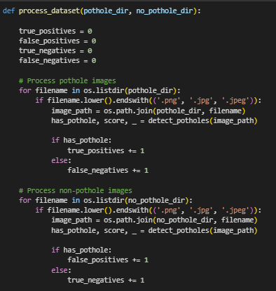

**The preprocessing part of the code is quite detailed and involves several steps:**

**1) Image Loading**:

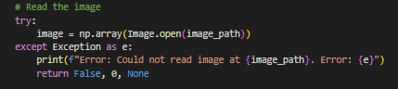

* Uses PIL (Python Imaging Library) to load the image
* Converts the image to a NumPy array for further processing
* Includes error handling for corrupted or missing images

**2) Grayscale Conversion**

* Converts the colour image to grayscale using the standard formula
* This reduces dimensionality while preserving important structural information
* Colour information is less important for pothole detection than intensity variations

**3) Gaussian Blur:**

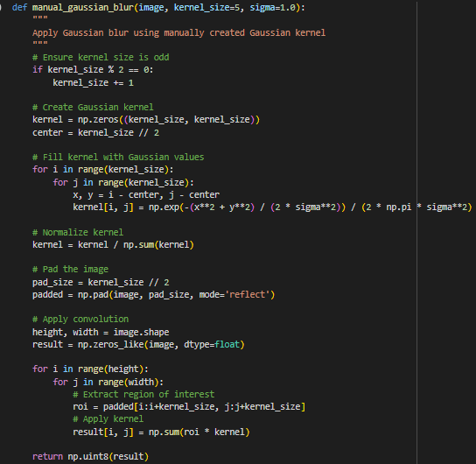

* Creates a Gaussian kernel based on the specified size and sigma
* Applies this kernel to smooth the image
* Helps reduce noise and small details that could interfere with pothole detection

4) **Adaptive Thresholding:**

* Converts the grayscale image to binary using local thresholds
* For each pixel, the threshold is calculated as the mean of its neighborhood minus a constant C
* This adapts to varying lighting conditions across the image
* Results in white (255) pixels for potential pothole areas and black (0) pixels for the road surface

5) **Morphological Operations:**

* **Closing**: Fills small holes within potential pothole regions
* Applies dilation followed by erosion
* **Opening**: Removes small noise artifacts
* Applies erosion followed by dilation

These operations help create cleaner binary regions for contour detection

CONCISE ALGORITHM:

1. **Input**: Road image
2. **Preprocessing**:
   * Convert to grayscale using standard formula (0.299R + 0.587G + 0.114B)
     + **Why**: Reduces complexity while preserving structural information; potholes are primarily detected by shape and texture, not colour.
   * Apply Gaussian blur (kernel size 5, sigma 1.0) to reduce noise
     + **Why**: Smooths out small irrelevant details and sensor noise that could lead to false detections.
   * Apply adaptive thresholding with block size 11 and C=2
     + **Why**: Creates a binary image that adapts to lighting variations across the road surface, better separating potholes from intact road.
   * Apply morphological closing followed by opening to clean binary image
     + **Why**: Closing fills small holes in pothole regions; opening removes small noise artifacts, creating cleaner regions for analysis.
3. **Feature Extraction**:
   * Find contours in preprocessed binary image
     + **Why**: Identifies the boundaries of potential pothole regions that were highlighted in the binary image.
   * Filter contours by shape metrics:
     + Area > 100
       - **Why**: Eliminates tiny regions that are too small to be actual potholes.
     + Perimeter > 50
       - **Why**: Ensures the region has sufficient boundary length to be a significant road defect.
     + Circularity between 0.2 and 0.9
       - **Why**: Potholes are somewhat circular but rarely perfect circles; this range captures realistic pothole shapes.
     + Aspect ratio between 0.4 and 2.5
       - **Why**: Potholes are not extremely elongated in one direction; this range filters out line-like defects.
     + Extent > 0.3 (area/bounding_rect_area)
       - **Why**: Ensures the region is reasonably "filled in" and not just a sparse outline.
     + Mean intensity < 0.9 * image mean
       - **Why**: Potholes typically appear darker than the surrounding road surface due to shadows.
4. **Texture Analysis**:
   * Apply Laplacian operator to measure texture variation
     + **Why**: Laplacian highlights rapid intensity changes, which are more common in the irregular surfaces of potholes.
   * Keep only contours with texture_mean > 5
     + **Why**: Potholes have more textural variation than smooth road surfaces; this threshold separates them.
5. **Edge Analysis**:
   * Apply Canny edge detection to find boundaries
     + **Why**: Potholes typically have strong edges where they meet the regular road surface.
   * Calculate edge density in potential pothole regions
     + **Why**: Higher edge concentration within a region indicates complex surface changes characteristic of potholes.
6. **Decision Making**:
   * Calculate composite score as weighted sum:
     + 50% * area_ratio + 30% * count_factor + 20% * edge_factor
       - **Why**: Combines multiple features with weights assigned based on their reliability for detection; area gets highest weight as it's most directly related to pothole presence.
   * Classify as pothole if score > 0.3
     + **Why**: Empirically determined threshold that balances false positives and false negatives.
7. **Output**:
   * Boolean pothole presence
     + **Why**: Provides a clear yes/no decision for automated systems.
   * Confidence score (0-1)
     + **Why**: Enables prioritization in maintenance systems and allows adjusting the detection threshold if needed.
   * Visualization with highlighted potholes
     + **Why**: Allows human verification and shows exactly where the defects are located in the original image.

**OUTPUT SAMPLE**:

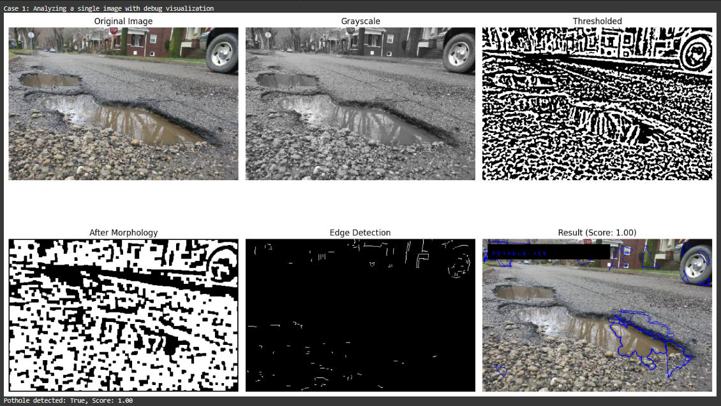

**From the output image provided,**

* The algorithm appears to be incorrectly identifying non-pothole regions as potholes (false positives), particularly at the bottom right where it's marking part of the rocky/gravelly area.
* The algorithm is picking up too many small variations in the road surface.
* The "After Morphology" image still contains significant noise that wasn't properly cleaned up by the closing and opening operations

**Likely Causes for these problems:**

1. The algorithm is likely too sensitive to textural variations
2. The thresholds used for filtering contours (circularity, aspect ratio, etc.) may need adjustment
3. In the "Edge Detection" image, edges aren't cleanly identifying pothole boundaries
4. The adaptive thresholding parameters (block_size=11, C=2) might not be optimal for this particular image, this could be the reason for over-segementation

**PERFORMANCE EVALUATION:**

**How our model will have advantages and disadvantages from a pretrained models:**

Manual preprocessing methods cover essential steps like

* grayscale conversion (standard),
* noise reduction via Gaussian blur (common, also learned by CNNs),
* adaptive thresholding for segmentation (addresses varying light, CNNs learn similar local feature analysis),
* morphological operations for cleaning binary masks (helps, CNNs learn robustness to small issues)
* edge detection with contour finding (highlights boundaries, CNNs directly predict regions).
* Feature extraction based on shape, size, intensity, and texture is our method for classification.

This manual approach differs significantly from deep learning architectures. Deep learning models automatically learn features from data, unlike our manually designed ones. They directly predict bounding boxes or segmentation masks, bypassing explicit contour finding. While our method requires manual tuning and **might struggle with variations in lighting, shadows, and complex textures**, deep learning models are generally more robust due to learned representations. Our approach might be faster for inference once set up but achieving high accuracy and generalization like deep learning models is challenging due to the fixed rules versus learned, adaptable features. Real-world pothole detection often benefits from the superior learning and robustness of deep learning**.**

**Conclusion:**

This pothole detection algorithm represents a comprehensive manual approach to computer vision-based pothole detection without relying on pre-built libraries for core functionality. The strengths of this approach include:

1. **Multi-layered detection strategy:** The algorithm employs several image processing stages (thresholding, morphological operations, contour analysis, and texture examination) to identify potholes.
2. **Feature-based confidence scoring:** Rather than using a single metric, the algorithm calculates a composite score incorporating area ratio, pothole count, and edge density factors**.**
3. **Shape and texture analysis:** By examining circularity, aspect ratio, mean intensity, and texture variation, the system can differentiate potholes from other road features.
4. **Quantifiable performance:** The evaluation framework provides clear metrics (accuracy, precision, recall) for assessing algorithm effectiveness across different road conditions.
5. **Independence from black-box CV libraries:** By implementing core functions manually, the algorithm provides transparency and educational value in understanding how each step contributes to detection.

However, the implementation has some limitations, including computational efficiency concerns (particularly the manual implementation of operations that would be optimized in libraries) and limited contextual understanding of road environments**.**

**Future Work**

To enhance this pothole detection system, several promising directions could be explored**:**

1. **Machine learning integration:** 
   * Incorporate a trained classifier (SVM, Random Forest, etc.) to learn from the extracted features
   * Implement a CNN or transformer-based approach which could better capture spatial relationships
2. **Performance optimization:** 
   * Parallelize the processing of image regions to improve computational efficiency
   * Implement SIMD (Single Instruction Multiple Data) operations for core functions
   * Explore GPU acceleration for convolution operations
3. **Enhanced feature engineering:** 
   * Include depth information if stereo cameras or LiDAR data is available
   * Incorporate temporal information from video sequences to detect potholes through motion analysis
   * Consider road context features (road markings, curbs) to reduce false positives