### Mobile Webcam Installation Guideline - EpocCam

Before Installation, please install the application according to the below table.

|  |  |  |
| --- | --- | --- |
|  | Android | iOS |
| Windows | IRIUN | EpocCam |
| MacOS | EpocCam (WiFi Only) | EpocCam |

# Software Installation

## Get EpocCam app

Open this site on your phone, and click below to install our phone app:

|  |  |
| --- | --- |
| [download EpocCam for iPhone from the App Store](https://apps.apple.com/us/app/epoccam-webcam-for-mac-and-pc/id449133483) | [download EpocCam for Android from Google Play](https://play.google.com/store/apps/details?id=com.kinoni.webcam2&hl=fi) |
|  |  |

## Download and install our computer drivers.

|  |  |  |
| --- | --- | --- |
| System requirements: | macOS 10.11 or later | Windows 7 or later |

Click below to download a driver package. Remember to install after downloading.

|  |  |
| --- | --- |
| [MAC OS](https://kinonicom.r.worldssl.net/wp-content/uploads/EpocCam-Installer_2_0.pkg_.zip) | [Windows](https://kinonicom.r.worldssl.net/wp-content/uploads/EpocCamInstaller298.zip) |

## Connect your computer and phone.

Using USB cable that connects your phone and computer.

Either connect your computer and your phone to the same WIFI network, or use a USB cable to physically connect them.

# Android Installation Guide

## Access the Developer Options Menu

2.1.1 To enable Developer Options, open the Settings screen, find and tap About phone.

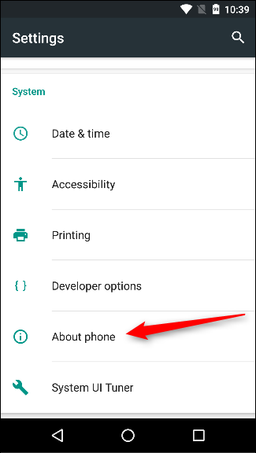

2.1.2 Scroll down to the bottom of the About screen and find the Build number.

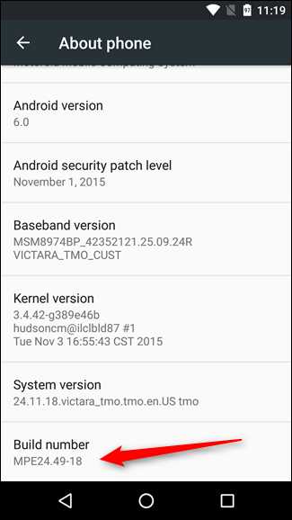

2.1.3 Tap the Build number field seven times to enable Developer Options.

[Tap a few times and you’ll see a toast notification with a countdown that reads “You are now X steps way from being a developer.”]

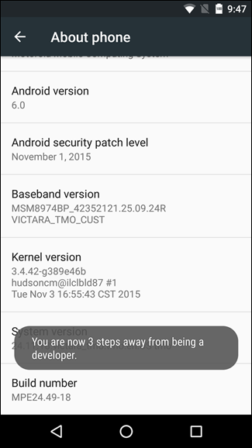

2.1.4 When you’re done, you’ll see the message “You are now a developer!”.

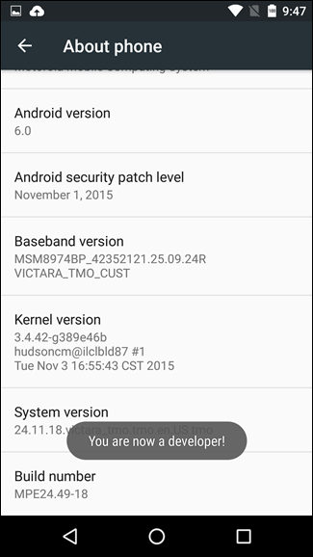

## Enable USB Debugging

2.2.1 Tap the Back button and you’ll see the Developer options menu just above the “About Phone” section in Settings. This menu is now enabled on your device.

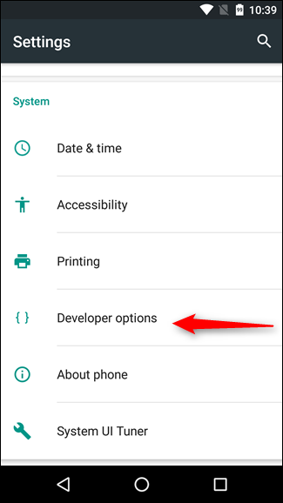

2.2.2 Scroll down to the Debugging section and toggle the “USB Debugging” slider.

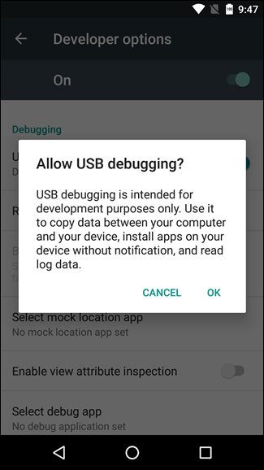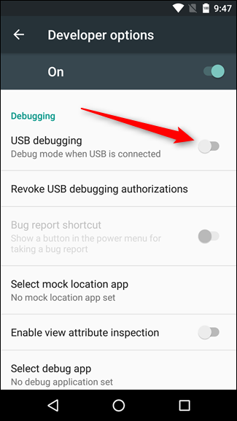

2.2.3 Once upon a time, USB Debugging was thought to be a security risk if left on all the time. Google has done a few things that make that less of an issue now, because debugging requests have to be granted on the phone—when you plug the device into an unfamiliar PC, it will prompt you to allow USB debugging (as seen in the screenshot below).

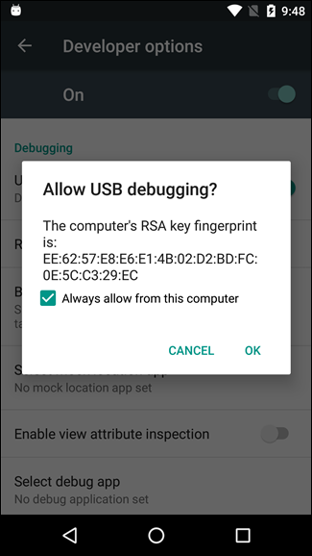

You may need to change to Media Transfer Protocol (MTP) [媒體檔案傳輸模式]

## Disable Developer Options

After you finished the exercise, you may want to disable the developer options for security reason.

If you want to disable USB debugging and other developer options when you don’t need them, slide the switch at the top of the screen.

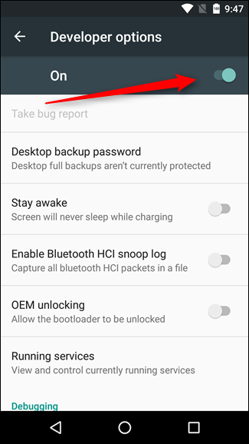

# iPhone Installation Guide

* For MacOS user, Congratulations!! You are finished the installation, have fun with EpocCam :D
* For Windows user, you are required to install iTunes in your PC.

You may download from the below link:

<https://www.apple.com/hk/itunes/>