PT0 - Network Representations

Packet Tracer is a network simulator that allows you to create a simulated network, configure the devices in the network, test the network, and examine the traffic in the network.

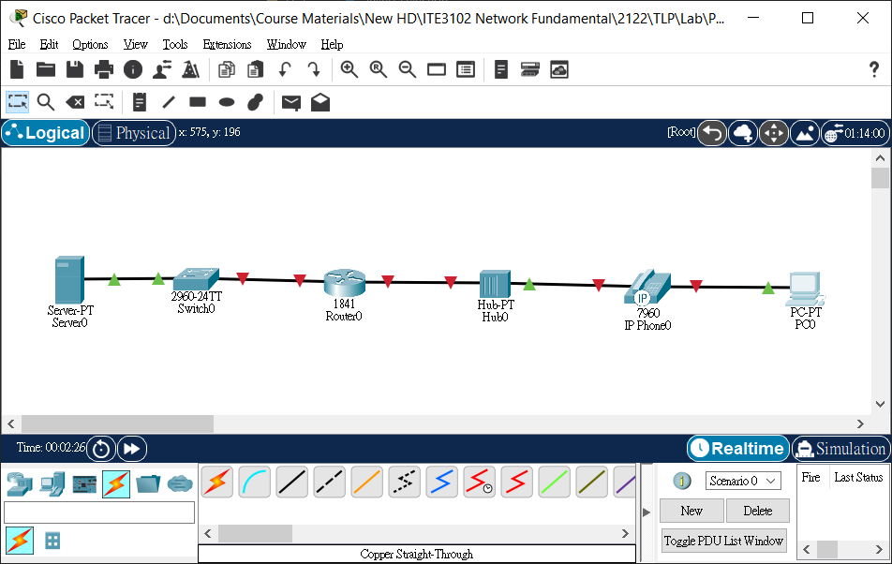

**Step 1. Explore the PT interface**

When Packet Tracer starts, it presents a **Logical** Workplace in **Realtime** mode. The bottom left portion shows **[Network Devices]**-[**Routers**] group selected by default.

**Step 2. Selecting and Placing Devices**

With **[Network Devices]**-[**Routers**] group selected, select an **1841** Router on the right. Point to the middle of the logical workplace and click to place a router there. On the lowest left, select [**Switches**] group and put a [**2960-24TT**] switch to the left of the router. Similarly, select [**Hubs**] group and put a Generic [**Hub-PT**] to the right of the router.

Select **[End Devices]** group on the bottom left. Put a Generic [**Server-PT**], a [**7960 IP Phone**] and a Generic [**PC-PT**] to the logical workplace.

**Step 3. Connect the devices using auto connect**

Click on the [**Connections**] group on the bottom left. The first specific type will [**automatically choose connection type**] based on the interfaces available on the devices. To connect two devices click the **auto connection** symbol, click the first device, and then click the second device. Starting with the server, connect each device to the device to its right using the auto connection symbol.

(28, 57, 64, 71, 100)

**Step 4. Packet Tracer Scoring**

To check your configuration, click **[Check Results]** button and then **[Assessment Items]** tab.

*Reference: Cisco Networking Academy, CCNA*