Name : ________________________
MHF4U1
Unit 2: Working With Polynomials
K/U  /20 | APP  /12 | COM  /9 | TH  /12

KNOWLEDGE/UNDERSTANDING

Multiple Choice
Identify the choice that best completes the statement or answers the question.

____ 1. The quotient form says that: [1K]
a. The polynomial P(x) is equal to the quotient Q(x) plus the remainder R
c. The remainder R will always be a non-zero number
b. The polynomial P(x) is equal to the divisor d(x) times the Quotient Q(x) plus the remainder R
d. The divisor d(x) is always a factor of P(x)

____ 2. If P(-3)=0 for a given a polynomial function P(x), the factor and the remainder would be: [1K]
a. (x+1), 2 c. (x-3), 0
b. (x+3), 0 d. (x+3), -3

____ 3. If P(2/3)=0, the binomial factor which corresponds to P(x) is: [1K]

a. (2x-3) c. (3x-2)
b. (2x+3) d. 3/2

____ 4. The polynomial P(x) is being divided by the binomial (x+2). When compared to the binomial
form (x-b), the b value would be: [1K]
a. -2 c. x-2
b. +2 d. 0

____ 5. The remainder of P(x) is being found by computing P(1). The corresponding binomial divisor
would be: [1K]
a. (x-1) c. (x+1)
b. (x+2) d. -1

____ 6. Following long division, the polynomial P(x)= 2x³ + x² - 3x – 6 can be re-written as
(x+1)( 2x² – x – 2)– 4. The quotient Q(x) is: [1K]
a. (x+1) c. (2x² – x + 2) - 4
b. (2x² – x – 2) d. (x+1)( 2x² – x – 2)

____ __7. If (x-4) is not a factor of f(x), then the quotient statement would be: [1K]

a. f(x)=(x-4) Q(x) + R c. f(x)=(x+4)(0)
b. f(x)= (x-4) Q(x) + 0 d. f(4)=(4-4)Q(4)+0

____ __8. A family member of the curve represented by the polynomial function f(x)=2(x+2)(x-1)(x-3) is:
[1K]
a. f(x)= -1/2 (x-2)(x+1)(x-3) c. f(x)= -1/4(x+2)(x-1)(x-3)
b. f(x)= -3(x+2)(x+1)(x-3) d. f(4)= -2.5(x+2)(x-1)(x+3)

____ __8. The y-values of the polynomial function P(x) = (x+4)² (x-1) are less than or equal to zero
[i.e. (x+4)² (x-1) ≤ 0] on the interval:
[1K]
a. x > -4 c. x ≤ 1
b. -4 < x < 1 d. x ≤ -4

____ __8. The solution to the polynomial inequality x² – 4 > 0 is: [1K]
a. x > 2 c. x > -2
b. x < -2 and x > 2 d. -2 < x < 2

10. Use long division to divide P(x) = 3x³ + 7x² - 2x – 11 by the binomial (x-2). Express your answer in quotient form, and check your answer using the Remainder Theorem. [3K]

9. Determine if the binomial (x+3) is a factor of the polynomial P(x)= x³ + x² - x + 6.
Explain using a theorem.
[2K]

8. Determine the remainder when 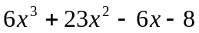 is divided by 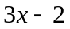. What information does the remainder provide about ? Explain. [2K]

9. Determine an equation for the quartic function represented by this graph. [3K]

APPLICATION

- Find all the factors of x³ + 2x² -7 x + 4. Write all the factors in quotient form. [5A]

(b) Graph the function.

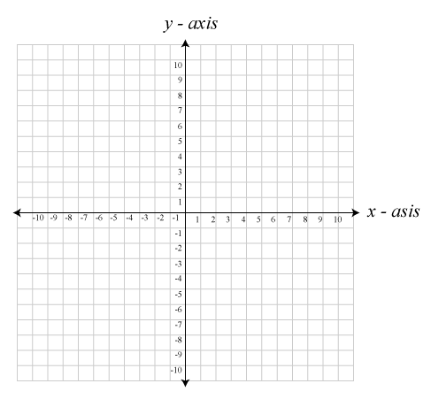

- Donkey Kong is competing in a shot-put challenge at the Olympics. His throw can be modeled by the function h(t) = -5t² + 8.5t + 1.8, where h is the height, in metres, of a shot-put t seconds after it is thrown. Determine the remainder when h(t) is divided by (t – 1.4). What does this value represent?
[Hint: Use the quotient form h(t) = (t - 1.4) Q(t) + R, and find h(1.4)]
[4A]





(b) Draw a graph which represents his throw.
[Hint: when drawing the graph, refer to the physics equation h(t) = -1/2 gt² + v₀ t + h₀]

- Determine the equation of the cubic function passing through +1 and touching -2. [3T]

(b) Write an equation for the family member whose graph passes through the point (0, 12)

COMMUNICATION

- The ________ Theorem states that when a polynomial function f(x) is divided by the binomial (x-a), the remainder is f(___), and in the case where f(x) is divided by the binomial (ax-b), the remainder is f(___). [2C]

- The _________Theorem states that if (x-a) is a __________of f(x), then f(a)=___. The equivalent statement says that if f(a)=0, then ______ is a factor of f(x). [2C]

- How can you determine the remainder of f(x) ÷ (x-a) without actually performing the
division? State the theorem you used. [1C]

- Without solving, describe a way to determine if 2, -1, 3, and -2 are the roots
(i.e. factors) of the polynomial equation x⁴ – 2x³ – 7x² – 8x + 12. State the theorem you used. [1C]

- Explain the difference between a polynomial equation [e.g. (x+1)(x-2)(x-4) = 0] and a polynomial inequality [e.g. (x+1)(x-2)(x-4) < 0]. What is the inequality asking us to solve? Explain by graphing the function. [3C]

THINKING

- Prove the Remainder Theorem. [2T]

Hint: When f(x) is divided by the binomial (x-a), we get the quotient form:
f(x) = d(x) Q(x) + R
= (x-a) Q(x) + R

Find f(a):

f(a)=

(b) When dividing a polynomial by a binomial, the Remainder Theorem can be used without having to apply ____________division.

- If the binomial (x-a) is a factor of the polynomial f(x), then the corresponding quotient statement would be: [2T]

[Hint: Use the quotient form f(x)=d(x)Q(x)+R]

f(x) =

(b) Solving for Q(x) gives us the remaining __________(s) of f(x).

- When the polynomial 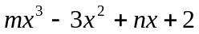is divided by 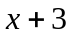, the remainder is -4. When it is divided by 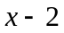, the remainder is 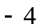. Determine the value of m and n. [3T]

- Determine the value of m so that (x-2) is a factor of x³ + 2mx² + 6x – 4 [2T]

