Name : ________________________

MHF4U1
Unit 5: Trigonometry Part 2
K/U  /9 | APP  /24 | COM  /4 | TH  /14

KNOWLEDGE/UNDERSTANDING

______ 1. For the function , which variable determines amplitude? [1K]
a. | A | c. | C
b. | B | d. | D

______ 2. What is the period of the function 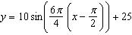? [1K]
a. |  | c.
b. |  | d.

______ 3. If k = , what is the period? [1K]
a. |  | c.
b. | 45 | d.

____ 4. The temperature of a swimming pool is cyclic and modelled by a trigonometric function. If its highest temperature is 82 °F and its lowest temperature is 76 °F, and it takes 12 hours for the temperature to change between its extremes, what equation models the temperature of the pool as a function of time in hours? [1K]
a. | 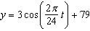 | c. | 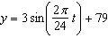
b. | 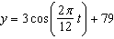 | d. | 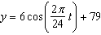

5. Use transformations to sketch the graph of the following function: y = 5 cos (x- π/4) – 2. [5 K]

Find the following:
- Amplitude?
- Period?
- Phase shift (left or right? And by how much?)
- Describe the vertical translation
- Graph the function

Application

- Mike Tyson was training for his fight and he was jabbing his punching bag. With Tyson’s raw poser, the punching bag reached a maximum and minimum horizontal distance of 75cm. One full cycle of the swinging punching bag had occurred every 2.5 seconds. Assume that the bag is at the equilibrium position at t = 0 sec. [8 A]

- What is the equation of a cosine function?
b) Graph the function. Fully label the axes.
c) Where would the bag be at 6.2 seconds?
Created by: J.T. and Millz


← ↕ →
-75cm 0cm 75cm

- The TREC Windshare turbine at the Exhibition Place, Toronto, has the following specifications:
[8 A]

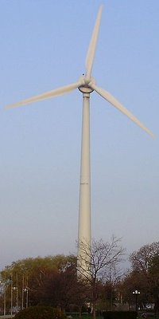
- 90 metres high to the tip of the blade
- Rotor diameter 52 metres
- Normal rotation speed 30 rpm

  - Using the information provided above, draw a graph which represents 2 complete cycles for a point at the tip of a blade on the wind turbine. Remember to fully label your axes.

  - Write either a cosine or sine function that models the rotating motion of the blades.

3.

COMMUNICATION

1. What adjustment is needed to change the cosine function to the sine function? [2C]

2. Explain graphically why sin x = 0.75 has 2 solutions for 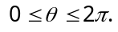 [2C]

THINKING

- A cosine function has a maximum value of 1, a minimum value of -5, a phase shift of π/4 to the right, and a period of 2. Write an equation for the function. [2 T]

- Determine all the solutions for the following trigonometric equations:

- Cos² x – cos x – 2 = 0 [4T]

- 2 sin ² x – 1 = 0 [4T]

- Sin (Ѳ + ) = √2 cos Ѳ [4T]

BONUS [+2 Points]

Determine all the solutions of the equation:

3 sin² x + sin x – 1 = 0

“C-A-S-T” Rule

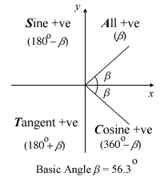

Double Angle Formulas

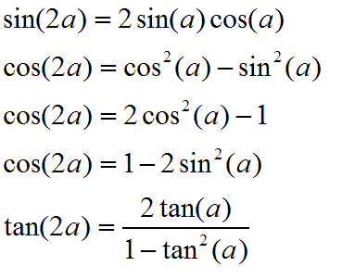

Compound Angle Formulas

