**E-Commerce system for techcontrol**

CAPSTONE A – FINAL REPORT

Andrej Roth K181080

Amarpreet Singh K170242

Rohan Jaswal K180583

Amolak Singh K190689

# **Project Summary**

This report will detailly discuss the proposed E-Commerce web information system for Techcontrol. The aim of the project being discussed is to develop a plan for the successful development and implementation of the e-commerce site. The aforementioned statement can be taken in account to state that the discussed project will assist the firm to establish itself in the digital competitive market that will add value to the organization and hence, offers huge scope for the organization. It will enable the firm to offer ease of purchase and awareness about the products offered by the firm. Furthermore, the development of the e-commerce site will enable the firm to reach new customers who are unaware of the product. The firm can leverage Google SEO to optimize its platform and present it on top of the list of security products offering firms in the country. The discussed benefit adds value to the project scope and has to be taken into consideration. The aim of the project has also extended to include the implementation of the e-commerce platform in order to attain adequate success. The discussion over the migration plan will enable the firm to ensure the safety of its content and will add value to the digitalization of the company. The implementation plan will assess the implementation requirements and risk assessment along with other aspects, which will ensure the successful implementation adding value to the organization.

Contents

**Project Summary** 1

**Introduction** 3

**Project Background** 3

**Project Purpose** 3

**Project Objectives** 3

**Project Scope** 3

**Constraints** 4

**Assumptions** 4

**Project Deliverables** 4

**System Requirements** 5

**Functional Requirements** 5

**Non-Functional Requirements** 6

**System Architecture** 7

**System Design** 8

**Home page:** 8

**Customer Registration:** 9

**Customer login:** 10

**About Us page:** 11

**Help page:** 12

**Products page:** 13

**Shopping Cart page:** 14

**Payment page:** 15

**Entity Relationship Diagram** 16

**UML notation ERD:** 16

**Use Case Diagram** 17

**Context Diagram** 18

**Data Flow Diagram** 19

**Sequence Diagram** 19

**Conclusion** 19

**Supervisor’s Feedback** 19

**References** 20

**Appendix** 20

**Table of Tables** 20

**Table of Figures** 20

# **Introduction**

## **Project Background**

TechControl is a Slovakian business specializing in installation and servicing of home security systems such as alarms, surveillance, and access controls. At the moment their web presence is limited. They are looking to establish an e-commerce system and start selling the products online with the option of onsite installation.

## **Project Purpose**

The purpose of this project is to develop a dynamic web information system, that will serve as an e-commerce store for Techcontrol. Being able to sell directly to the customers will give the Techcontrol a competitive advantage and opens a new space for growth. Using the new web information system, they will be able to provide a full service, from purchase to the installation and maintenance of the products, and improve interaction with existing and potential customers.

## **Project Objectives**

The objective of this project is to deliver a fully functional e-commerce website within a specified time, budget, and scope.

The main goals of the system are:

* Increase Awareness
  + Improve Techcontrol brand awareness by 15%
* Generate More Sales
  + Increase monthly sales by 25%
* Increase Customer Experience and Satisfaction
  + Improve the satisfaction rate by 10%
* Create Work Automation
* Establish Competitive Advantage
* Enable 24/7 access to customers

## **Project Scope**

This project will consist of creating an e-commerce system, that will be accessible over the internet, using any browser. The system must be secure and user friendly. The project will be completed by 4th October 2020. Users will be able to browse through the e-commerce site, add items to the shopping cart and make a purchase.

## **Constraints**

* The budget of this project is $10,000 AUD.
* The system will be developed by 27th September 2020.

## **Assumptions**

* TechControl will cover the costs of the project.
* Project will be concluded after evaluation on 4th October 2020.

# **Project Deliverables**

The following are the key deliverables of the project:

* Prototype Design
* Project Report
* Account and login information
* Fully Functional E-commerce System
  + Graphical User Interface
  + Application
  + Database
* A backup copy of the files
* Staff Training
* Support Documentation

# **System Requirements**

In this section, we will describe the operational parameters of the software product.

Laplante (2014) described requirement engineering as the branch of engineering concerned with the real-world goals for, functions of, and constraints on, systems.

## **Functional Requirements**

Functional requirements describe what the software system should do and the desired functions and operations it must perform.

The following functions will be deployed in Techcontrol E-Commerce System:

|  |  |
| --- | --- |
| Requirement ID | Requirement Description |
| FR1 | Customer can register to the system (Create account) |
| FR2 | Customer can login to the system |
| FR3 | Customer can view and edit their profile |
| FR4 | Customer can change their password |
| FR5 | Customer can browse through the products |
| FR6 | Customer can add/remove items from shopping cart |
| FR7 | Customer can view the shopping cart |
| FR8 | Customer can make a secure purchase |
| FR9 | Customer can view their orders |
| FR10 | Admin can login to the system |
| FR11 | Admin can view and edit their profile |
| FR12 | Admin can change their password |
| FR13 | Admin can view and manage the registered customers |
| FR14 | Admin can add, edit and delete the products |
| FR15 | Admin can view and manage the inventory |
| FR16 | Admin can manage the discounts |
| FR17 | Admin can view and manage the orders |
| FR18 | System can accept payments |
| FR19 | System can generate the invoices |
| FR20 | System can store the orders per day |

Table - Functional Requirement

## **Non-Functional Requirements**

Nonfunctional requirements, also known as software quality, specify the manner in which the software should behave and the attributes of the system.

Such types of requirements can be considered as quality attributes of the system. Non-functional requirements for Techcontrol Web Information System are as follows:

|  |  |  |
| --- | --- | --- |
| Requirement ID | Requirements Statement | Requirement Definition |
| NFR1 | **Performance and Efficiency** | This is including the response time for the utilization level of the system in both volumetric type as well as static type throughput where the standardized parameters should be followed by the system. |
| NFR2 | **Environmental requirements** | It is considered significant for legal as well as regulatory requirements. The system must be designed in a way that the operation and manufacturing will not be affecting the environment negatively. The carbon footprints for the system must be below statutory limits. |
| NFR3 | **Maintainability** | The system must be designed in a way that the system can be easily maintained, serviced, and expanded in the future. Creating structured modular design and by writing short and simple units of code with documentation. |
| NFR4 | **Interoperability** | The system is designed in a way that it becomes capable of integrating with various operating systems and can be modified according to user requirements. |
| NFR5 | **Recoverability** | A system must be capable of recovering data from the crash. It becomes mandatory that the system is having the inbuilt criteria for recovering themselves. |
| NFR6 | **Security** | Security is the main concern when developing the system as sensitive information is shared. Security measures for Techcontrol Web Information System require being embedded within the system for making sure that records are found in the system. The system should prevent unauthorized personnel from accessing it. |
| NFR7 | **Reliability** | The system must operate with minimal errors and faults. We will ensure reliability by performing a series of tests in a controlled environment and verifying/validating outputs before deploying the system. |
| NFR8 | **Usability** | The system must be easy to use and navigate. The graphical user interface will be implemented and focused on a positive user experience. |

Table - Non-Functional Requirements

# **System Architecture**

A system architecture diagram can be considered for showing the relationship existing among various components. Generally, these can be created for systems while including hardware and software which can be represented in the diagram for showing interaction among them. It is also considered for creating web applications. It shows how the different components such as hardware, software, and networks communicate with each other. Jaakkola (2011) described system architecture as a conceptual model that defines the structure and behaviour of a system.

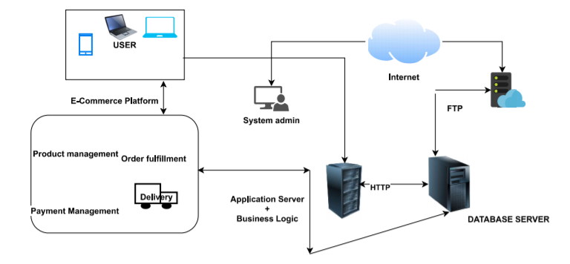

Figure -Software and Hardware Architecture

# **System Design**

In this part, we will propose a design for the user interface of the Techcontrol’s E-Commerce system. The wireframe, also known as a page schematic or screen blueprint, is a visual guide that represents the skeletal framework of a website. (D Brown 2011)

## **Home page:**

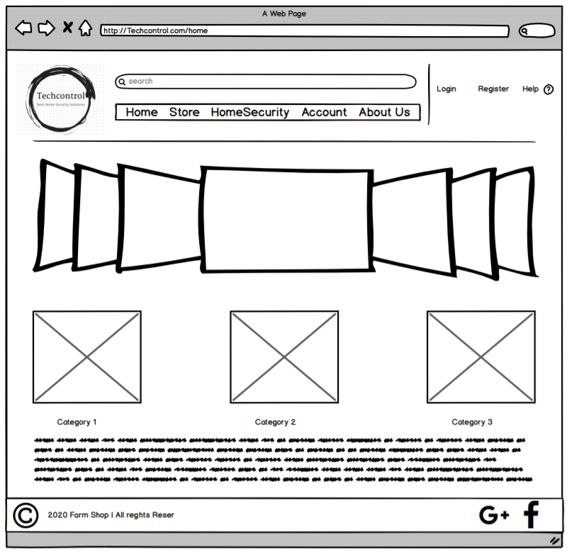

Figure - Design - Home Page

## **Customer Registration:**

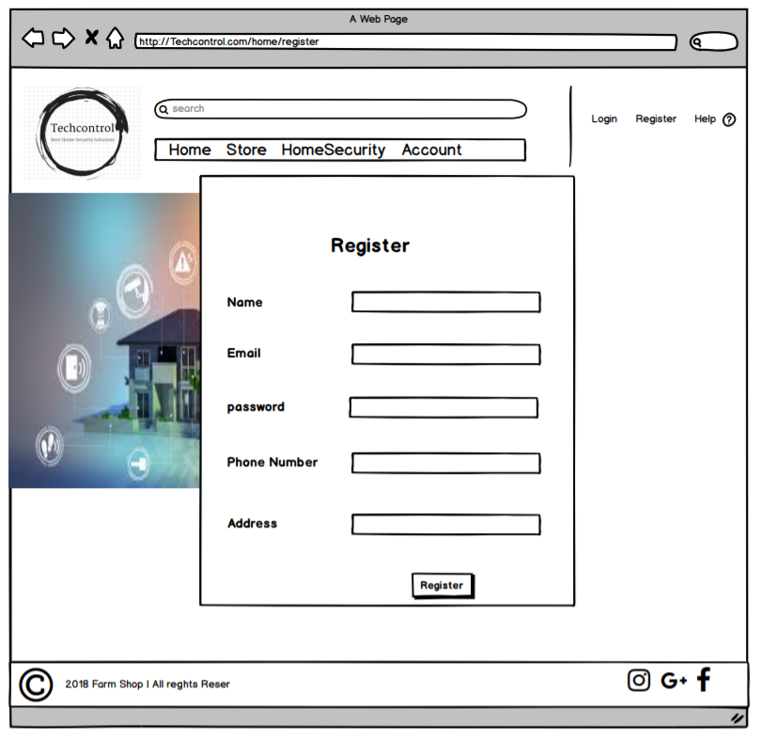

Figure - Design - Customer Registration

## **Customer login:**

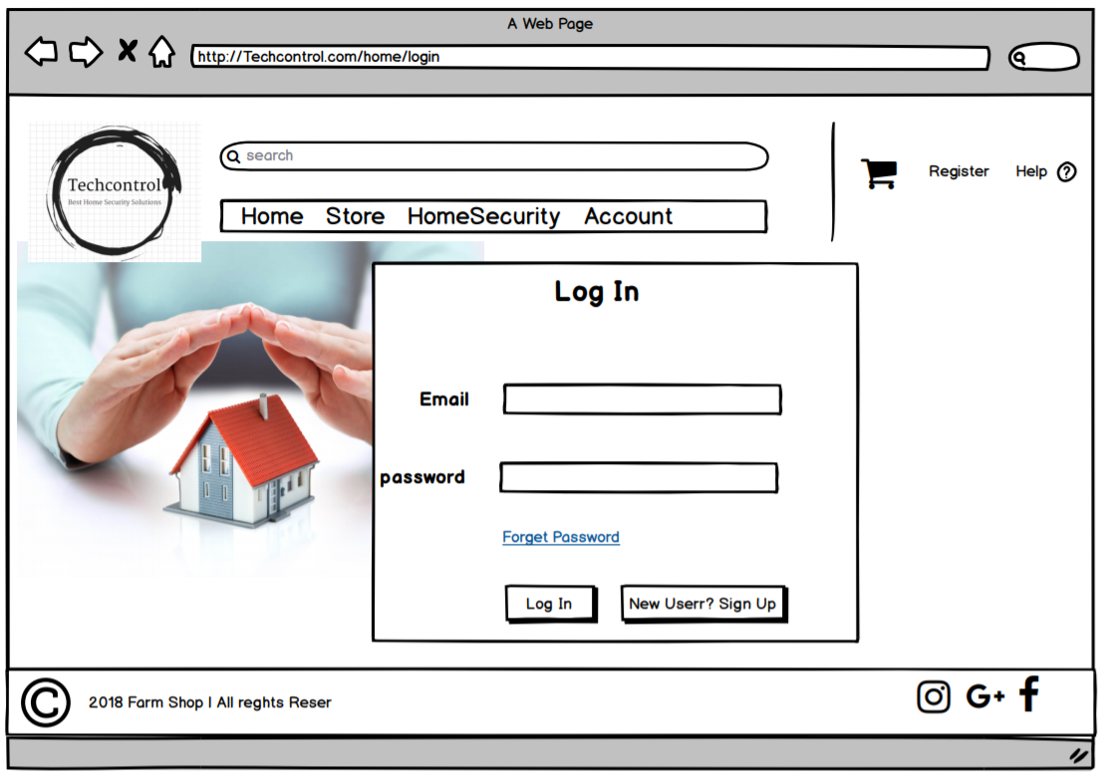

Figure - Design - Customer Login

## **About Us page:**

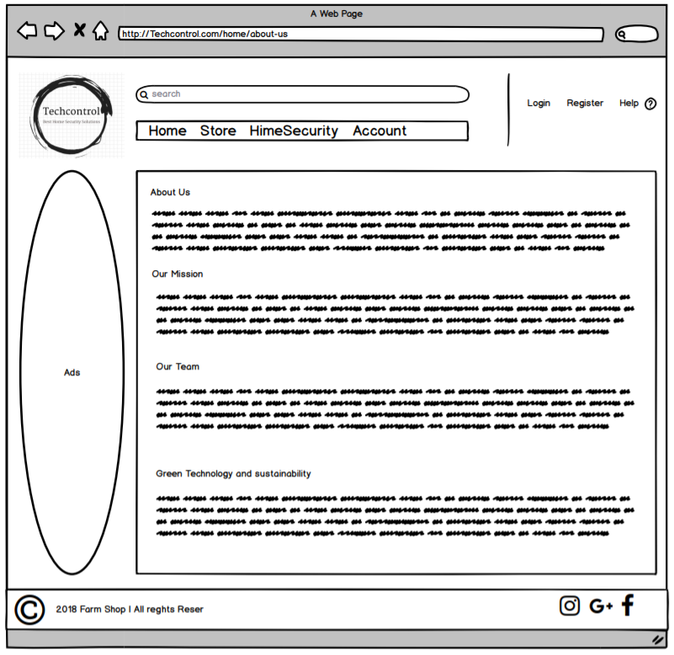

Figure - Design - About Us

## **Help page:**

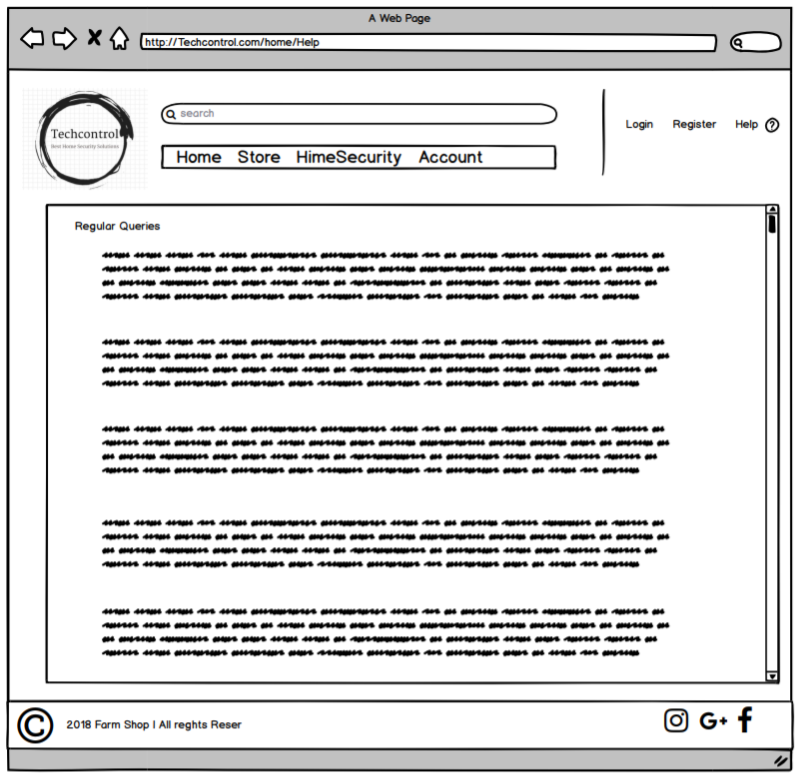

Figure - Design - Help Page

## **Products page:**

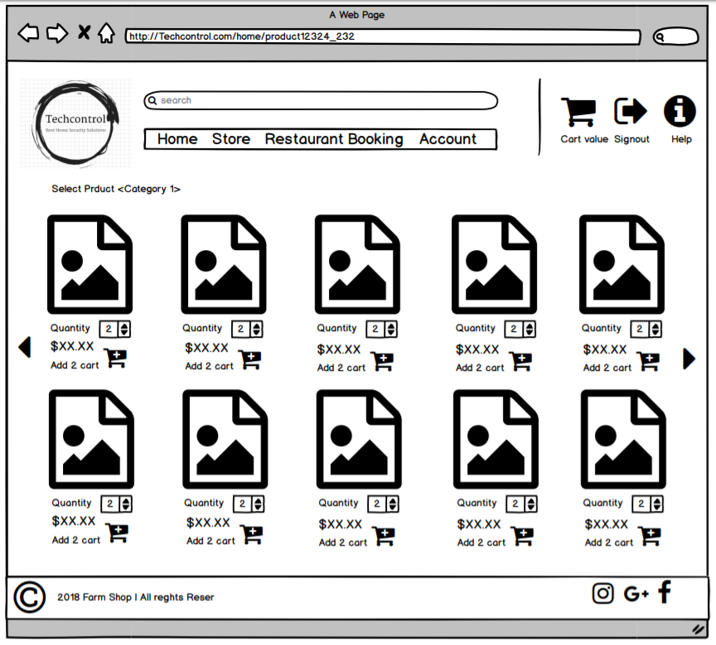

Figure - Design - Products Page

## **Shopping Cart page:**

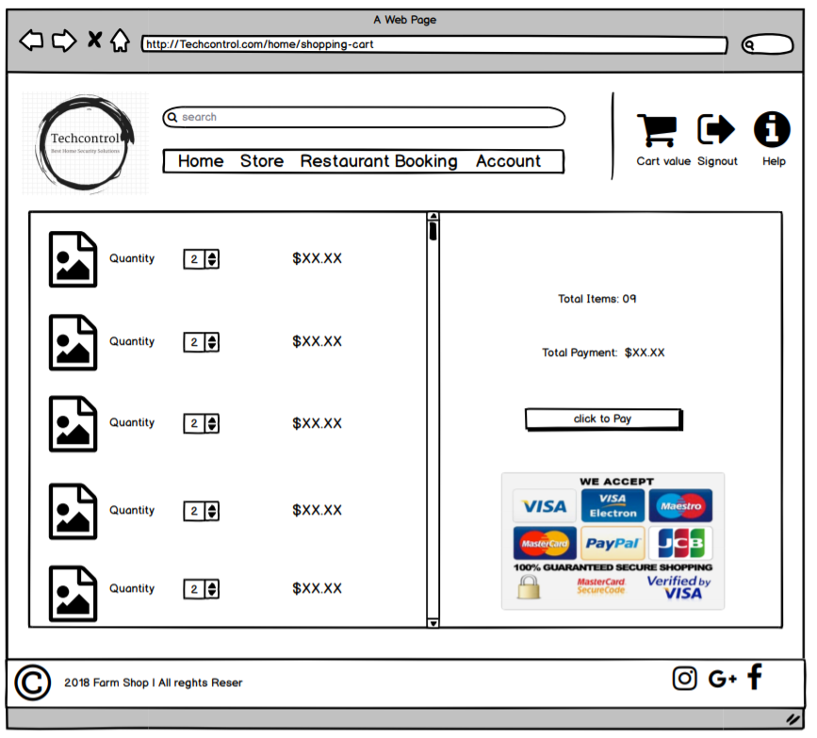

Figure - Design - Shopping Cart

## **Payment page:**

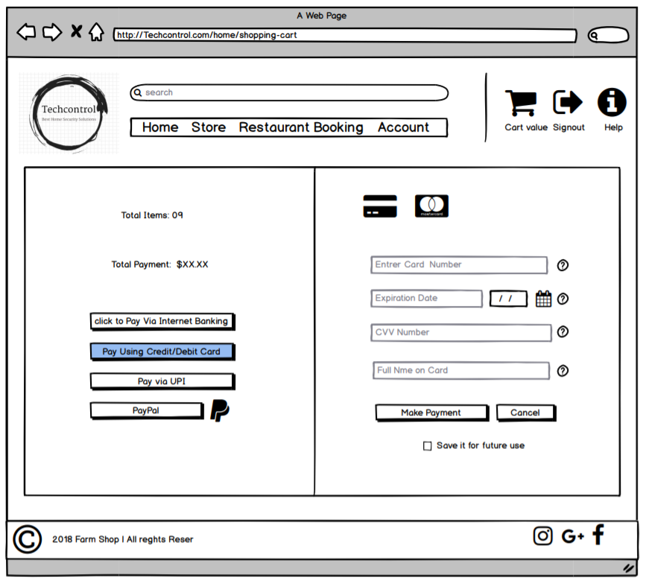

Figure - Design - Payment Page

# **Entity Relationship Diagram**

Figure – Entity Relationship Diagram

## **UML notation ERD:**

Figure - ERD, UML Notation

# **Use Case Diagram**

Use Case Diagram represents an interaction of users with the system and shows the relationship between the user and the different use cases. It helps us to specify the context of the system and to better define the requirement of the system.

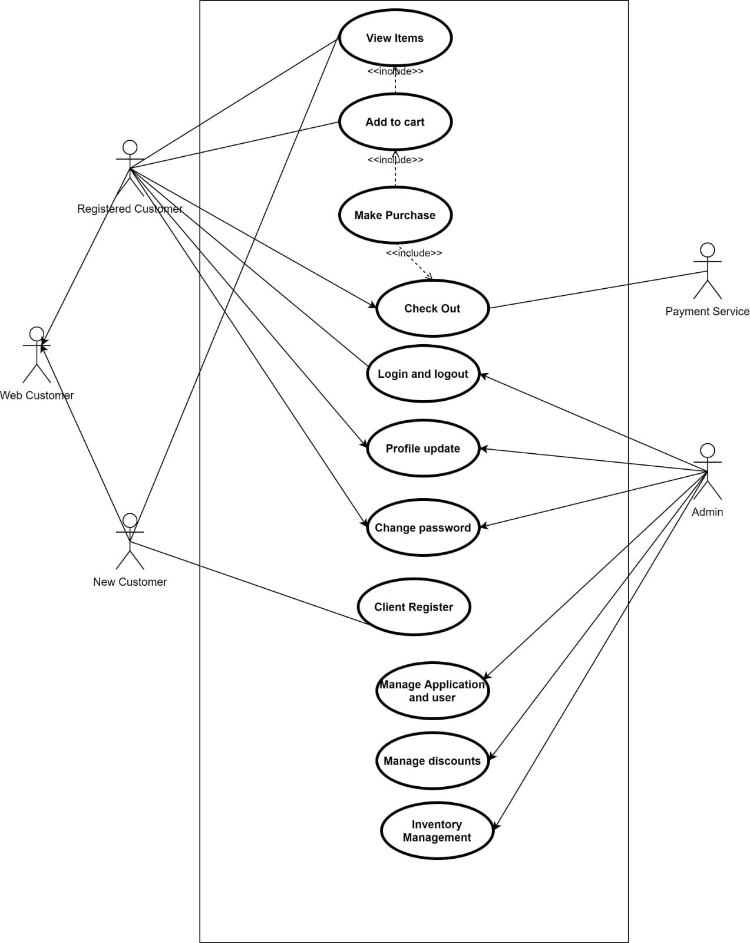

Figure - Use Case Diagram

# **Context Diagram**

Also known as top-level Data Flow Diagram (or Level 0). It defines and clarifies the boundaries of the proposed system. It clearly shows the flow of information between the entities and the system. It lets us see the entire system in a single process from a high level.

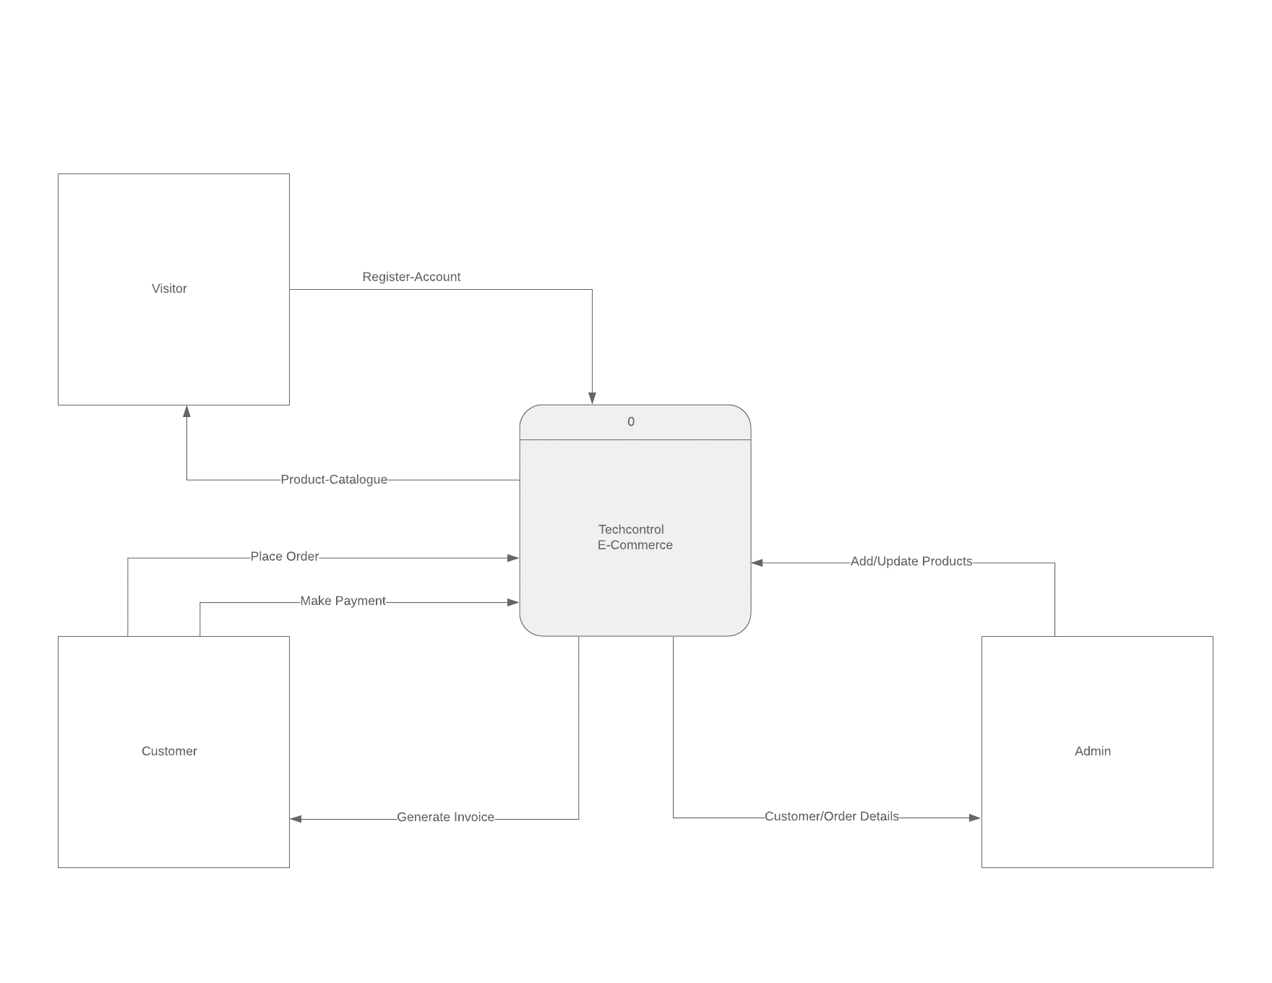

Figure - Context Diagram

# **Data Flow Diagram**

This diagram represents the flow of the data in Techcontrol’s E-commerce system.

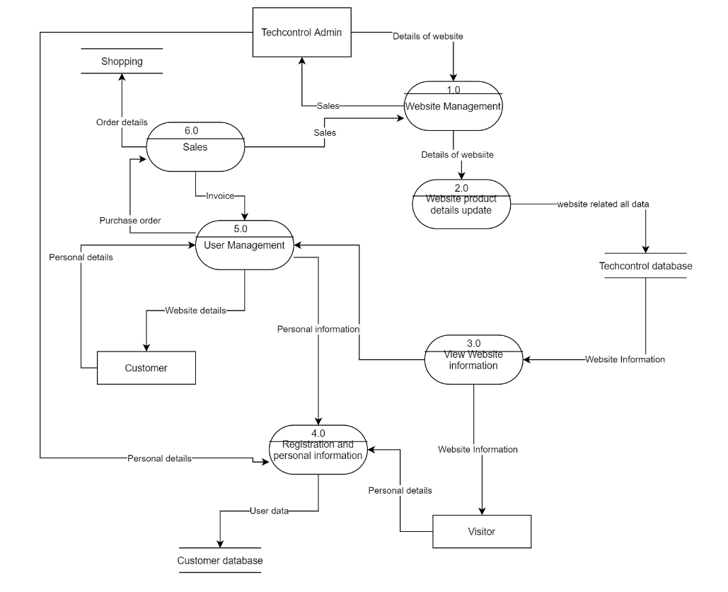

Figure - Data Flow Diagram

# **Sequence Diagram**

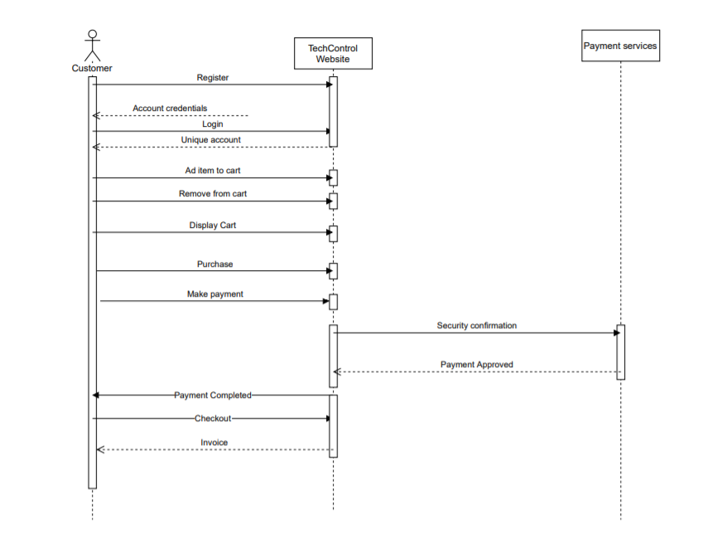

Figure - Sequence Diagram

# **Conclusion**

The proposed E-Commerce system will be developed, using HTML5, CSS, JavaScript, PHP, and MySQL to meet the requirements of Techcontrol. We will use this report as a blueprint in the Development phase. By following the proposed requirements and the skeleton outlined in this report, we will ensure to deliver the system on time, within a budget and scope. We will aim to deliver a system, that will be easy to maintain by admin and will have a user friendly interface.

# **Supervisor’s Feedback**

|  |  |
| --- | --- |
| Supervisor Feedback | Team response |
| Supervisor reached out to the team leader via email, to introduce other team members. | Team leader has contacted other team members via email and scheduled a meeting to discuss the project. |
| Supervisor advised to collaborate on the Github | Team has agreed, established Github presence, formed a team and created a project repository for further collaboration. |
| Supervisor has advised scheduling the tasks on Github. | Team leader has allocated tasks to each team member and set a deadline for each task. |
| Supervisor reviewed or report draft and suggested the following adjustments: |  |
| * Update scope statement, and include a detailed description of key deliverables | Task has been assigned to Amolak, to work on key deliverables part of the report which will be included under scope statement. |
| * Create a Gantt chart | Team leader has created the Gantt chart in Microsoft Project and inserted it into the report. |
| Crowsfoot ERD - Implementation ready & Clearly show the relationships | I have developed the Crowsfoot diagram and asked for feedback from the supervisor, who recommended a few changes which have been done right away. |
| Supervisor has advised to follow the rules when constructing the Context diagram | I have build the Context Diagram following the specific rules that apply and asked supervisor for feedback, which was positive |
| Supervisor recommended to sketch the frontend | Team has delivered the system design wireframe for different pages in the system |

Table - Supervisor's Feedback

# **References**

Laplante, P. A., 2014. *Requirements Engineering for Software and Systems.* Second ed. Boca Raton: CRC Press.

Jaakkola, H., Thalheim, B., 2011 "Architecture-driven modelling methodologies.", *Proceedings of the 2011 conference on Information Modelling and Knowledge Bases XXII*. Anneli Heimbürger et al. (eds). IOS Press. p. 98

Brown, D. M., 2011. Communicating Design: Developing Web Site Documentation for Design and Planning, 2nd ed., New Riders Press.

Lucidchart.com 2020, ‘Database ER Diagram Template’, Lucidchart, viewed 01 May 2020, <https://www.lucidchart.com/pages/templates/er-diagram/database-er-diagram-template>

Lucidchart.com 2020, ‘Context Data Flow Diagram Template’, Lucidchart, viewed 05 May 2020, <https://www.lucidchart.com/pages/templates/data-flow-diagram/context-data-flow-diagram-template>

Taba, N. and Ow, S., 2016. A new model for software inspection at the requirements analysis and design phases of software development. Int. Arab J. Inf. Technol.(IAJIT), 13(6), pp.51-57.

Davis, W.S. and Yen, D.C. eds., 2019. The information system consultant's handbook: Systems analysis and design. CRC press

Theorin, A., Bengtsson, K., Provost, J., Lieder, M., Johnsson, C., Lundholm, T. and Lennartson, B., 2017. An event-driven manufacturing information system architecture for Industry 4.0. International Journal of Production Research, 55(5), pp.1297-1311.

Jacobson, I., Spence, I. and Kerr, B., 2016. Use-Case 2.0. Queue, 14(1), pp.94-123.

de Sousa, T.C., Kelvin, L., Neto, C.D. and de Carvalho, C.G.N., 2017. A Formal Semantics for Use Case Diagram Via Event-B. JSW, 12(3), pp.189-200.

Attias, R., Cisco Technology Inc, 2020. System and method for dynamic domain-specific sequence diagram visualization. U.S. Patent 10,621,063.

Zhou, J., Reniers, G. and Khakzad, N., 2016. Application of event sequence diagram to evaluate emergency response actions during fire-induced domino effects. Reliability Engineering & System Safety, 150, pp.202-209.

Xiong, H., Zhang, H., Dong, X., Meng, L. and Zhao, W., 2017, September. DFDVis: A Visual Analytics System for Understanding the Semantics of Data Flow Diagram. In International Conference of Pioneering Computer Scientists, Engineers and Educators (pp. 660-673). Springer, Singapore.

Bani-Ismail, B. and Baghdadi, Y., 2019. Migrating two legacy systems to SOA: a new approach for service selection based on data flow diagram. International Journal of Web and Grid Services, 15(3), pp.251-281.

Castro, C.F., Fantinato, M., Aksu, Ü., Reijers, H.A. and Thom, L.H., 2019, May. Systematizing the Relationship Between Business Processes’ and Web Services’ Non-functional Requirements. In International Conference on Enterprise Information Systems (pp. 473-497). Springer, Cham

# **Appendix**

## **Table of Tables**

Table 1 - Functional Requirement 5

Table 2 - Non-Functional Requirements 6

Table 3 - Supervisor's Feedback 21

## **Table of Figures**

Figure 1 -Software and Hardware Architecture 7

Figure 2 - Design - Home Page 8

Figure 3 - Design - Customer Registration 9

Figure 4 - Design - Customer Login 10

Figure 5 - Design - About Us 11

Figure 6 - Design - Help Page 12

Figure 7 - Design - Products Page 13

Figure 8 - Design - Shopping Cart 14

Figure 9 - Design - Payment Page 15

Figure 10 – Entity Relationship Diagram 16

Figure 11 - ERD, UML Notation 16

Figure 12 - Use Case Diagram 17

Figure 13 - Context Diagram 18

Figure 14 - Data Flow Diagram 19

Figure 15 - Sequence Diagram 20