E-commerce Website for TechControl

Student Name:

Student id:

University

Author Note

# WBS

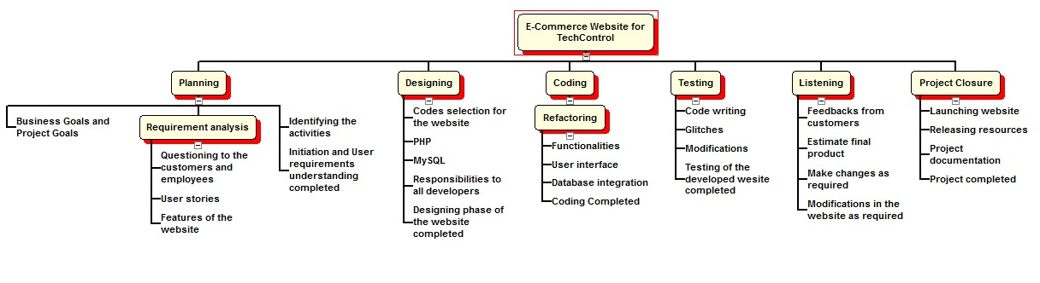

**Figure 1: WBS**

(Source: Created by author using WBS Pro)

# Schedule

|  |  |  |  |
| --- | --- | --- | --- |
| **Task Name** | **Duration** | **Start** | **Finish** |
| **E-Commerce Website for TechControl** | **76 days** | **Mon 04-05-20** | **Mon 17-08-20** |
| **Planning** | **16 days** | **Mon 04-05-20** | **Mon 25-05-20** |
| Business Goals and Project Goals | 4 days | Mon 04-05-20 | Thu 07-05-20 |
| **Requirement analysis** | **9 days** | **Fri 08-05-20** | **Wed 20-05-20** |
| Questioning to the customers and employees | 3 days | Fri 08-05-20 | Tue 12-05-20 |
| User stories | 4 days | Wed 13-05-20 | Mon 18-05-20 |
| Features of the website | 2 days | Tue 19-05-20 | Wed 20-05-20 |
| Identifying the activities | 3 days | Thu 21-05-20 | Mon 25-05-20 |
| Initiation and User requirements understanding completed | 0 days | Mon 25-05-20 | Mon 25-05-20 |
| **Designing** | **18 days** | **Tue 26-05-20** | **Thu 18-06-20** |
| Codes selection for the website | 4 days | Tue 26-05-20 | Fri 29-05-20 |
| PHP | 5 days | Mon 01-06-20 | Fri 05-06-20 |
| MySQL | 3 days | Mon 08-06-20 | Wed 10-06-20 |
| Responsibilities to all developers | 6 days | Thu 11-06-20 | Thu 18-06-20 |
| Designing phase of the website completed | 0 days | Thu 18-06-20 | Thu 18-06-20 |
| **Coding** | **15 days** | **Fri 19-06-20** | **Thu 09-07-20** |
| **Refactoring** | **15 days** | **Fri 19-06-20** | **Thu 09-07-20** |
| Functionalities | 3 days | Fri 19-06-20 | Tue 23-06-20 |
| User interface | 5 days | Wed 24-06-20 | Tue 30-06-20 |
| Database integration | 7 days | Wed 01-07-20 | Thu 09-07-20 |
| Coding Completed | 0 days | Thu 09-07-20 | Thu 09-07-20 |
| **Testing** | **12 days** | **Fri 10-07-20** | **Mon 27-07-20** |
| Code writing | 6 days | Fri 10-07-20 | Fri 17-07-20 |
| Glitches | 4 days | Mon 20-07-20 | Thu 23-07-20 |
| Modifications | 2 days | Fri 24-07-20 | Mon 27-07-20 |
| Testing of the developed website completed | 0 days | Mon 27-07-20 | Mon 27-07-20 |
| **Listening** | **11 days** | **Tue 28-07-20** | **Tue 11-08-20** |
| Feedbacks from customers | 4 days | Tue 28-07-20 | Fri 31-07-20 |
| Estimate final product | 3 days | Mon 03-08-20 | Wed 05-08-20 |
| Make changes as required | 4 days | Thu 06-08-20 | Tue 11-08-20 |
| Modifications in the website as required | 0 days | Tue 11-08-20 | Tue 11-08-20 |
| **Project Closure** | **4 days** | **Wed 12-08-20** | **Mon 17-08-20** |
| Launching website | 1 day | Wed 12-08-20 | Wed 12-08-20 |
| Releasing resources | 2 days | Thu 13-08-20 | Fri 14-08-20 |
| Project documentation | 1 day | Mon 17-08-20 | Mon 17-08-20 |
| Project completed | 0 days | Mon 17-08-20 | Mon 17-08-20 |

# Gantt Chart

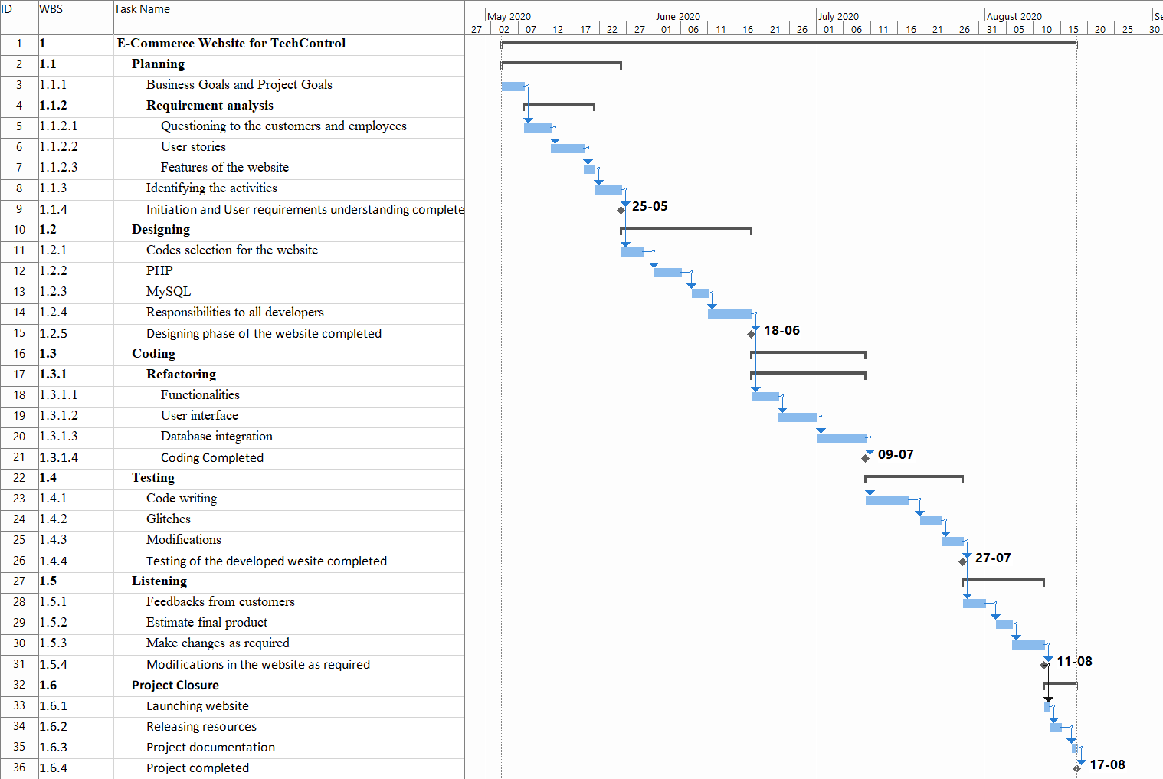

**Figure 2: Gantt Chart**

(Source: created by author using MS Project)

**References**

Chowdhury, M.I., 2017. *GreatBuyz AN ECOMMERCE WEBSITE* (Doctoral dissertation, Stamford University Bangladesh).

Pathirana, U.P.G.Y. and Wellala, D.S.M., 2018. E-Commerce Video Based Automobile Website. *INTERNATIONAL JOURNAL OF ACADEMIC RESEARCH IN BUSINESS AND SOCIAL SCIENCES*, *8*(11), pp.616-626.