**ALL EMPLOYESS**

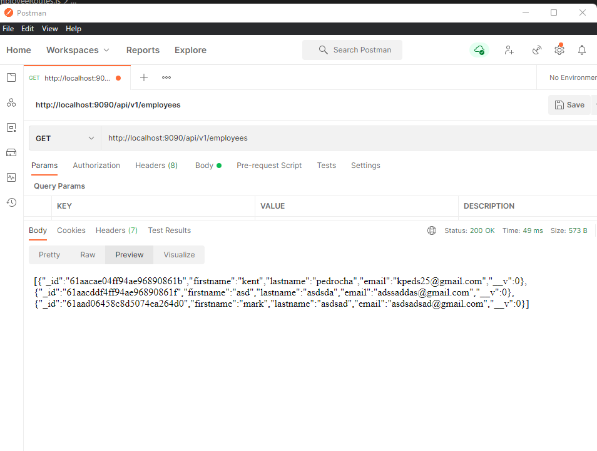

**CREATE EMPLOYEE**

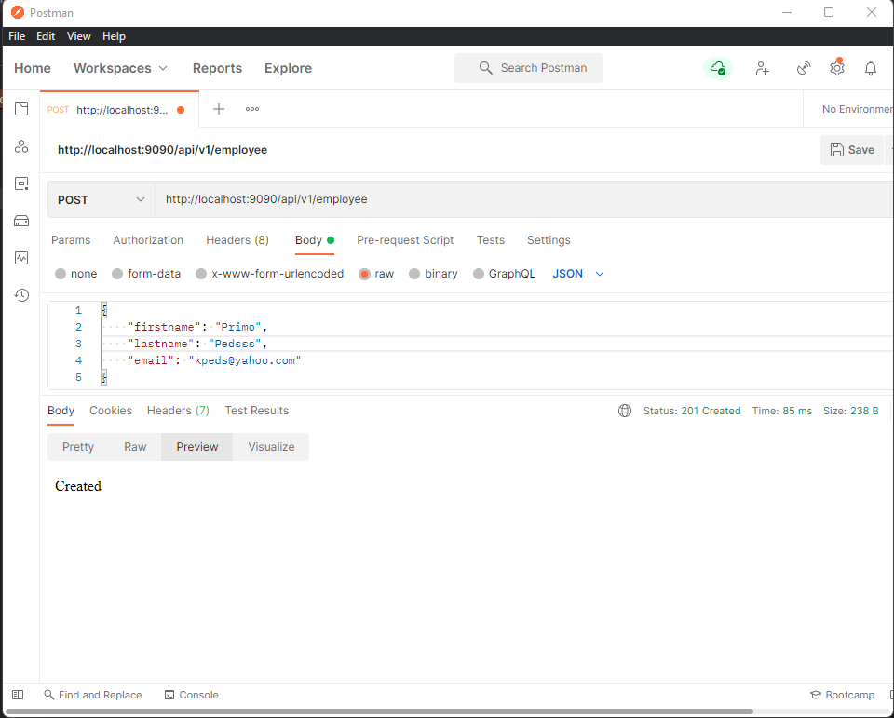

**DELETE EMPLOYEE**

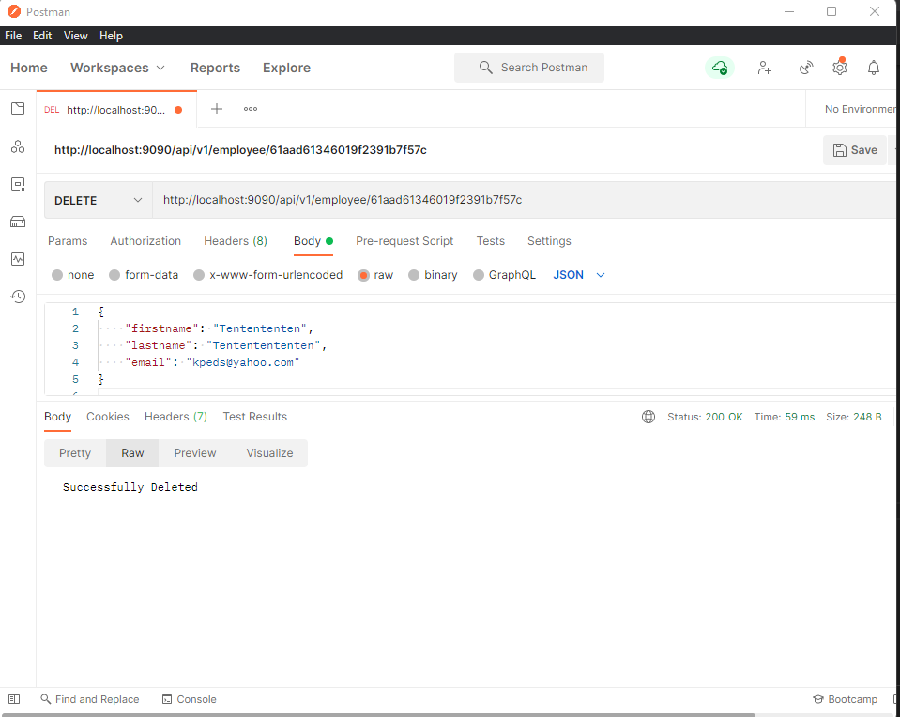

**CORRECT FORMAT VALIDATION BACKEND**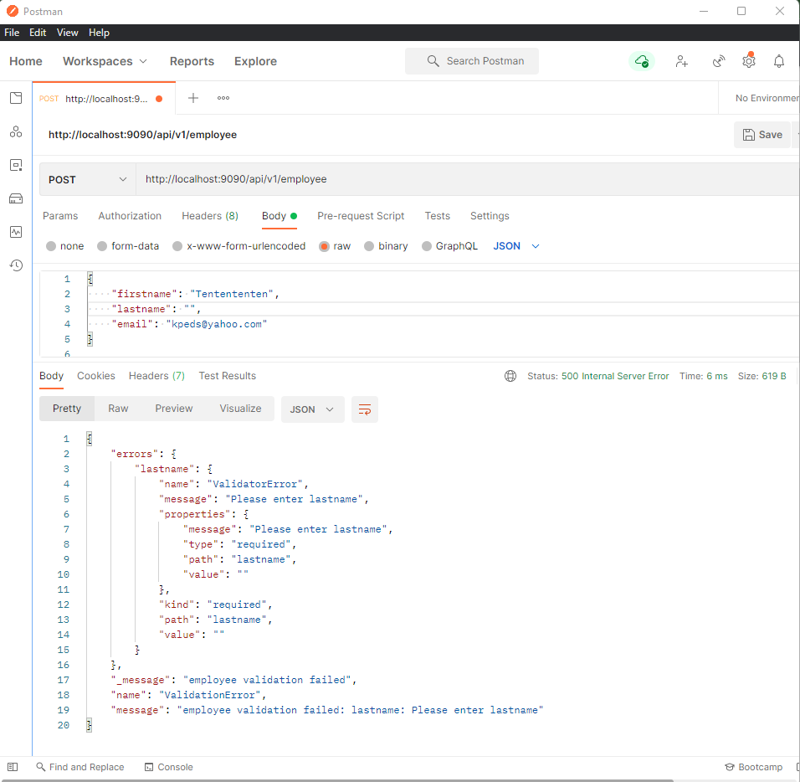

**REQUIRED FIRSTNAME**

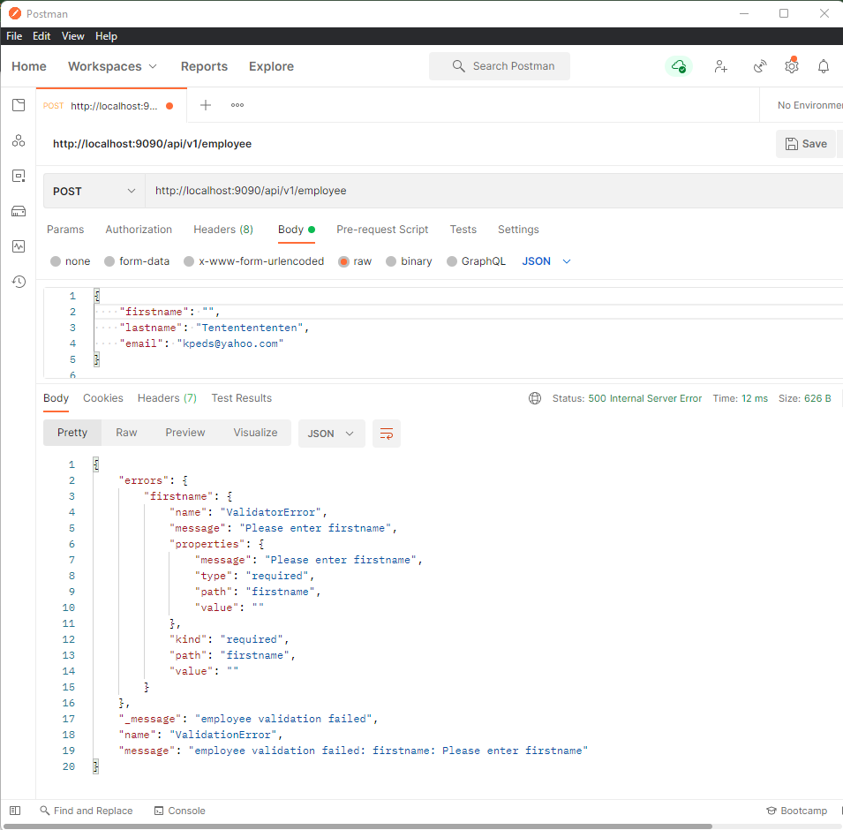

**REQUIRE LASTNAME**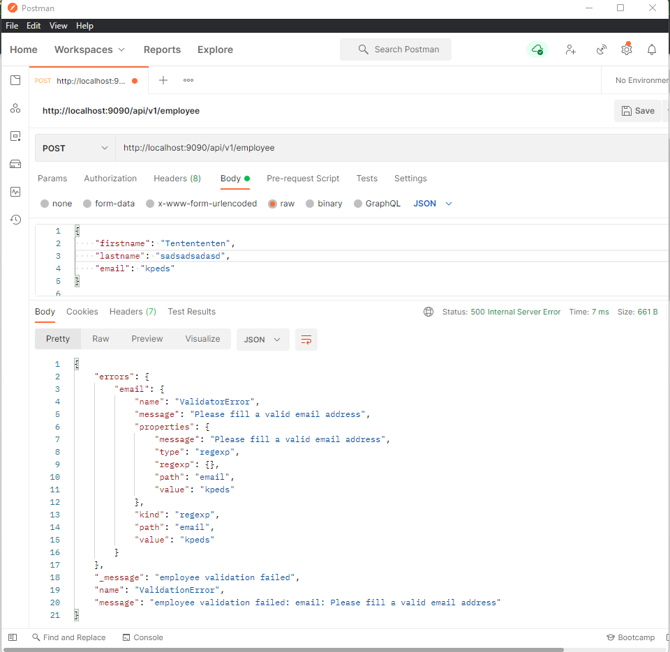

**FIND EMPLOYEE BACKEND**

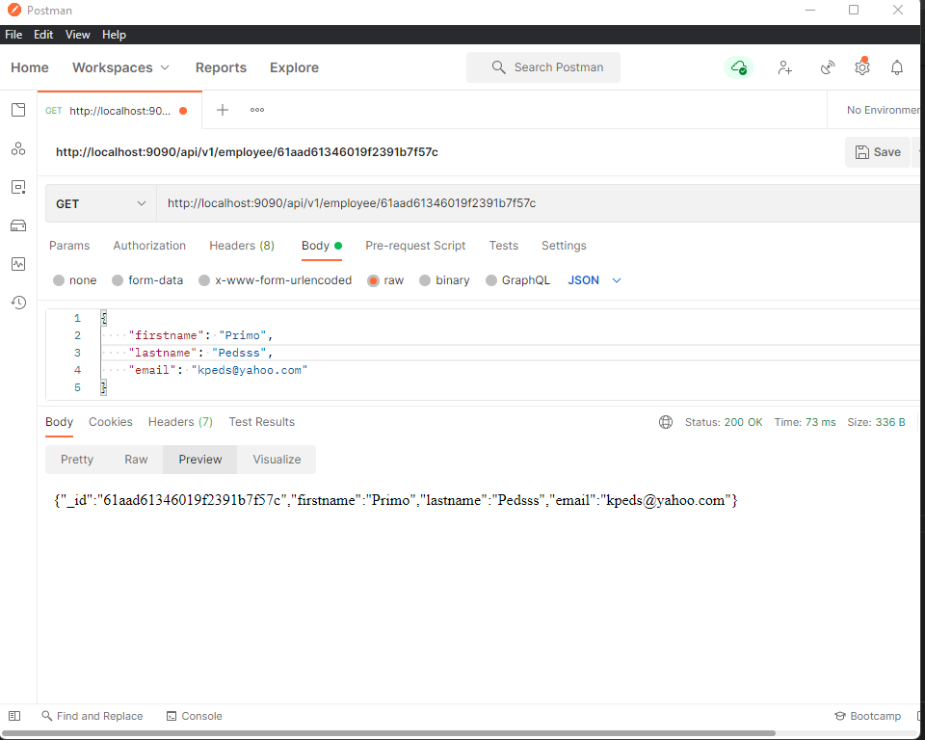

**MONGODB**

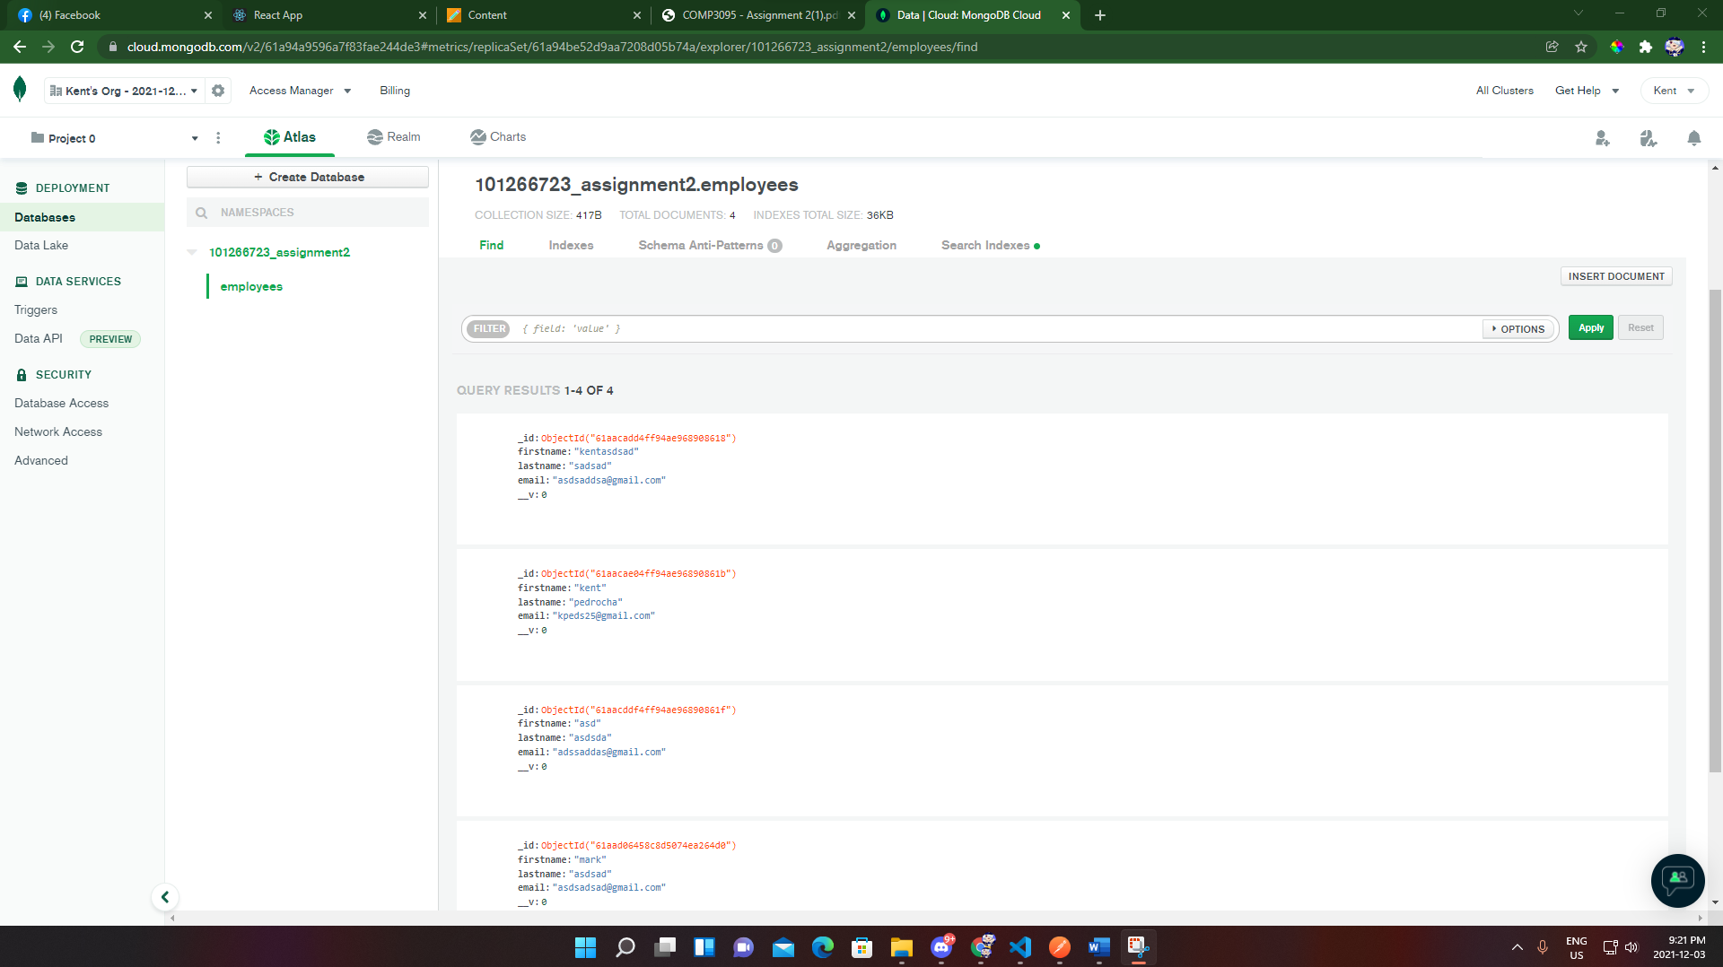

**UPDATE BACKEND**

