**LIST EMPLOYEES FRONT END**

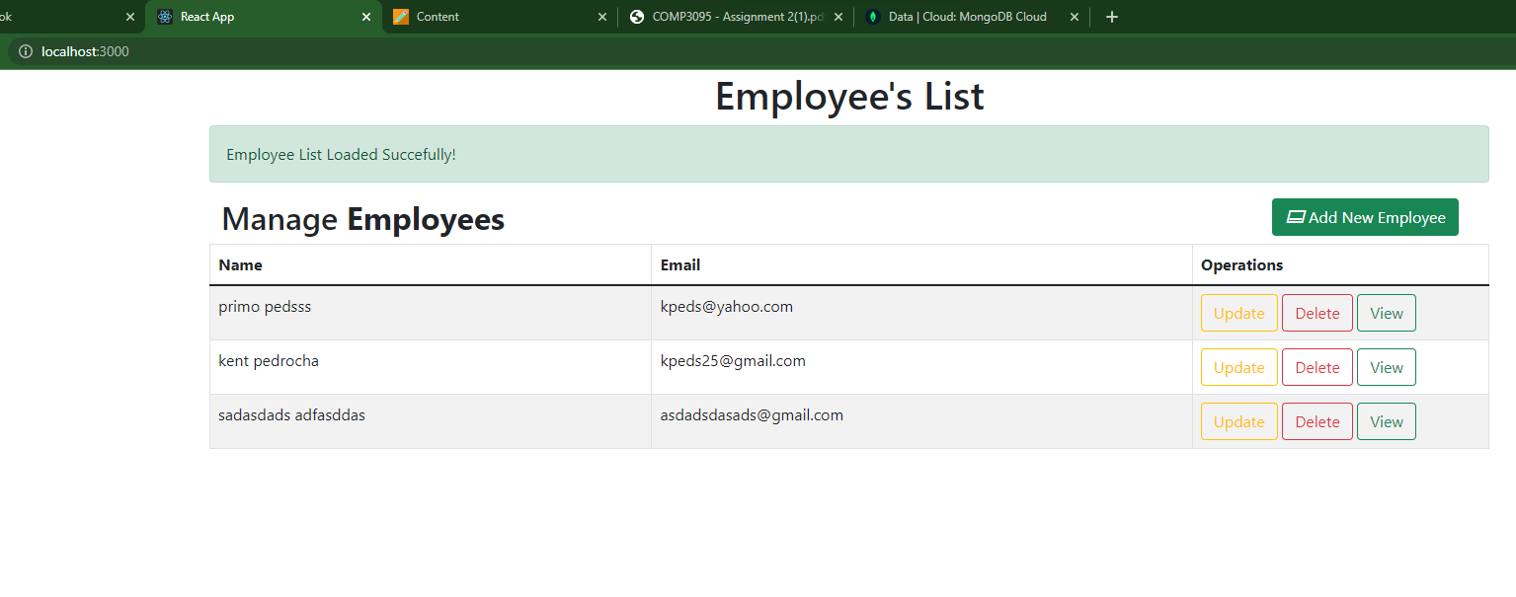

**UPDATE EMPLOYEE**

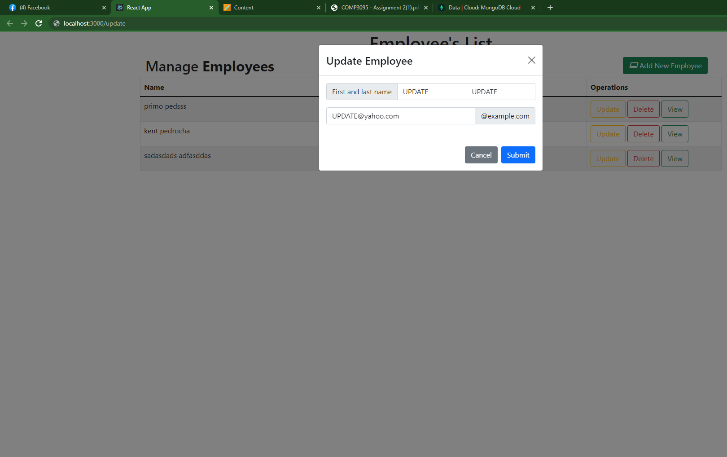

**UPDATED EMPLOYEE**

**VIEW EMPLOYEE**

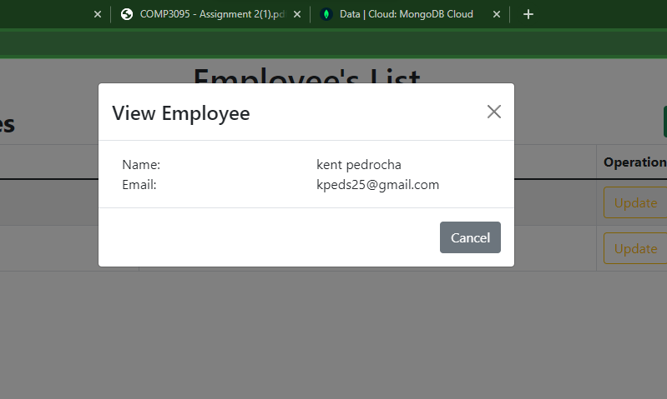

**DELETE EMPLOYEE**

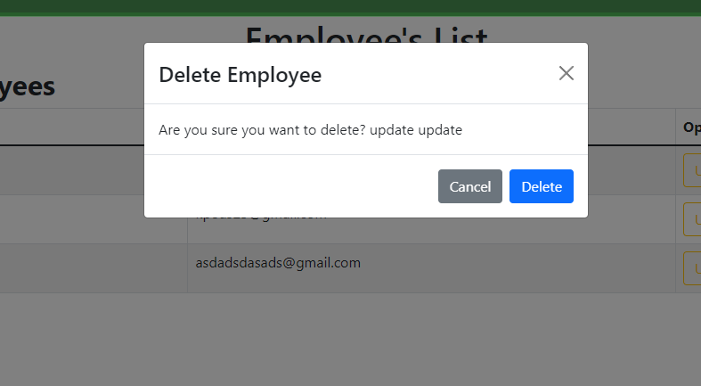

**DELETED EMPLOYEE**

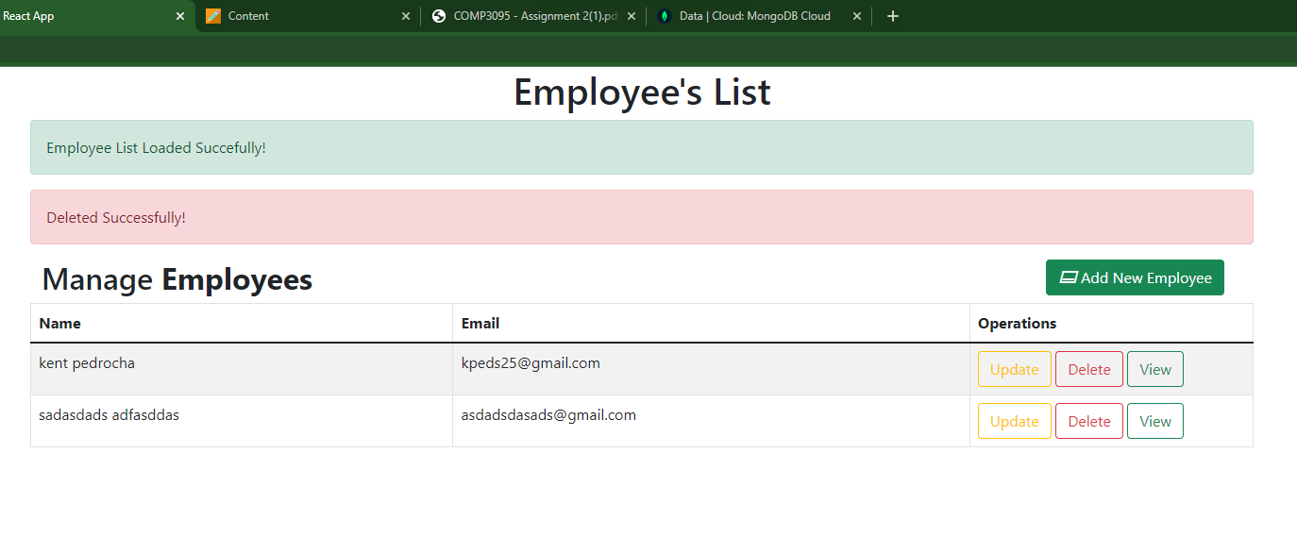

**ADD EMPLOYEE FRONT END**

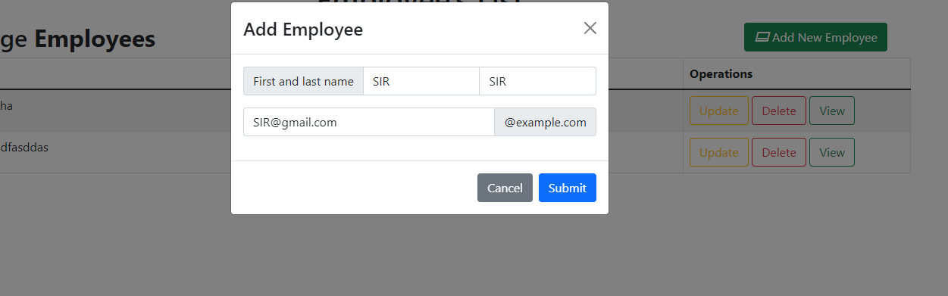

**ADDED EMPLOYEE**