**Name**: Kent Pedrocha **Studentno**: 101266723

Exercise-1

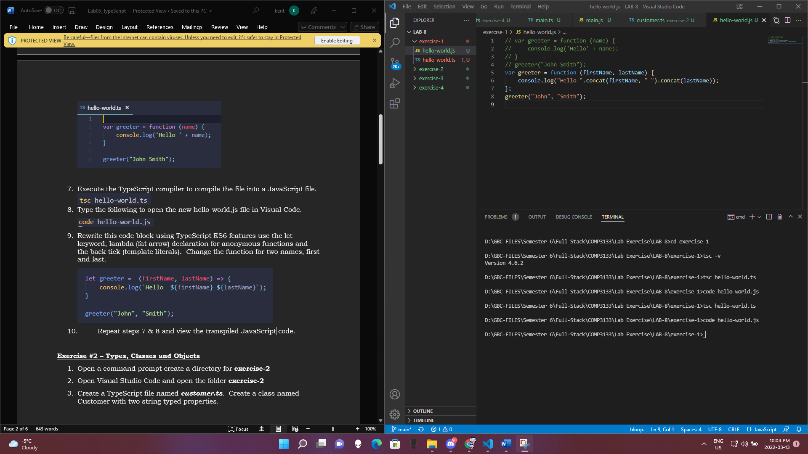

EXERCISE-2

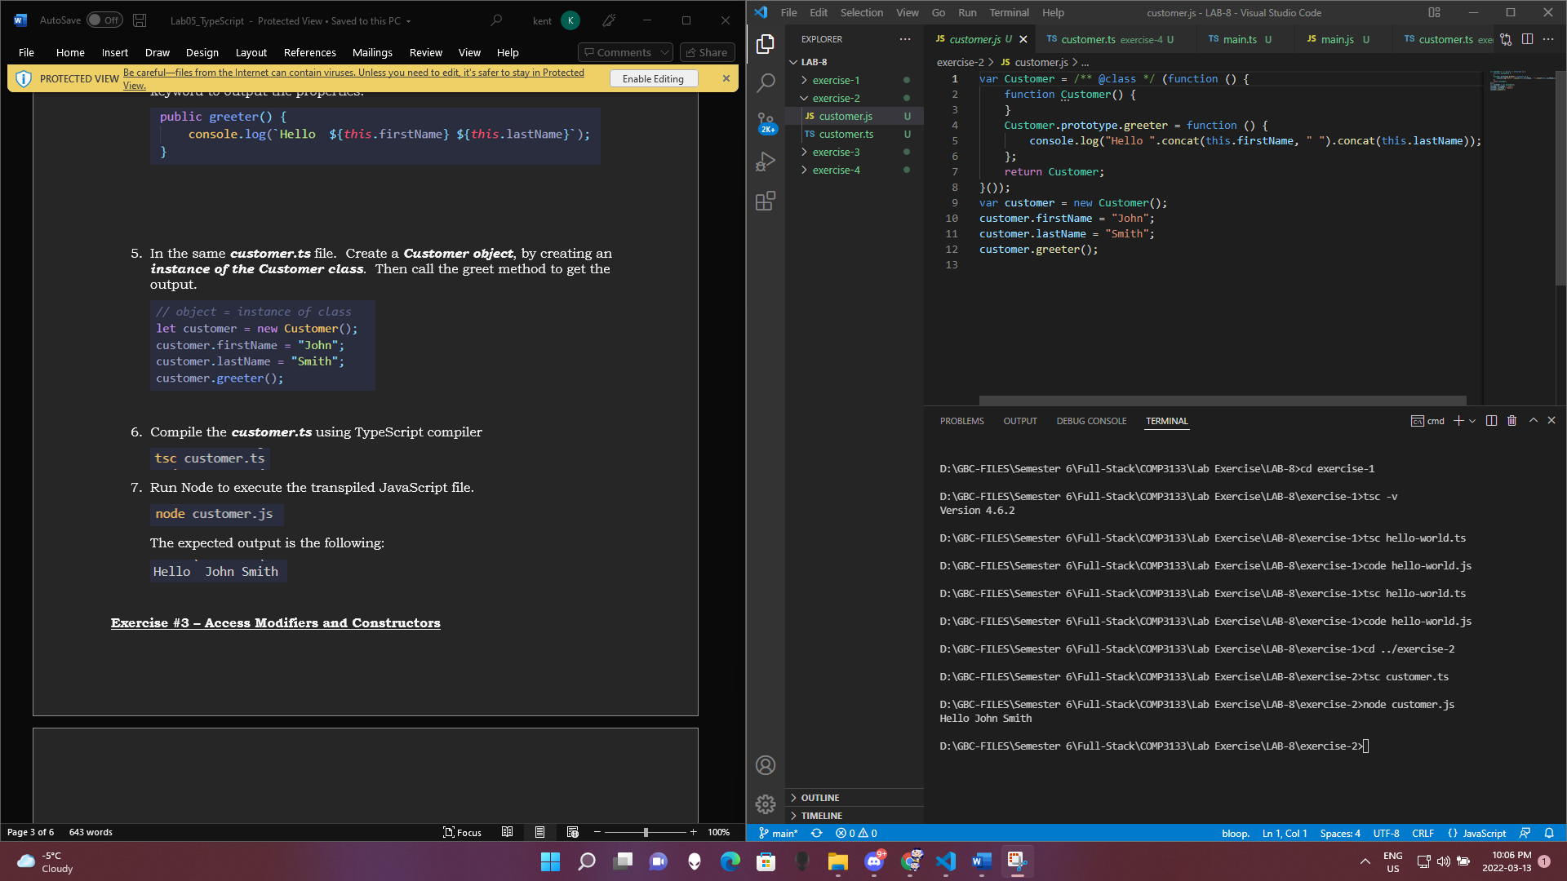

EXERCISE-3

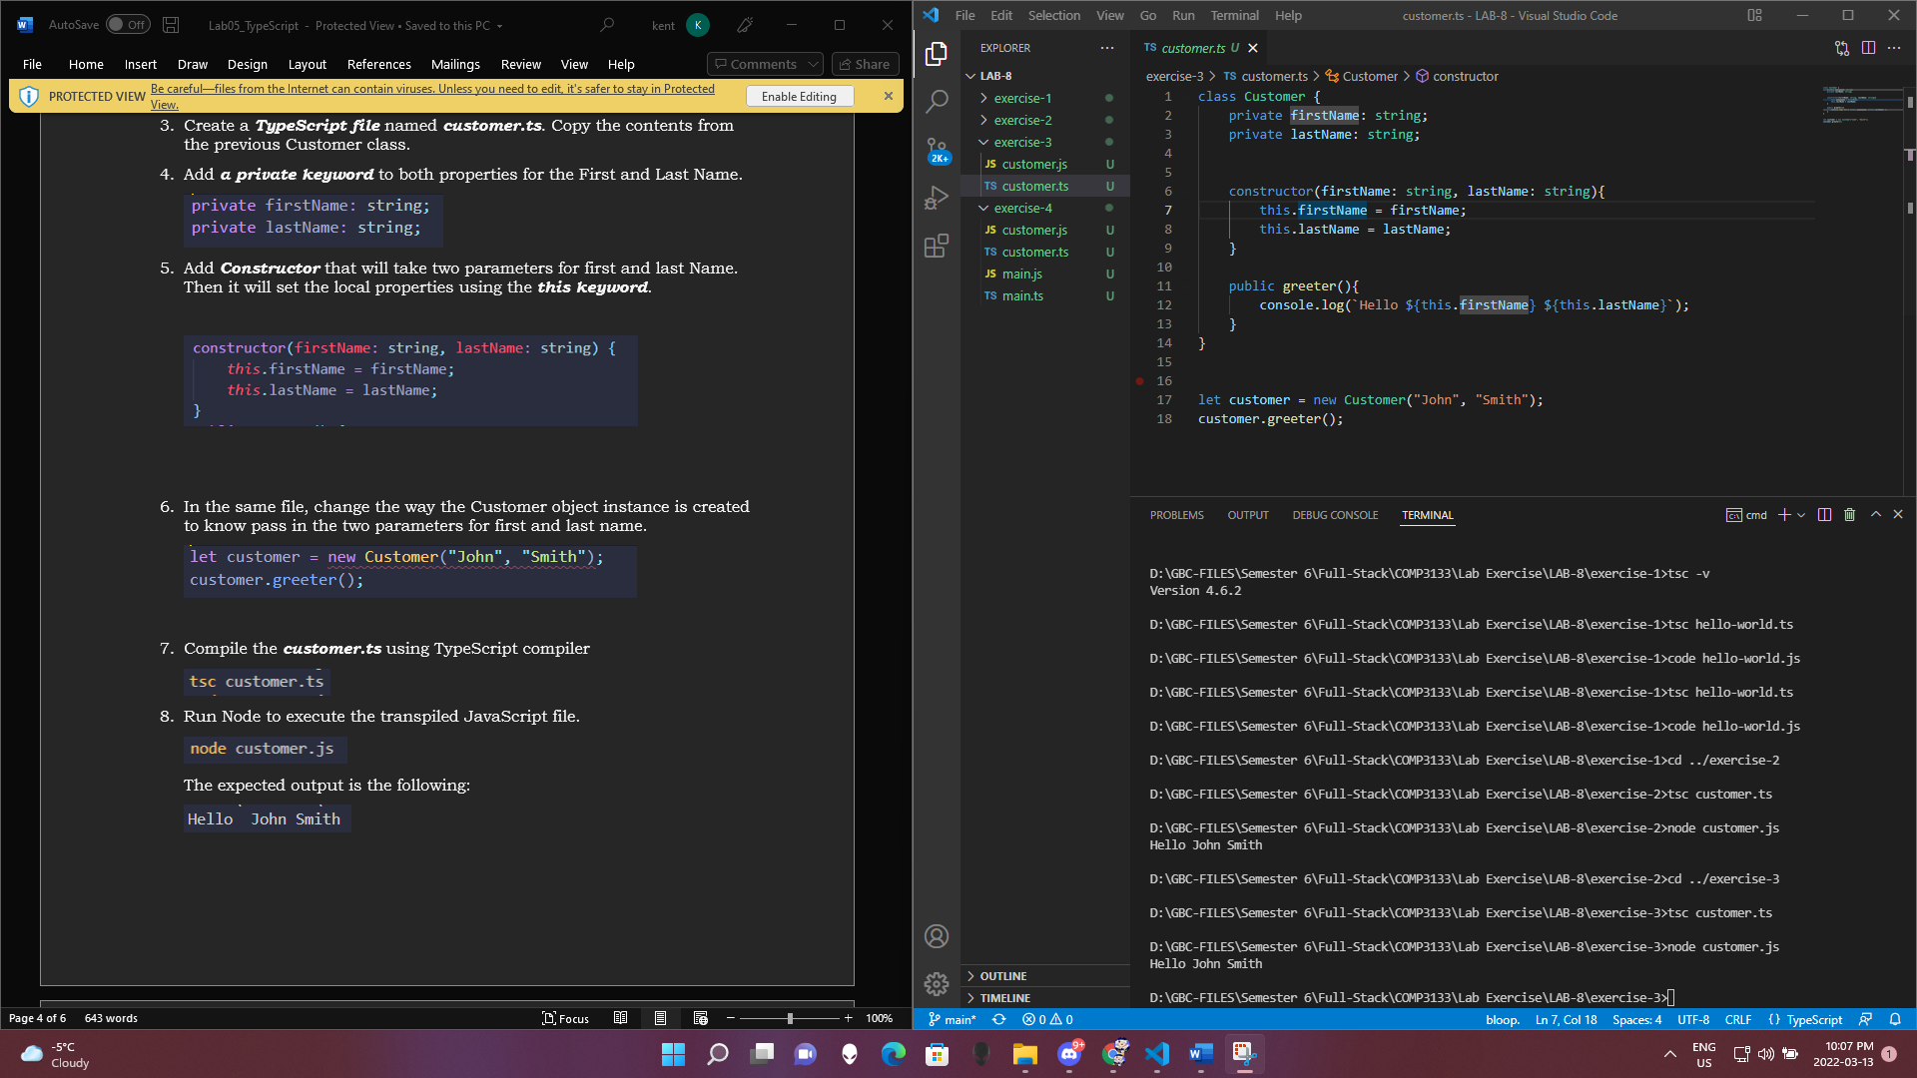

EXERCISE-4

