Ethan Kent

**Ubuntu Network Documentation**

The Ubuntu server is set up with a NAT connection as it was the default setting when setting up the network. This is good since NAT is “Network Address Translation” which can be used to communicate between my host system and the virtual servers if the IP addresses differ.

The configuration for the server when it is connected.

This tells me that dhcp for IPv4 is running.

For my script I’m going to be using “ifconfig” which will show us what the current ip address of the server is and if it has an address at all. I also have set the script to ping my other server, this way we can try and see if it can connect to something that is currently up and running. I used “ss -4a” and “ss-ta” which will list all IPv4 and TCP sockets which I feel are the most checked when troubleshooting arises. I have the “arp” command as well to look if our MAC addresses are paired correctly with our IP addresses. I’m also appending it to a file so we can just look over the results or we can search through it with some tools. Here is the script itself below.

Here is the results in the file I appended it to “Networkresults”

**CentOS Network Documentation**

Here is the servers network connections. I found it in the “etc/NetworkManager/system-connections” then in the file ens33.nmconnection, here’s the results below.

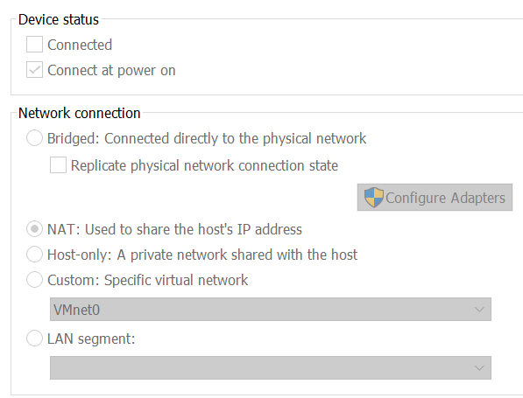 CentOS is also a NAT connection since this was the default option and I haven’t changed it.

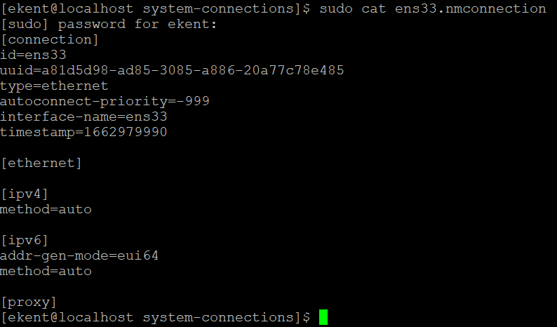

We can see the IPv4 and IPv6 addresses are set to auto which means they will be given a random address and not a static address.

The script for the CentOS server is the same as I used for the Ubuntu but I switched the ping command to ping the Ubuntu server.

192.168.80.128 is my Ubuntu server. Then I appended it into a file as I run it. The results show that I could ping my Ubuntu server so we know that’s up and we can connect. It shows what IPv4 sockets are listening, established, or unconnected along with the TCP sockets as well, then just the current ip and the configuration it’s connected to.

I feel that this is a good starting point for troubleshooting, getting a quick look at some common things that can have issues and checking them all at once can take up time. That’s why I decided to put all of these into one command then append it for a quick look over, if none of these are the issue now we can do some more in depth troubleshooting.

Sources for lab

<https://manpages.ubuntu.com/manpages/xenial/man8/ss.8.html>

<https://www.networkworld.com/article/3327557/using-the-linux-ss-command-to-examine-network-and-socket-connections.html>