|  |
| --- |
| T27 |
| SFD Dispatch  Scope and Mission |
| [Surrey Food Delivery] |
|  |
| **Daniel Park**  **Bill Xue**  **Kent Huang**  **Terence Leung** |
|  |

|  |
| --- |
|  |

**Table of Contents**

1. Document Version 3

2. Team Contact Information 3

3. Description 3

4. Proposed Solution 4

5. Stakeholders and Users 4

6. Proposed Technology 5

7. Assumptions 5

7.1. Non-Technical Assumptions 5

7.2. Technical Assumptions 5

8. Project Goals, Tasks, Features 6

9. Deliverables 7

10. Out of Scope 8

11. Existing System 8

12. Diagrams 9

12.1. Client Diagrams 9

12.2. Team Diagrams 9

12.2.1. Overall Design & Activities 9

12.2.2. Sample WorkFlow 11

12.2.3. Wireframes 13

13. High-Level Schedule 15

14. High-Level Work Breakdown 16

15. Risks and Issues 17

## Document Version

|  |  |  |  |
| --- | --- | --- | --- |
| **Version** | **Description** | **Date** | **Author(s)** |
| **1** | Created document, this is the original plan after the team’s first discussion with client | 28/04/2017 | Daniel Park  Bill Xue  Kent Huang  Terence Leung |

## 

## Team Contact Information

**Team:**

|  |  |
| --- | --- |
| Daniel Park  [daniel51_1994@hotmail.com](mailto:daniel51_1994@hotmail.com)  604-700-5909 | Kent Huang  [kenthuang426@gmail.com](mailto:kenthuang426@gmail.com)  604-618-8770 |
| Terence Leung  [terence.cy.leung@gmail.com](mailto:terence.cy.leung@gmail.com)  604-338-2232 | Bill Xue  [billxue9141@hotmail.com](mailto:billxue9141@hotmail.com)  778-866-9900 |

**Supervisor:**

Bill Klug

[bill_klug@bcit.ca](mailto:bill_klug@bcit.ca)

## Description

Surrey Food Delivery is a food delivery service based in Surrey. Currently, customers and restaurants contact the owner/dispatcher to request a delivery for a food or product. The dispatcher receives either a text or a phone call describing the pickup location, the item to be purchased, and the destination of the customer. If the dispatcher receives a text or call from a customer, he allocates a driver to purchase the order. The driver will then complete the order.

The task of the owner/dispatcher is quite heavy and will continue to grow as the business grows. The owner currently receives many text messages and calls per day due to the increasing number of customers. It is therefore difficult for the owner to manage multiple orders from the customers and restaurants. Also, as the business grows, the number of drivers required to meet demands grow making the owner/dispatcher’s job even more unmanageable.

## Proposed Solution

Our team will develop an android app where a customer and a restaurant can request a delivery service. A customer will be able to use the app to order food or any other item. We will also need another app for the company to use. The system will contain the dispatcher functionality and driver functionality. The benefit of this system is that all the communication between the different views can communicate between each other in an automated way.

## Stakeholders and Users

Asad Khan - Owner of Surrey Food Delivery

Work number: 604-783-3370

Website: [www.surreyfooddelivery.com](http://www.surreyfooddelivery.com)

Ayesha Khan - Main contact. Wife of the owner, helps manage the current business.

Phone: 604-537-8681

Email: [aftab_ayesha@hotmail.com](mailto:aftab_ayesha@hotmail.com)

Users:

Regular customers

Restaurants Customer

Dispatcher

Drivers

Business owner.

Development Team - T27:

Bill Xue

Kent Huang

Daniel Park

Terence Leung.

## Proposed Technology

1. **Java**: the language for android development.
2. **Android studio**: the IDE for android development.
3. **Firebase**: the backend development platform provides the database storage and account registration and login logout functionalities.
4. **Nosql**: the language used in Firebase real-time database.
5. **Object-oriented design**: the design techniques used in application design.
6. **Whatsapp**: communication tool for the development team.
7. **Github**: collaboration tool for the development team.
8. **Trello**: Scrum board for the development team to organize the development tasks.

## Assumptions

## Non-Technical Assumptions

1. The team will complete phase 1 of the project (developing an android app).
2. The next phase of the project may be completed by another team.
3. Development team will not be responsible for publishing the app to app store.
4. Student team is responsible for purchasing any equipment or paid software not provided by BCIT or SURREY FOOD DELIVERY.
5. Student team is not responsible for any other platform other than android.
6. Student team is not responsible for providing the Google account registered for Firebase platform services; SURREY FOOD DELIVERY is responsible for registration of Firebase services in production phase of the application.

## Technical Assumptions

1. The team will determine the backend and front-end technologies.
2. Project will be developed using Java and Firebase.
3. The system will consist of two android applications; one application is for customers and restaurants and another application is for the dispatcher and drivers.

## Project Goals, Tasks, Features

The goal of the current project is to create an app so that customers and restaurants can easily request a delivery to Surrey Food Delivery, and to also layout the foundations for an automated system that will reduce the tasks of the owner. In order to achieve this, a customer, dispatcher, and driver views will be created.

The clients have specified the overall project requirements including the end goal of the entire project. The most important requirement is to develop a system that would reduce the tasks of the owner/dispatcher. Therefore, an automated system is needed to automatically assign drivers tasks. Another requirement is to send a notification to the dispatcher through the app about any new deliveries, and notifications to the driver and customer about the order and the order status. There must also be a payment system and a customer, dispatcher, and driver views in which the communication should be handled by the dispatcher.

The final delivered project will be an android app that will be used by the customers, dispatcher, and the drivers. The app from the customer’s point of view will be able to request a delivery by filling out a form within the app. The customer may choose to register, login, or login as a guest. Once the form is completed, it will viewable by the dispatcher. A notification will be sent out to the customer via the app with regards to their order status.

As for the dispatcher, he will login and be able to manage all the new deliveries and drivers. The dispatcher will also receive notifications about new deliveries and view the status of each order and the drivers.

The drivers will also be able to login and receive notifications whenever a new delivery is assigned to them. Through the app, the driver can accept incoming deliveries, set the estimated arrival time, and complete the given task.

## Deliverables

|  |  |
| --- | --- |
| **Deliverable** | **Description** |
| Design application wireframes | Read through the project description and come up with the application interfaces that work for the business logic and data communication |
| Implement application UI | Implement the UI agreed on the application wireframe design |
| Implement application logic control(Java code) | Look into Firebase android development  and design and implement the system that can handle mainly the account management and real-time communication or notification among different ends. |
| Implement application database on Firebase platform | The database on Firebase Platform will be used to handle the data storage of account management and transactions recording. |
| set up Firebase environment | The Firebase configuration, the backend services, will be finished. |
| working prototype | integrate the UI with the Firebase services to produce the working prototype of the dispatch system. |
| handoff source code, compile apps | We will meet up with our clients and discuss the development decisions and present progress with them throughout the project.  At the end, we will formally handoff the source code and application to SURREY FOOD DELIVERY. From that on, we won’t be making changes to the code. |

## 

## Out of Scope

The project is to be separated into different phases. Our team will complete phase 1 of the project which is to complete an android app and layout the foundations for the other phases to come. The following tasks and features will not be included in our project scope:

1. iOS version of the app
2. web version of the app
3. Payment system
4. Algorithm to determine the best suitable driver for the delivery
5. GPS integration for the driver’s current location
6. Automated assignment of drivers to deliveries
7. a delivery orders queue for drivers (only 1 order at a time)
8. delivery tracking for customer

## Existing System

There currently is no existing system. The method of management is currently through text messaging, intuition and memorization. However, there are similar apps out there on the market, such as getswift, yellowcab and littlefleets.

## Diagrams

## Client Diagrams

Client did not provide any diagrams, they would like the team to build an app from scratch.

## Team Diagrams

Below are some sample designs for the app activities, workflow, and wireframes.

***12.2.1. Overall Design & App Activities***

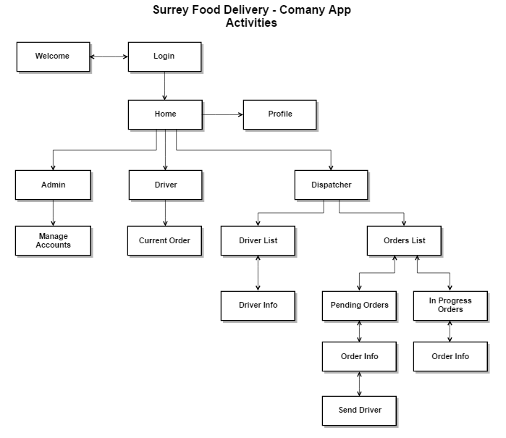

***12.2.2. Sample Workflow***

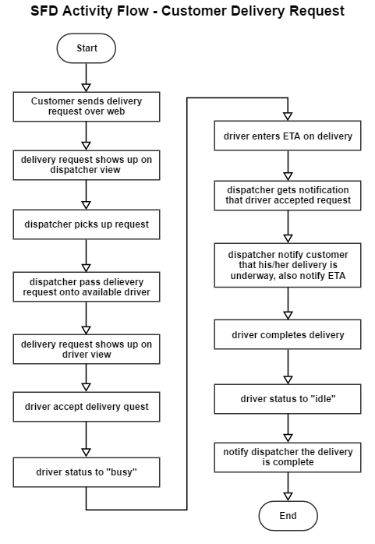

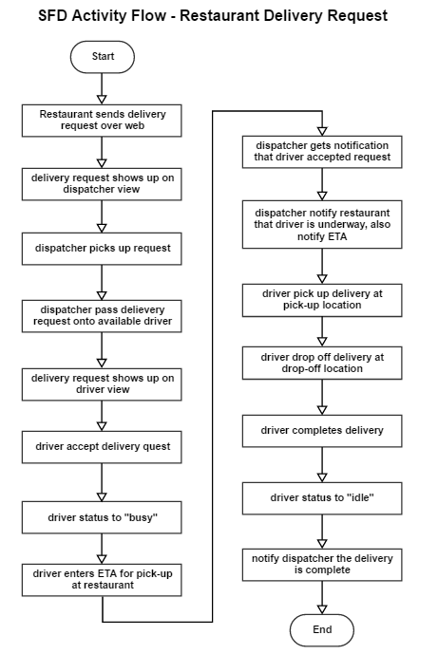

***12.2.3. Wireframes***

|  |  |  |
| --- | --- | --- |
| *Customer App*  *Welcome Page* | *Customer App*  *Login* | *Customer App*  *Register* |
| *Customer App*  *Guest View*  *New Order* | *Customer App*  *Customer View*  *New Order* | *Customer App*  *Restaurant View*  *Request Driver* |
| *Company App*  *Driver View*  *Idle* | *Company App*  *Driver View*  *Take Order* | *Company App*  *Driver View*  *Take Order (accept)* |
| *Company App*  *Driver View*  *Current Order* | *Company App*  *Driver View*  *Profile Page* | *Company App*  *Dispatcher View*  *In Progress Orders List* |
| *Company App*  *Dispatcher View*  *Select Pending Order* | *Company App*  *Dispatcher View*  *Select Driver* | *Company App*  *Dispatcher View*  *Drivers List* |
| *Company App*  *Dispatcher View*  *Pending Orders List* |  |  |

## High-Level Schedule

|  |  |
| --- | --- |
| **Stage** | **Schedule** |
| Week 1 - Planning | - Project and group selection  - Client and supervisor meetings  - Gather requirements and establish scope |
| Week 2 - Frontend | - Revise scope and mission.  - Finalize app design.  - Build frontend of app (both customer and company app).  - Learn Firebase real time database.  - Design backend database.  - Present frontend to client for revision |
| Week 3 - Backend | - Implement backend database.  - Integrate login & register functions into database.  - Present system iteration to client for revision. |
| Week 4 - Integration | - Integrate database into both app (customer and company).  - Test functionalities.  - Acceptance testing.  - Final changes and touch up.  - Project completion and delivery. |
| Week 5 - Presentation | - This week is dedicated to the practice and delivery of the presentation. |

## High-Level Work Breakdown

|  |  |  |
| --- | --- | --- |
| **Owner** | **Description** | **Completion Date** |
| Terence | communication between team, client and supervisor | N/A |
| Daniel | Documentations | N/A |
| Bill | Design | N/A |
| Kent | Problem solving, find out new technology | N/A |
| everyone | Wireframes for both app | Week 1  Saturday |
| Terence  Daniel  Kent  Bill | Scope and mission document - final version | Week 2  Wednesday |
| Daniel  Terence | frontend implementation | Week 2 |
| Daniel  Kent | Customer App UI | Week 2  Tuesday |
| Terence  Bill | Company App UI | Week 2  Thursday |
| everyone | Present frontend to client for revision | Week 2  Friday |
| everyone | Learn how to setup and use Firebase database. | Week 2  Sunday |
| Kent  Bill | backend implementation | Week 3 |
| Kent  Bill | Database design | Week 3  Monday |
| Kent  Bill | Database implementation | Week 3  Wednesday |
| Terence  Daniel | Integrate login & register functions into database | Week 3  Thursday |
| everyone | Present system iteration to client for revision | Week 3  Friday |
| Kent  Bill | Learn how Firebase real time database works | Week 3  Sunday |
| Terence  Daniel | Find out how to send notification to device when the database updates | Week 3  Sunday |
| Kent  Bill | Integrate database into both app (customer and company) | Week 4  Monday |
| Terence  Daniel | Integrate notifications into both app when database updates | Week 4  Wednesday |
| Kent  Bill | Acceptance testing | Week 4  Thursday |
| Terence  Daniel | Functionality testing | Week 4  Thursday |
| everyone | Build app apk  Handoff app to client | Week 4  Friday |
| everyone | Final presentation powerpoint slides | Week 4  Sunday |
| everyone | Final presentation practice | Week 5  Monday |

## 

## Risks and Issues

|  |  |  |
| --- | --- | --- |
| **Risk or Issue Description** | **Potential Impact** | **Mitigation/Resolution Steps** |
| Team is inexperienced with Firebase | May take up more time than expected to learn and use Firebase | Team will come together and start learning early |
| Project is extremely large with only 3 weeks | Project may not be completed on time | Project has been divided into multiple modules to be completed by other projects |
| Non-technical clients | Clients request functionality incorporated to the program which promotes high coupling | Persuade clients that certain functionality should not be included into the system |