Assessment |  |  | C-WT-AT2-POR-Phase-1 |  |  | Web Technologies Portfolio Phase 1
Lecturer name |  |  | Amir Khan Muhammad
Student name |  |  | Kent Novendio Simon
Student ID number |  |  | 20168585
Telephone contact number |  |  | Student to fill this section out
Email |  |  | Student to fill this section out
By completing and submitting this signed form to my lecturer, I am stating that:
- The attached submission is completely my own work
- I have correctly cited all sources of information used in this work (if required)
- I have kept a copy of this assessment (where practicable)
- I understand a copy of my assessment will be kept by the NMTAFE for their records
- I understand my assessment may be selected for use in the NMTAFE’s validation and audit process to ensure student assessment meets requirements
Student Signature |  | KENT NOVENDIO SIMON |  |  |  |  | Date | 23/07/2026
Assessors please note: Where verbal clarification has been sought from a student to gather additional assessment evidence from an assessment item, question/s and response/s must be recorded, signed, and dated by the assessor, against the relevant assessment item/s.
Assessment type ():
☐ | Questioning (Oral/Written) |  |  | ☐ | 3rd Party Report |  |  |  | ☒ | Practical Demonstration
☒ | Other – Project/Portfolio (please specify on the right):

Required Resources
The base requirements this assessment task, are listed below. They are listed as common (for both PC and Mac), and for the individual operating systems.

Common:
- Access to Office 365 & Microsoft Word
- VS Code
- Access to Figma.com for diagrams
- Access to TAFE Web Site Hosting (located on dev.ScreenCraft.net.au)
- WinSCP (PC) for deployment of site
- Git for version control, GitHub account for Portfolio work
- Web Browsers (Must have at least TWO different rendering engines)
  - Chromium based: Edge, Chrome,
  - Firefox
  - Opera
  - Safari
Use of some of these items may not be used in this part of the assessment task.

Instructions
- Complete each step of the document in the order given.
- Submission of the documentation, code, and associated items is at the end of each part of the portfolio.
- Provide evidence in the form of scanned documentation, completed assessment documents, screenshots, screencasts and other formats as required in this assessment.
- All GitHub work must be completed at the command line, except for starting the development environments.
- You will use the NMTAFE GitHub Classroom (or your own private one if specified by the lecturer)
- No external code frameworks are allowed unless specified in the assessment.

Scenario
- You are currently working as an intern for a small Perth-based start-up company called Incredibly Obvious Technologies.
- The company is challenging you to work on a project to assess your skills as you develop them.
- The project will build up in phases from the base content by adding semantic HTML, CSS & JS to provide layout and images to provided content.
- The final section of the project is to add a dashboard using the Tailwind framework to solve a specific problem.
- You will find the project specifications; an outline of the phases of development and other details are given below.
Site Structure Requirements
- Code must apply suitable code style detailed in Appendix A: Code Style Guidelines.
- All files must apply the naming conventions outlined in Appendix B: Naming Conventions.
- The project has a defined structure outlined in the Appendix C: Site Folder Structure.
- The primary page in each phase must be named index.html.
Answering Questions
- When a step includes a question, please answer it.
- Resize images to fit the space provided, ensuring they are still legible.
- All answers must be spelling & grammar checked
Add any code you’ve written in a separate file to your submission.
Code Storage
- We will be working exclusively in GitHub and you will be given a NMTAFE GIT repository, use this to store a copy of your work. Usage instructions are contained in the Repo README file
- If required by your lecturer, this assessment has instructions on setting up version control and a remote (private) repository. Do not initialise any version control until told to do so.
- Complete each step of the document in the order given.
- All GitHub work must be completed at the command line
Framework Requirements
No JS or CSS external frameworks are allowed in the portfolio excluding Phase 3 (final phase which only allows Tailwind).
This means that you may not employ frameworks such as Bootstrap, jQuery, Tailwind CSS unless specified by the lecturer.

Assessment Structure & Development Process
It is important that you do not start subsequent phases of the development process until the previous phase is completed and submitted.
The development phases include:
Phase 1
  - Clone your GitHub Staring repository
  - Create suitable semantic markup for the provided design concept and content.
  - Add a CSS Reset/Normaliser to the Web Page HTML in the correct location.
  - Create a CSS file for the site and link it to the page after the CSS Reset/Normaliser.
  - Add the required basic styling to create desired page layout.
  - Add the new content, imagery, and other media to the page.
  - Complete the styling of the page.
  - Seek clarification as required.
  - Deploy, Validate and Test your code.
Phase 2
  - Duplicate Phase-1 files into Phase-2 folder.
  - Create JavaScript solution for provided problem.
  - Display results in designated area on page.
  - Deploy, Validate and Test your code.
Phase 3
  - Implement Tailwind CSS into the provided site index page.
  - Provide one of the designated layouts for this page.
  - Ensure all other phases are correctly linked to this index page.
  - Deploy site to the NM Tafe ScreenCraft server using FTP transfer
  - Test code works as expected.
All Phases require you to deploy the solution to a provided web host and to demonstrate the solution to your lecturer. You may be asked to explain your code

Portfolio Specifications and Development Outline
The following are the specifications for the project you are undertaking as part of this portfolio of work.
Each part of the project corresponds to another part of the portfolio, with each part submitted according to provided deadlines.
- Phase 1:
  - Implement and test semantically and structurally correct HTML for the provided layout design and provided content.
  - Implement and test the required CSS to provide the layout as provided.
  - Add additional content and styling to amend the project to the given specifications.
- Phase 2:
  - Add and test a JavaScript solution for a predefined problem to the page.
- Phase 3:
  - Add a dashboard and implement the Tailwind CSS framework.
Each phase will be version controlled and uploaded to the ScreenCraft Development Server.

Wireframe Specifications
The wireframes below illustrate the desired layout of the site. Your semantic HTML should match the layout (NOTE: Images are required in Phase 1)
Basic Layout  The site will have a full width header and navigation, a main area that is approximately 960 pixels wide, and a full width footer.  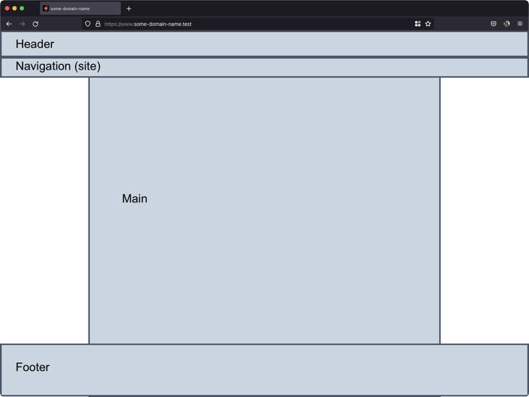 | Articles and Aside Concept  Please note that the articles should have two columns, but they may not have even lengths. This is a decision to be made by the developer.  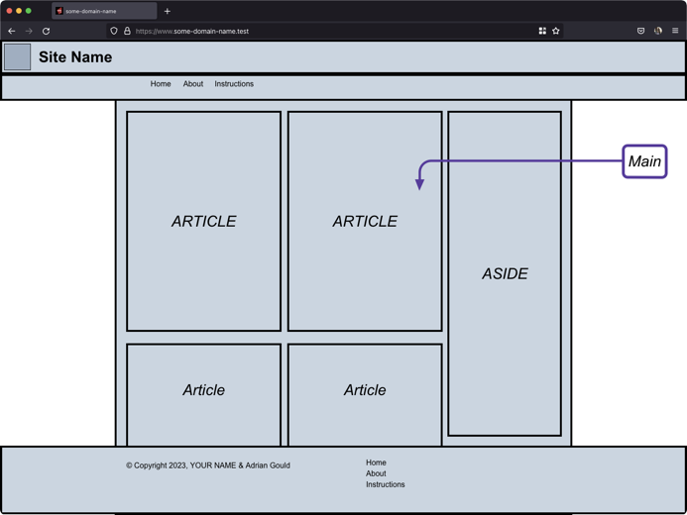
Article and Aside Layout  The article will have at least a header and section content. Footer may be omitted as required.  The section content may be used to split the article into subsections.  The aside is structured with multiple sections.  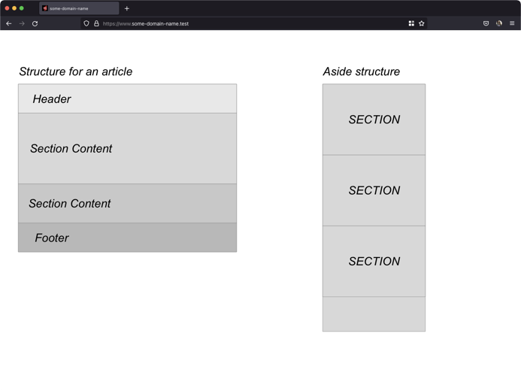 | Image Layout options  Images may have the caption over the top of the image at the bottom of the image space, or the image may occupy the top section of the area with its caption underneath the image.  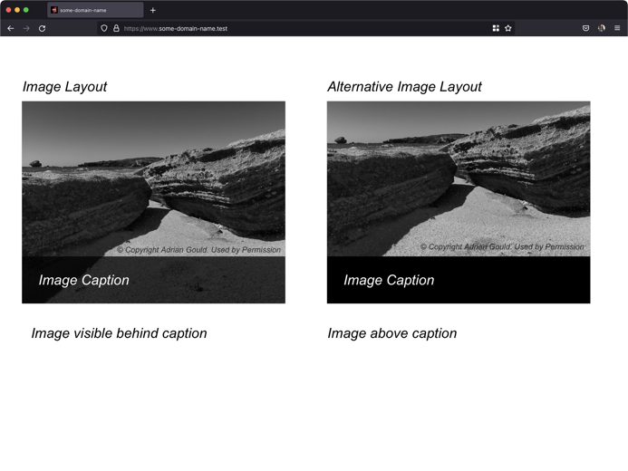

Aside Layout
The aside has multiple sections. One of the sections will have your name contained in a footer as shown. Others may or may not have a footer, but still must contain a heading.
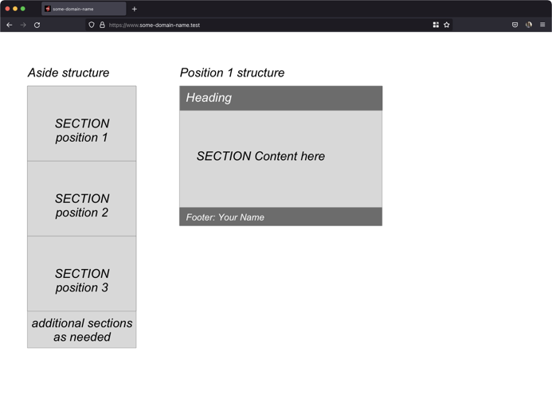

Assessment Steps
Complete the steps in the order given.
STEP | Task to perform
00 | Complete the Front Page & Review the Specifications  Make sure you have filled out the front page of this document.  Familiarise yourself with the content and document your progress in this assessment. This means, READ the WHOLE assessment AT LEAST ONCE before starting any work.  Make notes on the requirements of this assessment, as details appear as you progress through and are not given in one location.
Intentionally left blank

01 | Setting Up for Development  We recommend that all work for this and following portfolios are kept in:  - C:\Users\XXXXXXXX\Source\Repos  - ~/Source/Repos  PC (Using the Laragon terminal):  cd %USERPROFILE%  mkdir –p Source\Repos\WebTech  Mac:  cd ~  mkdir –p Source/Repos/WebTech  Then use the command:  cd Source/Repos/WebTech  All steps after this we will presume you will use this new folder as the starting point.  Create Project in IDE  As specified by your Lecturer to get the site folder structure and sample data. You will:  - clone the Classroom repo OR  - download & extract the provided compressed file  To your storage location, and rename the folder to:  C4Prog-WT-26S2-Portfolio-<YOUR NAME>  Update Git Ignore  You are provided with a predefined “.gitignore” file to reduce some aspects of version control, especially with files going to the remote.  You will want to add the “.idea”, “.idea/*” and “.idea/**” patterns to the ignore file.  Commit and Push Code  Using any suitable method, you will now create, commit, and push to a private repository:  - Initialise the whole local project as a git repository.  - Check all the content into the local repository.  - Create a PRIVATE remote repository using any appropriate method.  Push this starter code to the remote private repository.
A01 | What is the name and the URL of your GitHub repository?
  Repository Name: | C4Prog-WT-26S2-Portfolio--KENT-SIMON-
  URL: | https://github.com/KentSimon07/C4Prog-WT-26S2-Portfolio--KENT-SIMON-.git
02 | Create HTML for Page  - The content of the site is provided and is downloadable from the assessment page  - Use the Wireframes provided to determine your HTML structure for the page.  - Implement structurally and semantically sound HTML in a new HTML page in the phase-1 folder in the provided sample site structure.  - Add the new file(s) to your repository.  Commit and push your code start the commit message with  “feat: add HTML to …”  Please see Appendix E on how to create suitable commit messages.
03 | Validating the HTML  - Use the WC3 Validation engine to verify your HTML is valid.  - Copy the evidence for validity into the evidence folder inside phase-1.  - Screenshots of the final product for this phase will also be included as evidence in the above folder.  - Add the evidence folders to the “.gitignore” file in the repository.  - Once completed check in all your code to your local repository and push it to your remote.
A03 | Add a screenshot of the validation results for your code  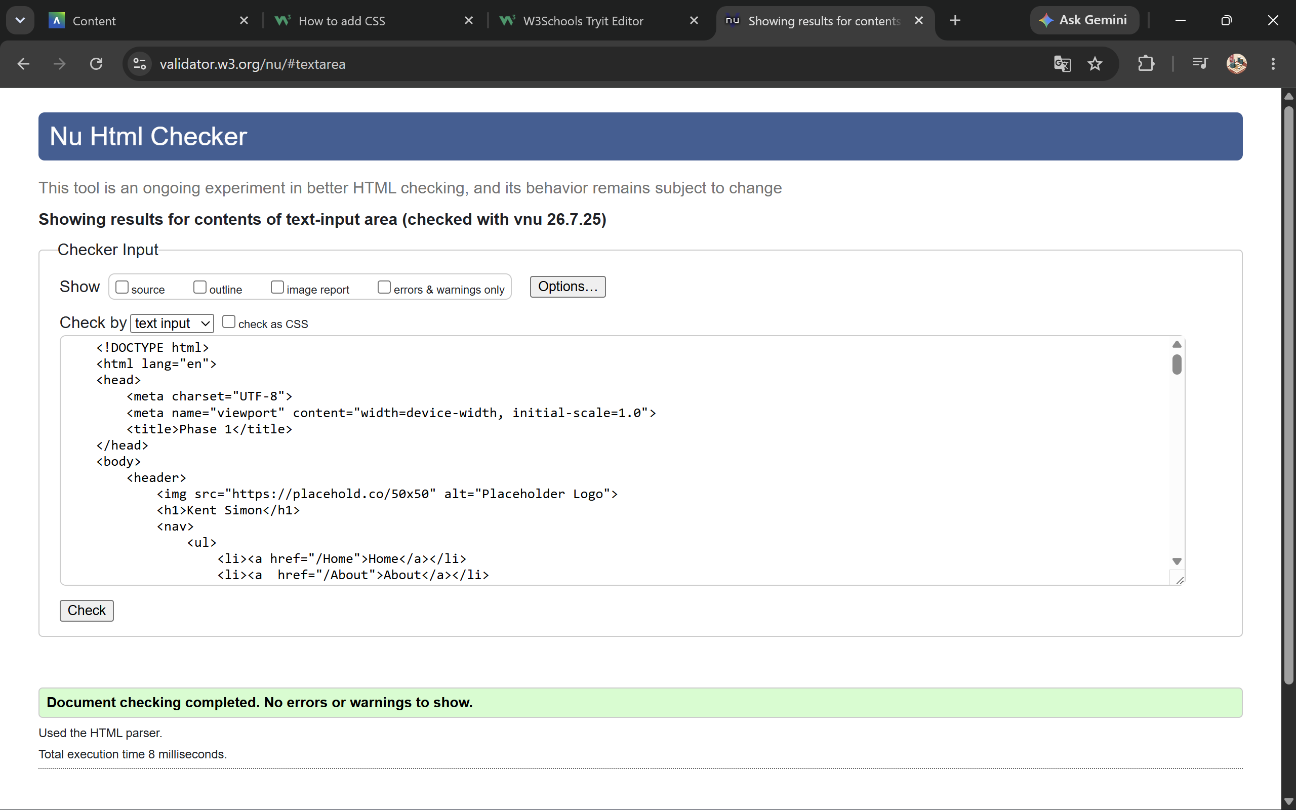
04 | Adding the Provided Content  Use the content provided in the phase-1.txt file to fill out the HTML page.  Verify the page still passes the validation.
A04 | Add a screenshot of the validation results for your updated code
05 | Testing the Web Page  During the previous steps, you have created and updated a single web page.  During this it is possible that you have been checking what it looked like on at least one web browser.  You are now to verify that the site works on at least two browsers that use different rendering engines.  Take a screenshot of the page in the two browsers.  Paste these into the two sections below.
A05.1 | Which browser is this screenshot from?  Microsoft Edge  Screenshot  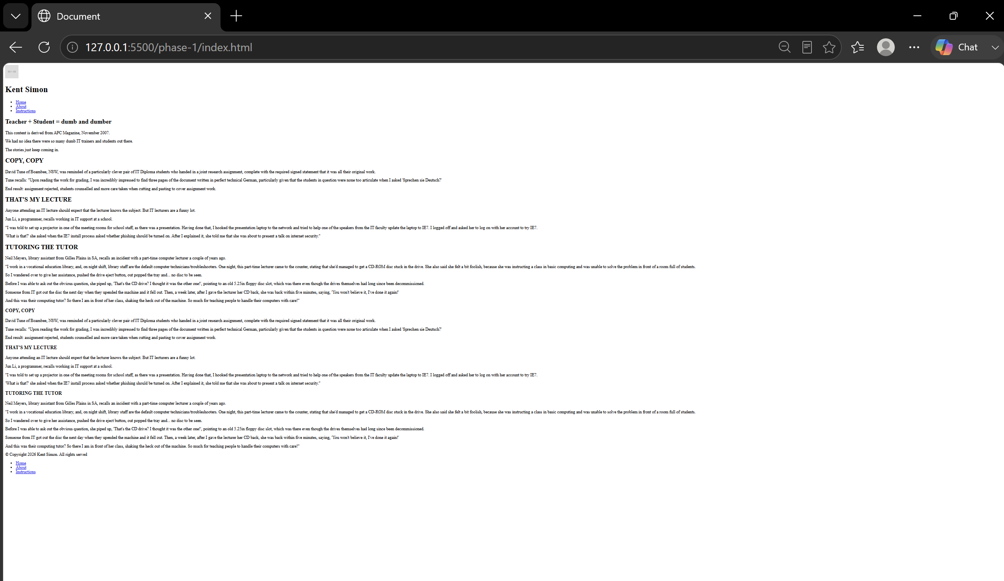
A05.2 | Which browser is this screenshot from?  Google Chrome  Screenshot  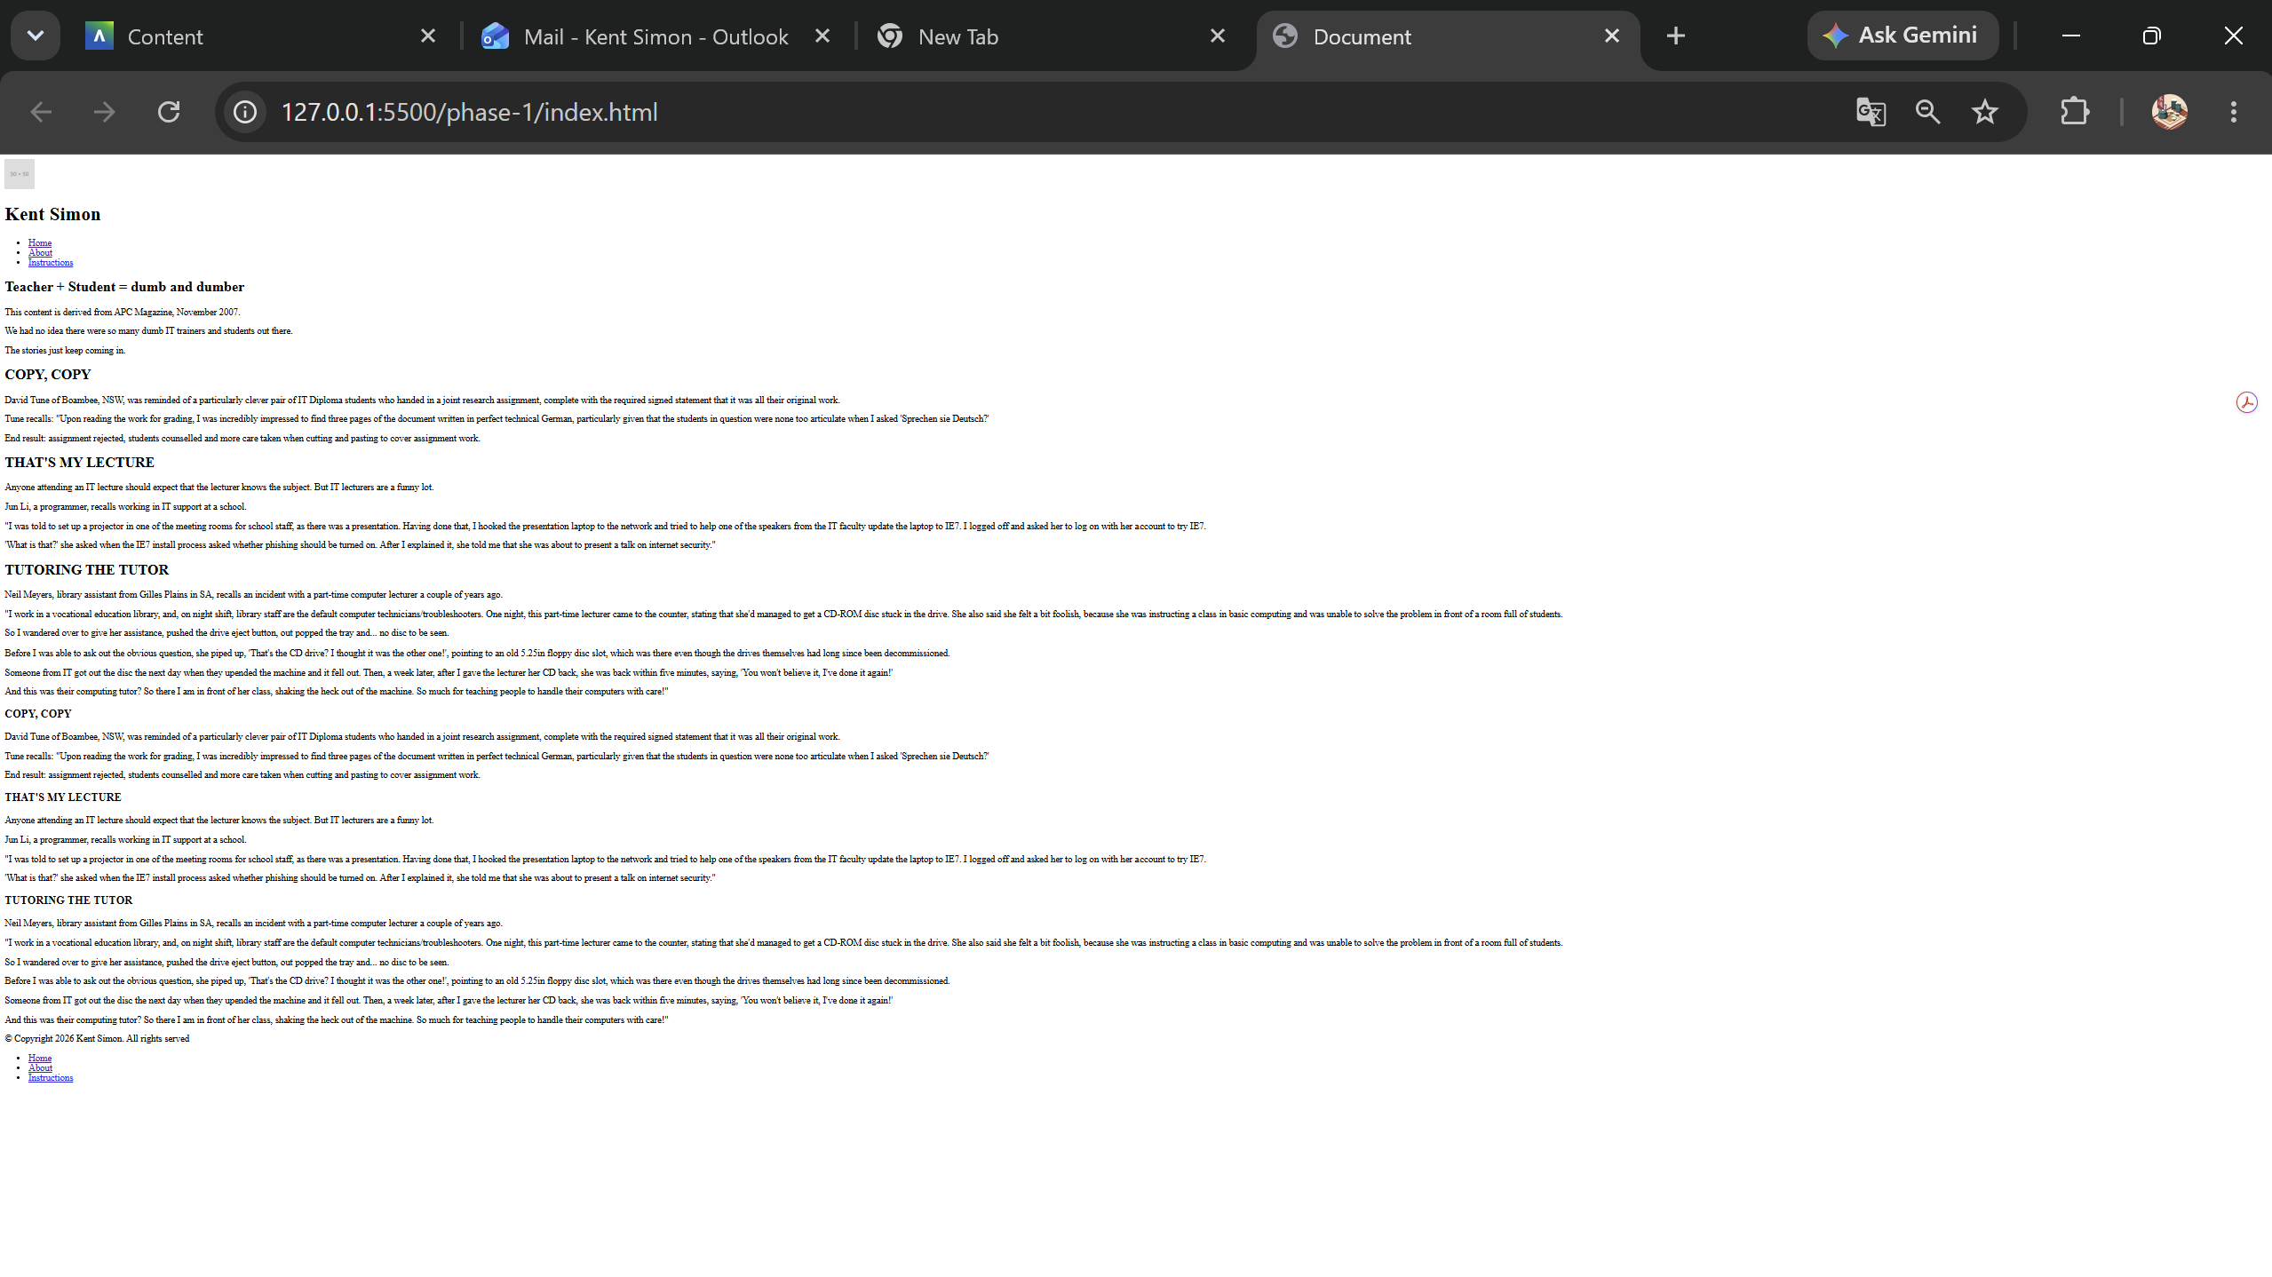
06 | Commit and push your code start the commit message with  “feat: add text to …”
A06 | What is the commit number & what commit message did you use?  505d0d1cfb4caa7556dc8551bf96719d916cf751  Feat: add text to index.html (phase-1)”  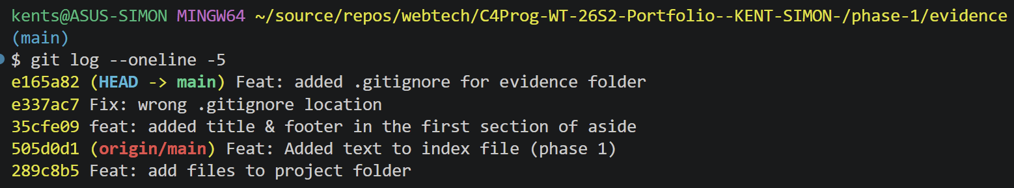
07 | Demonstrate to Assessor  Demonstrate to the assessor and obtain their feedback.  (Your lecturer may ask you to share your GitHub repository with them)
08 | Implement on the Page  Select one of these to use in your portfolio work.  We have provided the files in a separate compressed file (CSS-Resets.zip)  https://elad2412.github.io/the-new-css-reset/ (elad-reset.css)  https://meyerweb.com/eric/tools/css/reset/ (meyer-reset.css)  https://css-tricks.com/modern-normalize/ (modern-normalise.css)  https://csstools.github.io/sanitize.css/ (csstools-sanitise.css,  -typography.css, -forms.css)  https://necolas.github.io/normalize.css/ (necolas-normalise.css)  Once you have selected the CSS file, you should link to file that is contained in the root assets/css folder.  Add the changed/added files to version control.  Commit and push your code start the commit message with  “feat: add CSS to …”
A08 | Which of the CSS Reset/Normalise files did you select and why?  I chose sanitize.css because it provides consistent, cross-browser default styling alongside useful, clearly documented opinionated defaults, it's developed alongside normalize.css, so it includes every core normalization while clearly separating out browser-bug fixes from opinionated choices. This suited my project specifically because my HTML uses only semantic elements (header, nav, article, aside, footer).  What is the HTML you created to include the CSS file?  <head>  <meta charset="UTF-8">  <meta name="viewport" content="width=device-width, initial-scale=1.0">  <link rel="stylesheet" href="../assets/css/csstools-sanitize.css">  <title>Phase 1</title>  </head>  What is the Commit message you used?  “feat: add CSS to index.html phase 1”
09 | Implement CSS to create the required Base Mobile Layout.  - You will implement a mobile-first layout.  - Create the header, main area and footer.  - The Aside and Navigation areas from the desktop layout will be hidden.  - The Navigation will be shown when the “hamburger menu” is clicked.  - The hamburger menu does not need to function at this stage  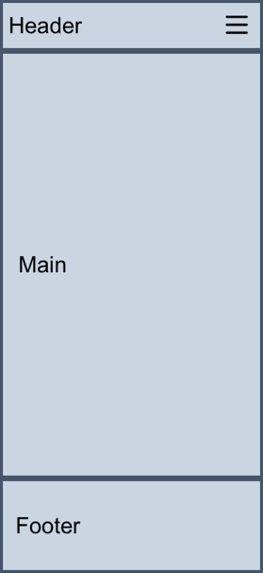  Implementing steps  You must implement the layout in the following order, with EVERY step being committed to version control using Semantic Commit Messages:  - Header  - Main  - Footer.  Remember: Navigation and Asides are to be hidden in the mobile view.  Commit and push your code start the commit message with:  - feat: site mobile header – add CSS to lay the site header
10 | Implement CSS to Implement the Mobile Article Layout  In this stage you will now add the Articles to the Mobile layout.  The layout is as shown below.  One important item is that the Footer will be fixed to the bottom of the articles (as in after all the articles are shown), the Header will stay in place.  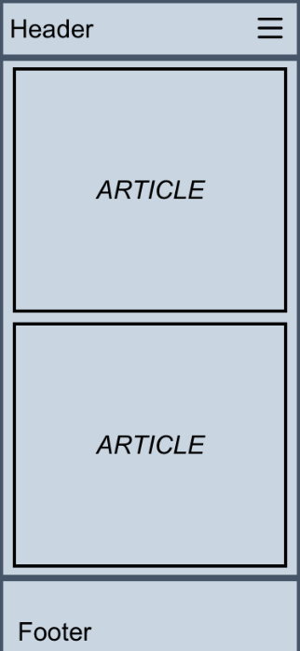  Implementing steps  You must implement the layout in the following order, with EVERY step being committed to version control using Semantic Commit Messages:  - Article(s)  Commit and push your code start the commit message with:  - feat: mobile article – add CSS for articles for mobile design
11 | Implement CSS to create the Base Desktop Layout.  The layout we present in the image below is for a desktop browser and is to be used as the layout for this type of device.  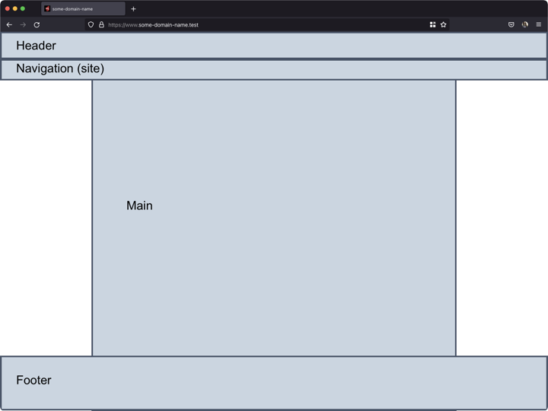  Implementing steps  You must implement the layout in the following order, with EVERY step being committed to version control using Semantic Commit Messages:  - Header  - Navigation  - Main  - Footer  Commit and push your code start the commit message with:  - feat: desktop base header – add CSS to lay the site header
12 | Implement CSS to Implement the Desktop Article Layout.  Now add the Articles to the Desktop layout.  As with the mobile layout, the Footer will be fixed to the bottom of the articles (as in after all the articles are shown).  The header and navigation, in the desktop layout will be fixed to the top of the screen and the content will slide behind them.  You may layout the desktop version in any form, the only requirement is that the aside MUST be on the right.  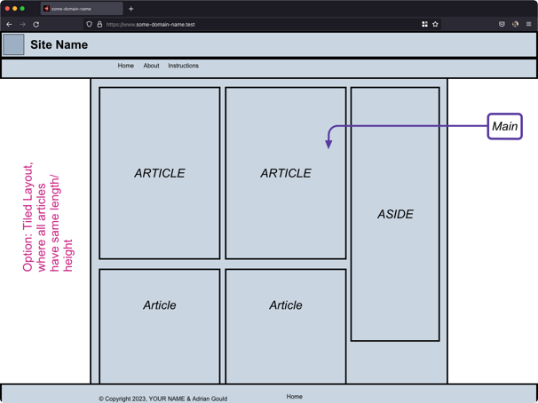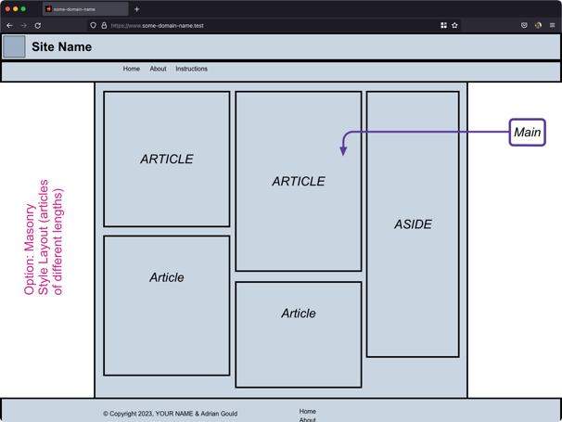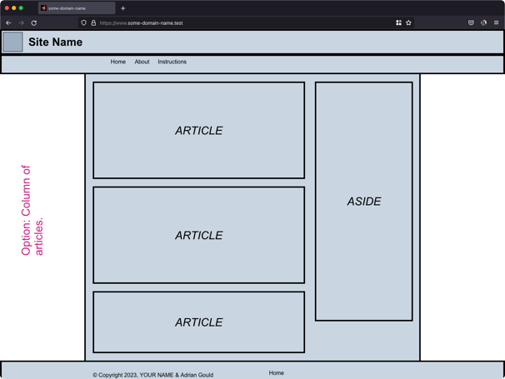  Create the layout above with EVERY step being committed to version control using Semantic Commit Messages:  Commit and push your code start the commit message with:  - feat: desktop article – add CSS for desktop design
13 | Implement CSS for Aside Design  In this stage you will now add the Aside to the DESKTOP layout.  The layout is as shown below.  The aside is ONLY visible for the Desktop layout.  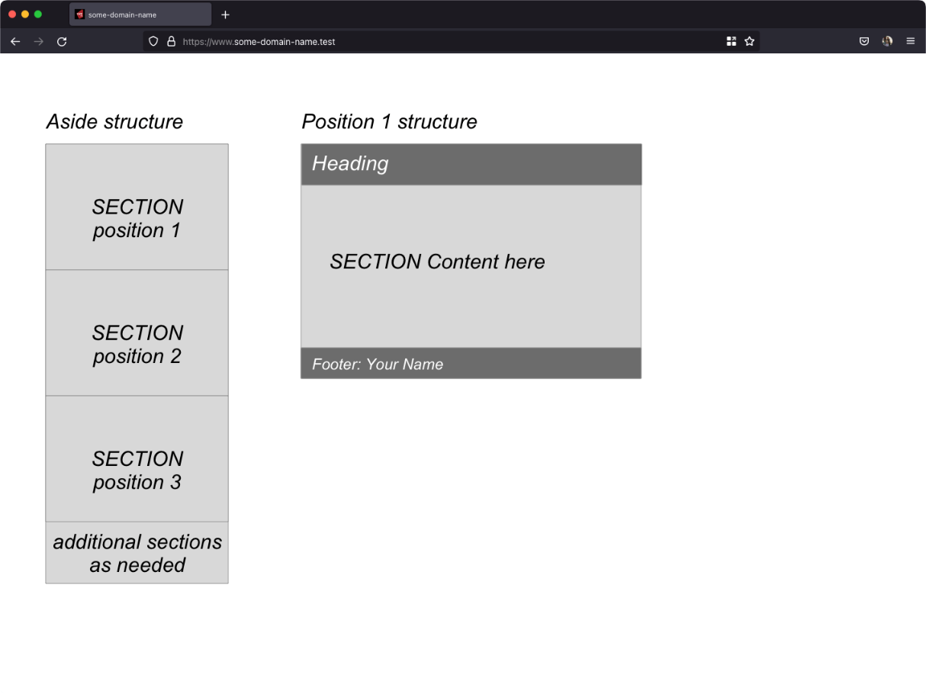  You must implement the layout above with EVERY step being committed to version control using Semantic Commit Messages:  Commit and push your code start the commit message with:  feat: desktop aside – add CSS for aside design
14 | Identify CSS3 Techniques/Features  During your development you will have used different CSS3 techniques to lay out the content of the site.  Identify FOUR techniques and/or features that you employed in styling the site layout.  Why did you use these techniques and/or features?  Add your answers to the answer section A14.  Important:  The articles may be presented as the same size or like masonry work, with different heights depending on the content.  This portfolio stage is about reproducing a layout, complete with the site header, navigation and footer area positions.  The main area should be between 70 – 90% of the width of the screen.  Have a look at Appendix D: Sample Wireframes
A14 | What 4 CSS features did you use in your code to create your layout?  Identify four key items and give one to two sentences to explain why you chose each one.  The key features that I selected and used were:  - CSS Grid  - Flexbox  - Media queries  - Sticky positioning
15 | Validating the CSS  Use the WC3 Validation engine to verify your CSS is valid.  Copy the evidence for validity into the evidence  Add the evidence folders to the “.gitignore” file in the repository.  Commit and push your code start the commit message with:  feat: implement layout for…
A15 | Add one or more screenshots of the validation results for your CSS code.  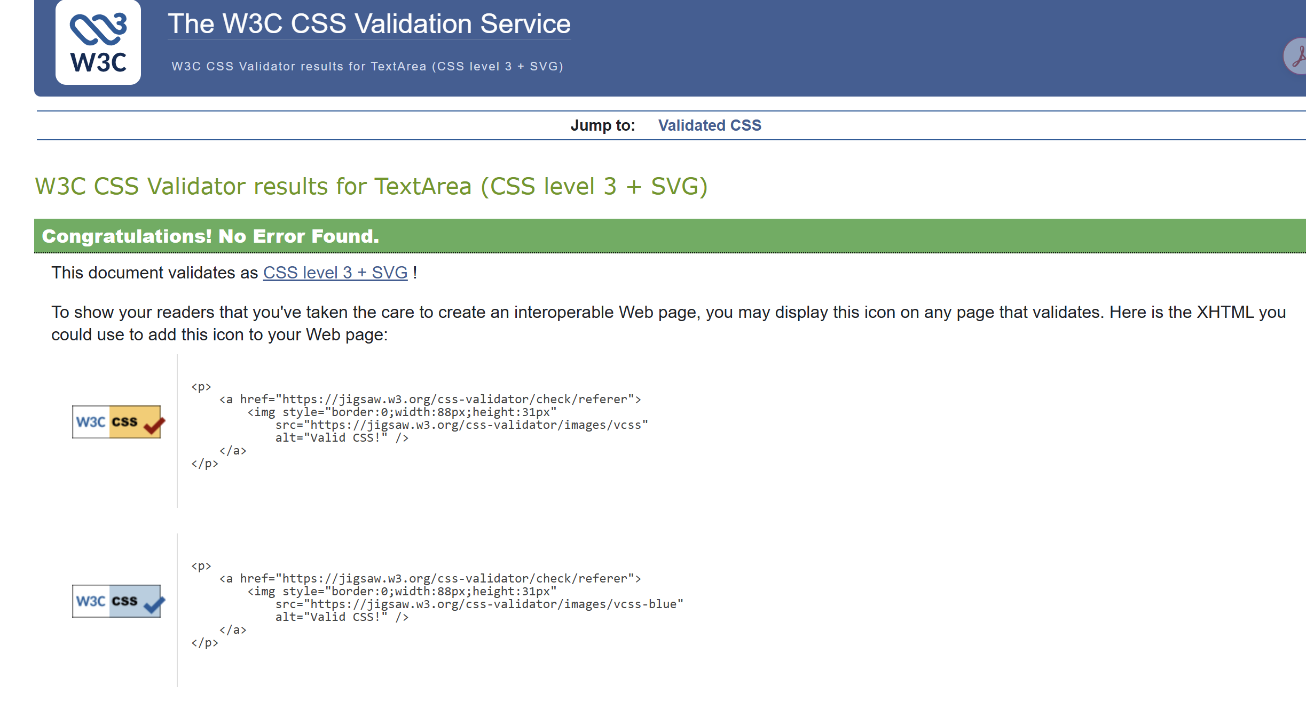
16 | Demonstrate to Assessor  Demonstrate to the assessor and obtain their feedback.  Update your work as required based on their feedback, ensuring all changes are noted as semantic commits using the “fix:…” tag at the start.
17 | Determine your Site Colour Scheme  Determine your colours for the site.  You are allowed up to 4 additional colours besides #000000, and #ffffff.  You may use a web application such as the ones listed below to create tints and shades of the 4 base colours you have selected.  Colour, Tint & Shade Schemer Apps  - https://coolors.co/  - https://uicolors.app/create  - https://www.tailwindshades.com/  - https://colorswall.com/  Add the changed/added files to version control.  - Add the colours to the table on the next page.  - Apply the 4 colours to your site using your own design  Commit and push your code start the commit message with:  feat: add colour scheme for site
A17 | What are your selected colours?  Provide the RGB and HEX versions of the colours.  Tab between cells, and tab on last cell to add new row.  Use the fill tool to colour final column.
  Name for Colour | RGB (rrr, ggg, bbb) | HEX (#rrggbb) | Sample
  Dark brown | 62, 50, 40 | #3E3228
  white | 255, 255, 255 | #ffffff
  black | 0, 0, 0 | #000000
  sand | 227, 213, 191 | #E3D5BF
  beige | 245, 245, 220 | #F5F5DC
  burlywood | 222, 184, 135 | #DEB887
18 | Locate and Select Appropriate Images  - You are required to locate FOUR images for the site to match the following basic requirements:  - a HTML/CSS or JavaScript Joke  - a joke about user error  - a photo to illustrate one of the stories on the site  - a joke about programming  All images MUST BE TAFE appropriate and suitable for GENERAL VIEWING.  - download a copy of each image and add to the assets/images folder in the portfolio file structure.  - add the following details for each image in the tables on the next page.  - Image File Name  - Photographer / Originator of Image  - URL of the page that the image is from  - Date retrieved  - A sample of the image  Commit and push your code start the commit message with:  - feat: identify and select images for site
A18 | Image Sources  Replace the text in each cell with the details indicated. We provide an example for your guidance.  Example:
   | ilya-pavlov-OqtafYT5kTw-unsplash.jpg
   | Unsplash - Ilya Pavlov
   | https://unsplash.com/photos/OqtafYT5kTw
   | 28 August 2025
  Sample | File Name
  Sample | Photographer / Image Origin
  Sample | Web Page URL
  Sample | Date Retrieved
  Sample | File Name
  Sample | Photographer / Image Origin
  Sample | Web Page URL
  Sample | Date Retrieved
  Sample | File Name
  Sample | Photographer / Image Origin
  Sample | Web Page URL
  Sample | Date Retrieved
  Sample | File Name
  Sample | Photographer / Image Origin
  Sample | Web Page URL
  Sample | Date Retrieved
19 | Validating the HTML  Use the WC3 Validation engine to verify your HTML is valid.  Copy the evidence for validity into the evidence folder inside phase-1.  Screenshots of the final product for this phase will also be included as evidence in the above folder.  Add the evidence folders to the “.gitignore” file in the repository.  Once completed check in all your code to your local repository and push it to your remote.
A19 | Add one or more screenshots of the validation results for your HTML code.
20 | Testing the Web Page  Verify that the site works on at least two browsers that use different rendering engines.  Take a screenshot of the page in the two browsers.  Use the WC3 Validation engine to verify your CSS is valid.  Paste these into the three sections below.
A20.1 | Which browser is this screenshot from?  Screenshot:
A20.2 | Which browser is this screenshot from?  Screenshot:
A20.3 | Add one or more screenshots of the validation results for your CSS code.  Screenshot:
21 | Demonstrate to Assessor  Demonstrate to the assessor and obtain their feedback.  Update your work as required based on their feedback, ensuring all changes are notes as semantic commits using the “fix:…” tag at the start.  Prepare for phase 2 of the site development.
END | Submission of Portfolio Work  To submit the portfolio, do the following:  - Save this document with your answers.  - Compress the portfolio folder including all your code  - Open Blackboard, locate and open the Phase 1 assessment  - Upload this completed assessment document.  - Upload the Word Document  - Upload the compressed site files.  - Click submit.

Appendix A: Code Style Guidelines
The following guidelines should be applied to your code as it is developed.

HTML/CSS Code
Please refer to the Google Style guide:
- https://google.github.io/styleguide/htmlcssguide.html
Note that VS Code will format code to their own standard, which is acceptable.

JavaScript
Refer to the Google JS Style guide:
- https://google.github.io/styleguide/jsguide.html
Note that VS Code will format code to their own standard, which is acceptable.

Appendix B: Naming Conventions

HTML, CSS and JS Files and folders
- No spaces.
- Alpha-numeric characters only except minus/hyphen (-) and full stop (.).
- All lowercase letters.
- Use hyphens (dash) between words.

File extensions
The following file extensions must be used:
HTML pages | .html
JS | .js
CSS | .css
JSON | .json
Node | .js

Appendix C: Site Folder Structure
The diagram below outlines a folder structure for the portfolio from Phase 1 to Phase 3:

Appendix D: Sample WIREFRAMES
These layouts provide the options you will use in your work.
A basic Mobile First layout (Mobile Phone) and a basic Desktop (1024px wide screen) layout is provided, with options for various components of the page.
Each page has:
- Header
- Navigation
- Main
- Footer

Basic Layouts for Desktop and Mobile
Desktop Layout on Right, Mobile on Left
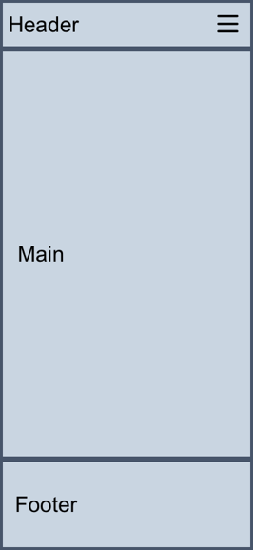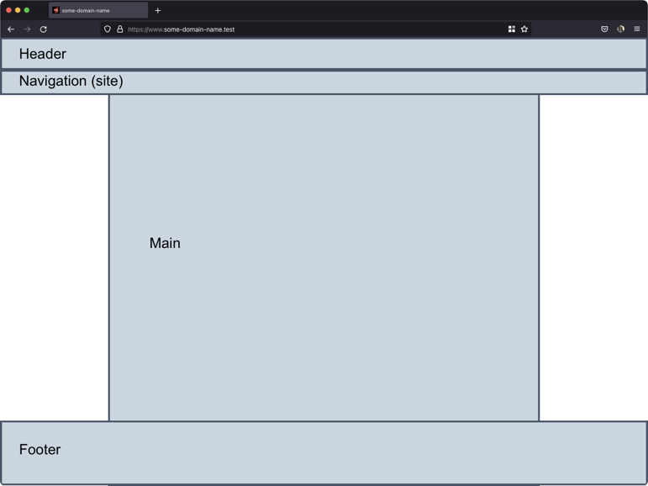

Basic Layouts with Articles for Mobile and Desktop
Desktop Layout on Right (3 options), Mobile on Left
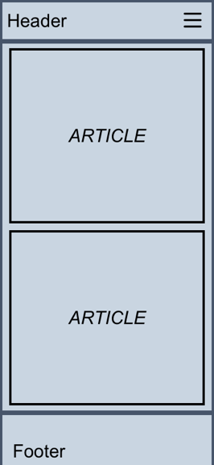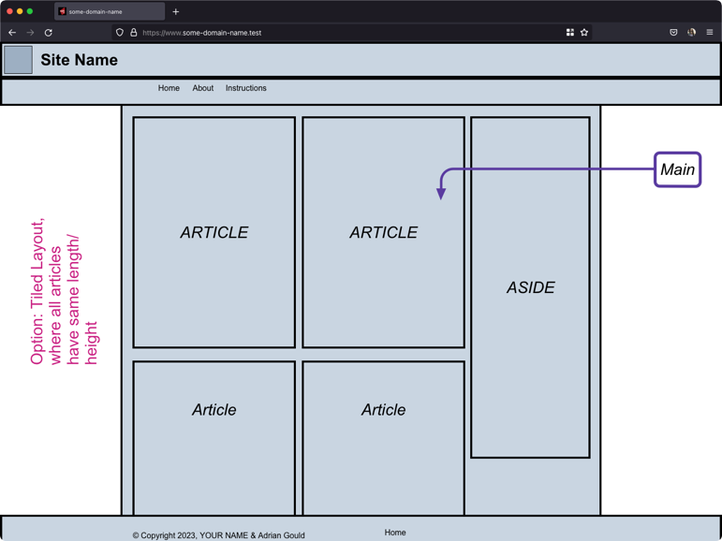
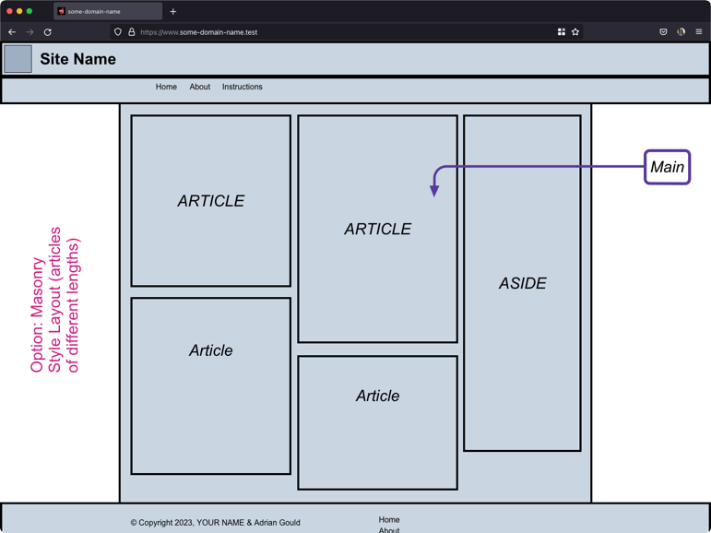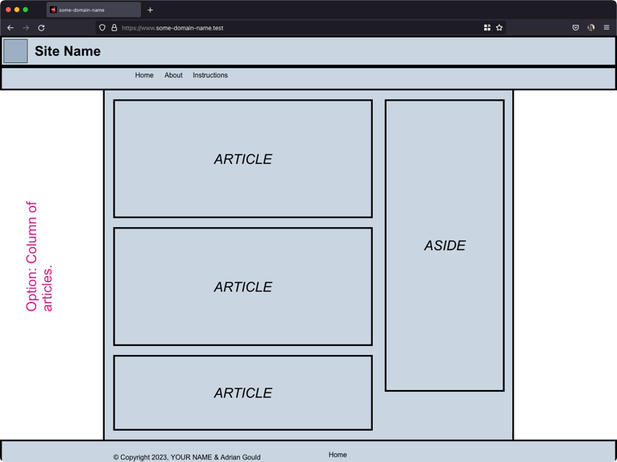

Header & Navigation Layout Options
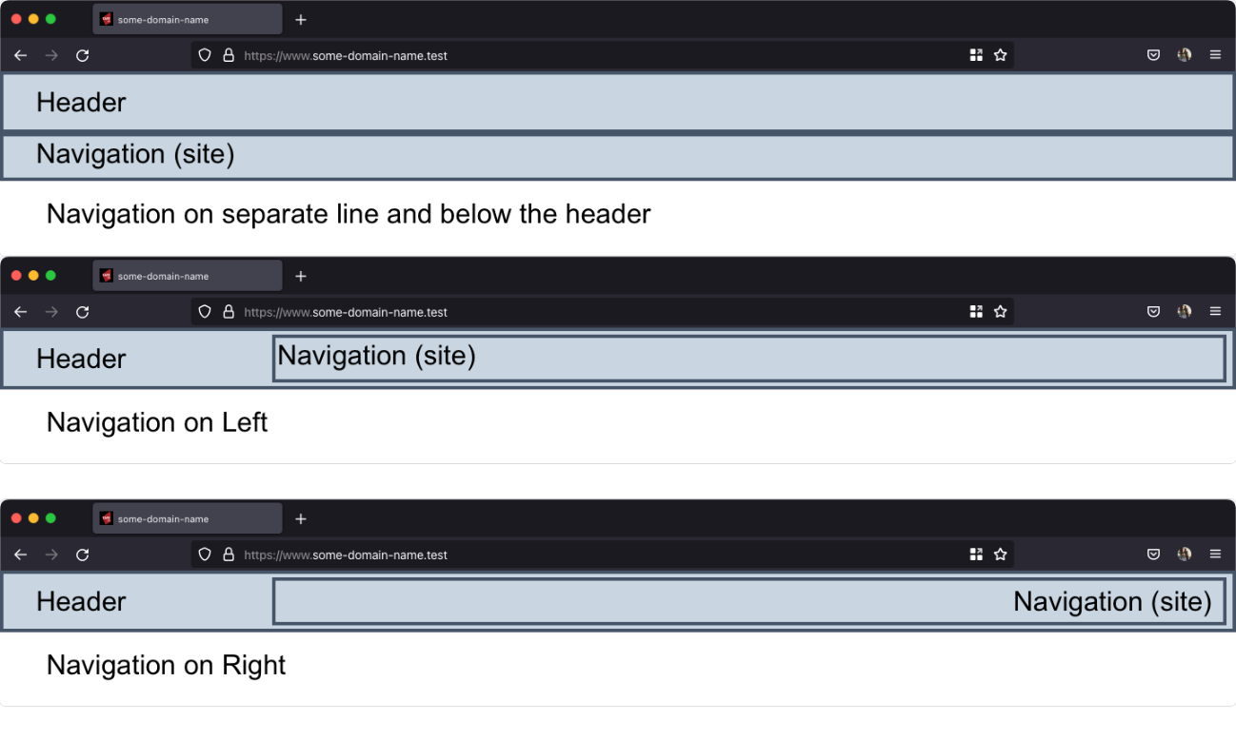

Footer Layout Options (Desktop and Mobile)
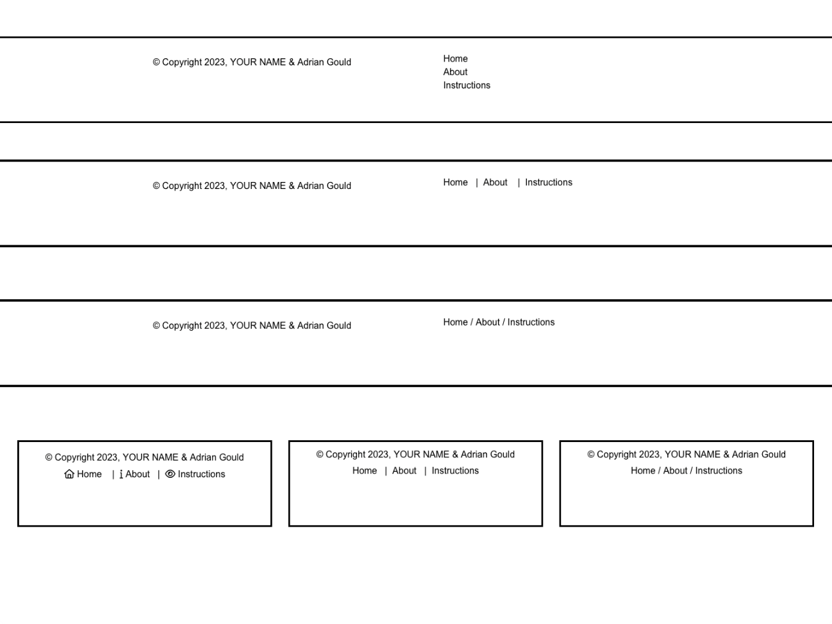

Article Layouts & Aside Layout
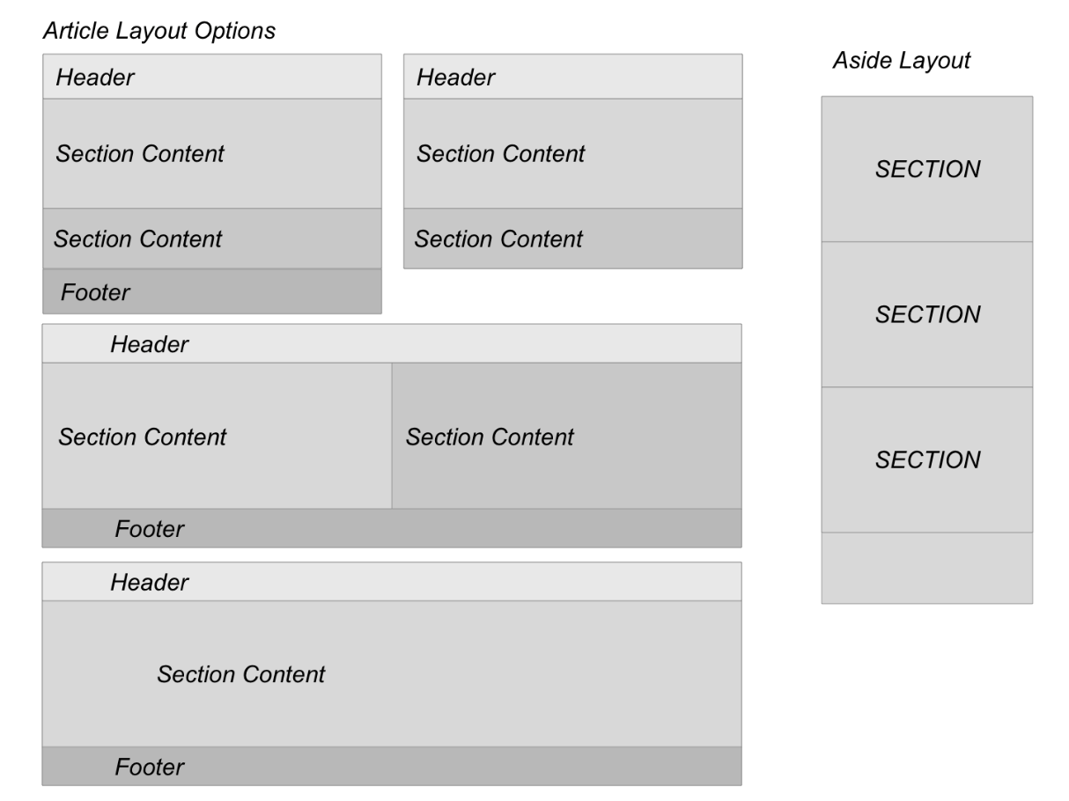

Image Layout
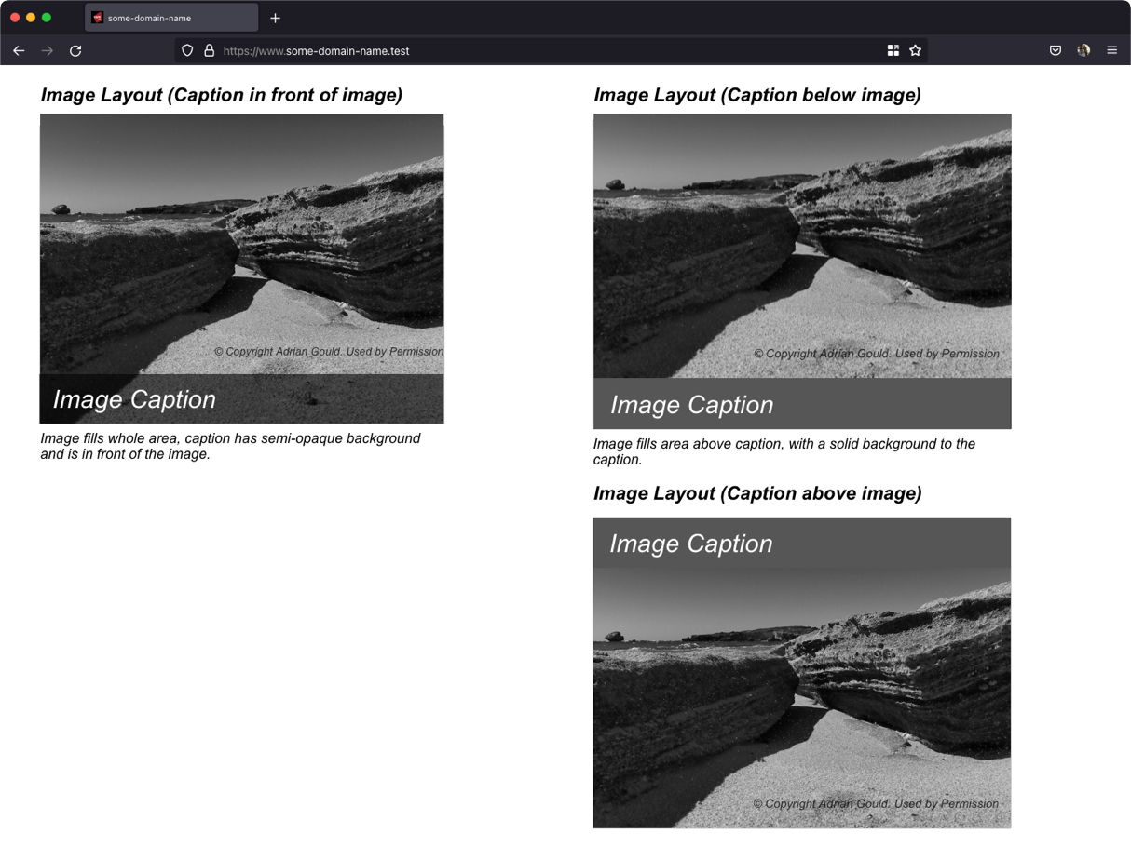

Aside Section Layout

Aside Content Layout

Appendix E: Conventional Commit Messages
Conventional Commit Messages, or Semantic Commit Messages, are a way to improve your commit messages and how you document what work has been completed.
See how a minor change to your commit message style can make you a better programmer.
The format of a SCM is:
<type>(<scope>): <subject>
Where the <scope> is optional

Example
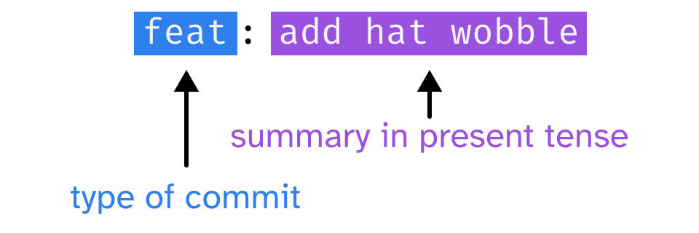

Types of Commit
- feat: (new feature for the user, not a new feature for build script)
- fix: (bug fix for the user, not a fix to a build script)
- docs: (changes to the documentation)
- style: (formatting, missing semi-colons, etc; no production code change)
- refactor: (refactoring production code, e.g. renaming a variable)
- test: (adding missing tests, refactoring tests; no production code change)
- chore: (updating grunt tasks etc; no production code change)

