**MODULE II**

**LESSON 1: DEFINITION, CHARACTERISTICS, TYPES, AND CLASSIFICATION OF FOLK DANCES**

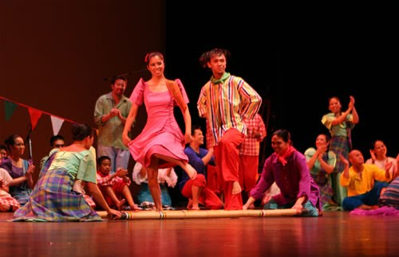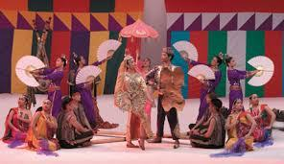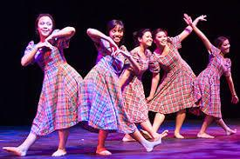

This lesson aims to discuss the learning expectations and its importance in the teaching-learning process with an expectation that the students are able to:

1. Identify the distinct characteristics of folk dancing;

2. Distinguish the types and significance of folk dances in relation to physical fitness domains; and

3. Value the richness of Filipino culture through shared customs, beliefs and traditions.

**Introduction to Philippine Folk Dances**

Folk dances are traditionally a dance of a country which evolved naturally and spontaneously in connection with the everyday activities and experiences of the people.

These are traditional dances handed down from generation to generation that describe the traditions, beliefs, occupations, and ways of life and characteristics of people living in a certain nation expressed through body movements.

**Values Derived from Studying Philippine Folk Dances**

Philippine folk dances mirror the culture of Filipino ancestors. Studying Philippine folk dances is likewise, studying the Filipino heritage. In this manner, students realize the significance of Philippine Folk Dance in various ways:

1. Strengthen patriotism and nationalism.

2. Appreciate the aesthetic value of Philippine folk dances.

3. Preserve the Filipino heritage through folk dancing.

4. Promote the Filipino culture through folk dancing.

5. Gain healthy posture through graceful and rhythmic coordination

6. Provide a healthy form of relaxation and recreation.

**Brief History of the Philippine Folk Dances**

When the Philippines was discovered by Ferdinand Magellan in 1521, it got inhabited by different racial groups: the Indonesians, Malays and Pygmies. The offspring of the Pygmies were the Negritos whose dances describe their daily activities like the Sinulog, a dual dance where two men use bolos.

For centuries, dancing and singing have been the principal past time of the people. The early filipinos considered dancing as a religious activity. They performed dances in thanksgiving for a fruitful harvest, a victorious battle and prosperous voyage or recovery from sickness.

During the Spanish period, dancing played an important part in the social activities of the filipinos. Kumintang, a pantomimed song and dance was the oldest recorded activity among the Christianized filipinos. The Spaniards introduced different dances such as Fandangos, Lanceros Rigodon, Carinosa and Curacha. Western cultures and dances of other European countries during 16th century were also introduced, absorbed and blended in 'in' our native culture which later became our traditional folk dances.

Nowadays, folk dancing is increasing in popularity. There are numerous fascinating Philippine dances which have already been documented and performed got only in schools but also by various dance groups, both by amateurs and professionals.

The University of the Philippines' Folk Song and Dances paved the way of the birth of Philippine dances and dance troupes well organized by Mrs. Tolentino. The UP Folk Song. and dances have performed and showed their prowess in several towns and provinces nearby Manila.

Furthermore, the Bayanihan, Filipinescas, Filipiniana, and others like the Barangay, Ramon Obusan Folkloric Dance troupes have performed outside the country, and their success obtained admiration and appreciation of Filipino culture by the foreigners. Thus, they have brought pride and prestige to the country.

***Characteristics of Philippines folk Dance***

1. As a rule, Philippine folk dances begin and end with a saludo.
2. In general, dancers are far apart. A distance of about 8-6ft. from each other is normal.
3. There is very little, if any, body contact although holding hands is common.
4. Most of the dances are done in pairs and hand movements play a very important role.
5. Many of our dances are done in long formation.
6. Our dances are performed by both young and old, and by both sexes.

***Classification* of Philippine Folk Dances**

Folk dancing is a very wholesome form of recreation that we jan enjoy. Significantly, part of the rich Filipino culture and arts is folk dance. There are several dances for all occasions, ie. wedding, occupation, festival, war and victory.

Francisca Reyes Aquino, the Philippines national artist and Mother of Philippine Folk Dances started the collection of dances and songs as early as 1924. She authored six (6) volumes of books in different Philippine Folk Dances and many other unpublished books. These dances have been categorized into non-Christian or their ethnic dances and Christian dances. The ethnic dances are described as the highest form of art of the Filipino dances because of their innate, unique and beautiful movements. The Christian dances mostly adopted the Spanish and other European influences, and mixed the native Filipino culture. These Christian dances include Jotas, Pandanggo, and Habaneras.

Most provinces in the Philippines have their own identifying folk dances wherein they showcase the elegance and beauty of the way they do things, the way they dress, the way they see things as shown in     different paintings, as they have been influenced by various events as that happened in history. There are five types of folk dances in the Philippines. Namely: [Maria Clara Dance](https://sites.google.com/site/folkdancesofthephilippines/philippine-folk-dance/maria-clara-dance), [Cordillera Dance](https://sites.google.com/site/folkdancesofthephilippines/philippine-folk-dance/cordillera-dance), [Muslim Dance](https://sites.google.com/site/folkdancesofthephilippines/philippine-folk-dance/muslim-dance), [Rural Dance](https://sites.google.com/site/folkdancesofthephilippines/philippine-folk-dance/rural-dance), and [Tribal Dance](https://sites.google.com/site/folkdancesofthephilippines/philippine-folk-dance/tribal-dance)**.**

1. A picture containing person, indoor, dancer, sport

   Description automatically generated**Maria Clara Dance**

Origin: Luzon and Visayas

Description: Named after the chief female character of Jose Rizal's Noli Me Tangere; Spanish influenced "Filipinized" by the use of bamboo castanets and abanico.

Examples: La Jota, Paseo de Iloilo

1. **Rural Dance**

Origin: Luzon

Description: Dances illustrate the fiesta spirit and love of life; best known type of Filipino dance. dance attire: girls - colorful balintawak and patadyong skirts, boys: camisa de chino and colored trousers.

Examples: Binasuan, Tinikling

1. **A picture containing text, dancer

   Description automatically generatedMuslim Dance**

Origin: Southern Mindanao

Description: characterized by vivid colors and rhythmic movements which reflect the influence of Arabian and Indo-Malaysian cultures.

Examples: Singkil, Vinta

1. **A group of people dancing

   Description automatically generated with low confidenceTribal Dance**

Origin: Mindanao

Description: Tribal dances performed essential "for the gods" ceremonial and ritual type dances.

Examples: Udol, Mandaya

1. **Cordillera Dance**

Origin: Northern Luzon

Description: dances to celebrate victories, festivals, religious rituals, thanksgiving, etc; musical instruments include nose flute, bamboo guitar, drums, gongs and wooden sticks.

Examples:Uya-uy

**Western Influenced Dances**

When the Spaniards came to the Philippines in the 16th century, they brought with them the Spanish religion and European arts and culture. The native religion and culture slowly gave way to Christianity and Western civilization. The natives started to lose most of their ancient traditions in the literary, visual, and performing arts. In no time, dances from Spain, France, and other European countries, such as the jota, pandanggo, habanera, and quadrille dances were adopted and adapted to the tastes and needs of a colonial society and the conditions of a tropical archipelago.

**Examples of Dances with Western Influenced**

1. **Quadrille Dances**

**Example: Rigodon de Honor**

**Description:** A quadrille dance commonly performed in formal gatherings in a quadrille formation.

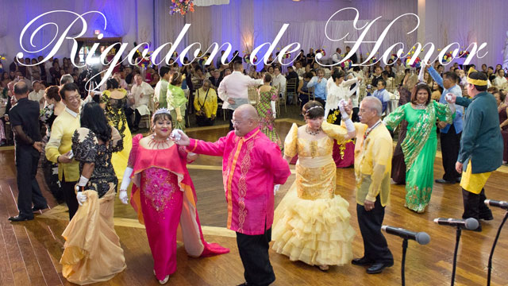

1. **Jota**

**Example: Jota de Manila**

**Description:** Manila’s version of the famous Jota with its typical Spanish stampas, cobradas and clicking of bamboo castanets bearing Hispanic culture.

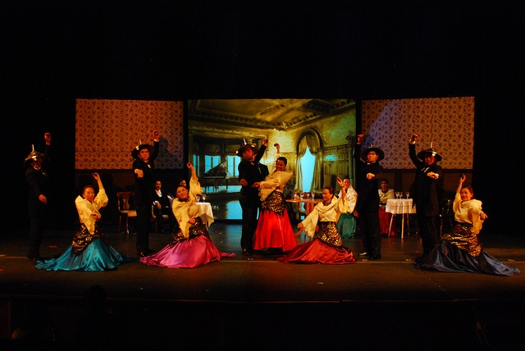

1. 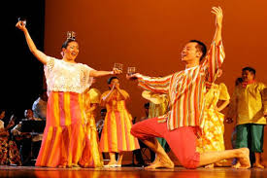**Pandanggo (Fandanggo)**

**Example: Pandanggo sa Ilaw**

**Description:** A dance from Mindoro using tinghoy or oil lamps placed on the top of the head and one on each hand.

1. **Habanera**

**Example: Habanera Botolena**

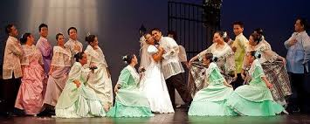**Description:** A dance which was supposedly performed in the earlier days in honor of a departing priest. Later on it became a dance performed during social gatherings in Botolan, Zambales.

**Descriptions**

1. Occupational Dances – depicting action of certain occupation, industry, or human labor. Examples: Planting, harvesting, pounding, etc.
2. Religious or Ceremonial Dances – performed in connection with religious vows and ceremonies. Examples: Putong, Sta. Clarang Pinung-Pino
3. Comic Dances – depicting funny movements for entertainment. Examples: Kinoton
4. Game Dances – done with play elements (dance mixers). Examples: Pabo, Lubi-lubi
5. Courtship Dance – depicting love making. Examples: Hele-Hele, Bago
6. Wedding Dances – performed during wedding feasts. Examples: Pandang-Pandang, Pantomina
7. Festival Dances – suitable for special occasions or any social gathering. Examples: Kuratsa, La jota, Pandango
8. War Dances – showing imaginary combat or duel. Examples: sasgayan, Palo-Palo.

***GEOGRAPHICAL ORIGIN***

**1. NATIONAL DANCES** - found throughout the islands. (e.g. Rigodon, Carinosa, Jota)

**Rigodon** - Originated from Spain, this dance is commonly performed at formal affairs like inaugural balls where prominent members of the government participate and enjoy.

**Cariñosa** - Cariñosa is a word that describes an affectionate, friendly and lovable woman. This dance is performed in flirtatious manner with fans and handkerchiefs to assist the dancers hide-and-seek movements.

**La Jota Manileña** - It is a dance named after the capital city of the Philippines, Manila, where an adaptation of Castilian Jota a floats with the clacking of bamboo castanets played by the dancers themselves. The costume and the graceful movements of the performers noticeably inspired by Spanish Culture.

**2. LOCAL DANCES** - found in specific locality. (e.g. Tinikling-Leyte; Subli-Batangas)

**Tinikling** - Tinikling is considered the national folkdance with a pair of dancers hopping between two bamboo poles held just above the ground and struck together in time to music. Originated from Leyte Province, this dance is in fact a mimic movement of tikling birds hopping over trees, grass stems or over bamboo traps set by farmers. Dancers perform this dance with remarkable grace and speed jumping between bamboo poles.

**Subli-Batangas** - This dance is one of the most popular dances in the Philippines and the favorite in Batangas. This dance is simply ceremonial in nature and this is performed as homage to the Holy Cross. The Holy Cross is known by the locals as the 'Mahal na Poong Santa Krus', and the Holy Cross plays an important role in the development of the dance. In fact, the Holy Cross is considered at the center of the dance and without the Holy Cross the dance will not materialize.