## Requirements:

1. Represented as a dedicated web page on the Personal Banking website channel
2. Customize the web page title independent of the branch location’s name
3. There will be 50 branches, all based in the USA
4. We will reuse this content in emails and our mobile application in 3 months, but we are just starting with the website today
5. Marketers want to have validation on address fields and phone numbers, but developers will add this (you just need to make it possible for validation to be applied later to these fields)
6. Hours of operation doesn’t require validation
7. We would like to use Latitude and Longitude to map directions with google or apple maps

## Stretch goals:

1. Be able to display, on the website, if a branch is “open” right now
2. Use this content in mobile banking app and marketing emails
3. Add validation to “Hours of operation” so marketers only enter valid options
4. Multiple branches will offer some of the same services. It would be great if we could link specific services of a branch to each of our service detail pages – some of them don’t make sense to link.
5. Use schema.org metadata for [Local Business](https://schema.org/LocalBusiness) and [Bank or Credit Union](https://schema.org/BankOrCreditUnion)
6. Find bank branches by the services they offer and their hours using a “location finder” experience on a website or mobile app
7. Use a single widget to display branches, ATMs, kiosks, headquarters

## Example content:

### Name and location

**Name:** West Hill

**Address:**

855 W Market St   
Akron, OH 44303

**Location:**

Latitude 41.09730731

Longitude -81.544655933

**Contact:**

Fax 330-762-4506   
Office 330-762-4210

### Media

**Location photo:**

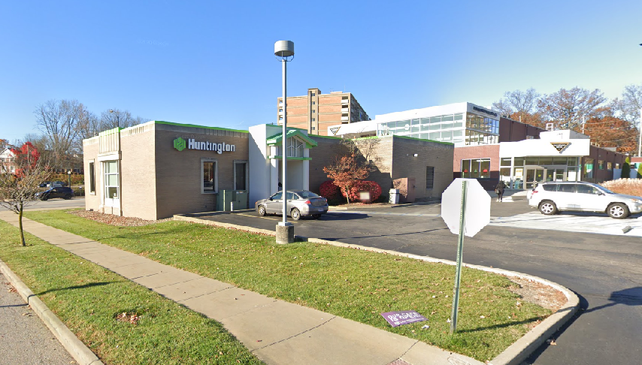

### Lobby

**Hours:**   
Mon: 9:00am - 5:00pm   
Tue: 9:00am - 5:00pm   
Wed: 9:00am - 5:00pm   
Thu: 9:00am - 5:00pm   
Fri: 9:00am - 5:00pm   
Sat: 9:00am - 12:00pm   
Sun: Closed

**Services:**

Accepts Deposits   
Accepts Loan Applications   
Accepts Loan Payments   
Check Cashing   
Credit Card Cash Advances   
Insurance Licensed PB - By Appointment Only   
Investment Licensed PB - By Appointment Only   
Limited Foreign Currency Exchange for HNB Customer   
Mortgage Certified PB - By Appointment Only   
Notary Service - By Appointment Only   
Official Checks   
Opens Deposit Accounts   
Savings Bond Redemption   
Signature Guarantee - By Appointment Only   
Wire Transfers

### Drive Thru

**Hours:**   
This location does not have a Drive Thru.

**Services:**   
This location does not have drive thru services.

### Walk-Up ATM

**Hours:**   
This location does not have a walk-up ATM.

**Services:**   
This location does not have walk-up ATM services.

### Drive-Up ATM

**Hours:**   
Mon: 24 Hours   
Tue: 24 Hours   
Wed: 24 Hours   
Thu: 24 Hours   
Fri: 24 Hours   
Sat: 24 Hours   
Sun: 24 Hours

**Services:**

Accepts Deposits   
Envelope Free Deposits   
Minimum Denomination Dispensed $1   
Somali Language Option Available   
Spanish Language Option Available