E-COMERCE

1. User Account & Authentication Module
This group handles the "gatekeeping" and personalization of the platform. It manages who the users are and what they are allowed to do.
- Core Functions: User registration/login, OAuth (Google/Facebook integration), profile management, and Role-Based Access Control (RBAC) for customers vs. admins.
- Key Database Entities: User, Role, AddressBook.

2. Product Catalog & Inventory Module
This group is responsible for the "storefront." They manage the data that users browse and ensure that stock levels are accurate.
- Core Functions: Product CRUD (Create, Read, Update, Delete), category management, search/filtering logic, and real-time inventory tracking (preventing overselling).
- Key Database Entities: Product, Category, SKU, InventoryLog.

3. Shopping Cart & Pricing Engine
This is the "logic" hub where products become potential sales. It handles the volatile state of a user's session before they commit to a purchase.
- Core Functions: Adding/removing items, session persistence, discount/coupon code validation, and tax calculations.
- Key Database Entities: Cart, CartItem, Promotion, TaxRule.

4. Order Management & Checkout Module
This group handles the transition from a "cart" to a "legal contract." It is the most critical module for data integrity, as it captures the snapshot of prices and products at the moment of sale.
- Core Functions: Checkout workflow, generating unique Order IDs, order history, and status updates (Pending, Shipped, Delivered).
- Key Database Entities: Order, OrderItem, TransactionRecord.

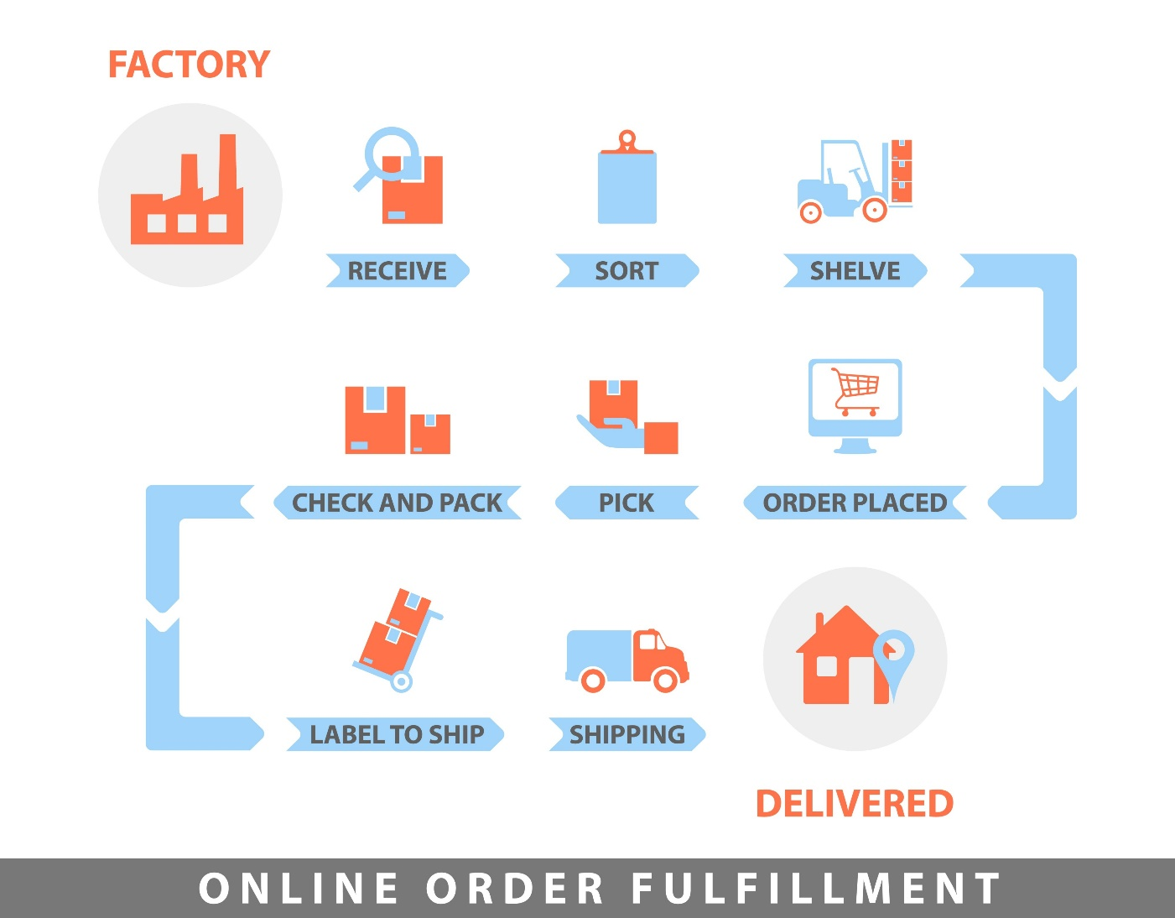

5. Payment & Shipping Integration Module
This group manages external communications. Since e-commerce sites rarely handle money or trucks directly, this module focuses on API integrations.
- Core Functions: Payment gateway integration (Stripe/PayPal), shipping rate calculation (FedEx/UPS APIs), and tracking number generation.
- Key Database Entities: PaymentMethod, ShippingProvider, TrackingLog.

Group 1: User Account & Authentication
Focus: Security, identity, and user data.
- Member 1 (Frontend): Build Login, Register, and Password Reset UI; implement client-side form validation.
- Member 2 (Frontend): Build the User Profile dashboard and Address Management interface.
- Member 3 (Backend): Implement JWT (JSON Web Tokens) or Session logic and secure password hashing (Bcrypt).
- Member 4 (Backend): Create API endpoints for Profile CRUD and Address Book management.
- Member 5 (Database/QA): Design the User/Role schema; write unit tests for registration edge cases (e.g., duplicate emails).
- Member 6 (DevOps/Lead): Set up the authentication middleware/Gatekeeper to protect private routes.

Group 2: Product Catalog & Inventory
Focus: Data display, searchability, and stock integrity.
- Member 1 (Frontend): Build the Product Grid/Gallery and Category landing pages.
- Member 2 (Frontend): Build the "Product Detail Page" (PDP) with image carousels and spec tables.
- Member 3 (Backend): Develop the Search and Filter API (filtering by price, brand, rating).
- Member 4 (Backend): Build the Admin Inventory Panel API (to add/edit/delete products).
- Member 5 (Database/QA): Manage Product/Category schemas; handle image storage logic (e.g., S3 or Cloudinary).
- Member 6 (DevOps/Lead): Implement "Concurrency Control" (ensuring two people can't buy the last item at the exact same millisecond).

Group 3: Shopping Cart & Pricing Engine
Focus: State management and business logic.
- Member 1 (Frontend): Build the Floating Cart sidebar and the main Shopping Cart page.
- Member 2 (Frontend): Create the "Promo Code" input UI and real-time price summary display.
- Member 3 (Backend): Build the Cart Persistence logic (saving cart items to the database or LocalStorage).
- Member 4 (Backend): Develop the Pricing Engine (calculating sub-totals, discounts, and tax).
- Member 5 (Database/QA): Design the Coupon/Discount schema and validation logic (expiry dates, usage limits).
- Member 6 (DevOps/Lead): Ensure sync between the "Inventory" stock levels and "Cart" quantities.

Group 4: Order Management & Checkout
Focus: Data snapshots and transaction flow.
- Member 1 (Frontend): Build the Multi-step Checkout Wizard (Shipping -> Review -> Confirm).
- Member 2 (Frontend): Build the "Order History" and "Order Receipt" views for the customer.
- Member 3 (Backend): Create the "Order Placement" logic (converting a Cart into a permanent Order record).
- Member 4 (Backend): Build the Admin "Order Fulfillment" dashboard to change status (e.g., Pending to Shipped).
- Member 5 (Database/QA): Design the Order/Order-Item schema (must store price-at-time-of-purchase).
- Member 6 (DevOps/Lead): Handle Email/Notification triggers (sending "Order Confirmed" emails).

Group 5: Local Payment & Shipping Module (6 Members)
Member 1: Frontend (Wallet UI)
- Primary Responsibility: User Financial Portal.
- Key Tasks:
  - Design and build the User Wallet Dashboard where customers can view their "Available Balance."
  - Create a "Link Card" interface to collect dummy payment info (Cardholder name, masked numbers, etc.).
  - Develop a Transaction History table showing a list of previous deposits and purchases.
Member 2: Frontend (Checkout)
- Primary Responsibility: Payment Processing UI.
- Key Tasks:
  - Build the custom "Pay with Wallet" checkout step that displays the final order total vs. the user's current balance.
  - Implement Security Modals, such as a UI popup for "Enter Transaction PIN" or a simulated "OTP" verification code.
  - Handle "Insufficient Funds" UI states to warn users before they attempt to pay.
Member 3: Backend (Bank Logic)
- Primary Responsibility: Transaction Engine.
- Key Tasks:
  - Develop the core Transfer Logic that moves credits from the User account to the Merchant account.
  - Precision Math: Ensure all calculations use integers (storing values in cents) or Decimals to avoid floating-point rounding errors (e.g., $19.99 + 0.01 = 20.00$).
  - Build the "Wallet Top-up" endpoint to allow users to add "fake" money to their accounts.
Member 4: Backend (Security)
- Primary Responsibility: Auth & Verification.
- Key Tasks:
  - Implement a Secondary Authentication layer (e.g., a 4-digit Transaction PIN stored as a hashed value in the DB).
  - Build Concurrency Logic to prevent "Double Spending" (ensuring a user cannot click 'Pay' twice quickly to bypass balance checks).
  - Develop an "Account Lock" feature if too many incorrect PIN attempts are made during payment.
Member 5: Database/QA
- Primary Responsibility: Ledger & Shipping Database.
- Key Tasks:
  - Design the Transactions table (The Ledger) which must act as an immutable audit trail for every cent moved.
  - Set up the Shipping_Zones table containing flat-rate costs for different regions.
  - Quality Assurance: Write rigorous unit tests to ensure Balance - OrderTotal never results in a negative number.
Member 6: Lead/Shipping
- Primary Responsibility: Logistics Logic & Integration.
- Key Tasks:
  - Build a Local Shipping Calculator function that takes a zip code/region and returns a shipping fee based on Group 5's internal table.
  - Create the Status Update Logic that moves an order from "Paid" to "In Transit" after a simulated 5-second delay.
  - Act as the Integration Liaison to ensure Group 4 (Order Management) knows exactly which API endpoint to call when a user hits "Confirm Order."

