**Title:**

Aggregated Distributed Cloud Storage

**Members:**

Kenton Hanifl – Programmer

**Type of Project:**

Development

**Motivation:**

Increase the storage and security capabilities for free users on cloud services.

**Objective:**

Design a system that would manage a user’s multiple cloud storage accounts and upload files to them, splitting them evenly across the different services. This would be useful to anyone with access to free cloud storage systems that feels they do not have enough free storage space.

**Architecture:**

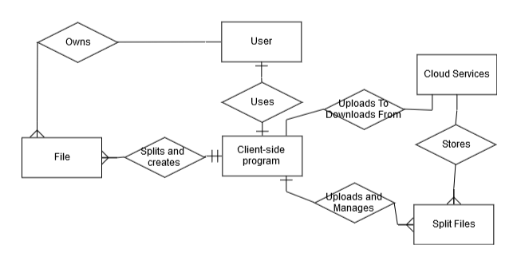

**Tools, Languages, Platforms:**

Python for the service, any number of cloud storage systems for the backend.

Most likely an Azure database to store “metadata” for the file locations on the cloud

**Development and Evaluation Plan:**

Data used in the project will be any reasonably large dataset because the actual data used does not matter much.

The program can be timed for speed and a complexity analysis can be done to calculate the time complexity of the algorithms in the program.

The project will be entirely managed through Github and done by a single person, Kenton.

**Expected Outcome:**

The program will be a simple GUI interface that will abstract away all unnecessary details like logging in to each cloud service and will split the files automatically, uploading them across any cloud services the user has provided accounts for.

**Learning Outcome:**

Become familiar with the APIs of many different cloud storage services.

Become more familiar with the Python programming language and GUI interfaces.