ATM Size

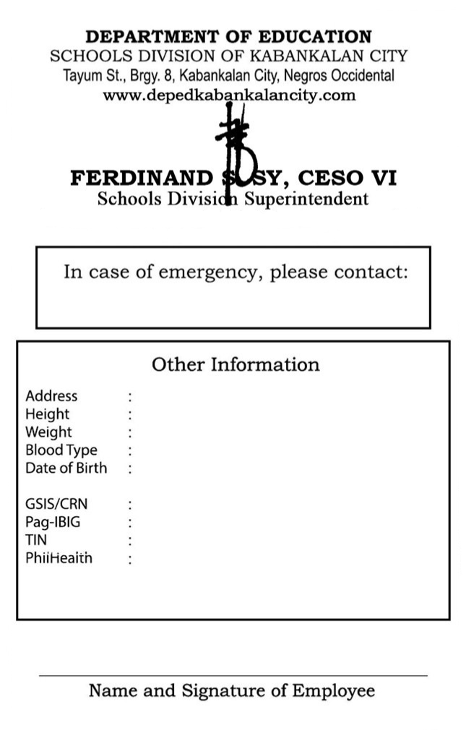
EMPLOYEE NO. 1234567
LASTNAME,
FIRSTNAME MI
STATION/OFFICE
POSITION

NEGROS ISLAND
REGION
SDO-Kabankalan City
JUANA DELA CRUZ
Tayum St., Brgy. 8, Kab. City
5’6”
42 Kg
O+
January 1, 1990
XXXXXXXXXXX
XXXXXXXXXXX
XXXXXXXXXXX
Juan Dela Cruz / 09xx-xxx-xxxx
click to insert image for QR Code
XXXXXXXXXXX

Click to insert image of Profile Picture

CSC Size (Back-to-back)


EMPLOYEE NO. 1234567
NEGROS ISLAND REGION
SDO-Kabankalan City

LASTNAME,
FIRSTNAME MI
STATION/OFFICE
POSITION

Point this side to QR reader

Click to insert image of QR Code
↑Click to insert image of Profile Picture

