# Activity Sheet 08

Consider the nonlinear Predator-Prey model described in the note “Readings for Practical 07” and

let at the beginning there were 110 foxes and 950 rabbits in the forest. Suppose that fox death and

birth factors are 1-a = 0.88 and b = 0.0001 and rabbit death and birth factors are –c = -0.0003 and

1+d = 1.039. Let:

𝐹𝑛 = 𝑝𝑜𝑝𝑢𝑙𝑎𝑡𝑖𝑜𝑛 𝑜𝑓 𝑓𝑜𝑥𝑒𝑠 𝑎𝑡 𝑡ℎ𝑒 𝑒𝑛𝑑 𝑜𝑓 𝑚𝑜𝑛𝑡ℎ 𝑛

𝑅𝑛 = 𝑝𝑜𝑝𝑢𝑙𝑎𝑡𝑖𝑜𝑛 𝑜𝑓 𝑟𝑎𝑏𝑏𝑖𝑡𝑠 𝑎𝑡 𝑡ℎ𝑒 𝑒𝑛𝑑 𝑜𝑓 𝑚𝑜𝑛𝑡ℎ 𝑛.

## Write down the corresponding nonlinear predator-prey model.

The model:

$$F_{n+1}=0.88F_{n}+0.0001R_{n}F_{n}$$

$$R_{n+1}=-0.0003F_{n}R_{n}+1.039R_{n}$$

where:

$$F_{n} is the fox population at time n (month n).$$

$$R_{n} is the rabbit population at time n (month n).$$

## Write an Octave script to plot (scatter graph) time plots for both species on the same figure for the first 400 months.

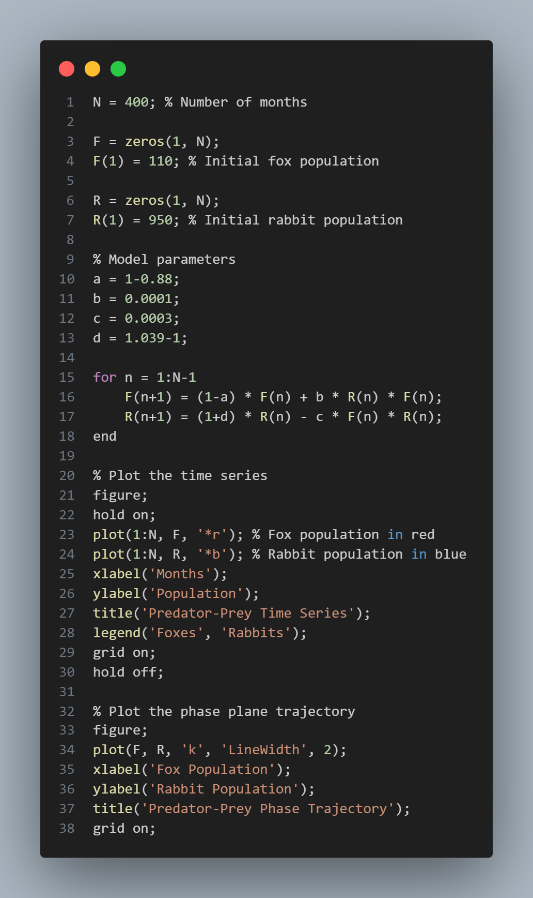

## Use the same Octave script to plot the corresponding trajectory of the system.

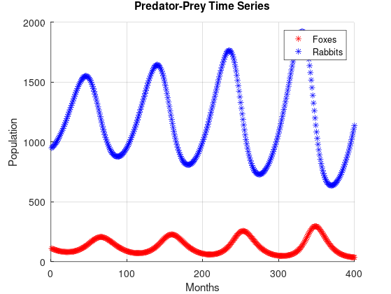

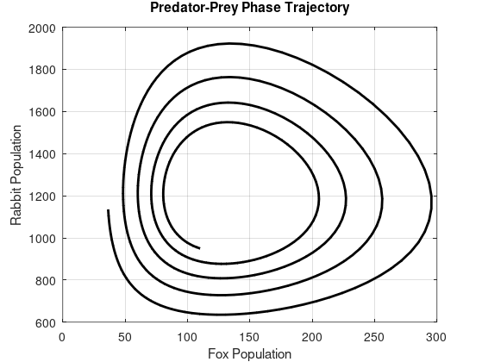

## Using (2) and (3), what can you say about the populations of foxes and rabbits over time?

* The time series plot shows regular changes in the populations of rabbits and foxes over time.
* The rabbit population (blue) shows bigger changes than the fox population (red).
* When rabbit numbers go up, fox numbers also increase after a delay, because more rabbits mean more food for the foxes.
* When fox numbers are at their highest, rabbit numbers start to drop because of more predation.
* The phase trajectory plot has closed loops, which means the system does not settle at one point but keeps cycling through changes.
* This indicates that both rabbit and fox populations stay in a stable cycle instead of facing extinction or continually increasing.

## Find equilibrium points of the model.

$$F_{n+1}=0.88F_{n}+0.0001R_{n}F_{n}$$

$$R_{n+1}=-0.0003F_{n}R_{n}+1.039R_{n}$$

When $F_{n+1}=F_{n}$ and $R_{n+1}=R_{n}$

$$F_{n}=0.88F_{n}+0.0001R_{n}F_{n}$$

$$0.12F_{n}=0.0001R_{n}F_{n}$$

$$R_{n}=\frac{0.12}{0.0001}=1200$$

also

$$R_{n}=1.039R_{n}+0.0003F_{n}R_{n}$$

$$0.039R_{n}=0.0003R_{n}F_{n}$$

$$F_{n}=\frac{0.039}{0.0003}=130$$

$$\left(F_{n},R_{n}\right)∈\{\left(0,0\right),\left(130,1200\right)\}$$

## Choosing suitable four set of values for initial population near equilibrium, check the above found non-trivial (except (0,0)) equilibrium point/s is/are stable or unstable graphically.

|  |  |
| --- | --- |
| Initial points $\left(F_{n},R_{n}\right)$ | Observation |
| $$(110, 1180)$$ | Stable, Dynamic (Oscillating) |
| $$(120, 1190)$$ | Stable, Dynamic (Oscillating) |
| $$(130, 1200)$$ | Stable, Static |
| $$(140, 1210)$$ | Stable, Dynamic (Oscillating) |
| $$(150, 1220)$$ | Stable, Dynamic (Oscillating) |

(If there are more points to test, please prepare tables as above and test them above)

## Suppose hunters are allowed to kill 𝑒𝑥𝑎𝑐𝑡𝑙𝑦 𝑚 rabbits at the end of each month. Further suppose that initial rabbits’ populations and foxes’ populations are 1000 and 110 respectively.

### Modify the model to take this into account (use the same parameters). Write down the modified model.

$$F_{n+1}=0.88F_{n}+0.0001R_{n}F_{n}$$

$$R_{n+1}=-0.0003F_{n}R_{n}+1.039R_{n}-m$$

### What effect will this have in the long-term? Would you say the system is sensitive to the parameter m? (To answer this question, create new Octave script to graph time plots and trajectory of the modified model for first 400 months. Compare time plots with m and without m. Take an integer value for m from the interval [7, 12].)

When m goes from 7 to 12 and further, the system spirals in to an instability. Even a change in 1 unit drastically changes the dynamics of the system. Therefore, m will in stabilise the system in long term.

Figure 1: m = 8

Figure 2: m = 9

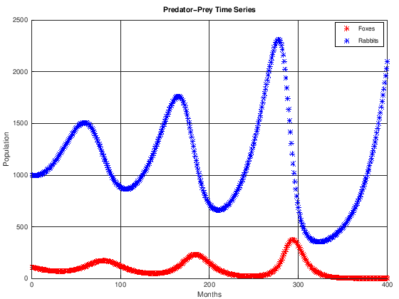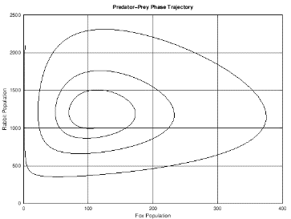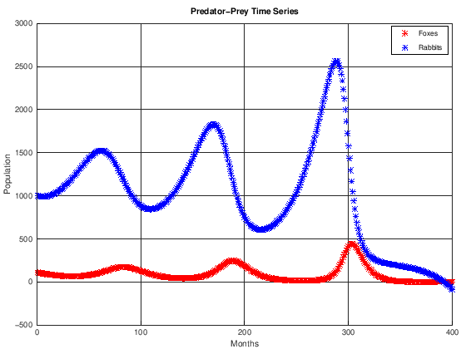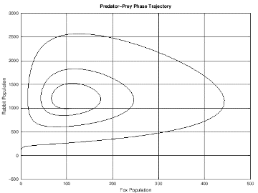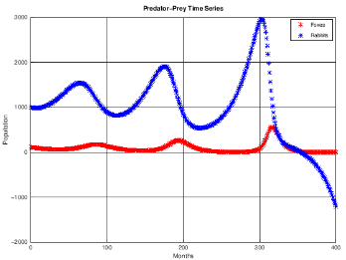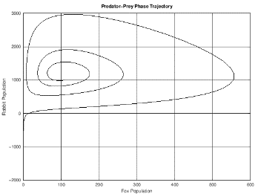

Figure 3: m = 10