Calibration of an NTC Thermistor Against a DS18B20 Reference
S17278 | 2023s20138 | M.W.T.S.Sampath

To find the temperature as a function of the ADC count, T = f(ADC), for an NTC thermistor read through a 10-bit ADC, using a DS18B20 as the reference; to state the accuracy and precision of the result and to measure the thermistor's response time.

1. Setup and configurations
The thermistor forms a voltage divider with a fixed 3.3 kΩ resistor, and the divider midpoint is read on pin A2 of an Arduino Uno (10-bit ADC, supply voltage as reference). The DS18B20 runs at 12-bit resolution on digital pin 2 with a 4.7 kΩ pull up resistor and a 5 V supply. The lab sheet lets the fixed resistor and the thermistor swap places. The two arrangements are complementary, so their sensitivities are equal in size and opposite in sign, and the choice between them has to rest on data quality. Both were therefore built and run together in one water bath, each with its own thermistor, DS18B20, Arduino and PC. The firmware logs time, DS18B20 temperature and ADC count once per loop, about every 1.5 s, because each loop waits for the 750 ms DS18B20 conversion and then a 1 s delay.

 | Configuration 1 | Configuration 2
Divider | Fixed resistor on the 5 V side, thermistor to ground | Thermistor on the 5 V side, fixed resistor to ground
Observed ADC | First thermistor: pinned near 1010 to 1022 counts at every temperature, so ADC against temperature was a block of points, not a curve. A replacement thermistor on another computer gave a proportional response. | Rises smoothly with temperature, from about 95 counts at 0 °C to 851 counts at 98.5 °C.
Used here | No | Yes

The cause of the pinned readings was not established; a faulty thermistor or connection is suspected. The replacement run used a different thermistor on a different computer, so pooling it with configuration 2 would mix two devices in one calibration. Each rig needs its own curve, and this report covers configuration 2 alone.

2. Data collection
Calibration Data: The stirred bath was heated from about 0 to 98.5 °C (file log_20261002_141803) and then left to cool (log_20261002_144604). An ice cube added during cooling caused a sudden drop from 84 to 55 °C. As the automation section of the sheet directs, the DS18B20 was the reference and its datasheet accuracy was taken as given. Response Data: The rig was moved repeatedly between a beaker of room-temperature water and an ice bucket, recording four warming and four cooling steps, of which the three complete cycles in the middle were analysed.

3. Analysis and reasoning
Cleaning and splitting. Only configuration 2 files with an ADC column were used. The ice drop was cut out by time window, and the cooling run was split into an upper part (85 to 98 °C) and a bottom part (31 to 56 °C), because during a sudden drop the two sensors respond at different speeds, so those points show lag and not calibration. Stray points beyond 2.5 standard deviations of a cubic fit were then removed, in up to three passes.
Polynomial degree. Degrees 1 to 10 were fitted to the heating, cooling and pooled data and judged by RMSE, R², adjusted R² and residual plots. With over a thousand points per set, adjusted R² equals R² to six decimals and cannot separate the degrees, so the elbow in RMSE was used to decide. It falls sharply at degree 3 and improves little afterwards, and the remaining scatter is lag and hysteresis, which a higher degree would only fit as noise.
Hysteresis and pooling. Heating and cooling were compared at equal ADC directly from the data, not only from the fitted curves, so that a polynomial could not create or hide a gap. If the gap is no larger than the reference accuracy, one curve serves both directions, and the sets can be pooled into one cubic with a 95% prediction interval. That interval gives the range where a single new reading will fall, whereas a confidence interval would shrink to almost nothing with thousands of points and overstate the sensor.
Physical model. For an NTC, ln r plotted against 1/T should be a straight line whose slope is β, where r is the thermistor resistance divided by the fixed resistance, found from the ADC count as (1023 minus ADC) divided by ADC for this wiring. β was fitted to the heating, cooling and pooled data and to the narrow cooling ranges to test whether it stays constant. This checks the calibration against physics and gives a constant that can be compared with a datasheet.
Response analysis. The ADC was converted to temperature with the pooled cubic. Each warming step was fitted for both sensors separately with a delayed first-order exponential, because the DS18B20 lags too and is reliable only at settled values, not during fast changes. The cooling steps start late and are not exponential, because the ice contact was uneven, so their 10 to 90 per cent fall time was measured instead. Cycle 2, with a much sharper dip, was left out of the cooling average. As an independent test on a different day from the calibration, the calibrated thermistor was compared with the DS18B20 on the settled plateaus of the response run only, since the reference is accurate only when it is not changing.
Uncertainty. The fit scatter, the DS18B20 datasheet limit (treated as rectangular) and the offset seen between the two days were combined in quadrature with a coverage factor of 2, so that the stated accuracy refers to true temperature and not only to the reference. Sensitivity was taken as the derivative of the cubic, because rates measured in the transient run mix two sensors with different lags.

4. Results
The pooled cubic is T = 0.00000021266 A³ minus 0.00028857 A² plus 0.22985 A minus 19.007, with A the ADC count, valid for A from 95 to 851 (0.3 to 98.5 °C). It has an R² of 0.99993 and an RMSE of 0.226 °C, which is the precision, and its 95% prediction half-width is ±0.44 °C relative to the DS18B20.
Data set | N | Temperature range (°C) | RMSE (°C) | Largest error (°C)
Heating | 1071 | 0.3 to 98.5 | 0.345 | 0.937
Cooling, upper | 354 | 84.9 to 98.4 | 0.199 | 0.466
Cooling, bottom | 1681 | 31.5 to 55.7 | 0.101 | 0.299
Pooled | 3106 | 0.3 to 98.5 | 0.226 | 0.937
Table 2. Errors of the pooled cubic against the DS18B20, by data set.
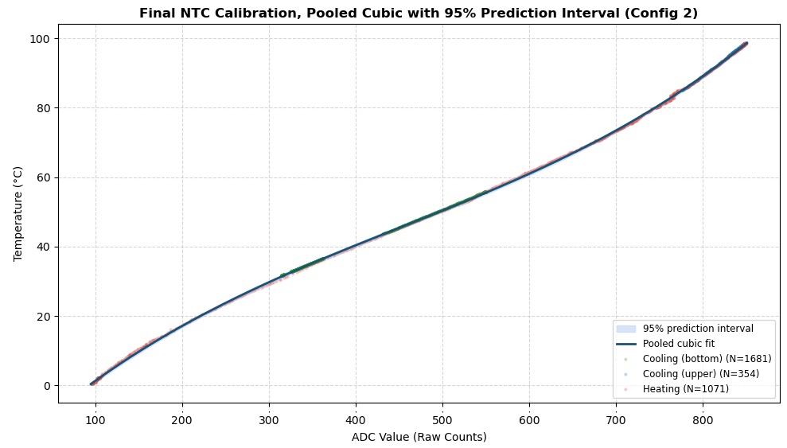  Figure 1. Pooled cubic with its 95% prediction interval over all three data sets. | Hysteresis. At equal ADC, heating read lower than cooling by 0.17 °C on average over the upper range and 0.49 °C over the bottom range (largest gaps 0.69 and 1.11 °C). This is comparable to the ±0.5 °C reference accuracy, so the sets were pooled.  β model. β is 3973 K (heating), 4026 K (cooling) and 3992 K (pooled), constant to about 1 per cent. The upper range alone gives 4277 K, but 85 to 98 °C covers too little of 1/T to fix β. The ratio of R25 to the fixed resistor is 2.96, about 9.8 kΩ for a 3.3 kΩ fixed resistor, to be confirmed with a multimeter. In temperature, the β model has an RMSE of 0.43 °C, against 0.23 °C for the cubic.
Response. The DS18B20 rise times match 2.197 τ, so one exponential describes it. The thermistor rise is 10 to 20 per cent longer than 2.197 τ, a mild slow tail. Cooling times depend on the ice contact, and the DS18B20 had not fully settled when each record ended, so its fall times are lower bounds.
Step | Sensor | Time constant τ (s) | 10 to 90 per cent time (s)
Warming | Thermistor | 3.5 ± 0.6 | 8.8 ± 1.5
Warming | DS18B20 | 10.2 ± 1.1 | 22.9 ± 1.8
Cooling | Thermistor | not fitted | 18 to 24
Cooling | DS18B20 | not fitted | 60 to 82 (lower bound)
Table 3. Response times. Warming: mean ± standard deviation of three cycles. Cooling: range of cycles 1 and 3.
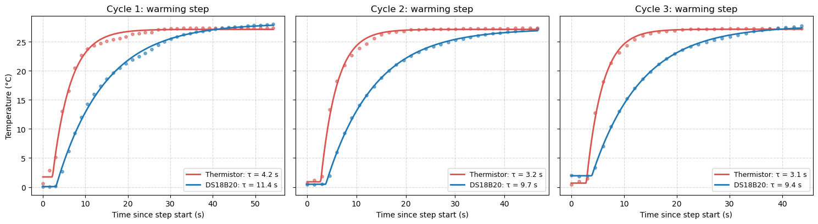
Figure 2. Delayed first-order fits to the three warming steps, thermistor (red) and DS18B20 (blue).
On settled points, the calibrated thermistor agrees with the DS18B20 at the ice plateau (difference 0.01 °C, spread 1.0 °C, mostly bath and reference noise) but reads 1.03 °C below it at the room plateau (spread 0.10 °C). The sensitivity dT/dADC from the cubic is 0.10 to 0.20 °C per count over the range, so one count sets the resolution. Against true temperature, the accuracy is ±0.73 °C up to 85 °C and ±2.35 °C above, where the DS18B20 limit widens to about 2 °C. Adding the offset between days raises these to ±1.47 °C and ±2.67 °C.

5. Conclusion and limits
A single cubic converts the ADC count to temperature over the whole range, with a precision better than the reference accuracy, because heating and cooling agree on average to within that accuracy and one curve serves both directions. The β model shows that the thermistor behaves as a physical NTC with one material constant, but its larger error means curvature matters over this wide range, so the cubic is the working calibration and the Steinhart Hart equation is the natural next model. The DS18B20 is a valid reference for slow changes only: it responds about three times slower than the thermistor, which probably explains the small heating and cooling gap. We attribute the offset at the room plateau to reference lag during the heating run, but this is untested; correcting the reference for lag and recalibrating would test it. Other limits are the 1.5 s sampling, which gives only about two samples per thermistor time constant, the small number of cycles, cooling steps that depend on ice contact, and the fact that configuration 1 was not analysed.

