Calibrating Temperature Sensors
Calibration of an NTC Thermistor Against a DS18B20 Reference
S1728 | 2023s20138 |M.W.T.S.Sampath

1. Aim
To calibrate an NTC thermistor as a temperature sensor read by an Arduino Uno, using a DS18B20 as the calibrated reference; to estimate the accuracy and precision of the calibration; to measure the response time of the thermistor; and to answer the prelab questions on thermistor interfacing.

2. Prelab questions

2.1 Nominal resistance of a thermistor
The nominal resistance is the resistance of the thermistor at 25 °C (298.15 K) written as R25, and measured with so little current that self-heating is negligible.
$R_{T}=R_{25}⋅exp(β(\frac{1}{T}-\frac{1}{298.15}))$
So a 10 kΩ thermistor has 10 kΩ at 25 °C, and it is quoted with a tolerance, so two parts of one type can differ. For our part, the calibration gives R25 divided by the fixed resistance as 2.96, which is about 9.8 kΩ for a 3.3 kΩ fixed resistor. It is therefore probably a 10 kΩ part..

2.2 Methods of interfacing a thermistor
The resistance has to become a voltage or a time before a microcontroller can read it. Table 1 compares the common methods.
Method | Advantages | Disadvantages
Voltage divider with a fixed resistor | Ratio metric with the ADC reference, so supply drift cancels. | Nonlinear output. Sensitive mainly near the temperature where the two resistances match. Current causes self-heating.
Wheatstone bridge with a differential amplifier | Output can be zeroed at a chosen temperature. Gain gives a larger signal. Rejects common-mode noise. | Four resistors to match, plus an amplifier with its own offset. More parts and board area.
Constant current source | Output voltage is proportional to resistance. Wide voltage swing. | Needs a current source. High resistance in the cold can saturate the output. Self-heating at high current.
Parallel linearising resistor | Straightens the response over a narrow range with one part. | Lowers sensitivity. Useful only over a limited span.
Resistance to time or frequency (RC charging, 555 oscillator) | Digital output, so no ADC is needed. Good noise immunity. | Slower. Needs a timer and a stable capacitor, whose drift adds error.
Table 1. Methods of interfacing a thermistor to electronics.
Any of these can be combined with software linearisation, using the Steinhart-Hart equation or a lookup table, to obtain accuracy over the full span. We used the divider with software conversion, because it needs no extra parts on the Arduino and its ratiometric reading makes the result independent of the supply voltage.
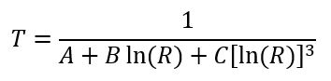
“T” is in degrees Kelvin and “A”, “B”, and “C” are coefficients derived as follows:

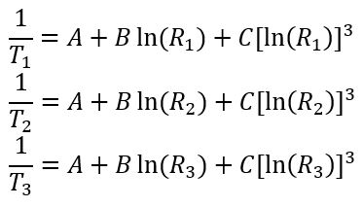 | 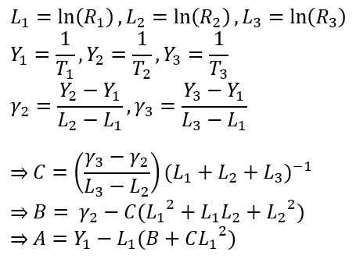

2.3 Accuracy, precision, span, dynamic range and sensitivity
Accuracy is how close a reading is to the true value.
Precision is how closely repeated readings of one quantity agree. It reflects random scatter, such as electrical noise and the size of one ADC step.
Span is the difference between the largest and smallest input that the sensor measures.
Dynamic range is the ratio of the largest to the smallest output.
Sensitivity is the change in output per unit change in input.
2.4 Simulation of the interface circuit
Both arrangements of a 3.3 kΩ thermistor and a 3.3 kΩ fixed resistor on a 5 V supply were simulated numerically from 0 to 100 °C in steps of 0.25 °C, using the transfer function of the sheet with B equal to 3992 K, the value fitted to our own data in section 4.5. Sensitivity is the derivative of the divider output with respect to temperature.
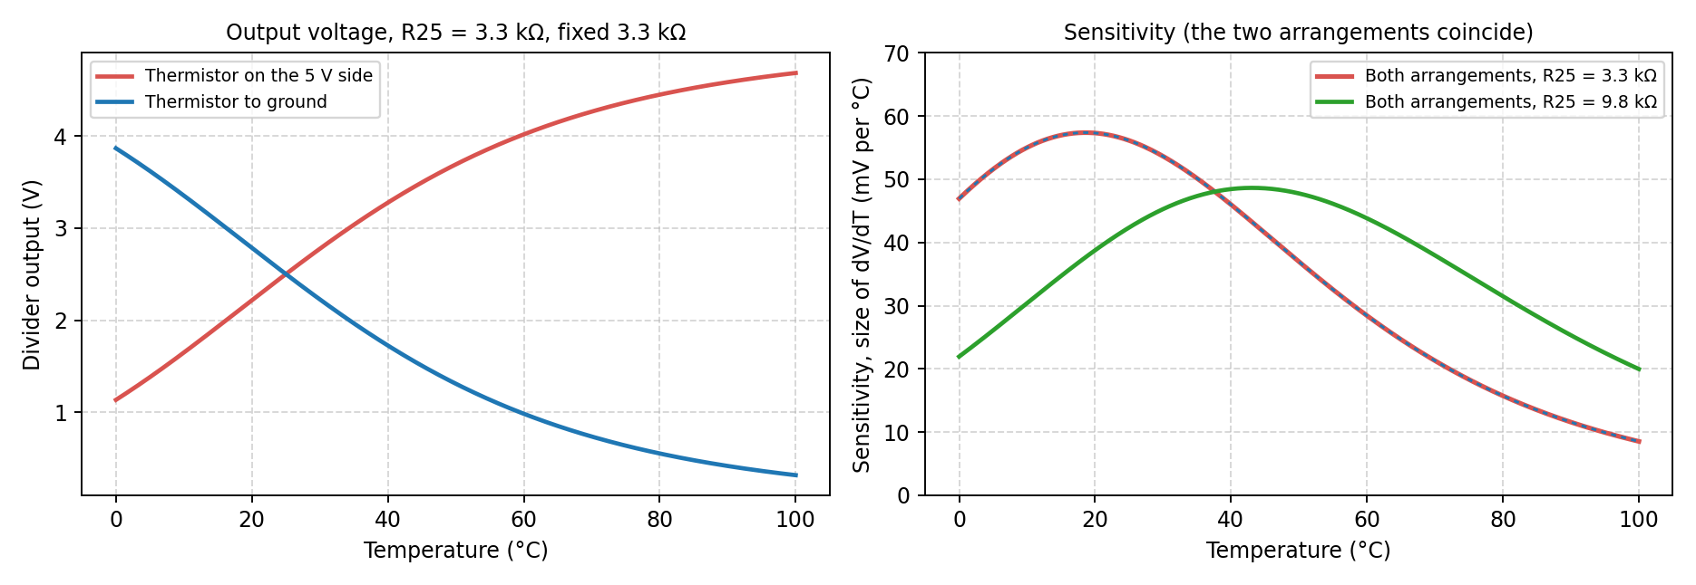
Figure 1. Simulated divider output (left) and its sensitivity (right) from 0 to 100 °C.
With the thermistor on the 5 V side the output rises with temperature, and with the thermistor to ground it falls. The two outputs always add up to 5 V, so the two sensitivities are equal in size at every temperature and differ only in sign. The simulation therefore cannot name a more sensitive arrangement. With R25 of about 9.8 kΩ, the value found for our part, the peak moves to 49 mV per °C near 43 °C, which suits a span reaching 98 °C better.
Because the arrangements tie, the choice rests on practical grounds. We analysed the arrangement with the thermistor on the 5 V side, where the ADC count rises with temperature. The other arrangement was built as a second rig, but its first thermistor failed, with the ADC pinned near full scale at every temperature, so only the first rig is analysed here.

3. Method

3.1 Circuit and program
The thermistor and a fixed 3.3 kΩ resistor form the divider, powered from the 5 V pin of the Arduino, with the midpoint on analogue pin A2 (10 bit ADC, 5 V reference). The DS18B20 data line is on digital pin 2 with a 4.7 kΩ pull up resistor to 5 V, the device is powered from 5 V and shares the ground, and it is set to 12 bit resolution. The program uses the OneWire and DallasTemperature libraries. In every loop it requests a conversion, reads the DS18B20, reads the ADC and sends one comma separated line of time in milliseconds, temperature in °C, temperature in K and ADC count at 9600 baud. A loop takes about 1.5 s, made up of the 750 ms conversion and a 1 s delay. The sheet asks for measurements on demand, but ours log continuously so that every moment of a run is recorded, and a reading at any wanted moment is the row nearest that time.
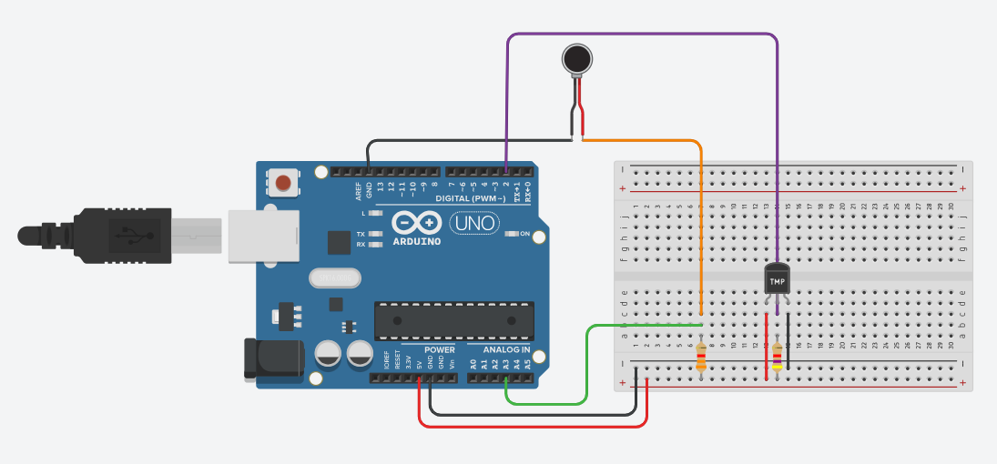

3.2 Calibration procedure
The thermistor and the DS18B20 probe were placed together in a water bath. The bath started near ice temperature, was heated slowly to 98.5 °C, and was then left to cool. During cooling, an ice cube was added to reach lower temperatures, which caused a sudden drop from 84 to 55 °C. The 1.5 s logging interval kept the step between consecutive readings well below the 1 °C limit of the sheet, except during that drop.

3.3 Transient procedure
The sheet calls for a bath at 0 °C and one near 80 °C. We had a beaker of room temperature water (about 28 °C) and a bucket of ice, so the rig, with the thermistor and DS18B20 together, was moved by hand between them. Four cooling steps. The logger script was used to get ADC count and the DS18B20 temperature every 1.5 s.

3.4 Data processing
Analysis used Jupyter notebooks. The ice drop was removed by time window, which split the cooling run into an upper part (85 to 98 °C) and a bottom part (31 to 56 °C), because during the drop the two sensors respond at different speeds and the points show lag, not calibration. Isolated points beyond 2.5 standard deviations of a cubic fit were then removed, in up to three passes, leaving the points counted in Table 3. For the transient run, the ADC count was converted to temperature with the calibration of section 4.4.

4. Calibration results

4.1 Raw data
The heating run logged 1079 rows and the cooling run 2207, of which 1078 and 2205 had both an ADC count and a temperature. Figure 2 shows the raw data. The ADC count rises smoothly with temperature, from 95 counts at 0.3 °C to 851 counts at 98.5 °C, and is steeper at low counts, as expected from the divider and the exponential thermistor. The gap in the cooling data between 55 and 85 °C is the ice drop.
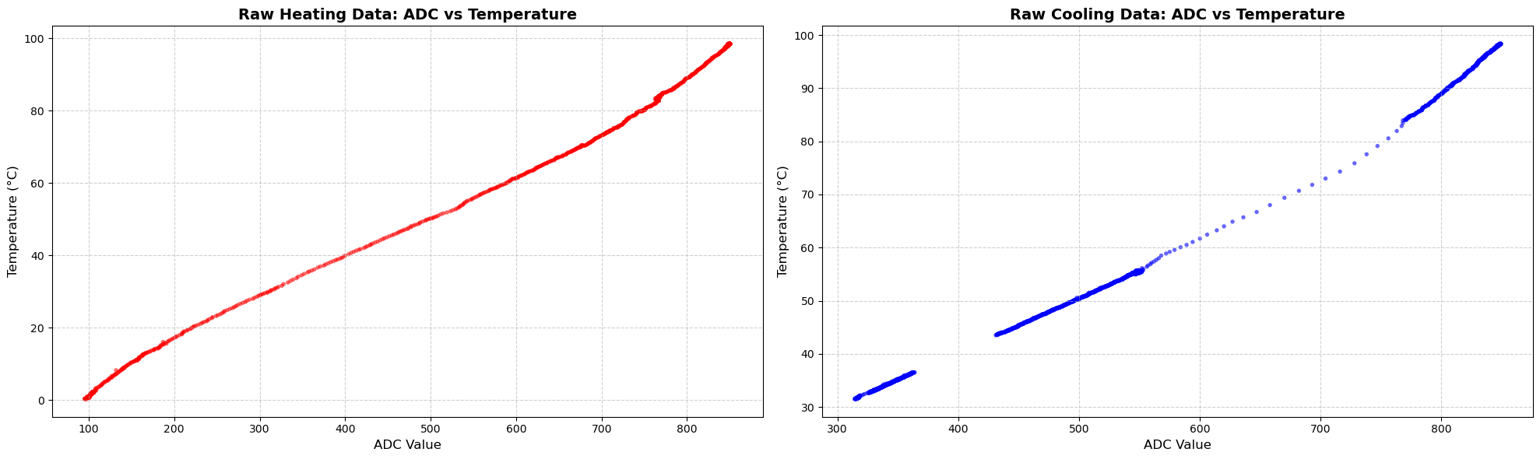
Figure 2. Raw data, DS18B20 temperature against ADC count: heating (left) and cooling (right).

4.2 Polynomial fits
Polynomials of degree 1 to 10 were fitted to temperature against ADC count for the raw heating data, the raw cooling data and the cleaned pooled data. Table 2 gives the RMSE for each set and the R² and adjusted R² for the pooled set.
Degree | Heating RMSE (°C) | Cooling RMSE (°C) | Pooled RMSE (°C) | Pooled R² | Pooled adjusted R²
1 | 2.326 | 1.840 | 2.031 | 0.994637 | 0.994635
2 | 1.951 | 0.475 | 1.912 | 0.995248 | 0.995245
3 | 0.345 | 0.162 | 0.226 | 0.999934 | 0.999934
4 | 0.345 | 0.131 | 0.222 | 0.999936 | 0.999936
5 | 0.259 | 0.131 | 0.194 | 0.999951 | 0.999951
6 | 0.232 | 0.129 | 0.193 | 0.999952 | 0.999952
10 | 0.213 | 0.122 | 0.172 | 0.999961 | 0.999961
Table 2. Fit statistics by polynomial degree.
A straight line is inadequate: its RMSE is about 2 °C and its residuals form an S shape, with errors up to about 4 °C. A quadratic barely helps the heating and pooled data, while a cubic cuts the RMSE by a factor of ten. Beyond degree 3 the gains are small, because the pooled RMSE improves by only about a quarter for seven more coefficients (Table 2). That remaining scatter comes from lag and hysteresis (section 4.3), which a higher degree would only fit as noise. We therefore chose degree 3. With over a thousand points per set, the adjusted R² equals the R² to five decimals and cannot separate the degrees, so the RMSE and the residual plots decided.
Figure 3 shows the chosen fit with its residuals. The cubic is adequate: it follows the curvature, and the residuals stay within about 1 °C, comparable to the accuracy of the reference. The cooling residuals are small and smooth, while the heating residuals show a slow wave of 0.5 to 0.9 °C that the cubic cannot follow because it reflects the different lag of rising and falling data and not the shape of the sensor. Residuals in neighbouring points are strongly correlated, so the interval of section 4.4 is approximate.
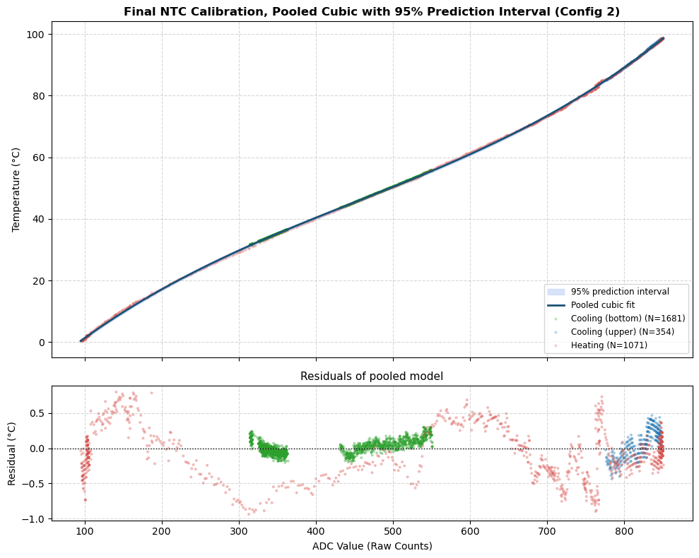
Figure 3. Pooled cubic fit with its 95% prediction interval (top) and the residuals (bottom).

4.3 Heating and cooling
Figure 4 shows the cubic fits to the heating data and to the two cooling sets. They overlap closely. To avoid a polynomial creating or hiding a gap, the gap was measured directly from the data, by interpolating the heating data at the ADC value of each cooling point. At equal ADC, heating read lower than cooling by 0.17 °C on average in the upper range (ADC 776 to 849, largest gap 0.69 °C) and by 0.49 °C in the bottom range (ADC 314 to 551, largest gap 1.11 °C). The gap is comparable to the accuracy of the reference, so we do not claim hysteresis in the thermistor and treat the heating and cooling data as one calibration.
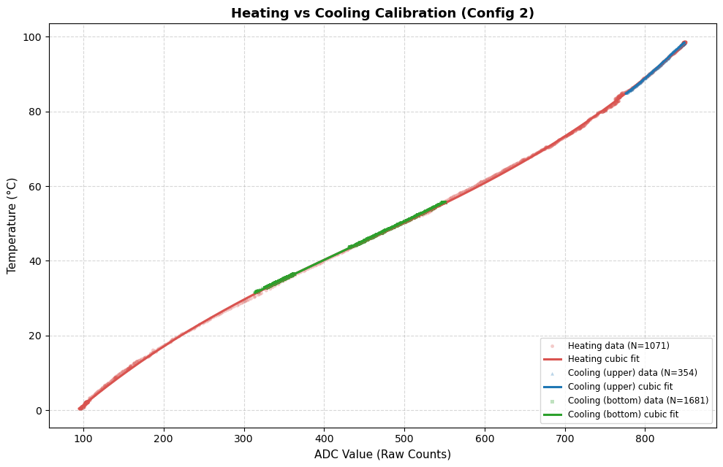
Figure 4. Cubic fits to the heating, upper cooling and bottom cooling data.

4.4 Pooled calibration
The three cleaned sets were pooled (N = 3106) and one cubic was fitted. With A the ADC count, the calibration is T = 0.00000021266 A³ minus 0.00028857 A² plus 0.22985 A minus 19.007 in °C, valid for A from 95 to 851 (0.3 to 98.5 °C). It has R² of 0.99993. Table 3 gives its errors against the DS18B20, by data set and for the whole fit, and its 95% prediction interval is used in section 4.6.
Data set | N | Temperature range (°C) | RMSE (°C) | Largest error (°C)
Heating | 1071 | 0.3 to 98.5 | 0.345 | 0.937
Cooling, upper | 354 | 84.9 to 98.4 | 0.199 | 0.466
Cooling, bottom | 1681 | 31.5 to 55.7 | 0.101 | 0.299
Pooled | 3106 | 0.3 to 98.5 | 0.226 | 0.937
Table 3. Errors of the pooled cubic against the DS18B20, by data set.

4.5 Fit to the transfer function of the sheet
Writing r for the thermistor resistance divided by the fixed resistance, the wiring gives r as (1023 minus ADC) divided by ADC. The sheet equation then makes ln r plotted against 1/T a straight line whose slope is B. Table 4 gives B for each data set, with the error in temperature when the fitted line is used as the calibration.
Data set | B (K) | R² of ln r against 1/T | RMSE (°C) | Largest error (°C) | Cubic RMSE (°C)
Heating | 3973 | 0.99985 | 0.534 | 1.351 | 0.337
Cooling, full | 4026 | 0.99994 | 0.176 | 0.800 | 0.116
Cooling, upper | 4277 | 0.99845 | 0.166 | 0.402 | 0.119
Cooling, bottom | 3979 | 0.99995 | 0.060 | 0.174 | 0.057
Pooled | 3992 | 0.99976 | 0.432 | 1.329 | 0.226
Table 4. B value and accuracy of the exponential model.
B is constant to about 1 percent between the heating, full cooling and pooled data, so one value describes the thermistor. The upper cooling range gives a higher value, but 85 to 98 °C covers only about a tenth of the span of 1/T, so B is poorly fixed there. Over the whole span the two-parameter model has about twice the RMSE of the cubic. The thermistor therefore follows the exponential law closely.
4.6 Accuracy and precision
The precision is the scatter of the readings about the fitted curve, the pooled RMSE of Table 3, to which the size of one ADC step contributes (section 4.7). The accuracy against the DS18B20 is the half-width of the 95% prediction interval, in the first row of Table 5. Accuracy against true temperature also includes the reference. We combined the fit scatter, the DS18B20 datasheet limit (±0.5 °C up to 85 °C and about ±2 °C above, each treated as a rectangular distribution) and, for use on another day, an allowance of 1.1 °C for the offset seen between days (section 5.3), in quadrature with a coverage factor of 2. Table 5 gives the result.
Condition | Accuracy (± °C)
Against the DS18B20 only | 0.44
Against true temperature, same rig and day, up to 85 °C | 0.73
Against true temperature, same rig and day, above 85 °C | 2.35
Against true temperature, another day, up to 85 °C | 1.47
Against true temperature, another day, above 85 °C | 2.67
Table 5. Accuracy of the calibrated thermistor (95% coverage).

4.7 Sensitivity of the calibrated sensor
From the derivative of the calibration, one ADC count corresponds to 0.18 °C at 0 °C, 0.12 °C at 25 °C, 0.10 °C at 50 °C, 0.17 °C at 85 °C and 0.20 °C at 98 °C. The sensor is most sensitive near 50 °C and least at the ends, where the divider output flattens. This agrees with the simulation of section 2.4: for R25 of about 9.8 kΩ the simulated sensitivity at 50 °C is 47.8 mV per °C, which is 9.8 counts per °C or 0.102 °C per count, against 0.101 °C per count from the cubic.

5. Transient response

5.1 Warming steps
Figure 5 shows the thermistor ADC over the run, divided at the four sharp rises. The first and last records are incomplete, so the three complete cycles in the middle were analysed. Each warming step was fitted separately for the thermistor and for the DS18B20 with a delayed exponential, in which the temperature stays at its start value for a short delay and then approaches its final value with time constant τ. The DS18B20 was fitted as well because it is also a lagging sensor, so it cannot be assumed to show the true temperature during a fast change.
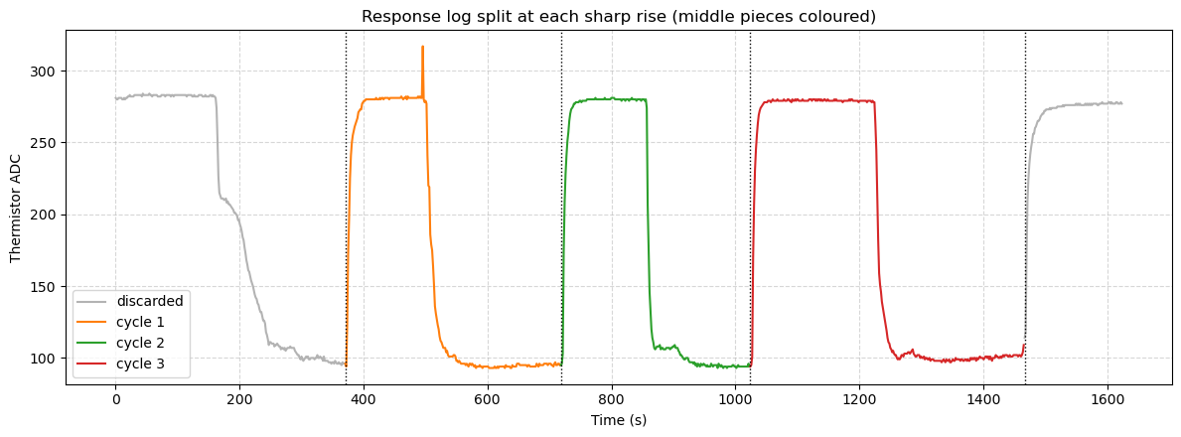
Figure 5. Thermistor ADC over the response run, split at each sharp rise.
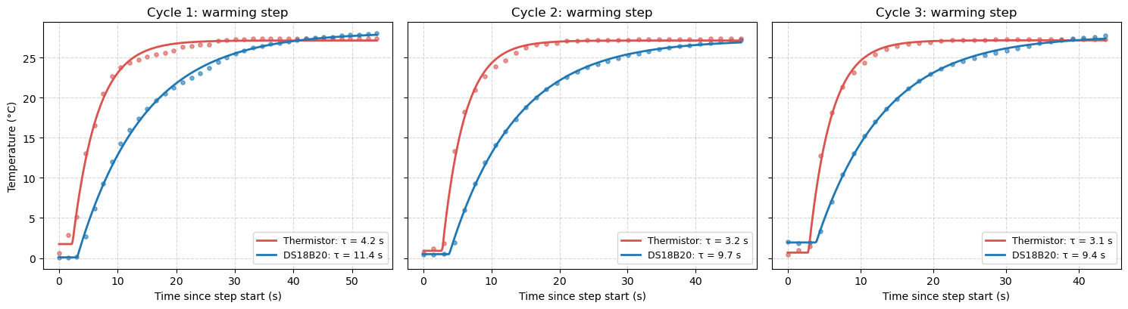
Figure 6. Exponential fits to the three warming steps, thermistor (red) and DS18B20 (blue).
Cycle | Thermistor τ (s) | DS18B20 τ (s) | Thermistor 10 to 90 percent (s) | DS18B20 10 to 90 percent (s)
1 | 4.21 | 11.39 | 10.45 | 24.99
2 | 3.25 | 9.75 | 8.55 | 21.99
3 | 3.06 | 9.36 | 7.47 | 21.62
Mean ± std | 3.51 ± 0.61 | 10.16 ± 1.08 | 8.8 ± 1.5 | 22.9 ± 1.8
Table 6. Time constants and response times (10 to 90 percent rise) of the warming steps.
The last row of Table 6 gives the response time of the thermistor, the 10 to 90 percent rise, and its time constant. The DS18B20 is about three times slower, and the ratio of the two time constants is steadier between cycles (2.7 to 3.1) than either value alone, because cycle 1 was slow for both sensors, probably from how the rig was plunged. The spread between cycles is larger than the fit standard errors of 0.07 to 0.25 s, so the spread is the honest uncertainty. The DS18B20 rise times match 2.197 τ, so one exponential describes it. The thermistor rise is 10 to 20 percent longer than 2.197 τ, which shows a mild slow tail, so a single time constant slightly flatters the thermistor.

5.2 Cooling steps
Figure 7 shows the cooling steps. They start after a delay of 7 to 8 s for the thermistor and 10 to 12 s for the DS18B20, and they are not single exponentials, because the ice contact was uneven. The thermistor falls quickly and then creeps towards the final value. Their 10 to 90 percent fall time was therefore measured instead (Table 7). Cycle 2 had a much sharper dip and is left out of the average.
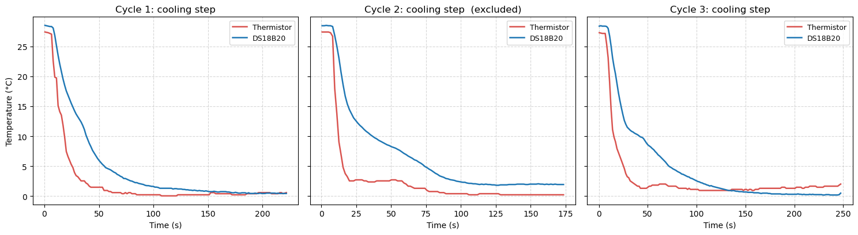
Figure 7. The three cooling steps, thermistor (red) and DS18B20 (blue).
Cycle | Thermistor fall time (s) | DS18B20 fall time (s) | Used in comparison
1 | 23.9 | 60.0 | Yes
2 | 10.8 | 66.3 | No, sharper dip
3 | 18.3 | 81.6 | Yes
Table 7. 10 to 90 percent fall times of the cooling steps.
The thermistor fall time is longer than its rise time because ice contact is poorer than contact with the beaker. The DS18B20 fall times are lower bounds, because it had not fully settled when each record ended.

5.3 Agreement on settled points
The calibration of 2 October was tested on the settled plateaus, since the reference is accurate only when it is not changing (Figure 8). At the ice plateau the calibrated thermistor agrees with the DS18B20 (difference 0.01 °C, spread 1.02 °C, mostly from the bath and the reference). At the room temperature plateau it reads 1.03 °C below the DS18B20 (spread 0.10 °C).
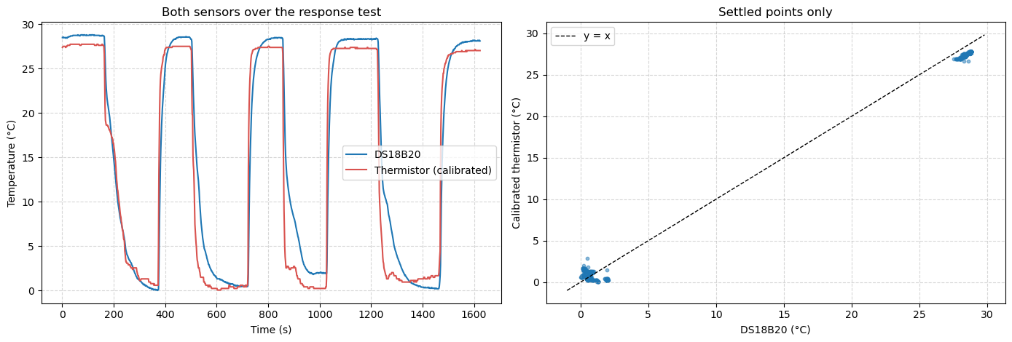
Figure 8. Calibrated thermistor and DS18B20 over the response run (left) and on settled points only (right).
An offset at one end only points to a bias in the calibration, not a shifted rig. A likely cause is the lag of the DS18B20 during the heating run: the lag error grows with the heating rate, which was close to zero near ice and of order 0.1 °C per second near 28 °C, so the calibration maps the thermistor onto readings that are too low in that region.
6. The DS18B20 as an automated reference
Automation gave thousands of calibration points and hundreds of response points, logged with exact timestamps and loaded directly into the analysis, where a hand calibration would give a few dozen readings. It also has costs. The accuracy of the DS18B20 sets the limit of the calibration (Table 5). The 1.5 s loop gives only about two samples per thermistor time constant. Most importantly, the DS18B20 is the slower sensor, so it is a valid reference for slow changes only, and the fast heating ramp biased the calibration (section 5.3). Improvements are to remove the extra 1 s delay, because the library already waits for the conversion; to read the ADC continuously while the conversion runs in the background.

7. Conclusion
The thermistor in configuration 2 was calibrated against the DS18B20 with a single cubic, given in section 4.4, which converts the ADC count to temperature over the whole measured range within the accuracy of Table 5. Heating and cooling agree to within the accuracy of the reference, so one curve serves both directions. The thermistor follows the exponential law of the sheet with one constant B, but the two-parameter model is less accurate than the cubic, so the cubic is the working calibration. The sensor is most sensitive in the middle of the range, as the simulation predicted. The thermistor responds about three times faster than the DS18B20, with a response time given in Table 6, which makes the DS18B20 a valid reference for slow changes only and probably causes the bias seen at the room temperature plateau. The next steps are a lag-corrected recalibration, a check of the reference at fixed points, and a Steinhart-Hart fit.

6. Homework

6.1 PID Controller
PID means:
- P — Proportional
- I — Integral
- D — Derivative
A PID controller is used when you want a system to reach and maintain a desired value (called the setpoint). The proportional part responds to how big the current error is. The integral part looks at the accumulated error over time. Derivative looks at how quickly the error is changing.
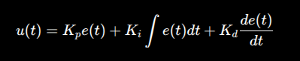

6.2 Sensor Characteristic Parameters

Static characteristics
How the sensor behaves when the input is constant or changes very slowly.

Accuracy | How close the measured value is to the true value.
Precision | How consistently the sensor gives the same result.
Sensitivity | This one is very important for sensors.
Resolution | Resolution is the smallest change in input that the sensor/system can detect.
Range | The range tells you the minimum and maximum input the sensor can measure.
Linearity | Ideally, when the physical quantity increases, the sensor output should increase proportionally.

Dynamic characteristics
How the sensor behaves when the input changes with time.

Response time | How long does the sensor take to respond to a change in input?
Time constant

