# **Bonnie The ultimate kit assemble management service**

System design (kind of)

Version: 0.0.1

# **Goal**

There is a shop, which is selling different kits which can be ordered assembled or unassemled. Our service takes asyncronous orders from the shop. Every order can contain multiple types and amounts of kits.

Those orders that contains some kits to assemble can then be claimed by an assembler, who assembles them. After the successful assemble the order is passed to the delivery company.

Our service needs to provide some communication channels that the shop can use to place orders, and needs to provide information to the shop about the status of the placed orders.

Assemblers needs to be able claim unassigned orders and modify their status in the system.

There needs to be an admin as well, who can place an order manually, and who can modify almost any data related to the system

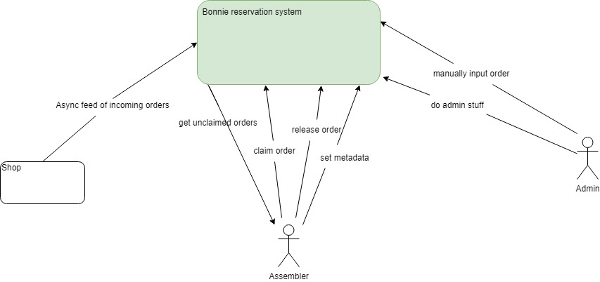

# **Roles**

* Assembler
* Admin

# **Interactions by roles:**

1. **Assembler**

* getUnclaimedOrders

(We need to keep track of orders and if they are already assigned to an assembler, so the free assemblers can easily pick from the unclaimed ones.)

* getClaimedOrders

(We need to provide a way to the assemblers to list the orders claimed by them, so they can update the status of them.)

* AssignKitToAssembler

(Assemblers needs to be able to claim a kit, so there won't be any conflicts during the assembling process.)

* updateOrderStatus

(Assemblers needs a way to update the status of the kit(s) claimed by them, so that the shop can be updated on the status of the order.)

1. **Admin**

* **createOrder**

(The admin need to be able to manually create an order)

* **setUserRole**

(The admin need to be able to set the role of a user)

* **setUserData**

(The admin needs to be able to modify user data)

* **setAssignment**

(The admin need to be able to assign an order to a different assembler)

* **modifyOrder**

(The admin need to be able to modify an order based on the Id (TrakcingNr maybe))

**User Stories:**

Shop **As a shop I want to...**

1. **be able to make orders on preassembled goods, so that I can sell them to my customers**
2. **be sure that the goods I ordered are managed correctly, so I need to be able to check the status of the orders by the trackingNr provided**

Assembler **As an assembler I want to be able to ...**

1. **get the list of orders I can assemble (unclaimed orders), so that I can pick one to work on it.**
2. **claim an order, so that I can be sure there is no other assembler working on the same order**
3. **release unfinished orders if I'm not capable of finishing it, so that others can claim it and complete the assemling process from the beginning (no progress in assemble, it's either not started or finished)**
4. **modify order status, so that the shop can keep track of that.**

Admin **As an admin I want to be able to ...**

1. **manually create an order, so that I can create a new order if needed**
2. **make other users admin, so in case of an admin change, I can delegate the role**
3. **modify non credential user data, so I can fix if there is some problem with it**
4. **reassign/unassign an order, so if something happens to an assembler the process can still continue**
5. **modify not shipped order based on id or tracking number, so I can fix if there is some problem in the data**