Compte-rendu TD10

Prédicats retourneUtile/3 et retourne/2 pour renverser une liste qu’on utilisera pour renverser les listes de cases, plus précisément les chemins solutions du labyrinthe
retourneUtile([T|Q],X,L) :- retourneUtile(Q,X,[T|L]).
retourneUtile([],L,L).
retourne(L,R) :- retourneUtile(L,R,[]).

Prédicat dessine_chemin/2 pour colorier les cases d’une liste de case
dessine_chemin([], _).
dessine_chemin([ case(X,Y) | Q ], C) :-
laby(X,Y, V), V \== 3,
N is 19*Y+X,
gr_rect_couleur(N, C),
dessine_chemin(Q, C)
.
dessine_chemin([ case(X,Y) | Q], C) :-
laby(X,Y, 3),
dessine_chemin(Q,C).

Prédicat avanceDe/2 qui cherche les solutions d’un labyrinthe et dessine les résultats
avanceDe(X,Y,_) :- sleep(0.01), rougeXY(X,Y),fail.

avanceDe( X, Y, L) :-laby(X,Y,3),
retourne([case(X,Y)|L],Chemin),
dessine_chemin(Chemin,yellow),
sleep(0.5),fail.

avanceDe(X,Y, ListeAriane) :-
laby(X,Y,R),
R \== 1,
Y1 is Y - 1,
laby(X,Y1,R1),
R1 \== 1,
\+ member(case(X,Y1),ListeAriane),
avanceDe(X,Y1,[case(X,Y) |ListeAriane]).

avanceDe(X,Y, ListeAriane) :-
laby(X,Y,R),
R \== 1,
X1 is X - 1,
laby(X1,Y,R1),
R1 \==1,
\+ member(case(X1,Y),ListeAriane),
avanceDe(X1,Y, [case(X,Y) |ListeAriane]).

avanceDe(X,Y, ListeAriane) :-
laby(X,Y,R),
R \== 1,
X1 is X + 1,
laby(X1,Y,R1),
R1 \== 1,
\+ member(case(X1,Y),ListeAriane),
avanceDe(X1,Y, [case(X,Y) |ListeAriane]).

avanceDe(X,Y, ListeAriane) :-
laby(X,Y,R),
R \== 1,
Y1 is Y + 1,
laby(X,Y1,R1),
R1 \== 1,
\+ member(case(X,Y1),ListeAriane),
avanceDe(X,Y1, [case(X,Y) |ListeAriane]).

avanceDe(X,Y,_) :- blancXY(X,Y), fail.

Prédicat avanceDeCollect/4 qui génère les chemins solutions C du labyrinthe
avanceDeCollect( X, Y, L,Chemin) :-laby(X,Y, 3),
retourne([case(X,Y)|L],Chemin).

avanceDeCollect(X,Y, ListeAriane,C) :-
laby(X,Y,R),
R \== 1,
Y1 is Y - 1,
laby(X,Y1,R1),
R1 \== 1,
\+ member(case(X,Y1),ListeAriane),
avanceDeCollect(X,Y1,[case(X,Y) |ListeAriane],C).

avanceDeCollect(X,Y, ListeAriane,C) :-
laby(X,Y,R),
R \== 1,
X1 is X - 1,
laby(X1,Y,R1),
R1 \==1,
\+ member(case(X1,Y),ListeAriane),
avanceDeCollect(X1,Y, [case(X,Y) |ListeAriane],C).

avanceDeCollect(X,Y, ListeAriane,C) :-
laby(X,Y,R),
R \== 1,
X1 is X + 1,
laby(X1,Y,R1),
R1 \== 1,
\+ member(case(X1,Y),ListeAriane),
avanceDeCollect(X1,Y, [case(X,Y) |ListeAriane],C).

avanceDeCollect(X,Y, ListeAriane,C) :-
laby(X,Y,R),
R \== 1,
Y1 is Y + 1,
laby(X,Y1,R1),
R1 \== 1,
\+ member(case(X,Y1),ListeAriane),
avanceDeCollect(X,Y1, [case(X,Y) |ListeAriane],C).

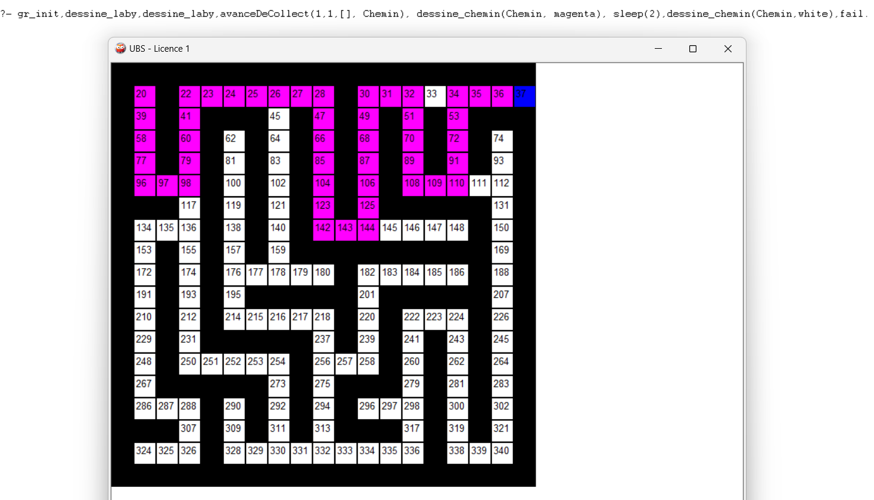
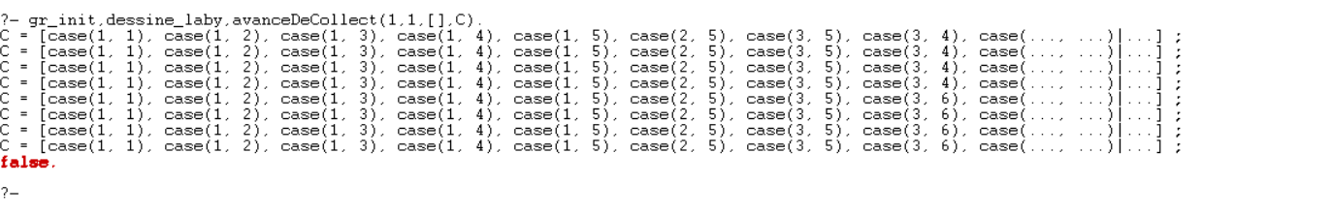
Prédicat eviteMinotaure(X,Y, Chemin)/3
eviteMinotaure(X,Y, Chemin) :- avanceDeCollect(1,1,[],Chemin),
\+ member(case(X,Y),Chemin).

Dans la console
?- findall(C,eviteMinotaure(13,12,C),L).
L = [[case(1, 1), case(1, 2), case(1, 3), case(1, 4), case(1, 5), case(2, 5), case(3, 5), case(..., ...)|...], [case(1, 1), case(1, 2), case(1, 3), case(1, 4), case(1, 5), case(2, 5), case(..., ...)|...], [case(1, 1), case(1, 2), case(1, 3), case(1, 4), case(1, 5), case(..., ...)|...], [case(1, 1), case(1, 2), case(1, 3), case(1, 4), case(..., ...)|...]].

?- findall(C,eviteMinotaure(1,1,C),L).
L = [].

?- findall(C,eviteMinotaure(14,9,C),L).
L = [[case(1, 1), case(1, 2), case(1, 3), case(1, 4), case(1, 5), case(2, 5), case(3, 5), case(..., ...)|...], [case(1, 1), case(1, 2), case(1, 3), case(1, 4), case(1, 5), case(2, 5), case(..., ...)|...], [case(1, 1), case(1, 2), case(1, 3), case(1, 4), case(1, 5), case(..., ...)|...], [case(1, 1), case(1, 2), case(1, 3), case(1, 4), case(..., ...)|...], [case(1, 1), case(1, 2), case(1, 3), case(..., ...)|...], [case(1, 1), case(1, 2), case(..., ...)|...], [case(1, 1), case(..., ...)|...], [case(..., ...)|...]].

