Part F — The Recommendation
Memo to the Academic Director — Remote-Attendance Policy for Long-Commute Students
The Answer
Do not run the full remote-attendance policy as proposed. The commute-time data does not show that commuting meaningfully hurts academic performance — the correlation between commute time and final score is essentially zero (r = −0.04). The same budget would do far more good directed at the factor the data actually points to: study time, which correlates far more strongly with final score (r = +0.60).
The Evidence
Commute time is right-skewed (mean 45.4 min vs. median 33.0 min), so we report the median as the “typical” commute, not the mean — a small number of very long commutes pull the average up. Cairo alone drags the branch-wide average from 35.4 min (excluding Cairo) up to 45.4 min overall (Chart 1, Chart 2, Table 1). Despite this real commute burden, the correlation between commute time and final score is only −0.04. By contrast, study_hours_week correlates at +0.60 with final score — roughly fifteen times stronger, and by far the strongest relationship in the dataset (Chart 3). Comparing the top quartile of commuters to everyone else shows almost no score gap (78.5 vs. 79.4, well under one point — far smaller than one standard deviation within either group).
Who Qualifies
If the board wishes to proceed on wellbeing grounds rather than performance grounds, we recommend the top quartile of commute time — above 59.2 minutes — as the threshold. This is the 75th percentile (Q3), a standard, defensible statistical cut rather than an arbitrary round number. It covers 61 of 243 students with valid commute data (≈25.1%).
What We Cannot Conclude
We cannot claim commuting has no effect on performance — only that none was detectable in this sample. The survey was voluntary response, not random: students without laptops (10%–24% of respondents depending on branch) and, plausibly, the most time-burdened long-commute students were likely under-represented, which would bias the measured effect toward zero rather than away from it. We also cannot claim study hours cause higher scores — only that the two move together; motivated students may simply study more and perform better for unrelated reasons. About 22% of students have missing data on favorite sport, concentrated in specific tracks (Web Development / UI-UX show roughly double the missing rate of Data Science and Embedded Systems), which may further shift who is represented in these numbers.
What We Should Do Next
Before committing budget, re-run this survey using stratified random sampling (by branch × track, drawn from the enrollment roster rather than a voluntary form) with active follow-up on non-respondents, to confirm whether the near-zero commute effect holds once the sampling bias is removed.

Supporting Charts & Summary Table
Submitted per the case study requirements (4 charts + branch summary table)
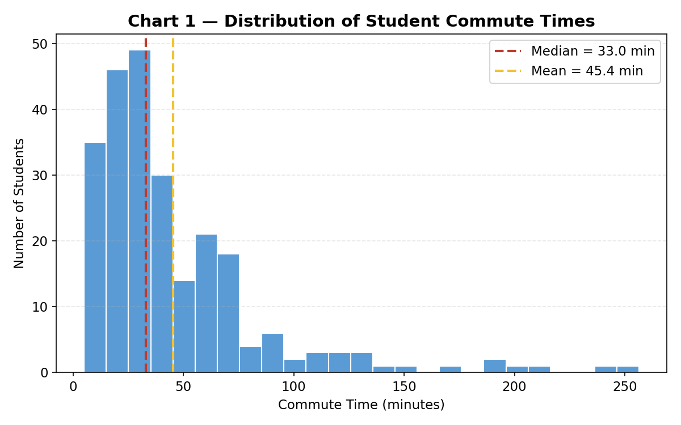
Chart 1 — Distribution of commute times (minutes). Right-skewed: median (33.0) well below mean (45.4).
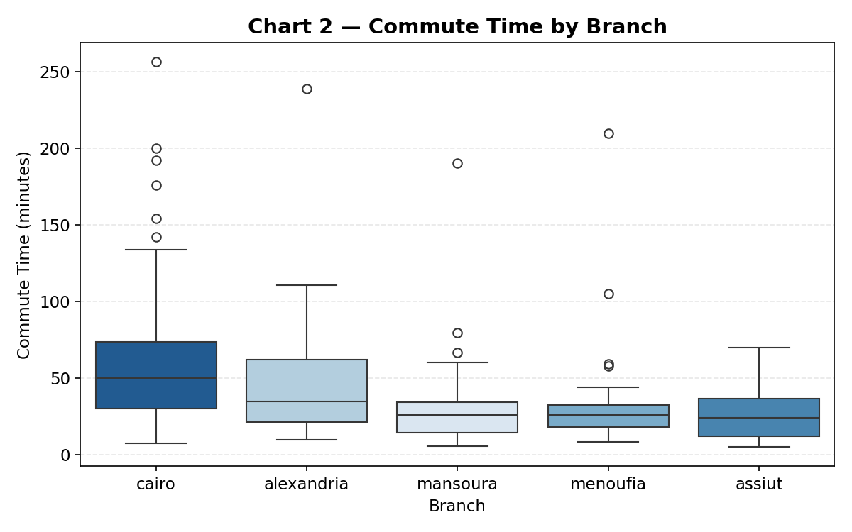
Chart 2 — Commute time (minutes) by branch. Cairo has both the highest median and the widest spread.
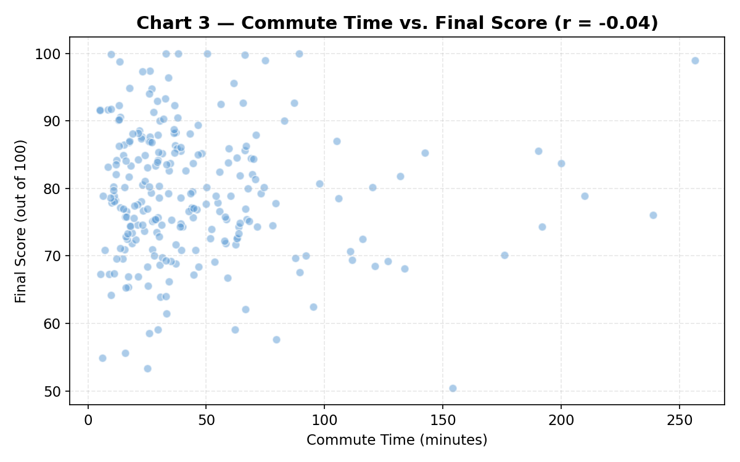
Chart 3 — Commute time (minutes) vs. final score (0–100). No visible relationship; r = −0.04.
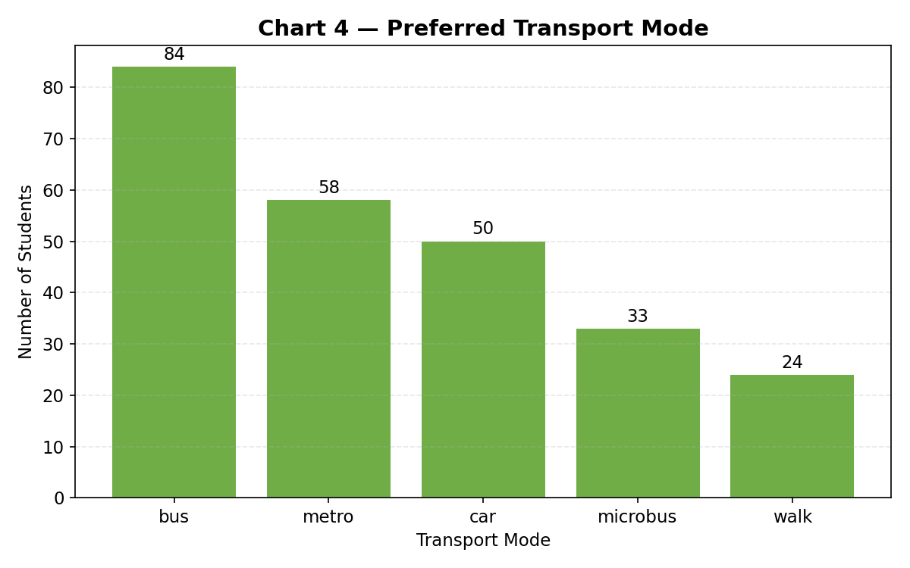
Chart 4 — Preferred transport mode (count of students). Nominal variable → bar chart, not a pie chart.
Table 1 — Commute Time and Final Score by Branch
Branch | n | Commute Mean (min) | Commute Median (min) | Commute SD | Score Mean | Score Median | Score SD
Cairo | 95 | 61.1 | 50.1 | 45.4 | 79.8 | 80.0 | 10.0
Alexandria | 49 | 43.8 | 34.8 | 37.1 | 79.0 | 78.5 | 10.7
Mansoura | 40 | 31.9 | 26.0 | 30.7 | 77.6 | 77.0 | 9.2
Menoufia | 30 | 35.7 | 25.8 | 37.9 | 77.2 | 77.0 | 8.8
Assiut | 29 | 25.9 | 24.0 | 16.4 | 80.5 | 82.4 | 8.8

