OPERATING SYSTEMS PROJECT
Round Robin vs Priority Scheduling
Comparison Project

Technical Documentation Report
An interactive browser-based simulation of CPU scheduling algorithms
Course | Operating Systems
Project Title | Round Robin vs Priority Scheduling Comparison
Implementation | HTML | CSS | JavaScript
Platform | Browser-based Web Application
Academic Year | 2025 – 2026
Repository | https://github.com/KenzyHussein/scheduler-simulation-os

1. Project Overview
This project implements a fully interactive, browser-based CPU scheduling simulator that demonstrates and compares two classic scheduling algorithms: Round Robin (RR) and Preemptive Priority Scheduling. The simulator enables students and instructors to input custom process sets, observe execution behavior through animated Gantt charts, and evaluate performance through computed scheduling metrics.

The primary objective is to provide a hands-on, visual tool that illustrates the trade-offs between fairness-oriented and urgency-oriented scheduling strategies. Rather than relying on static diagrams or theoretical derivations, users interact directly with the simulation engine to explore how scheduling decisions affect turnaround time, waiting time, and response time across different workload patterns.

Project Goals
• Implement Round Robin and Preemptive Priority scheduling in pure JavaScript
• Provide a dynamic process input interface with real-time validation
• Visualize execution order through interactive Gantt charts
• Calculate and display per-process metrics: CT, TAT, WT, RT
• Compare algorithm averages side-by-side in a unified results panel
• Support configurable time quantum for Round Robin
• Include reset/clear functionality to restart simulations

2. Technologies Used
The project is implemented entirely using client-side web technologies, requiring no server infrastructure, build tools, or external runtime dependencies. The complete application runs in any modern browser by opening the HTML file directly.

Technology | Version / Source | Role
HTML5 | Native Browser | Page structure, input forms, result containers
CSS3 | Native Browser | Dark-theme UI, Gantt chart layout, responsive grid
JavaScript (ES6+) | Native Browser | Scheduling logic, DOM manipulation, metrics computation

No JavaScript frameworks, bundlers, or back-end services are required. The application is structured across four files to separate concerns clearly:

- os_scheduler.html
- Entry point and DOM structure. Imports all other files.
- logic.js
- Contains runRoundRobin() and runPriority() — the core scheduling engines.
- metrics.js
- Contains calculateAverages() and compareAlgorithms() — aggregation and comparison helpers.
- style.css
- Full visual theme: dark background, accent palette, table styles, Gantt chart layout, and responsive breakpoints.

3. Algorithms Description

3.1 Round Robin (RR)
Round Robin is a preemptive, time-sharing scheduling algorithm designed to distribute CPU time fairly among all ready processes. Each process is assigned a fixed execution window called the time quantum (Q). When a process's quantum expires, it is preempted and added to the back of the ready queue, allowing the next process to run.

Round Robin — Key Behavioral Properties
• Preemptive: a running process is interrupted when its quantum expires
• FCFS-ordered ready queue: newly arrived processes join the back of the queue
• Configurable quantum: user sets Q before simulation; affects context-switch frequency and responsiveness
• No starvation: every process is guaranteed CPU time within a bounded cycle
• Gantt chart may show a process appearing multiple times (fragmented execution)

Implementation note: The simulator uses a simulation-clock approach with an explicit ready queue. At each scheduling decision, the clock advances by min(remainingTime, Q). Newly arriving processes detected during the quantum window are added to the ready queue before the running process is re-queued (if it has remaining time). This matches standard RR semantics.

Metric | Formula
Completion Time (CT) | Time at which the process finishes execution
Turnaround Time (TAT) | CT − Arrival Time
Waiting Time (WT) | TAT − Burst Time
Response Time (RT) | First CPU Start Time − Arrival Time

3.2 Preemptive Priority Scheduling
Priority Scheduling assigns each process a numeric priority value. At every clock tick, the scheduler selects the available process with the lowest priority number (lower number = higher urgency). If a higher-priority process arrives while a lower-priority one is running, the running process is immediately preempted.

Priority Scheduling — Key Behavioral Properties
• Preemptive: higher-priority arrivals immediately displace the current process
• Lower priority number = higher urgency (e.g., priority 1 runs before priority 3)
• Tie-breaking: when two processes share the same priority, the one with the earlier arrival time is preferred (FCFS tie-breaking)
• Starvation risk: low-priority processes may be indefinitely delayed if high-priority processes keep arriving
• Gantt chart: consecutive ticks of the same process are merged into a single segment for readability

Implementation note: The scheduler evaluates all ready processes at each unit clock tick (tick-by-tick simulation) and selects the minimum-priority process among those with arrivalTime ≤ currentTime. The Gantt chart builder merges adjacent ticks of the same process into a single bar to reduce visual noise.

4. Features Implemented

4.1 Dynamic Process Input
Users construct the process set interactively through a form interface. Each process requires the following input fields:

Field | Data Type | Description
Process ID (PID) | Text / Auto-generated | Unique identifier shown in Gantt chart and results table
Arrival Time | Non-negative Integer | The clock tick at which the process becomes available
Burst Time | Positive Integer | Total CPU time required to complete the process
Priority | Positive Integer | Used by Priority Scheduling only (lower = higher urgency)

Processes are added to a live table below the input form. Each row shows all entered values and includes a delete button for selective removal. The entire process list can be cleared with the Reset button.

4.2 Round Robin Time Quantum Configuration
Before running a Round Robin simulation, the user specifies the time quantum Q through a dedicated input field. A quantum display badge confirms the selected value. The simulator enforces Q ≥ 1. Choosing a small quantum increases context switching (better responsiveness, lower throughput), while a large quantum approaches First-Come-First-Served behavior.

4.3 Gantt Chart Visualization
Both algorithms generate a horizontal Gantt chart displaying the execution timeline. Each colored segment represents a scheduling interval and shows the Process ID and time range. An axis beneath the chart labels the start and end times of each interval. The chart container supports horizontal scrolling for long execution sequences.

4.4 Per-Process Metrics Table
After simulation, a results table is generated for each algorithm displaying the following columns for every process:
- CT — Completion Time: the absolute time the process finishes
- TAT — Turnaround Time: total elapsed time from arrival to completion (CT − Arrival)
- WT — Waiting Time: time spent waiting in the ready queue (TAT − Burst)
- RT — Response Time: delay between arrival and first CPU allocation (First Start − Arrival)

Average values for WT, TAT, and RT are computed and displayed in a summary statistics bar below each table using the calculateAverages() function from metrics.js.

4.5 Side-by-Side Comparison
The compareAlgorithms() function in metrics.js combines both simulation results into a unified comparison structure. Averages for both algorithms are displayed simultaneously, enabling direct assessment of which algorithm performs better for a given workload in terms of average waiting time, turnaround time, and response time.

4.6 Reset Functionality
A dedicated Clear / Reset button wipes all input processes, clears the Gantt charts, and resets all metrics tables to their empty state. This allows the user to run multiple test scenarios within a single session without reloading the page.

5. Input Validation
The simulator enforces strict input validation before adding a process or running a simulation. The following rules are applied:

Rule | Condition Checked | Error Behavior
Non-empty PID | PID field must not be blank | Alert shown ;process ID is required
Unique PID | PID must not duplicate an existing process | Alert shown; PID already exists
Valid Arrival Time | Arrival ≥ 0 and is an integer | Alert shown; Enter a Valid Arrival Time
Valid Burst Time | Burst ≥ 1 and is an integer | Alert shown; Burst Time must be >=1
Valid Priority | Priority ≥ 1 and is an integer (Priority mode only) | Alert shown; Priority must be >=1
Valid Quantum | Q ≥ 1 and is an integer (Round Robin only) | Alert shown; Time Quantum must be >=1
Minimum Processes | At least one process must exist before running | Alert shown; Add process first

All validation is performed client-side in JavaScript before any scheduling computation begins. Invalid inputs do not corrupt the process list or trigger partial simulations.

6. Test Scenarios
Five test scenarios were designed to evaluate the algorithms across different workload patterns. Each scenario targets a specific scheduling property: balanced throughput, urgency handling, fairness, starvation risk, and input validation.

Scenario A — Basic Mixed Workload
Purpose: Verify that both algorithms produce correct metrics on a typical workload with mixed burst times and arrival times.
PID | Arrival | Burst | Priority
P1 | 0 | 6 | 2
P2 | 2 | 4 | 1
P3 | 4 | 2 | 3
P4 | 6 | 8 | 2

Time Quantum (RR): Q = 3
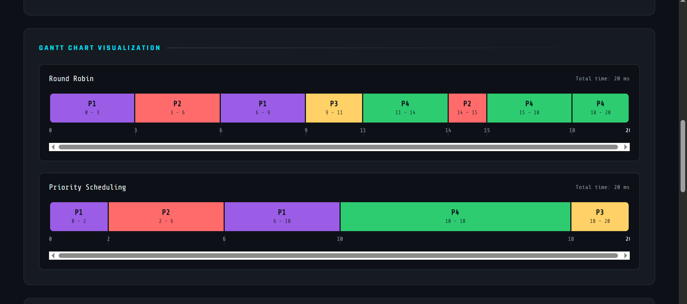
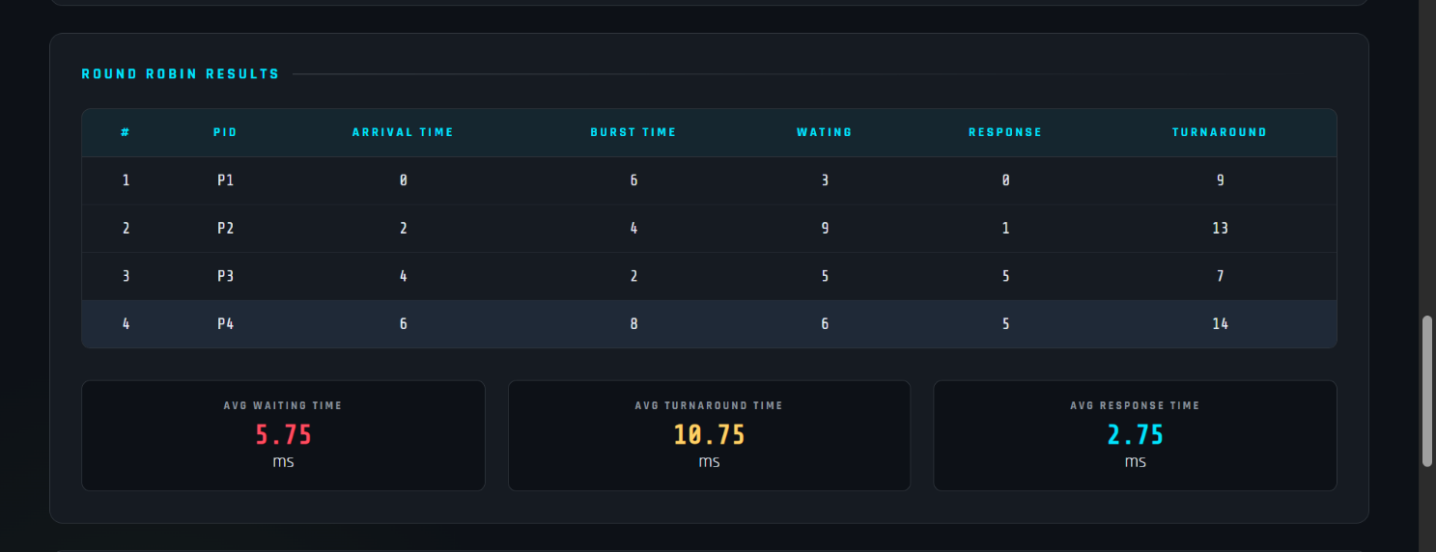
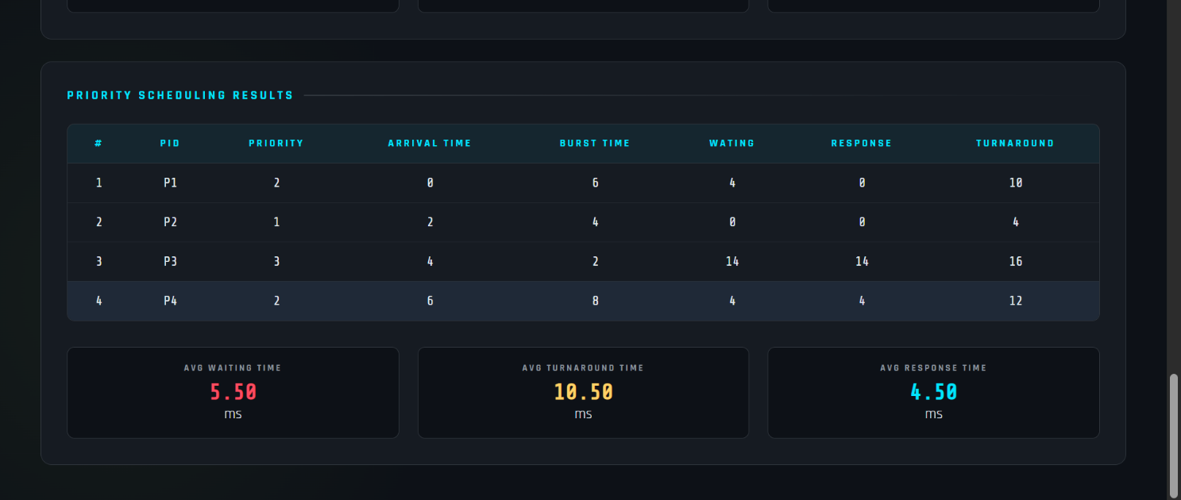

Scenario B — Urgency Case
Purpose: Demonstrate that Priority Scheduling correctly handles an emergency process arriving mid-execution, preempting the running process.

PID | Arrival | Burst | Priority
P1 | 0 | 10 | 3
P2 | 4 | 2 | 1
P3 | 5 | 3 | 2

Time Quantum (RR): Q = 3
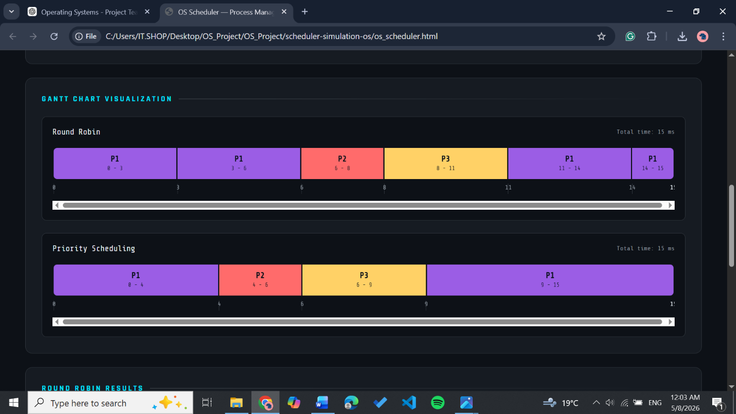
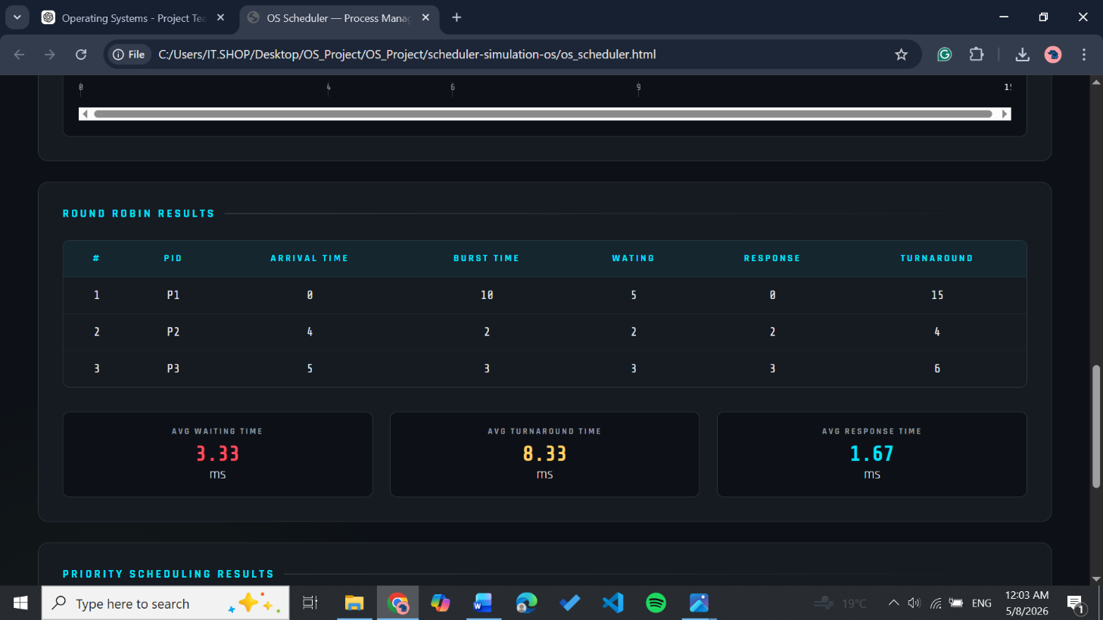
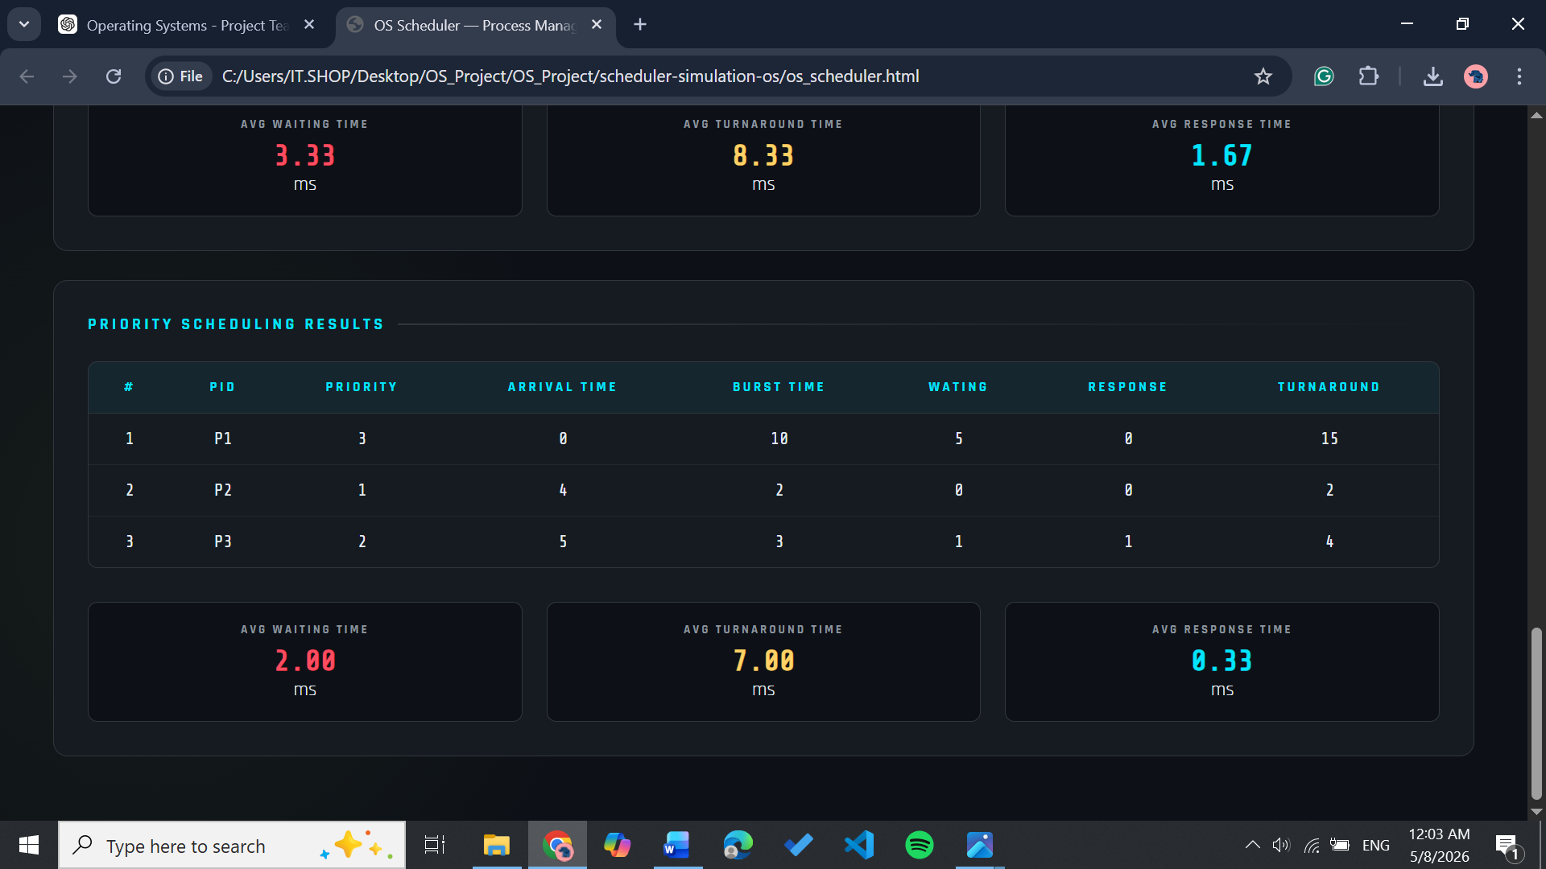

Scenario C — Fairness Case
Purpose: Show that Round Robin distributes CPU time evenly among equal-priority processes, while Priority Scheduling may unfairly favor certain processes.
PID | Arrival | Burst | Priority
P1 | 0 | 8 | 1
P2 | 0 | 8 | 1
P3 | 0 | 8 | 1
Time Quantum (RR): Q = 3

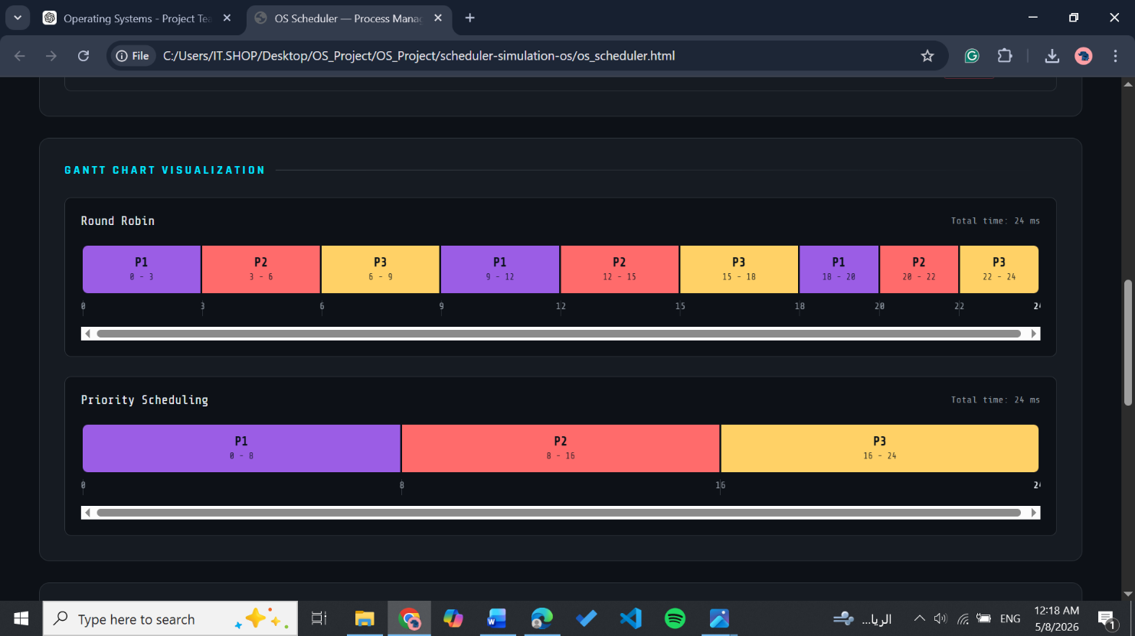

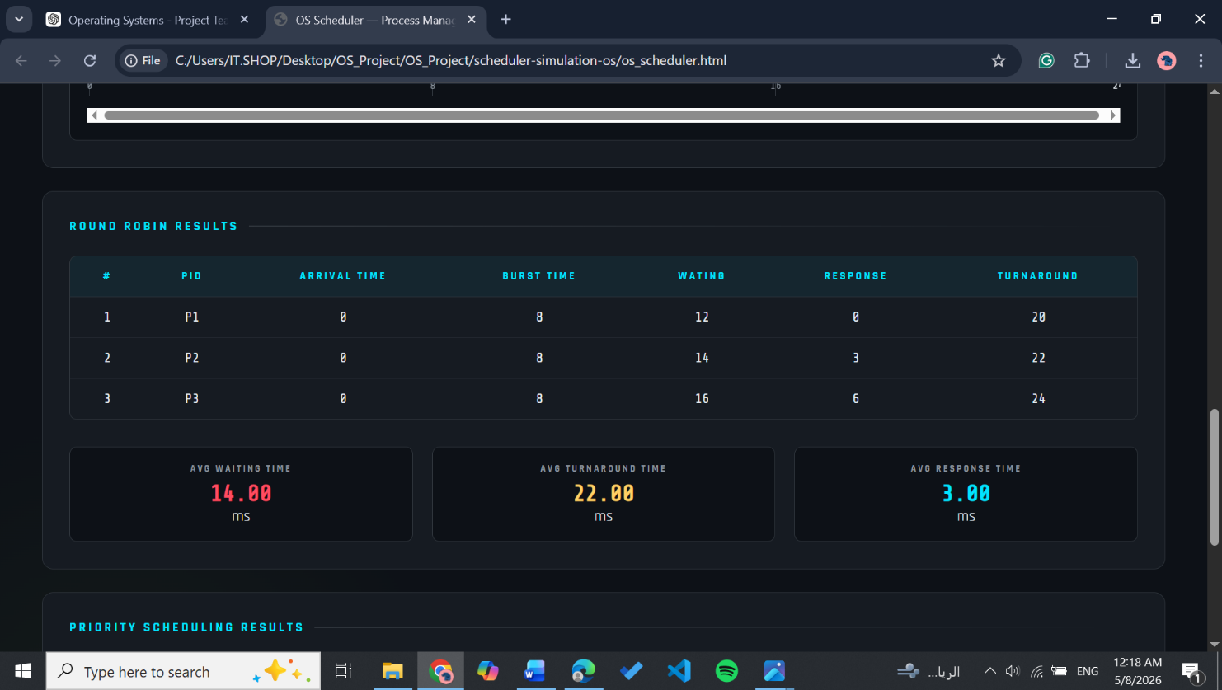

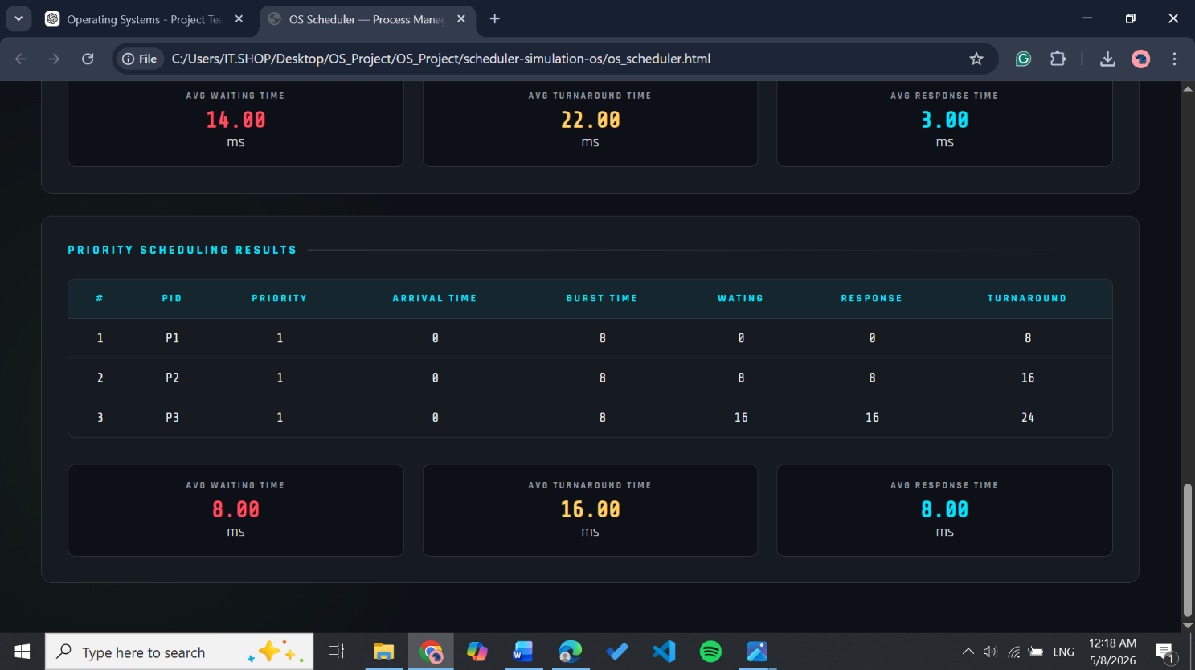

Scenario D — Starvation Case
Purpose: Demonstrate starvation in Priority Scheduling when a continuous stream of high-priority processes prevents a low-priority process from receiving CPU time.
PID | Arrival | Burst | Priority
P1 | 0 | 4 | 1
P2 | 1 | 4 | 1
P3 | 2 | 4 | 1
P4 | 0 | 6 | 5
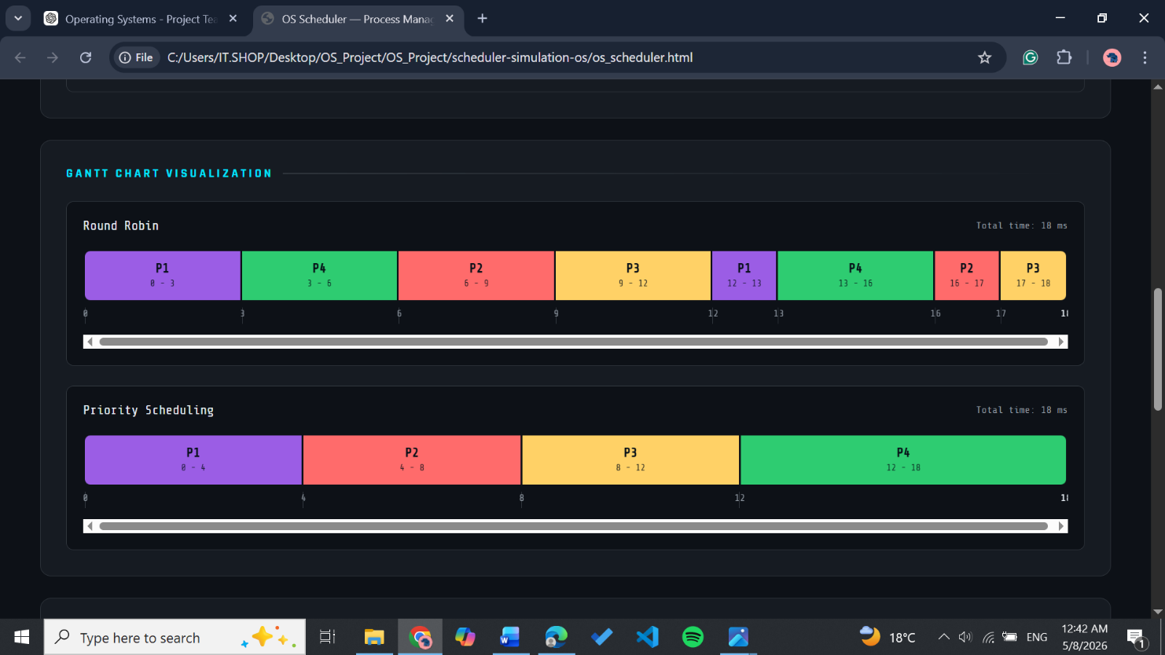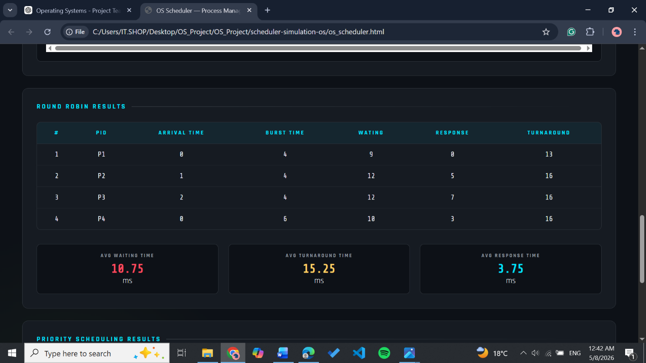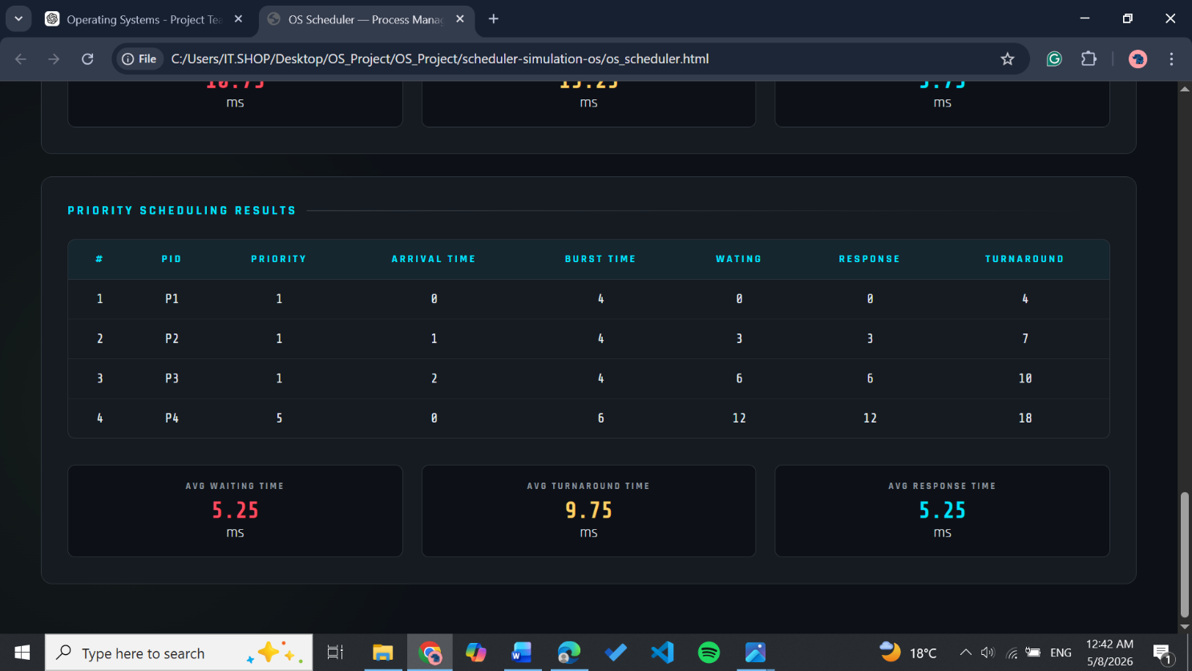

Scenario E — Validation Case
Purpose: Verify that the input validation subsystem correctly rejects invalid inputs and prevents erroneous simulations.

Test Action | Expected System Response
Submit form with empty PID | Error alert: process ID is required
Enter duplicate PID | Error alert: PID already exists
Enter Burst Time = 0 | Error alert: Burst Time must be >=1
Enter negative Arrival Time | Error alert: Enter a Valid Arrival Time
Set Q = 0 then run RR | Error alert: Time Quantum must be >=1
Click Run with empty process list | Error alert: Add process first
Add new processes immediately after clicking CLEAR ALL | Input fields are cleared with no leftover values and ready to accept new data

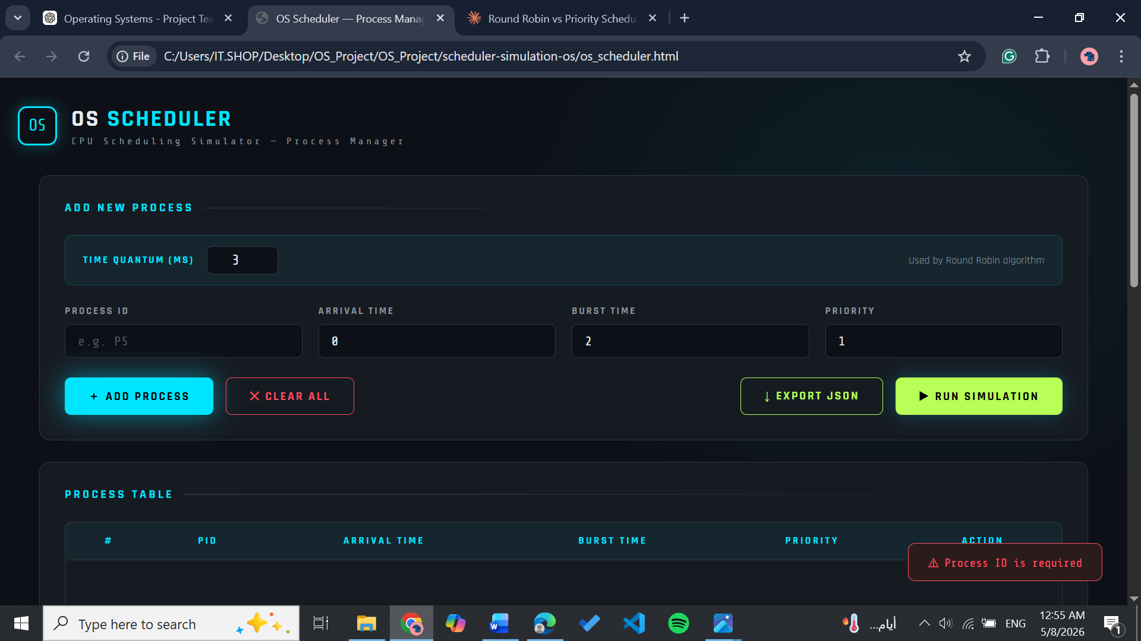
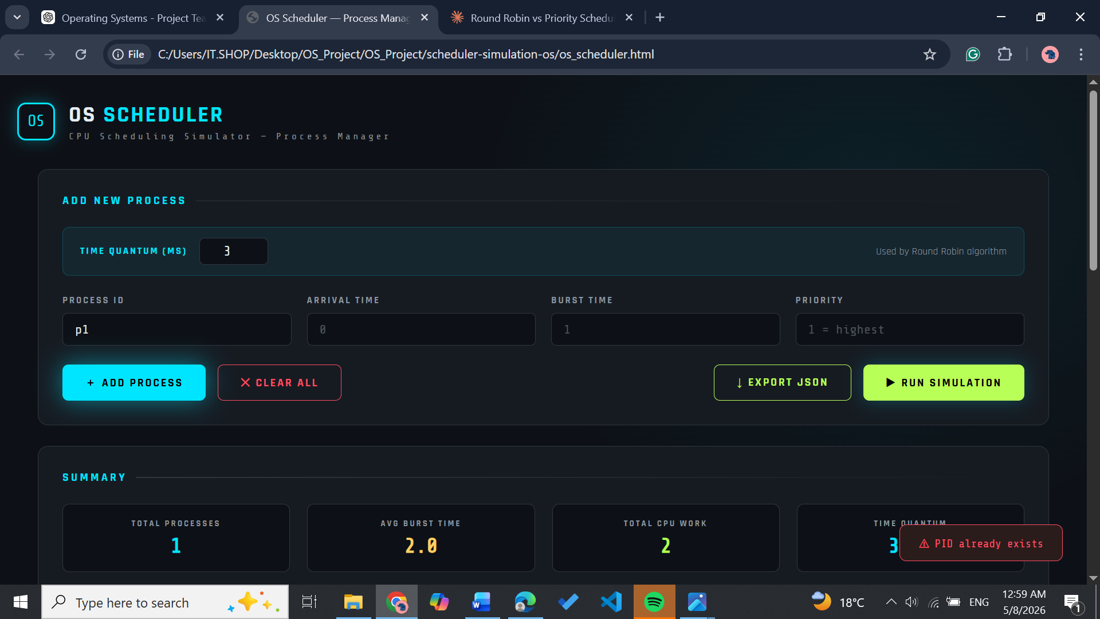

7. Comparison Analysis
The following table summarizes the behavioral and performance characteristics of both scheduling algorithms based on the test scenarios above.

Criterion | Round Robin | Priority Scheduling
Scheduling Type | Preemptive (time quantum) | Preemptive (priority-based)
Decision Criterion | Time quantum expiry | Lowest priority number wins
Tie-breaking | FCFS order in ready queue | Earlier arrival time (FCFS)
Starvation | Never — guaranteed CPU share | Possible for low-priority processes
Fairness | High — equal time slices | Low — priority-biased allocation
Urgency Handling | Not supported | Direct — high priority runs first
Avg Response Time | Low (bounded by Q × n) | Very low for high-priority, high for low-priority
Avg Waiting Time | Moderate — depends on Q | Low for urgent, high for non-urgent
Context Switches | Higher — every Q ticks | Lower — switches only on new arrivals or completion
Best Use Case | Interactive systems, equal-weight tasks | Real-time, urgent tasks, mixed criticality

7.1 Effect of Time Quantum on Round Robin
The quantum value Q is the primary tuning parameter for Round Robin:
- Q too small: excessive context switching increases overhead; poor throughput.
- Q too large: degrades to FCFS behavior; poor response time for late-arriving processes.
- Optimal Q: typically set to slightly greater than the average burst time of interactive tasks.

7.2 Priority Inversion and Starvation
Scenario D demonstrates a classical priority scheduling problem: a low-priority process (P4) suffers from starvation because a stream of higher-priority processes continuously occupies the CPU. In production operating systems, this is addressed through aging — gradually increasing the priority of waiting processes over time. This simulator does not implement aging, intentionally showcasing the raw starvation problem.

8. Required Analysis Questions

8.1 Which algorithm gave better average waiting time?
The answer depends on the workload. In scenarios where high-priority processes had short burst times (Scenario B), Priority Scheduling achieved a lower average waiting time because urgent processes were served immediately upon arrival. However, in balanced workloads (Scenario C), Round Robin produced more consistent and equitable waiting times across all processes. It is important to note that Priority Scheduling's average WT is misleading — it appears favorable overall but conceals extremely high waiting times for low-priority processes, as demonstrated in Scenario D.

8.2 Which algorithm gave better response time?
Priority Scheduling gave better response time for high-priority processes, since they preempt any running process the moment they arrive — their first CPU allocation is nearly immediate. Round Robin's response time is bounded but not instant: a process must wait for at most Q x (n-1) ticks before receiving its first CPU slot. However, for low-priority processes in Priority Scheduling, response time can be extremely high or effectively infinite in the presence of continuous high-priority arrivals.

8.3 Did higher-priority processes gain significant advantage?
Yes, clearly. In Scenario B and Scenario D, high-priority processes (priority = 1) received CPU access almost immediately upon arrival regardless of what was currently running. Their completion time, turnaround time, waiting time, and response time values were all significantly lower compared to low-priority processes in the same run. This confirms that Priority Scheduling actively rewards urgency at the direct cost of fairness to lower-priority processes.

8.4 Did Round Robin appear more balanced across all processes?
Yes. In Scenario C, where three identical processes arrived simultaneously, Round Robin produced nearly equal TAT and WT for all three by serving each in strict rotation. In Scenario D, even the low-priority process P4 received CPU time proportionally alongside the other processes, unlike in Priority Scheduling where it was continuously delayed. Round Robin's design inherently prevents any single process from monopolizing the CPU, making it the fairer choice across all tested scenarios.

8.5 Was starvation observed or likely in Priority Scheduling?
Starvation was directly observed in Scenario D. Process P4 (priority = 5) arrived at time 0 but received no CPU time until all higher-priority processes P1, P2, and P3 (all with priority = 1) had completed. In a real system where high-priority processes arrive continuously, P4 could be postponed indefinitely. This confirms that Priority Scheduling without an aging mechanism is vulnerable to starvation for low-priority processes. Round Robin showed complete immunity to this problem in the same scenario.

8.6 Which algorithm would you recommend for the tested workload, and why?
For the tested workload, Round Robin is the recommended algorithm. The scenarios used in this project consisted of general-purpose processes with no strict real-time deadlines, mixed burst times, and no genuine urgency distinctions that would justify priority-based preemption. In this context, Round Robin delivered fairer CPU distribution, predictable response times bounded by the time quantum, and complete immunity from starvation — ensuring that every process received CPU time within a reasonable window.

Priority Scheduling would be the better recommendation only if the workload contained genuinely time-critical tasks — such as interrupt handlers or real-time processes — where some processes must be served before others regardless of fairness. Since the tested scenarios did not represent such an environment, and since starvation was directly observed in Scenario D, Round Robin proved to be the more reliable and balanced choice for this specific workload.

9. Final Conclusion
This project demonstrates the practical implementation of two fundamental CPU scheduling algorithms — Round Robin and Preemptive Priority Scheduling — in a fully interactive, browser-based simulator. Through five structured test scenarios, the simulator confirms the following conclusions:

9.1 Which algorithm performed better on the selected datasets?
Round Robin performed better overall on the selected datasets due to its consistent and fair distribution of CPU time across all processes. Across the five test scenarios, Round Robin produced more balanced turnaround times and waiting times, ensuring that no process was left behind regardless of its priority value.

9.2 Did priority-based service improve urgent-task treatment?
Yes. Priority Scheduling significantly improved the treatment of urgent tasks — high-priority processes achieved notably lower response times and waiting times by preempting running processes immediately upon arrival. This confirms that priority-based service is effective when the workload contains genuinely time-critical tasks that must be handled before others.

9.3 Did Round Robin improve fairness?
Yes. Round Robin demonstrated clear fairness across all tested scenarios — every process received CPU time in equal time slices regardless of burst time or priority value. No process was left waiting indefinitely, and completion times were distributed evenly among processes sharing the same arrival time, as confirmed by Scenario C.

9.4 Did starvation risk appear?
Yes. Starvation was directly observed in Scenario D, where the low-priority process P4 was continuously delayed by higher-priority processes P1, P2, and P3 and received no CPU time until all others had completed. In a real system with a continuous stream of high-priority arrivals, P4 could wait indefinitely. Round Robin showed complete immunity to this problem in the same scenario.

Key Takeaways
• Fairness and urgency are fundamentally competing scheduling objectives
• Small time quanta improve responsiveness but increase overhead in Round Robin
• Starvation in Priority Scheduling requires aging to be solved in practice
• Visual Gantt charts make execution behavior immediately intuitive
• Client-side JavaScript is sufficient to fully simulate OS scheduling behavior

10. GitHub Repository
The complete source code for this project is hosted on GitHub. The repository contains all four project files (os_scheduler.html, logic.js, metrics.js, style.css) along with a README describing how to run the simulator locally.

Item | Details
Repository URL | https://github.com/KenzyHussein/scheduler-simulation-os
Main File | os_scheduler.html (open directly in browser)
Scheduling Logic | logic.js — runRoundRobin(), runPriority()
Metrics & Comparison | metrics.js — calculateAverages(), compareAlgorithms()
Styles | style.css — full dark-theme UI

Operating Systems Project

