Project Vision

# Title: Fractium Framework

# Team

|  |  |  |  |
| --- | --- | --- | --- |
| Name | Degree | Primary Role | Secondary Role |
| Keonwoo Ryoo | BSCSGD | Systems Programmer | Gameplay Designer |
| Justice Mealer | BAGD | Narrative Designer | UI/UX Designer |

# Project Duration

This is a two semester project. The first semester of the project is planned to be done solo. Based various circumstances, the second semester may be done as a team.

# Overview

Fractium Framework is set to deliver a minimum viable product of a 2D sprite-based combat system that contains tools for random generation and asset integration. The framework is designed for an appointment-based gameplay experience commonly found in mobile games but on a PC platform. Core systems will include concepts such as stamina systems, time-gating, and a classic RPG-style progression.

The objective is to take the well-established core system in mobile games and attempting to improve and integrate them into a PC environment. An example would be tying the stamina system to units in a situation where players have multiple individual units: Units sent to dungeons would lose stamina and maximum health to discourage or disable their continued use. This deviates from the global approach to stamina systems and adds a layer of complexity that is necessary to validate it as a PC game and not a mobile game.

The game itself is a dungeon-crawling RPG system utilizing 2D actors and 3D environments. Players will recruit multiple units to create a ‘faction’ of around 20 units. Each unit will be randomly generated with individual skills and stats pulled from multiple templates. Players will then form a party of up to 3 units to explore dungeons for resources and gear. This gameplay loop would be the core of the game with additional systems being added in as time allows.

# Genre / Subject

RPG, Management, Mid-core

References: Octopath Traveler, Rimworld,

# Target Users

The main audience of this game is RPG mobile gamers who are looking for a bit more complexity and RPG pc gamers who are looking for a bit more simplicity.

Fractium Framework is designed to appeal to mobile gamers by offering familiar systems with a faster-paced and more complex combat system that would be difficult to experience on a mobile platform.

Fractium Framework is designed to appeal to PC gamers by offering systems that limit prolonged gameplay, mitigating the pressure to play constantly, but keeping the same depth of RPG gameplay with optimal gear and build paths.

# Platform

Windows PC

[Stretch] Possible port to Android devices.

Users

Single Player

[Stretch] Asynchronous Multiplayer – Leaderboards, Events

[Stretch] Synchronous Multiplayer – Guilds, Trading

# Inspiration

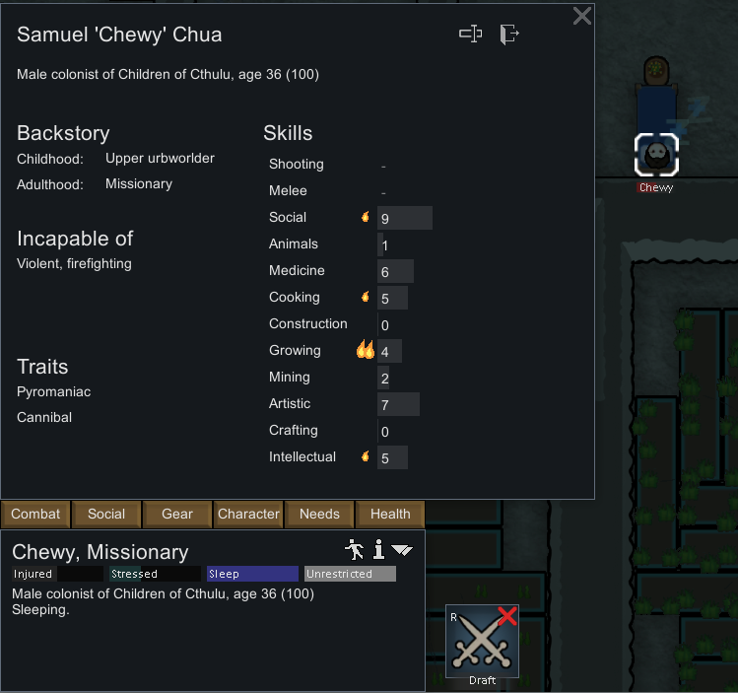Stories and concepts of managing a group of heroes have been prevalent for quite a long time. Many games utilize the template, but most games have a number of unique heroes that players must mix and match or a singular character that must select from a number of builds. I want to make a game where players can own a completely unique hero of their own and truly create a group of characters that they feel they raised.

The inspiration for this uniqueness comes from Rimworld: a survival colony simulation game where every colonist the player manages has different skills, traits, and needs. A colonist in Rimworld may appear as a one-armed one-legged cripple who is more than worthless in such a hostile environment. The journey of turning this character into a cybernetically augmented superhuman is an experience that truly bonds the player with the character, which also enhances the feeling of loss when said superhuman is flattened by a random chunk of falling spaceship. The usage of random generation to create unique experiences through an interactable medium that the player has total control over is something that I feel is a very powerful concept that could be applied to the current gaming market.

Rimworld: A cannibal incapable of violence healing in bed.

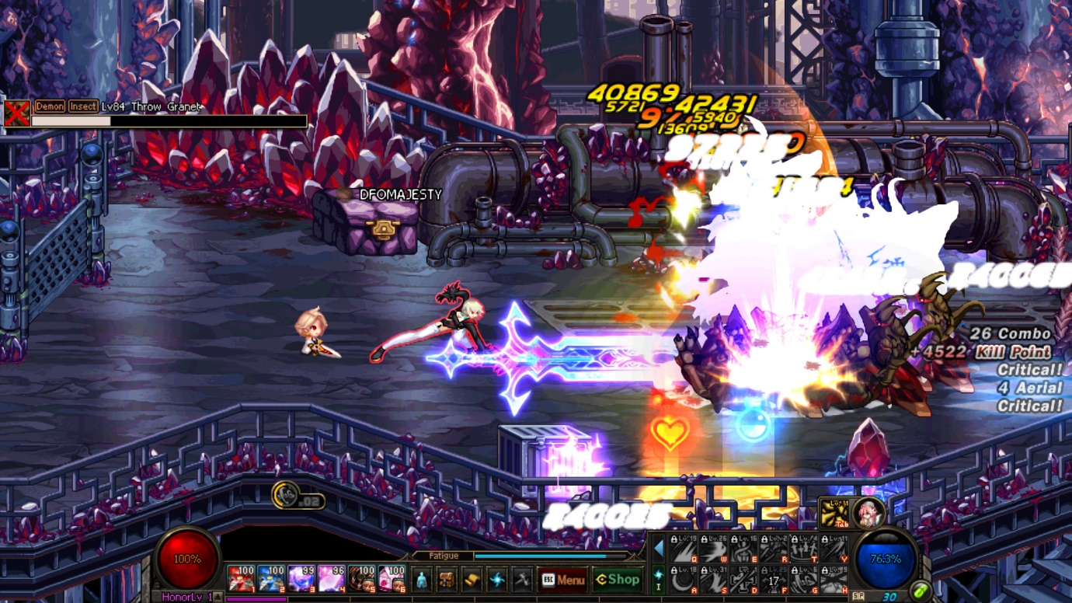

*Dungeon Fighter Online:*

*A player using a large AOE attack that is quite common in all classes.*

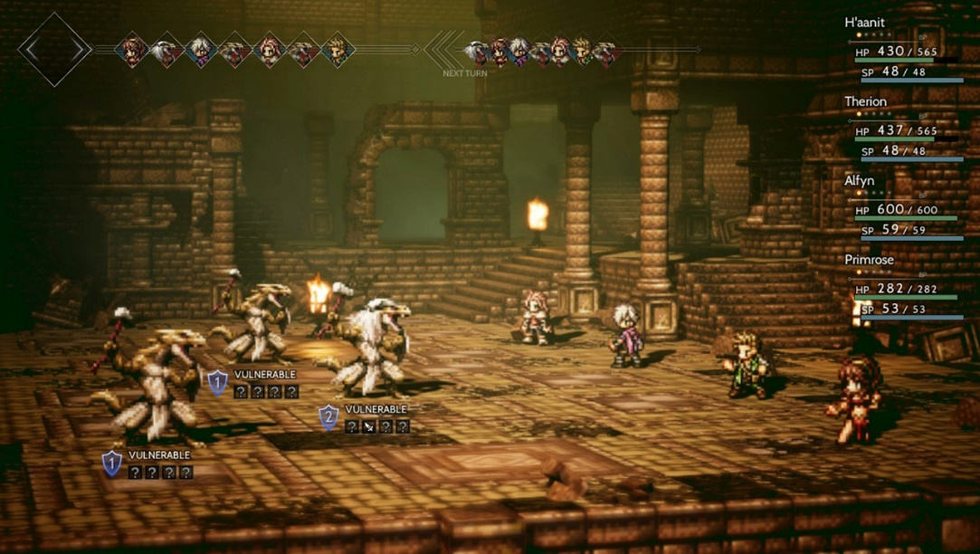

*Octopath Traveler:*

*The party faces off against 3 kobolds.*

*The sprites are flat but project a shadow and keep their orientation facing the camera.*

The idea to mix 2D sprites and 3D environments comes from two sources: Dungeon Fighter Online (DFO) and Octopath Traveler. DFO is a 2D belt-scrolling action game with solid gameplay and beautiful artwork. However, DFO suffers from a critical flaw that originates from how they handle visual depth. The game has a 2.5D perspective on a completely 2D environment. This makes it very difficult to perceive or express depth and causes some gameplay issues as well. This is where Octopath Traveler comes in. Octopath Traveler utilizes 2D sprites to express its characters but uses a 3D environment. Though strange, it looks great. The usage of 2D sprites is also much less work than making and animating 3D models. Because environmental objects seldom move, a 3D environment is also an efficient tradeoff; allowing the game to have depth and shadow without having to draw and animate every background. The efficient of this kind of setup along with the proof that the style can looks great inspired me to attempt it.

# Core Loop

Fractium Framework’s focus is to give players randomly generated characters that they can nurture. Players will be given recruitment options and a limited number of slots to hold around 20 characters. Each character would have its own resources and players would choose which characters to utilize. As characters go through dungeons each will lose a set amount of stamina and will temporarily lose maximum health as they get damaged. Character stamina could also be spent by sending them on expeditions or quests for a time, giving players a hands-off way of spending their resources. Clearing dungeons and quests will give players resources to improve their characters allowing them to access harder content. This is the main loop for Fractium Framework.

The gameplay length is designed to be around a total of 2-4 hours a day with sessions being around 10-30 minutes long each. Players would launch the game, send certain characters on expeditions, run dungeons averaging around 2-5 minutes of gameplay, and once their resources are spent, they would close the game and wait for their characters to recover. This loop would continue daily until eventually the player hits the hardest content in the game. The plan is to give players who have reached this point a sink for their resources, such as a dungeon that scales its difficulty infinitely. If the project would become larger, the availability of online options would enable time-limited events, asynchronous cooperative content, and social features.

# Mockups