DATABASE PRINCIPLES
CSC6302 · Fall 2026 - 2027
Module One Practice: Getting Started With
Database Design

SUBMITTED BY  Keown "KeKe" White  Graduate Student, Computer Science | COURSE DETAILS  Professor Wendy-Beth Minton  Merrimack College

Submitted OCT 31, 2026

AI DISCLOSURE \\ PERSONAL DISCLOSURE

RESPONSE
ChatGPT was used as a tutoring resource to clarify database concepts, discuss SQL and Java syntax, and assist with sample test data. All submitted work was created, reviewed, tested, and understood by me.
Some of the mathematical notation, formal analysis, and technical methods used in this exercise come from material I have already encountered through previous computer science coursework and professional experience. This includes concepts learned across courses such as CSC6304, CSC6013, CSC6023, and other related classes, along with my bachelor's-level computer science background and earlier software engineering experience. Because of that background, I may use methods, notation, or verification techniques that go beyond what is directly required in the current assignment. These additions reflect concepts I already use when working through technical problems rather than material introduced only for this exercise.

Optional Extension: Paranormal Expedition Mode
The optional section does not need to be graded and is not part of the required exercise. I built it simply because I wanted to have some fun with the material and see how far I could extend the database beyond the assignment requirements, without changing the database entirely and creating new relations to select players and the infected.
The game reuses the same family vacation data and builds a small interactive application on top of it using Java, JDBC, MySQL, stored procedures, and a browser-based interface. It was created as an extra experiment in applying the course concepts in a more practical and creative way.

Personal Disclosure

Language and Spelling Note
My writing may occasionally switch between American English and British English spelling or usage. I completed my undergraduate education in the Caribbean, where British English conventions were commonly used, while my later graduate studies have been completed in the United States using American English. Because of that background, both forms sometimes appear naturally in my academic writing.

Problem

You may work on these problem sets together (citing your collaborators), but the write up must be your own. Assignments must be submitted digitally by the beginning of class; late assignments will receive a grade of zero (0). Your problem set must be updated to Canvas. You may update as many files as you wish to Canvas for the assignment. As I have a MAC, please do not submit Microsoft Word files. Export your file to a PDF

Design a database schema that keeps track of what you need to pack to go on
vacation with your family to your favourite spooky destination. Consider data like:
● Where does each member of the family want to go?
● What activities could be done in those places?
● What costumes do you need to pack?
● What comfort/safety items do you need to pack? Hats? Gloves? Scarves?
Warm wool socks? Boots? Snacks? Hand warmers? Glow sticks?

The goal here is to design a small database, and think about how to organise data.
There is no right answer here, and as the course progresses, we will be talking about
How to design efficient and well performing databases. For now, we are experimenting.
Feel free to consider the above prompts, or come up with your own spooky destination
database.

1. (100 Points) For your database design, you must:
● (30 Points) List out the schema definition for at least three relations.
● (10 Points) Select appropriate types for each column, and include them in
your schema definitions.
● (60 Points) List all the super keys, the candidate keys and the most
reasonable primary key of each relation. Please ensure you justify your
primary key choice.
Brief Database Purpose & Requirements

RESPONSE
The Family Spooky Vacation Database was designed to organise the information needed to plan a family trip involving several themed destinations. It records each member, the locations they prefer, activities available at those sites, and supplies required for travel. Packing information is separated into categories such as costumes, comfort items, safety equipment, food, and other essentials so individual needs can be assigned without duplicating the underlying item details. The structure also supports ranked destination choices and many-to-many relationships between people, places, activities, and personal packing lists. This design provides a clear way to answer practical planning questions while keeping related facts separated into appropriate relations.

Development Environment and Database Requirements
The required exercise was developed and tested on a Windows 11 system using the following environment:
- Operating System: Windows 11
- Database Server: MySQL Server 8.0.46
- Database Administration Tool: MySQL Workbench
- Code Editor: Visual Studio Code
- Version Control: Git
- Database Schema: FamilySpookyVacation
The submitted document can be reviewed without installing any additional software. MySQL is only needed if the database implementation is being recreated or tested.
To reproduce the relational design, MySQL Server 8.0 or a compatible release should be available. MySQL Workbench was used for schema administration, query execution, constraint testing, and EER diagram generation, although another MySQL-compatible client could perform the same database operations.
The implementation files are organised so the schema can be recreated from the supplied SQL scripts. The core database should be loaded in the following order:
- schema.sql
- seed.sql
- queries.sql
tests.sql contains the additional checks used to verify constraints and referential behaviour. It is not required simply to create the database.

Relation Schemas and Key Analysis

RESPONSE
The database contains seven relations that separate family members, destinations, activities, packing items, and the associations connecting those subjects. Each definition includes the attribute data types, identified superkeys, candidate keys, selected primary key, and a brief justification for that selection.

1. FAMILY_MEMBER
FAMILY_MEMBER(MemberID INT UNSIGNED, MemberName VARCHAR(80))
Superkeys
  - {MemberID}
  - {MemberID, MemberName}
Candidate Key
  - {MemberID}
Primary Key
  - MemberID
Justification
MemberID provides a stable identifier for each relative without depending on a person's name for uniqueness. Two individuals could share the same name, while the assigned numeric value continues to distinguish their records.

2. VACATION_SITE
VACATION_SITE(SiteID INT UNSIGNED, SiteName VARCHAR(100),
Location VARCHAR(100), SpookinessLevel TINYINT UNSIGNED)
Superkeys
  - {SiteID}
  - {SiteID, SiteName}
  - {SiteID, Location}
  - {SiteID, SpookinessLevel}
  - {SiteID, SiteName, Location}
  - {SiteID, SiteName, SpookinessLevel}
  - {SiteID, Location, SpookinessLevel}
  - {SiteID, SiteName, Location, SpookinessLevel}

Candidate Key
  - {SiteID}
Primary Key
  - SiteID
Justification
SiteID uniquely identifies a destination without assuming that its descriptive information will remain unchanged or exclusive. A location or title may be modified later, whereas the identifier can continue representing the same place.

3. ACTIVITY
ACTIVITY(ActivityID INT UNSIGNED, ActivityName VARCHAR(100), ActivityCategory VARCHAR(40))
Superkeys
  - {ActivityID}
  - {ActivityID, ActivityName}
  - {ActivityID, ActivityCategory}
  - {ActivityID, ActivityName, ActivityCategory}
Candidate Key
  - {ActivityID}
Primary Key
  - ActivityID
Justification
ActivityID distinguishes each available experience independently of its description or category. Similar activities may appear under comparable names, making the numeric identifier a more dependable choice for establishing identity.

4. PACKING_ITEM
PACKING_ITEM(ItemID INT UNSIGNED, ItemName VARCHAR(100), ItemCategory VARCHAR(20))
Superkeys
  - {ItemID}
  - {ItemID, ItemName}
  - {ItemID, ItemCategory}
  - {ItemID, ItemName, ItemCategory}
Candidate Key
  - {ItemID}
Primary Key
  - ItemID
Justification
ItemID identifies one packing-item definition without tying its identity to descriptive wording. This approach allows an item's name or category to be adjusted without changing the value used by related records.

5. FAMILY_SITE
FAMILY_SITE(MemberID INT UNSIGNED, SiteID INT UNSIGNED, PreferenceRank TINYINT UNSIGNED)
Superkeys
  - {MemberID, SiteID}
  - {MemberID, PreferenceRank}
  - {MemberID, SiteID, PreferenceRank}
Candidate Key
  - {MemberID, SiteID}
  - {MemberID, PreferenceRank}
Primary Key
  - {MemberID, SiteID}

Justification
The combination of MemberID and SiteID represents one person's preference for one destination. Although {MemberID, PreferenceRank} also provides uniqueness under the stated business rule, a ranking may change as plans develop, while the relationship between the relative and location remains the same.

6. SITE_ACTIVITY
SITE_ACTIVITY(SiteID INT UNSIGNED, ActivityID INT UNSIGNED)
Superkeys
  - {SiteID, ActivityID}
Candidate Key
  - {SiteID, ActivityID}
Primary Key
  - {SiteID, ActivityID}

Justification
Neither attribute can identify a row independently because one destination may provide several activities, while the same experience can be available at multiple locations. Their combination therefore represents one specific site- activity association without requiring an additional identifier.

7. MEMBER_ITEM
MEMBER_ITEM(MemberID INT UNSIGNED, ItemID INT UNSIGNED,
Quantity TINYINT UNSIGNED, PackedStatus BOOLEAN)
Superkeys
  - {MemberID, ItemID}
  - {MemberID, ItemID, Quantity}
  - {MemberID, ItemID, PackedStatus}
  - {MemberID, ItemID, Quantity, PackedStatus}

Candidate Key
  - {MemberID, ItemID}
Primary Key
  - {MemberID, ItemID}
Justification
The composite key identifies one packing item assigned to one family member. Quantity and PackedStatus describe that assignment rather than establish its identity, so neither attribute belongs in the minimal key.

EER DIAGRAM

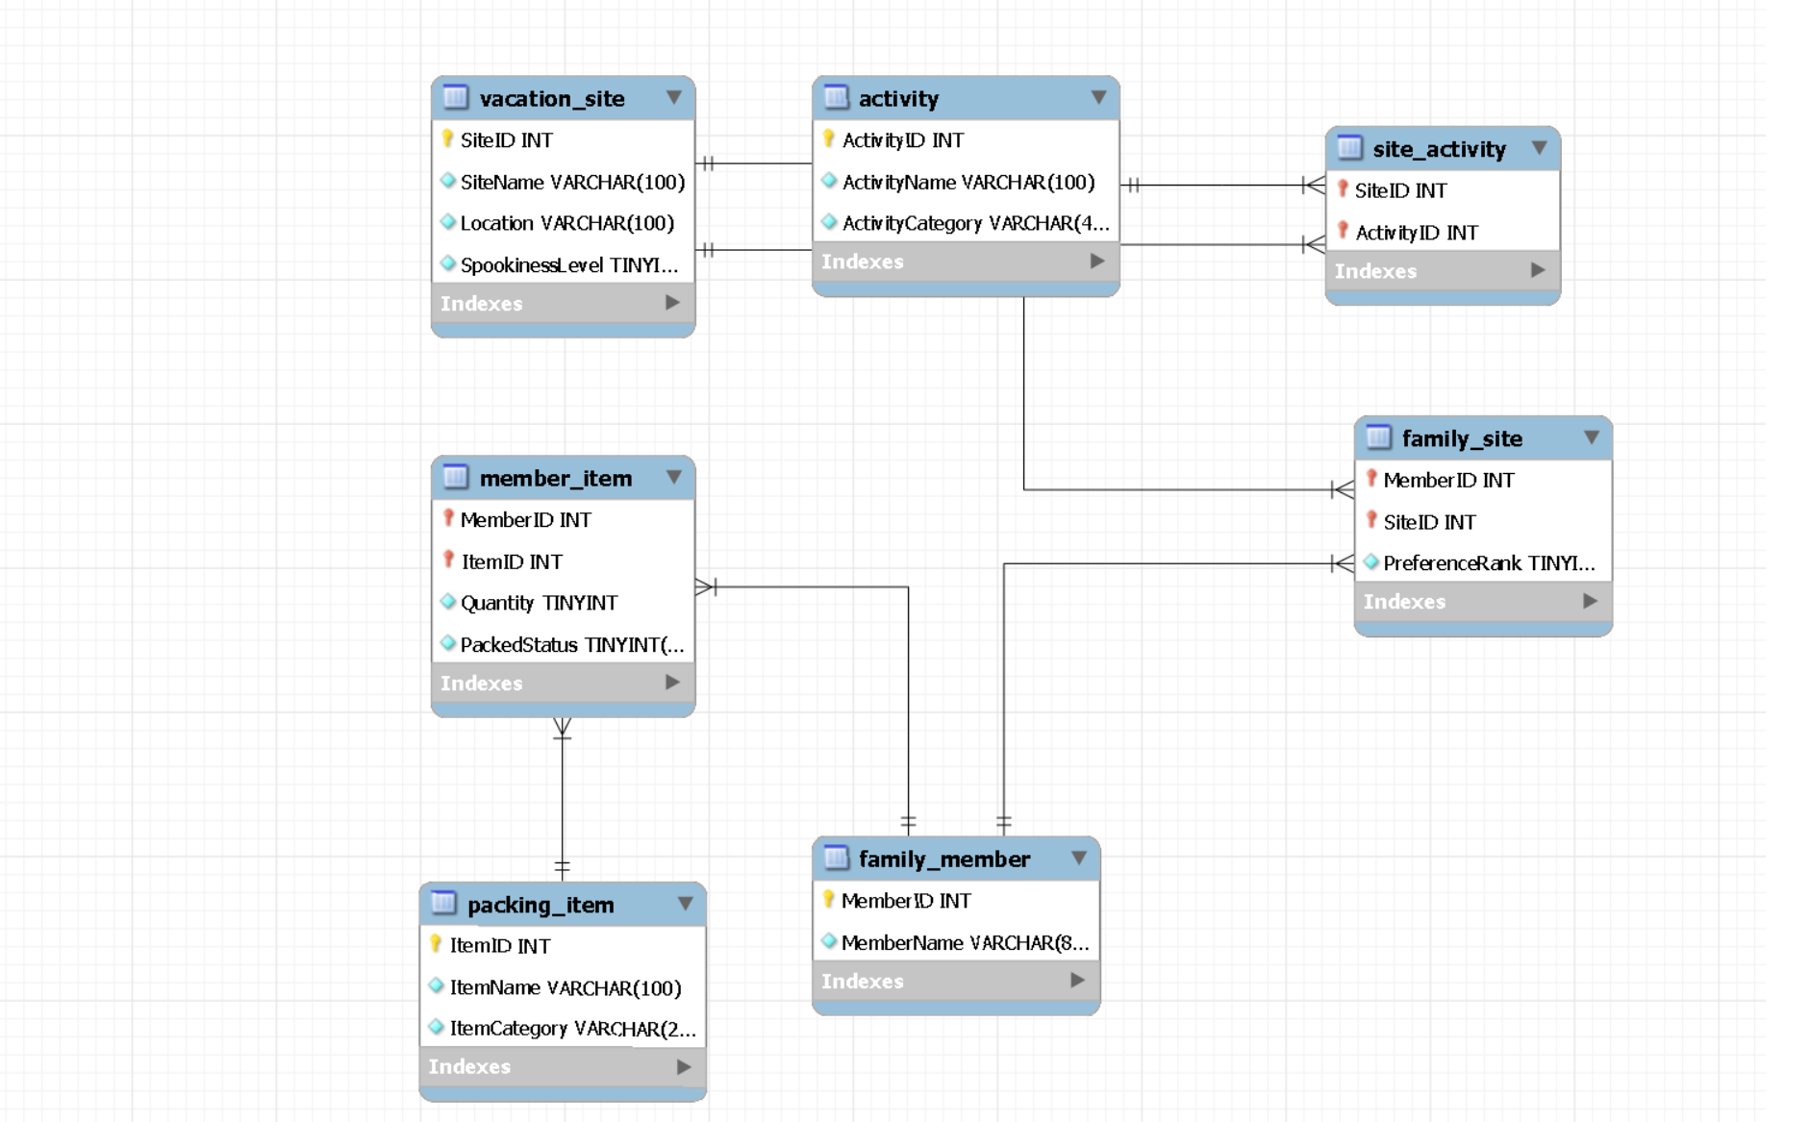
RESPONSE

Design Summary and Mathematical Verification

RESPONSE
The relational structure was checked mathematically in addition to being tested through MySQL. Attribute closure was used to confirm candidate keys, set relationships were applied to verify superkeys, and functional dependencies were examined against the normal-form requirements. This provides a second check that the implemented schema follows the intended business rules.

Candidate-Key Verification
For any relation R with a proposed candidate key K:
K⁺ = R
A candidate key must also be minimal:
∀ A ∈ K, (K − {A})⁺ ≠ R
Therefore, K must determine every attribute in R while no proper subset of K can do the same.

FAMILY_MEMBER
R = {MemberID, MemberName}
Functional dependency:
MemberID → MemberName
Attribute closure:
{MemberID}⁺ = {MemberID, MemberName} = R
Because:
∅⁺ ≠ R
the key cannot be reduced further.
Therefore:
Candidate Key = {MemberID}

VACATION_SITE
R = {SiteID, SiteName, Location, SpookinessLevel}
Functional dependency:
SiteID → SiteName, Location, SpookinessLevel
Attribute closure:
{SiteID}⁺= {SiteID, SiteName, Location, SpookinessLevel} = R
Since:
∅⁺ ≠ R
SiteID is minimal.
Therefore:
Candidate Key = {SiteID}

ACTIVITY
R = {ActivityID, ActivityName, ActivityCategory}
Functional dependency:
ActivityID → ActivityName, ActivityCategory
Attribute closure:
{ActivityID}⁺ = {ActivityID, ActivityName, ActivityCategory} = R
Since no smaller attribute set determines R:
Candidate Key = {ActivityID}

PACKING_ITEM
R = {ItemID, ItemName, ItemCategory}
Functional dependency:
ItemID → ItemName, ItemCategory
Attribute closure:
{ItemID}⁺ = {ItemID, ItemName, ItemCategory} = R
Therefore:
Candidate Key = {ItemID}

FAMILY_SITE
R = {MemberID, SiteID, PreferenceRank}
The principal dependency is:
{MemberID, SiteID} → PreferenceRank
Under the business rule that one family member cannot assign the same preference rank to two destinations:
{MemberID, PreferenceRank} → SiteID
First closure:
{MemberID, SiteID}⁺= {MemberID, SiteID, PreferenceRank} = R
Second closure:
{MemberID, PreferenceRank}⁺= {MemberID, PreferenceRank, SiteID} = R
Minimality of the first set:
{MemberID}⁺ ≠ R
{SiteID}⁺ ≠ R
Minimality of the second set:
{MemberID}⁺ ≠ R
{PreferenceRank}⁺ ≠ R
Therefore:
K₁ = {MemberID, SiteID}
K₂ = {MemberID, PreferenceRank}
Both are candidate keys.
The selected primary key is:
PK = {MemberID, SiteID}
because PreferenceRank may change without altering the underlying member- destination relationship.

SITE_ACTIVITY
R = {SiteID, ActivityID}
No single attribute uniquely determines the relationship:
{SiteID}⁺ ≠ R
{ActivityID}⁺ ≠ R
Together:
{SiteID, ActivityID}⁺ = {SiteID, ActivityID} = R
Therefore:
Candidate Key = {SiteID, ActivityID}

MEMBER_ITEM
R = {MemberID, ItemID, Quantity, PackedStatus}
Functional dependency:
{MemberID, ItemID} → Quantity, PackedStatus
Attribute closure:
{MemberID, ItemID}⁺= {MemberID, ItemID, Quantity, PackedStatus} = R
Neither component is sufficient by itself:
{MemberID}⁺ ≠ R
{ItemID}⁺ ≠ R
Therefore:
Candidate Key = {MemberID, ItemID}

Superkey Verification
A superkey S must contain a candidate key K: K ⊆ S ⊆ R
When a relation contains n attributes and has one candidate key containing k attributes, the number of supersets containing that key is: N = 2⁽ⁿ⁻ᵏ⁾
This expression counts the candidate key itself plus every possible addition of the remaining n − k attributes.

FAMILY_MEMBER
n = 2
k = 1
N = 2⁽²⁻¹⁾
N = 2¹
N = 2
Superkeys:
{MemberID}
{MemberID, MemberName}

VACATION_SITE
n = 4
k = 1
N = 2⁽⁴⁻¹⁾
N = 2³
N = 8
Therefore, eight superkeys contain SiteID.

ACTIVITY
n = 3
k = 1
N = 2⁽³⁻¹⁾
N = 2²
N = 4
Therefore:
N = 4 superkeys

PACKING_ITEM
n = 3
k = 1
N = 2⁽³⁻¹⁾
N = 2²
N = 4
Therefore:
N = 4 superkeys

SITE_ACTIVITY
n = 2
k = 2
N = 2⁽²⁻²⁾
N = 2⁰
N = 1
The only superkey is:
{SiteID, ActivityID}

MEMBER_ITEM
n = 4
k = 2
N = 2⁽⁴⁻²⁾
N = 2²
N = 4
The four superkeys are:
{MemberID, ItemID}
{MemberID, ItemID, Quantity}
{MemberID, ItemID, PackedStatus}
{MemberID, ItemID, Quantity, PackedStatus}

FAMILY_SITE With Two Candidate Keys
FAMILY_SITE requires a different calculation because two candidate keys exist:
K₁ = {MemberID, SiteID}
K₂ = {MemberID, PreferenceRank}
Let S(K) represent all superkeys containing candidate key K.
Then:
|S(K₁)| = 2⁽³⁻²⁾ = 2
|S(K₂)| = 2⁽³⁻²⁾ = 2
Both groups contain the full three-attribute set, so that overlap must only be counted once:
|S(K₁) ∩ S(K₂)| = 2⁽³⁻³⁾ = 1
Using inclusion-exclusion:
|S(K₁) ∪ S(K₂)| = |S(K₁)| + |S(K₂)| − |S(K₁) ∩ S(K₂)| = 2 + 2 − 1 = 3
Therefore, the distinct superkeys are:
{MemberID, SiteID}
{MemberID, PreferenceRank}
{MemberID, SiteID, PreferenceRank}

Normalisation Verification
For a functional dependency:
X → Y
Boyce-Codd Normal Form requires:
X is a superkey
for every non-trivial dependency in the relation.
Equivalently:
∀(X → Y), Y ⊄ X ⇒ X is a superkey
For the principal relations:
MemberID → MemberName
SiteID → SiteName, Location, SpookinessLevel
ActivityID → ActivityName, ActivityCategory
ItemID → ItemName, ItemCategory
{MemberID, SiteID} → PreferenceRank
{MemberID, PreferenceRank} → SiteID
{MemberID, ItemID} → Quantity, PackedStatus
Each determinant is a candidate key or superkey of its relation.
Therefore:
∀ nontrivial X → Y, X is a superkey
∴ FAMILY_MEMBER ∈ BCNF
∴ VACATION_SITE ∈ BCNF
∴ ACTIVITY ∈ BCNF
∴ PACKING_ITEM ∈ BCNF
∴ FAMILY_SITE ∈ BCNF
∴ SITE_ACTIVITY ∈ BCNF
∴ MEMBER_ITEM ∈ BCNF
Since:
BCNF ⇒ 3NF ⇒ 2NF ⇒ 1NF
the design also satisfies the lower normal forms under the stated functional dependencies and business rules.

Referential and Implementation Verification
The relational model was also checked through executable constraints in MySQL. Primary-key duplication, invalid foreign-key references, missing required values, prohibited categories, repeated preference rankings, and non positive quantities were deliberately tested.
The verification can therefore be represented as two complementary checks:
V = M ∧ I
where:
M = mathematical verification
I = implementation verification
Both conditions were satisfied:
M = TRUE
I = TRUE
Therefore:
V = TRUE ∧ TRUE
V = TRUE
The schema is consequently supported by both relational analysis and observed database behaviour rather than relying on either form of verification alone.

END OF REQUIRED EXERCISE

The required portion of this assignment ends here.
The remaining pages are included only as an optional extension and do not need to be graded. I created the additional material to experiment with the database beyond the stated requirements and to have some fun applying the concepts in a working application.

Optional: Paranormal Expedition Mode

The Paranormal Expedition Mode was built as a separate application layer on top of the Family Spooky Vacation Database. It reuses the original members, destinations, and activities, then adds game-specific records for sessions, player status, contacts, observations, scoring, accusations, and fictional infection states.
One participant is secretly assigned as Patient Zero at the beginning of a session. The remaining players move through the expedition by selecting locations, completing available activities, recording interactions, and investigating clues. Evidence appears through fictional symptoms that become visible only when the correct conditions are met, which requires the group to compare timing, contact history, discovered information, and movement between sites before making an accusation.
The application uses Java with JDBC to communicate with MySQL, while stored procedures control the main game actions and enforce the rules defined in the database. A browser interface provides the player-facing controls without exposing hidden information such as Patient Zero or internal infection states.
This extension was created as a practical experiment rather than part of the required exercise. I spend a significant amount of my free time gaming and working with game-design ideas, so applying technical concepts through that perspective helps me understand them more clearly. Building the database into a playable system gave me a familiar way to explore relationships, state changes, stored procedures, and application logic while keeping the original assignment structure intact.

Optional: How the Original Database Is Reused

The game does not replace the original Family Spooky Vacation Database. Instead, it uses the existing relations as its foundation and adds a separate layer for interactive behavior.
`FAMILY_MEMBER` becomes the source of player identities, so names are not duplicated inside the extension. `VACATION_SITE` supplies the locations used during each expedition, while `ACTIVITY` provides the actions that can be performed at those places. The existing `SITE_ACTIVITY` relation also remains important because it limits each destination to experiences that are actually available there.
This approach preserves the original design and allows the application to build on information that already exists. The optional tables reference the core relations through foreign keys rather than creating separate copies of the same facts.
The relationship can be represented as:
FAMILY_MEMBER → GAME_PLAYER
VACATION_SITE → CONTACT_EVENT
VACATION_SITE → ACTIVITY_EVENT
ACTIVITY → ACTIVITY_EVENT
SITE_ACTIVITY → ACTIVITY_EVENT
As a result, the class database remains complete on its own, while Paranormal Expedition Mode depends on that structure for its players, destinations, and available activities.

Optional: Game Database Extension

Paranormal Expedition Mode adds a separate group of relations that control sessions, player progress, hidden conditions, recorded encounters, discovered evidence, scoring, and accusations. These tables extend the original vacation schema without changing its required structure.
GAME_SESSION stores the state of each playthrough, including the current turn and overall status. GAME_PLAYER links participants back to FAMILY_MEMBER, which preserves the identities already defined in the core design rather than creating another copy of that information.
INFECTION_STATE maintains the concealed game condition for each participant. This relation records progression through the fictional states used by the application and identifies Patient Zero internally. Those attributes remain unavailable through the player-facing interface so the deduction mechanic is preserved.
CONTACT_EVENT records encounters between two participants at a particular destination and turn. The pair is stored in a consistent order, which prevents the same interaction from appearing twice simply because the names were entered in reverse.
SYMPTOM_EVENT represents fictional evidence produced as the hidden state develops. OBSERVATION_EVENT is kept separately because a symptom may exist before another participant discovers it. This distinction allows the application to compare the appearance turn with the discovery turn when calculating clue points.
SCORE_EVENT maintains the history of point changes instead of storing only a running total. Positive and negative events can therefore be traced individually, while the displayed score is derived from the recorded entries.
ACCUSATION_EVENT stores each attempt to identify Patient Zero. Correctness is determined from the concealed state rather than saved as a duplicate value, reducing the possibility of inconsistent records.
ACTIVITY_EVENT connects a participant, destination, and available experience during a specific turn. The relation references the original SITE_ACTIVITY association so an action can only be recorded where that option is valid. ACTIVITY_CLUE_RULE then links particular activities to the types of fictional evidence they can uncover.

The extension can therefore be viewed as:
Core Database
↓
Player and Session Layer
↓
Turn-Based Events
↓
Evidence and Scoring
↓
Accusation and Outcome
This separation allows the original assignment schema to remain independent while the additional relations provide the state and event history required by the interactive application.

Optional: Game EER Diagram

The following EER diagram shows the additional relations used by Paranormal Expedition Mode and how they connect to the original Family Spooky Vacation Database. The extension depends on the core schema for member identities, destinations, and available activities. Game-specific relations then record sessions, participants, hidden state, contacts, symptoms, observations, scoring, accusations, and turn-based actions. Foreign-key relationships preserve those links without duplicating information already stored in the required database. This diagram is separate from the graded EER model because it represents the optional application layer rather than the original exercise design. A stand-alone copy of the diagram is also provided for easier viewing.
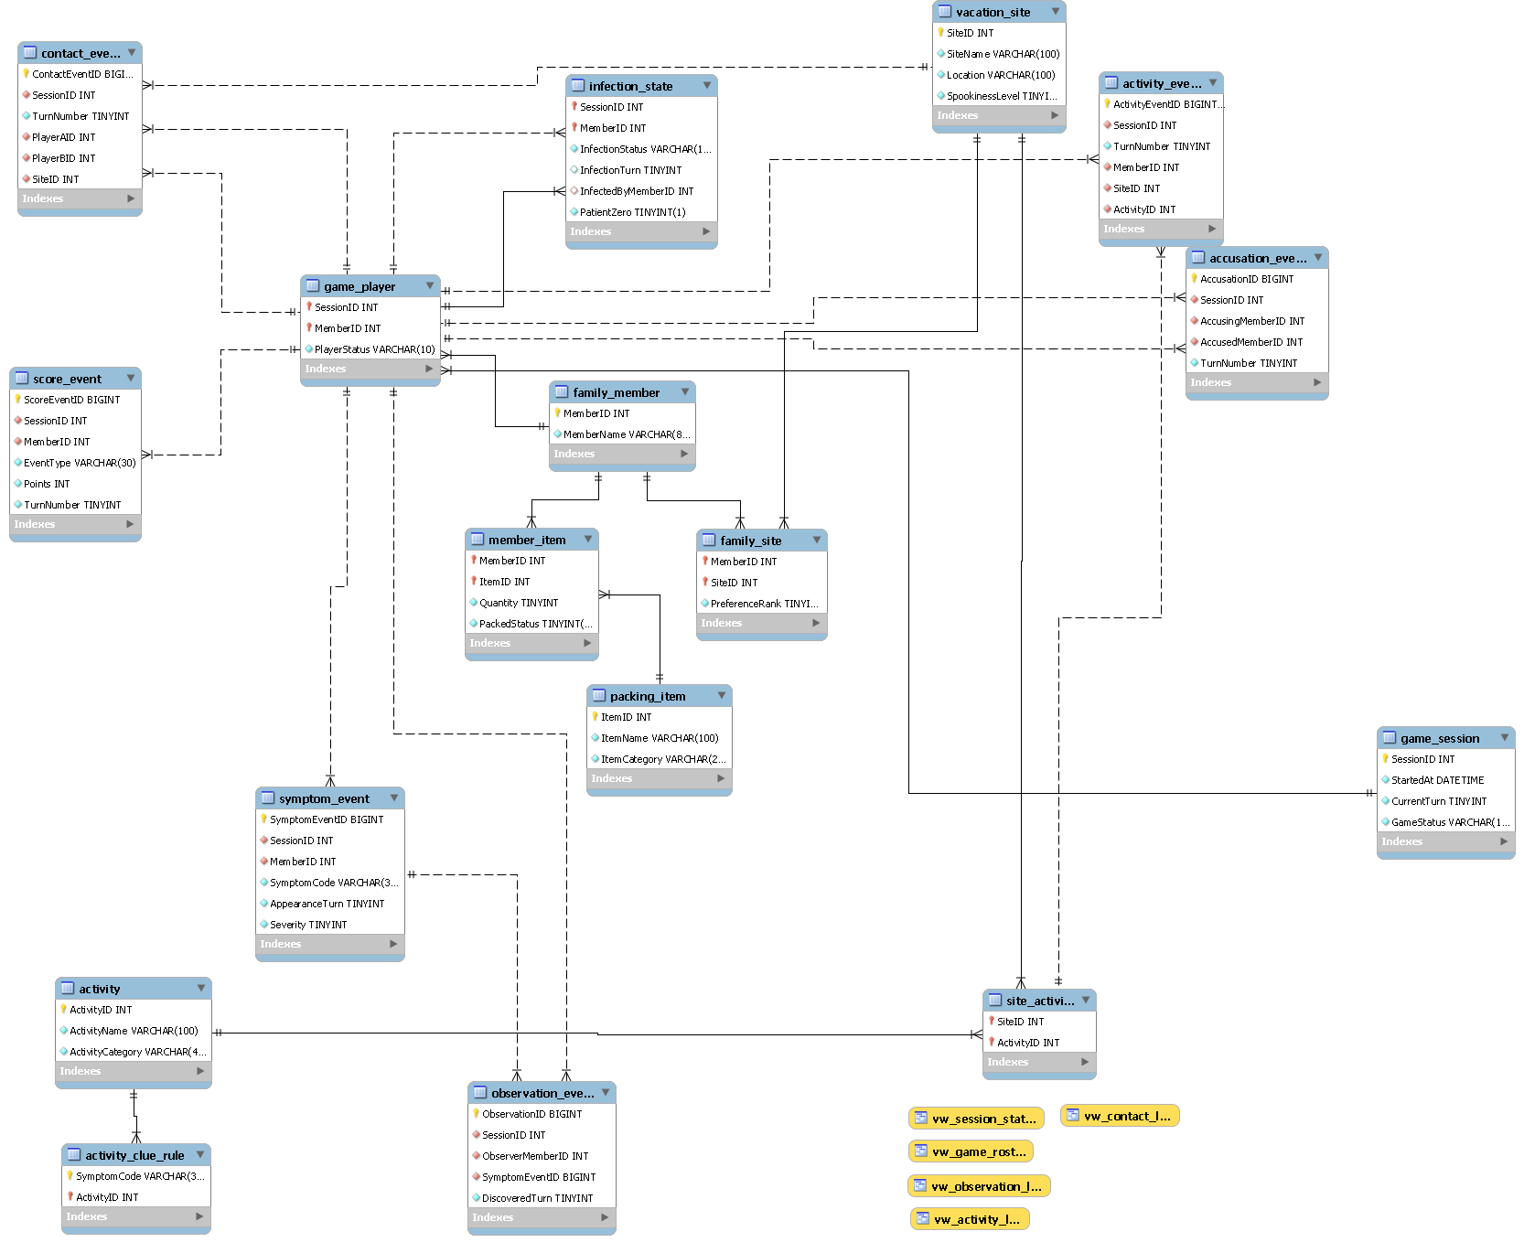

Optional: How the Game Works

Paranormal Expedition Mode is a hidden-identity deduction game built on the family vacation database. At the beginning of a session, one participant is secretly assigned as Patient Zero, while the remaining players begin without that information. The objective is to identify the original source before the fictional infection spreads too far or the available turns are exhausted.
Each turn allows participants to record activities, document contact with other players, investigate for clues, and review the evidence already discovered. Activities must match the selected destination because the application checks the original SITE_ACTIVITY relation before accepting the choice.
Contact records create a timeline showing who interacted, where the encounter occurred, and during which turn. The hidden game logic can use those relationships when determining whether another participant becomes affected. As the session progresses, fictional symptoms may appear, but they are not automatically shown to the players.
Investigations are used to discover those clues. Certain activities are associated with specific evidence types, so an investigation succeeds only when the required conditions are present. Earlier discoveries receive a higher score than findings made several turns after the symptom first appeared.
Players can make an accusation when they believe enough evidence has been collected. A correct selection identifies Patient Zero and immediately ends the session with a win. An incorrect attempt reduces the accuser's score and counts toward the maximum number of failed guesses.
The game can also end if the affected population reaches the defined loss threshold or if the group passes the final playable turn without making the correct identification. The dashboard therefore requires players to compare contacts, timing, locations, activities, and discovered evidence rather than relying on a single clue.
The basic play cycle is:
Select Activities
↓
Record Contacts
↓
Investigate for Evidence
↓
Review the Timeline
↓
Make an Accusation or Advance the Turn
This process repeats until the group identifies Patient Zero or one of the loss conditions is reached.

Optional: Game Interface

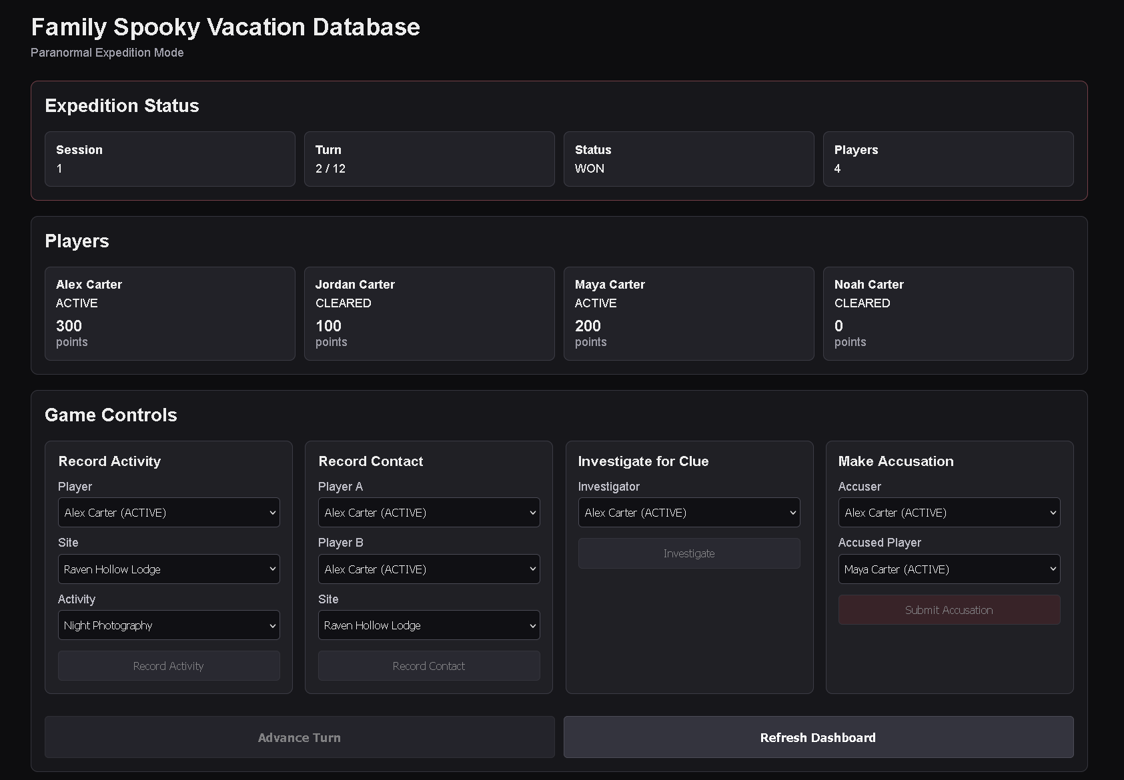

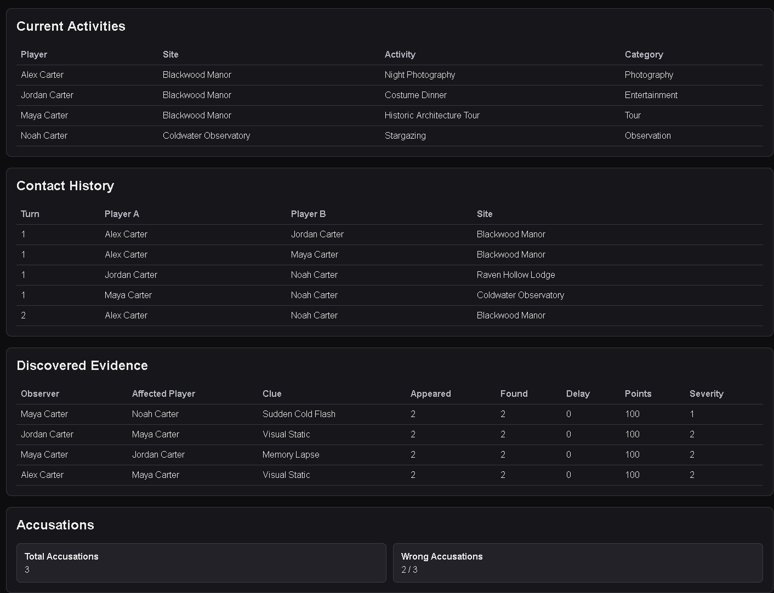

Optional: Technical Concepts Applied

The optional extension applies several ideas beyond the minimum requirements of the exercise while continuing to rely on the original relational structure. Relational design remains the foundation of the application. Primary keys, foreign keys, junction relations, and controlled dependencies preserve consistency between players, destinations, activities, and game events. Additional tables separate session state, observations, scoring, accusations, and contact history so each fact has a defined purpose.
Stored procedures handle actions that change the game, including recording encounters, submitting activities, investigating evidence, advancing turns, and making accusations. Views provide selected information for the dashboard while keeping concealed values outside the player-facing result set. Java connects to MySQL through JDBC and acts as the application layer between the browser and database. The HTTP server receives requests from the interface, calls the required procedure or query, then returns the resulting information for display.
The infection mechanic also uses state-transition logic. Participants move through defined fictional conditions as turns progress, which provides a simple example of applying concepts previously encountered in finite-state systems to a database-backed application.
Contact records can be interpreted as a graph:
G = (V, E)
where:
V = set of players
E = set of recorded contacts
Each participant represents a vertex, while an interaction forms an edge between two members. This structure makes it possible to examine connection paths and event timing when reasoning about possible transmission routes. The scoring model uses recorded events rather than a permanently stored total. A player's displayed score can therefore be derived as:
Score(p) = Σ Points(e)
for every scoring event e associated with player p.
Taken together, the extension applies relational modelling, referential integrity, stored procedures, views, JDBC communication, event-based records, state transitions, and graph-oriented reasoning within one small working system.

Optional: Extension Closing Note

Building Paranormal Expedition Mode gave me a practical way to explore the database beyond the minimum exercise requirements. I often understand technical material more clearly when I can connect it to gaming or game-design ideas, so turning the schema into a small playable system helped reinforce several concepts from the course.
The extension also gave me a chance to combine relational design with Java, JDBC, stored procedures, views, state transitions, and event-based logic in one project. More importantly, it showed that the original vacation database could support additional behaviour without changing the required structure.
This section was included only as an optional demonstration of what I explored while working with the material. It does not need to be graded as part of the required exercise.

