CST8921 – Cloud Industry Trends

Deploy Python Application on Kubernetes

Introduction:
This lab aims to create a simple Python application, create a docker file, and deploy it to Azure Kubernetes Service (AKS). Afterwards, I explore how to monitor and log an AKS deployment and scale an application using replica sets. Below I learn the usefulness of Azure Monitor and Prometheus which can send me alerts when a container usage exceeds a certain point. Grafana can also display the various resources such as CPU usage and memory usage of pods within AKS.

Steps In Screenshots:

Create a Simple Python Application:
Python Code: uses Flask to serve up the web app
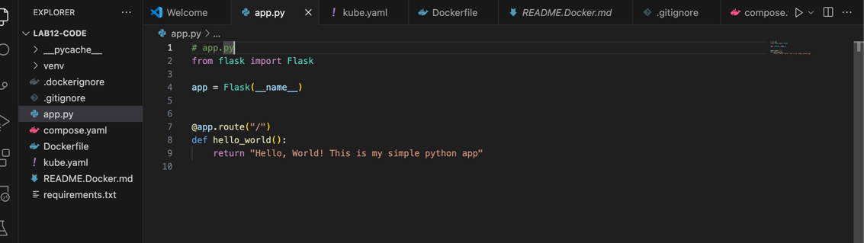

Create a Dockerfile
I used Docker init to create all the required files for python
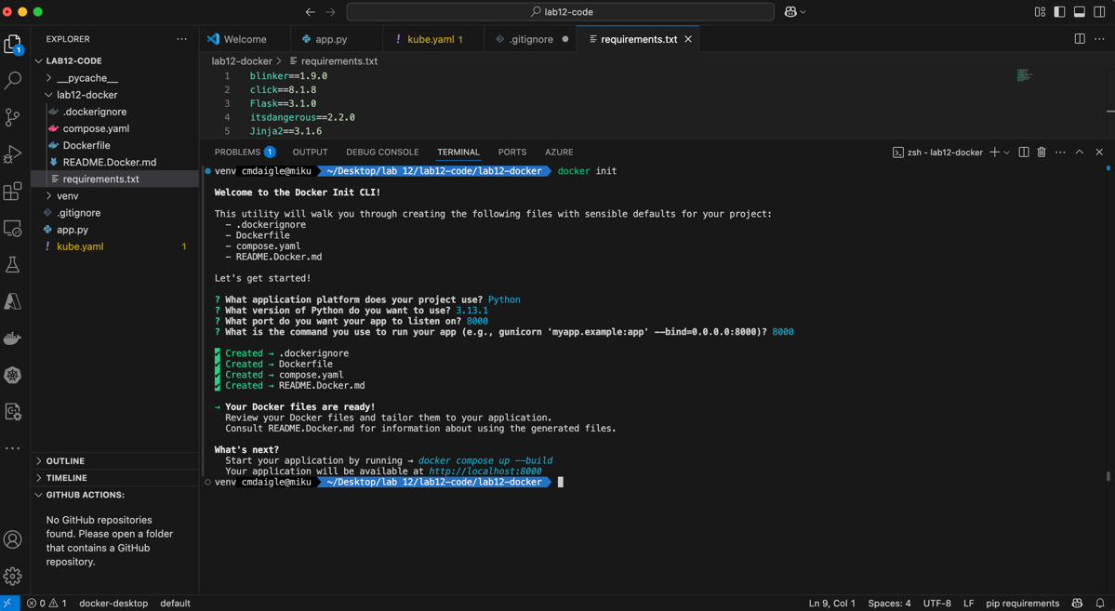
Dockerfile code:
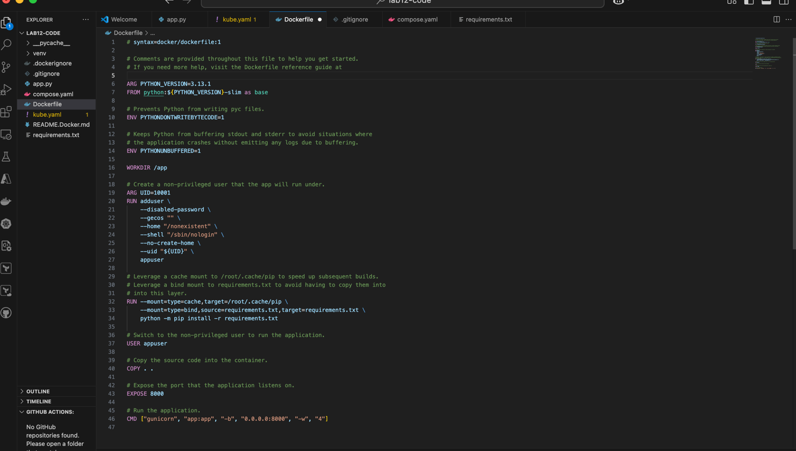
Written docker-compose to test file locally:
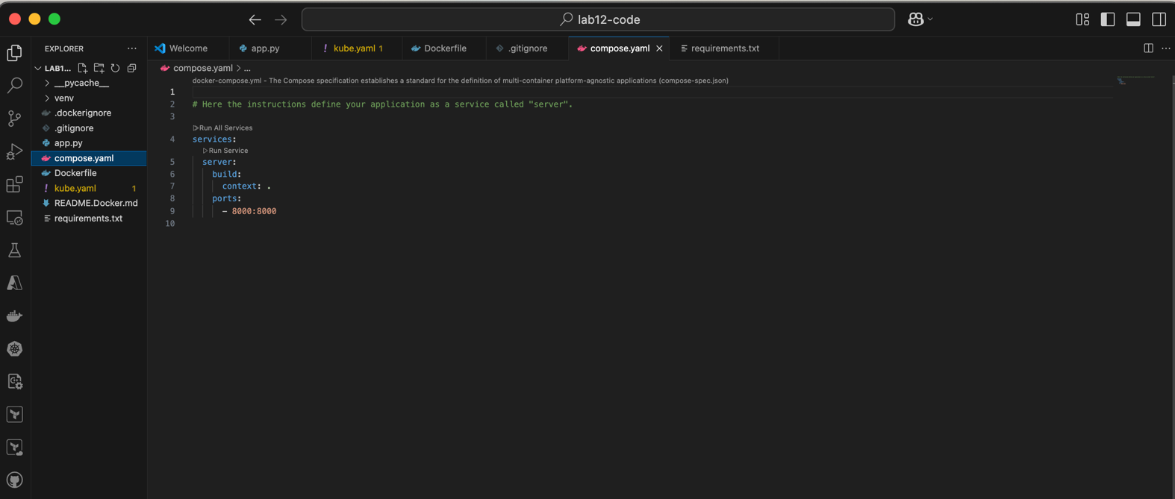

Pushing and Building the Docker File: The file opens up at port 8000:
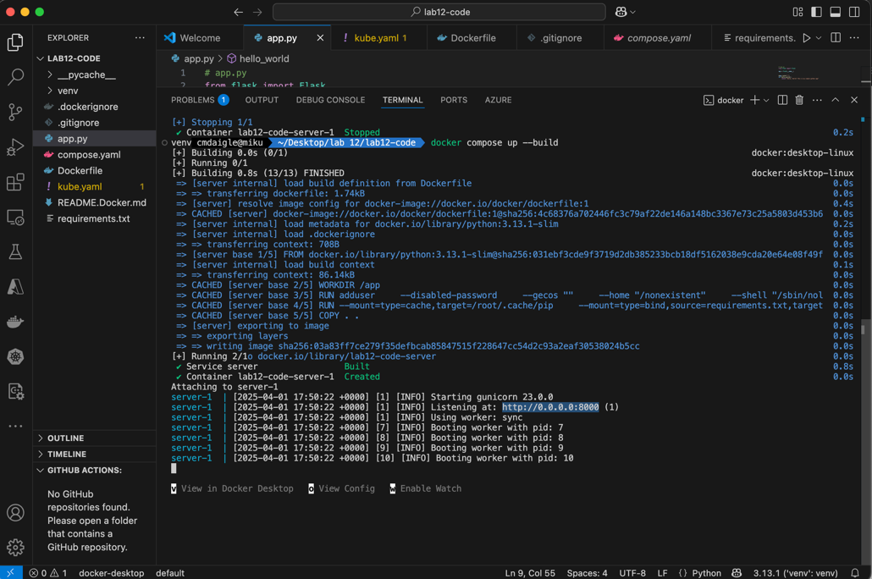
Result web application:
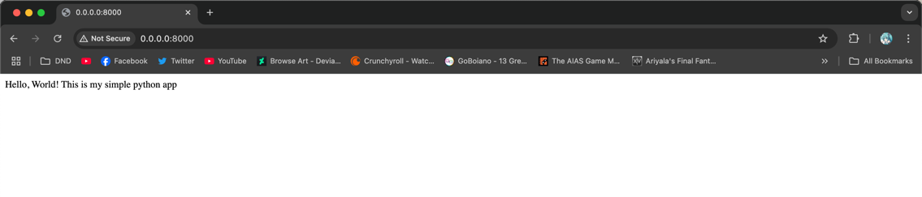

Create Kubernetes Deployment and Service Files
Kubernetes YAML file:
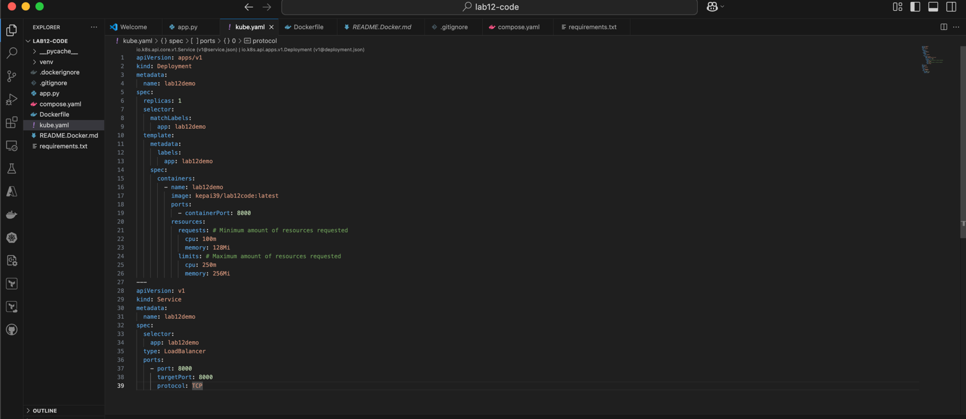
Pushing Docker Image to Docker Hub Repository (This is needed for the Kube YAML to pull the container from)
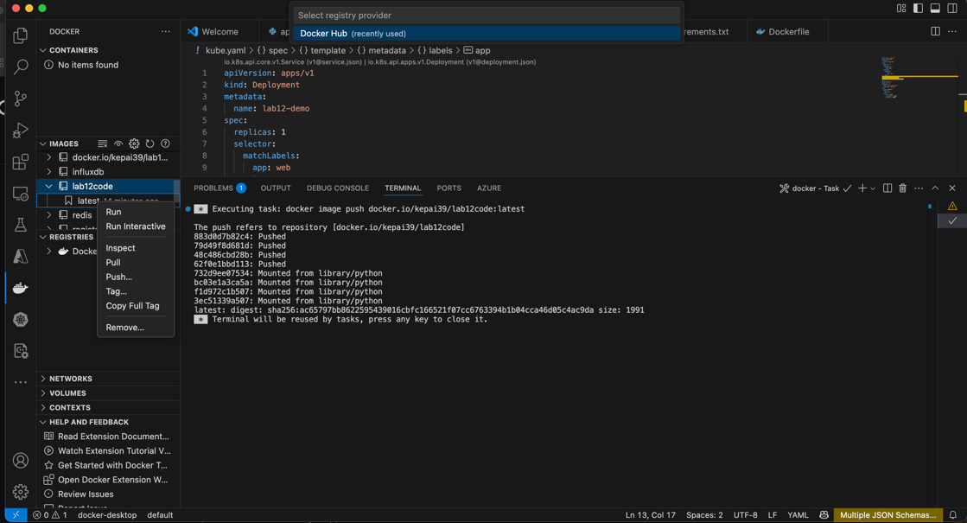

Deploy to Kubernetes
I first Deployed locally using Kubernetes within docker using NodePort as the service to access the webserver.
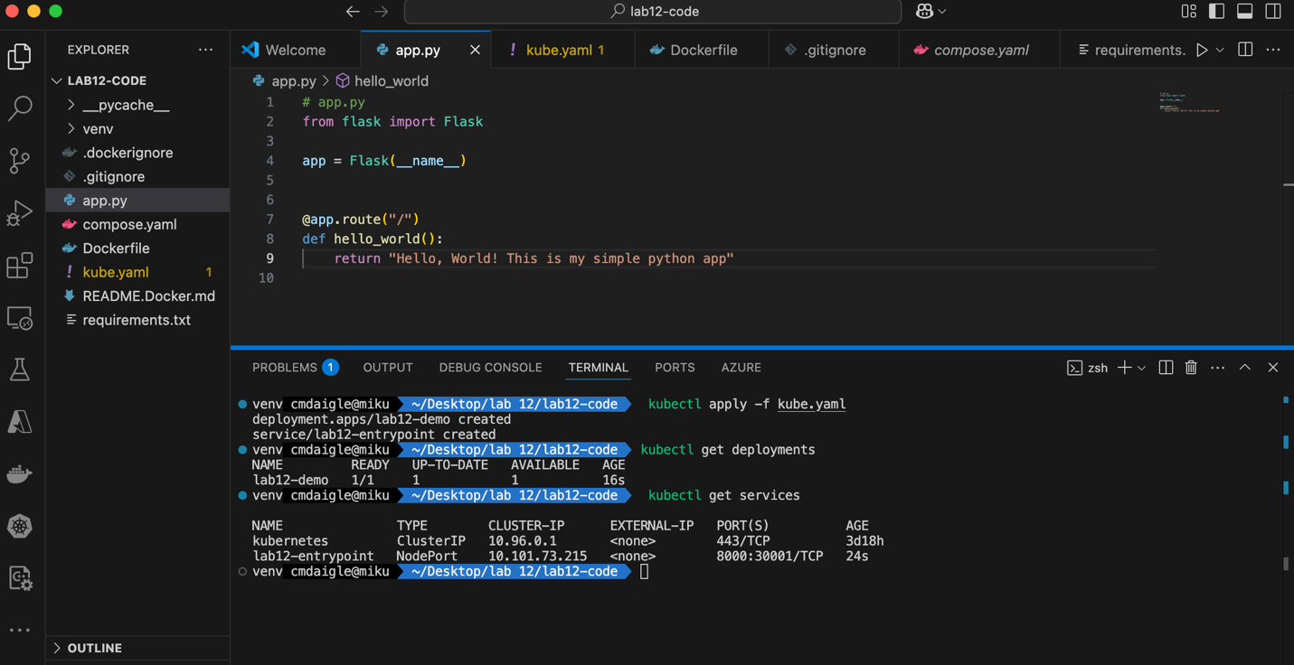

Result:
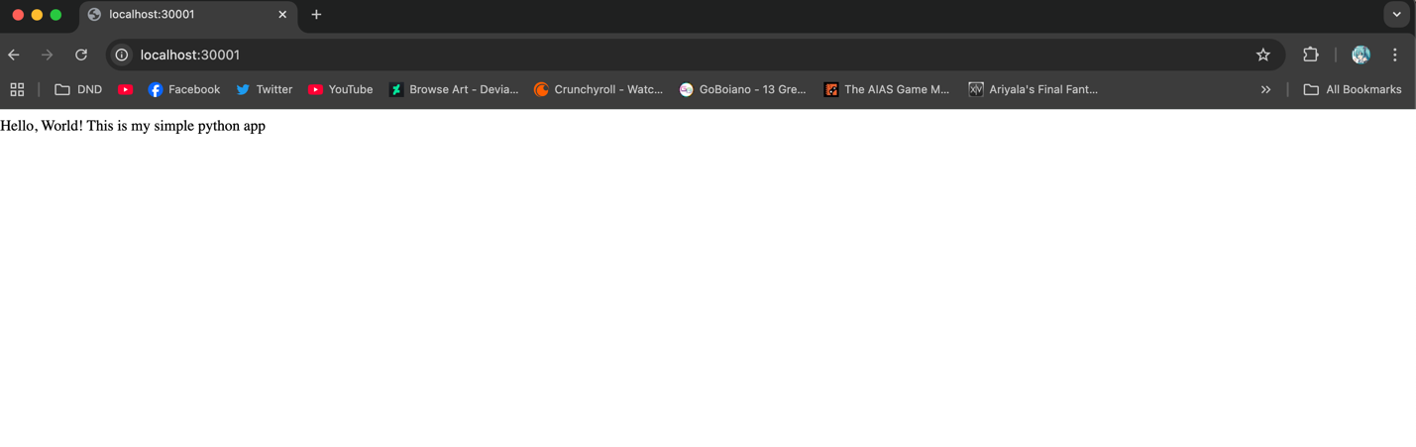

Access the Application either using nodeport or loadbalancer
I then switched to loadbalancer as Azure AKS does not support nodeport Below is deployment to AKS: Creating the cluster, I chose the most cheapest options.
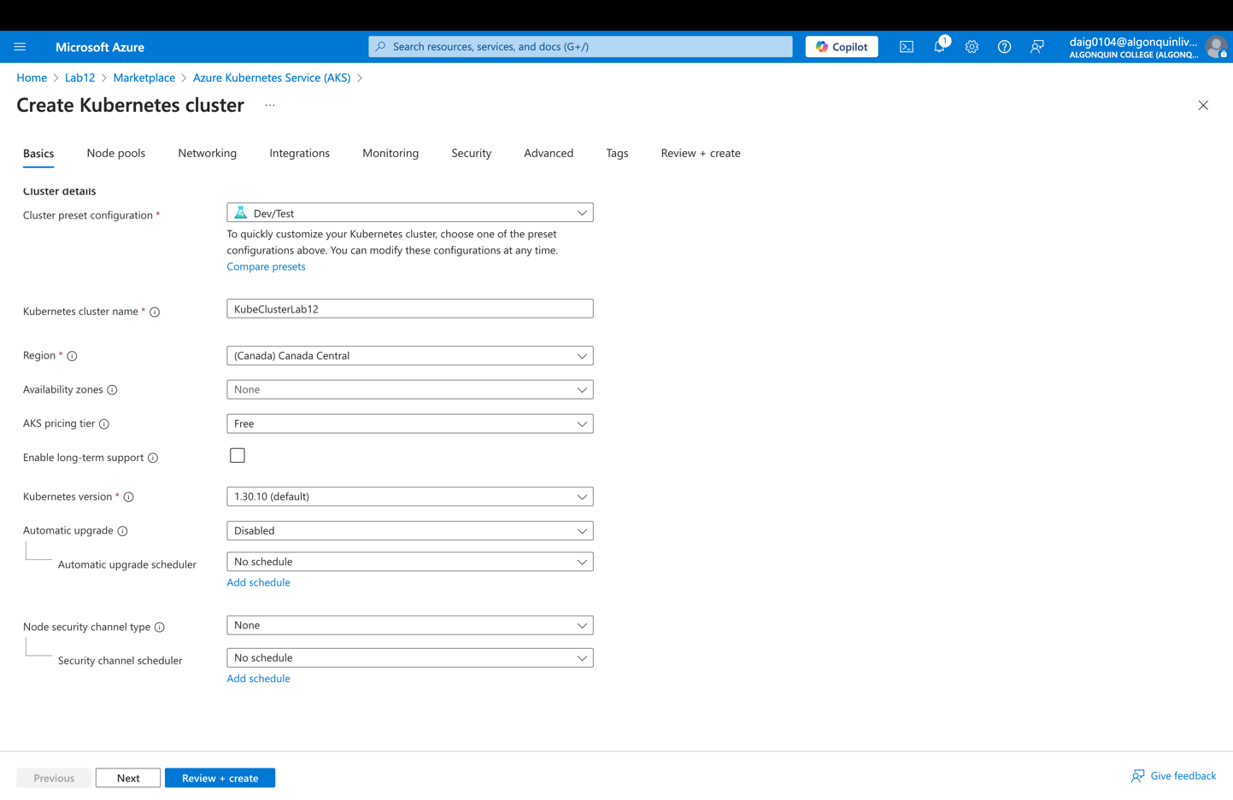

Creating the workerspool node is set as D2as_V4 as it was one of the cheaper options without sacrificing too much computing power.
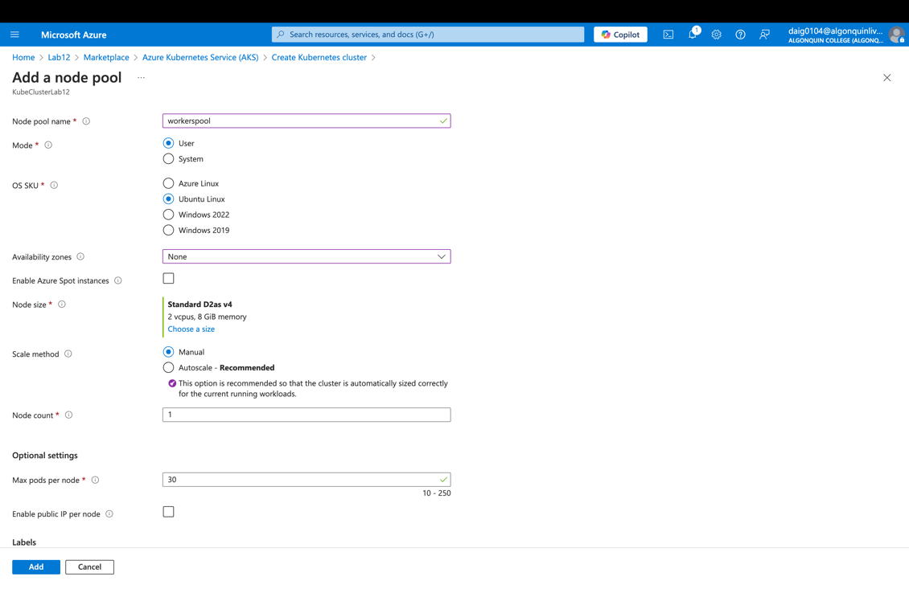
Updating agentpool(same size as workerspool)
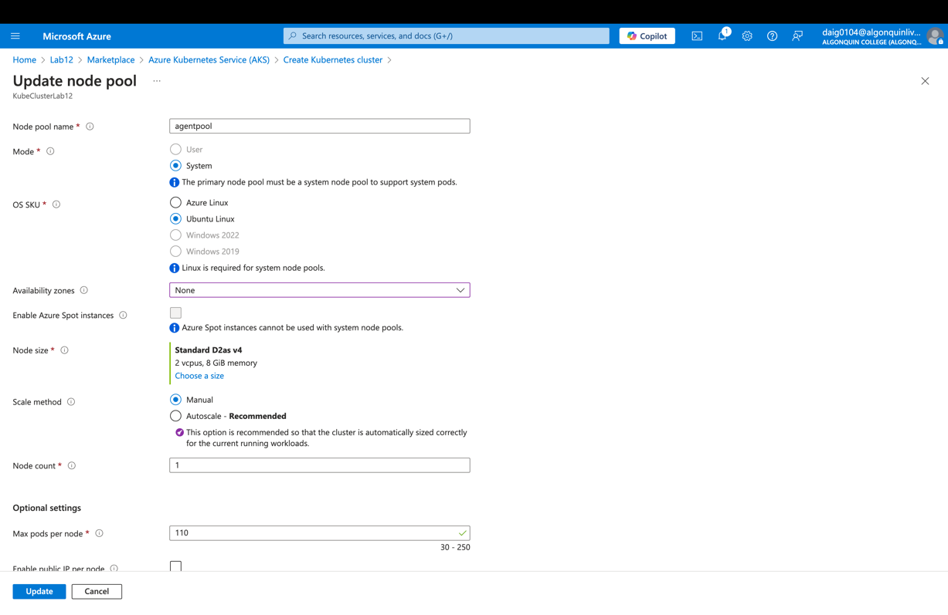
Review:
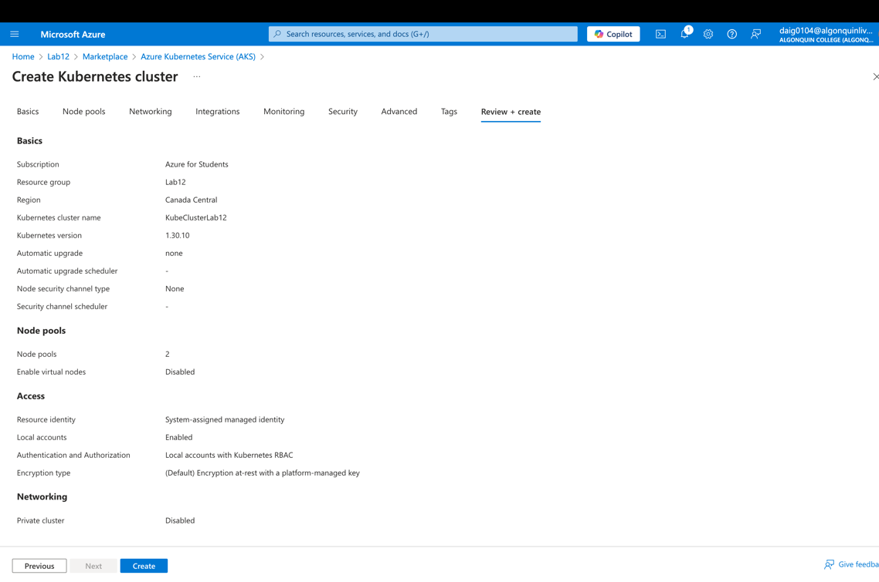

Connecting to Kubernetes via terminal: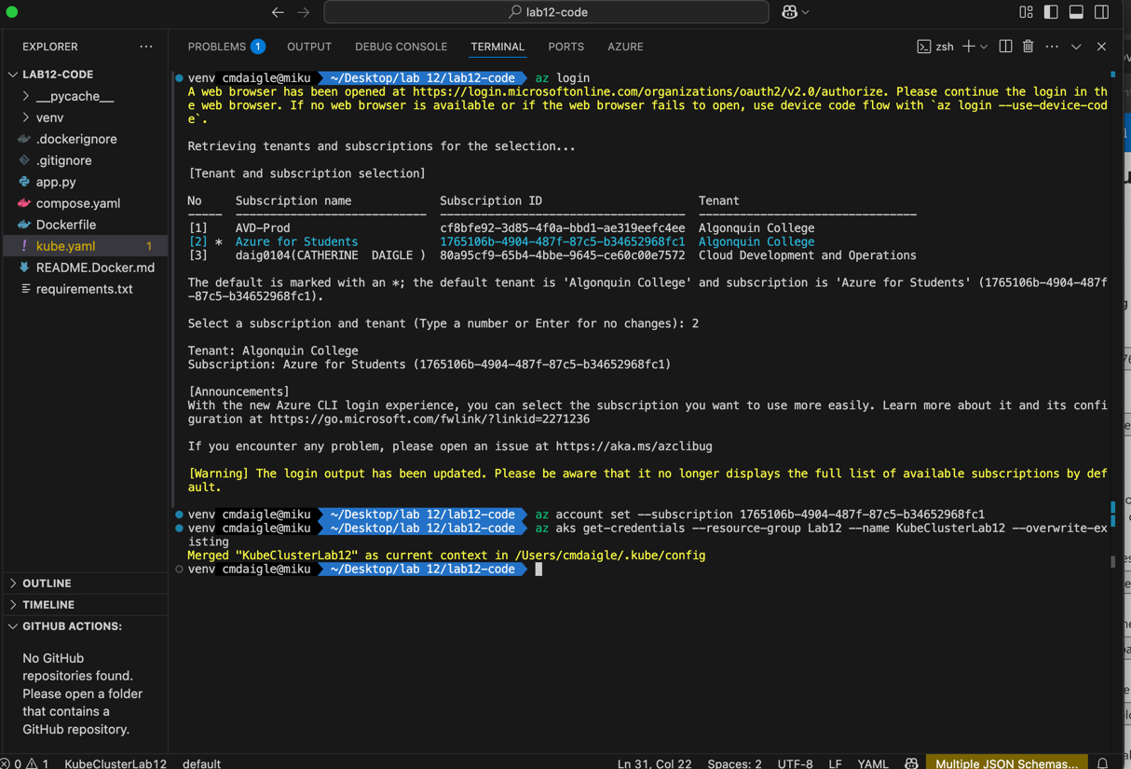

Deploying the Kubernetes Application:
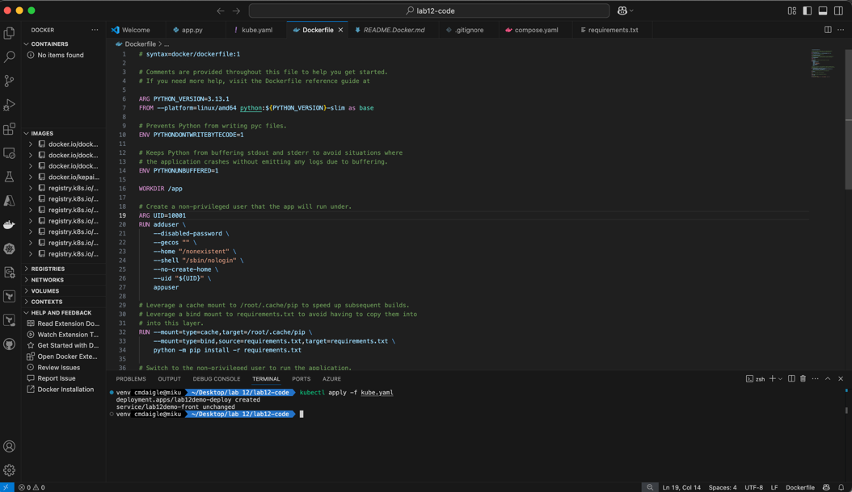
Issue: I had an error deploying to Kubernetes as the worker container would keep crashing and Kubernetes would continue restarting the container. This error is called CrashLoopBackOff and below is my process in solving the error.
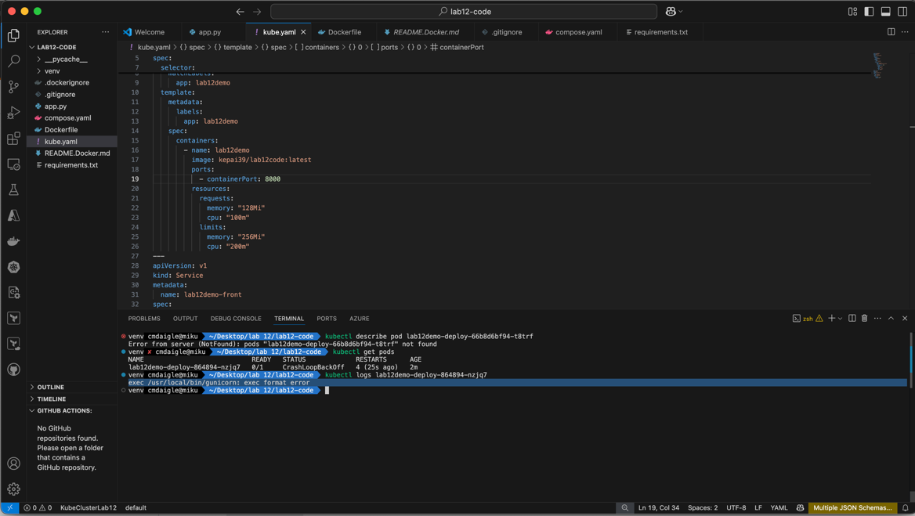
Below Is the command to describe the specific pod that is having the error. Unfortunately, it does not give much information on what caused the error but does show that it successfully pulls from the docker hub.
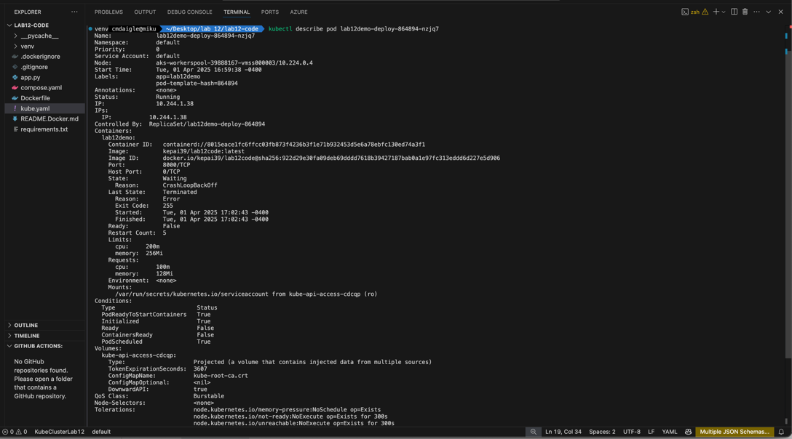
What did reveal the error is Kubectl logs of the pod. It then revealed it was a format error.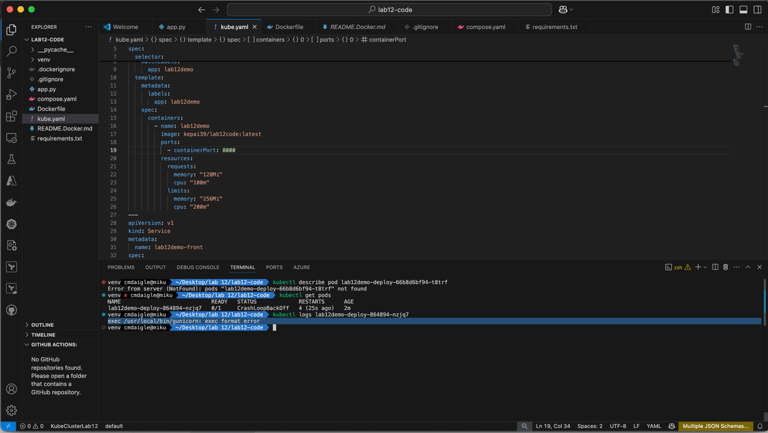
Through Research I learned that the format error is due to the docker file and that when I deployed to AKS it was deploying expecting an M1 Architecture (which Linux does not support). Therefore, the docker file had to be changed to support a Linux architecture. Where FROM –platform=Linux/amd64 is added.
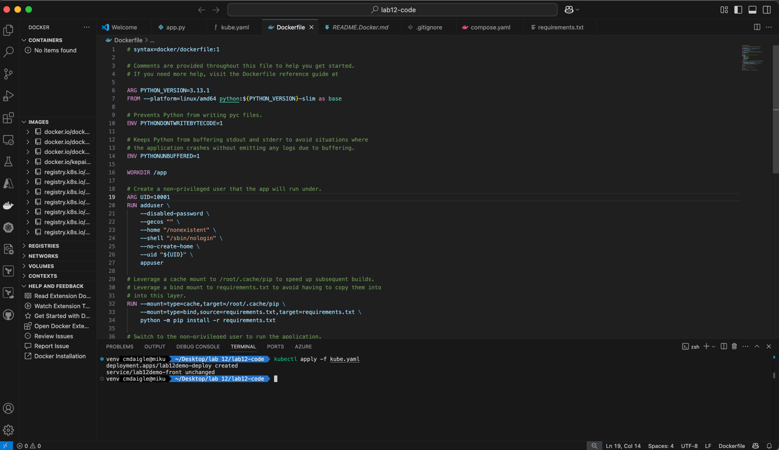

The result is the successful deployment of containers:
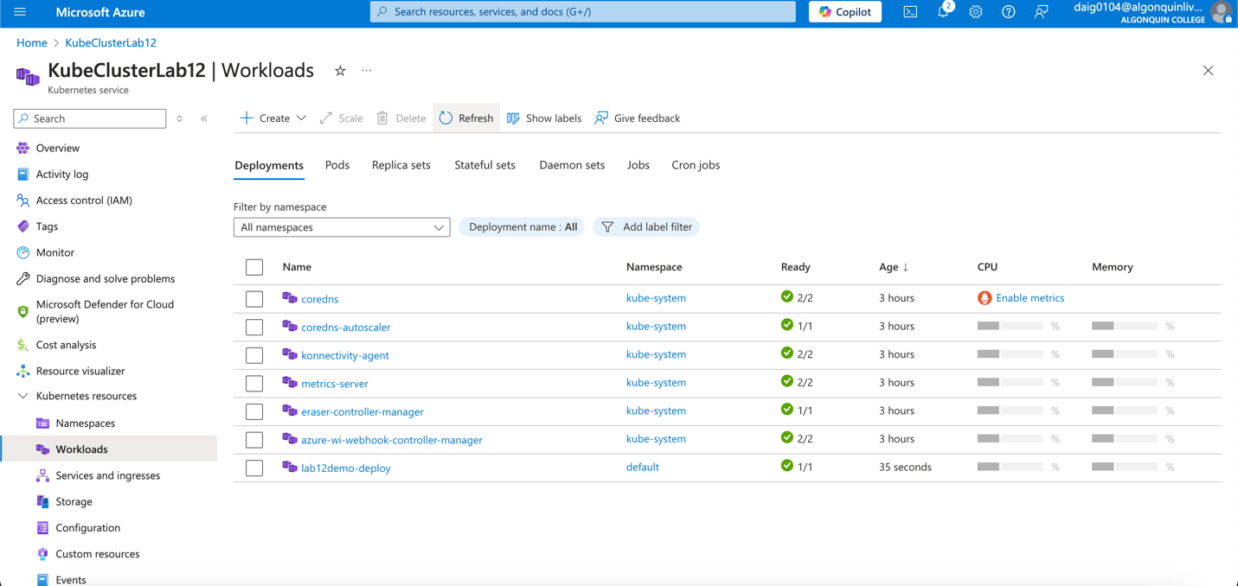
Successful deployment of services:
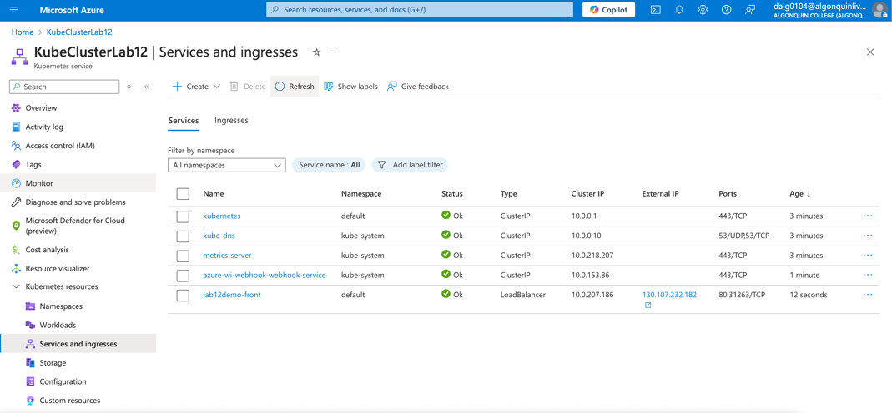
Application Result:
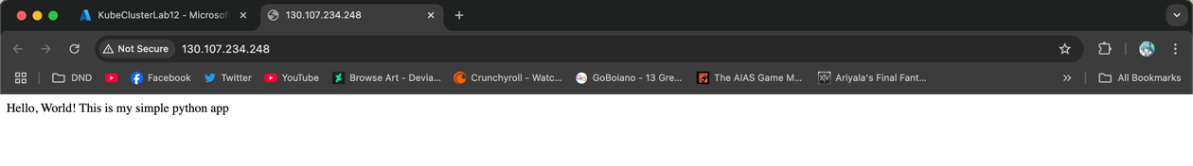

Scaling the Application –optional step
Scaling is rather simple at least in the application sense, in this case I simply increased the replication number like so:
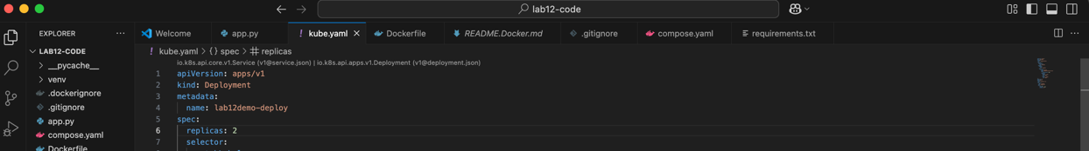
Now the result after re-applying kubectl apply <filename>: As you can see there are now 2 workload pods within lab12demo-deploy:
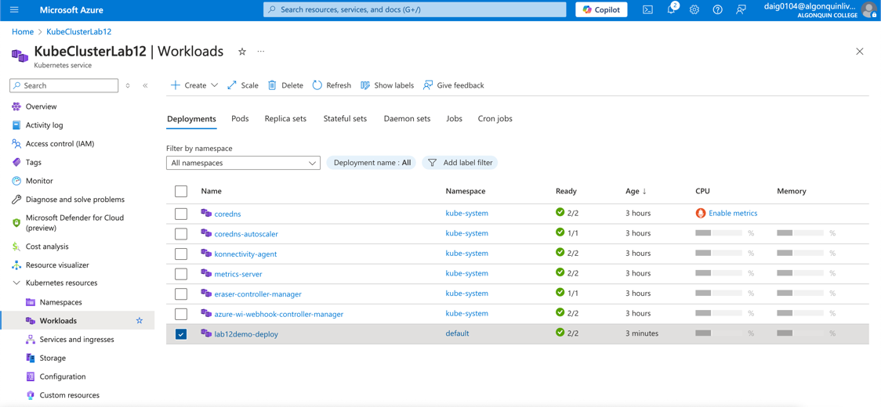
Here you can see the two pods as the result in increasing the replication number. Therefore, we scaled up the application by one.
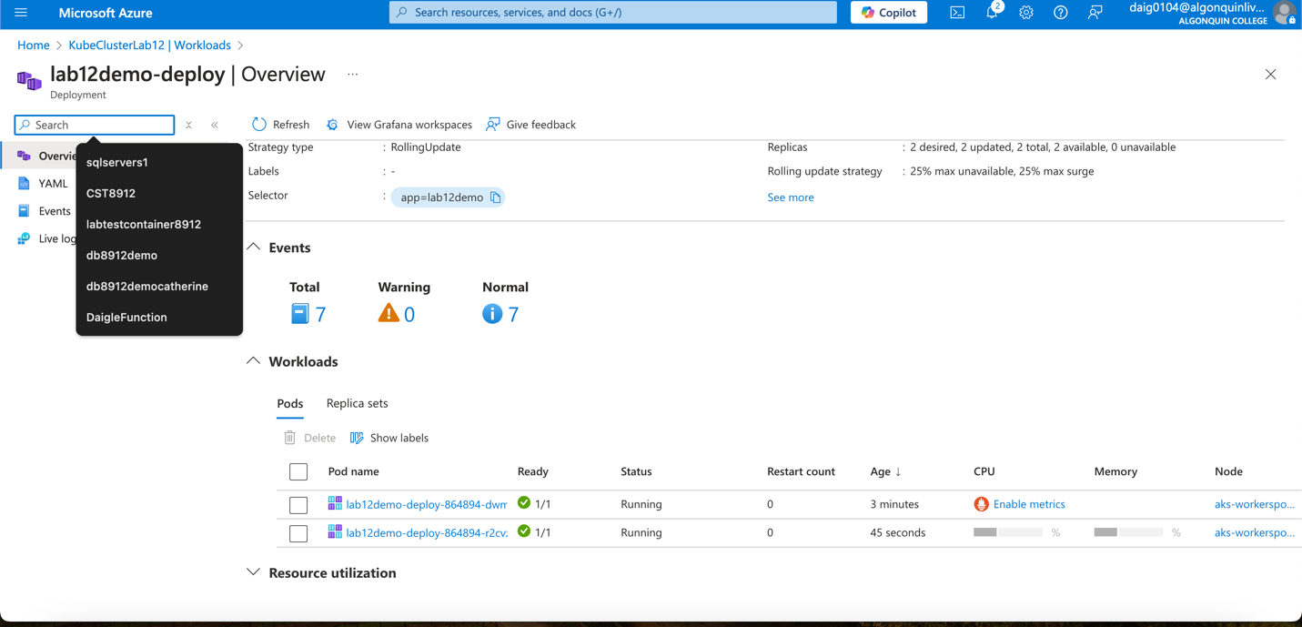

Monitoring and Logs
There are a couple of different ways to monitor pods both are Azure Monitor, Using Kubectl, and Prometheus. Below are steps I used for Prometheus and monitoring using Grafana.
Configuring Prometheus with Grafana: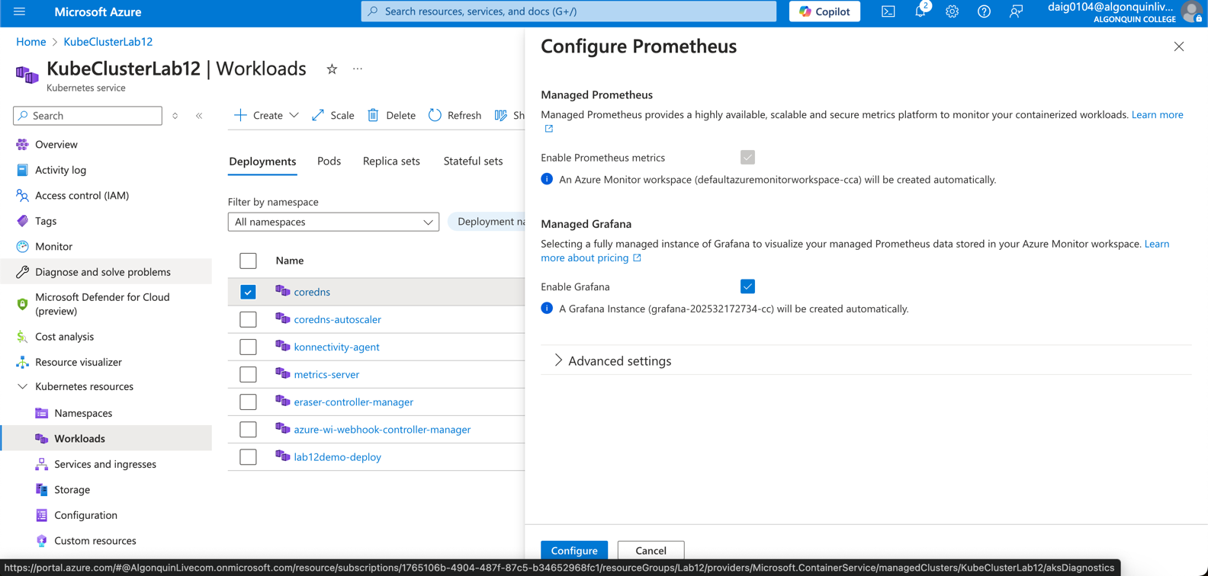
Accessing Grafana:
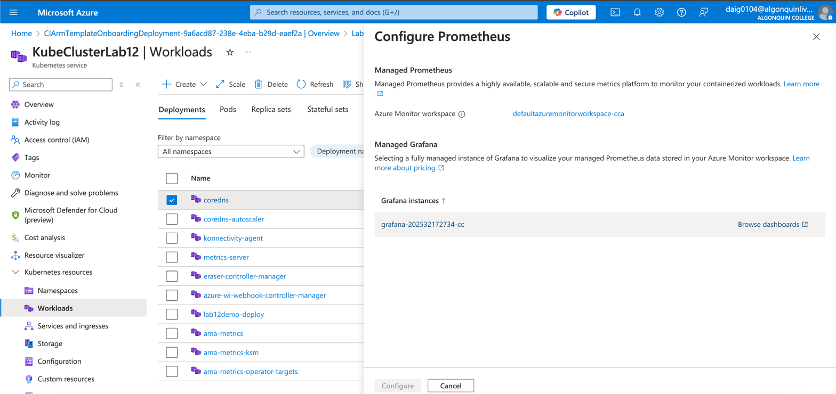

Below I use the dashboard to monitor pods and workspaces:
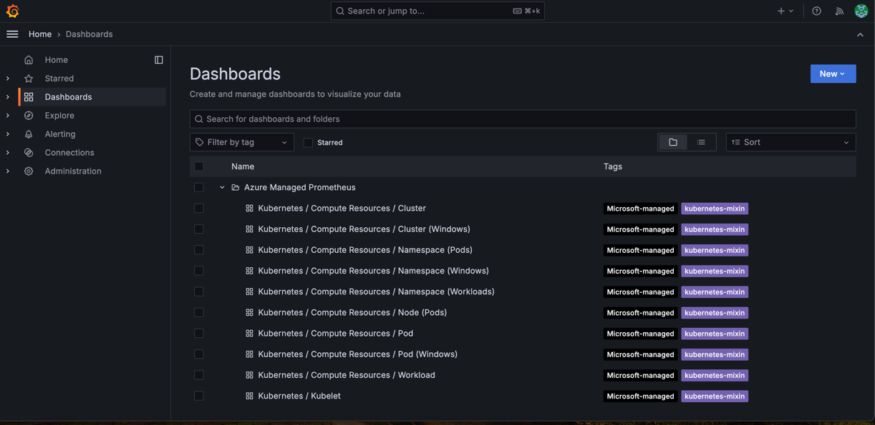
Monitoring workspaces, below is the CPU usage in past hour:
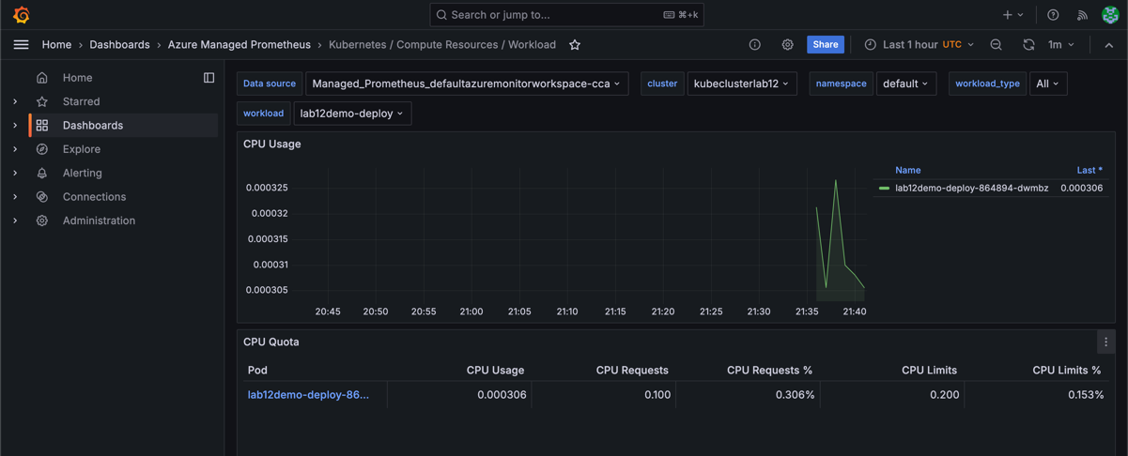
I then Added 3 more pods to test if the CPU usage of the workspace differs: In this case, you can see the pods below and a increase of CPU usage.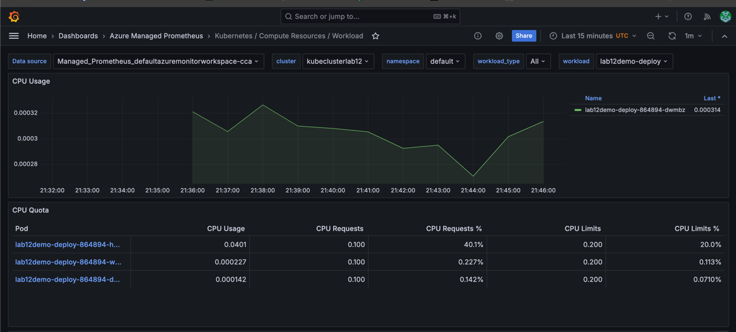
This is the CPU usage when removing the other pods, Below you can see the spike of other pods startup and the sudden drop with their deletion.
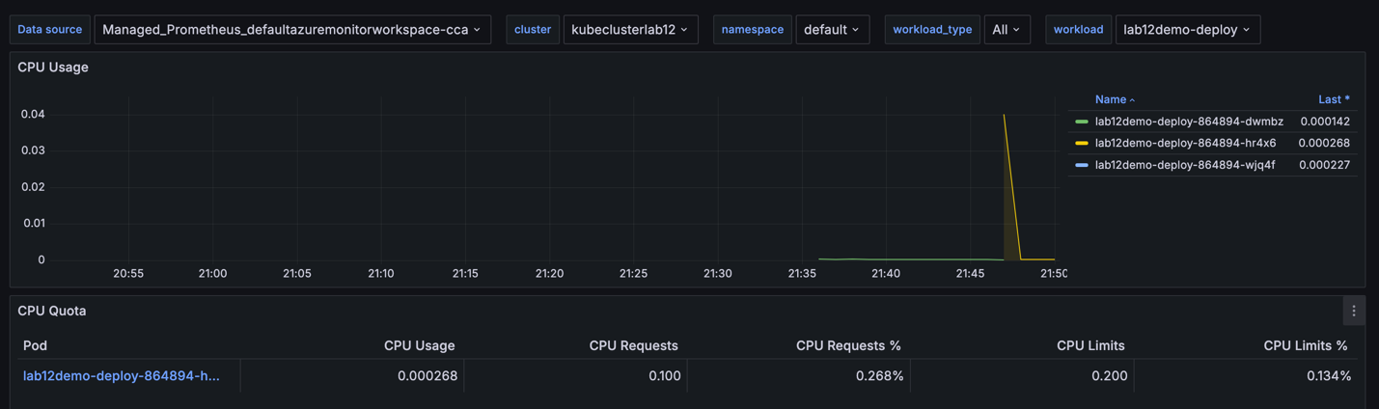Monitoring of the workspace itself within an hour:
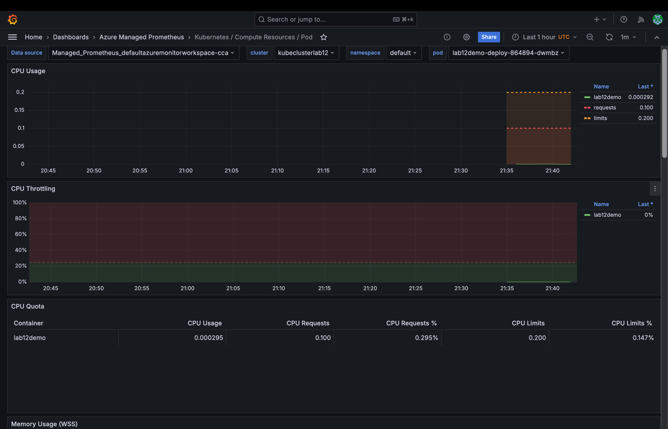

Below I tried Azure Monitor, these graphs monitor the bandwidth and IOPS consumed. Azure monitor was configured similarly along with Prometheus within the “configure Prometheus” step:
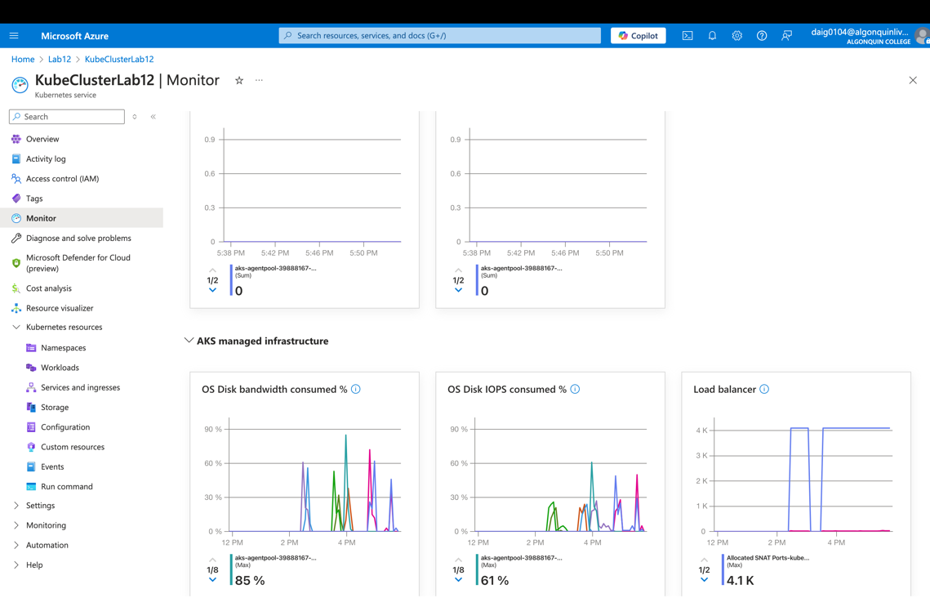
Below are the various logs I went through. I wanted to try Azure Analytics, however, I had a bit of trouble and worried the cost might have been too much as there seemed to be growing deployments of monitoring resources:
Activity logs:
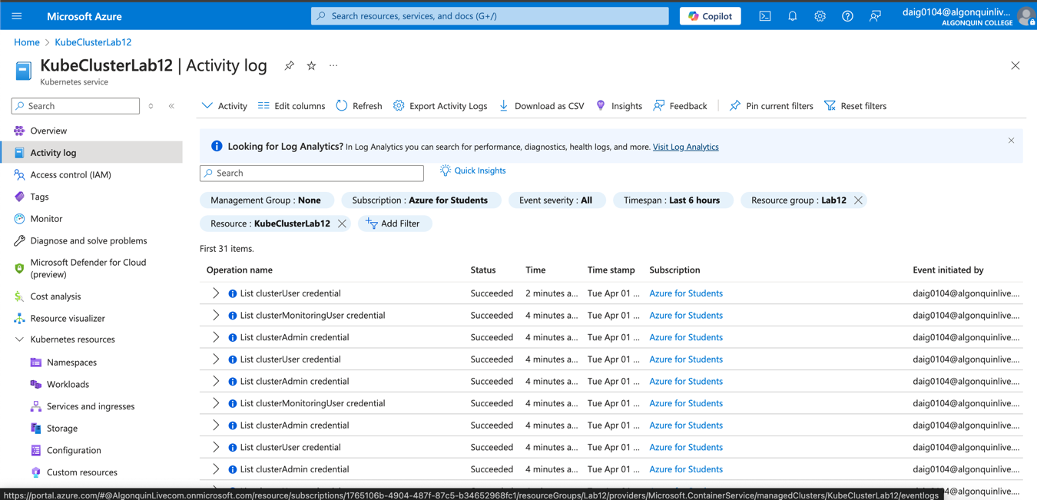
Event logs: This showed the earlier scaling events as you can see the replica set scaled from 1 to 2 to 3.
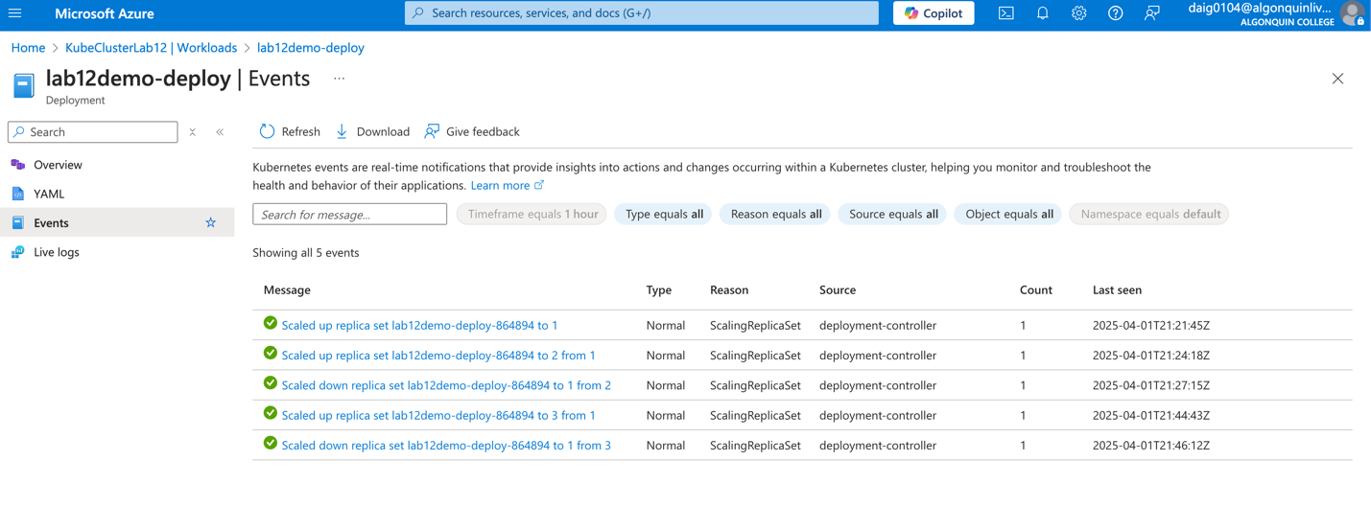
Kubectl logs: These were very helpful in determining why the pods were failing and helped solve the format error I had above. The logs here tell me of the condition and what exactly the workers/pods are doing.
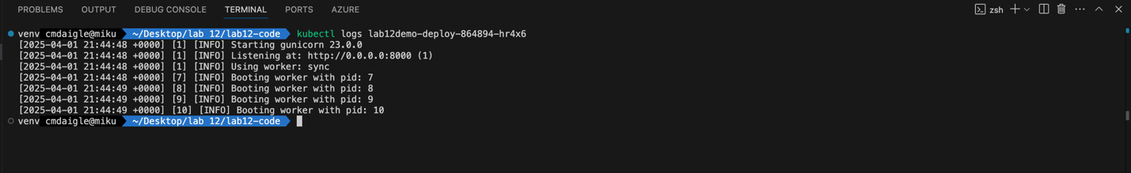

Clean Up
As you can see I had many resources to delete since I explored many ways to monitor the Kubernetes pods. This is also why I did not continue with log analytics as it was too much time.
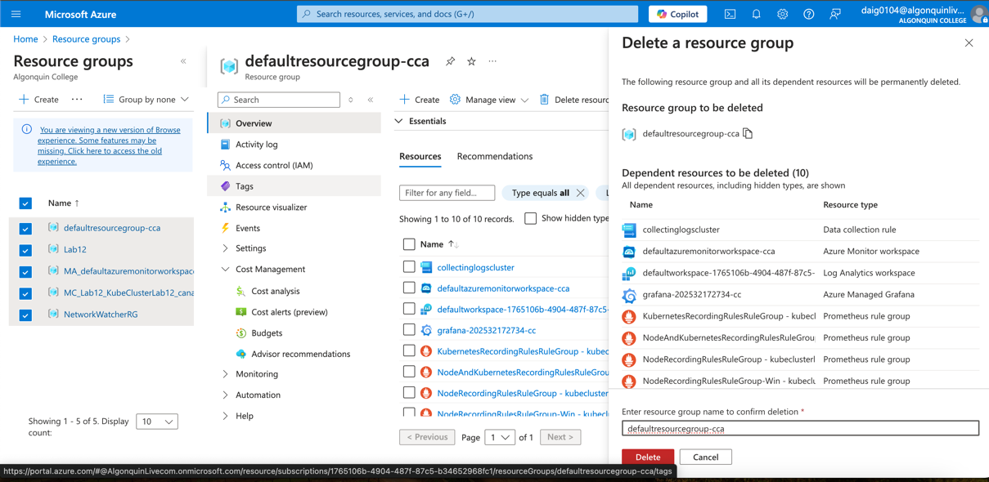
Deletion of other resource groups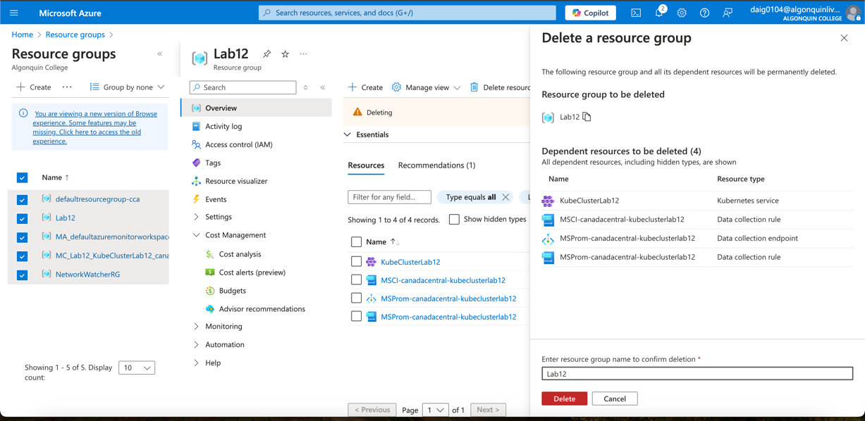
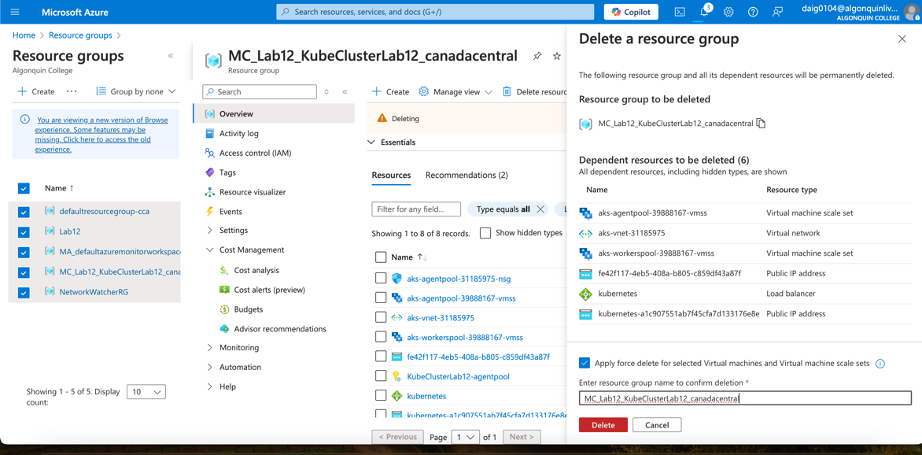
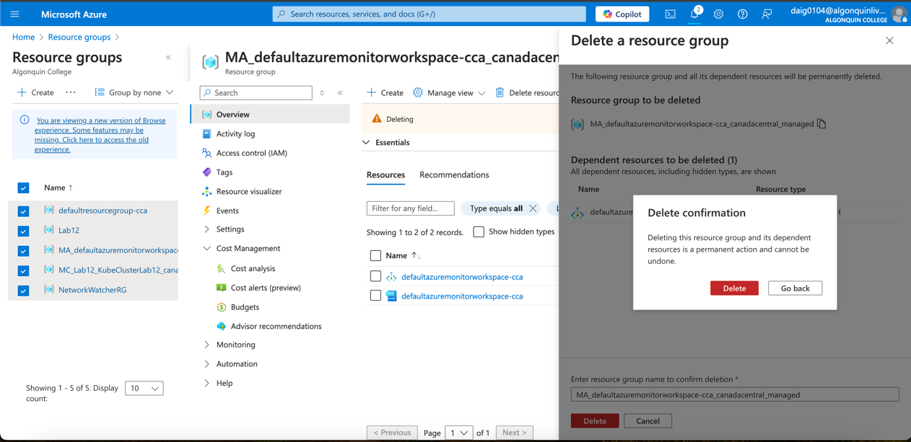
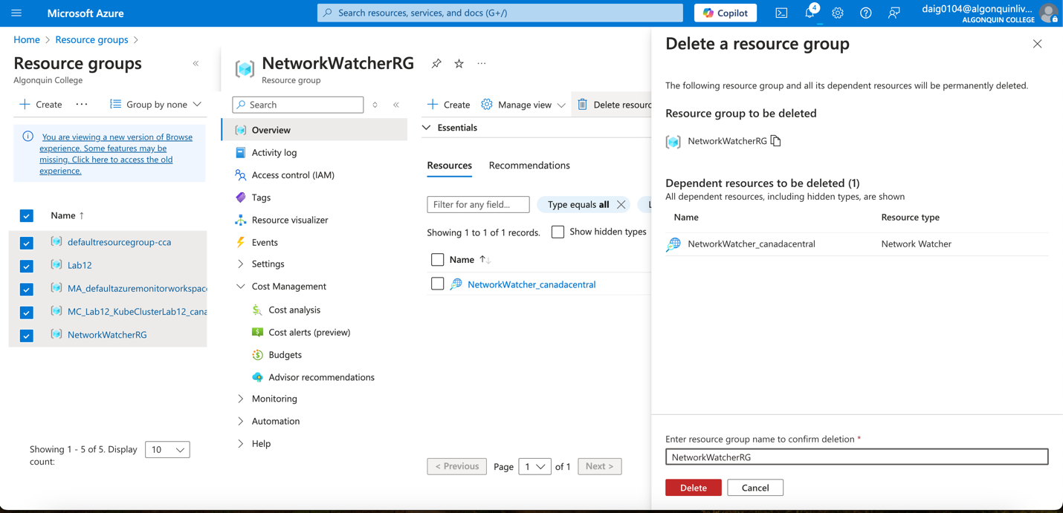
Checking that I deleted all resources:
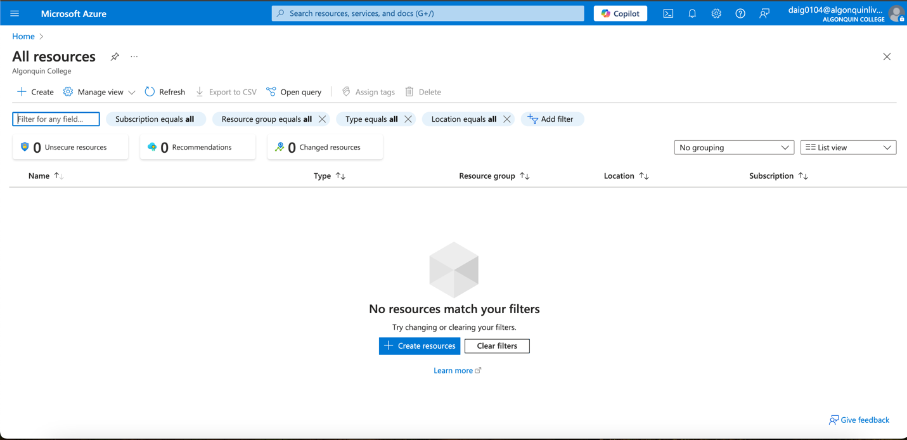

Conclusion:
In conclusion, I have made a Python application and a Dockerfile to deploy Kubernetes locally with my computer first. My original intent is that if I had it working within my local environment it would be easier to transfer that publicly to Azure AKS. Unfortunately, the two environments contrast as Azure AKS cannot use Nodeport to serve a web application. To solve this, I instead had to use load balancing.

Even then, when deploying to an AKS cluster I had issues with a CrashLoopBackOff error that can be difficult to solve due to many factors causing it. Using Kubectl logs and pod descriptions I looked into what caused the error and found a formatting problem with the Dockerfile code. The cause of the issue is that the Dockerfile made locally had my Mac M1 architecture in mind which does not support a Linux/amd64 architecture. After solving the error, I successfully deployed the pods and accessed the application on the web.

It was simple to manually scale as I changed the replicas within the YAML from 1 to 2, since pods are immutable, AKS automatically replaces the pod with the new configuration. I then used Prometheus and Grafana to monitor the pods and look at the CPU differences when scaling resources. I observed that CPU usage spikes considerably upon scaling as new pods in their start-up processes, and then CPU usage returns to a constant rate. Similarly, memory also spikes upon start-up (This is shown within step 7). I also used Azure monitor and observed the IOP spikes and bandwidth consumed as the pods ran the web service.

For logging, I looked at the activity and event logs which logged the events when I scaled up and down the pod resources by changing the YAML code. Additionally, I used kubectl to describe pods when I wanted to see a log of each pod and their processes and kubectl log. kubectrl log was handy for debugging pod errors as without it, I would not have known what had caused the CrashLoopBackOff error as it is a generic error. I wanted to experiment with log analytics however, as I explored the workspace it did not seem to display logs towards the workspace. As I was currently running many monitoring deployments such as Prometheus, I did not want to incur further costs and proceeded to delete the resources as connecting log analytics to AKS was taking too much time.

In the end, I was able to deploy, monitor and even visualize pods and container metrics such as CPU or memory usage within Azure AKS. I was then able to monitor the effects of scaling up 2 additional resources on these metrics.

