CST8921 – Cloud Industry Trends
  - Lab 14 – Monitor services that are deployed to Azure

Introduction
In this lab, I learn to create an Azure application insights resource to monitor and log data for issues or review. I also learn how to set the resources to automatically scale when a certain threshold has occurred and Insights logs the data to see changes within how the service is used.

Objective
The goal of this lab activity is to familiarize students with Azure app insights, and web API’s

Lab Activity Screenshots:

Exercise 1:

Step1: Create an Azure application insights:
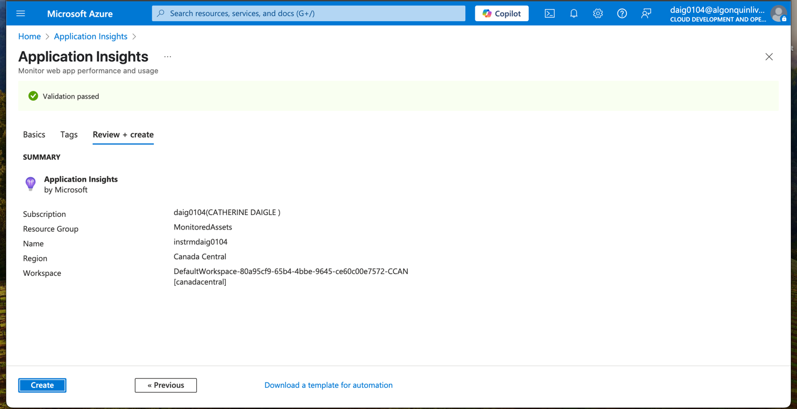

Step 2: Get the Instrumentation Key:
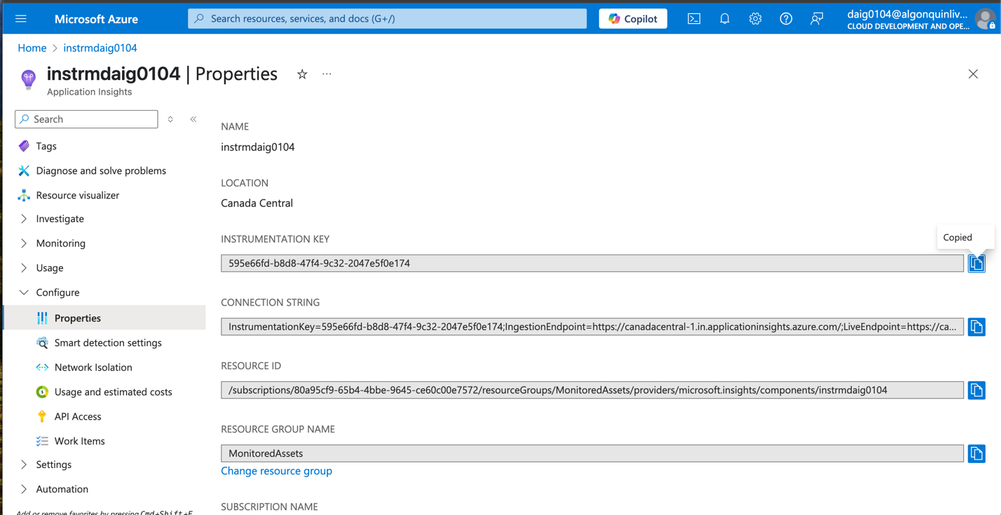

Step 3: Create WebApp:
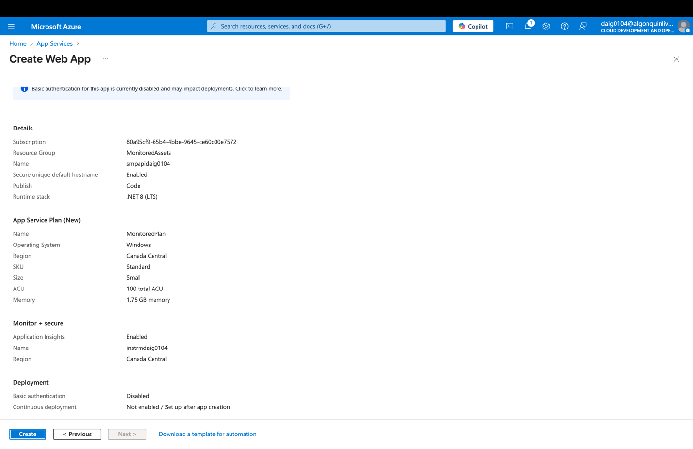

Observe that the Web app connection string is the instrumentation key:
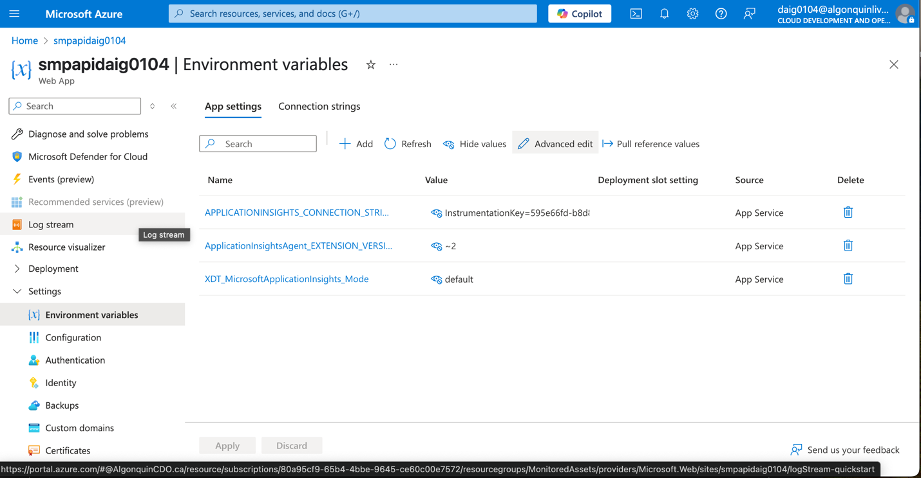Step 4: Get the default domain link for later:
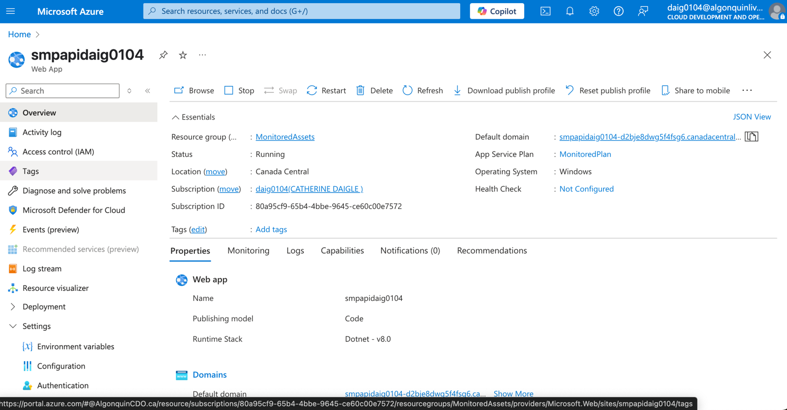

Step 5: Pick rules-based scaling (I had to change the web app to standard tier. Apparently, free does not enable this feature)
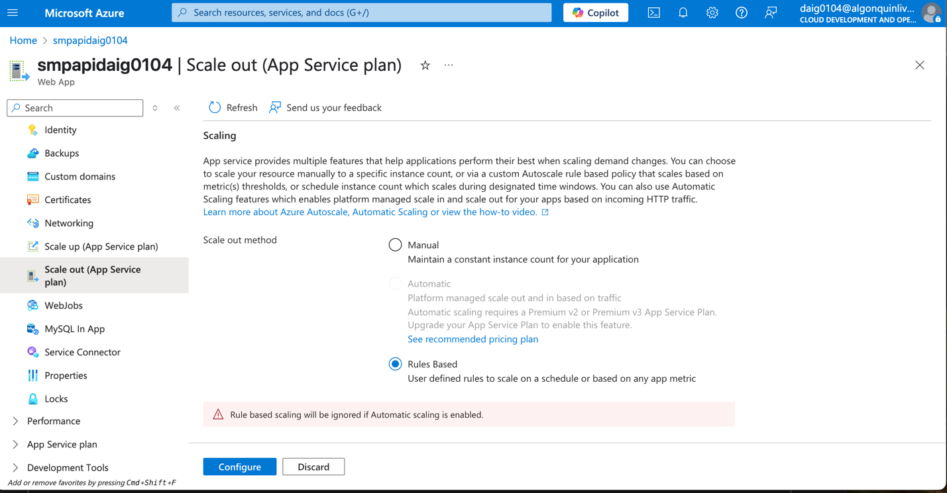

Step 6: Set the scaling settings
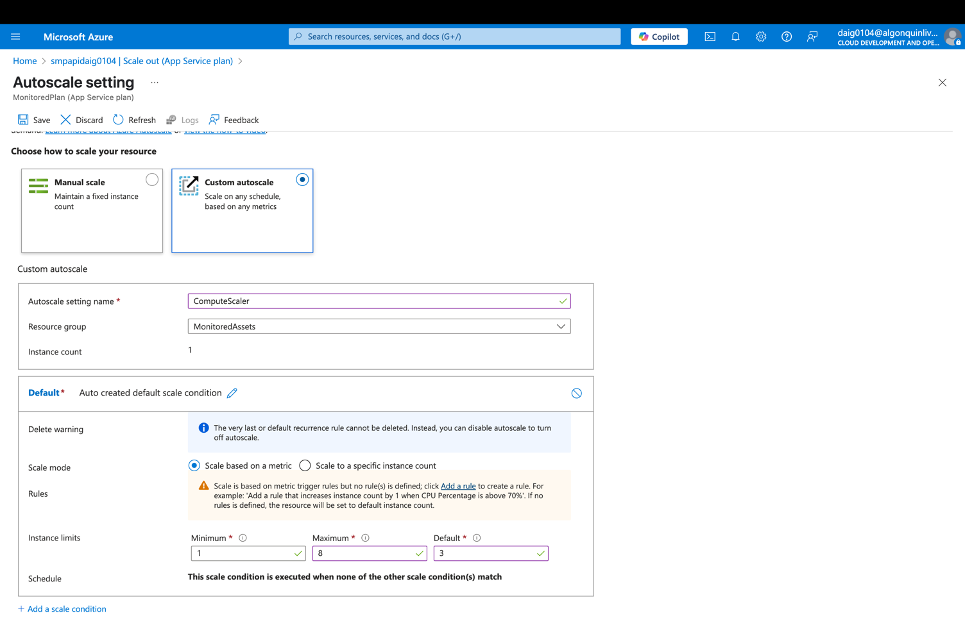

Step 8: Add a Scale Rule:
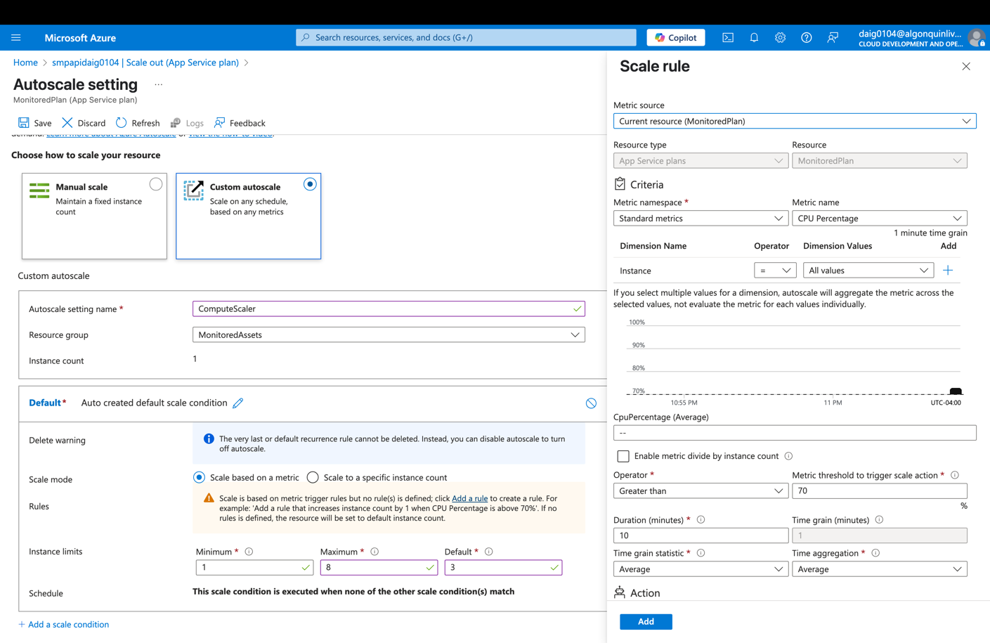

Exercise 2:

Step 1: Create a new VS Code project and run the following command on the terminal (From here I edit a folder I added called code) dotnet installations:

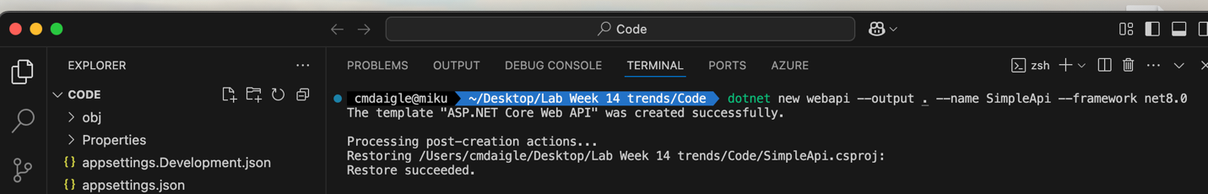

Step 2: Imports Microsoft Application Insights from NuGet to the project:
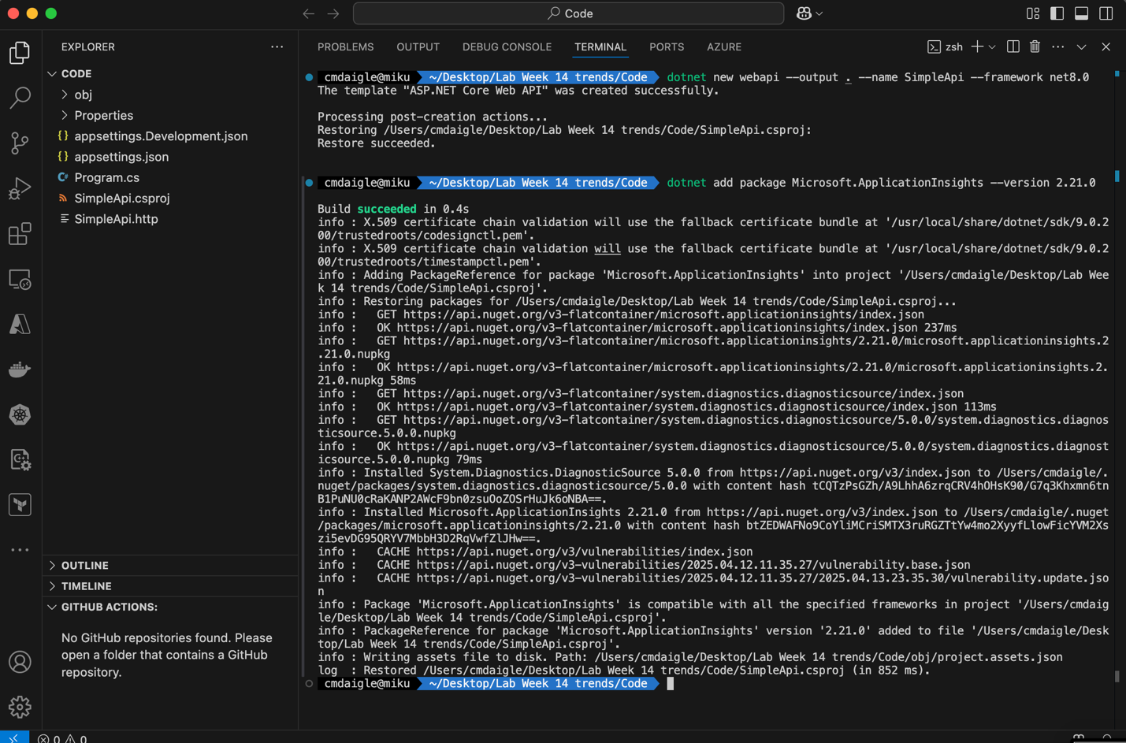

Step 3: Imports Microsoft ApplicationInsights.AspNetCore from NuGet to the project:
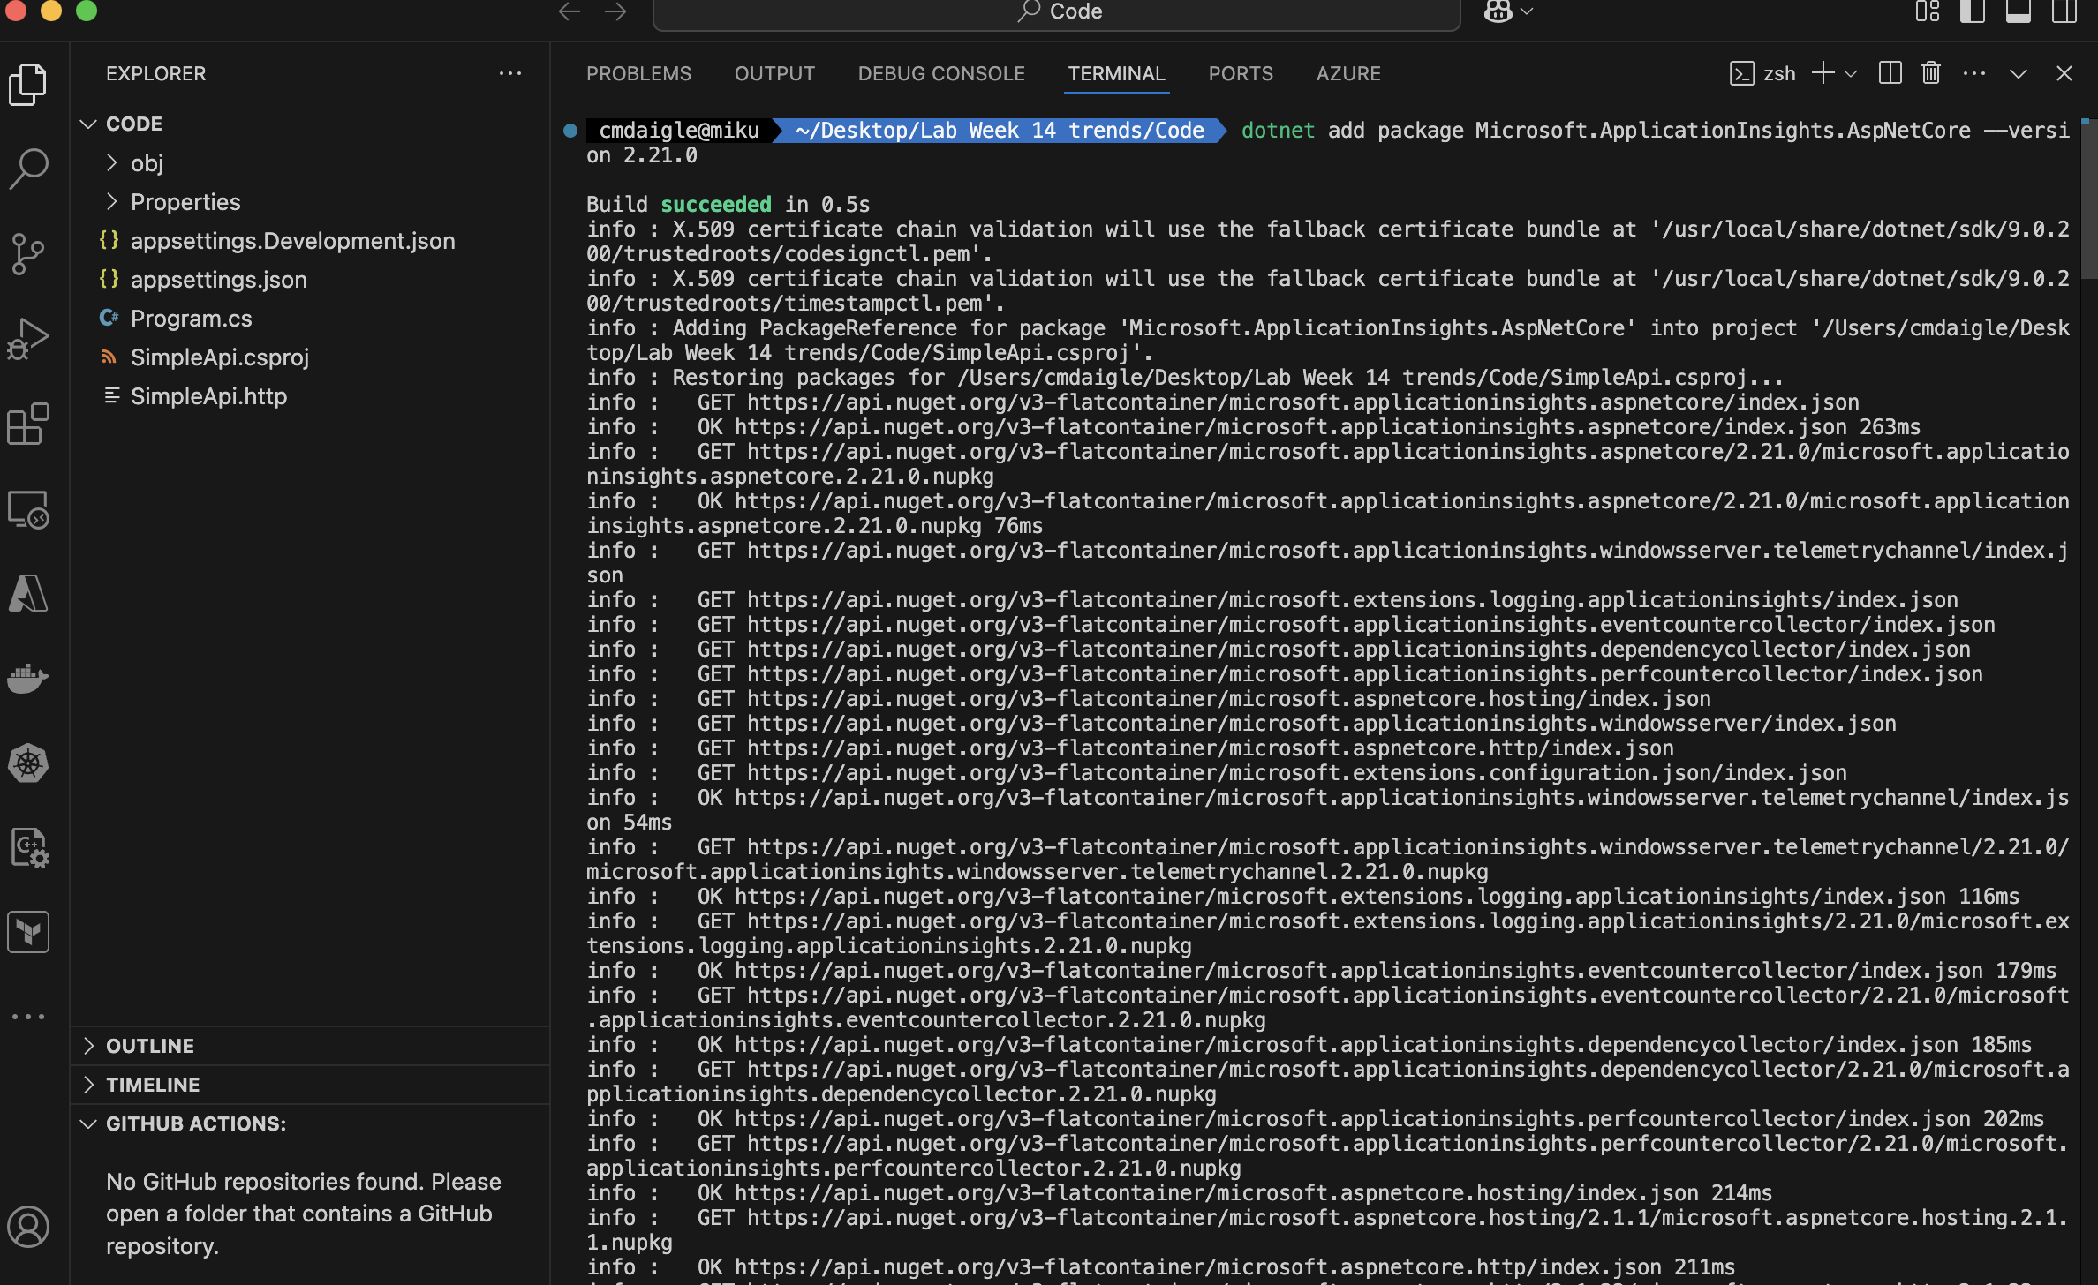

Step 4: Imports Microsoft ApplicationInsights.PerfCounterCollector from NuGet to the project:
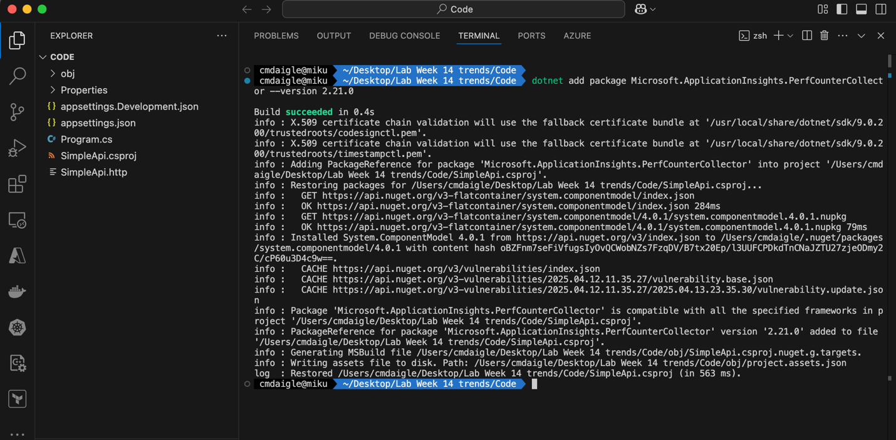

Step 5: Imports Microsoft ApplicationInsights.Profiler.AspNetCore from NuGet to the project:
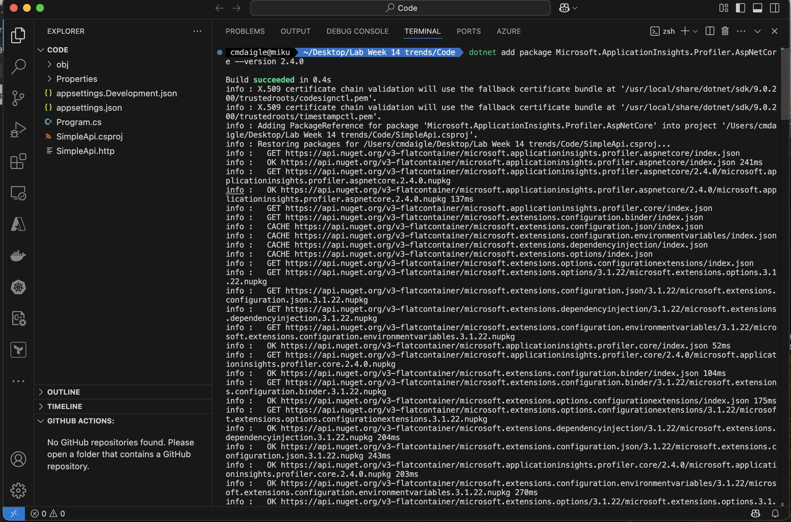

Step 6: Build the project:
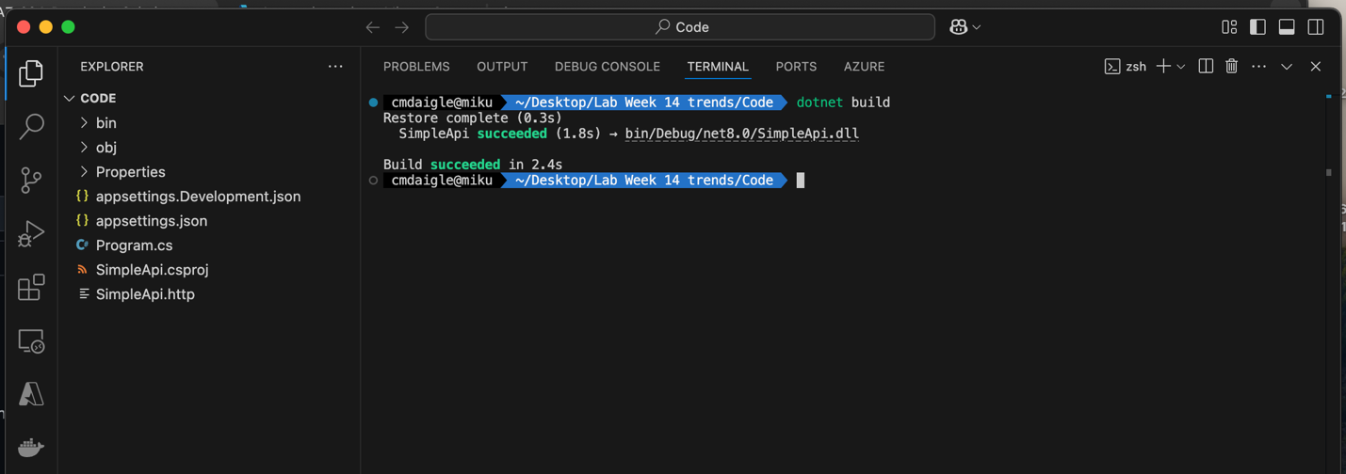

Step 7: Add Code: Use HTTP, Services and Instrumentation key
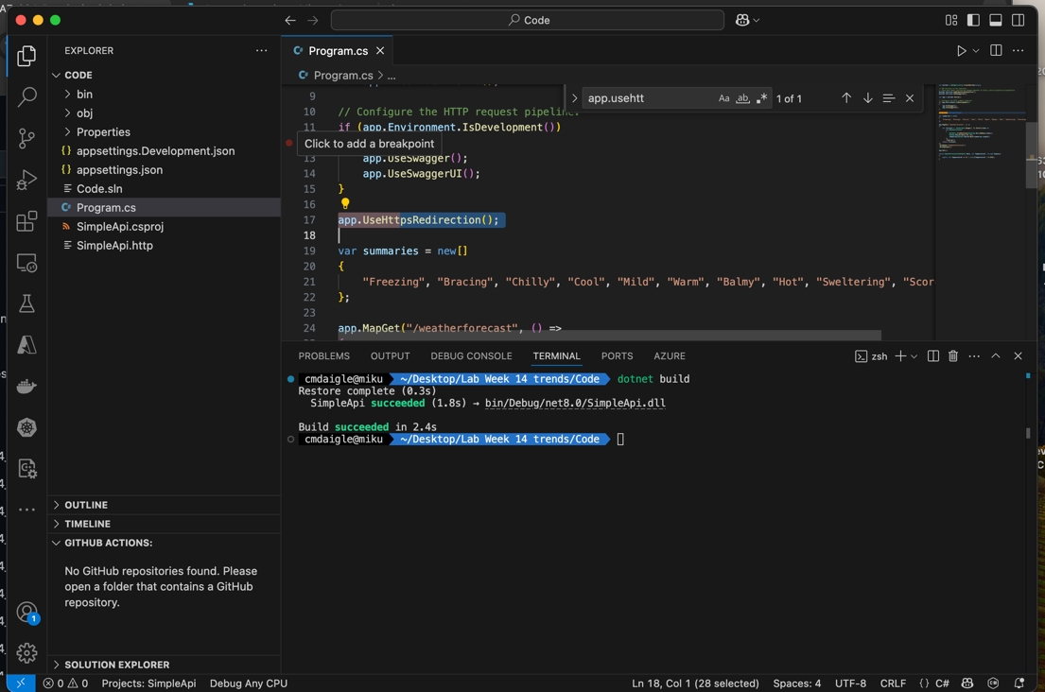
Services:

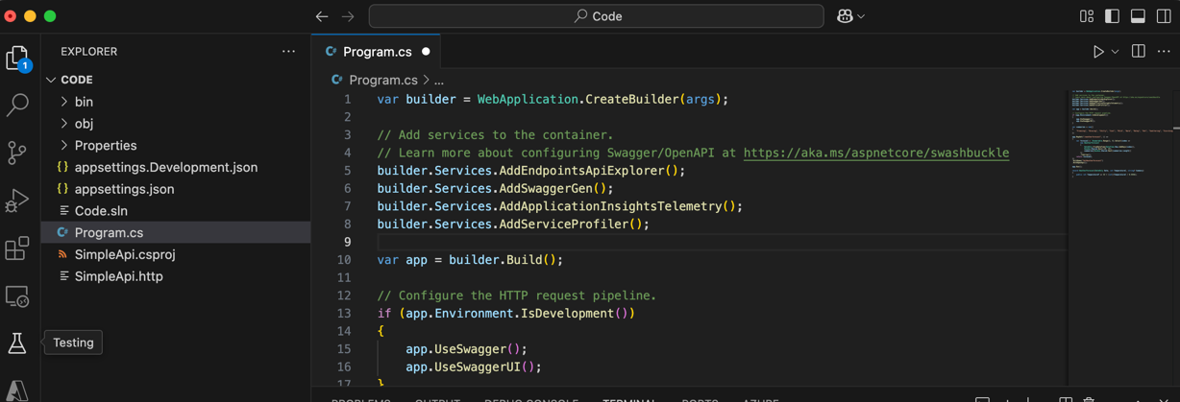

Adding instrumentation key to appsettings.JSON
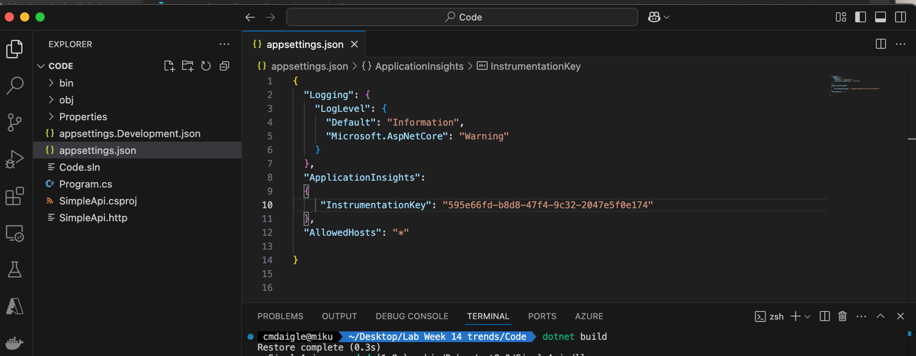

Step 8: Build the .NET web API:
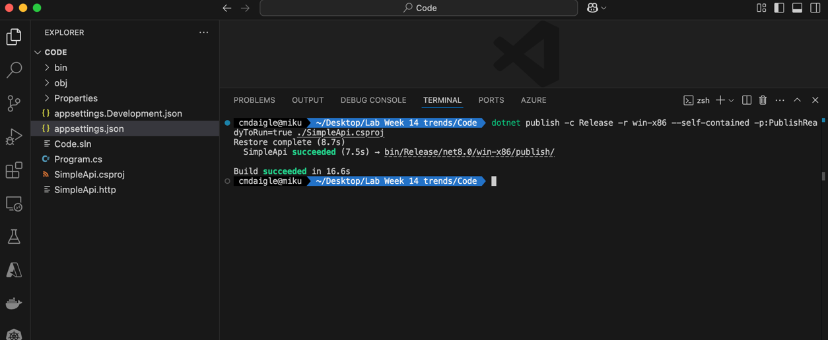
Step 9: Test App Locally:
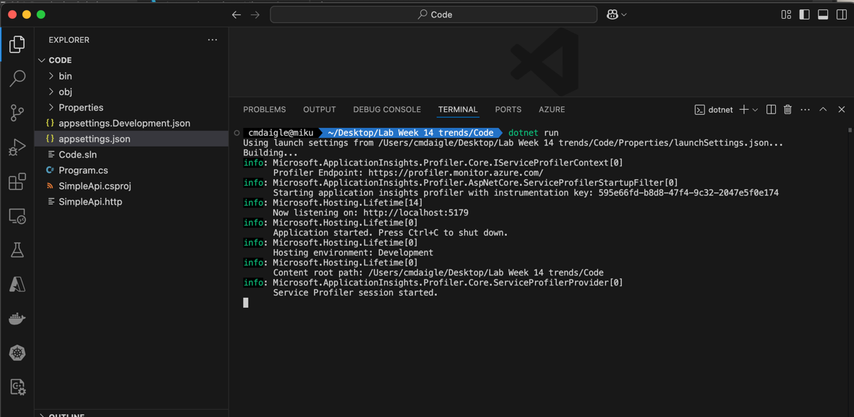
Test Results: Refreshing the application many times for the next task:
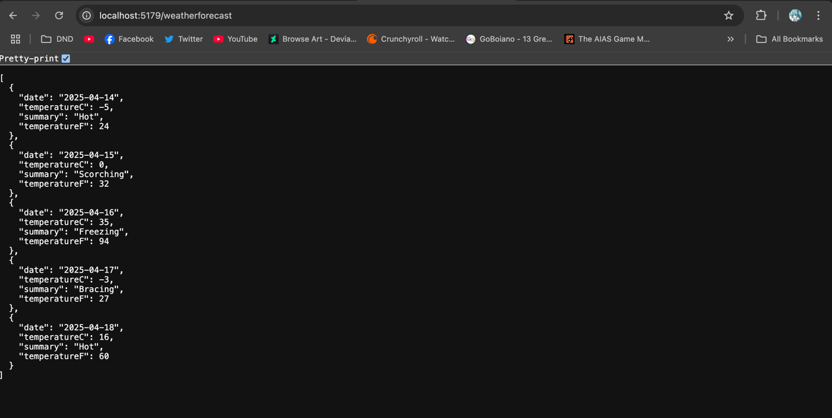

Step 10: monitoring web app with app insights and see changes in server requests increase by refreshing the above page:
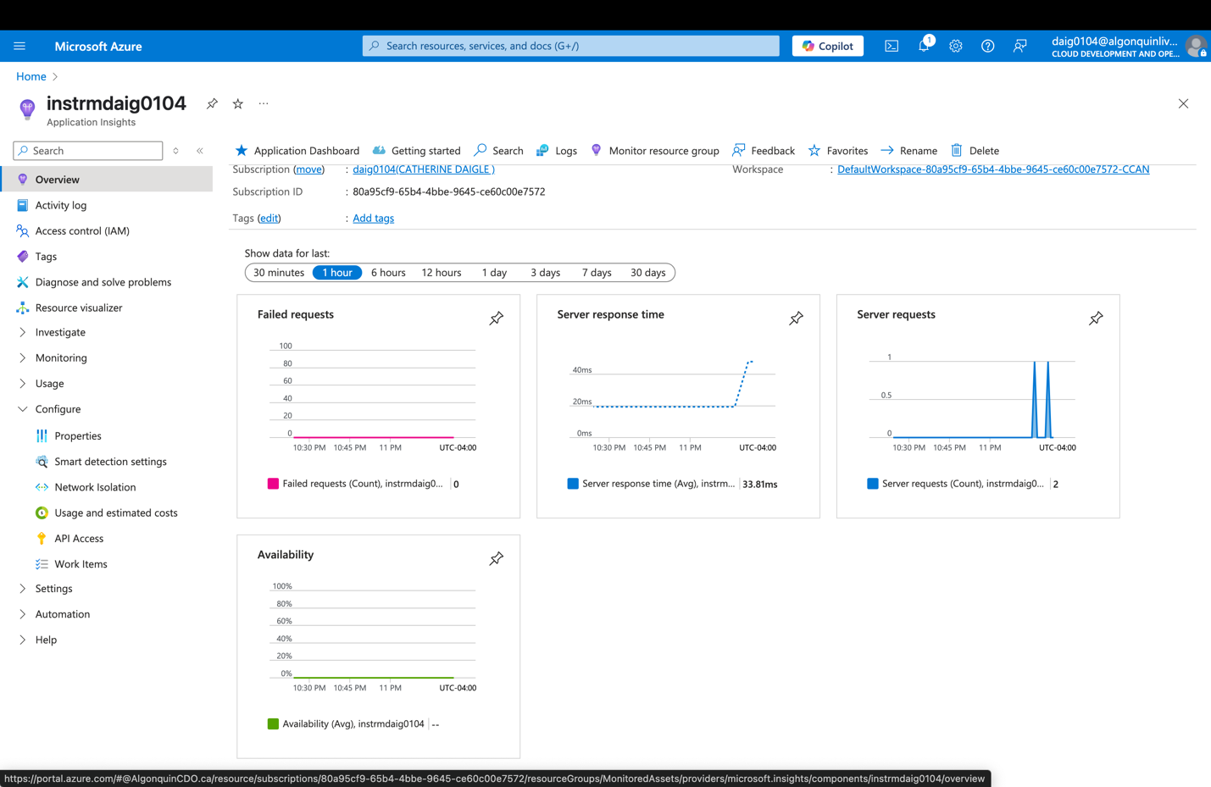

Exercise 3:

Step 1: Create s a Zip file of the previous exercises (the code file, of publish): I had quite a few files not found issues, but it was solved by using the terminal and not zipping
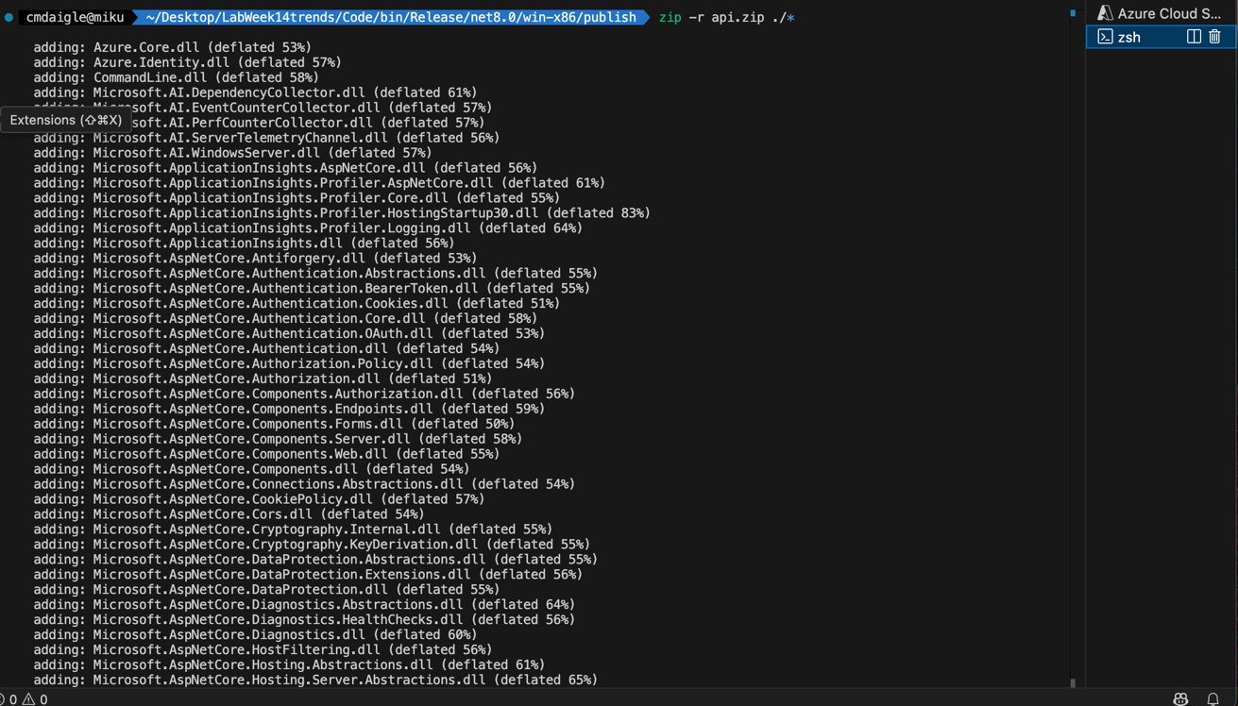

Step 2: Connecting to Azure Cloud Shell:
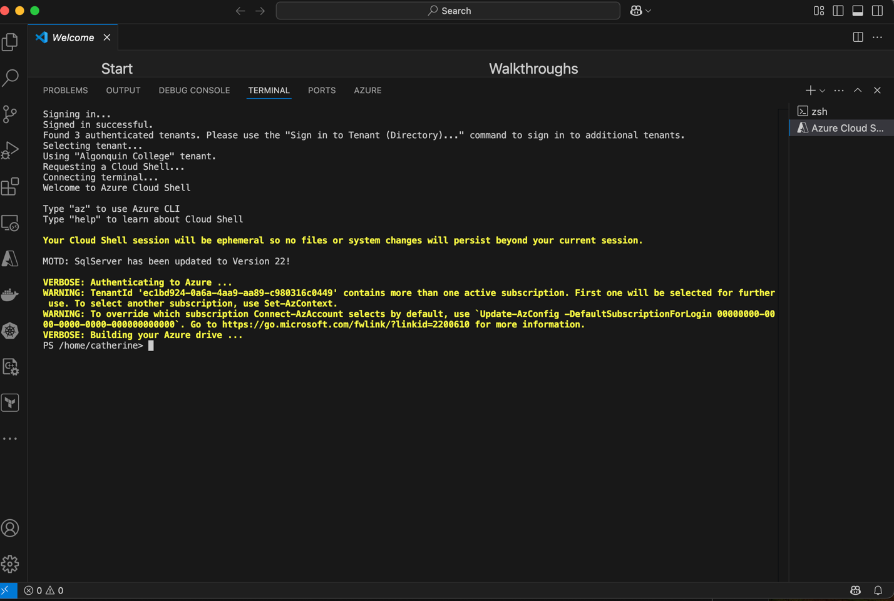

Step 3: Display all web apps within the MonitoredAssets resource group
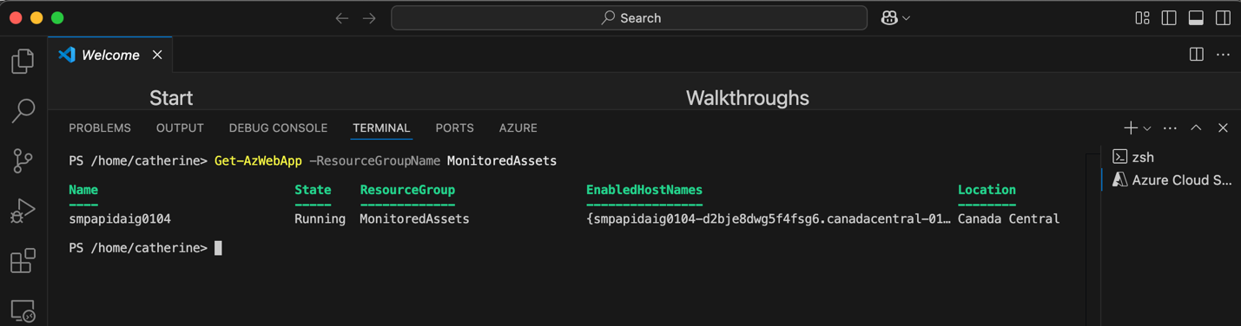

Step 4: Filter web apps to display a list with names that start with smpapi:
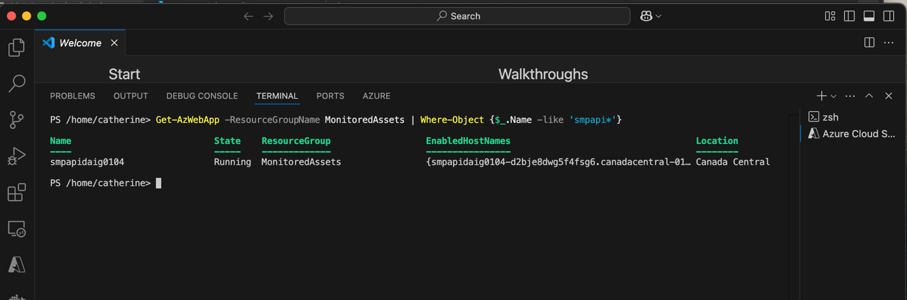

Step 5: Store the name of the web app in a variable
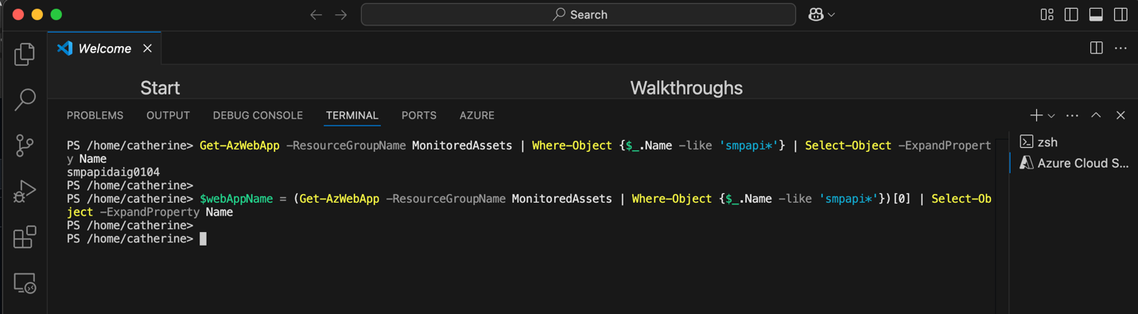

Step 6: Publish the web app with the project's Zip from earlier. Here I had an issue as I could not retrieve the Zip file. (the second attempt was after the fix):
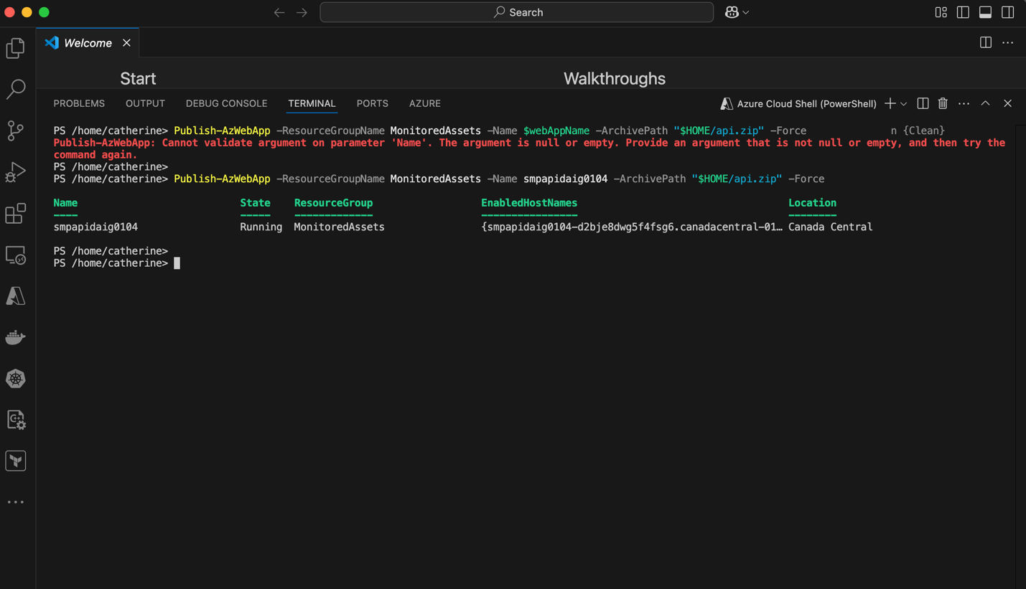

Step 7: To solve this problem I uploaded the zip to Azure Cloud Shell within its directory.
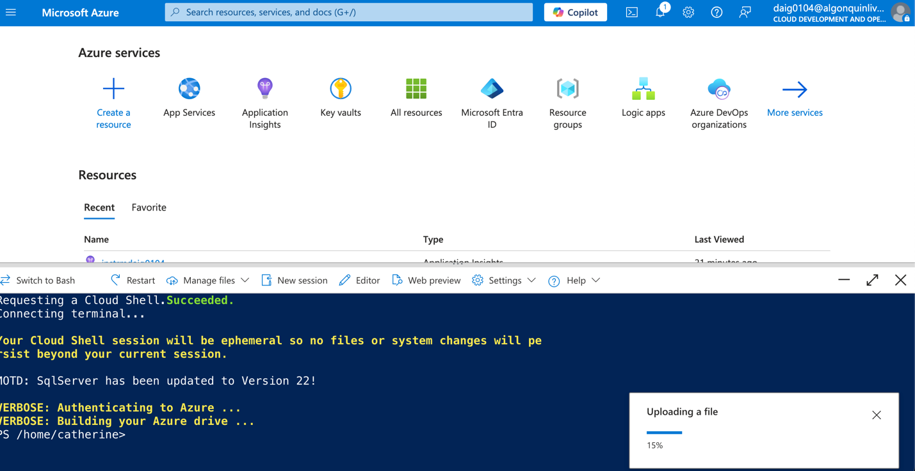

Step 8: Testing that the output is similar to the local service:
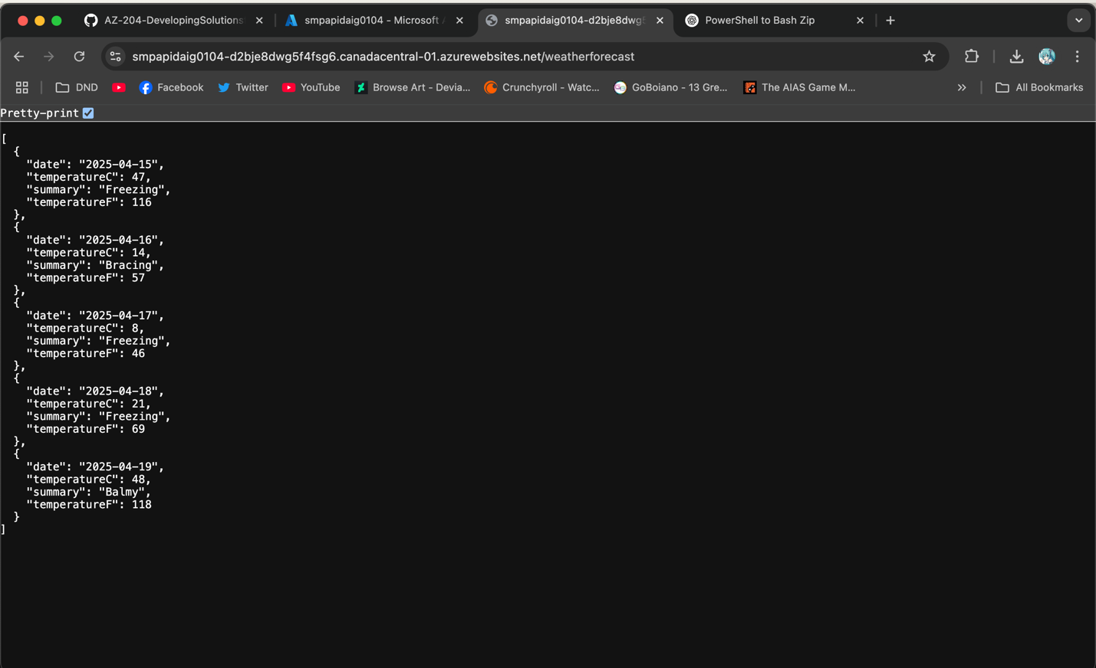

Step 9: Configure a metric-collection for the Web App:
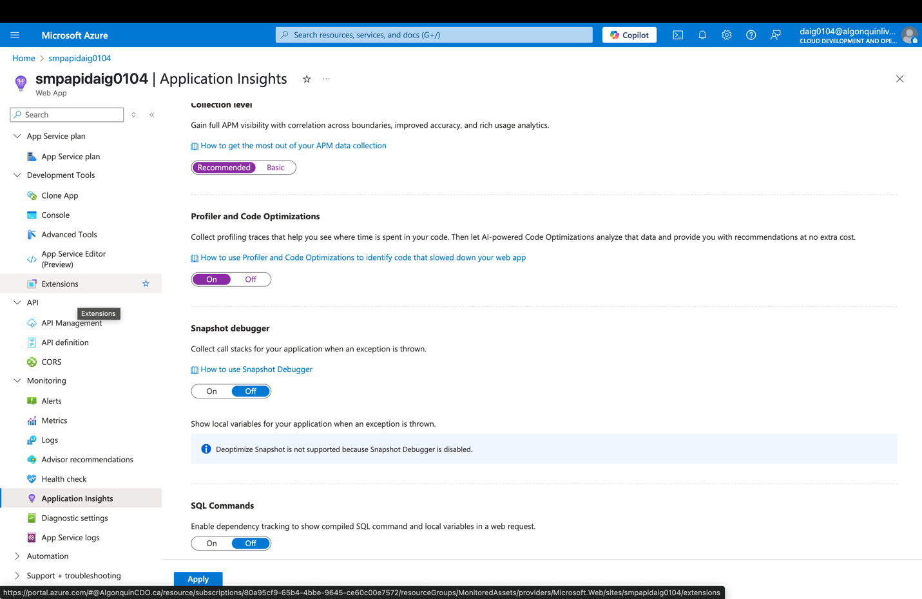

Step 10: Switching to the URL webpage and refresh many times for application insights:
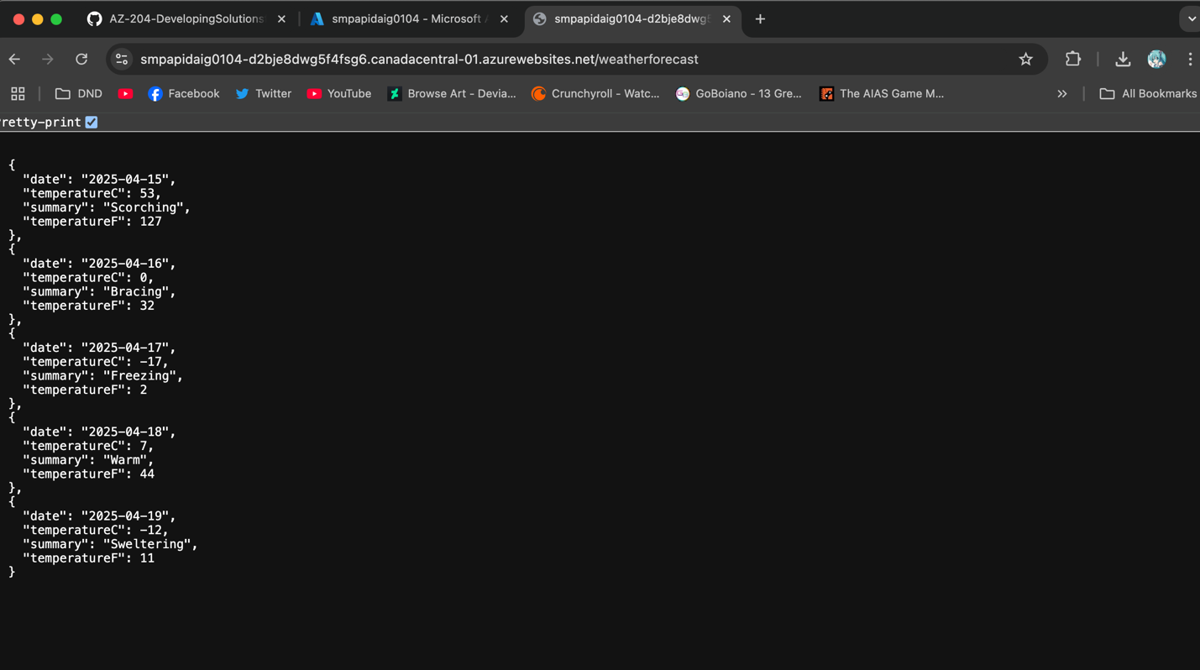

Step 11 The Results: Below, you can observe the spike and rapid decline of requests and failed requests by refreshing the above page many times.
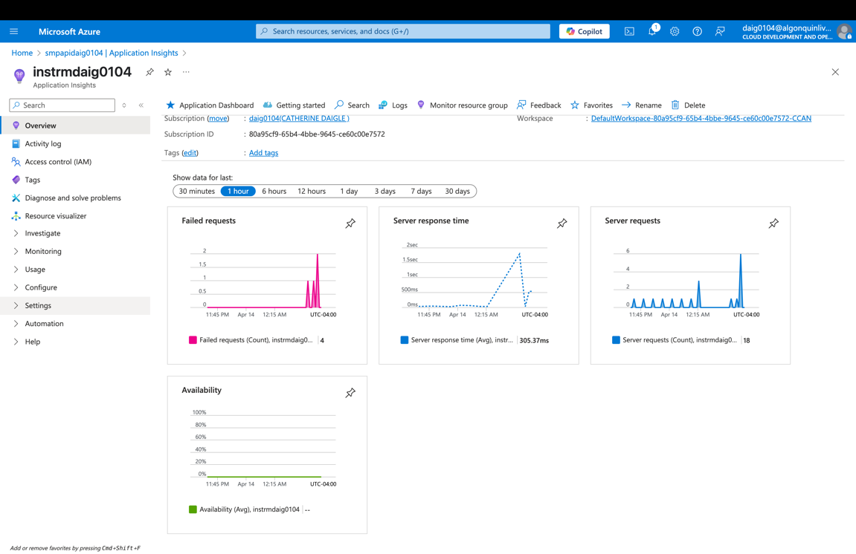

Step 12: Live Metrics: In this case, it shows my refreshing the page in real-time
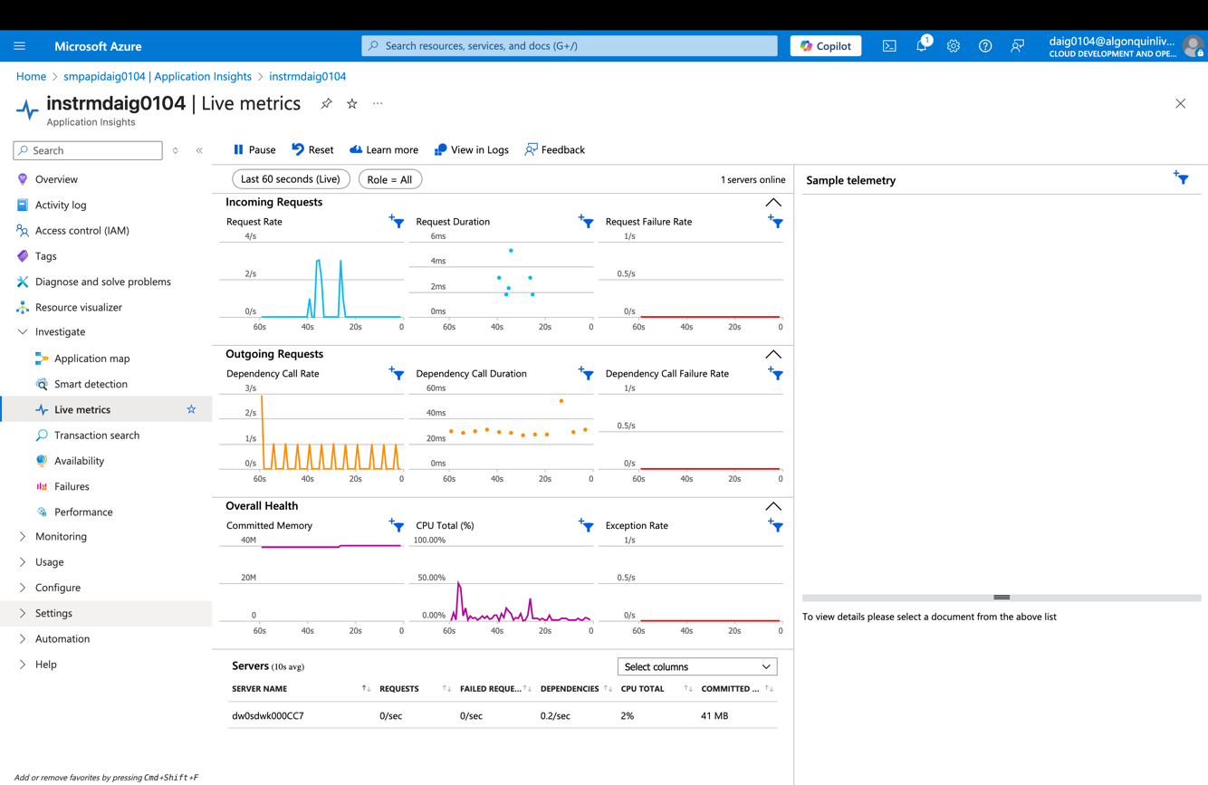

Conclusion:
In conclusion, I learned how to deploy Azure insights and use them to monitor the differences between web applications before and after being refreshed many times. I did, however, have a small issue with publishing the zip file, as the command in Step 6 could not access local files due to connecting with Azure Cloud Shell. I found that within the Azure portal, you can upload files to the Azure Cloud Shell, allowing the command to access the appropriate file within the Cloud Shell. I found the live metrics useful in informing me of the responses of the web page in real-time, as you can see above the CPU total, outgoing requests and request rate spiked when I refreshed the page many times. It is good that there is a maximum of 8 scaling units when there is too much traffic and, reduces to 1 unit if traffic is sparse. It’s important to note that if there were not a maximum of scaling units there would be a possibility of receiving too many requests such as a DDoS attack would lead to extremely high costs.

