CST8921 – Cloud Industry Trends
  - Lab 10 – Setting Up Azure Cognitive Search Index and Deploying Embedding & LLM Models

Introduction
In this lab, I will explore and understand AI and ML and how they are used. In terms of the lab, the usage refers to having AI interpret and read documents so that users can query the document and expect related results. This can be very useful with extremely long documents that take too much time to review, such as legal or political documents. With the AI, we can query a 50-page document with a prompt such as “What are the consequences of copyright law?” The AI will be able to interpret the legal document and output an answer that pertains to the question prompt.
In the case of this lab, the document the AI will be interpreting is: https://journalofbigdata.springeropen.com/articles/10.1186/s40537-014-0007-7

Objective

The lab aims to set up an Azure Cognitive Search Index and deploy Embedding & Large Language Models (LLM) on Azure OpenAI for Retrieval Augmented Generation (RAG). The result should have an Azure Cognitive Search Index and a script using LangChain to retrieve answers from query Q&A in a PDF

Lab Activity Screenshots:

Part 1: Setting Up Azure Cognitive Search Index

Step 1: Create an Azure AI Search Service
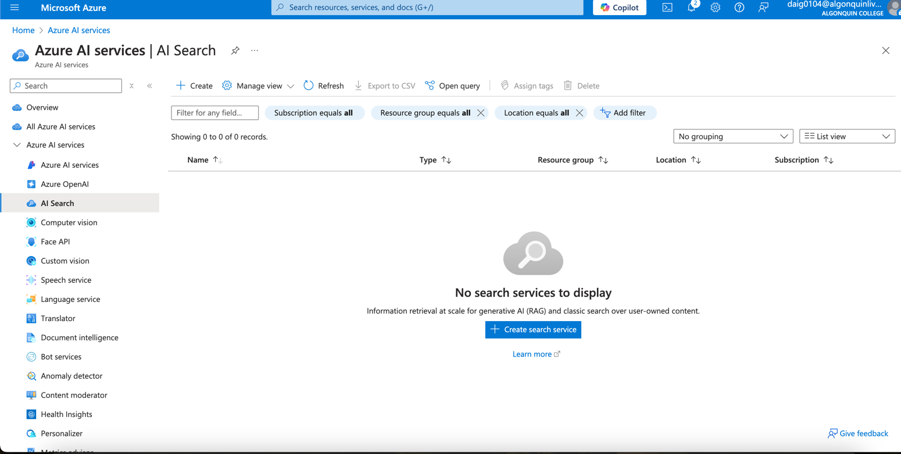

Creating service, Canada Central Free Tier.
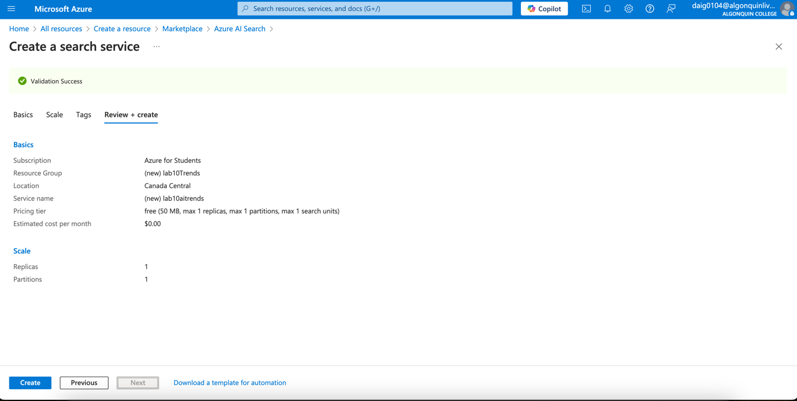

Step 2: Create an Index in Azure AI Search
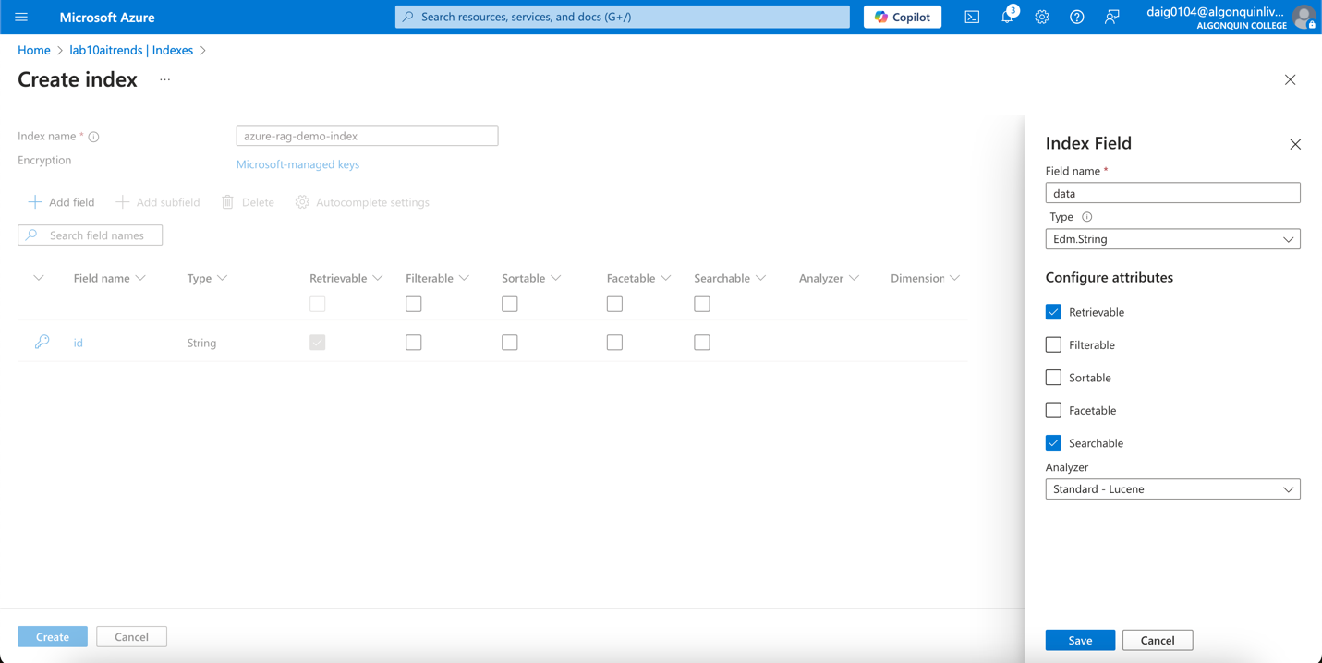

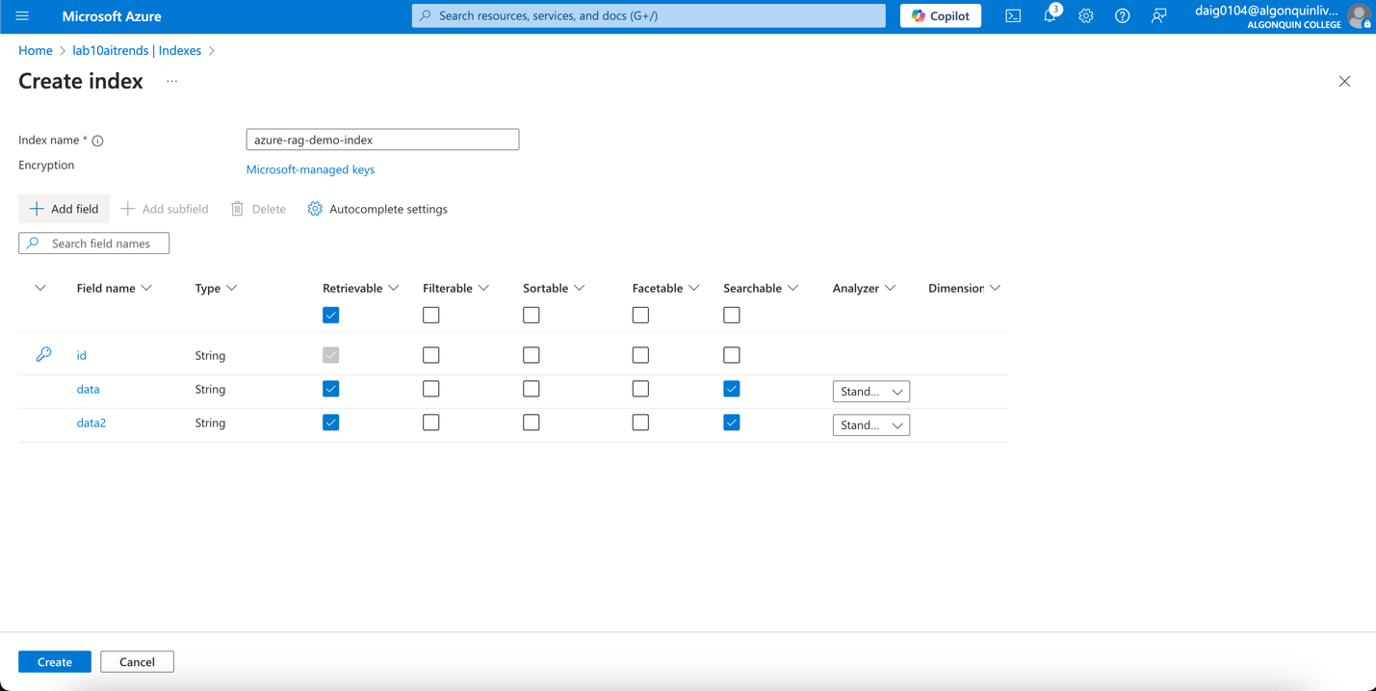
Later on, I added a new index field called source since I had an error in the code where it needed an index field called source.
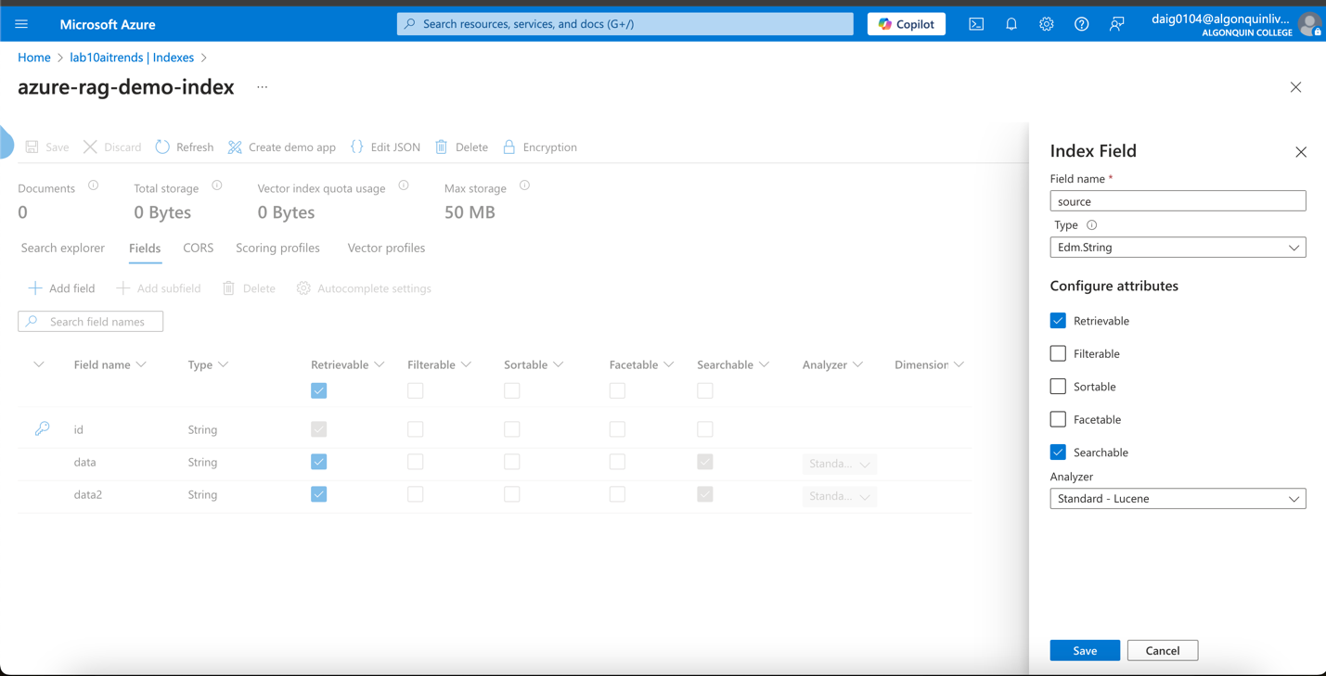

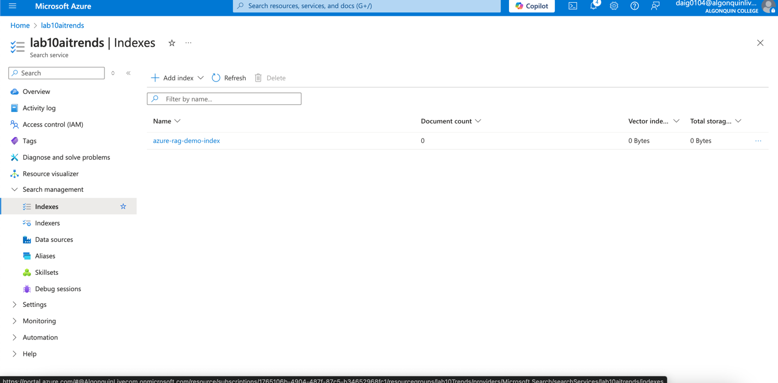

Step 3: Retrieve Endpoint & Key
Navigate to Overview to find the Endpoint URL:
https://lab10aitrends.search.windows.net
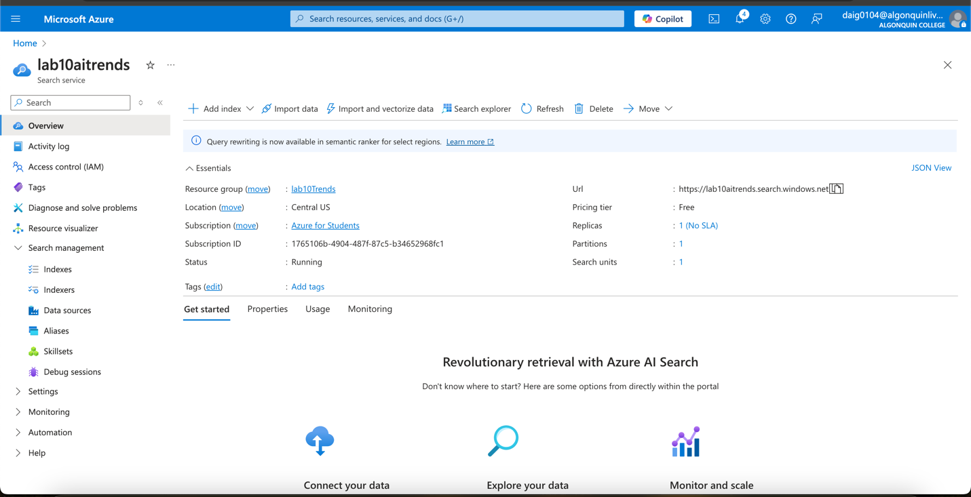

Navigate to Keys, copy the Primary Admin Key:
dpBqccuWj08kpXut0m9I2NIMU2FY1gn4uljbY1v8snAzSeD6x9SB
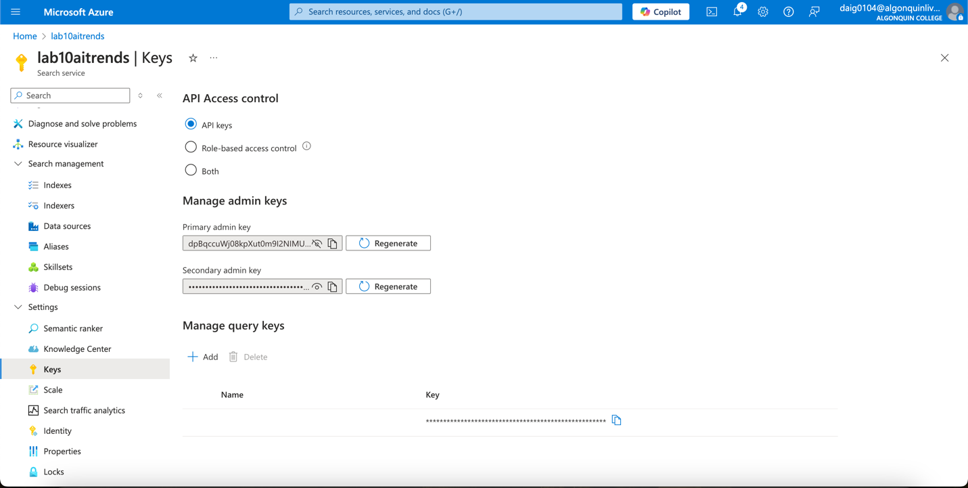

Part 2: Deploying Embedding and LLM Models on Azure OpenAI

Step 1: Create an Azure OpenAI Service
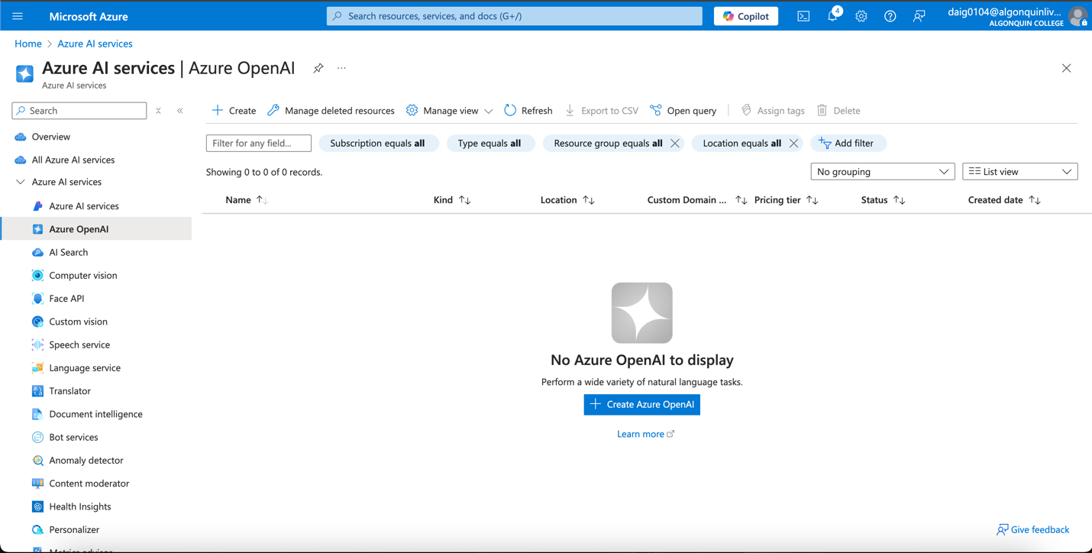

Canada Central, Standard pricing. All Network Types (that is the first option).
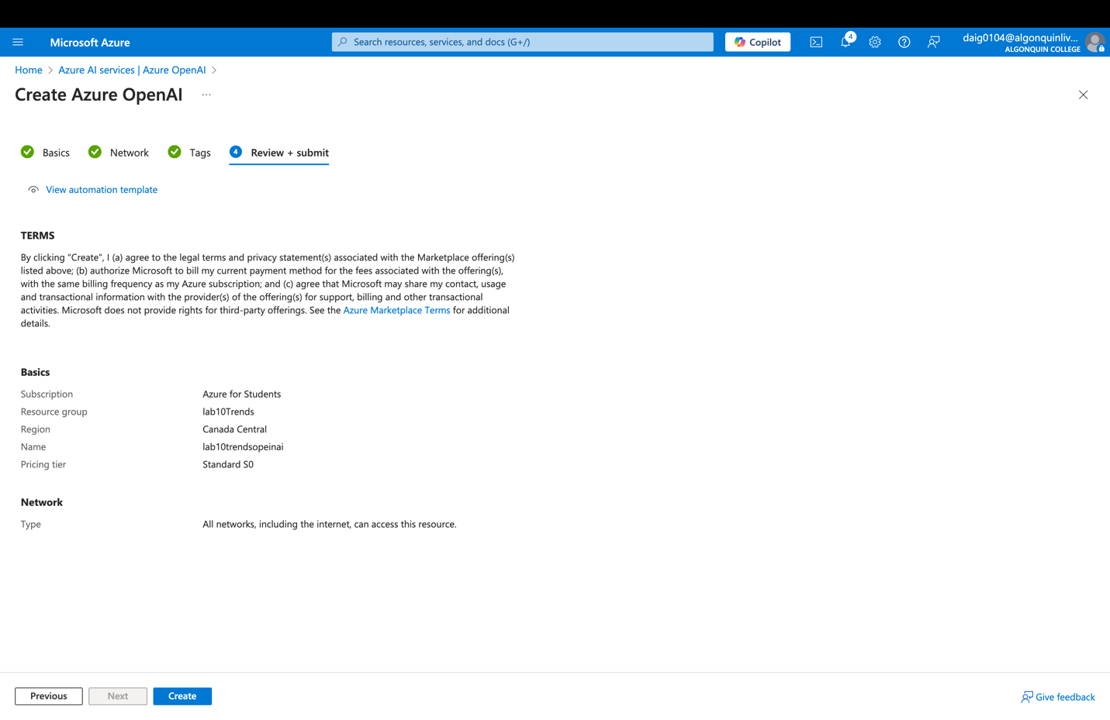

Go to resource:
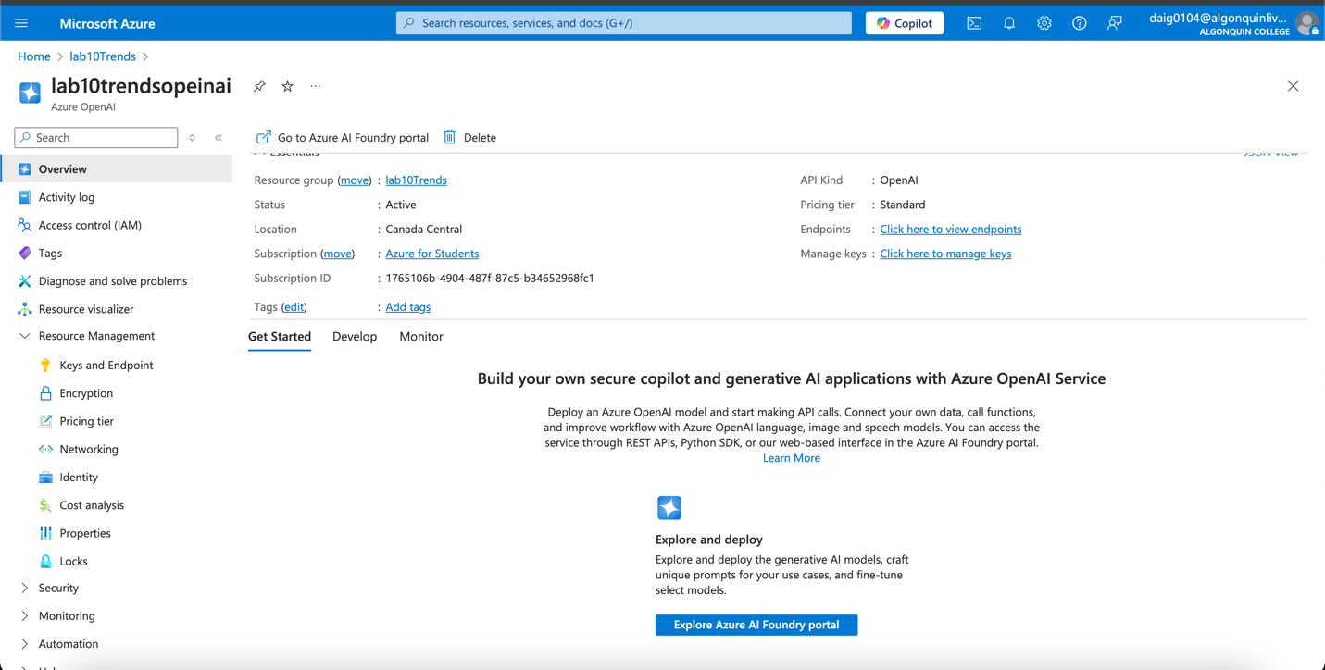

Step 2: Deploy Embedding and LLM Models
Click “Deployments” → “+ Deploy Model”.
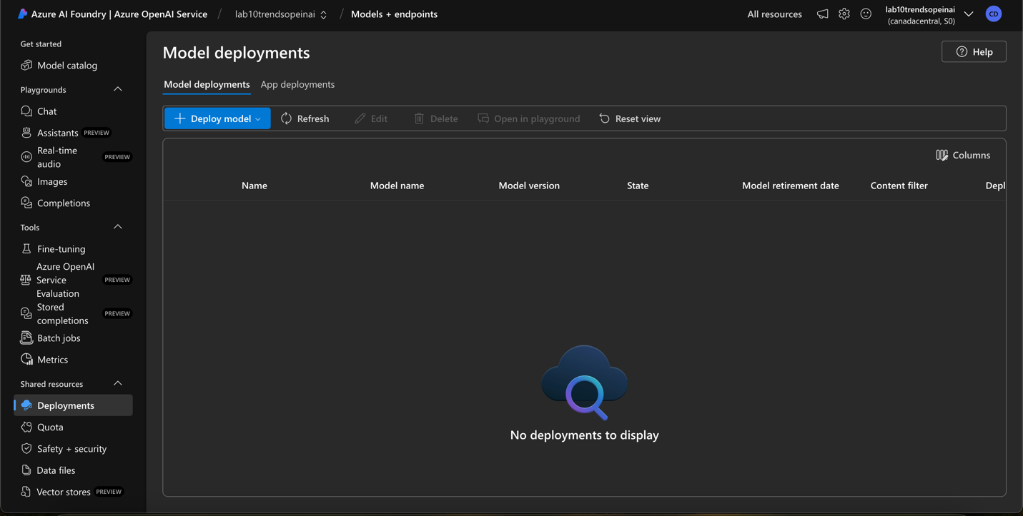
Deploy an Embedding Model: Model: text-embedding-ada-002
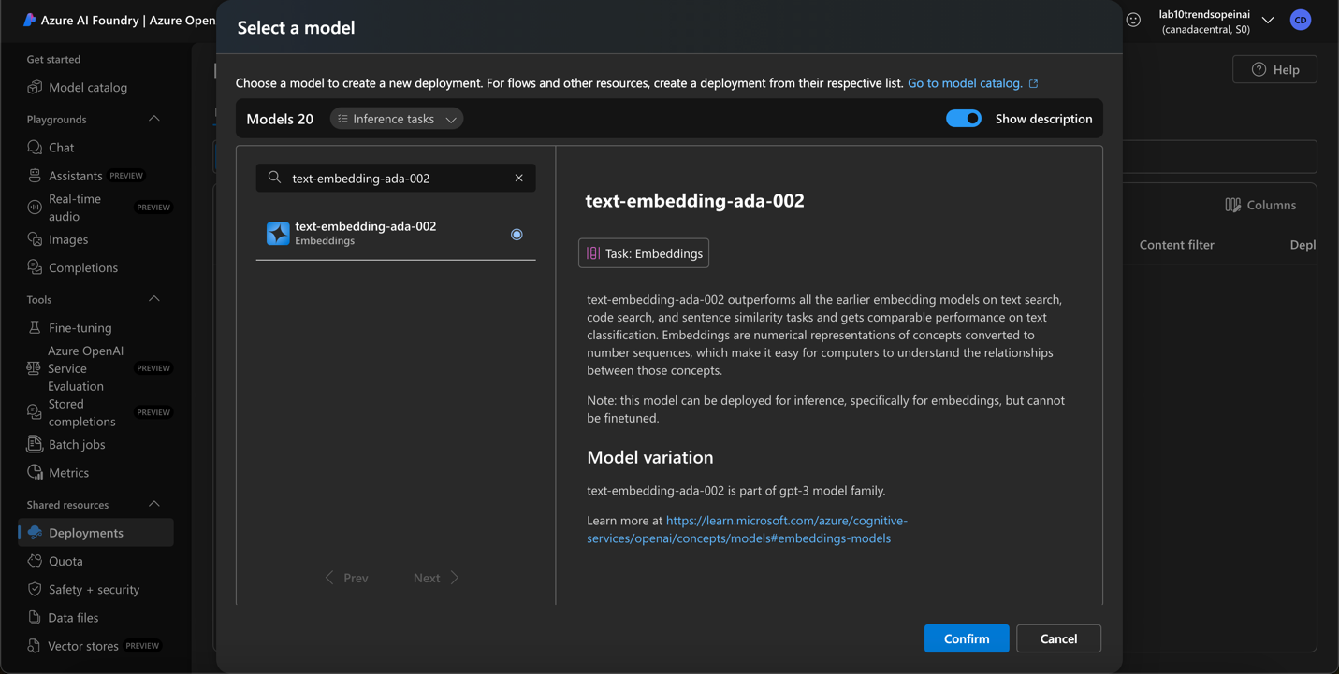

Settings of the model (lowest capacity for pricing, Sweden Central (It was the only available Quota for the other model, and both models had to be in the same region)
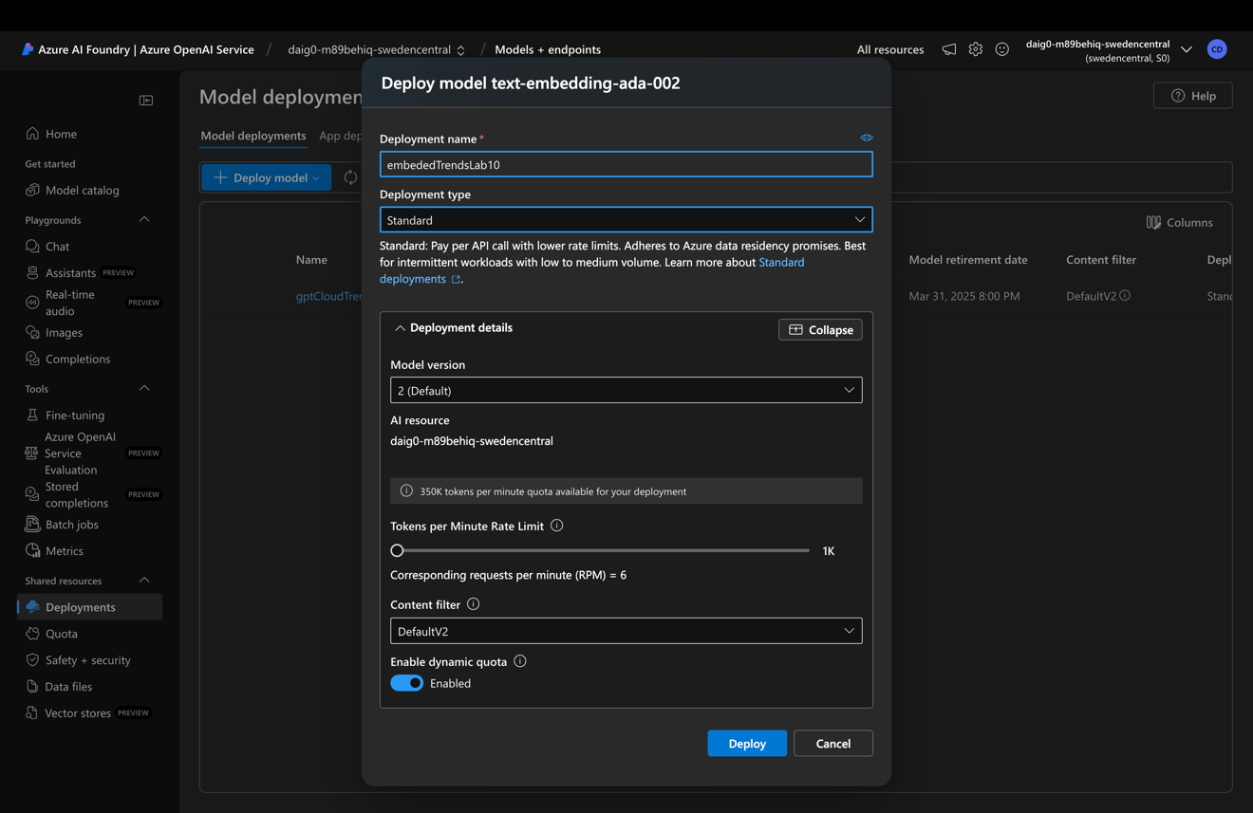
Overview:
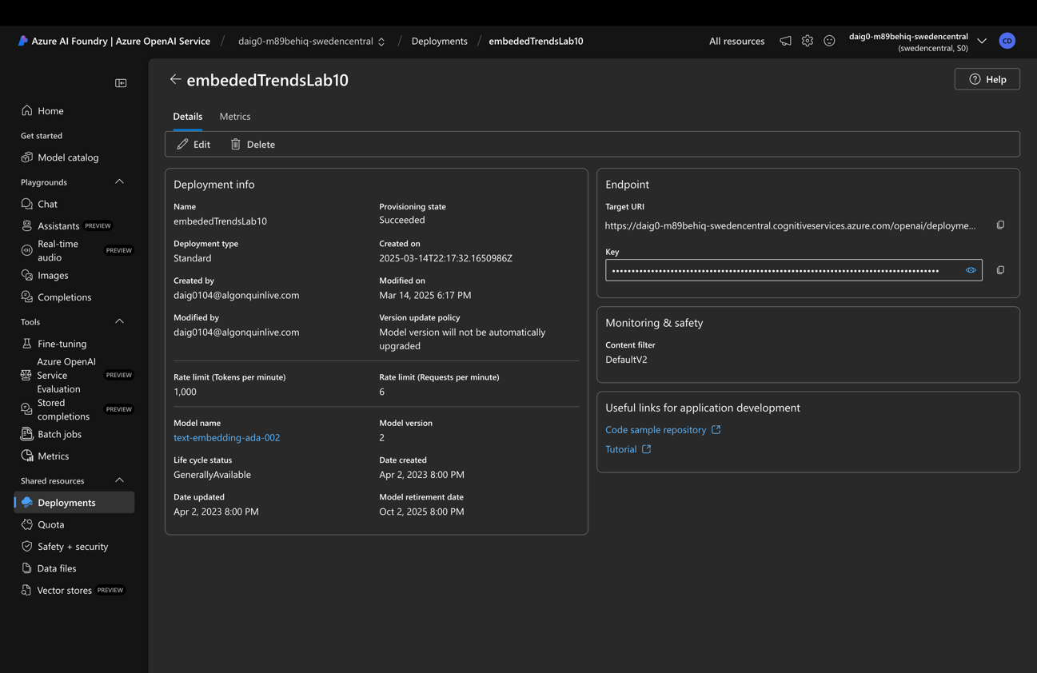
Deploy an LLM Model: Model: gpt-3.5-turbo-instruct
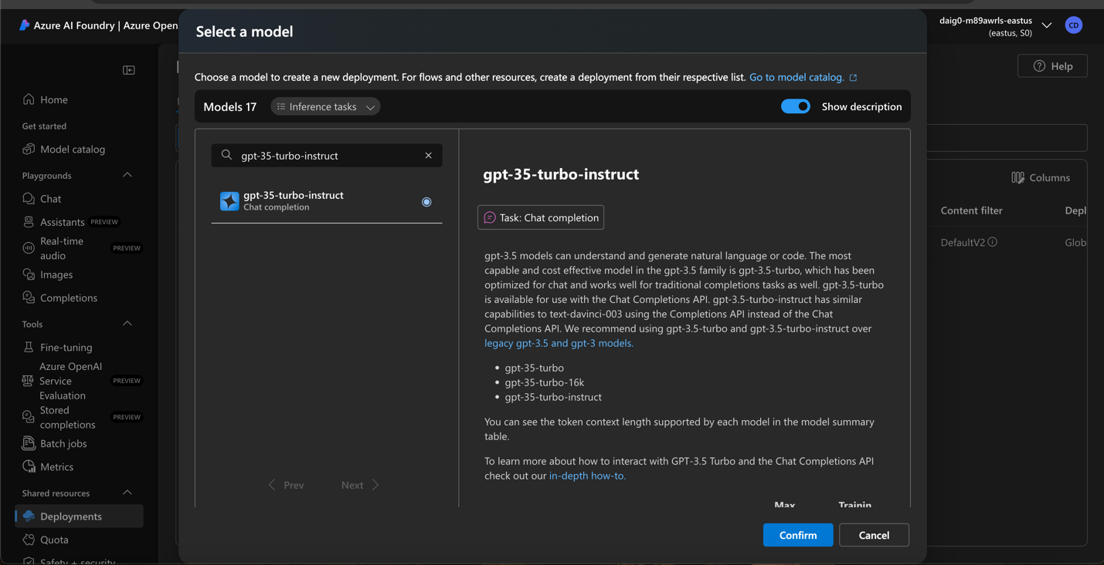

Sweden Central is the only region that had a quota for gpt-35-turbo-instruct.
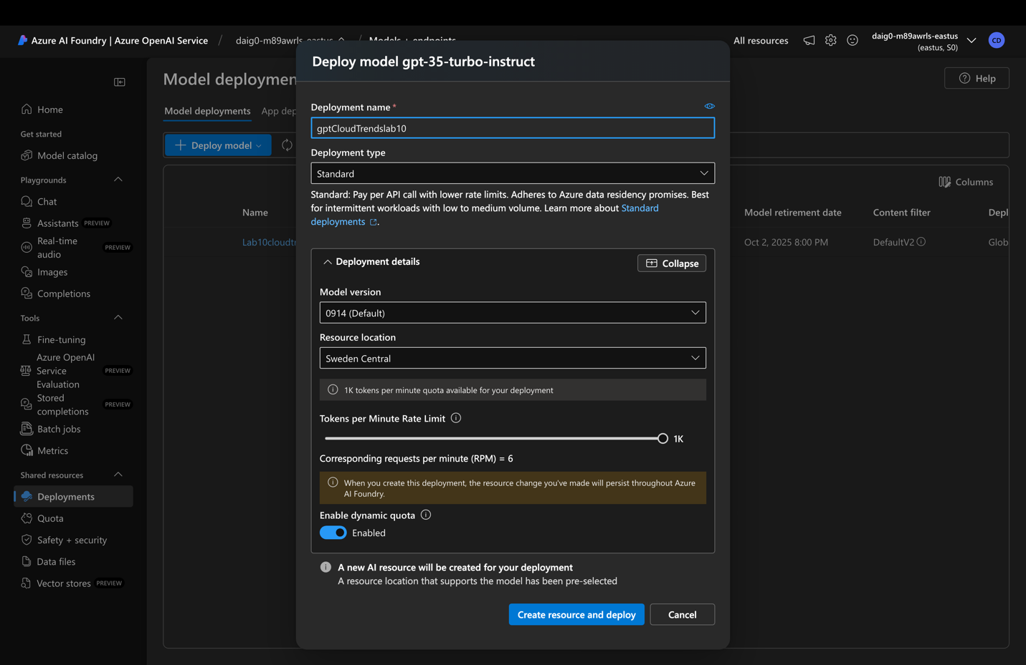
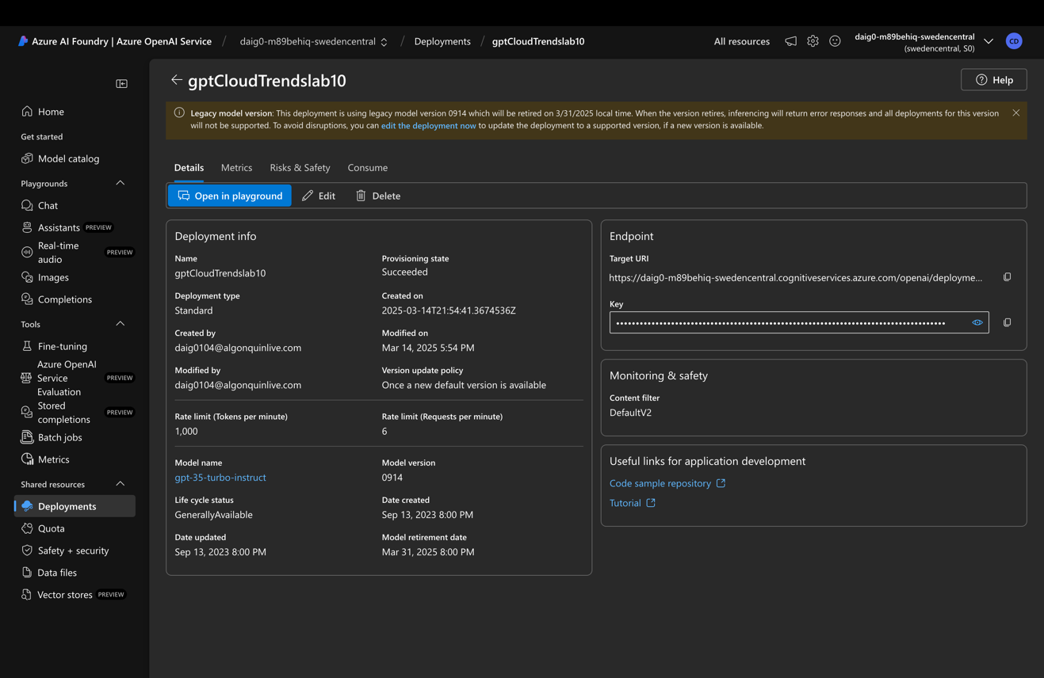

Step 3: Retrieve Endpoint & Key
Copy the Endpoint URL and Key.
API Key: WqRaeig3mX860TKpUzAeMzixbUMsET2LEyKZzYo6OKewGNuqoo3GJQQJ99BCACfhMk5XJ3w3AAAAACOGAv3O
Endpoint: https://daig0-m89behiq-swedencentral.cognitiveservices.azure.com/

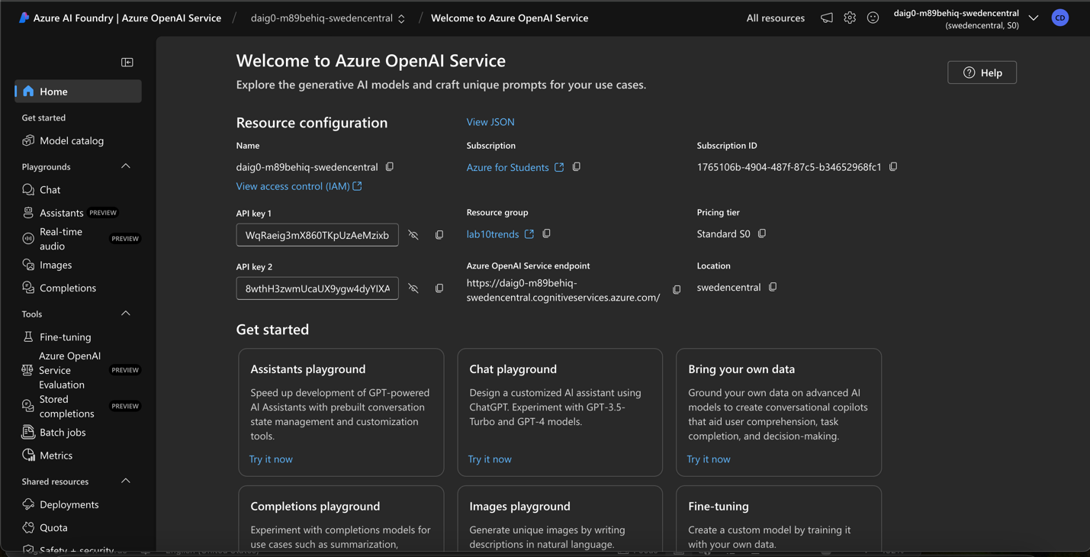

Part 3: Scripting with LangChain for RAG

Step 1: Install Required Libraries
Error fixes: pip install -U langchain-community. (It caused installation error otherwise)
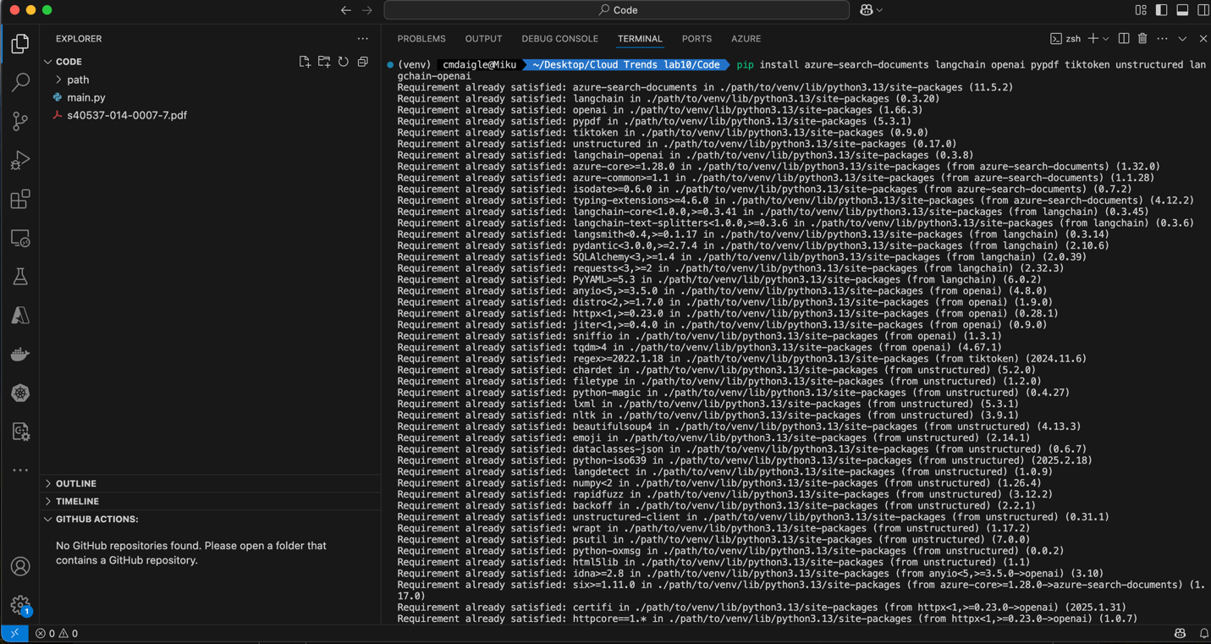

Step 2: Import Required Libraries
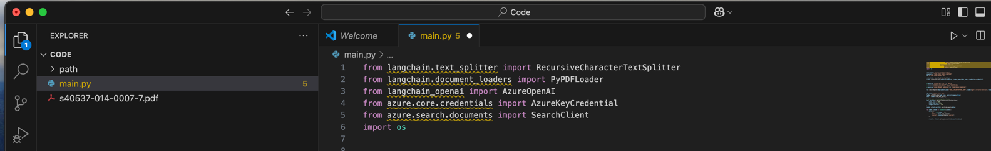

Step 3: Configure Azure Cognitive Search Client
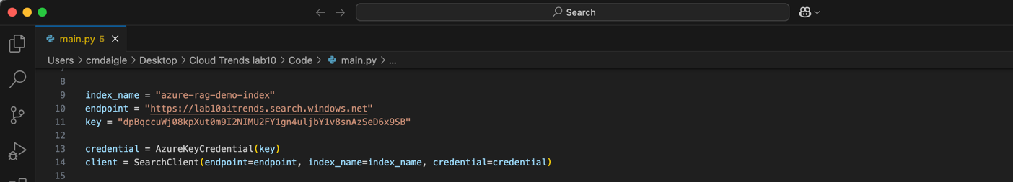

Step 4: Configure LLM Model
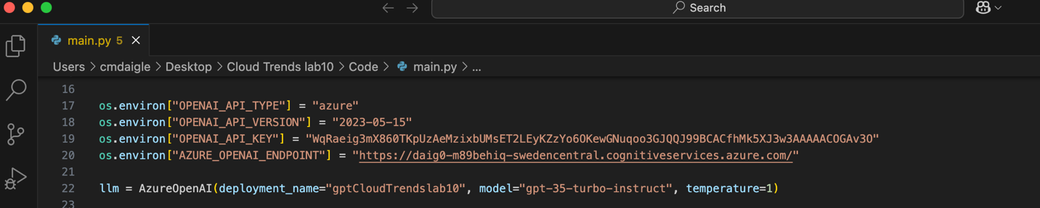
Step 5: Load and Process PDF Data
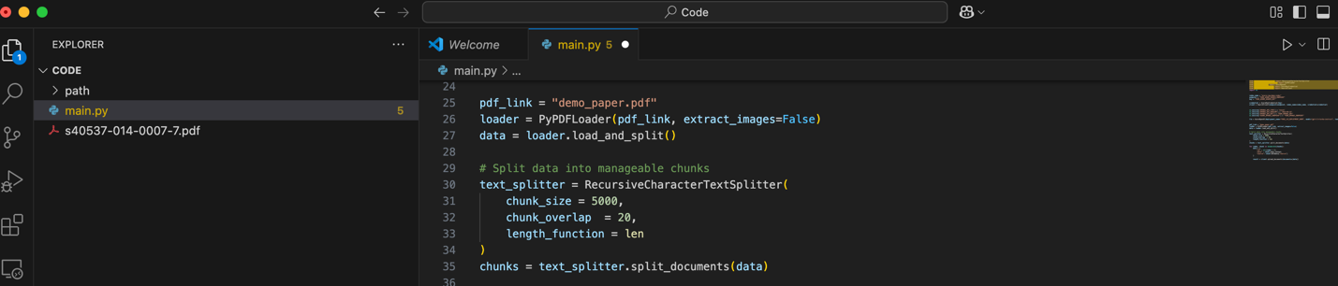

Step 6: Store Data in Azure Search Index
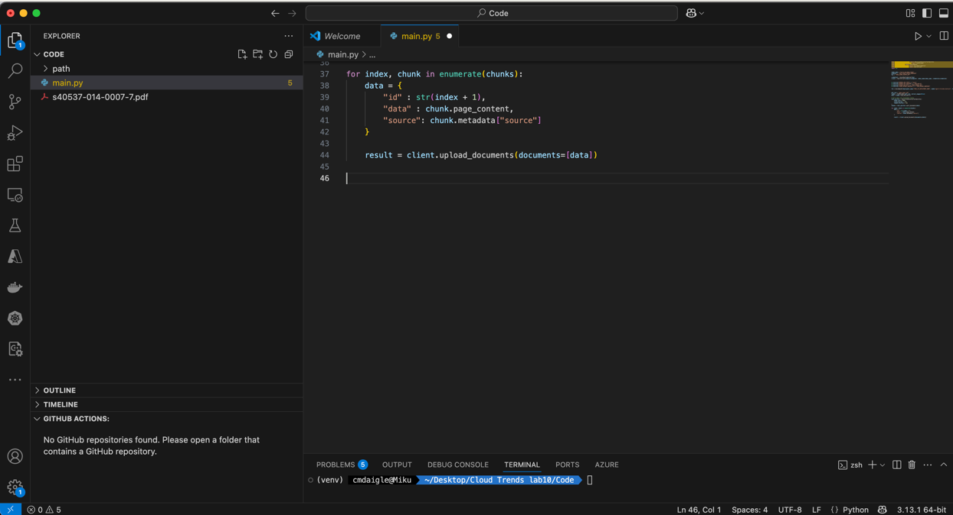

Step 7: Create a Function for Retrieval Augmented Generation
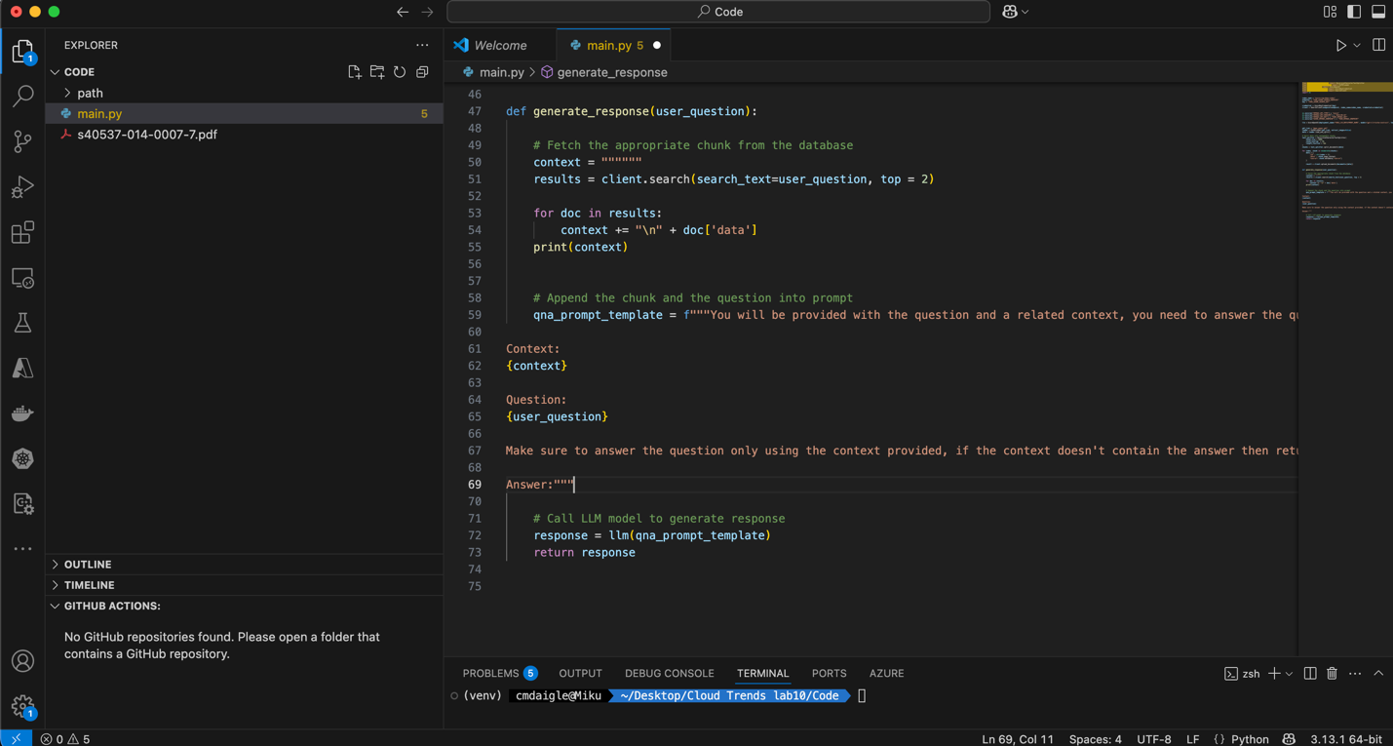

Step 8: Test the System

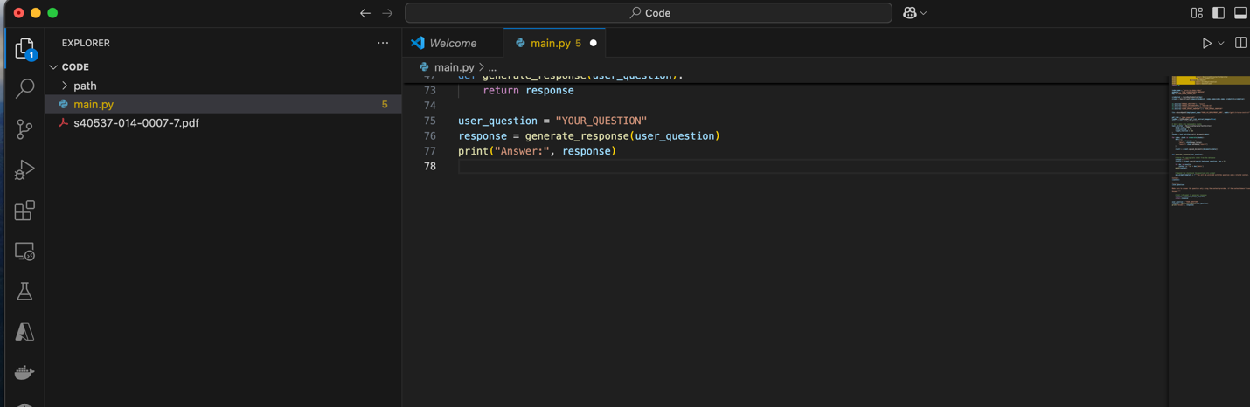
View of the entire code:
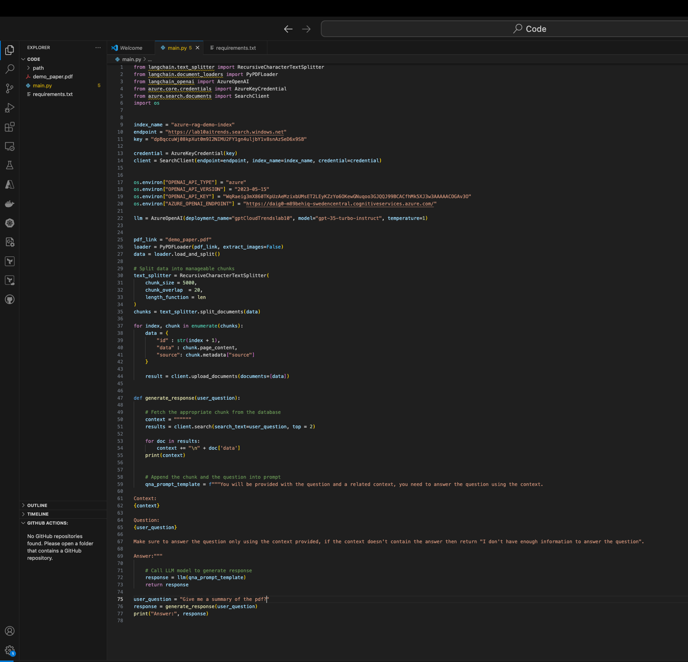Error 1: The property ‘source’ does not exist: This is the error that was solved within Step 2: I had to add an index field of “source” because the name for the 2nd data field needed to be “source” for the code.
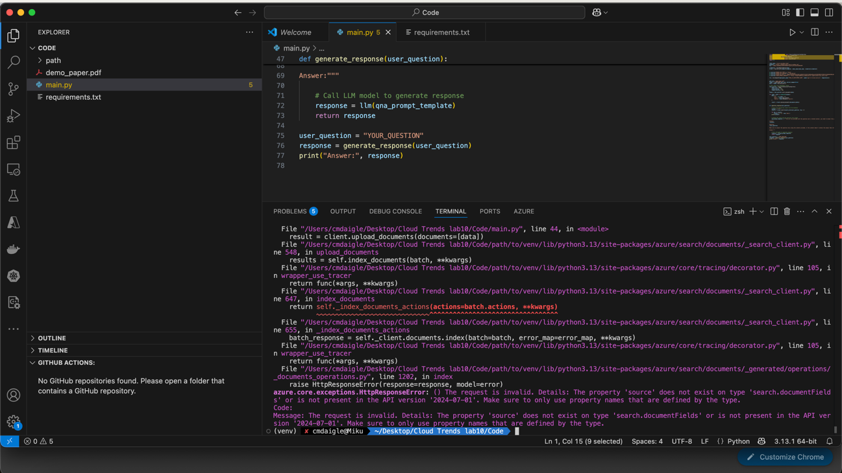
Error 2: “Deployment not found.” This error was solved because the deployment_name had to equal my model deployment, which had the name gptCloudTrendslab10. (a unique name)
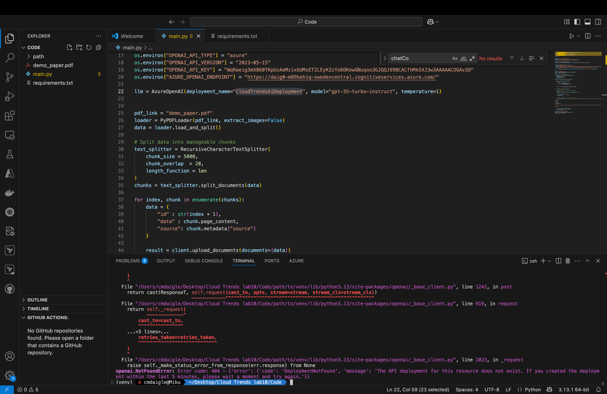
Below is the Solution:
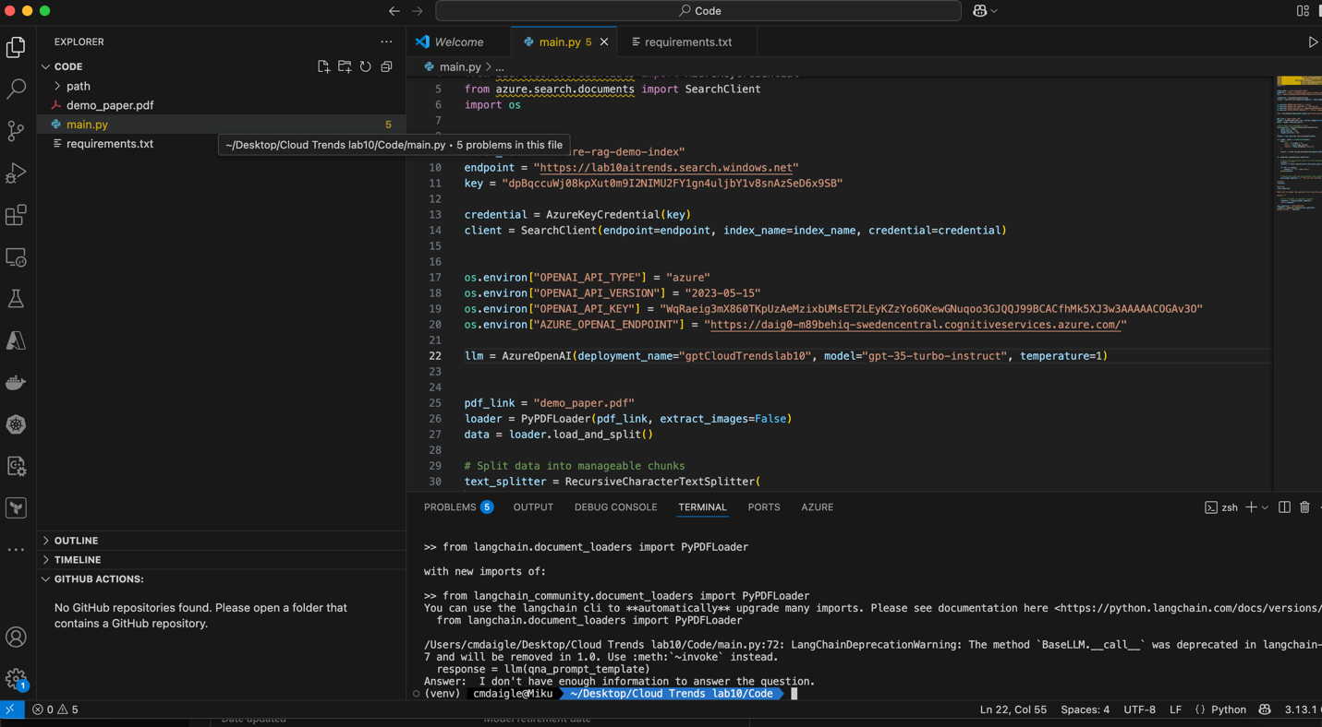
Testing with Unique Questions, this is asking the AI to give me a summary of the pdf inputted:
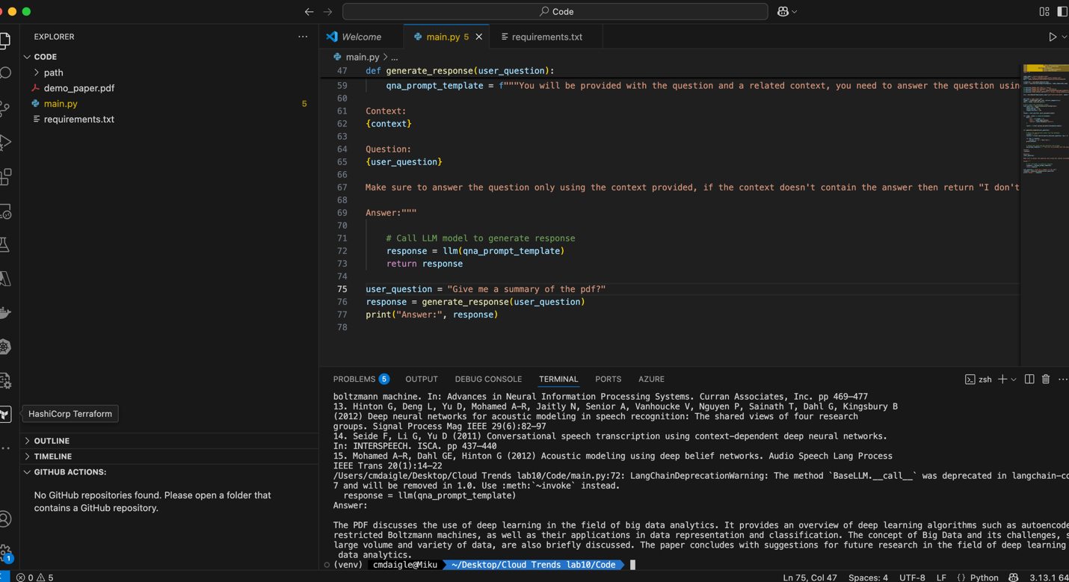

Another Question: who are the authors of the PDF? (the AI is a little touchy with the prompts when asked, “Who are the creators?” It does not associate the word with “authors” and comes up with a non-sense answer.
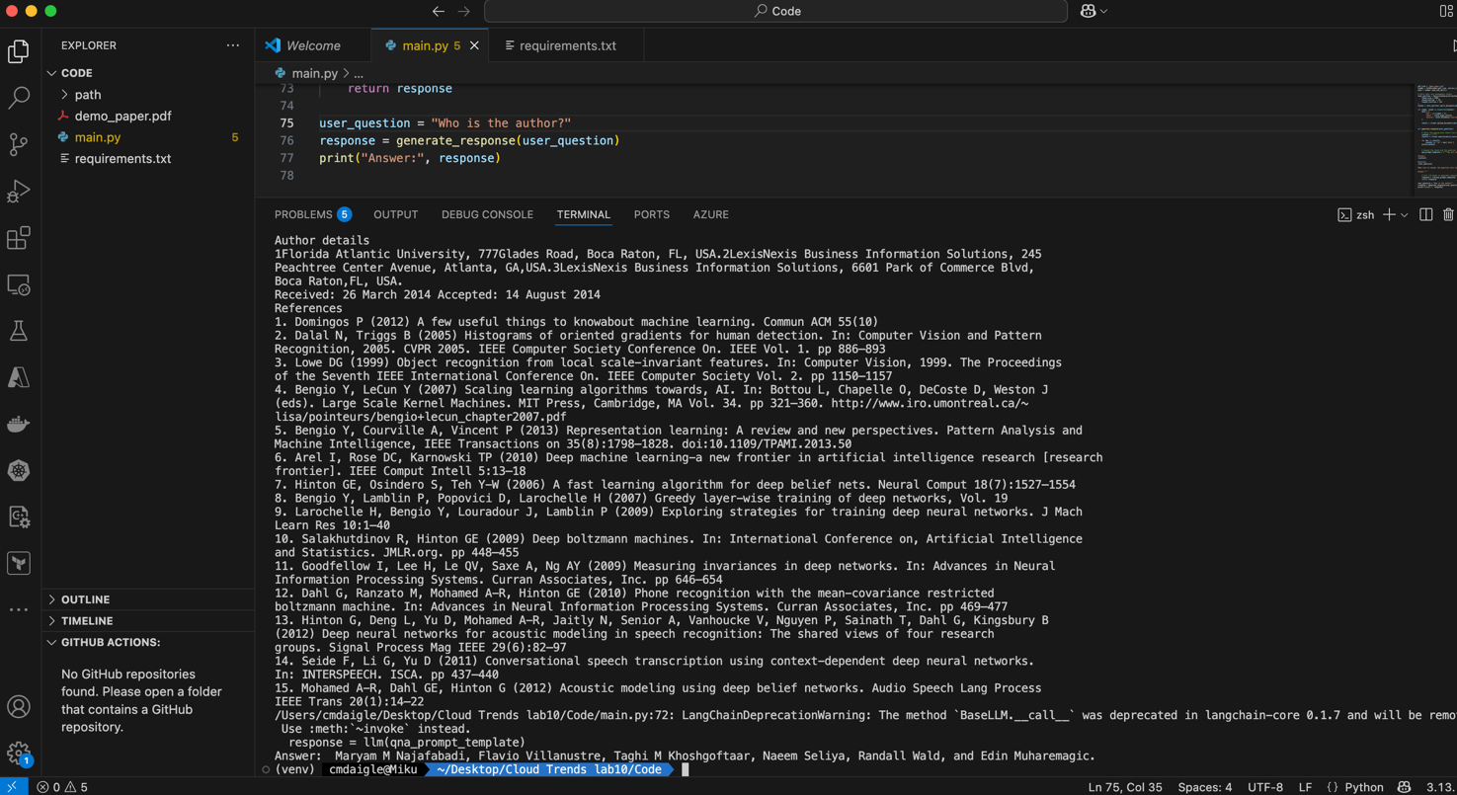
Part 4: Deleting Resources
Step 1: Deleting the ML Models
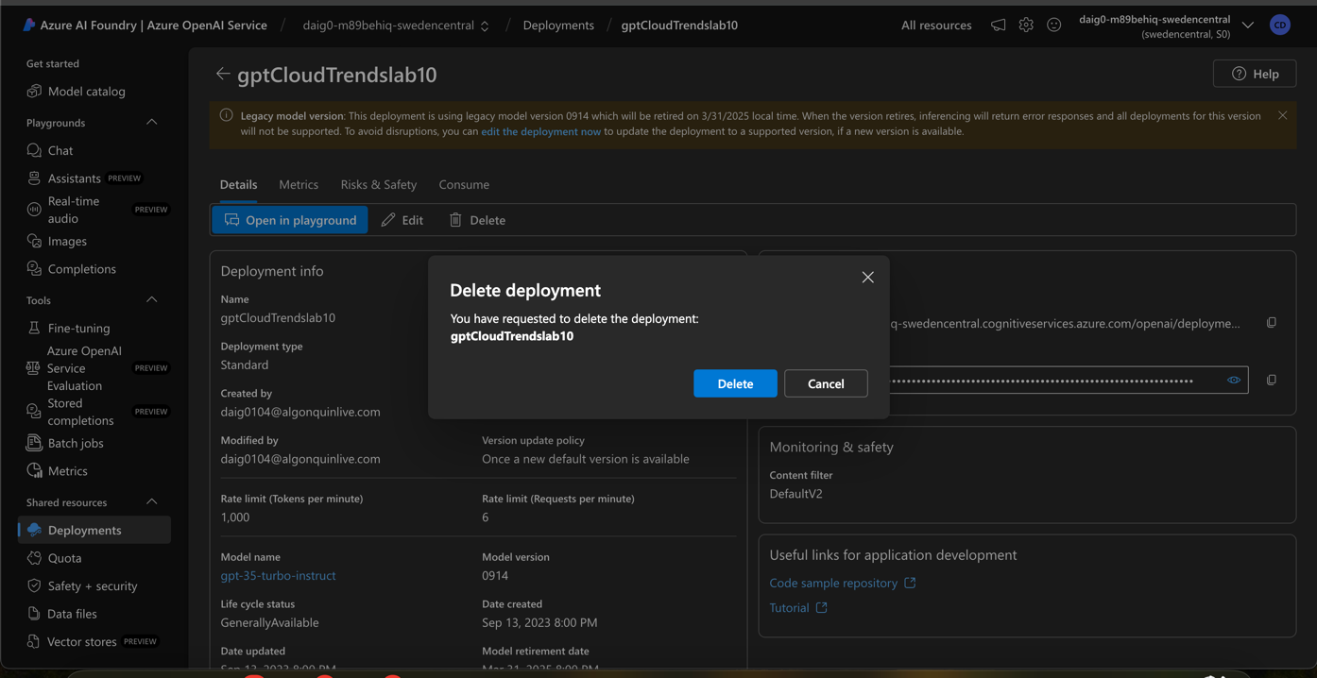
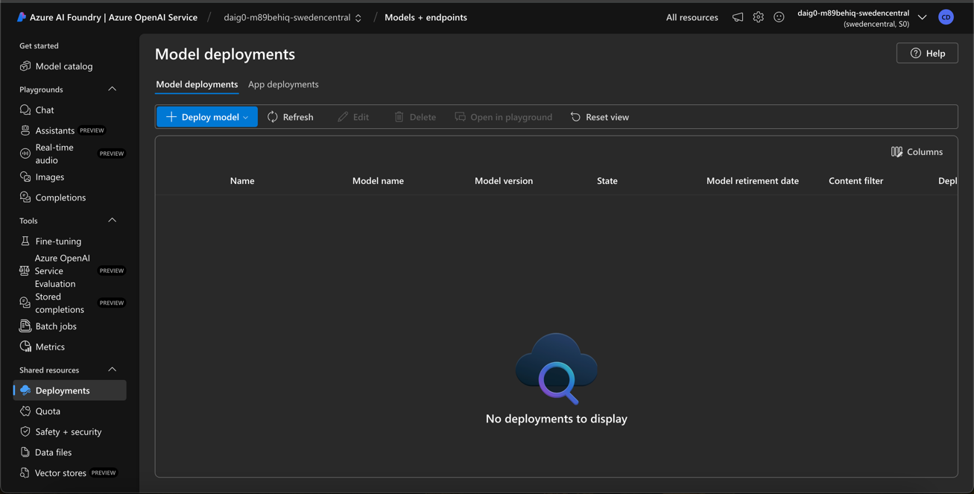

Step 2: Deleting the resource group:
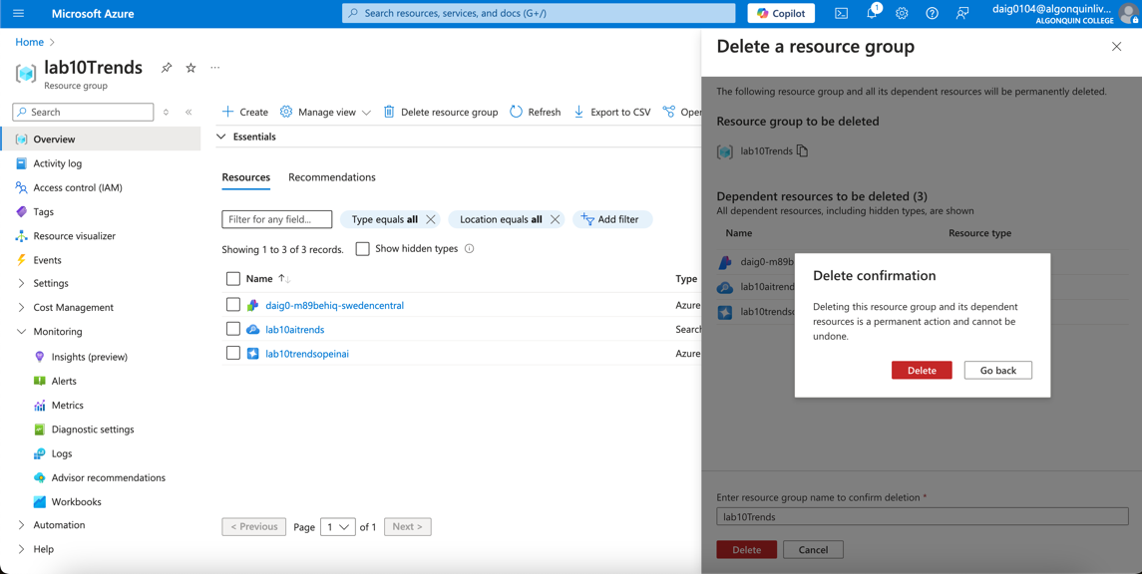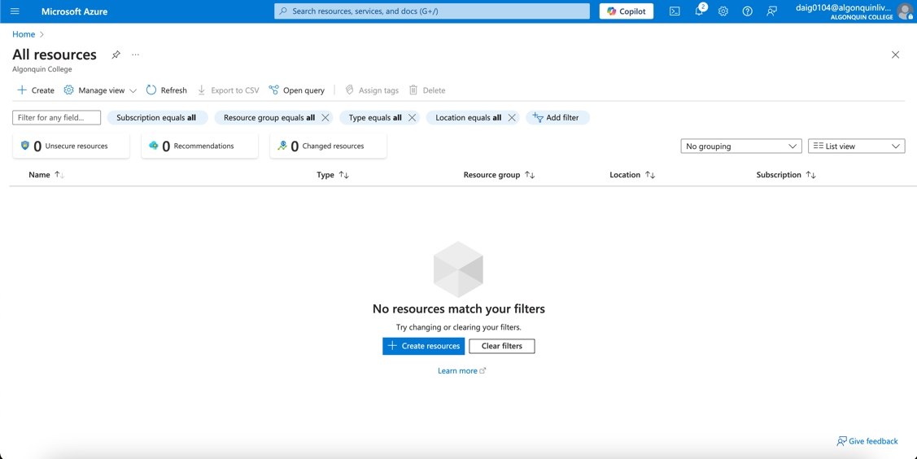

Results:
The lab's results are that I have successfully been able to query a question such as “give me a summary of the PDF” and have the AI models interpret, read, and output an answer. The answer accurately relates to the question at hand however, I found that the models have difficulties interpreting some prompts.

Conclusion:
In conclusion, I have successfully deployed a large language model and an Azure cognitive search index to interpret the prompt and scan a PDF for relevant answers to the prompt. The end result is that the AI can pull and find related answers, such as summarizing the PDF or finding the PDF’s authors.
Along the way, I encountered a few errors, as listed above, but they did not take much time to debug. One such error is “Deployment not found” within step 8 of the screenshots. This error was easily debugged by changing the deployment name to the appropriate AI model name, as using unique names caused this oversight. Another error is that I did not have a source index as it was written in code (Step 2 and Step 8). The solution was to add a source index.
Another issue I found that is important to keep in mind is that Azure OpenAI has quotas for the model you use. I unfortunately did not have any quotas for East US for both models. The models could not be used in different regions since the API key and Endpoint URL have to match the location. In short, I had Sweden Central available for both models and picked Sweden as the region.
Lastly, I did not expect that the Open AI LLM does not have a vast understanding of the meaning/intention behind different prompts. For “give me a summary of the PDF,” the model behaved as expected. However, when I asked the model, “Who are the creators of the PDF?” I did not get the authors of the PDF except when I changed “creators” to “authors.” Similarly, I asked a prompt, “What are the PDF’s Resources?” The AI gave a generalized answer, such as general titles of resources, but not necessarily a bibliography, which is my expectation.
Overall, the AI models performed well as long as the prompts were clear and specified. I assume the issue earlier is that the word “resources” can be interpreted in many ways, and the LLM may have gotten confused that “resources” could mean bibliography. A word such as “author” or “references” does not leave for other interpretations.

